
Nicolae Alin Craciun (2010279)

SECOND
ASSESMENT
Data Analysis and Visualization

Lecturer – Anupam Mazumdar

No.


W

07 January 2021 1055 ACCB4002

Submission : Word count : Module number :

Outlier Test
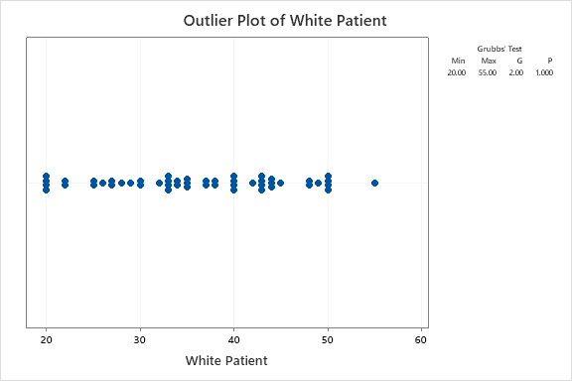
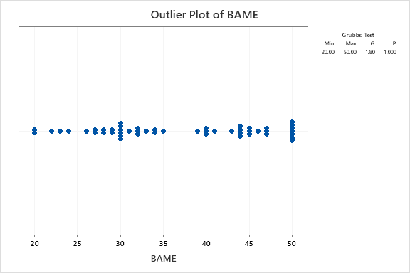
An outlier is an observation that lays an irregular separation from different qualities in an arbitrary example from a populace. As it were, this definition surrenders it to the expert (or an agreement cycle) to choose what will be viewed as irregular. Before strange perceptions can be singled out, it is important to describe ordinary perceptions.
The above graph and test represent there is no outlier in data set white patient and BAME patient.
The purpose behind no outlier in this data on the grounds that A perception is an outlier on the off chance that it falls more than over the upper quartile or more than underneath the lower quartile. The minimum value is so there are no outliers in the low end of the distribution.
The above graph and test represent there is no outlier in data set white patient and BAME patient.
Independent Sample T test
Independent sample t test is used to test the statistically significance difference between two means. The independent samples t-test is a test that looks at two gatherings on the mean estimation of a ceaseless, ordinarily conveyed variable. The model assumes that a difference in the mean score of the dependent variable is found because of the influence of the independent variable that distinguishes the two groups. The independent samples t-test thinks about two autonomous gatherings of perceptions or estimations on a solitary trademark. The independent samples t-test is the between-subjects simple to the needy examples t-test, which is utilized when the examination includes a repeated estimation or matched observations. Here I test difference among two means at different significance level such 0.10, 0.01 and 0.02.
Null Hypothesis:
A null hypothesis generally denoted by the symbol H₀ is any hypothesis which is to be tested for possible rejections under the assumption that it is true. Today the term is used for any hypothesis that is being tested. The word null in the term null hypothesis implies that usually H_{o} is the hypothesis of no effect. A null hypothesis should always be precise such as the data shows there is no statistically significant difference between White patient and BAME.
Ho: There is no statistically significant difference between White patient and BAME patient.
OR
Ho: $μ_{1}-μ_{2}=0$

Alternate Hypothesis
An alternate hypothesis is any other hypothesis which I accept when the null hypothesis H_{o} is rejected. In hypothesis testing, an alternative hypothesis is an explanation which an analyst is trying. This assertion is valid from the analyst's perspective and at last, demonstrates to reject the null to replace it with an alternative assumption. In this hypothesis, the distinction between at least two variables is anticipated by the researchers, with the end goal that the example of information saw in the test isn't because of possibility.
Ha: There is statistically significant difference between White patient and BAME patient.
OR
Ha: $μ_{1}-μ_{2}≠0$
Level of significance = 0.10
Results
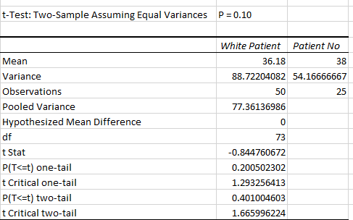
Interpretation
The output indicates that mean for white patient is 36.18 and for patient no. it is 38. Looking in the Variances row, I can see that they are not exactly equal, but they are close enough to assume equal variances. The p-value is the most important statistic value in it and plays an important role in the output and interpretation of this statistical data. I have also observe that the critical values for a test of hypothesis depend upon a test statistic, which is mainly to the type of test, and the significance level, α, which defines the sensitivity of the test. A value of α = 0.05 implies that the null hypothesis is rejected 5 % of the time when it is in fact true. The choice of α is not a thumb role, although in practice values of 0.1, 0.05, and 0.01 are common. Critical values are essentially cut-off values that define regions where the test statistic is unlikely to lie; for example, a region where the critical value is exceeded with probability α if the null hypothesis is true. The null hypothesis is rejected if the test statistic lies within this region which is often referred to as the rejection regions. The results show that p-value in terms of one-tail and two-tail test is higher that the given critical value which is 0.10. It means that the difference between mean is statistically significant.
Decision Rule
If p value less than critical value 0.10 I reject Ho and conclude difference between means is statistically significant.
Conclusion
In this analysis sig value 0.40 greater than critical value 0.10 (0.40>0.10) I accept Ho and conclude that there is no statistically significant difference between White patient and BAME patient.
Null and Alternate Hypothesis:
Ho: There is no statistically significant difference between White patient and BAME patient.
OR
Ho: $μ_{1}-μ_{2}=0$

Ha: There is statistically significant difference between White patient and BAME patient.
OR
Ha: $μ_{1}-μ_{2}≠0$
Level of significance = 0.01
Results
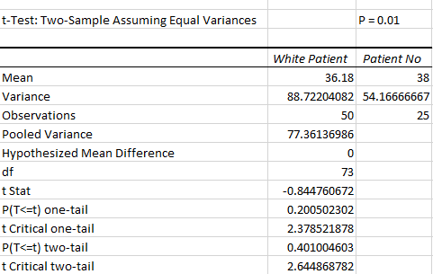
Interpretation
The t-test in terms of two-samples assuming equal variances, when the p-value its 0.01 because the p-value a quantitative measure for detailing the consequence of a trial of the theory is the p-value. The p-value is the likelihood of the test measurement is in any event as outrageous as the one noticed given that the invalid theory is valid. A little p-value means that the null hypothesis is false.
Decision Rule
If p value less than critical value 0.01 I reject Ho and conclude difference between means is statistically significant.
Conclusion
In my analysis sig value 0.40 greater than critical value 0.01 (0.40>0.01) I accept Ho and conclude that there is no statistically significant difference between White patient and BAME patient.
Null and Alternate Hypothesis:
Ho: There is no statistically significant difference between White patient and BAME patient.
OR
Ho: $μ_{1}-μ_{2}=0$

Ha: There is statistically significant difference between White patient and BAME patient.
OR
Ha: $μ_{1}-μ_{2}≠0$
Level of significance = 0.01
Results
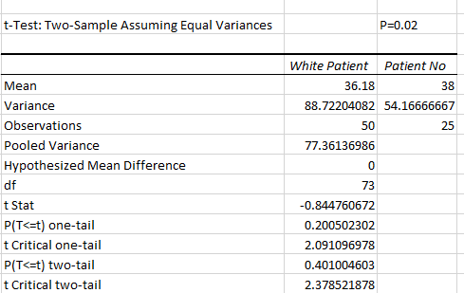
Decision Rule
If p value less than critical value 0.02 I reject Ho and conclude difference between means is statistically significant.
Conclusion
In my analysis sig value 0.40 greater than critical value 0.02 (0.40>0.02) I accept Ho and conclude that there is no statistically significant difference between White patient and BAME patient.

