Name: Imayinkhor Johnbull Osawaru
Student Id: 1920459

Academic and Employability Skills
Submitted to
Adesewa Ajayi
University of Wales Trinity St. David


Table of Contents
Table of Contents 2
1. Introduction 3
2. Literature of Employability Skills 3
3. Techniques of Employability 5
4. Framework of Employability 6
5. Classroom Activities 7
6. Personal Employability skills 8
7. Personal Development plan 10
8. Conclusions 10

Introduction

Employability is a measurement of someone’s skills, knowledge and other capacities which can lead them to obtain employment in the world job market. It can be defined in many different ways, ‘Employability is the capability to move self-sufficiently within the labor market to realize through sustainable employment. For the individual, employability depends on the knowledge, skills and attitudes they possess, the way they use these assets and present them to employers and the context (personal circumstances and labor market environment) within which they seek work’. (Hillage and Pollard, 1998). It has also defined ‘a set of achievements – skills, understandings and personal attributes – that make graduates more likely to gain employment and be successful in their chosen occupations, which benefits themselves, the workforce, the community and the economy’. (Professor Mantz Yorke, 2004).
As a student this is very important to understand the required skills and knowledge set for the marketplace to be hired. Knowing the appropriate learning and research methods, is also important for every learner. In this coursework, it is to make responsible for learners on their own learning, and gaining confidence and competence as effective employees by developing a range of employability skills such as reflection, time management, communication and presentation skills, digital knowledge.

Literature of Employability Skills
In generally, employability skills depends on the level of employment that some is looking for. To understand better, the desire employability skills differ from a managerial role to a fresh graduate student. However, the required skills set is more or less similar but the level or skills may differ. The careerEDGE model (Pool and Sewell, 2007) summaries five essential elements for student’s employability.
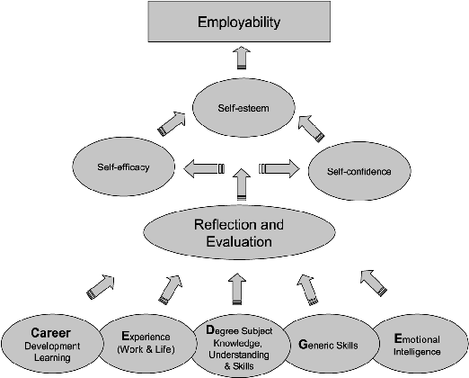
Figure 1: The essential components of employability (Pool and Sewell, 2007)
Essential elements | What is it?
Career Development learning | It is lifelong learning curve that could be used throughout the career- the knowledge, skills and experience.
Experience | People learn and gain knowledge and skills by different mean, for example- by seeing that other people did or does, by reading- knowledge is endless, as someone read, they learn more, self-experience- people also learn from their own doings and they develop a broader range of skills and attractive for employers.
Degree | Obtaining a degree let people gain subject knowledge, understanding and skills. For example- a Business Management student and a Civil engineering student will have different subject knowledge and skills.
Generic Skills | This skills letting people to know different basic skills which is transferable skills not specific to work or attach to an occupation but essential for work (Time management, resource management, team management or working in a team, Prioritization, delegation, Listening, Research and analysis). (Cheary, 2020)
Emotional Intelligence | ‘The capacity for recognizing our own feelings and those of others, for motivating ourselves, and for managing emotions well in ourselves and in our relationships’. (Goleman, 1998).

These all skills has been categorized as an essential skills for someone graduated recently. ‘A set of achievements-skills, understanding and personal attributes- that make individual more likely to gain employment and be successful in their chosen occupations, which benefits themselves, the workforce, the community and the economy’. (Knight and Yorke, 2003). They have represented USEM model of employability and which is one of the best known within the industry and could be explained as follows-
Components | Definitions
Understanding | Having understanding of subject knowledge and how organization works.
Skillful | Practice academic, employment and life in general.
Efficacy beliefs | It is all about keeping trust on themselves, the learner’s notion of self-belief and self-developments.
Metacognition | It is about lifelong learning curve. It encompasses knowledge of strategies for learning, thinking and problem solving. It is like continuous professional develop (CPD).

The USEM model provides a framework for thinking about how to embed employability into the curriculum and acknowledges the needs of students, employers and other stakeholders must be taken into account. (Knight and Yorke, 2004) has evidences their theory as follows-
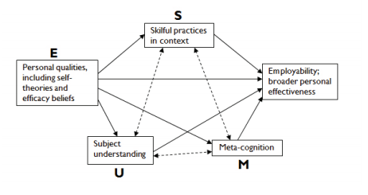
Figure 2: The USEM model provides a framework (Knight and Yorke, 2004)
It is very important to focus how students and get more engaged on employability and encourage them to take the responsibilities of their own employability. The (CBI/NUS. 2011) produced a resource which enable students to get relevance skills set of employability – including range of skills, attributes, knowledge and positive attitude.
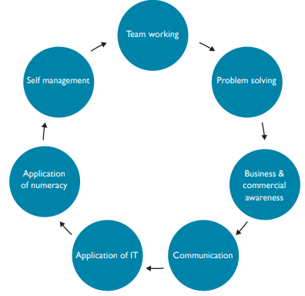
Figure 3: Positive attitude of Employability (CBI/NUS, 2011)

Techniques of Employability
There are several techniques in obtaining the employability. In the previous section, it has explained different models of employability. In this section, it will describe different techniques that can enable someone to obtain required employability skills. It has also given many people to enhance their skills while they are in lockdown due to COVID-19. It is very essential for individual to identify their best suitable learning methods/ styles (visual, auditory, reading/writing and kinesthetic) (Kansas, 2020), which can let them to learn and gain required skills for the employability.
The UK has significant skills gap since most adult fail to demonstrate core employability skills such as leadership, creativity, soft skills, right direction of career and knowledge. Therefore it is important we know the correct techniques of employability. Employability open up when someone has right set of employability skills (Figure: 3).
After gaining required basic skills set, we should know how we may get hired by the company. It is to bear in mind ‘someone is looking for you’, but you don’t know who is looking for you. Therefore, we need to prepare our marketing material in such a way that recruiter can identify us every easily. At this stage, with help of information technology someone can do their marketing in an easy way without any cost. In order to do appropriate marketing ourselves, we need to know how to prepare an appropriate resume/CV, portfolio (reed, 2020), (CV, 20). After creating CV, we need to make sure that recruiters have received the CV, it can be done by doing registration in different jobsites such as (jobs.ac.uk, reed.co.uk, monster.co.uk, totaljobs.co.uk and many more). It is also to note that every council in UK have a job center and advise center who can help us to send our CV towards many recruiters. The newspaper, social media (facebook, linkedin and other platform) plays a vital role in recruitment.
It not just we have skills and get an employment right away, job market is always competitive in its nature. We need to need that for which job, the applicant have right skills set, and apply for the jobs and face the interview as scheduled. Getting prepare for interview is also a challenging task- before going for the interview (Georgevich, 2016), the applicant must do the primary research of the business, review their skills sets. If someone can get ready properly for the interview and have right skill set, they must get success in their employment market. To give an example how Veolia works with its hiring process from start to end (note that most of the UK company works in similar pattern).
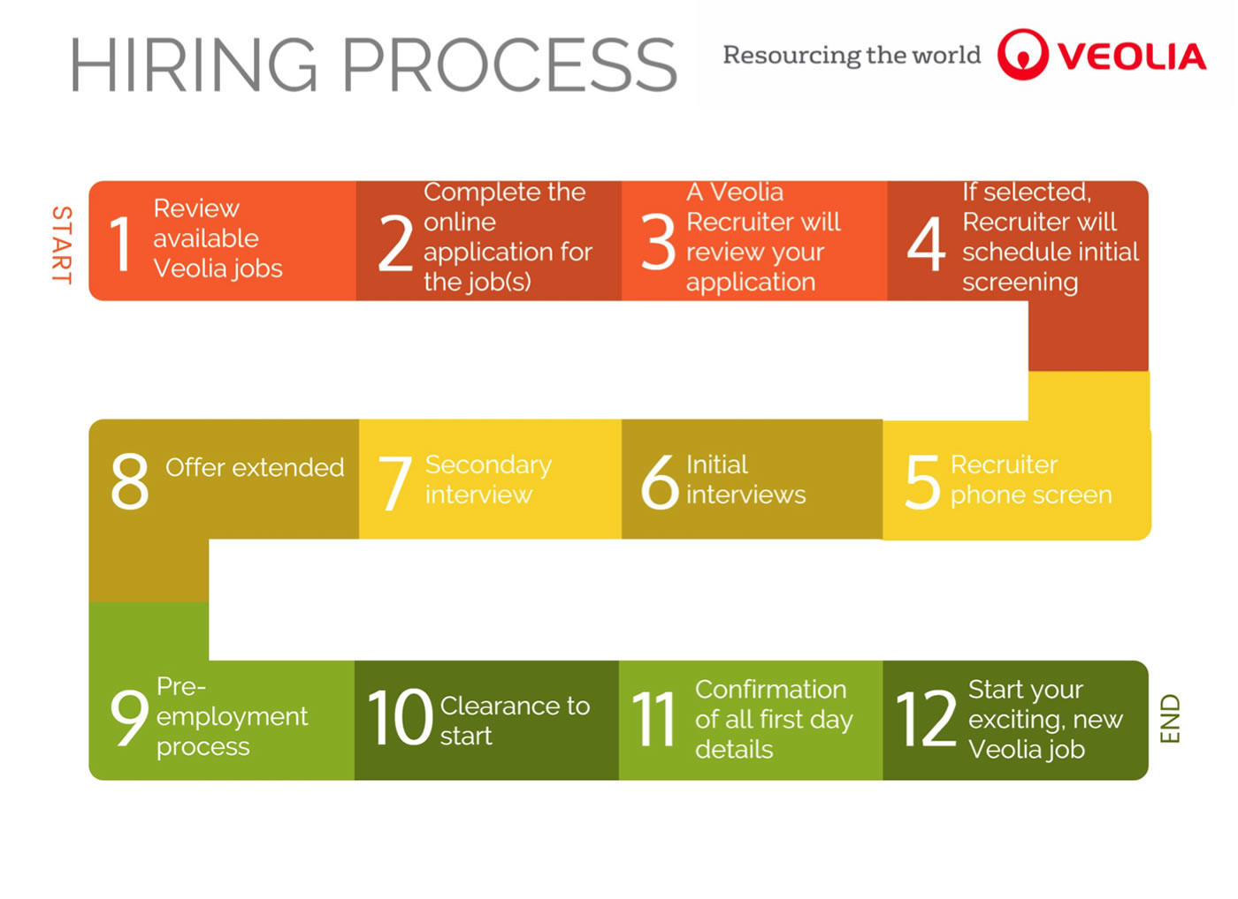
Figure 4: Veolia Recruitment Process (HR, 2020)

Framework of Employability
The Higher Education Academy, UK has published an article with a framework of employability with the following approaches (Tibby, 2013) -
- Stage 1: Discussion and reflection- We need to understand at the beginning the definition of employability to the learner, team and stakeholders. In this stage, the applicant need to understand the institutional employability definition, strategy, stakeholders and their required (personal specification) knowledge, experience, skills, competencies, attitudes, attributes and behaviors.
- Stage 2: Review and mapping- In this stage, the applicant/ learner need to use or reflect on the agreed point those were considered in the stage 1. The learner needs to map and review the required skills and knowledge, it is also need to consider how a training reflected on employability and identify the skills gap provision.
- Stage 3: Action- In this stage, the learner must take the action on the gaps has been identified in stage 1 &2 discussed. How this will be address, priorities and embed them with in the time scale. Do you have staff training/continuing professional development (CPD) needs which require addressing and, if so, who can support this?
- Stage 4: Evaluate- In the evaluation phase, the learner need to see on what extend, it was defined, cohesive and comprehensive approach to employability, what evidences has been produced that the work was effective and how the impact was assessed.

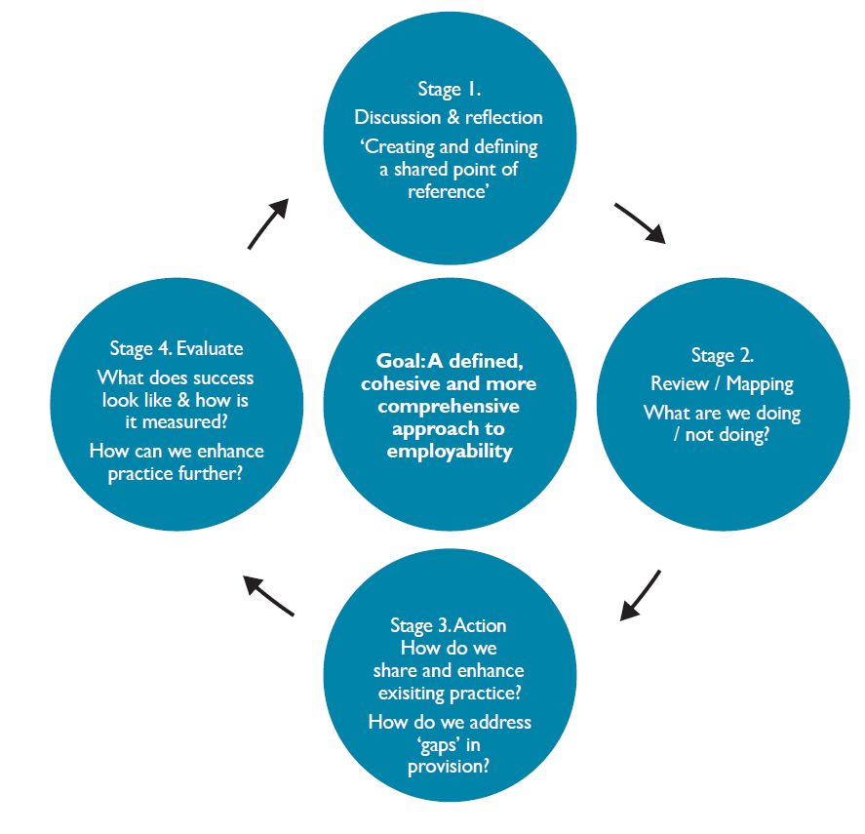
Figure 5: Using the framework for defining and developing your own approach (Tibby, 2013)
As discussed in the previous section, it is very important to identify someone skills need to fill the gap and enhance the required knowledge and skills as appropriate in timely fashion.

Personal Employability skills
This is important for everyone to present their skills, knowledge and attributes to the employer so that employers can feel confident on their capacity for employer’s need. The table below been compiled that potential employers are looking for the skills set and I believe I have all the following skills set-
Skills that employers want | What that means | Evidences in Academic | Evidences out of Academic
Communication and interpersonal skills | This is the ability to demonstrate that someone knows, how they speak, listen and response to others, it also mean concise written skills of an individuals. | Evidence of having presentation in course work, for example in this course, we have digital skills unit, were we have created a group presentation, and every individual is responsible to demonstrate their capacity in presentation, written and other skills set. And I am the group leader of that group presentation which I have demonstrated and gained this skills. | I have been doing different task, working part-time while studying, participating in different club and getting professional/ student membership which helps someone interpersonal skills greatly.
Problem solving skills | The ability to understand a problem by breaking it down into smaller parts, and identifying the key issues, implications and identifying solutions. | As part of my course work and project I have solve the critical problem by breaking it into smaller segments. | In the workplace or social event, obtaining critical situation and solving them effectively. Employers may testify this by taking screening test of IQ.
Using initiative and being self-motivated | Use the self-understanding, generate new ideas and implement them in the reality. | The current or previous coursework, someone can take self-responsibility and drive it with own initiative. | It can be demonstrated in the workplace or even in the social work, when someone sees there is leadership absence, need to take charge and finish the job with self-motivation.
Working under pressure and to deadlines | Handling stress that comes with deadlines. | It could be obtain by planning appropriately and in timely fashion, for example preparing for the examinations or submitting assignments work. | At workplace or outside projects/ or event working in hard deadline.
Organizational skills | The ability to understand a problem by breaking it down into smaller parts, and identifying the key issues, implications and identifying solutions. | It could be gain through the project work, other deadline related work. I am using this skills as a daily basis for my course work. | Mostly could have been gained by workplace and I produce report to my supervisor as a daily baisis.
Team working | Working with others from different discipline or background and expertise to complete any given task. | Teamwork ability could be obtained through course work such as in the project or group tasks. | In any sort of workplace teamwork plays vital role, and someone can obtain this skills by running a team or working in a team.
Ability to learn and adapt | To be enthusiastic about your work, and to identify ways to learn from your mistakes for the benefit of both you and your employer. | Receive the feedback, listen the teacher’s guidelines and understand and work through. | It gives more opportunity for the people who likes to learn from the team. There are also huge online tools and resources that could be used more effectively.
Numeracy | The ability to use data and mathematics to support evidence or demonstrate a point. | In school or high school, it teaches the basic of numeracy. | In daily life, some sort of numeracy calculations comes.
Valuing diversity and difference | Understand the value of different diversified people, who lives and comes from different part of the world. | In the class, or college/ university we meet different people, it is necessary to understand them and act upon their need. | UK is most diversified country and it is very good place to learn new skills.
Negotiation skills | Brining other people on board, and make the necessary agreement to accomplish the given task. | For example, even in the digital skills module, we have agreed between team that who will take what role and complete the task. | It is not only take place in the book, but in daily activities it take place and hugely impacted.

Personal Development plan

Gaps identified | Action planned | Expected outcomes | Timescale and review date | Person/ people responsible | Resources and support required
IT skills | Need to watch YouTube videos and learn more skills from the courses | Know- word processing software, presentation software, spreadsheet software. | September 2020 | John | Laptop and Internet
Time Management | Preparing appropriate plan for the given project | Learn time management tools, such as GANT Chart. | October 2020 | John | Software, Microsoft Project
Subject Knowledge | Doing more research and access more resources from the moodle. | Study course materials and gain expected learning outcome of each module. | June 2021 | John | Access Moodle, Library, Internet articles and Business Magazine
Team Management | I enjoy to work in effective team, where all the team members are responsible to certain job. | Understand the team members need and act upon their need. | September 2020 | John | Build the team within the class.
Ability to work quickly | Need to improve the work speed. I am still working on this to improve. | The task should finish before the deadline. | September 2020 | John | Course work, assignments, projects.

Conclusions
This report has explained the meaning of employability by demonstrating different models of employability. It has also explained the attributes are required for the employment that mostly employers are looking for. It has explained the framework for employability and concluded by a personal development plan which could lead someone to get hired in the job market.

References
Cheary, M. (2020, 06 01). What are transferable skills? Retrieved from reed.co.uk: https://www.reed.co.uk/career-advice/what-are-transferable-skills/
CV, M. p. (20, 07 28). Build your perfect CV. Retrieved from My perfect CV: https://www.myperfectcv.co.uk/homepagec
Georgevich, D. (2016, 10 26). Top 10 Job Interview Questions & Answers (for 1st & 2nd Interviews). Retrieved from Job Interview Tools: https://www.youtube.com/watch?v=Csl2ccBpo4g
HR, V. (2020, 07 01). Hiring Process. Retrieved from Veolia: https://www.veolia.ca/en/hiring-process
Kansas, T. U. (2020, 07 31). 4 Different Learning Styles You Should Know: The VARK Model. Retrieved from The University of Kansas: https://educationonline.ku.edu/community/4-different-learning-styles-to-know
reed. (2020, 07 31). Free CV builder. Retrieved from reed.co.uk: https://www.reed.co.uk/cvbuilder#:~:text=CV%20builder%20is%20a%20free,scratch%20in%20four%20easy%20steps.
Tibby, D. C. (2013). Defining and developing your approach to employability. A framework for higher education institutions.
CBI/NUS (2011) Working towards your future: making the most of your time in higher education. CBI: London. Available from: http://educationandskills.cbi.org.uk/reports/(15 February 2013).
Dacre Pool, L. & Sewell, P. (2007) The key to employability: developing a practical model for graduate employability. Education & Training. 49 (4), 277-289.
Knight, P. and Yorke, M. (2004) Learning, Curriculum and Employability in Higher Education. London: Routledge Falmer.

Appendix-1



