Assessment 2 – Entrepreneurship LCBB5001
Anita Petreus 2024822

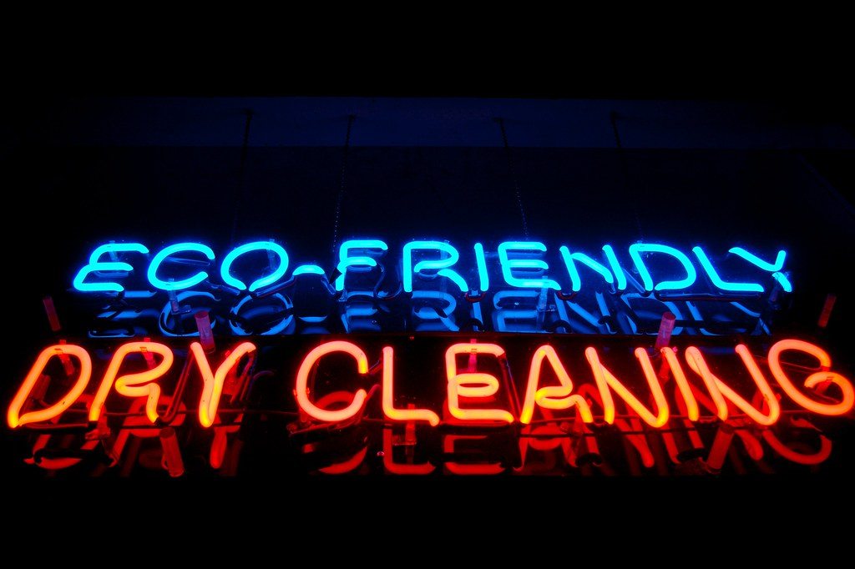
This Photo by Unknown Author is licensed under CC BY-NC

To start a new business is important to have a good business plan, research about the business, market research, and a financial plan. Also is very important to make sure that the business operates with a system that ensure every job is done thorough and is done with high level of standard so the customers will be pleased and very happy with the services they receive and will keep returning. Is important to distinguish the business with products and techniques that will demonstrate the professionalism and good care of the customers belongings and the importance of environment protection and peoples health. It is important to follow up the feedbacks and to deal with the negative feedbacks quickly and efficiently. A good insurance is vital in case the customers belongings get damaged to cover the expenses with the insurance.

Bright Professional Dry cleaning & Laundry is a start up enterprise , the company will provide dry cleaning, laundry and garment alterations, offered with regular home pick up and delivery services.

The ability to make a good profits in the business is dependent upon the strength of the position of the business in the market. Porter’s 5 forces is useful to help to discover the competitive power in a business situation. Any of this can work against me so it is important to understand them.
Porter’s 5 forces will help in measuring the probability of success, options, and dealing with problems.
Rivals between existing competitors: how many competitors are already operating? their services or products are better or not ? how to establish a strong advantage over them?
The business plan one part is to open a physical store in Zone 2 central London, the direct competitors are in the near area dry cleaners, and coin operated cleaning shops. The business strong advantage over the competitors could be the eco friendly chemicals use, that is protecting the environment and in the same time won’t cause allergic reaction to the skin.
Power of suppliers: the number off suppliers the company depends it can affect the profits, if there is several suppliers for a particular product and there is a possibility to swich to another supplier with better prices. Having alternatives of changing the suppliers helps the business smooth run. As is mentioned above there are several opportunities of detergents and companies who are selling them so it could give a great chance to negotiate the best price.
Power of customers: the small client base the more power it holds, more customers is the power of the business, also it depends of the customers financial status the prices that can be applied at the business.
The business prices for the services need to be similar to the prices on the market, it will be detailed as per items, every item will have a separate price for dry cleaning, and a price for the everyday laundry that is for kg, for example 6kg of laundry for 17 £. Offers and reductions for the customers and also students is part of the business plan.
Threat of substitute: how easy is for my customers to find another way to get what is offered by this business. Mentioned earlier there are several laundry and dry cleaning businesses around London, the online presence of the business and pick up service offered will ensure the comfort to the customers that is key to the future return of the customers.
Customers will have the option to choose the payment either at the time of delivery or by monthly credit card billing, at the end of the month customers will receive the bill with the service fees detailed.

Bright Professional Dry cleaning & Laundry aims to: establish sustainable business by the end of the first year, producing net profit.
Our mission to offer dry cleaning , laundry and clothing alteration service with free home pick up and delivery. Out high quality and convenience will save time for working customers.
The business is entering in the first year of operation and a comprehensive marketing strategy will be the key success to the business. Is important to remember that the customers have money and want to be provided high quality service therefore they will only use this service if they are highly satisfied.

Threat of new entrants: the easiest is for new entrants to start the same business the harder is for the existing ones to make profit. To enter in this business it’s really depends on every one’s personal experience in this business , and experience in what it means dry cleaning and laundry, fine materials, and different cleaning techniques and stain removing, because one of the reason people request specialist cleaning is that either the material of the clothes they are wearing needs to be dry cleaned or there is a stain that can be removed only by specialists.

Dry cleaning and other cleaning services industry’s revenue grow at annual rate, and if over the five years through, consumers disposable income are expected to rise over the next five years, and this will support industry revenue growth as it shows in the statistics and market research.
Is likely to be increase in demand from households for laundry and dry cleaning services.
Being in the cleaning business, experiences shows that people never stop using this kind of services, demand during the covid pandemic and lock downs was a little down when everything was closed , until the lockdown was lifted and the world started to live normally. Dry cleaning and laundry business could run for long term targeting every social classes and provide the same high level service and quality to every customers.

The marketing plan includes the four P’s: product, price, place and promotion. Putting the right product in the right place at the right price at the right time. Product: our service will be exclusive and maintain high quality to get customer value and satisfaction. Price: will use a pricing strategy that will put the business in profit and help achieve the long term objectives, paying attention to the prices used in the market by the competitors. Place: online, web, social media, news, radio.
Promotion: will include discounted prices , offers, personal plan price for customers who sign contract for regular weekly or monthly use of the services , student discounts.
In a research online a statistics shows that dry cleaning and other cleaning services in the UK industry are 5683 businesses in total, with a market size of 2 billion Pounds, and 46,126 industry employment.

With a business name of Bright Professional Dry cleaning & Laundry will offer professional laundry and dry cleaning, with a possibilities of pick up and delivery to the doorstep as quick as 24 hours and also physical store will be available for our customers to come and bring their laundry and meet the team and discuss any specific question they have.
Online presence will make available for customers to make their enquiry of pick up and schedule the best time for them with our app or online on our website what they can use easily whenever they are, at the office, on the go or at home. Also company Facebook and Instagram will be available for advertises and for customer reviews and to show insight in our day to day work and cleaning phrase with videos and pictures.
Will use a technology and detergents that is desired to protect the environment and earth also fabrics and it won’t cause skin allergies. Won’t be used the traditional chemicals used at other dry cleaning shops, this company will use liquid silicone, odourless and colourless solution that have a fabric care and protective properties and is environmental safe.
For the stains a steam air and vacuum machine will be used that removes all stains from fabrics. Dry cleaning machine will wash the clothes with the silicon based solvent, and no water is used, clothes go in dry and comes out clean, dry and ready to wash.
The wet cleaning will be with professional machines that calculates the washing cycle accordingly to the type of fabric, using the right amount of detergent, softener, and water.
Pressing stations will be different types designed for certain type of fabrics.

Regards to financial plan, funding for the dry cleaning business will be personal savings, credit cards and bank loans.
Fixed costs of the business will be the electricity and water used at daily basis what will also depends on the how many days will be open and how busy will we be. Rent is also fixed cost but doesn’t have the space now, what a research shows that prices are between 2000 – 3000 pounds / month in zone 2 area. Laundry detergent we have a wide range of opportunities for eco friendly chemicals and also to have the best prices from these providers, for example: smol products, true earth, e cover. Other costs will be the salaries of employees, that will be my family, mum dad, husband and one friend who used to work as a laundress, and an accountant for the business. For a hybrid or electric car our budget is between 15K to 20K, to have lower expenses and low emission we choose to have a hybrid or electric car to use it for deliveries and pick up. For advertise we will do apart from online presence the vehicle graphics and that will cost between 200 to 2000pounds to cover the car with wrapping and sign writing design with a company logo, name and describe the services we do. Custom flyers and leaflets are available online to order different sizes and quality and quantity, that could cost up to 300 Pounds.
The biggest costs will be the equipment, there are companies specialised for selling, installing, maintenance all the equipment’s we need for this business, for example Washco, Jla, or another opportunity could be to buy used laundry equipment from businesses that don’t operate, and that could cost for 1 washing machine, 1 tumble dryer , 1 commercial iron with iron board and dry cleaning machine , between 15.000 to 30.000. Another fixed expense will be the monthly insurance to cover any damaged items or any work accidents and in case if in the store someone broke in to stole our equipment or clothes. The price of this insurance is still in progress of research we want to find the best company with the best price.
Startup expences , founded through a combination of owners equity capital and commercial loan.

Social and environmental sustainability is important in the business activity, by using hybrid car to reduce emission , looking for to use the water reduction and electricity consumption, and by using detergents that are made to be mild and to protect environment. The business mission is to provide laundry and dry cleaning services without harming Earth. Will be advertised this plan to be environmentally friendly, apart from the water saving machine , and green earth detergents also will recycling is important to us, customers could send back hangers to reuse them, and planning to use cotton laundry bags that also can be reused instead of the plastic bags.

Why this business? Laundries and dry cleaners rated on the top ten enterprises with the lowest failure rate. Payment for the service is by cash, credit card , check. No capital stagnancy, receive payment every month easy to get instant profit. Capital requirement for purchasing commercial laundry equipment is minimal, therefor the risk of the business is low. The service only requires a few staff. Supplies a needed service for customers frequent demand. The demand for using this service is increase due to changing life styles, incomes and the increase in clothing expenditure. We will be targeting both part time and full time employed customers and also the opening hours will be convenient to everyone.

The business idea is after a long term research and planning , that contain an expand in the future. The business promises a high quality finish and service, natural processes and products, and convenient in everything it’s done.

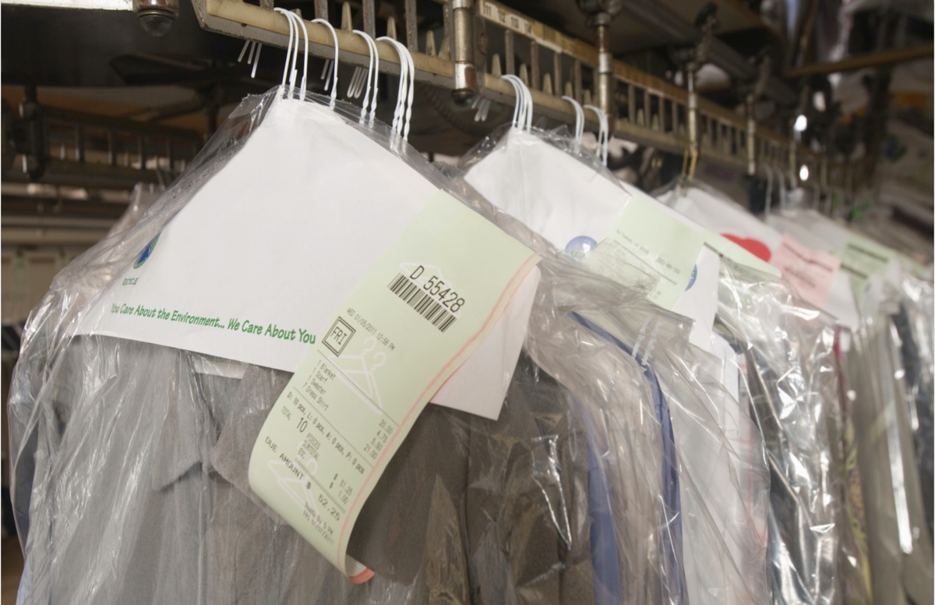
This Photo by Unknown Author is licensed under CC BY

References

Entrepreneurship: successfully launching new ventures, Barringer, Bruce R.,, Ireland, R. Duane,, 6th edition 2019

The financial times Guide to business start up 2019/20, Williams, Sra., 31th ed., Harlow, United Kingdom

The small business start-up workbook : a step-by-step guide to starting the business you’ve dreamed of, Rickman, Cheryl D., New Delhi 2011
Entrepreneurship : starting & operating a small business, Mariotti., Steve,, Glackin, Caroline,, 4th ed, 2016
How to prepare a business plan, Blackwell, Edward., 5th ed., London 2011

A dictionary of business and management, Law, Jonathan,, 6th ed Oxford, England 2016

wwwblancliving.co

www.thebusinessplan.com

http://www.mindspring.com/~jimgirone/cleanpage/desire.html

