Critical Analysis of Architecture
Post 1945

by Valerie Emma Vaughan
(2103742)

History and Theory 2
ACAA5003
Ian Standen
University of Wales Trinity Saint David
BSc Architecture

30th March 2023

Table of Figures

Figure 1: contextual site plan of the Louis Vuitton Foundation, showing that it is situated within the park grounds (Google, 2023) ……………………..…………………….…………….3
Figure 2: Schooner Susanne, 154ft in 1911 (Beken, 1911) ...……………………….…………4
Figure 3: The Guggenheim Museum Bilbao, designed by Frank Gehry (Guggenheim Museum Bilbao, n.d.) ……………………………...………………………………………...……...5
Figure 4: it is distinguished by its curved façade (Los Angeles Philharmonic Association, n.d.) …………..………………………………………………………………………………………..5
Figure 5: photo taken by author, walking westwards towards the entrance to the Louis Vuitton Foundation….……………………………………………………………………………….5
Figure 6: Galeries Nationales du Grand Palais (Caradec, n.d.) …………………………...…...6
Figure 7: exposition d’horticulture, Palmarium du Jardin d’Acclimatation (Rol, 1921)……..6
Figure 8: photo taken by author, of the opening in the roof over the terrace……...………..6
Figure 9: photo taken by author, of the glulam beams fixed to the steel frame, holding the glass panels up…………………………………………………………………………………….....7
Figure 10: photo taken by author, of the ‘LV’ logo on the entrance wall……………………..8
Figure 11: photo taken by author, of the limestone flooring, surrounded by the glass panels…………………………………………………………………………………………...……..8
Figure 12: photo taken by author, of the timber to steel bonds……..………………………..9
Figure 13: Observatory of Light by Daniel Buren at Fondation Louis Vuitton (Fondation Louis Vuitton, n.d.b) ………………………………………………………...……………………..10
Figure 14: the building has come under fire from environmental groups (Harris, 2011)…………………………………………………………………………………………………11

Introduction
Frank Gehry can be seen as one of the most well-known architects, whether people like or dislike his work. But one thing most can agree on, is that his buildings are unique and distinctive of his deconstructivist style. As Gehry is recognised by architects and non-architects alike, this essay will be looking into whether his buildings, and himself in the process, deserve the recognition they get. In particular, it will focus on his Parisian art museum, the Louis Vuitton Foundation.

Context
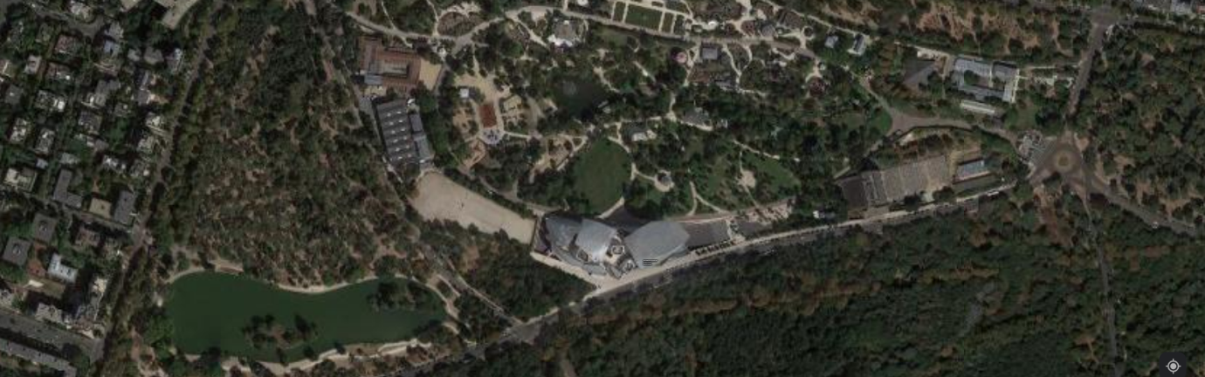
Th Louis Vuitton Foundation is located in the Bois de Boulogne region in Western Paris, France, as shown in Figure 1. It is situated next to the Jardin d’Acclimatation, offering a natural view out from the upper floors of the museum, resting beneath the view of the urban background that is La Défense (Goldberger, 2017). The site is of a former bowling alley, in which LVMH (Louis Vuitton Moët Hennesy) acquired the land when they bought the Boussac group (Camhi, 2014). The idea behind the museum was first mentioned when LVMH Chief Executive Officer Bernard Arnault visited the Gehry designed Guggenheim Museum in Bilbao, and decided he wanted to collaborate with the architect to design the Louis Vuitton Foundation (Fondation Louis Vuitton, n.d.a). As it was built on public land and had some controversy surrounding its size and location, LVMH signed a long-term lease which will hand the building over to Paris in 2062 (Moore, 2014; World Construction Network, 2014).
Figure 1: contextual site plan of the Louis Vuitton Foundation, showing that it is situated within the park grounds (Google, 2023)

The building’s primary purpose was to house both Arnault’s and the company’s collection of art, along with temporary exhibitions, which is still its purpose almost ten years since its opening in 2014 (Cash and Ebony, 2006). The structure is now seen as a prominent piece of architecture in Paris, with over one million visitors in 2017, according to the Statistica Research Department (2023). However, the main driver behind the idea of the building may be more political than architectural. Arnault launched the Louis Vuitton Foundation for Creation project (as it was previously known) in 2006, one year after his luxury brand rival François Pinault failed to build his own museum in Paris due to public disagreement and setbacks (Mun-Delsalle, 2014). Harris (2014) implies that Arnault fuelled this idea to aggravate his opposition. Goldberger (2017) even states that LVMH was even eager to spend the proposed cost of around $140 million (£120 million). It is not confirmed, but if true, the building could be seen as more of a medal or trophy, rather than a gift to Paris.

Inspiration
Gehry was a keen sailor back in Canada, his home country, and he wanted his passion to come through in this design (Howarth, 2015). What is more, is that he also wanted the waterfall in Jardin d'Acclimatation to influence the design. So, he created an idea that merged these two principles into a building that represents a ship and its sails on the water, such as that of the yacht ‘Susanne’, built in 1911 for the yacht race America’s Cup, as can be seen in Figure 2 (DETAIL, 2015; Classic Boat, n.d.). The twisted glass ‘sails’ seem as though they are swaying in the wind when the waterfall beneath is activated. This motion gives the impression that the building is moving along the water. Furthermore, the inclusion of a restaurant, auditorium/concert hall, terraces and the pool below are also all included on cruise ships, therefore another reference to the sea and water transportation (Bousteau, 2014).

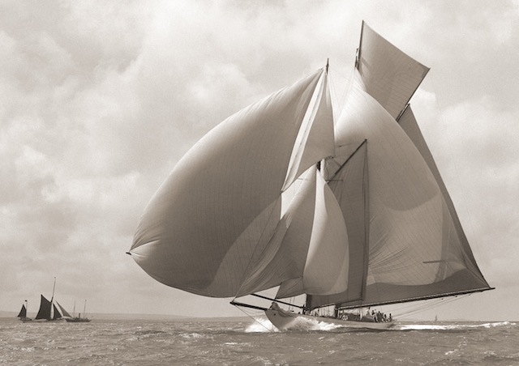

Figure 2: Schooner Susanne, 154ft in 1911 (Beken, 1911)
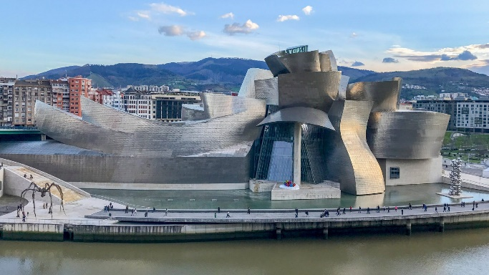
The shape of these sails is characteristic of Gehry’s deconstructivism, or in other words, his ‘logotecture’. Such as that of the winding titanium sheets of the Guggenheim Museum, Bilbao or the stainless-steel shell of the Walt Disney Concert Hall, Los Angeles, both shown in Figure 3 and Figure 4 respectively (Guggenheim Bilbao, n.d.; Jones, 2013). However, some suggested that the concept for the Louis Vuitton Foundation was far from the likes of Gehry’s previous work. Cash and Ebony (2006) suggested that the museum will be different to his other notable works that are featured in metallic cladding. However, they do recognise that Gehry chose glass to compliment his design to add to the numerous glazed structures that Paris is renowned for.
Figure 4: it is distinguished by its curved façade (Los Angeles Philharmonic Association, n.d.)
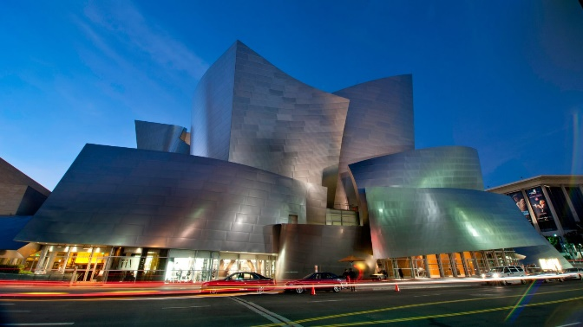
Figure 3: The Guggenheim Museum Bilbao, designed by Frank Gehry (Guggenheim Museum Bilbao, n.d.)

Materiality
Walking westwards along the Avenue du Mahatma Gandhi, the structure starts to come into view, imposing on the line of trees below. The translucent glass sails used as the exoskeleton of the Louis Vuitton Foundation draws its tone and lightness from the sky, giving the illusion that the building is floating, as can be seen in Figure 5 (Fondation Louis Vuitton, n.d.a). The floating illusion also comes from the building being positioned on a stepped waterfall and moat.

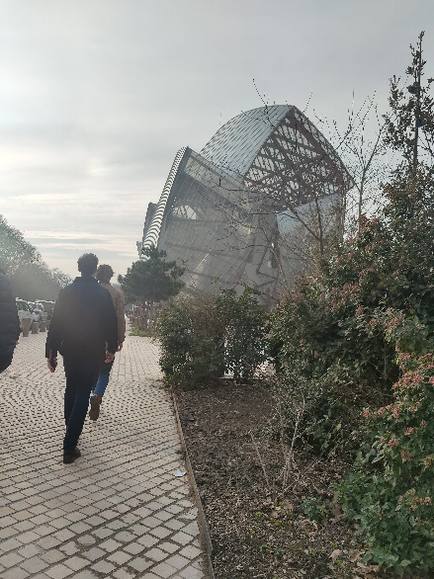

Figure 5: photo taken by author, walking westwards towards the entrance to the Louis Vuitton Foundation

In reference to these glass panels, Gehry took inspiration from the Grand Palais (along the Champs-Élysées) and the Palmarium (a structure that used to be in Jardin d’Acclimatation) with their glazed structure, both shown in Figure 6 and Figure 7 respectively. However, he wanted to put a twenty first century twist on it (Goldberger, 2017; Vinci, 2014). The 3,600 curved glass panels, each with a unique shape on the twelve sails, are connected to the base of the building using carbon and stainless-steel framework, timber beams and curving columns and act as another wall layer (World Construction Network, 2014).
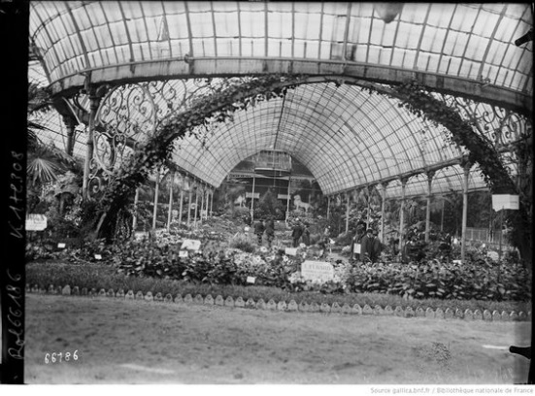
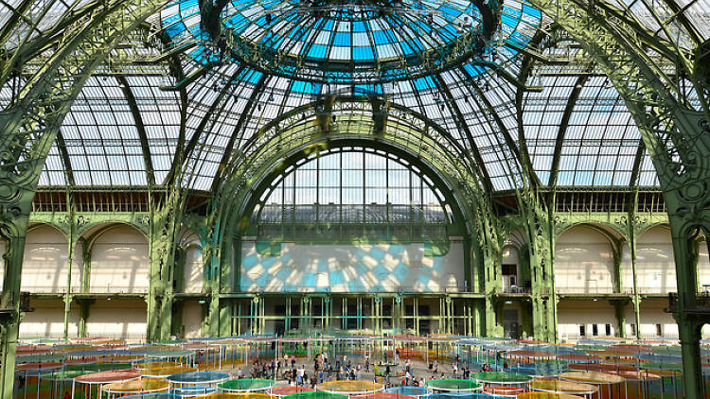

Figure 7: exposition d’horticulture, Palmarium du Jardin d’Acclimatation (Rol, 1921)
Figure 6: Galeries Nationales du Grand Palais (Caradec, n.d.)

However, as well as being used for the walls, the glazing is also used as a partial roof for the upper floor terrace. During the planning stage, conditions needed to be met, such as the building being no more than two storeys high (Woodman, 2014). Being the architect he is and wanting to have his design become reality, Gehry managed to work around this clause by keeping the third floor/terrace partially open roofed, as shown in Figure 8. This then allowed for the visitors to look out into Paris and have natural light filling the space (Woodman, 2014).
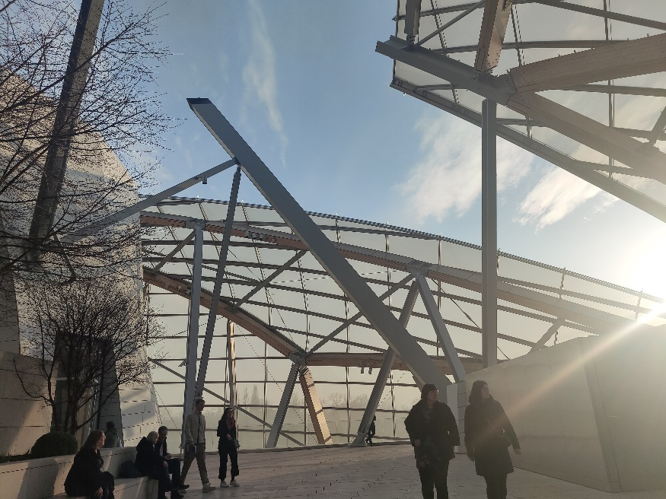

Figure 8: photo taken by author, of the opening in the roof over the terrace

To hold up the twelve glass sails, timber and steel were used as its structural supports (Goldberger, 2017). The 222 glulam larch beams (Figure 9), all being single or double curved beams, were connected to timber-metal bonds (HESS Timber). These bonds, of which there are 480, had to be subjected to loading tests to assess what size they need to be, each being unique, therefore individual calculations for each bond (SETEC, 2015).

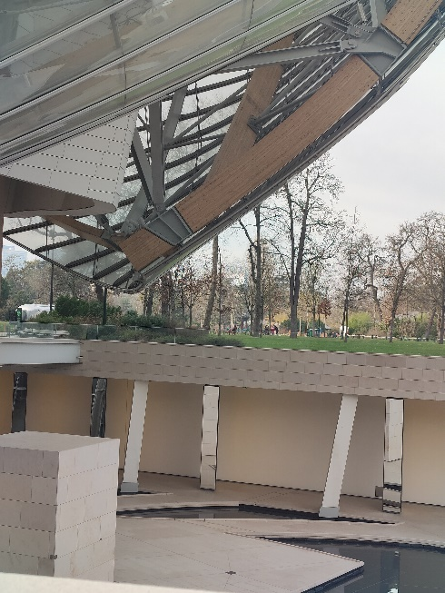

Figure 9: photo taken by author, of the glulam beams fixed to the steel frame, holding the glass panels up

The primary structural body beneath the glass façade is wrapped with more than 19,000 individual Ductal Envelope concrete panels, with just over four-fifths of the panels having unique curvatures (Ductal, n.d.). This variety of concrete proved to be the only material capable of withstanding, without fail, the various forces and deformations that a building of this size might encounter (Ductal, n.d.). These panels were coated with a water and oil repellent mixture for weatherproofing, along with an anti-graffiti coating for the panels that are exposed to the public (Ductal, n.d.). According to Ductal (n.d.), these finishes are important to guarantee that it will last 100 years, part of the environmental strategy as listed by SETEC (2015). The entrance wall with the signature ‘LV’ logo, as shown in Figure 10, shows the curvature of each panel, and how they fit with one another.
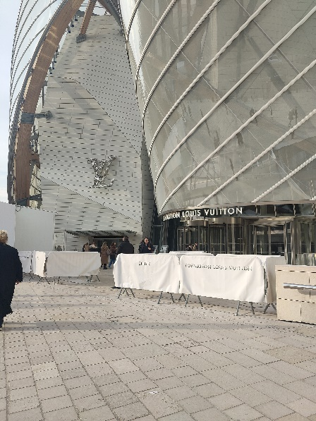

Figure 10: photo taken by author, of the ‘LV’ logo on the entrance wall

The Iceberg of the museum is made up of the eleven galleries, with all walkways (Figure 11) being paved with local Rocherons Doré Clair limestone (Stoneworld, 2020). Using locally sourced materials such as this limestone, which Arnault insisted on, assisted the museum in being the first building of its calibre to receive French HQE (High Environmental Quality) certification (SETEC, 2015). The creamy-beige tones of the stone add to the buildings clinical and relaxed atmosphere, all the while being a widely used, locally sourced material (Stoneworld, 2020).

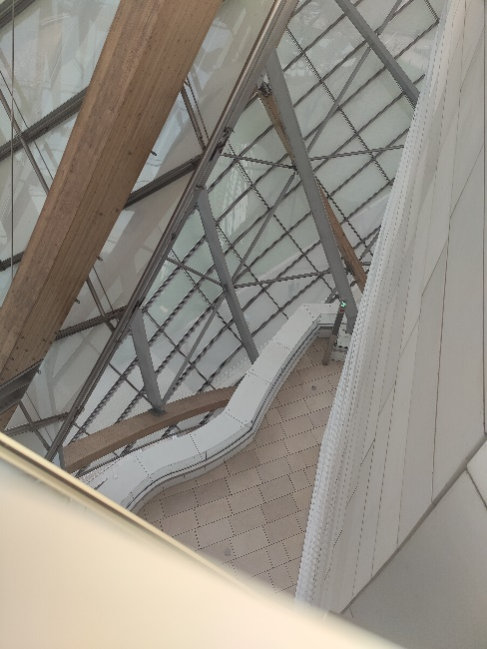

Figure 11: photo taken by author, of the limestone flooring, surrounded by the glass panels

Almost every building that has been constructed has gone through numerous calculations and software to establish whether they are structurally safe. But the Louis Vuitton Foundation required additional assessments. Each glass panel was designed by cylindrical surface optimisation, which looks at how each pane needs to be shaped in order to have the desired profile of Gehry’s concept, and to be able to withstand being exposed to the wind (SETEC, 2015). The glulam larch beams that are secondary structures for the twelve glass ‘sails’ required the invention of a new calculation software to design the size of each beam, and how they join to the steel frame as shown in Figure 12 (SETEC, 2015). According to SETEC (2015), they even developed a new process of designing the concrete panels, to test for their strength. With all the technological software developed directly from the designing of the museum, architecture then had the capability to advance tremendously.

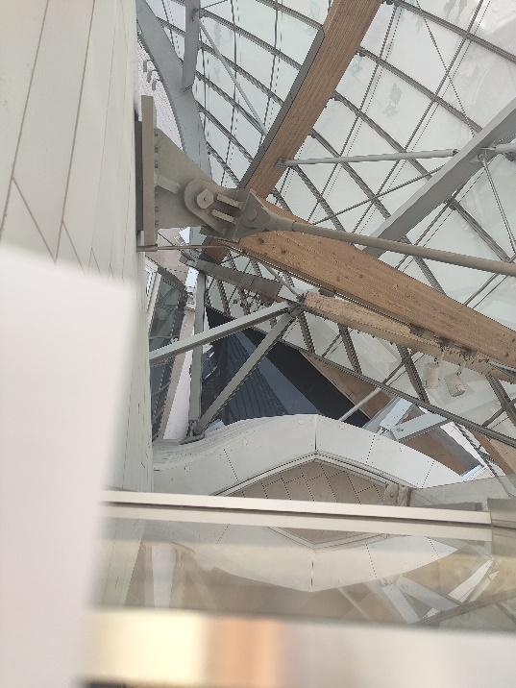

Figure 12: photo taken by author, of the timber to steel bonds

Impact on Visitors
The Louis Vuitton Foundation is widely recognised as a translucent white glazed structure, which allows the sky to define the tone of the structure. But in 2016, the museum was installed with bright, colourful filters (Morby, 2016). Daniel Buren, a French artist who is famous for transforming prominent pieces of architecture into vivid art pieces, covered the 3,600 glass panels in site-specific coloured filters (Kaplan, 2017). Titled ‘Observatory of Light’ (Figure 13), this installation received a lot of criticism, as well as appraisal. The colours of the panels that surround the interior spaces are projected inside, causing a kaleidoscope effect, distorting the visitor’s perceived view of the building (Wright, 2016). Referring to the design philosophy behind the building, Gehry states:

“To reflect our constantly changing world, we wanted to create a building that would evolve according to the time and the light in order to give the impression of something ephemeral and continually changing.” – Frank Gehry (Fondation Louis Vuitton, n.d.a)

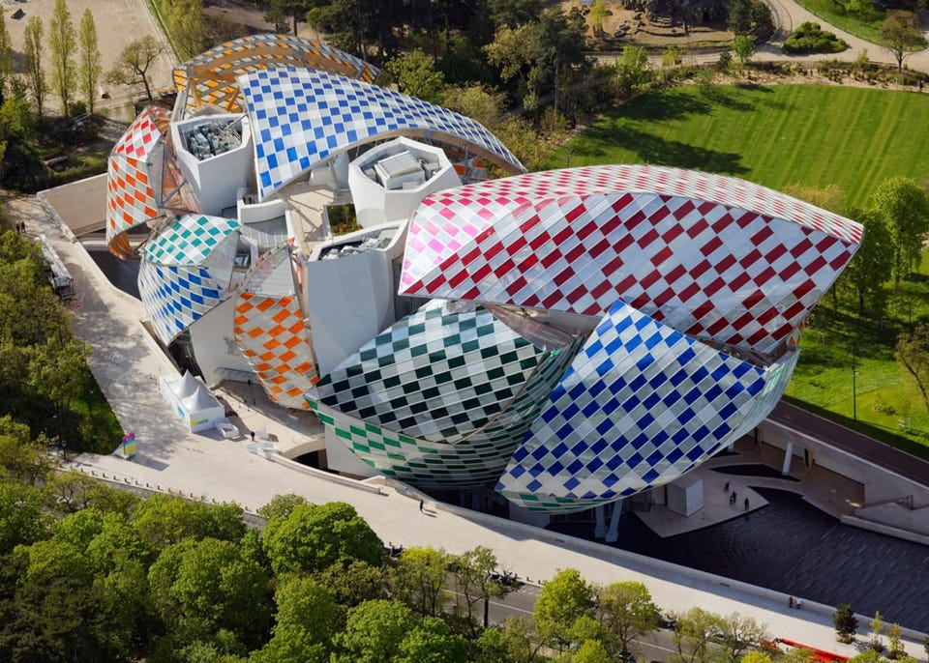

Figure 13: Observatory of Light by Daniel Buren at Fondation Louis Vuitton (Fondation Louis Vuitton, n.d.b)

Gehry also admits that he purposefully made the building look unfinished so that people would interact with it (Wainwright, 2014). With the installation of Buren’s coloured filters, he essentially took Gehry’s philosophy and incorporated it into his art. With the different colours that were assigned to different parts of the sails, visitors had a sense that they were walking through different buildings. But with the weather and natural lighting changing constantly, the light projection from the panels into these spaces may have also changed the feeling and atmosphere of each area. Gehry’s use of the word ‘ephemeral’ also describes Buren’s installation, in which it was only temporary.

Objections
The grand scale of this project, compared to the smaller buildings around Paris, caused a great deal of controversy. Being in the location it is, surrounded by over 2,000 acres of green spaces, the local residents didn’t want the landscape to be altered by the addition of this giant silver tinted structure. So, the French did what they are notorious for, protesting. In 2011, halfway through the building being built, construction was halted due to losing a court battle against the Association to Safeguard the Bois de Boulogne (Samuel, 2011). Figure 14 below shows the phase in which construction was halted. The court ruled that the site’s location was too close to an asphalt pathway, which was considered a public right of way (Harris, 2011).

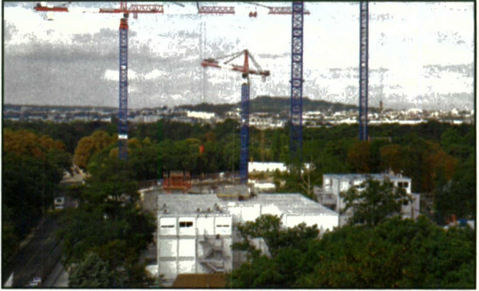
Figure 14: the building has come under fire from environmental groups (Harris, 2011)
The association’s leader, François Douady expressed his concerns about the ‘concretisation’ of the park, that if one company is allowed to build a structure as big as the Louis Vuitton museum in an area of the grounds, then what is stopping other companies from following suit (Harris, 2011). With François Pinault giving up on constructing his own Parisian art museum because of excessive bureaucracy, this association was hopeful that this would be the case for Arnault’s museum (Harris, 2011). However, the Assemblée Nationale passed a law to allow the construction of the Foundation to continue as they deemed it “a major work of art for the whole world” (Moore, 2014; Wainwright, 2014).

Conclusion
The Louis Vuitton Foundation can be seen as one of the most prominent pieces of contemporary architecture, possibly even in general. The technology that was created just for this building will help aid future architects in creating their own Foundation imitation (SETEC, 2015). The philosophy behind the building, such as it appearing unfinished so that people would interact with it, is not a belief that many architects or buildings adopt (Wainwright, 2014). With the number of visitors the museum receives each year and the thought process behind every detail, the recognition that the building and the architect get is truly justified.

References
Beken, F. (1911) Schooner Susanne, 154ft in 1911. [Online photograph]
Available at: https://www.classicboat.co.uk/news/beken-archive-for-sale/
[Accessed 3 March 2023]

Bousteau, F. (2014) ‘Fondation Louis Vuitton, Et vogue l’art contemporain… [Louis Vuitton Foundation, and contemporary art sets sail…]’, Beaux arts magazine (Levallois-Perret), (365), pp. 92-99

Camhi, L. (2014). ‘Setting Sail’, Vogue (New York), 204(9), pp. 776-783

Caradec, Y. (n.d.) Galeries Nationales du Grand Palais. [Online photograph]
Available at: https://www.timeout.com/paris/en/museums/galeries-nationales-du-grand-palais
[Accessed 16 March 2023]

Cash, S. and Ebony, D. (2006) ‘LVMH Taps Gehry for New Paris Museum’, Art in America (1939), 94(10), p232

Classic Boat (n.d.) Beken archive for sale. [Online]
Available at: https://www.classicboat.co.uk/news/beken-archive-for-sale/
[Accessed 3 March 2023]

DETAIL (2015) DETAIL: Review of Architecture and Construction Details – Roofs, 1(2015). Munich:Institut für Internationale Architektur-Dokumentation. pp. 14-15

Ductal, (n.d.) Fondation Louis Vuitton. [Online]
Available at: https://www.ductal.com/en/fondation-louis-vuitton
[Accessed 15 March 2023]

Fondation Louis Vuitton, (n.d.a) The Building. [Online]
Available at: https://www.fondationlouisvuitton.fr/en/fondation/the-building
[Accessed 24 February 2023]

Fondation Louis Vuitton (n.d.b) Observatory of Light by Daniel Buren at Fondation Louis Vuitton. [Online photograph]
Available at: https://www.forbes.com/sites/neloliviawaga/2016/05/31/daniel-burens-transforms-the-fondation-louis-vuitton-to-an-observatory-of-light/?sh=4bb4a7b8653f
[Accessed 16 March 2023]

Goldberger, P. (2017) Building Art: The Life and Work of Frank Gehry. (First Vintage Books edition). New York: Vintage Books. p397.

Google Maps, (2023) Google Maps. [Online]
Available at: https://www.google.com/maps/@48.87745,2.2634763,686m/data=!3m1!1e3
[Accessed 1 March 2023]

Guggenheim Bilbao, (n.d.) The Construction: A Structure of Titanium, Glass and Limestone. [Online]
Available at: https://www.guggenheim-bilbao.eus/en/the-building/the-construction
[Accessed 3 March 2023]

Guggenheim Museum Bilbao (n.d.) Guggenheim Museum Bilbao, designed by Frank Gehry. [Online photograph]
Available at: https://www.dezeen.com/2022/05/18/frank-gehry-guggenheim-museum-bilbao-deconstructivism/
[Accessed 16 March 2023]

Harris, G. (2011) ‘Setback for Louis Vuitton museum’ Art Newspaper, 20(222), p. 5. [Online]
Available at: https://web-s-ebscohost-com.ezproxy.uwtsd.ac.uk/ehost/pdfviewer/pdfviewer?vid=11&sid=c032c44f-4696-40f6-acb3-daddff75dc60%40redis
[Accessed 12 March 2023]

Harris, G. (2014) What we know we know about the mysterious Fondation Louis Vuitton in Paris, brainchild of Bernard Arnault. [Online]
Available at: https://www.theartnewspaper.com/2014/09/01/what-we-know-about-the-mysterious-fondation-louis-vuitton-in-paris-brainchild-of-bernard-arnault
[Accessed 1 March 2023]

Howarth, D. (2015) Frank Gehry forays into yacht design to create his own boat. [Online]
Available at: https://www.dezeen.com/2015/10/19/frank-gehry-sailing-yacht-for-himself-foggy-german-frers/
[Accessed 1 March 2023]

HESS Timber (n.d.) Museum Fondation Louis Vuitton. [Online]
Available at: https://www.hess-timber.com/fileadmin/medien/service/downloads/Referenzdatenblaetter/HESS_TIMBER_MuseumFondationLouisVuitton_EN.pdf
[Accessed 19 March 2023]

Jones, R. (2013) AD Classics: Walt Disney Concert Hall/Gehry Partners. [Online]
Available at: https://www.archdaily.com/441358/ad-classics-walt-disney-concert-hall-frank-gehry
[Accessed 3 March 2023]

Kaplan, Z. (2017) ‘across the spectrum‘, Interior Design, 88(1), pp. 170-213 [Online]
Available at: https://web-s-ebscohost-com.ezproxy.uwtsd.ac.uk/ehost/pdfviewer/pdfviewer?vid=6&sid=c032c44f-4696-40f6-acb3-daddff75dc60%40redis
[Accessed 11 March 2023]

Los Angeles Philharmonic Association (n.d.) it is distinguished by its curved façade. [Online photograph]
Available at: https://www.dezeen.com/2022/05/27/frank-gehry-walt-disney-concert-hall-deconstructivism/
[Accessed 16 March 2023]

Moore, R. (2014) Fondation Louis Vuitton, Paris review – everything and the bling from Frank Gehry. [Online]
Available at: https://www.theguardian.com/artanddesign/2014/oct/19/-sp-louis-vuitton-foundation-creation-paris-review-frank-gehry
[Accessed 1 March 2023]

Morby, A. (2016) Daniel Buren colours the sails of Frank Gehry’ Fondation Louis Vuitton. [Online]
Available at: https://www.dezeen.com/2016/05/12/daniel-buren-colours-sails-frank-gehry-fondation-louis-vuitton-site-specific-installation-paris/
[Available 11 March 2023]

Mun-Delsalle, Y. (2014) The Long-Awaited Fondation Louis Vuitton Will Open Its Doors in Paris on October 27. [Online]
Available at: https://www.forbes.com/sites/yjeanmundelsalle/2014/10/07/the-long-awaited-fondation-louis-vuitton-will-open-its-doors-in-paris-on-october-27/?sh=704b9f214bfb
[Accessed 1 March 2023]

Rol, A. (1921) exposition d'horticulture, Palmarium du Jardin d’Acclimatation. [Online photograph]
Available at: https://www.pinterest.fr/pin/327425835395681238/
[Accessed 16 March 2023]

Samuel, H. (2011) World’s top architect Frank Gehry brands Paris residents ‘philistines’ after planning permission revoked. [Online]
Available at: https://www.telegraph.co.uk/news/worldnews/europe/france/8306976/Worlds-top-architect-Frank-Gehry-brands-Paris-residents-philistines-after-planning-permission-revoked.html
[Accessed 12 March 2023]

SETEC, (2015) SETEC Candidature – The Foundation Louis Vuitton. [Online]
Available at: https://fidic.org/sites/default/files/SETEC%20Candidature%20-%20Fondation%20Louis%20Vuitton%20_1.pdf
[Accessed 9 March 2023]

Statistica Research Department, (2023) Number of visitors to the Louis Vuitton Foundation in Paris in 2016 and 2017. [Online]
Available at: https://www.statista.com/statistics/995603/visitors-louis-vuitton-foundation-paris-france/
[Accessed 1 March 2023]

Stoneworld (2020) ‘French limestone and sustainability go hand in hand’. Stoneworld, 37(9), pp. 66-71 [Online]
Available at: https://www.proquest.com/docview/2442627973/fulltextPDF/75027B7711FA4455PQ/14?accountid=130472
[Accessed 17 March 2023]

Vinci, (2014) The Louis Foundation, an extremely complex structure. [Online]
Available at: https://www.vinci.com/vinci.nsf/en/news-update/pages/the_louis_vuitton_foundation_an_extremely_complex_structure.htm
[Accessed 1 March 2023]

Wainwright, O. (2014) Frank Gehry’s Fondation Louis Vuitton shows he doesn’t know when to stop. [Online]
Available at: https://www.theguardian.com/artanddesign/2014/oct/21/frank-gehry-fondation-louis-vuitton-shows-he-doesnt-know-when-to-stop
[Accessed 1 March 2023]

Woodman, E. (2014) Carte Blanche: Fondation Louis Vuitton, Paris, France, by Gehry Partners. [Online]
Available at: https://www.architectural-review.com/today/carte-blanche-fondation-louis-vuitton-paris-france-by-gehry-partners
[Accessed 3 March 2023]

World Construction Network, (2014). Louis Vuitton Foundation Paris. [Online]
Available at: https://www.worldconstructionnetwork.com/projects/louis-vuitton-foundation-paris/
[Accessed 1 March 2023]

Wright, H. (2016) ‘Observatory of Light, Paris/Daniel Buren’, Blueprint, (347), p. 38 [Online]
Available at: https://www.proquest.com/docview/1805993765?accountid=130472&parentSessionId=RMGbXvpXlu1irIkoUi7y1DxUXxUGjqCoPBRG4f7Ne04%3D&pq-origsite=primo
[Accessed 11 March 2023]

