Gallwch ychwanegu’ch targedau o’ch aseiniad diwethaf (Ond yn berthnasol os yr ydych wedi cwblhau aseiniad) / Please add your targets from the previous assignment (Only relevant if you have completed an assignment)
Targed/Target 1 | Proofread your work to avoid written inaccuracies and loss of clarity.
Targed/Target 2 | Greater critical engagement in the sources that you cite.
Targed/Target 3
Targed/Target 4
Targed/Target 5

This is the Header (Ariel 18, Bold Underline, 1.5 line spacing) (AssignHeader: Styles)
This is the sub header (Ariel 14, Bold, 1.5 line Spacing) (AssignSubHeader: Styles)
This is the main font (Ariel 11, 1.5 line spacing) To use quotation style select AssignQuote from Home. (AssignBody: Styles)
This is a quotation text (Ariel 11, 1.5 line spacing, Indented paragraph on left and right by 2cm) (AssignQuote: Styles)
Once you type the enter key from the quotation it will automatically switch to the main body text.
Critically reflect on your pedagogical progress demonstrated through required elements of the Professional Learning Passport, identifying a specific area for professional development and justifying next steps for improvement.
PLP Link - https://v3.pebblepad.co.uk/spa/#/public/kwhG4Zxgbpptq3x5g8HHrjZRZM
Part 1 – Professional Learning Passport.
Reflection on subject knowledge development (Tab 5).
Asset One – SKD Literacy.
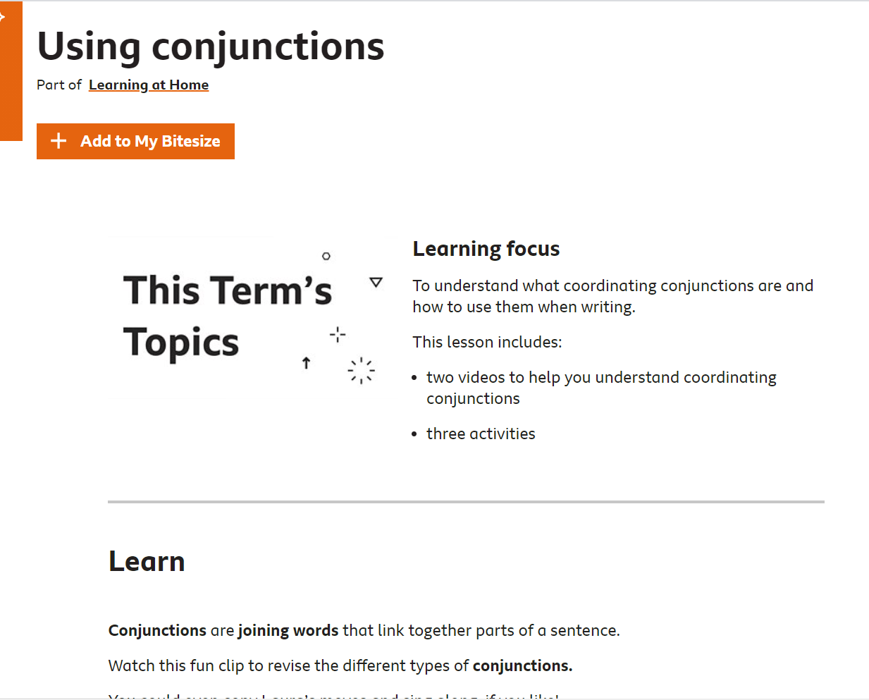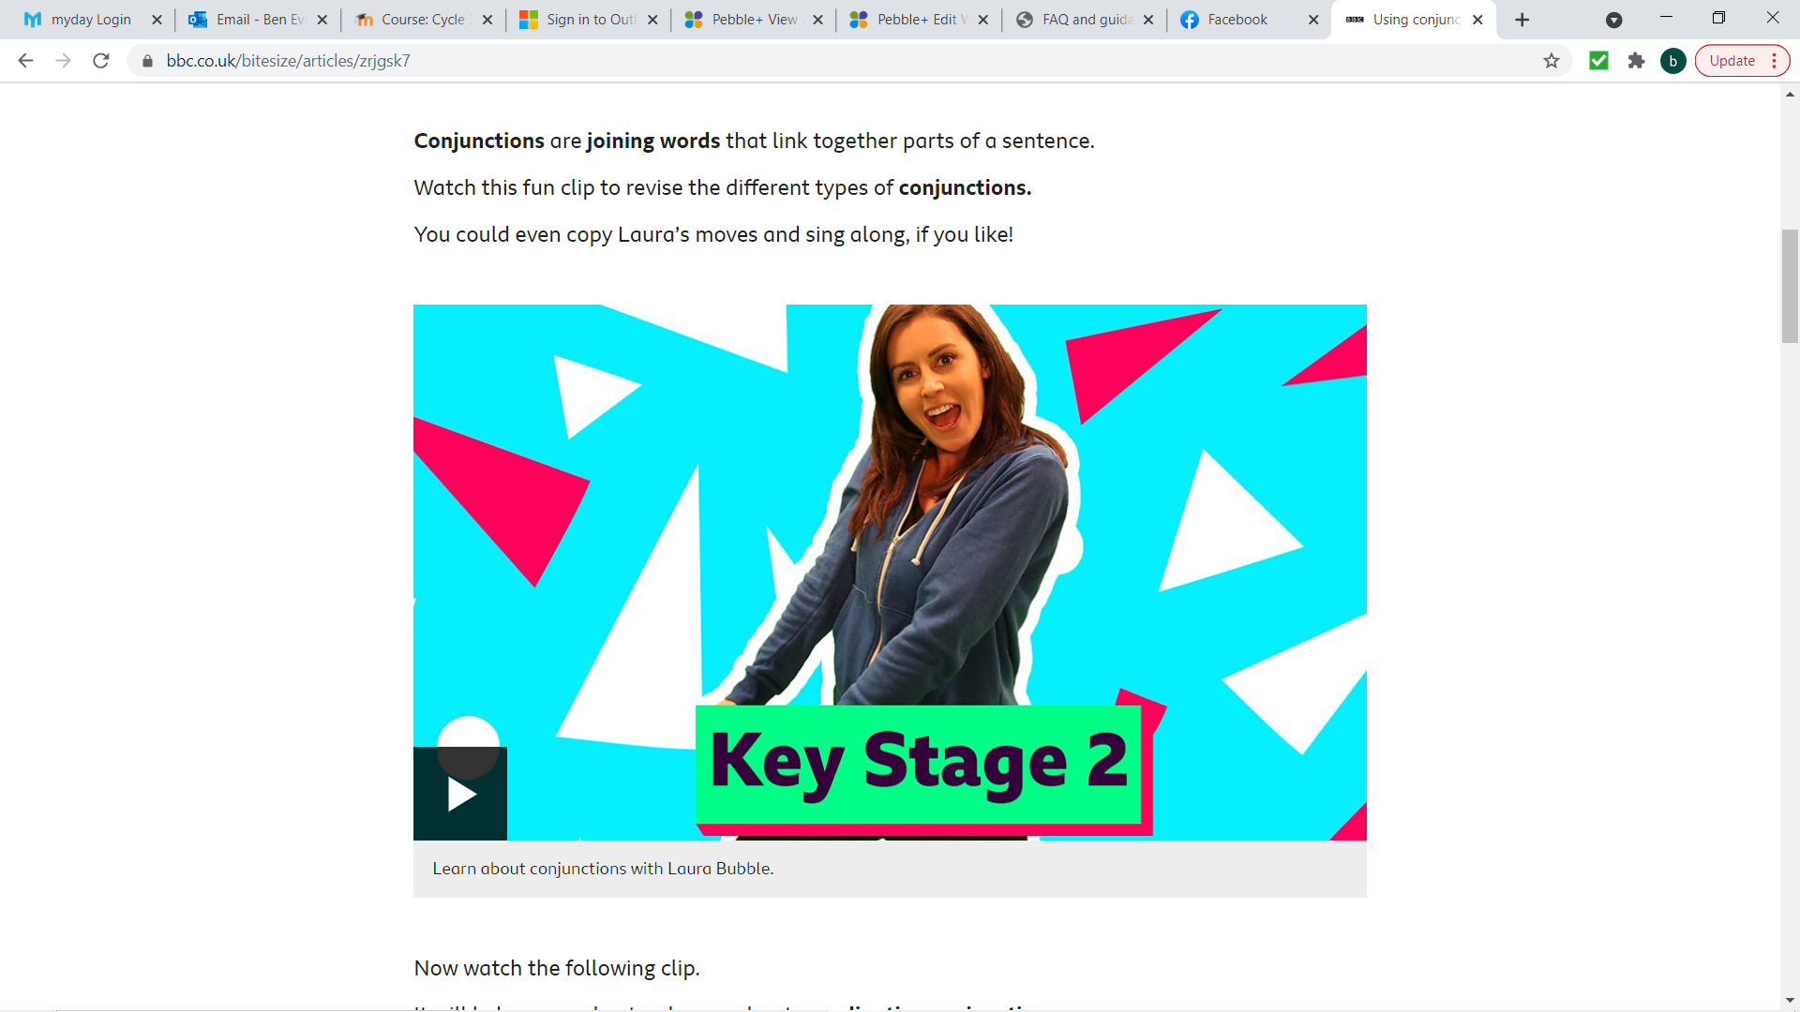
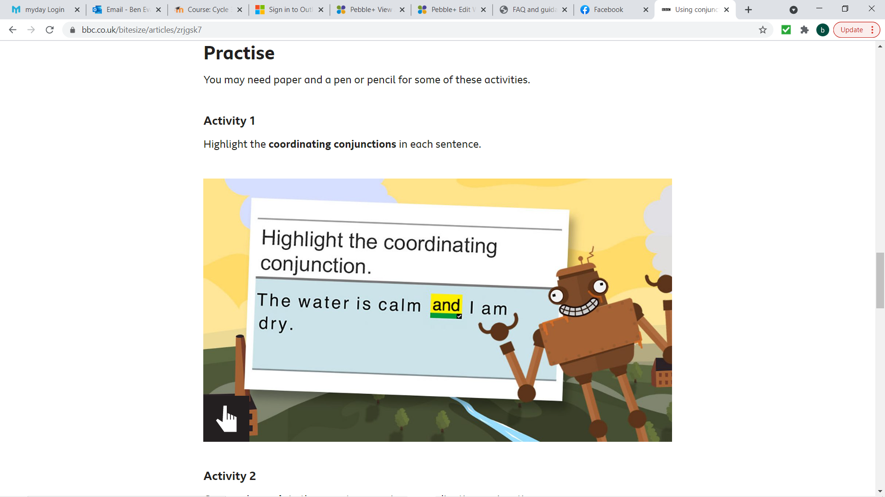
Evidence
Power point (Selection of slides) – Appendix 1.
During my final placement I was asked to teach a year 6 class conjunctions. While I had an idea of what conjunctions were and how to use them, I didn't feel that I would be confident enough to accurately teach a lesson on them. I wanted to make sure that I was knowledgeable enough to deliver the lesson correctly, but also be able to answer any misconceptions or questions confidently that could arise throughout the series of lessons. I looked to do some personal research on conjunctions and gain confidence on the topic. This led me to BBC Bitesize. Here I was able to read through, watch videos and engage in activities that helped me to develop my understanding of conjunctions and their correct uses. The website was able to give me all the information I needed on co-ordinating, correlating and subordinating conjunctions. Welsh Government (2020) explain the importance of practitioners undertaking research in helping to plan for and deliver the new curriculum, as well as ensuring they have sound pedagogy for the classroom. In light of the research I undertook myself, I feel it helped me to create and deliver highly effective lessons on conjunctions that helped children to meet their lesson objectives (Lesson insight in appendix 1). I feel it is important as a teacher that wherever possible you research and up skill yourself on topics that you are unsure of. This will help to reduce the misinformation that is passed along, as well as being able to answer and engage with feedback in the lessons that will help promote and develop a deeper understanding of the topic and learning in general.
Asset 2 – SKD Numeracy.
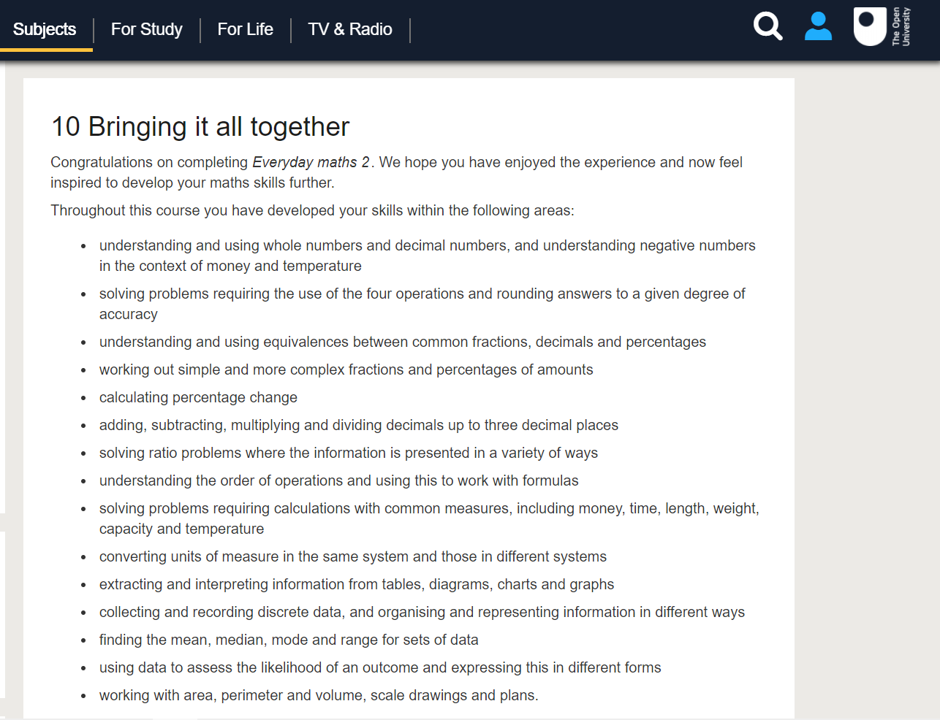
During my most recent placement I was asked to deliver a series of lesson on Mean, Median, Mode and Range (MMMR). This is something I haven't covered significantly since I left school, so I knew I would need to refresh my memory as to which average matched up to which way of finding the answer. To help me, I checked on the open university for any free courses. I found one which had MMMR within it and signed up to take the course. As you can see from the image, I covered various aspects of mathematics throughout the course, one of which was recapping and working through various activities on MMMR. I found this course very helpful; it gave me the confidence to plan and deliver highly effective lessons in this area. I made sure to do additional research to help the children be able to remember and learn the various ways we work out each average. I found and adapted a song to use for them which I made sure to sing at the start of each of the four lessons, this helped significantly as upon our return to face to face teaching, 4 weeks later, I had children coming up to me singing the song. This clearly shows how using a memorable tune can help in children remembering information such as this.
I also decided to split the lessons into 4 and concentrate each day on just one of the averages. I feel this was beneficial as it limited the possibility of children getting mixed up with average is which.
It is important that teachers research and up skill themselves on topics that they are unsure of. This allows the teacher to plan and deliver lessons which are then accurate, engaging and misconception free. It also gives the teacher the confidence to answer any questions that should arise throughout the lessons in the best possible way.
With the worksheets throughout the week, I also ensured that I had a go at answering all the questions and creating answer sheets to add at the end of all the work. This allowed me to check all the answers were possible throughout each lesson, as well as giving children the ownership over checking their own work when they are finished. It had the added benefit of allowing the teachers to easily mark and provide feedback on the work when it was submitted.
As I move forward in my career, I will make sure I use free courses such as this one on the open university to help me in all aspects of my subject knowledge development. The more knowledgeable a teacher is, the better chance they have of passing on that knowledge accurately to their children. This will then give children the best chance to understand the content and develop the skills required in the lesson to succeed.
Asset 3 – SKD Digital Competence.
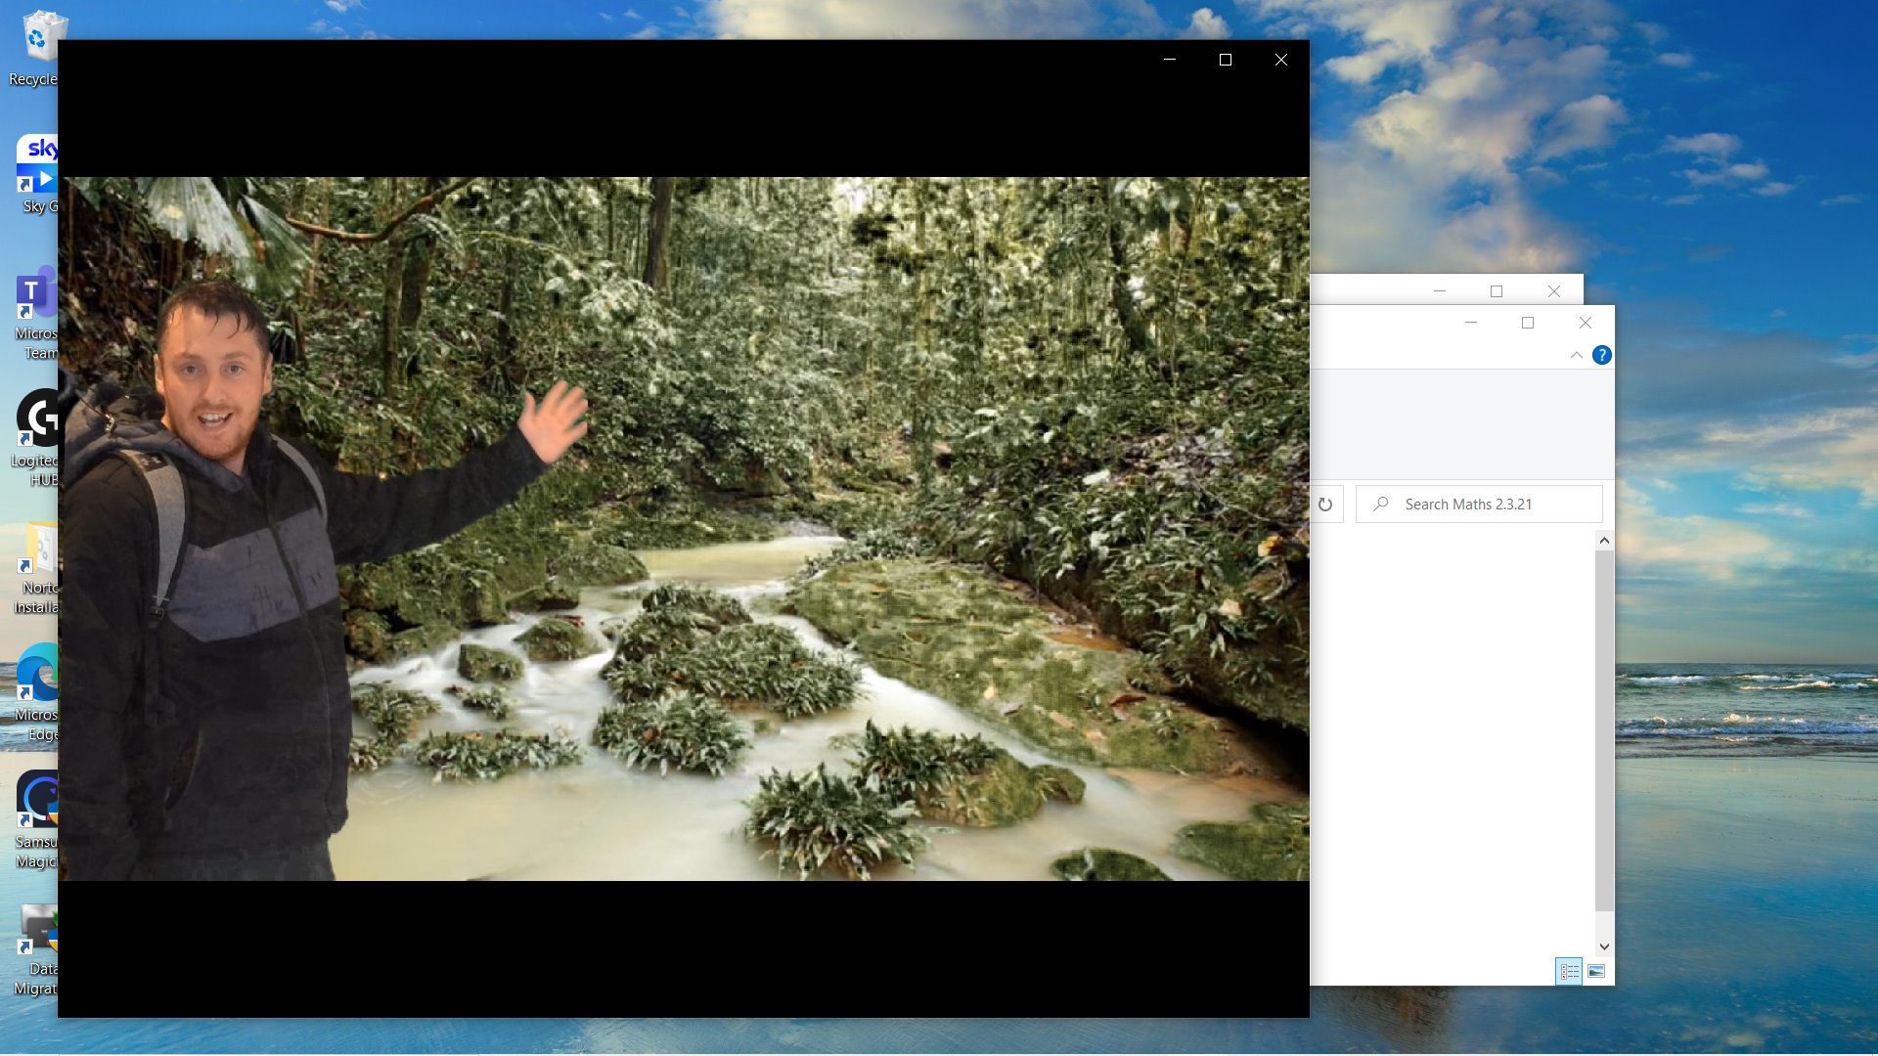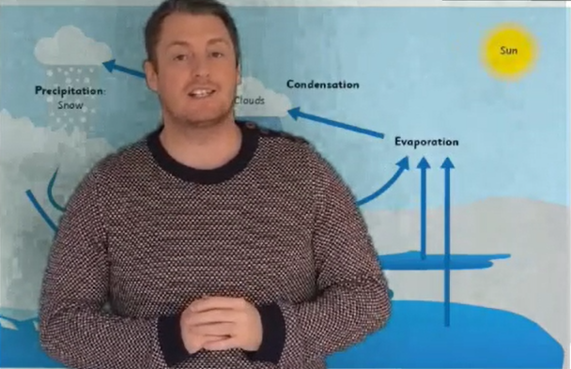
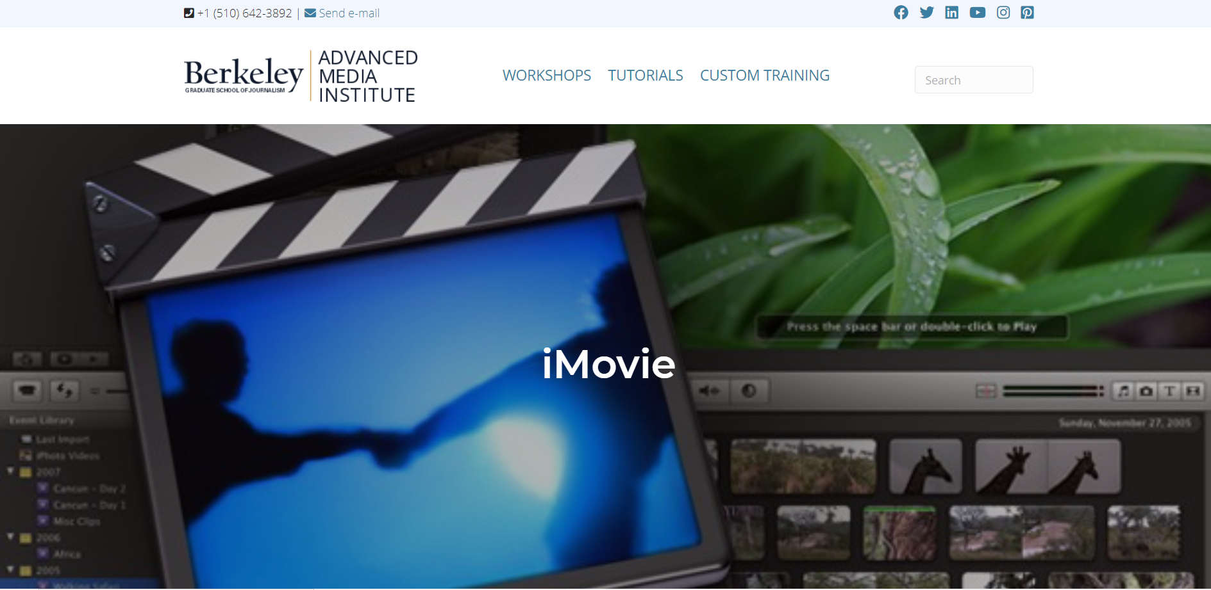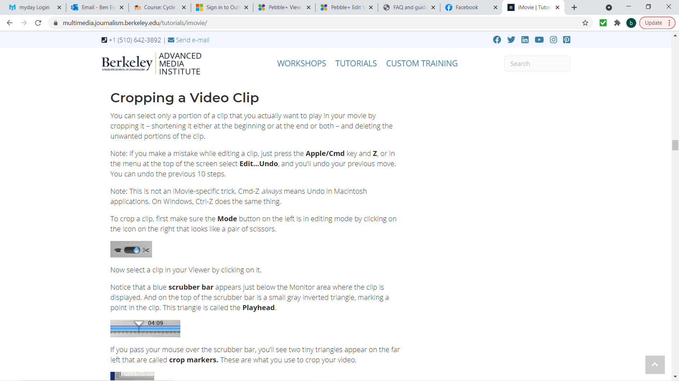
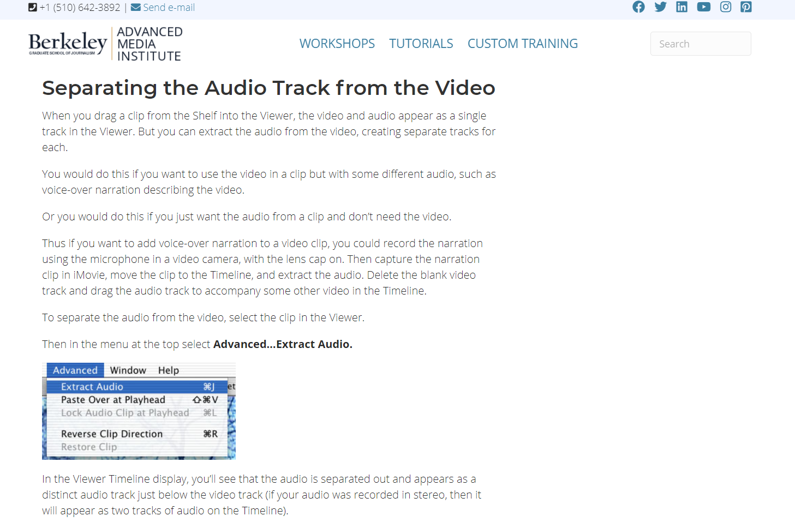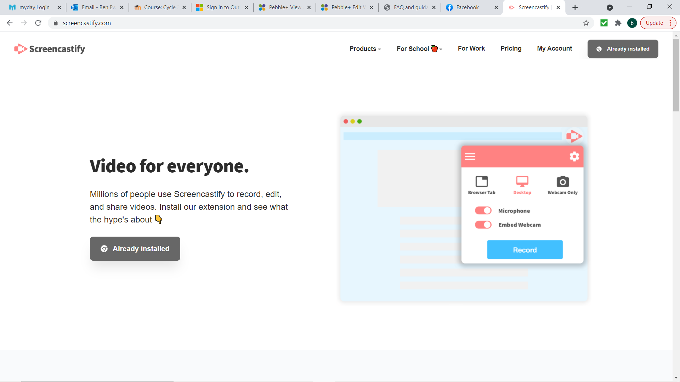

At the start of my practice and because of the global pandemic, all my teaching was online and A-synchronous. As a result, the school and my class teachers favoured method of creating lessons was i-movie. Before I created any videos and when I had recorded my first lessons, I made sure to research i-movie, how to use it, crop edit etc. I was then able to create lessons from my power points and input video and voice overlays to then put online for the children to engage with. Even though i believed the software was excellent, especially if you wanted to do a lot of editing and effects, I didn't think it was suitable to my needs. This is because I would have to record myself talking through the lesson and power point, I would then have to input the video into I-movie, then put the power point as an over lay to the video, then cut crop and edit my video to match each slide of the power point. When the video was finished I then needed to export it and then upload. This resulted in long editing times which I felt could be shortened. As a result, I researched into googles Screencastify, I downloaded the extension and recorded a test video. This software was much easier, it recorded my screen, as well as myself as I talked through the power point which enabled me to cut out the editing part entirely. The only issue was that unless you upgraded you could only record 5 minutes at a time, this wasn't a problem however because all I needed to do was upload each video side by side into my laptops free video editing software and then it was 1 complete video. I feel making the switch to Screencastify saved me a lot of time throughout my placement, time that was better spent in creating lesson plans and creating resources to help the children develop the targeted skill within the lesson. It has also made me feel a lot more confident in my use of video editing software and I feel I would have the confidence to take these skills forward into my teaching career whether that would be online or in the classroom to help aid in my lessons and promote a deeper understanding of learning with my use of technologies.
I also wanted to try and make the lessons I was creating more engaging for the students. I know how difficult it can be to concentrate when you are at home and just watching someone talking on a screen. I decided to teach myself how to use green screen. I investigated the different apps that could be used and because I had a borrowed I-pad from the school I decided the best one was 'do ink'. I downloaded the app (with permission) and set into motion playing around with it to understand the mechanics of editing in green screen software. I set up my kitchen to have a 'green screen' wall where I sellotaped green paper to one of my walls. I then took a series of videos in front of it and played around with the app. This gave me the confidence to believe that I could create effective and engaging lesson introductions or stop points that would help to engage children, grab their attention and facilitate in the learning that was taking place.
The first video I created was a trek through the amazon. This was a great introduction to the lesson on rainfall for maths. The second was a lesson on geography where children had to access prior knowledge to label the water cycle. I then acted as a type of weatherman to talk them through each of them and see how much they knew already. My class teacher commended me on my innovation and use of this technology and I feel that in my career moving forward I will be able to create highly effective green screen videos with myself or the children that will help the learning taking place in the classroom.
Reflection on planning for progression.
Professional Learning Template 1 – ‘The Magic Box’.

Evidence
Lesson plan – Appendix 2
Tracking – Appendix 3
Vocabulary list – Appendix 4
What you did and why?
One week on my placement I was asked to choose and develop a skill over a series of lessons in Literacy. After looking at the curriculum and LNF I had decided upon the skill of 'Produce poetic writing, using imagery and poetic devices.' Welsh Government (2008) I chose this skill because it was something I had not taught so far and I wanted to challenge myself with something new. After deciding on the skill, I researched different ways in how I could develop this skill. I came across a lovely resource called, 'The Magic Box.' This is a beautiful poem that expresses various items with lovely description and how they can all be in this imaginary box. Children, over a series of 3 lessons were given the opportunity to choose various items that could go in their box, describe them and then use their own work to create their own magic box poems. Throughout the sessions I gave children the opportunity to engage with the original poem as well as giving them examples of my own work that would help to inspire the children as the lessons progress.
What have you learned?
Progression in learning
The development of this skill through this lesson is a great example of how beneficial using progression and building up to a piece of work can impact on learning. I could have easily developed the magic box idea over one lesson and I am sure I would have had some good work produced. However, the idea here was not to just have the children produce good work. It was to help them understand poetic writing, to experiment with vocabulary and gather their work into a piece of work that makes them appreciate and develop the skill of poetic writing. I started off in the first lesson by taking them through a power point which led to them finding their own items and researching/gathering vocabulary that could be used to describe them. In the next lesson children were taken this work and compiling it into their own paragraphs and poems. I also challenged some of the children to use alliteration and superlatives in their writing as well as seeing if they could use the work we had covered a couple of weeks ago on conjunctions. As a bonus task I had spoken with my class teacher to see if i could ask them to develop their Oracy skills further through the work by videoing themselves reading their poems aloud. This was added as an extension to the 'screen free/fun Friday' day.
This work has helped me understand the importance of carefully planning for progression to ensure that a piece of work is carefully worked through so that the children are given the best opportunity to develop the skill within the piece of work.
What will you do next?
As I progress in my own learning and career, I will ensure that I take every opportunity to explore progression in learning. Children need to be given time and opportunity to develop at a pace that is suitable to them. This means that I will need to make sure that lessons are suitable to the needs of all learners and that I plan highly engaging and effective lessons that facilitate learning through progression. I believe that children are able to learn and develop new skills better when they have the opportunity to build on them through a series of experiences and real life authentic experiences rather than in short sharp lessons.
Reflection on planning for progression.
Professional Learning Template 2 – Welsh Language Progression.
Evidence
Appendix 5 – Lesson plan
Appendix 6 - Paragraph example.
What you did and why?
During placement I wanted more input in the development of children's Welsh. I was therefore tasked to plan and develop Welsh learners reading, writing, and speaking skills.
I spoke with my teacher and looked through children's workbooks to get a good understanding of their level of Welsh, from this I had a 3-week plan in mind where children build upon prior knowledge to develop their learning further.
1st Week Welsh lesson
On week one children started off my creating a fact file (fact file template) on a friend (Welsh lesson plan 1). They would have to ask and answer questions in Welsh and taking note of the answers given. To unlock prior knowledge, children were asked in the introduction to play a matching card game (matching card game evidence). The cards were cut up and placed in random orders in an envelope and each group of children had to work together to pair each question and answer.
2nd Week Welsh lesson
During week two, we built upon this learning and progressed further. Children had to develop their fact file into a paragraph or two based on their friend (Welsh lesson plan 2). In this lesson to activate prior knowledge, children were given A3 (A3 picture evidence) paper between each group and using the picture as well as knowledge they already had of myself, had to come up with sentences in Welsh using the 3rd person questions we had learned in the last lesson. After this I gave children an example (Welsh paragraph example) on the type of work I was expecting during the lesson. This was also a good opportunity for us to discuss the example and I could answer any questions that the children had. Children had time to look through the example, I then gave them the top part of the paragraph with some English to help them.
3rd Week Welsh lesson (What would have happened)
I had also planned on delivering week 3 which would have been recording children speaking their paragraphs about their friends and then turning them into QR codes to put up on the Welsh display. Unfortunately, due to the busy time constraints of school life in the lead up to Christmas. This had to be pushed back until the new year. I worked with my teacher and told her what I would have planned to do for this lesson, and I believe she took my planning on board, coupled it with her own and delivered the lesson in the new year.
What have you learned?
Learning progression
It is vitally important that teacher understand the ability level of all children in their class as well as the prior learning that has taken place in each area of learning. Teachers are then able to understand the capability levels of each child and what needs to be done to help progress that learning forward. I took it upon myself to look at books and talk with my class teacher to better understand the ability levels of the children in Welsh, I was then able to plan and deliver a series of lessons that built upon prior knowledge, as well as each week further developing upon the last lesson to progress their learning at a pace that was suitable to their developmental needs.
I feel it is very important that lessons are planned not on their own but with the idea in mind of being able to further link to lessons in the past and future that will all work together in developing children's skills across the curriculum. My lesson plans took a simple idea of creating a fact file on a friend and by linking them each week I was able to build upon the idea and eventual cover reading, writing and speaking in Welsh and develop each learner's Welsh in each of these area.
What is next?
What are my Targets
Welsh development is a personnel target of mine. I want to become a more confident and knowledgeable Welsh learner. The more I develop my Welsh language skills, the better prepared I feel I will be in passing on that knowledge through teaching.
How Will I develop this target
To do this I will continue to engage fully with the Welsh learning module in university. I also have people around me who are first Language Welsh speakers, I try my best to speak to them in Welsh when I can and ask them questions about the language. I feel this has been most beneficial because I am able to experience and use the language first-hand in a more natural way.
Reflection on planning for the Four Purposes.
Professional Learning Template 3 – ‘Healthy, Confident individuals.’
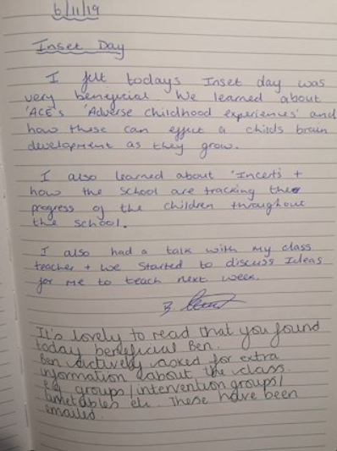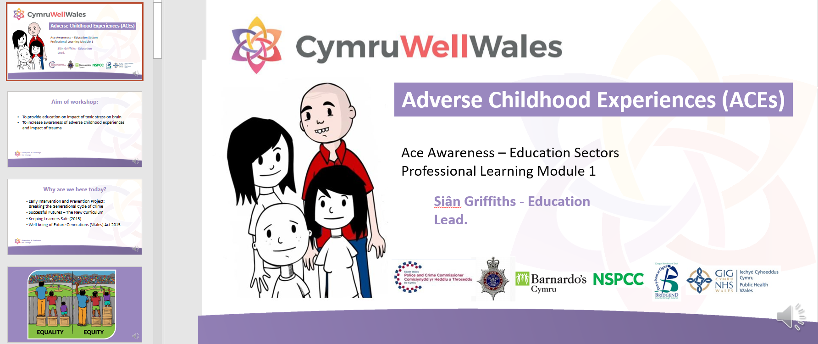
What did I do and why?
I have learned a great deal about Adverse childhood experiences (ACE's) through training during school meetings (Adds) (Evidence photo from diary), as well as undertaking University training on ACE's (Screenshot of power point).
During Adds, I collaboratively worked with staff on my placement school to gain valuable insight into the effects that ACE's can have on the lives of the children within our classrooms. The reason for this training for staff was to ensure that we are aware of how ACE's can effect children in their day-to-day routines, as well as how we can do all we can to help children in these situations.
The university training (power point evidence) helped to further my understanding of ACE's. I think that the training should be essential for all student teachers. As teachers it is very likely that we will be teaching children in our class that suffer 1 or more Ace's. It is our responsibility to do all we can to identify (where applicable) children that are suffering and do all we can to help that child lead a life that will ensure that these experiences don't affect them as they develop and grow.
What have I learned?
One of the Welsh Governments (2020) 'four purposes' is that children should be 'healthy, confident individuals.' Underneath this heading they say that one of the ways that this can be planned for and achieved is to help children build their emotional and mental well-being through resilience, confidence and empathy. Teachers can't control what happens in the lives of children when they are not in school, teachers need to understand that each child in the class has vastly different experiences to one another. These experience could include adverse childhood experiences. Therefore, we need to constantly stay up to date with ACES training and things that can have a very detrimental effect on a child, their well-being, education and impact their lives forever. When teachers are aware of how a child's well-being can impact their day to day lives, we can start to plan for and educate children in these matters, giving them the tools and developing the skills to better cope and deal with their own feelings and emotions. This can lead to children having more confidence, talking more, trusting more and becoming mentally stronger to cope with different life experiences that could arise. As I move forward in my practice, I will endeavour to see each child as the unique individual they are and look deeper into their behaviour, look past their emotions and try to understand them on a deeper level to where I can help them in developing their own mental and emotional well-being and become more resilient confident individuals.
What next?
I would like to continue to develop my understanding of ACE’s. Ensuring that I am able to help any children in my class that are suffering from ACE’s in the best way possible. This will help in my own development of understanding the needs of children and how i can help promote mental and emotional wellbeing within the classroom.
Reflection on planning for the Four Purposes (Tab 7).
Professional Learning Template 4 – ‘Ethical, Informed Citizens’.

What did you do and why?
As part of the theme 'Frozen Kingdom', we had decided that we would use the Titanic disaster as the basis for a lot of our literacy and thematic work. For one week on my practice, I was tasked with developing a series of lessons around the Titanic that would develop their skills in research, deciding on reliable information, interpret information and then prepare and deliver a news report on their findings.
These skills would be developed throughout a series of 3 lessons where children would research and engage in various activities that will provide them with all the information, they need to make informed decisions about the disaster as well as create and perform a report on the disaster.
Activities included being detectives, arranging sources into the correct categories, decide on a culprit and provide arguments, engage in Padlet, hot seating and work within a group to assign roles and role play characters that could be interviewed during a news report on the disaster.
What have you learned?
Four purposes for learners
When I planned these series of lessons, I ensured that the Four purposes were the driving factor with my intended outcome. Welsh Government (2020) under the 'ethical, informed citizens' of the four purposes strand explain that children should be given opportunities to 'find, evaluate and use evidence in forming views'. I wanted to create fun and practical sessions that would allow children to develop these skills within the four purposes. Children were tasked with researching various bits of media about the Titanic, collating, and evaluating the data and then 'accusing' a culprit with evidence in their arguments. Children have engaged well with this theme and topic overall and this was evident throughout these lessons. There were highly engaging discussions and debates about who they thought was responsible, excellent arguments and persuasive language used and children were able to form and express their views clearly.
I have learned that when you carefully plan for the four purposes in a series of engaging lessons, children will develop and progress in their knowledge and skill development throughout these lessons at a good pace suitable to their ability. Children throughout these lessons and at a pace suitable to them can become more informed through research and develop their ability to engage with research and suitable information to provide evidence for arguments to back up their views. I believe it is important to continue to provide children with rich valuable experiences that build upon each other and provide them with opportunities to further develop skills throughout school that can benefit them now and in the future.
What will you do next?
I will continue to ensure I plan for the four purposes. I believe that when planning for the four purposes, you are ensuring that children are developing skills though engaging experiences that will benefit them throughout school and become valued members of society. I would be keen to develop my understanding on how listening to the learners and their views around their own learning and pedagogy can help me in producing highly effective lessons that are suitable to their needs. As I move forward in my own learning and career, I will make sure that children are active participants in their own learning, helping me to shape the learning to meet their own specific needs.

Part 2

PLP Link - https://v3.pebblepad.co.uk/spa/#/public/kwhG4Zxgbpptq3x5g8HHrjZRZM
This part of the assignment will explore an area for professional development that will impact on learner progression. Welsh Government (2020, p. 11) has identified ‘Four Purposes’ which are to be the driving factors of the new curriculum. One of these purposes are that children should be given opportunities to develop as, ‘Healthy, confident individuals.’ More specifically, they identify that children should be able to build upon their mental and emotional well-being. Seligman (2012) defines his theory of well-being as having five key elements, positive emotion, engagement, relationships, meaning and accomplishment (PERMA), he believes that this is the criteria for people to flourish. Teachers and children can cover all 5 of these elements in their time together at school which would mean that teachers are able to help children ‘flourish’ in more than just education. Mental and emotional wellbeing, therefore, is the area for professional development that will be explored throughout this assignment. After exploring adverse childhood experiences (template 3 part one), it is clear how detrimental experiences and emotional and mental wellbeing can affect a child throughout school and into their adult lives. Throughout their career, teachers will experience children who are suffering from ACE’s and therefore need to understand the needs of the children in those situations. Maslow’s (2019) motivational theory believed that for people to achieve ‘self-actualisation,’ where a person reaches their full emotional and physical potential, there is a pyramid of needs that first must be met. These include necessities such as food, water and shelter then moving up the pyramid to health and security, then love and friendship, self-esteem and respect and finally self-actualisation. Maslow postulated that a person can’t move up the pyramid until their needs are met at each level. He argued that if needs are not met at certain stages, then it can lead a person to develop illnesses, mental health issues, lack of esteem and depression. Therefore, developing professionally and understanding the mental and emotional well-being needs of children are important as a teacher. A teacher that is aware of these needs, how to fulfil them and ways to deal with children whose needs are not being met, are able to give children a much better chance at developing the skills they need to progress within their own mental and emotional wellbeing.
Teachers are in a very prominent position in the classroom. Each day they work in front of thirty children who are very observative. They will pick up on language used and replicate behaviour witnessed. In this position teachers need to be aware of their behaviour, language, and content within their teaching, as children will be learning from them. Gray and Macblain (2012) explain Bandura’s (1961) experiment within social learning theory. This experiment involved children watching a woman show aggressive behaviour towards a bobo doll, once then left alone with the doll, the children engaged in the same behaviour. Children were imitating the behaviour they had witnessed. Zealley (2001) concurs, she believes that children learn by replicating the behaviour they witness from significant people within their lives. If children are exposed to and experience love, warmth and laughter consistently then they will grow to value themselves and others around them. Conversely, if they experience and witness aggression, rejection and inconsistent behaviour then these patterns of behaviour will be replicated by the child. This idea is carried into the classroom, she believes that the people who work with children in a professional capacity have a duty to provide a positive, caring and warm environment to help contribute to their optimal well-being and health. This would suggest that as teachers, we need to understand our responsibility and behaviour within the classroom. We are not just teaching a curriculum to children, we are models of behaviour and it is our duty to ensure our behaviour and the environment we create for children is that of a positive, warm and holistic nature.
Some people argue that teachers are asked to do too much in schools rather than just educate children. Mason (2019) highlights that between 2018 and 2019 there was a fall in teacher numbers, while pupil numbers grew along with child expulsions. She believes that as a result, especially in the most challenging schools, education is not able to be effectively delivered for all children. After conducting a survey asking teachers what they believe the reason for the decline of teachers were, she found that one of the highest responses was based around a lack of support from other professionals. Mason interprets this as teachers potentially having too many responsibilities within the classroom. Teachers are tasked on a daily basis with being educators, nurses, counsellors, parents and much more. However, with the rise of expulsions we can clearly see a link between teacher decline and the overload of responsibilities faced by teachers leading to a lack of support for them in a number of these areas. If teachers already have too much responsibility within the classroom, then why should they even consider the emotional and mental well-being of their children and concentrate solely on education. Conversely, Dowling (2001) believed that twenty years ago the issue was that teachers were forced to concentrate more on attainment, rather than concentrate on other issues that matters in the classroom such as the emotional well-being of pupils in relation to their overall development. This led to teacher’s not being able to take on other roles which children crucially needed, instead, concentrating on grades and attainment outcomes. The Mental Health Foundation (2016) emphasise that 1 in 10 children are suffering from depression or anxiety as a result of experiences in their lives. As a result of statistics like these, Dowling (2014) now believes that teachers are becoming much more aware of what is expected of them and they are not just teaching for intellectual purposes. She explains that the link between emotional wellbeing and other aspects of their learning is becoming far more recognised. Welsh Government (2015, p. 3) has recognised these needs and identified goals for public bodies to contribute towards ‘improving the social, economic, environmental and cultural well-being of Wales.’ With teachers being part of the public sector within Wales, they explain that it is their duty to ensure that, for the benefit of a Welsh future, physical and mental health should be maximised as much as possible. Therefore, teachers need to ensure that they are providing an education for the whole child and not just intellectual purposes and outcomes.
The current global covid pandemic has impacted the lives of everyone. The NSPCC (2021) highlight that mental well-being has affected everyone over the last year, especially children. They state that because of the pandemic children would have a completely different routine from what they are used to. They would be spending much more time at home, not being able to play with friends as they normally would, see family and some children would have even experienced loved ones becoming very ill or even passing away. Children can be very resilient; however, we need to instil that resilience into them and provide them with the strategies and coping mechanisms to promote positive mental and emotional wellbeing. One strategy that can develop professional learning is to involve parents and build a strong link between them and the school. Wild and Street (2013) highlight the importance of the relationship between parents and the school in working together for the benefit of the child. They believe that children’s development throughout school can be helped when schools encourage the whole family to engage with and be involved in their child’s education. Families can offer parental expertise and share information that the school can utilise in their planning and development of a child’s education. However, not only do the school benefit from this partnership, parents and families have also expressed their views on how it has benefitted their understanding of their child. Evangelou et al. (2008, cited in Wild and Street, 2013, p. 116) explain that what parents benefitted from was being involved in a range of activities, learning together with their child, having deeper conversation with other parents and developing their own learning and understanding through professional support. We can see that building positive relationships between the school and parents can potentially help the holistic development of each child. ESTYN (2018) has identified the work St Julian’s Primary School has engaged with in parental involvement as good practice. The school set up a committee that included staff and parents with the aim of promoting parental engagement through a variety of events. They were impressed with how the school gave opportunity to parents to support wellbeing and learning in school and at home. It provided opportunity to parents to get involved with their child’s learning so that this could be carried on in the home, leading to parents feeling more confident and having a positive impact on pupil wellbeing. We can see the potential benefits here of involving parents in workshops to improve the relationship between the school and parents, leading to pupil wellbeing increasing as a result. Teachers who engage with and understand the importance of strategies like this will have a better chance at improving the wellbeing of children within their own class.
Another effective strategy and one that can help in professional development is to listen to and build positive relationships based around your learners needs. The best way to understand your learners is to get to know them individually. Building strong relationships will allow them to feel more confident and be more open to discussions around the areas that matter to them. ESTYN (2018) have identified this area as good practice at Redhill Preparatory School. They have placed great emphasis on emotional intelligence and wellbeing. To identify how to improve these areas the school have given the children questionnaires and created pupil led focus groups to allow the children freedom to discuss the ideas that matter to them. With these activities pupils have been able to give their concerns as well as allowing the school to identify their social and emotional needs. By listening to the learners, the school have been able to identify needs at an early stage and put strategies into place to meet these needs. This gives us good insight into the potential benefits of listening to learners and giving them the opportunity to discuss issues in a safe environment with teachers acting upon responses. Hattie (2012) agrees, he believes that with dialogue, and more importantly teachers listening to pupils’ responses, it can lead to the addressing of questions or issues of concern, learning about and deciding on ways that these issues can be addressed, appreciating different viewpoints, and then collaboratively resolving the problems. This can then lead to the teacher becoming more aware of the educational and emotional needs of the pupil, but also, the pupil feeling more valued and confident about giving his thoughts and opinions leading to a more positive state of wellbeing.
As teachers progress throughout their career it is important that they build a strong foundation of relationships within their class. This foundation should be based around each individual learner, listening to them, identifying their needs and putting into practice the research and reading that they undertake to meet each of their needs. Much emphasis has been placed by Welsh Government (2020) on the need to promote mental and physical well-being in schools. They believe that when designing the new curriculum, a school should ensure that learners health and mental health are integrated throughout the curriculum. This is because children are the future and investing in our children today is an investment for the Wales of tomorrow. This is mirrored by Bradshaw (2016) he believes that children are the workforce, citizens and parents of tomorrow and that investing in their well-being matters to all of us as it shapes the country for the future. In conclusion, teacher progression is just as important as learner progression. Teachers need to stay up to date with curriculum changes, research, legislation and with their learners’ interests and needs. This is to ensure that they can constantly create learning environments that are based around the holistic development of children and are always providing the best care and education that they deserve. ESTYN (2018) identify ‘Teachers as researchers’ as effective practice at Ysgol Cynwyd Sant. They were impressed with the way the school were able to develop innovative ways of developing teacher research skills without the added pressure of overburdening them. As a result of the strong emphasis on teacher’s development and research in education, considerable progress has been made at the school in preparation of the new curriculum. They have instilled confidence within the pupils to discuss the four purposes, pupils are readily involved in the planning of work which then leads to high engagement levels in learning and there is strong pupil wellbeing within the school. This practice highlights the benefits of teachers being involved and taking ownership over their own progression. Not only can it lead to better lessons and education for the children, it can also help in creating a holistic environment, at the heart of which is the child and their individual mental and emotional wellbeing.
References
Bradshaw, J. (2016) The Well-being of Children in the UK. 4th edn. Bristol: Policy Press.
Dowling, M. (2001) Young Children’s Personal, Social and Emotional Development. London: Paul Chapman Publishing ltd.
Dowling, M. (2014) Young Children’s Personal, Social and Emotional Development. 4th Edn. London: Sage Publications Ltd.
ESTYN (2018) Effective Strategies Support the Social and Emotional Wellbeing of Pupils. Available at: https://www.estyn.gov.wales/effective-practice/effective-strategies-support-social-and-emotional-wellbeing-pupils (Accessed on: 2nd May 2021).
ESTYN (2018) Supporting Parental Engagement Through Workshops. Available at: https://www.estyn.gov.wales/effective-practice/supporting-parental-engagement-through-workshops (Accessed on: 2nd May 2021).
ESTYN (2018) Teachers as Researchers. Available at: https://www.estyn.gov.wales/effective-practice/teachers-researchers (Accessed on: 2nd May 2021)
Gray, C. And Macblain, S. (2012) Learning Theories in Childhood. London: SAGE Publications ltd.
Hattie, J. (2012) Visible Learning for Teachers: Maximising Impact on Learning. Oxon: Routledge.
Maslow, A. (2019) A Theory of Human Motivation. New Delhi: General Press.
Mason, D. (2019) Are We Asking Too Much of Teachers? Available at: https://www.thersa.org/blog/2019/09/teachers (Accessed: 2nd May 2021).
Mental Health Foundation. (2016) Children and Young People. Available at: https://www.mentalhealth.org.uk/a-to-z/c/children-and-young-people#:~:text=Mental%20health%20problems%20affect%20about%201%20in%2010%20children%20and%20young%20people (Accessed on: 2nd May 2021).
NSPCC. (2021) Supporting Children and Young People’s Mental Health. Available at: https://learning.nspcc.org.uk/news/covid/supporting-children-young-people-mental-health (Accessed: 2nd May 2021).
Seligman, M. (2012) Flourish: A Visionary New Understanding of Happiness and Well-being. New York: Simon & Schuster.
Welsh Government. (2015) Well Being of Future Generations (Wales) Act 2015. Available at: https://www.futuregenerations.wales/wp-content/uploads/2017/02/150623-guide-to-the-fg-act-en.pdf (Accessed: 2nd May 2021).
Welsh Government. (2020) Curriculum for Wales Guidance. Cardiff: Crown Copyright.
Wild, M. And Street, A. (2013) Themes and Debates in Early Childhood. London: SAGE Publications ltd.
Zealley, H. (2001) Healthy Young Children: Promoting the health and well-being of young children. London: The British Association for Early Childhood Education.

Appendices
Appendix 1
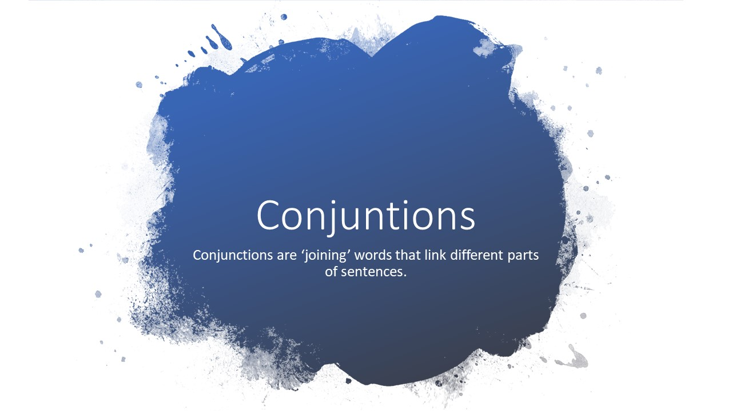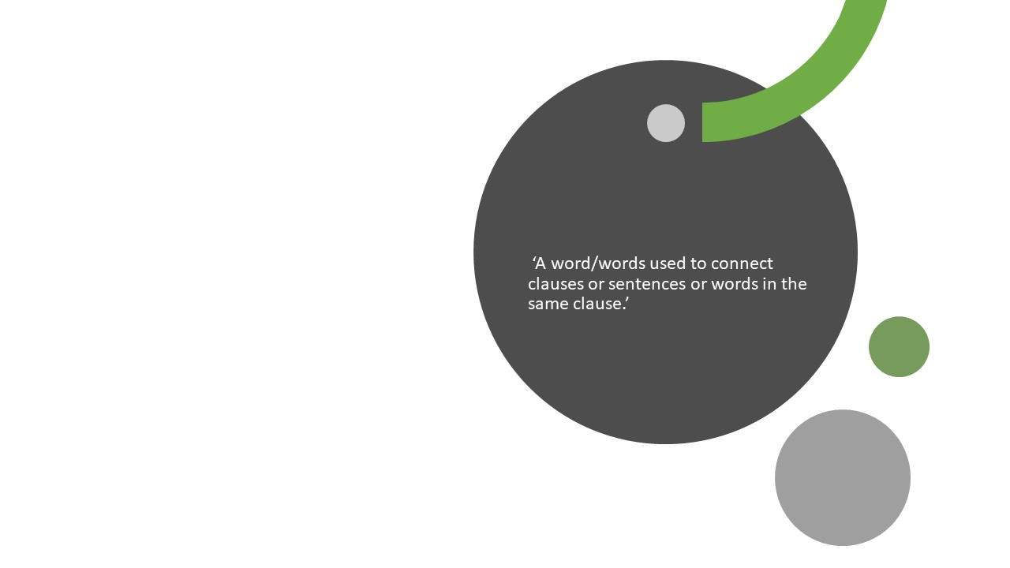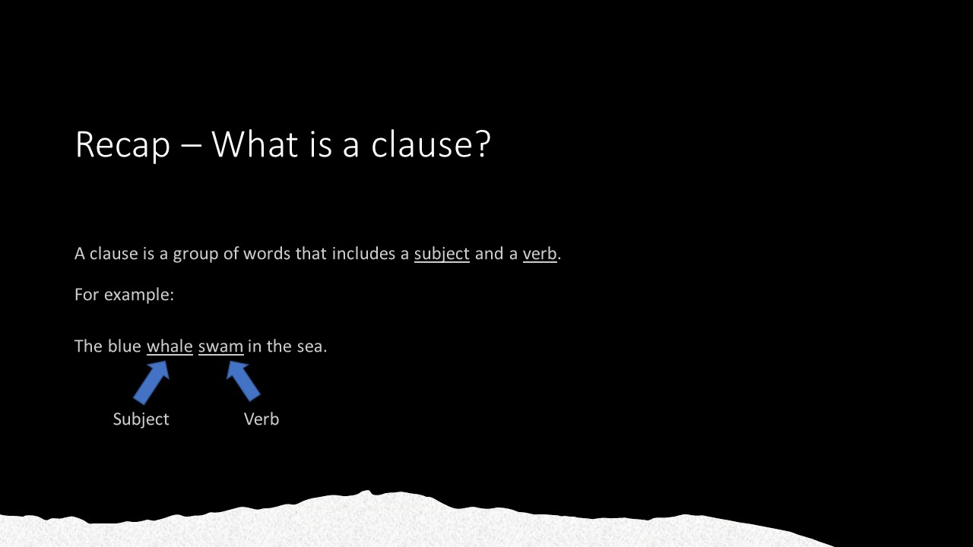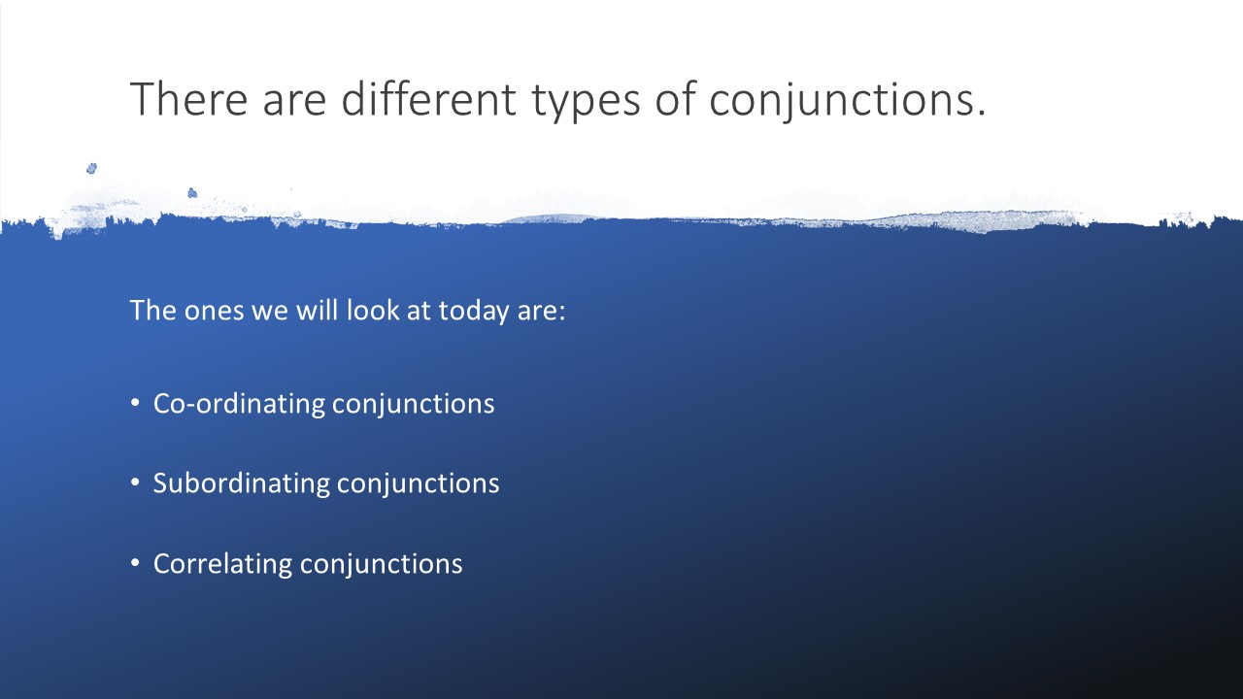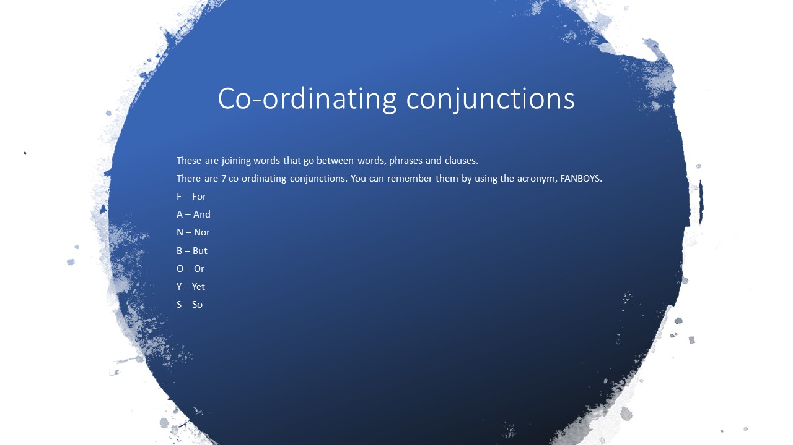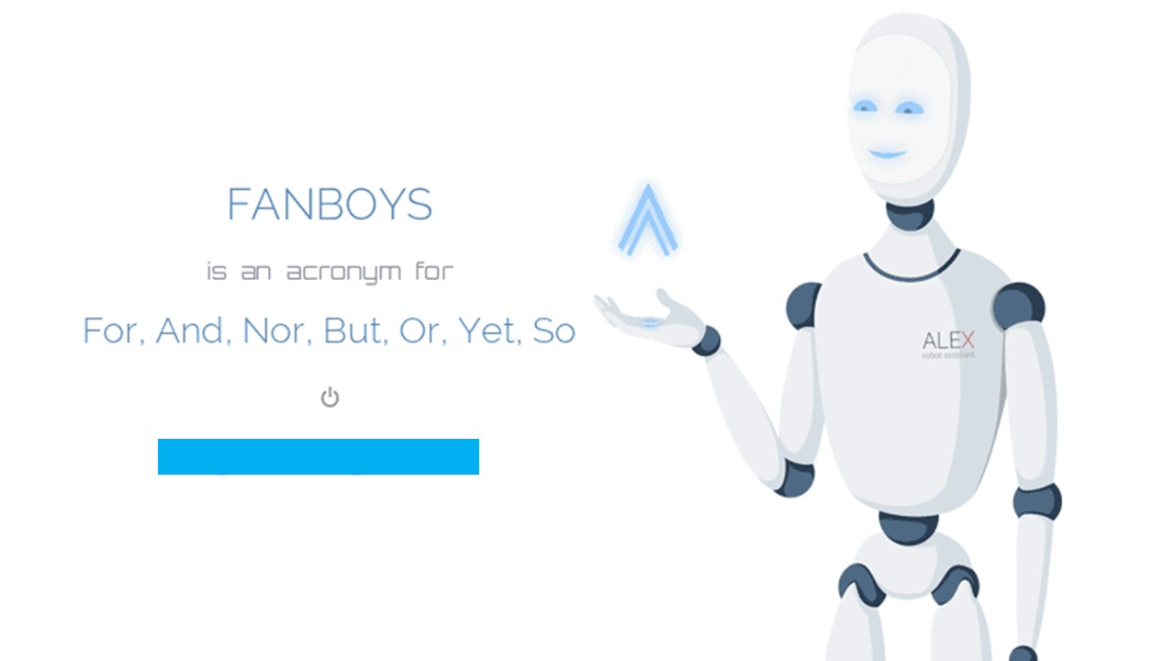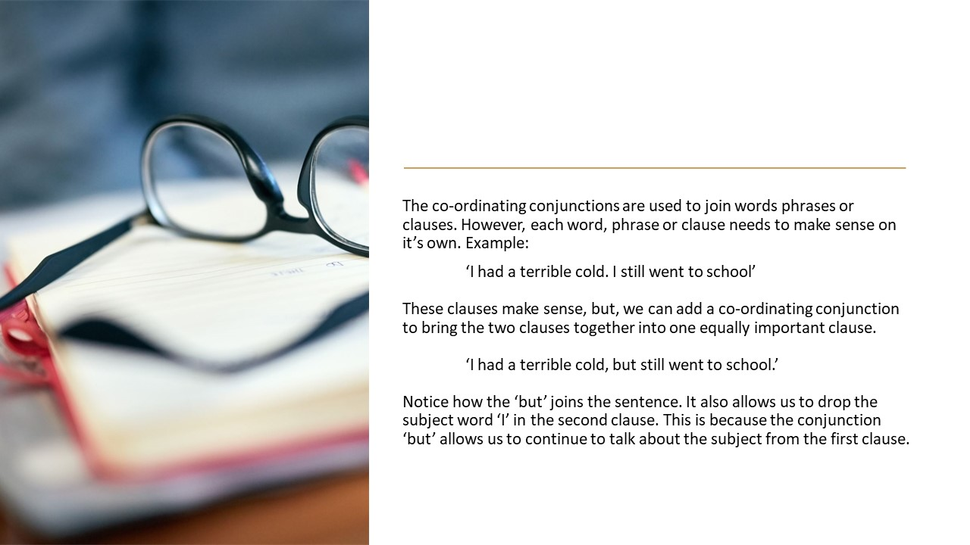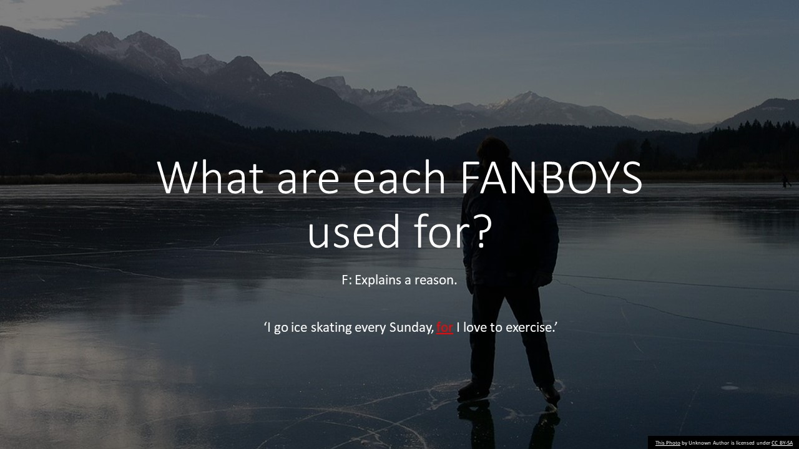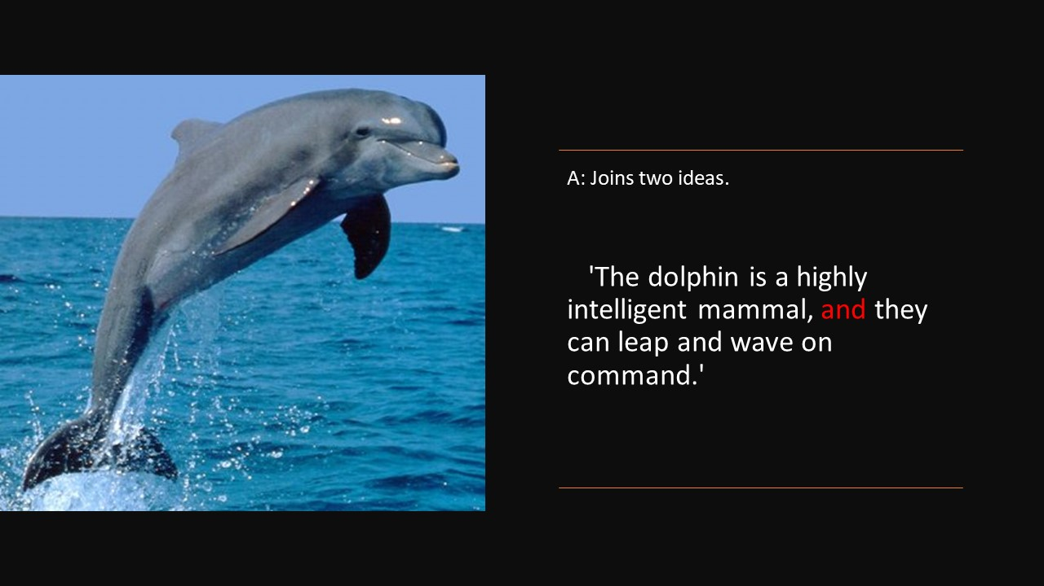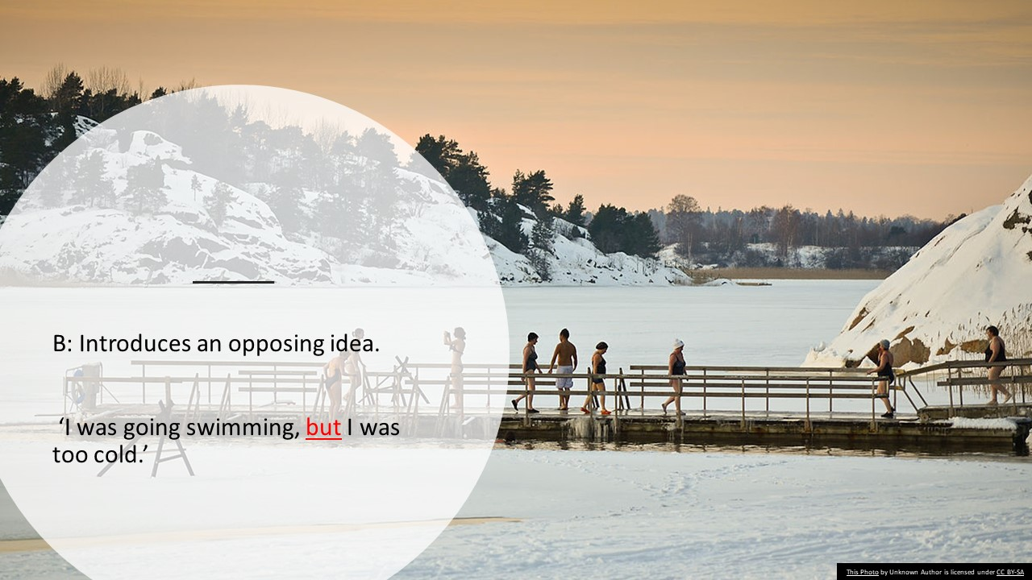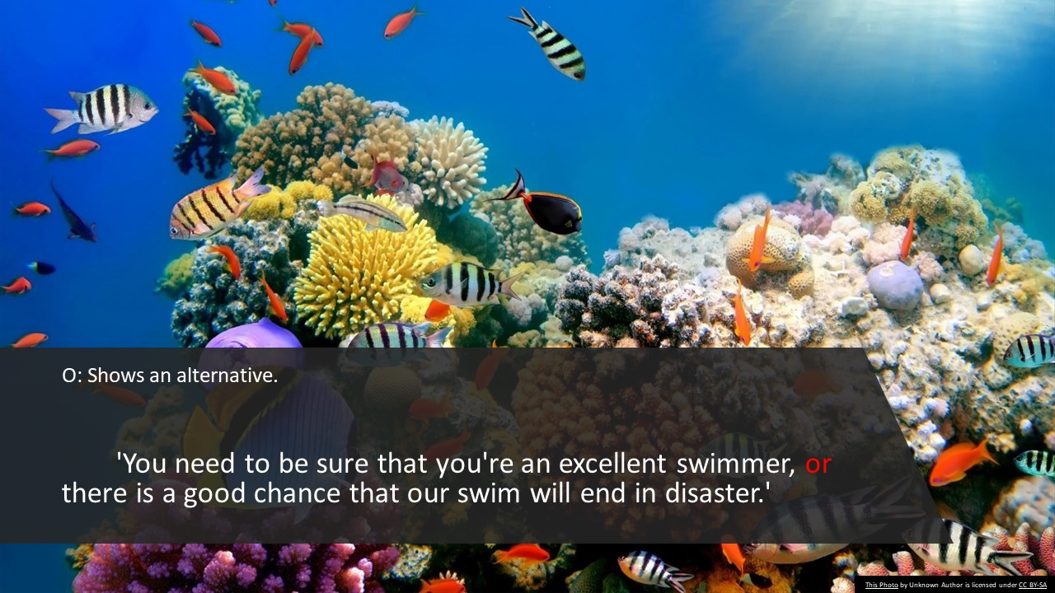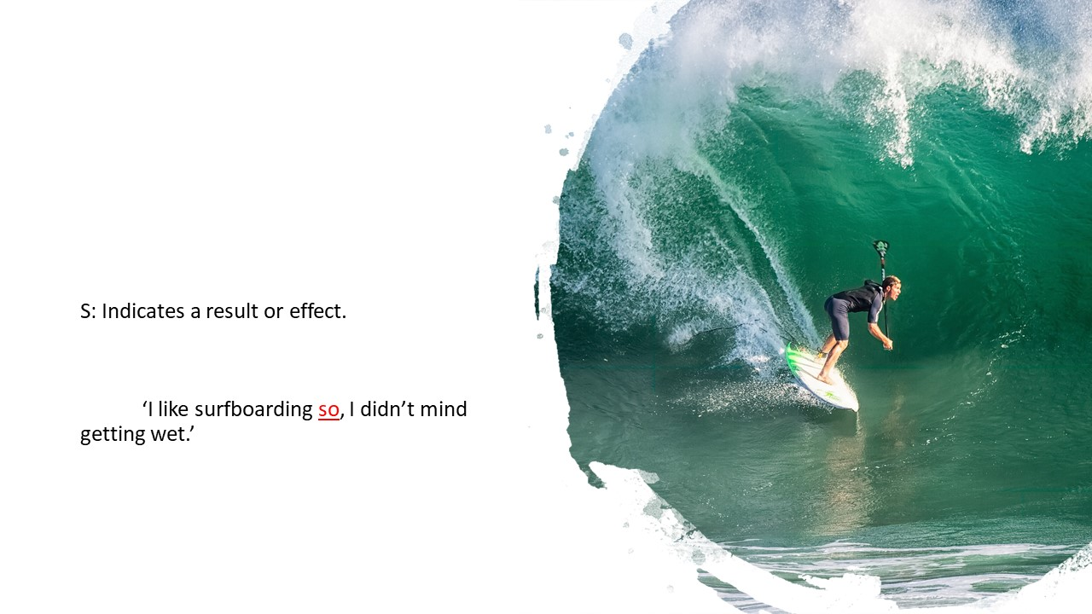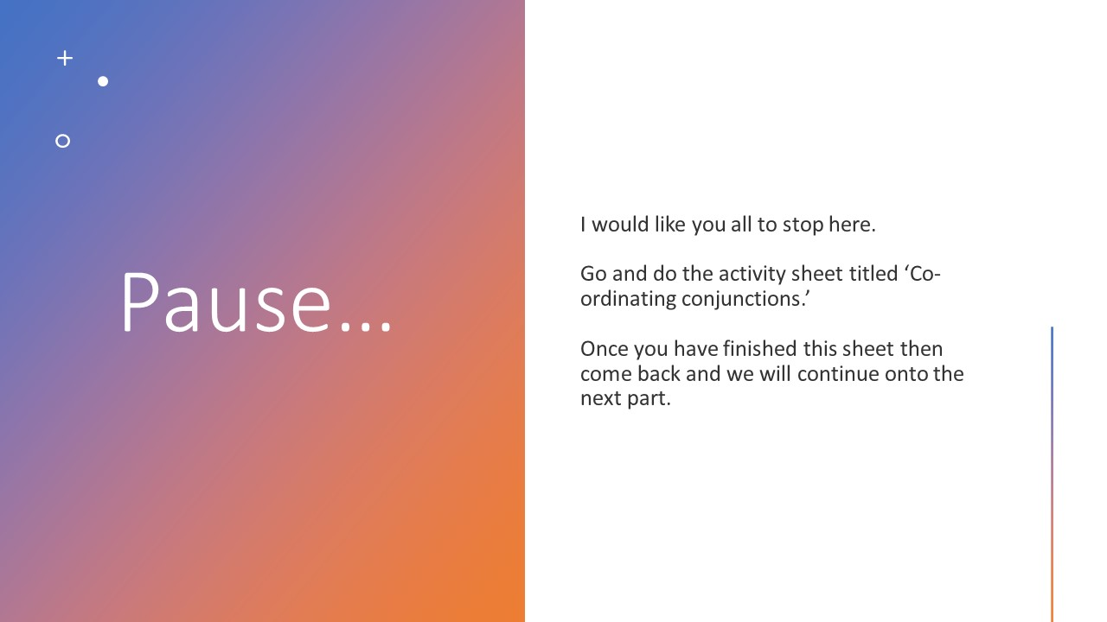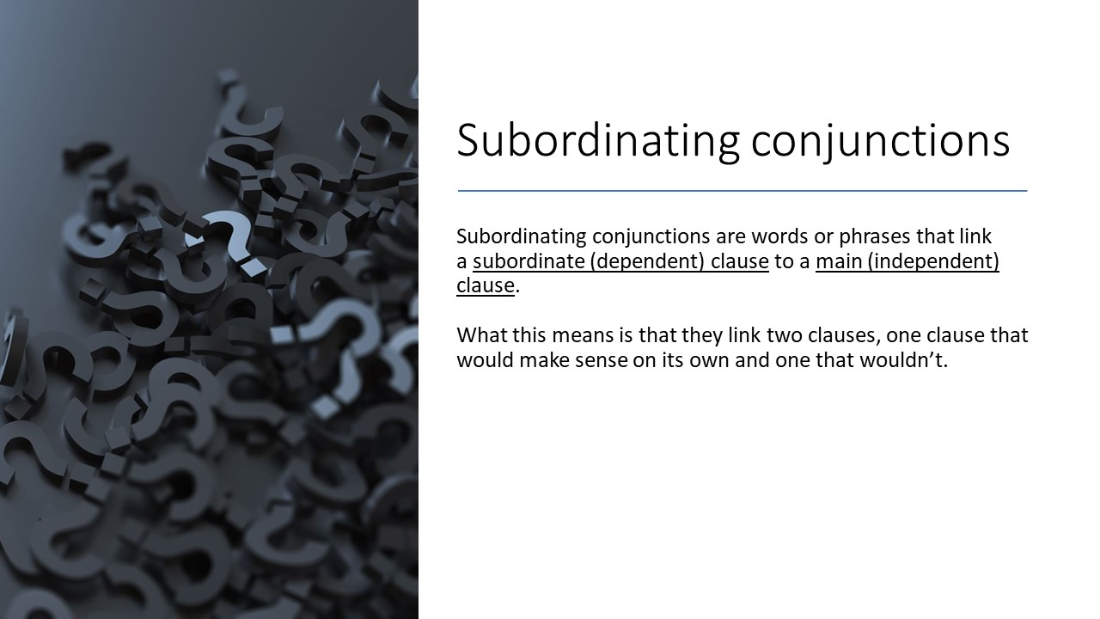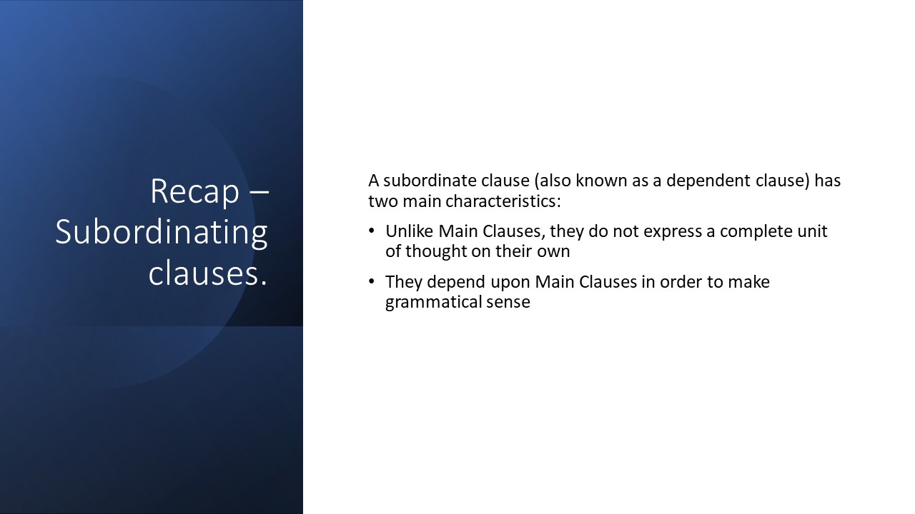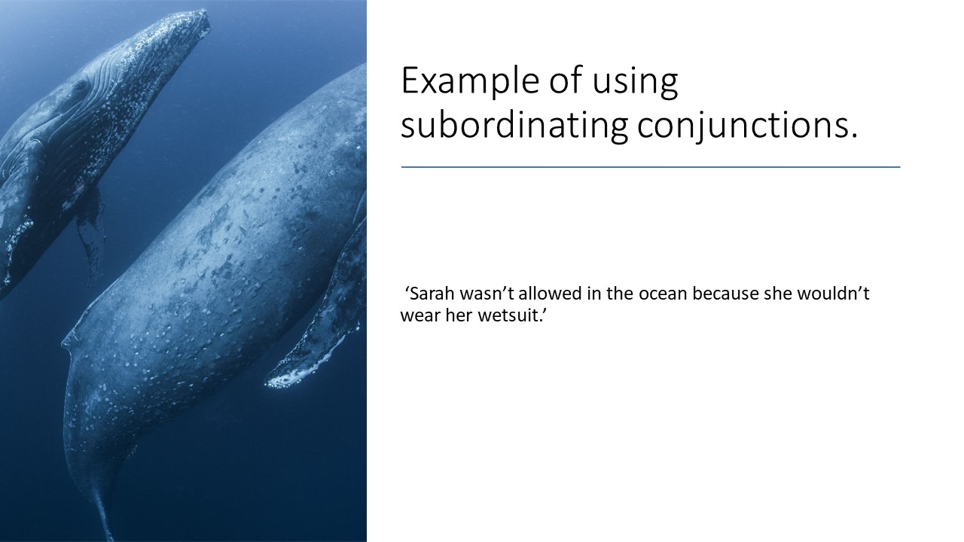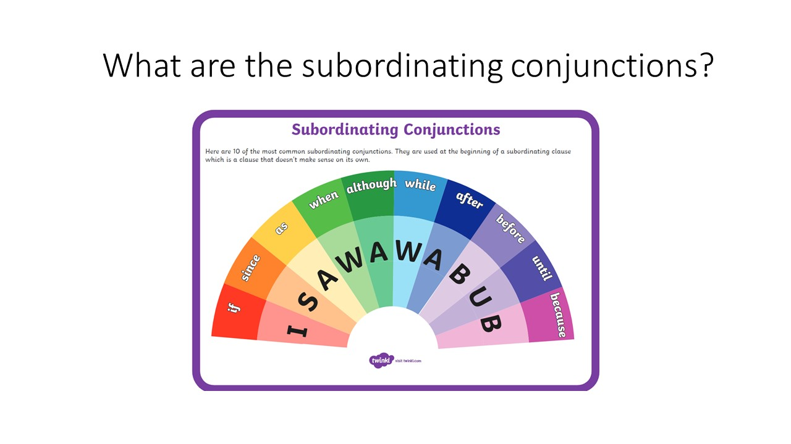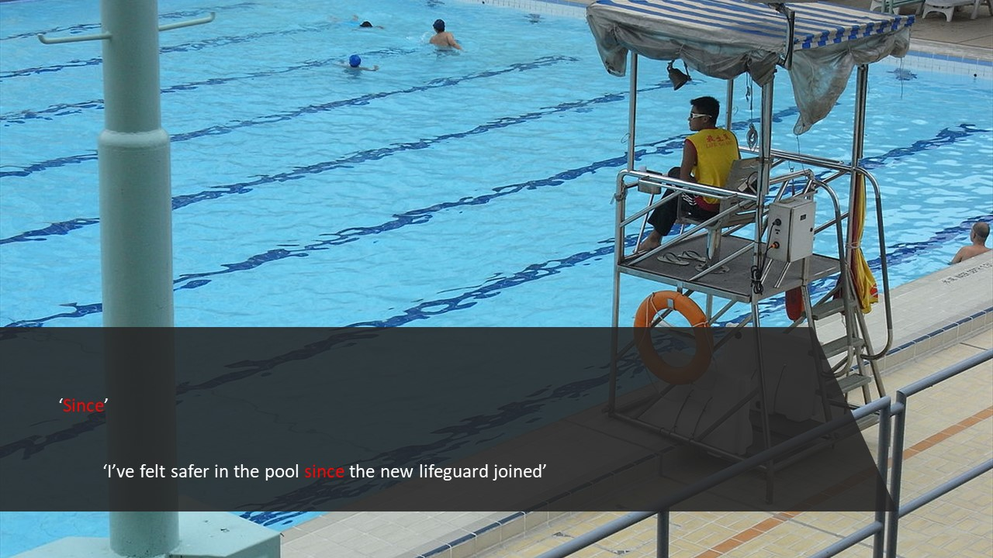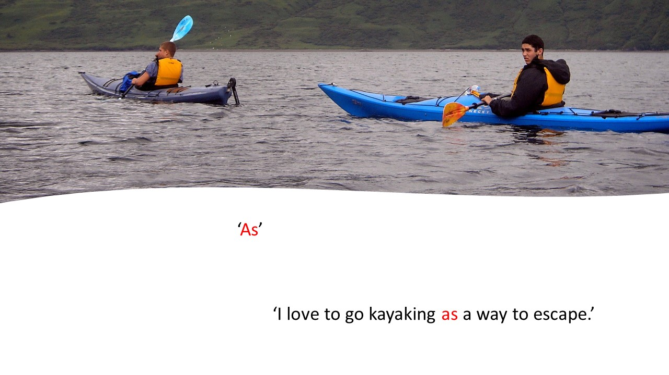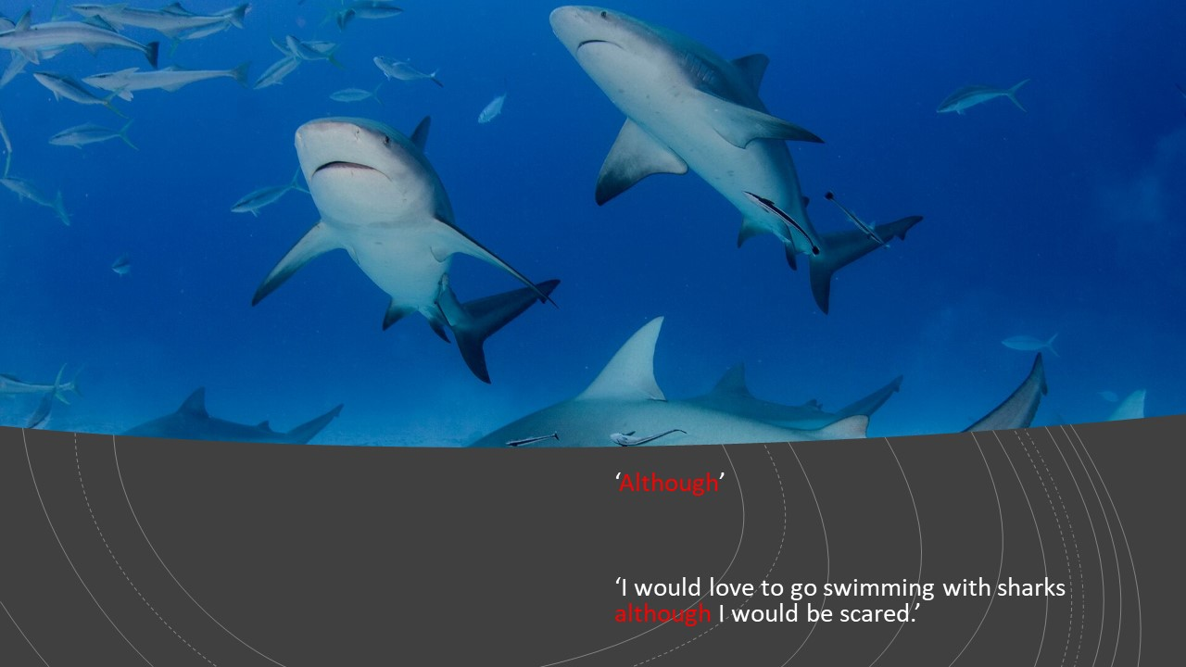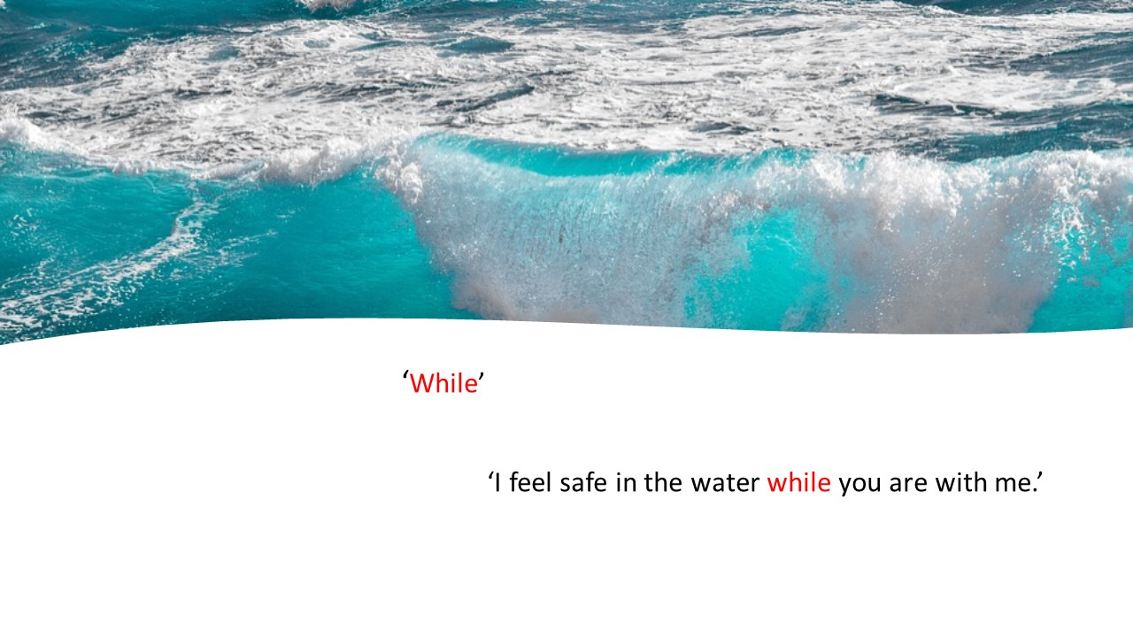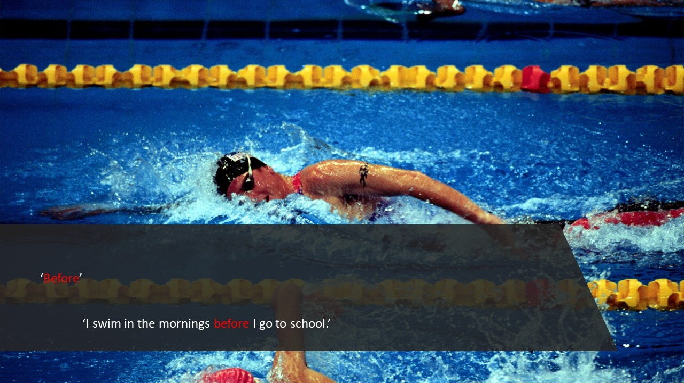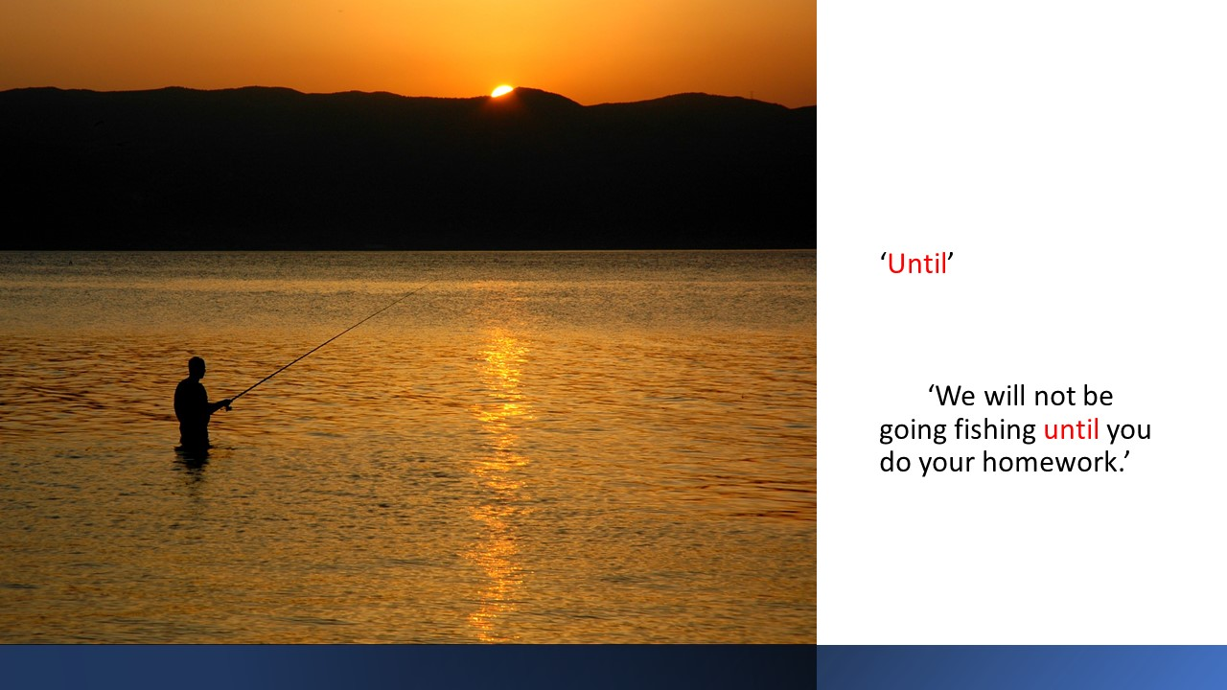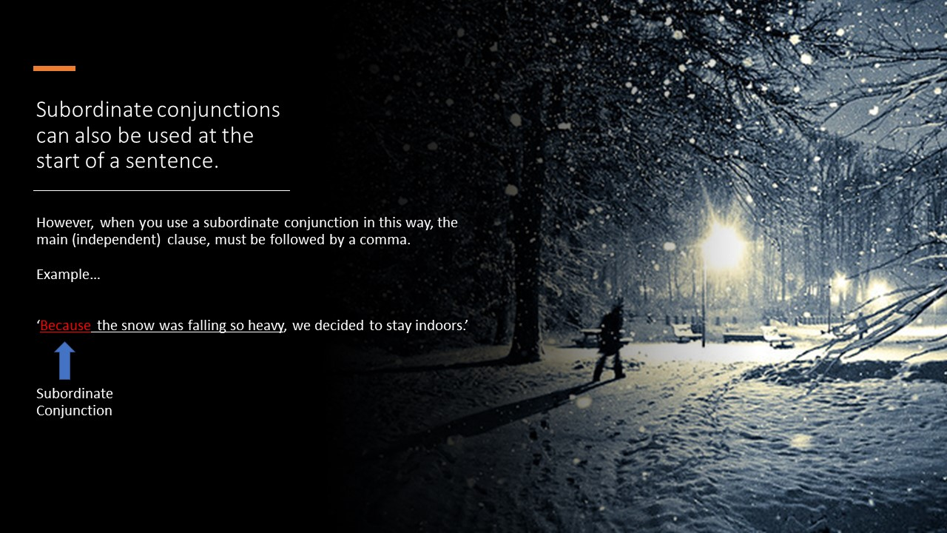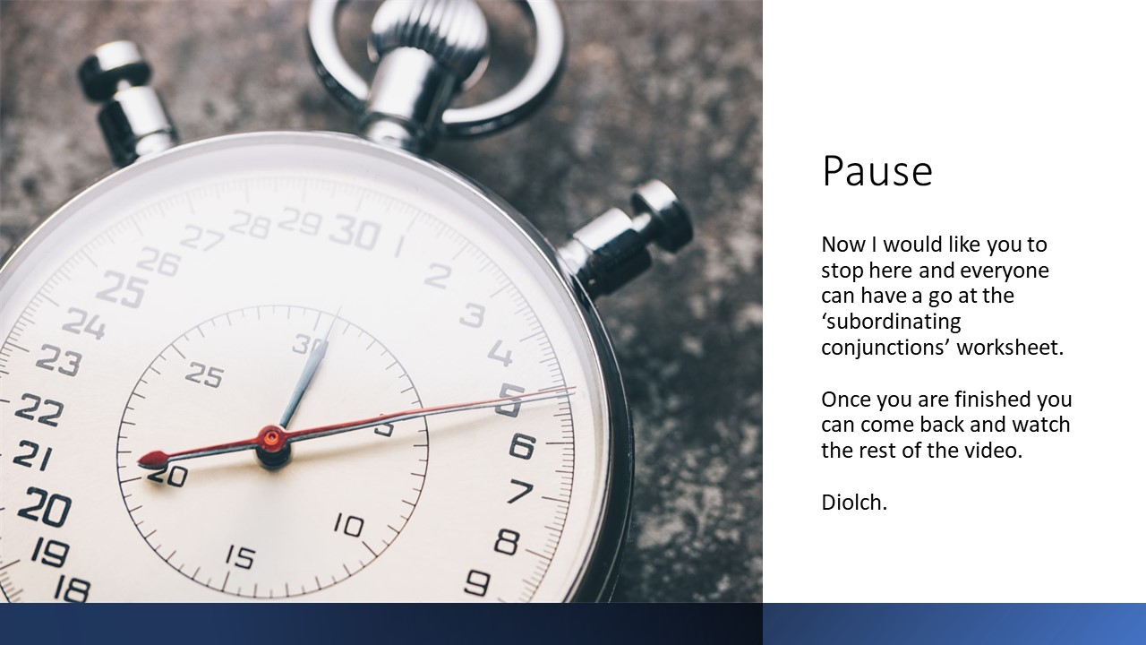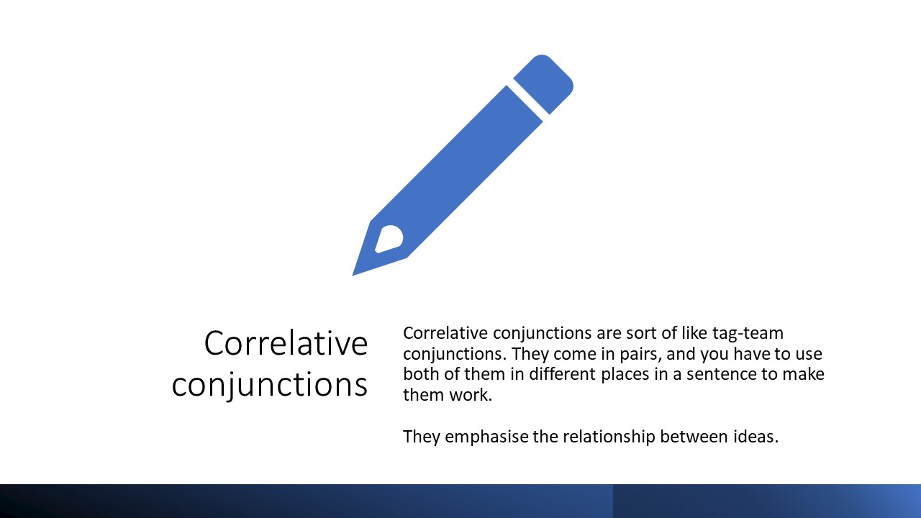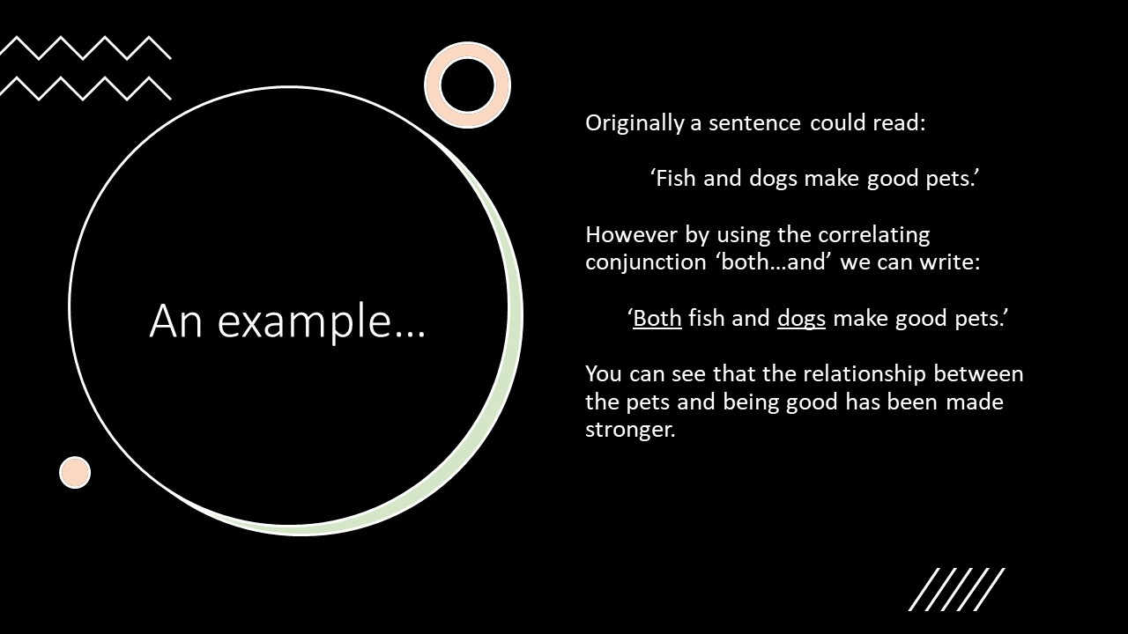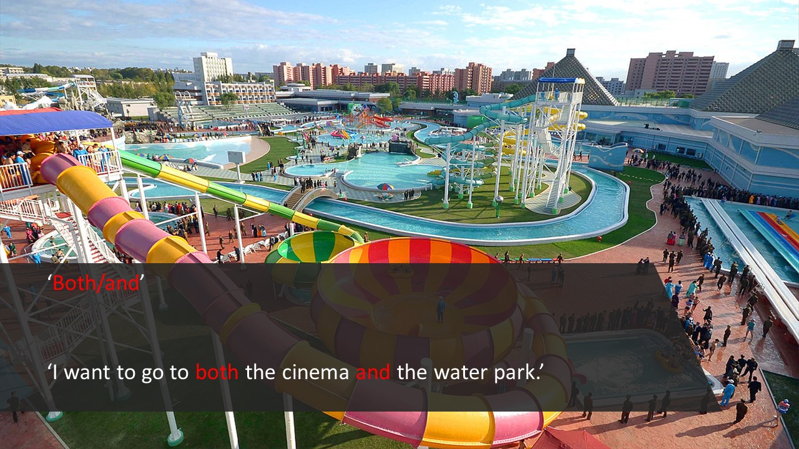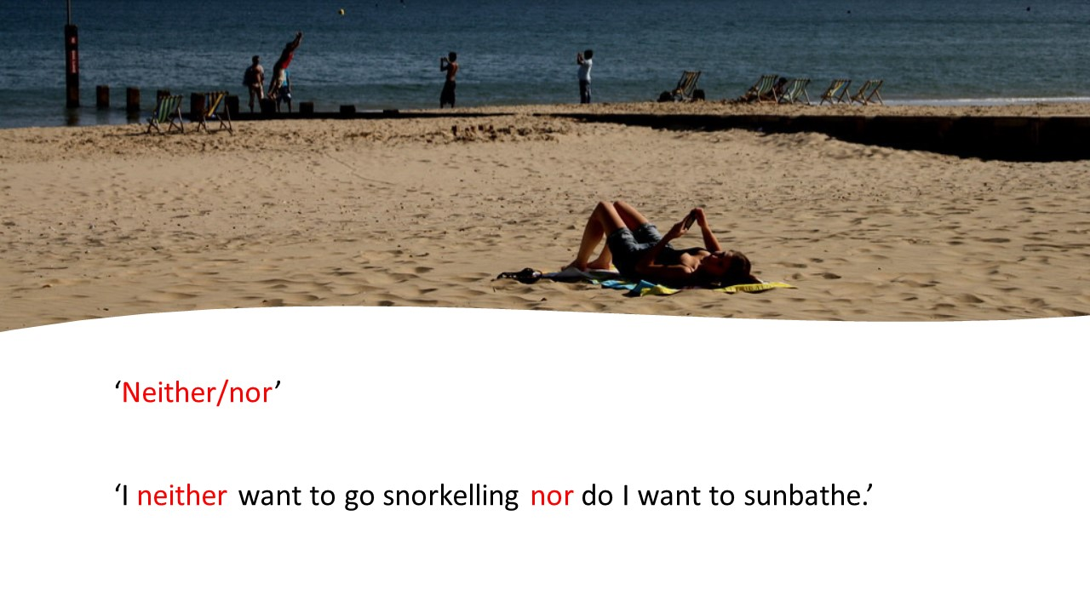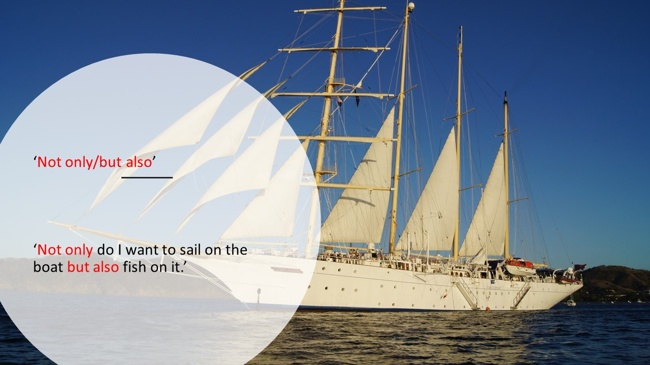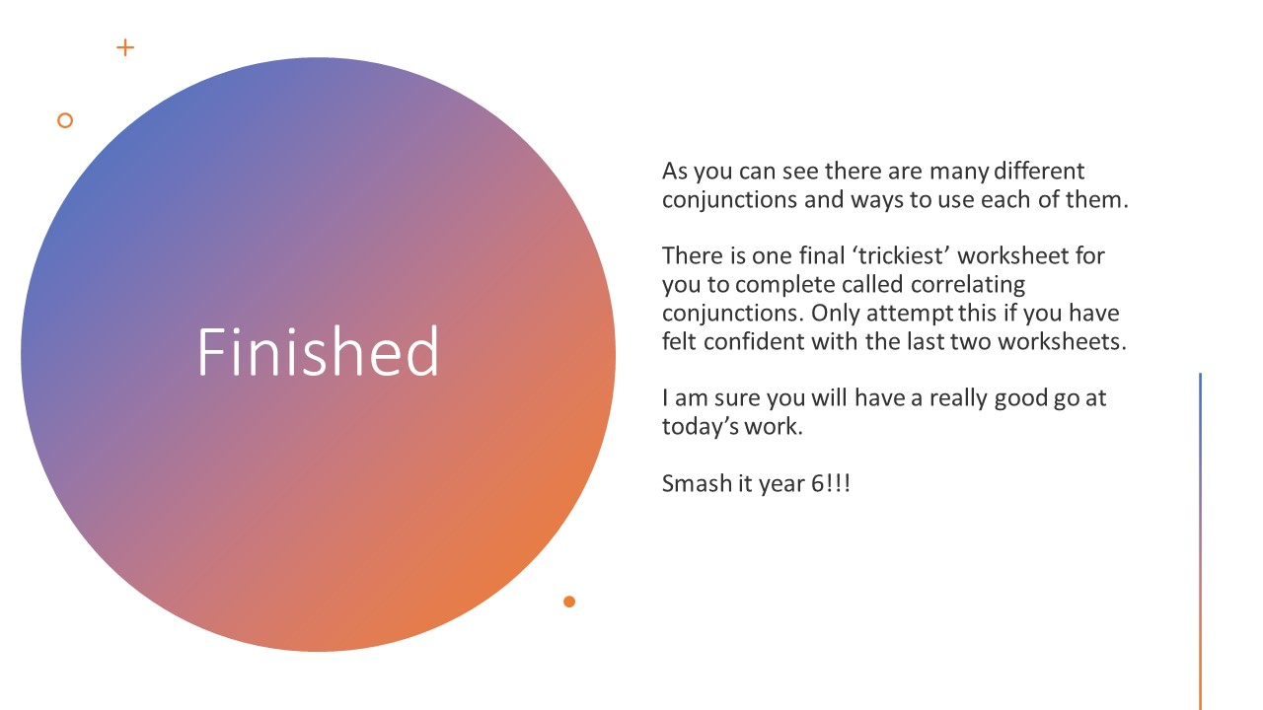
Appendix 2

Lesson Plan – BA3

Student-teacher | Ben Thomas | Class: | Year 6
AoLE/Subject | English | Date: | 24.2.21
Lesson Focus: | Produce poetic writing, using imagery and poetic devices, e.g. rhyme and form.
Relevant/meaningful links to:  Curriculum  &  Cross-curricular responsibilities | English  - Produce poetic writing, using imagery and poetic devices, e.g. rhyme and form.  - Use a range of strategies to plan writing.  - Use varied and appropriate vocabulary, including subject-specific words and phrases.  Personal and social education  - Express their views and ideas confidently through a range of appropriate methods.
Personal Targets  (Linked to QTS and identfied in weekly review) | Seeking advice and support  After discussions in the weekly review and from feeback this week, it has been decided that I need to ensure my lesson plans are of a much higher standard. My target here is that each lesson plan I create will be detailed enough so that another teacher could pick up my plan and teach it in exactly the same way with the intended learning outcomes.

Learning Objectives (Focus on Learning) | Produce poetic writing, using imagery and poetic devices, e.g. rhyme and form.
Success Criteria  (process/product) | In order to be successful children will:  - Watch and listen carefully to the pre recorded video presentation.  - Read the poem carefully themselves.  - Look up and identify the meaning of unfamiliar words.  - Be adventurous in their choice of vocabulary.  - Create a detailed plan of what they would like to include in their poem.

Key Resources Health & Safety | Internet  Children will need a stable connection to the internet to access the resources for the days lesson. This can be accessed on a PC/Laptop/I-pad/Tablet or even a phone. As long as children are able to see the work released for the day they will be able to interact with it.  Children will also need some external programmes for them to see allt he work that is set for them.  Microsoft word will be the main programme thatw ill be needed today. There have been previous issues with word and some of the work I have set so I will make sure that the work is either word friendly, or i ensure i release it in another format that the children have access to such as PDF.  Teams  As well as the internet children will need to be able to access teams either on the desktop site or the app. We currently know that all children have access to teams. This is where the videos/reseources will be released.  Resources  Presentation video – This will be the main bulk of the opening phase of the lesson. Children will be given a link on teams which will take them to the video. Children will watch the video through, In the video i will be explaining the lesson objectives as well as the success criteria in how they can be successful during the lesson. I will then move on to talk about the ‘magic box’ poem.  Magic box poem – This will be in 2 variations. One will be a talk through slide by slide version in the video. This is where i will talk about the vocabulary used and the way the imagery has helped with the choice of vocabualry. The second variation will be the complete poem for children to read through themselves and also to inspire them as they create their plan.  Plan templates – I will release variants of the templates to each group, they can choose to use them or to create their own but they will help give them guidance on what sort of things they can include in their ‘magic box’. These will be key questions such as ‘what smells can you put in the box’ ‘what sights can you put in the box’ etc.  Magic box video – I will also film myself taking a couple of onjects out of a physical box. I will explain that this box is a physical representation of what a ‘magic box’ is. I will explain that their box can be physical or imaginary and look like anything they want them to. In the box will be a few objects that I will pull out one by one. I will then discuss the object and how i could make this object sound even more magical with my choice of vocabulary.

Time | Content, Pedagogy & Assessment Opportunities (key teaching points and questions)
Links to Previous Learning | These are the areas that the children would have previously covered of the LNF over the last couple of years.  Literacy  - listen carefully to presentations using techniques to remember the main points, e.g. making notes, summarising.  - Use a wide range of written and dynamic stimuli, e.g. stories, picture books, images, poems, experiences, film, paintings, music.  I will also be looking for children to utilise previous skills learned that I have taught them. We haven’t long covered conjunctions, if children use any in their writing I expect them to be used correctly in the correct sentence structure and with the correct punctuation.
Opening Phase | The introduction video will be the first thing the children engage with. The first couple of slides on the video will show todays WALT and the success criteria for the days work. I will then give a brief definition of what poetry is. I will explain to the children that poetry covers a very wide range of writing and poems have many forms, rythyms and styles.  I will explain that many poems are written from the heart and covers a wide array of thoughts, feelings and ideas. (This section will take 2 mins approx)  I will then indroce the poem ‘The magic box’ I will have split the poem up into seperate slides with pictures, i think the pictures will help them visualise the vocabulary more that is used in the poem. The images will also help them in identifying their own ideas of what possible vocabulary may have been used. I will example more basic vocabulary in place of some words to show the children how better vocabulary makes the sentence sound more exciting. This will help them to understand how their own use of vocabulary effects their sentences as the audience reads. At the end of this presentation I will explain that in order to be successful in this lesson they will come up with a plan that will include various items as well as corresponding vocabulary that is varied and exciting to describe their items, i will show three different slides for tricky, trickier and trickiest and how each group can be successful in todays work (please see main teaching for more information). I will explain that there is a planning template and that they can use this if they would like to, or they can use it as a guide and create their own plan in a format of their choice. I.e, boxes like mine, poster, word document etc. (This section will take 6-8 mins approx)  The presentation will then cut to the ‘My magic box’ video. Here i will show the children a visual representation of what a magic box could be. I will explain that even though this is a physical box, their box can be any size, shape, material that they would like. This will help them use their imagination more. I will fill the box with a couple of every day items such as car keys, a wallet and a dream. I will take them out one by one and give a very plain description, at this point i will ask the children to pause the video and write down some vocabulary that they could use for my item to make it sound more magical and exciting, I willa dvise them that if they would like to upload the vocabulary that they came up with for my items then they can do as a bit of extra work (they can upload this with their own work for the day). I will continue by giving a couple of my own examples on how to make the items more exciting and alluring. I will finish the video by reinforcing how that by using better vocabulary my items sound much more magical and worthy of being in a magic box, it will be explained that this is how they can be successful int heir plans, by thinking of items and then coming up with a wide range of vocabulary that can go along with their item. (This video will be approximately 5mins)
Teaching & Core Learning | The children will be offered planning templates to use in the lesson. They can choose to use the templates i provide or they can make their own planning templates in whatever format they would like, this would have already been explained to them at the end of the video.  The guidance on the template will state that I am looking for variety in their vocabulary that relates to each item they have chosen to include. Each box on the template will have a different question to help inspire them in the variety of things they can include. They will see that items don’t need to be physical if they don’t want them to be. They can be anything their imagination can think up, as long as they have magical and interesting vocabulary to go with their items.  Tricky  These children will be advised to use the template with the 4 question boxes, (tricky template). They can choose to use this template specifically, or they can use it as a guide and create their own plan in their choice of format.  In order for the ‘tricky’work to be successful children will need to think of at least 15 items with at least 3 vocabulary words for each item. This will also be made explicit on the planning template worksheet. I will expect a good variet of vocabulary that also makes sense for each item. Children will not have to create sentences at this point.  Trickier  Children doing the trickier work will have the (trickier template) to use as guidance. This will have 6 question boxes so will provoke the children to think a little more about some of the items. Children can again use this template if they wish, or, they can decide to plan it int heir own way and just use the template questions as a guide.  In order for the children doing the ‘trickier’work to be successful I would expect them to come up with at least 20 items that could go in their box with 3 supporting vocabulary words for each.  The planning template will also include this guidance on how they can be successful in today’s work. Children will not have to create sentences at this point, they can however start to think about how they could turn their items and vocabulary into sentences.  Trickiest  The children here can use the ‘trickiest’ template as a guide, they would however be expected to create their own template in whatever way they would like (examples are mentioned above). In the success criteria at the end of the video it will be explained that children doing the trickiest work, to be successful will think of 20 items, 3 vocabulary words for each and come up with at least one full sentence for each. The sentence will be similar to that of what they have already seen in ‘The magic box’ poem, they should make sense and include magical and interesting vocabulary.  I will also challenge the children doing the trickiest work to try and create senetnces using alliteration and/or superlatives. These will be covered in the presentation briefly on what they are and how to use them.  Children will be able to create more sentences if they would like to, however only one sentence per item will be expected at this point.  Throughout the day I will post one or two questions in the team chat. Questions could include, can anyone tell me a magical item they would like to include in their box. Another question could be, can anyone give me one excellent bit of vocabulary and it’s meaning. This will help me to see if the children are on track and give me an idea at what type of work the children will be submitting later in the day.
Plenary | When children are finished with their work for the day they will upload it to the teams assignment page. Here I will be able to see who has submitted and have access to their work. I can provide feedback on the work they upload at this point directly to the student.  Towards the end of the day to get an idea of how the children felt the work went I could ask them on teams what they thought went well (WWW) in their work. I could even ask them if they think they could have improved in their work in some way, an even better if (EBI). Children will then post in the chat to respond to my questions if they feel comfortable to do so. I will then reply to each comment/suggestion with gratitude for giving their opinion.  Another option would be to post the success criteria in the chat and get the children thinking about whether they met the success criteria this day. Children can give a thumbs up on the comment if they feel they met the success criteria.  Design your box. As an extra task in the group chat I will ask them to think about what their box will look like, they dont have to repond in the chat but they can either draw and label their own box, or describe their box in written form using the video (the slide where it describes the box) as inspiration for their own box. This will then be kept for themselves and can be used as part of their own poem on day 2.

Lesson Plan – Phase 2
Evaluation of the Learning Experience
(include references to QTS)

Evaluation of Pupil Learning

Evidence of Learning (including attitude to learning over time) | After creating a tracking and assessment template I have been able to take information from Teams about who has completed the work and if they have met the learning objective.  After going through Teams and filling out the template it was evident that there were not many children who fully met the Learning objective, children did produce good work, however, the quantity of the work produced wasn’t sufficient against what I asked of the children.  The children were able to choose various items and come upw ith some exciting vocabulary that will help them as they progress into day two of their poetic writing.
Next Steps for Progress | Tomorrow we will look at taking the plans that the children have created today, and turning them into complete poems similar to that of the ‘magic box’.  Children will be challenged to turn their vocabulary into complete sentences and some will even be challenged to use alliteration and duperlatives in their work.  In order to ensure children are fully understanding of what is required it needs to be made explicitly clear what is expected of them in order for them to progress. As a result I will make sure to ask qestions on teams that will prompt them to think about the work and ensure that they uderstand what is expected of them.

Reflective Analysis of Teaching and Strategies for Development – including justification/rationale for pedagogical choices

Evidence of my Effective Practice | I think that making an assessment template is a good way to track progress with online learning. It helps me to see all of the childrens work from that day, who has sybmitted, met the LO as well as any additional comments I have made about their work. This helps me to assess the children as a whole as well as individually and am able to plan accordingly as the week progresses based on the work they have produced.  I am also happy that my lesson plans are now of a better standard and they are helping to inform me, giving me a better idea of the lesson as a whole, what i expect from the children as well as key questioning opportunities that i can utilise throughout the day on teams.
Areas for my Development  Personal Targets for Progress | In order to develop further i need to maintain my level of standards in my lesson plans. This will help me in ensuring that my lessons are as detailed as possible, making me aware of each step int he elarning progress and how i can address issues should they arise.  I will continue to use the tracking template, I need to make sure i fill it in each evening after the learning has taken place. This will help give me an overview of the learning in the class and help me to identify any issues that I can then address the following day to help children develop in their learning.

Appendix 3

Name | Work submitted Y/N | WALT Met?  Y-yes  N-no  P-Partly | Additional comments
Aisha | Y | P | Some good work submitted, however she didn’t fully meet the success criteria as she only submitted 3 items instead of 15.
Aliya | N
Bradley | N
Cai | N
Connor | N
Ellis | Y | P | Some lovely vocabulary used for the items he has submitted, however he didn’t fully meet the SC because he only submitted 3 items instead of the 15 minimum.
Enzo | N
Imogen | N
Jackson | N
Jacob A | N
Jacob W | Y | P | Partly met success criteria because he only thought up 3 items with vocabulary instead of 15.
Joshua | Y | P | Some nice vocabulary used, only submitted 5 items so only partly met SC.
Kacey-Leigh | N
Kayla | N | P | Has come up with a few items and some nice vocabulary, however, seems to have gotten confused with what was asked of her, only submitted 4/5 items, 3 of which were my own items from the video I made for them to help.
Kia | N
Lacey | N
Larisa | N
Levi | N
Mia | Y | P | Some beautiful vocabulary used, however, 8 items were submitted instead of the 15 asked.
Michelle | Y | Y | 15 items submitted each with 3 interesting bits of vocabulary. Lovely work.
Oscar | N
Scott | N
Segun | Y | P | Some lovely vocabulary, even submitted some good sentences using them. However, only 5 items submitted instead of the 20 asked to hot the success criteria.
Shay | N
Summer | N
Taliya-Jayne | N
Thomas | N
Victoria | Y | Y | Fantastic work. Beautiful vocabulary and some lovely sentences made from them.

Appendix 4
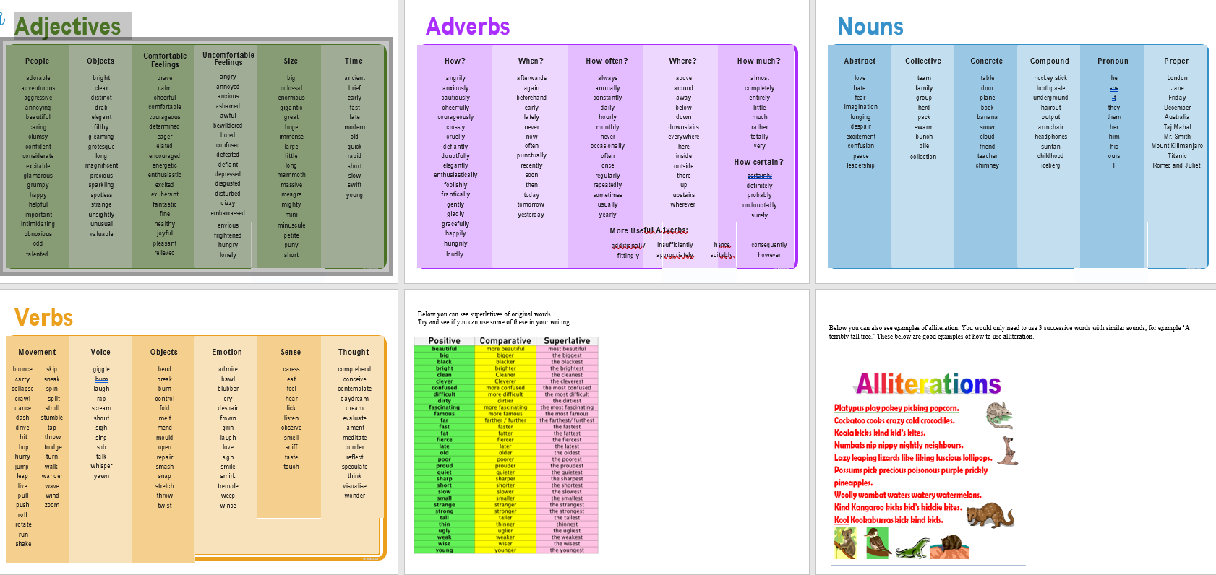

Appendix 5

Lesson Plan Phase 1

Lesson Plan – Step 1 Cynllun Gwers – Cam 1

Student-teacher | Ben Thomas | Class: | Year 6
AoLE or Subject | Welsh | Date: | 25/11/19
Lesson Focus: | Create a fact file on a friend.
Meaningful links to Curriculum | LNF:  - Welsh-medium statement: mutate correctly after prepositions and pronouns, becoming aware that not every letter follows the usual order.  - Speak clearly, using formal language, varying expression, tone and volume, to keep listeners interested.
Meaningful links to:  Cross Curricular Responsibilities | English:  - Respond to others with questions and comments.  - Reflect on, edit and redraft to improve their writing.
Personal Targets (Linked to QTS and identifed in weekly review)

Learning Objectives (focus on Learning- use accessible vocabulary):
The pupils will learn to:
- Confidently ask key questions, pronunciating correctly to gather information.
- Gather information by asking a variety of questions with good pronunciation.
- Use simple and key questions to gather information.
- Speak clearly, using formal language, varying expression, tone and volume.
- Respond to others with questions and comments.
- Follow up points in group discussions, showing agreement or disagreement giving reasons.

Success Criteria (clearly linked to each Learning Objective and related to the process and/or product of learning) | Assessment of Pupils’ Learning  Evidence  (What have the learners to say/write/do/produce – to demonstrate learning)
In order to be successful i will be able to create a fact file on my firend, i will be able to ask and answer questions in welsh, focusing on the correct pronunciation. | Create a factfile on their friend.  Use correct questioning and pronunciating when asking and answering questions.

Time | Activities/Methodology/Key Concepts  (Teacher’s Role – including key teaching points, differentiation strategies and key questions) | Pupil Tasks  (Pupils’ role –including differentiation, engagement in formative assessment and homework) | Resources  (Including Health and Safety requirement)
Opening phase (with links to prior learning) | To start off the teacher will put a mix of questions and answers on each table. The Group will then have to match to correct answer to each question.  Children will then feedback to the class to see what ones they got right or wrong.  The teacher will then use the random name generator for each child to pick their partner. (Children were allowed to choose their own partners)  The teacher will explain that with the factfile template they will ask questions and fill in the factfile about their friend. They must ask and answer the questions in Welsh. | Children will match the questions and answers correctly. They will then feedback to the rest of the class ont heir answers.  Children will then find out their partners that they will create a fact file on. | Incidental Welsh is to be used as much as possible throughout the lesson.  Name generator  Question and answer cards
Teaching & Core Learning | Green – Will have the full factfile with questions from the opening task on the table to help them.  Red – Will have the factfile but no help from the cards.  Blue – Will have the factfile and be expected to ask and eleborate more with the questions and answers.  The teacher will make sure children are asking and answering questions in Welsh.  All teachers/TA present will be on hand to help with this and offer help with the questions and answers.  As the lesson moves along the teacher will be creating a vocabulary list on the board to help the children create their factfile. | Children will create their factfile on their friend in their groups.  Children will make sure to ask and answer all questions in Welsh.  Children will be able to refer to the vocabulary list and build on it to help them with their work. | Vocabulary list  Fact file template  Dictionarys (Welsh)  Pens
Plenary | Some children will be asked if they would like to share the factfile they have created with the rest of the class.  The teacher will explain that next lesson we will be turning this into a paragraph in 3rd person. Ask if they know how to talk about someone in the 3rd person. | Children will share the work they have created with the class about their friend.  Children will discuss what they know about talking in the 3rd person and share what they know.

Lesson Plan – Phase 1
Evaluation of the Learning Experience
(include references to QTS)

Evaluation of Pupil Learning

Evidence of Learning (including attitude to learning over time)) | The children engaged well in a Welsh lesson that they havent previously been subjected to. The topic of 3rd person isnt easy but i was happy with the way the children were able to concentrate and engage with me during the introduction.  I think this is helped thanks to previously lessons where i know i have needed to engage the children more, so i am making it a priority to attempt to hook the children as soon as we start so they are fully engaged in the lesson ahead.  A couple of children were a little unsure throughout the lesson what was fully expected of them. I need to make sure that i am explicit in the learning objectives and i make sure the children understand the tasks they have to complete.
Next Steps for Progress | This is lesson 1 of 3 so next week the children will have the opportunity to develop this welsh lesson further. I will be making sure to recap and engage the children from the start and fully explain what the children have to do and ensure they understand before starting the lesson.

Reflective Analysis of Teaching and Strategies For Development – including justification/rationale for pedagogical choices

Evidence of my Effective Practice | It really helped that i revised myself before the lesson on 3rd person Welsh. It gave me more confidence to deliever the lesson adn i felt i was able to deliever it to a good standard.  I chose a task to start and spoke to the children in a way that was engaging for them, this helped to ensure they were involved and a part of the lesosn from the start.
Areas for my Development  Personal Targets for Progress | Subject knowledge is always an area that can be improved, i will always make sure that i am confident in the area i am teaching before the lesson, if extra revision is needed then that is what i will do.  When i am explaining lesson tasks and objectives i need to be sure that i am explicit and the children are fully aware of what is expected of them. If i do this then i think i will get less times in my career where children are a little unsure of what they need to do to complete the tasks.

Appendix 6
Paragraph Fy Ffrind
Dyma fy Ffrind Mr Thomas. Mae e’n tri deg oed. Mae e’n byw yn Saron, gyda Mam, Dad a Betsi y gath.
(This is my friend Mr Thomas. He is 30 years old. He lives in Saron with his mam, dad and cat Betsi.)
Mae Llygaid Brown a gwallt brown gyda e. Mae e’n uchder canolig (medium height). Mae breichiau blewog gyda Mr Thomas (Mr thomas has hairy arms).
Mae e’n hoffi chwarae pel droed achos mae’n ymarfer corf da ac yn hwyl.
He likes to play football because its good exercise and its fun.
Mae Mr Thomas ddim yn hoffi gwneud gwaith o am gylch y ty achos Mae Mr Thomas yn Ddiog.
(Mr thomas doesn’t like to do work around the house because Mr Thomas is lazy)
Mae Mr Thomas yn hoffi’r lliw Coch.
Mae Mr Thomas yn hoffi bwyta byrgyr a sglodion. Hefyd mae e’n hoffi bwyta cacen siocled ar gyfer pwdin.
Mr Thomas
Dyma fy Ffrind Mr Thomas. Mae e’n tri deg oed. Mae e’n byw yn Saron, gyda Mam, Dad a Betsi y gath. Mae Llygaid Brown a gwallt brown gyda e. Mae e’n uchder canolig. Mae breichiau blewog gyda Mr Thomas.
Mae e’n hoffi chwarae pel droed achos mae’n ymarfer corf da ac yn hwyl.
Mae Mr Thomas ddim yn hoffi gwneud gwaith o am gylch y ty achos Mae Mr Thomas yn Ddiog.
Mae Mr Thomas yn hoffi’r lliw Coch.
Mae Mr Thomas yn hoffi bwyta byrgyr a sglodion. Hefyd mae e’n hoffi bwyta cacen siocled ar gyfer pwdin.

