Reflective essay - visit to St.Fagans

Student number 2602707

October 15th 2026

1150 words

As we drove to St.Fagans from Carmarthen I thought little of the journey, a stretch of the
M4 that I have travelled many times before. However, after our classroom discussion I
reflected on my reflection and thought more about the journey – how distant some of
the buildings in St.Fagans are from their original home for example, sitting in parkland
that doesn’t reflect their original location which may have been industrial or very rural.
I’d been looking at a book by Bonnett( 2026) “New Ruins – The Story of the World in
Twenty-One Abandoned and Collapsing Places” and thought about how St.Fagans
might look if it were abandoned and untended for 100 years. I also thought about
Port Talbot steel works and how that might be mothballed; and what if no road repairs
were carried out on the M4, what would my journey be like then, travelling from one
abandoned place to another?
Back to the present: According to the Cardiffians
https://www.cardiffians.co.uk/suburbs/stfagans.shtml# St.Fagans is a
historic village and open air museum chronicling Welsh life and culture, with roots going
back to ancient Roman and early Christian times. Originally the Welsh Folk Museum,
the castle and lands were given to the nation in 1946 by the Earl of Plymouth and
opened as an open air museum in 1948. Inspired by Skansen in Sweden the museum
was visualised by Iorwerth Peate as a place to preserve and showcase everyday lives of
ordinary Welsh people https://museum.wales.stfagans-history/ Housing more than fifty
historic buildings it is one of Wales’s most popular visitor attractions. In 2018 a thirty
million pound redevelopment created new galleries and modern visitor facilities and in
2019 St Fagans was awarded the Uk Art Fund’s Museum of the Year.
The museum itself however is not unproblematic, and may be seen to show a
somewhat sanitised and romanticised version of the past that does not address the
harshness and poverty of some people’s lives. This can be seen perhaps in the children
dressed in Victorian clothes whilst still experiencing contemporary comforts and
conveniences – shoes that aren’t overly worn, flushing toilets, heating and lighting, and
a café serving hot food.

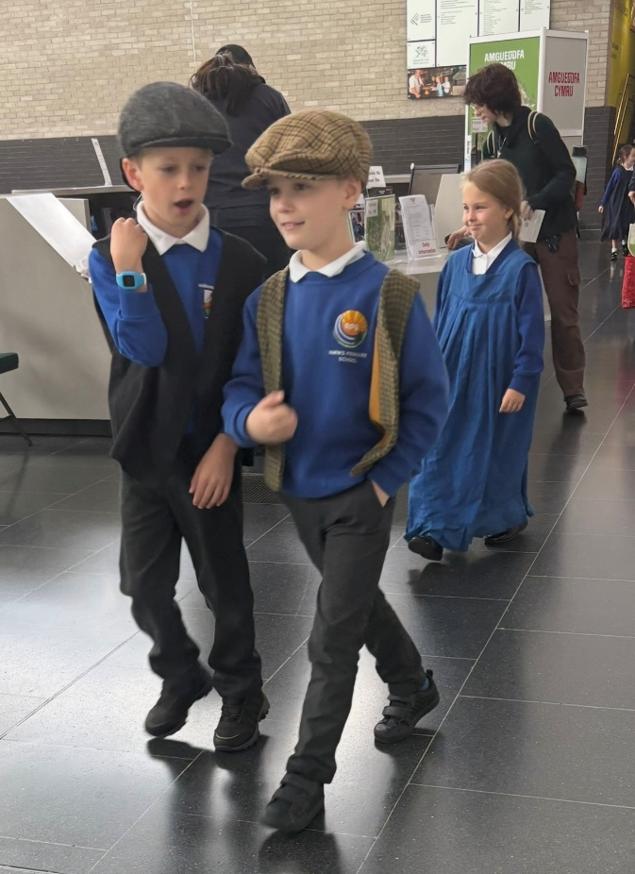
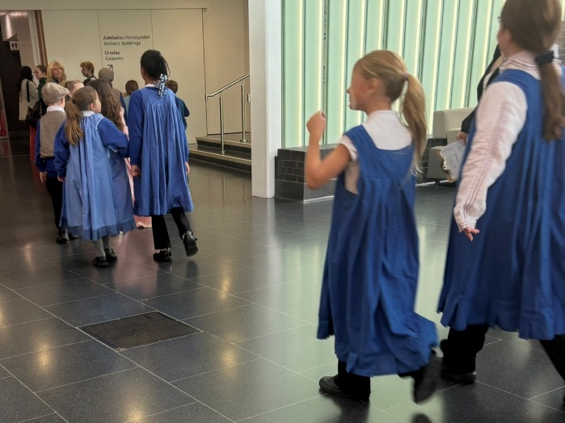
Photo - author’s own
Iorwerth Peate (1901-1982), the founder of the Museum, does not come across as a
progressive thinker - a legacy which is reflected in the museum’s presentation today.
For example, he did not want the word ethnology replacing folk lore.
He had become interested in folk studies and anthropology when studying colonial
history, writing his 1924 MA dissertation on the dialect and folklore of the people of the
Dyfi valley. A pacifist and conscientious objector Peate declined an OBE in 1963.
Walking around the site with its pristine dwellings and manicured grassland anything
that is contentious or difficult is underplayed (such as slavery) and instead the
viewer is presented with sweet shops, a grocery store and a bakery that may be seen as
a pastiche.
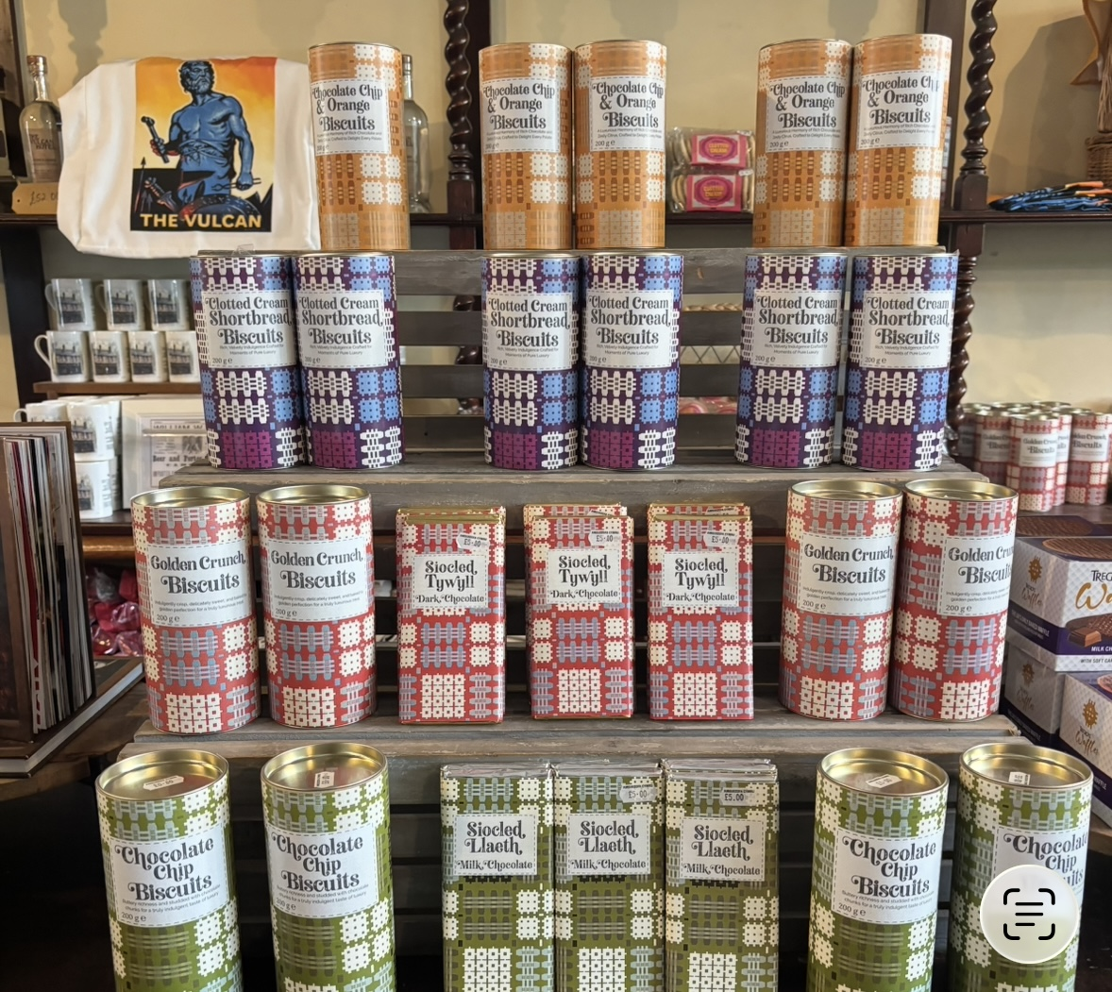
This is not a snapshot of Wales that reflects Welsh identities but rather a
performance created to appeal to the visitor from outside of Wales. It presents a
chocolate box image that plays with nostalgia and memory by using costumes to
give a feeling of situation in history whilst ignoring the industrial revolution, seaside
communities, mining, and railways and canals. There are different ways of being
Welsh of course but it is worthwhile to consider what it is that we are actually
encountering. Photos – author’s own
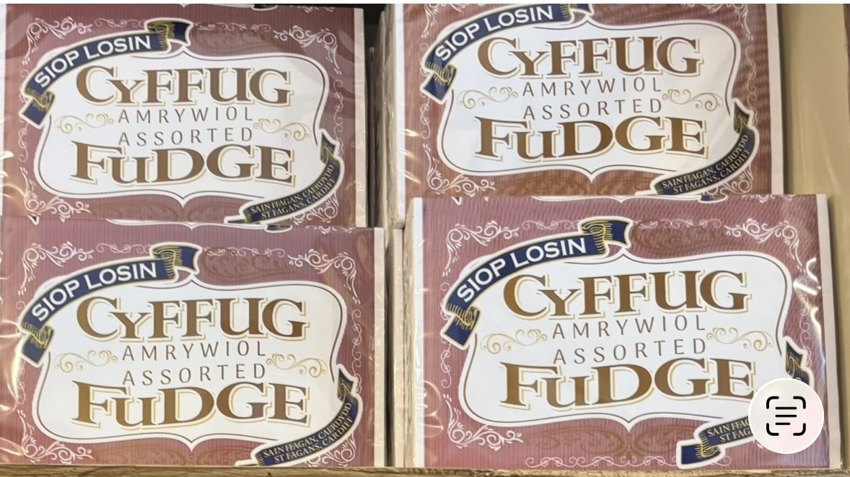
The presentation of identity issues is limited at St.Fagans although one of the galleries
makes attempts to address this by showing a black family in Welsh costume for
example. I felt uncomfortable encountering this, it felt like it was trying too hard to show
people “fitting in” in an artificial way: why not celebrate the cultural differences of those
people and how learning from them might enrich our experience?

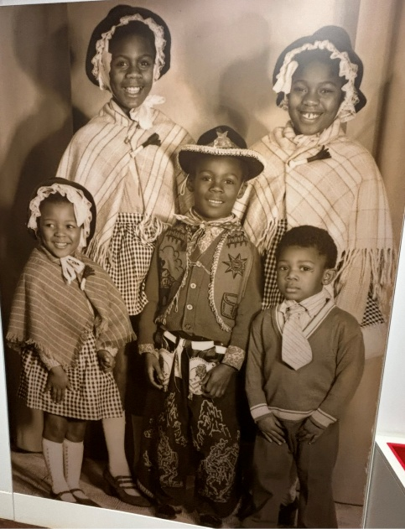
It was a drizzly day so I did not venture to the further reaches of the site but loitered in
the gift shop awhile, considering how many plastic items were for sale which seemed
unnecessary and not the product of a forward thinking project attempting to reduce our
impact on the planet and address climate change. The shop sold some Welsh food
products but these were expensive and in some cases over packaged. This café had
very limited plant based food which would be an area that could be improved. In a
similar vein I was reminded that our children had won a “recycler of the year” award
from the museum some years back, their photos had featured adding urine to a
compost heap (which I think it was what clinched it) but their prize had been a
plastic games console.
What are museums for though, and what ought their future be? On one hand they can
be seen as preserving, educating, inspiring and caring for history (albeit a selected
presentation of) A day at a museum may lead to an interest in following up what is
presented to us. On the other hand it can be argued that museums play an active role in
the broader concerns in our lives. Indeed, in recent years there has been a shift in focus
towards this for example by addressing slavery and colonial history.
Sleigh (2024) notes that the contemporary museum is a cultural battleground -who
decides what to display, what not to display and how to present items. Sleigh believes
that the museum is for everyone and that inclusion must be central to what museums
do. Can we support communities more impactfully, and more directly? Can we make
our displays with communities rather than for them? Can we address practical
solutions to pressing social and environmental concerns?
St.Fagans may not be an obvious contender for an activist museum but I want to look
lastly at an item of interest to me in The Vulcan Pub, the spittoon, and consider the
health messages that can be drawn from that item.
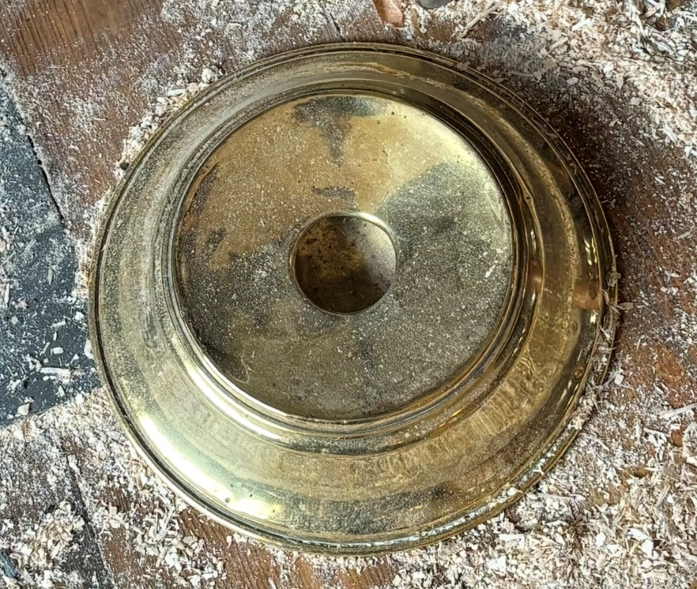
By 1859 spitting was seen as disgusting. Spittoons were used openly in the 19th century
to provide an acceptable outlet for spitters. The flu epidemic of 1918 led to spittoons
being less common and their use virtually disappeared. In the first half of the 20th
century there were campaigns against spitting to reduce the chances of contracting
tuberculosis.
For some people though spitting is a protection against evil, with North Indian mothers
lightly spitting to the side of their child to protect them from the evil eye, with spitting
signifying disparagement and imperfection: extreme admiration even from well meaning
people might attract the evil eye. Over time, hygiene practices have changed and
consequently kohl is used on the forehead instead. There is scope here for a further
piece of work on spitting reflecting my interest in medical anthropology. Meanwhile
reflecting on my visit to St.Fagans has lead to thinking differently about the site, its
limitations and future potential.
Bonnett, A (2026) New Ruins – The Story of the World in Twenty One Abandoned and
Collapsing Places Ivy Press
Sleigh, J (2024) What are Museums For Bristol University Press

