Student name: Shahida Parbin
Student ID number: 1814474
Programme: BSc Health and Social Care
Module: Changemakers: Creativity and Value Creation
Module code: BMHP5014_BIRM Contribution to
Lecturer: Dr Azora Hurd

Table of Contents
Task 1 3
Task 2 6
References: 9

Task 1
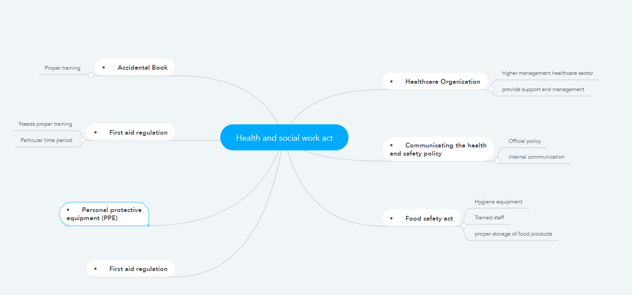
Health and Social work act
Personal protective equipment (PPE)
- The employees should wear plastic aprons and latex gloves for personal care. Then dispose of it after each service user.
- The workers of the health care organization should take proper measure to prevent workplace illnesses and injuries.
Food safety act
- Personal hygiene equipment’s that is hair should be tied back.
- Staffs working in the health sector should be qualified and trained
- Proper storage of records and food are kept to trace back if suddenly its outbreaks.
First aid regulation
- Every staff should be kept updated by the healthcare organizational sector. And there must be a re-do of every gap of 2 years.
- The staffs working in the organization must sterilize themselves after every specific time period.
- There must be an adequate ratio for the trained first aid worker to use in their service of healthcare organizational site.
Accidental Book
- The staffs should be trained on proper completion.
- There should be an appropriate record book of the patients, that must be kept confidential.
- Every minor or major accidental case should be kept on record.
Communicating the health and safety policy
- The healthcare organization should display their policy statements of intend on their official notice boards
- The inspectors of the organization should explain their official policy content during their recruitment or induction of training courses.
- The policy of the organizational sector is referred to according to their internal communication.
Healthcare Organization
- There are some important role and responsibilities that are performed by the functional management.
- The healthcare organization should identify their competent to provide support, advise and monitoring.
- The employees as well as the higher management healthcare sector should learn how to deal with emergencies.
- The healthcare organizational sector should perform their own responsibilities and duties with full dedication.

Task 2
The workers working in a healthcare organization should take proper health and social care. They should maintain their hygiene and sanitization while working in a healthcare organization. There are some suitable equipment’s to wear like latex gloves and plastic aprons for their personal health care. And each kit must be disposed of after every service use. The workers working in the healthcare sector should sterilize and keep themselves clean so that they can prevent viruses that can cause illness and weakness. The workers working in the healthcare sector especially the women should maintain their personal hygiene by the time their hair back. This personal care includes distributing or donating personal hygiene kits and beauty products such as tissues, shaving razors, cotton pads and many more among the underprivileged community (Bozeman, 2020).
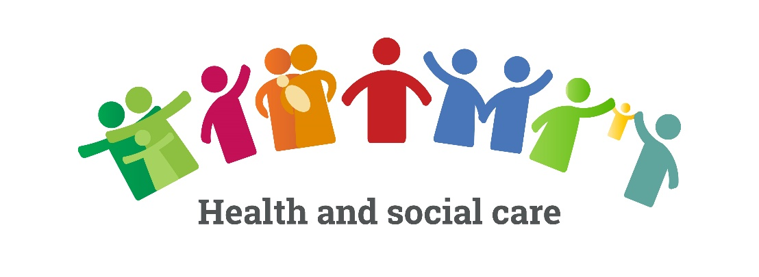
Fig: Health and Social Care
Source:(Bozeman, 2020)
The organisational sector should update their staff and even redo their process after every 2 years. The workers working in the healthcare sector should be trained properly so that no unexpected hazard takes place. The personal records of the patient as well as their employees should be kept confidential so that no outbreaks occur. Every major, as well as minor cases, should be kept on record so that no further issues or problems occur in the organisation. The healthcare organisation needs to display their health and safety policies on their official notice boards. The higher authority of the healthcare organisation should explain its policy content during the recruitment process of training courses. There should be good communication in the environment in the workplace of the healthcare organisation. There are some essential responsibilities and roles of their higher management authority to take proper hygiene for the workplace (Kunz et al., 2020).

Fig: Effectiveness of Health Care
Source: (Kunz et al., 2020)
So that no employees or workers suffers from diseases and fall sick and illness. Safety is as important to run a successful organizational sector as inventory service, financial planning and customer service. The records should include all inspections, training activities, first aid treatments and incident investigations (Cherry, 2020). The healthcare sector should identify several competent that provides advice, support and monitoring. The higher management authority and their employees of the healthcare sector should know how to deal with unexpected emergencies. The healthcare sector needs to perform their own duties and responsibility about maintaining proper hygiene level in the organisation. The health and social sector emphasize the value of committed and trained workforce, the higher management authority and their employees of the healthcare sector should know how to deal with unexpected emergencies (Nieuwenhuizen, 2020). The healthcare sector needs to perform their own duties and responsibility about maintaining proper hygiene level in the organisation. The health and social care emphasize the value of committed and trained workforce without that we cannot able to apply the support and care to the people need. The purpose of health and social protect their workers, customers, members and subcontractors of the public that involves in their business. the healthcare organisation should provide proper training that is necessary for the employees specially to reduce the risk factor that can occur potential injury or illness that is associated with the job (King et al., 2020). There should be proper supervision on employees to ensure that they are applying their training for performing their job safely and properly.

Fig: Importance of Health Care
Source: (Odari, 2020)
Heath care mainly focuses on providing and implementing medical care to the communities and individuals. As healthcare socially deals with treatment and diagnosis of both mental and physical disabilities. This has always been perceived as the greatest necessities for society. Whereas it strives to minimize social inequality whenever it accesses healthcare (Odari, 2020). Therefore, social care also deals with certain daily activities or performances of living which does not only includes deed like feeding as well as maintaining the basic hygiene. It also involves the maintenance of a person's independence, protection from the vulnerable causes and promoting social interaction and also coping the complex relationship. The social care is commonly funded by the organizational social service and focusing the children’s, adults, philanthropists and the elderly at risk from suffering from poverty, poverty and disability. There are certain campaigns and social organizations, even the governmental sectors also provide funds to promote and donate personal hygiene goods to make a clean society place.

References:
Bozeman, K., 2020. 4-H Tech Changemakers Project: Empowering Teens & Serving Rural Communities.
Cherry, L.R., 2020. Changemakers of Color: A Model for Racial Equity in the Nonprofit Sector (Doctoral dissertation, University of Southern California).
King, F., Feeney, M., Corrigan, T., Flynn, P., Furlong, C., Lodge, A., Ní Ghairbhith, L., Tiernan, P. and White, J., 2020. Beyond what works: what matters in Irish Changemaker schools.
Knott, T., Patini, C., N’guessan, J., Holmes, W. and Ollard, J., 2020. Classroom Changemakers.
Kunz, K., Hall, M. and Lella, R., 2020. Literacy Changemakers: Bringing the Joy of Reading and Writing Into Focus for Teachers and Students. Guilford Publications.
Nieuwenhuizen, C., 2020, September. Innovation and Social Value Creation of Female Social Entrepreneurs in Africa. In ECIE 2020 16th European Conference on Innovation and Entrepreneurship (p. 419). Academic Conferences limited.
Odari, M.H., 2020. The Role of Value Creating Education and Ubuntu Philosophy in Fostering Humanism in Kenya. Soka Approaches in Education Vol 9 No SI (2020).

