HEALTH ASSESSMENT REPORT

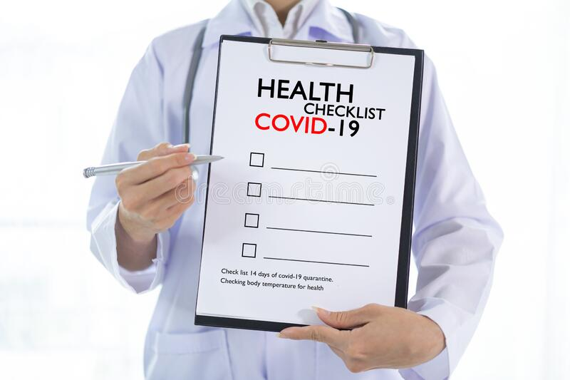
(Dreamstime, 2022)

Student Name: NOREEN AKHTAR
Student Number: 2016543
Module Code: BMHP5003
Module: INTRODUCTION TO PHYSIOLOGY
Lecturer: MUHAMMAD HUMZA SAEED

CONTENTS

Introduction 3
Case Report 4
Assessment Report 5-7
Care Plan 8-12
Recommendation 12
Conclusion 13
References 14-15
Lifestyle Questionnaire 16-17

INTRODUCTION

I have approached an anonymous person and have done a questionnaire about her health and asked her questions to help me throughout this assignment. I have named her Rose Smith. She has been diagnosed with long Covid. Long Covid has taken its toll on her and she has not been herself since then. For the purpose of this report the focus has been the effects on the respiratory system.
In this report I will produce a case report from the initial information Rose has told me. She was chosen as a candidate on the basis of the health based Lifestyle Questionnaire. The Lifestyle Questionnaire is made up of various questions based on the current lifestyle including basic health monitoring questions i.e. family history of medical conditions.
An assessment will include speaking with Rose, completing medical review and acknowledging any medical reports that Rose will forth. With the information I will gain from her and the health service websites l will be able to assess her health and create a care plan to help support her and her medical needs.

CASE REPORT

Rose Smith is 40. She is married with three young children and living with a good quality of life. She was working fulltime. She had a healthy life style. She has never smoked and drank alcohol in her life. Her dietary includes daily fruits and vegetables, and would go for regular walks to keep fit.
Then Rose contracted Corona-virus first time in July 2020 which she was not feeling herself and had to take days off work. Since then she tried and rebuild herself again by not pushing herself and taking each day as it comes. She was getting breathless more often that restricted her from going on long walks. Then the second time in January 2022 she contracted Covid again. This time she was really weak and not feeling to be herself. She had to take leave from work because of her symptoms where not getting better. Post Covid she was initially treated for has developed breathing issues and commenced on inhalers with a working diagnosis of long Covid and acid reflux. Over time she has started to develop more symptoms and diagnosis.
Rose describes a cough which is worse at night, her chest pain may be linked to reflux/GORD as she describes stabbing central chest pain during or after eating. She is monitoring her pulse rate and this ranges between 75-90bpm, there has been no loss of consciousness, but she does describe feeling faint at time. Rose describes a family history of cardiovascular disease and has elevated Cholesterol and Obesity. Fatigue is quite a debilitating symptom for Rose, who has chronic fatigue and does not feel refreshed after a night sleep. She has no witnessed apnoea’s but wakes often with coughing. She is taking her Proton pump inhibitors (PPI) regularly. Rose describes that food can get stuck and she has modified her diet to avoid eating foods which are difficult to swallow such as meats. Rose describes her appetite as poor and has lost her sense of smell. She has gained weight and reports bloating, abdominal pain, and nausea after eating. She gets muscle cramps and tremors and complains of daily headaches with migraines. Rose also, mentioned she has some depression and anxiety, she is not feeling suicidal but is struggling with day-to-day activities, reduced mobility and struggling to care for her children.

ASSESSMENT REPORT
A normal functioning respiratory system is when whenever somebody breathes in, air into the lungs and goes to the organs. Carbon dioxide is released into the air when they breaths out. A proper respiratory rate is essential for maintaining the levels of oxygen and carbon dioxide in the body (Rowden, 2021). Lungs are the most important function of the respiratory system. Lungs are components of a respiratory system, which is a collection of organs and tissues than work together to allow people to breathe. The primary function of the respiratory system is to deliver new oxygen into your body while eliminating waste gases (Association, 2022).
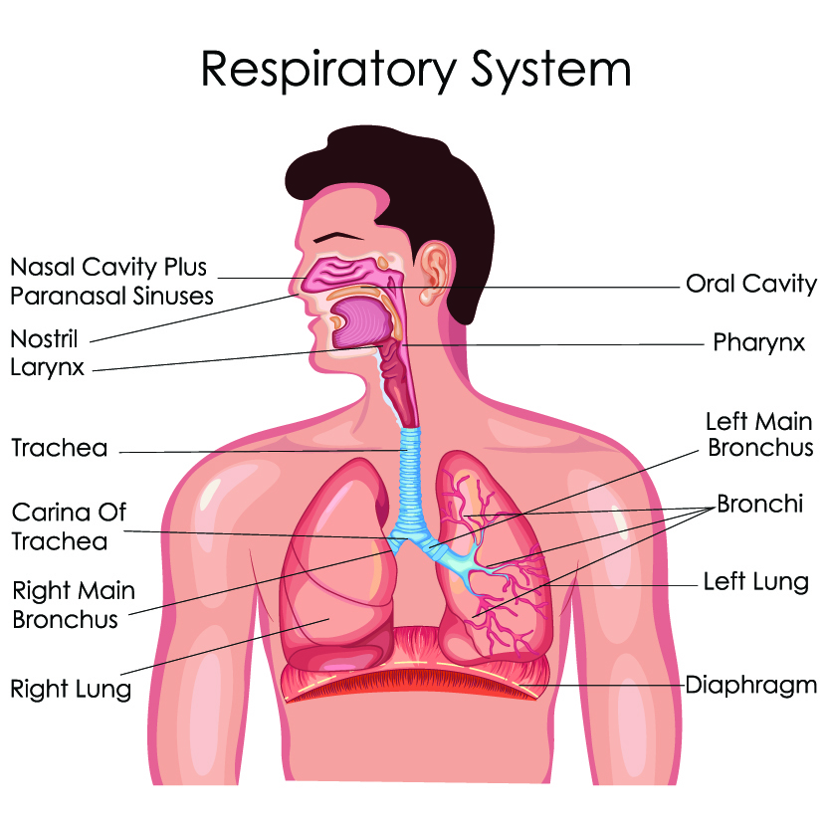 (Paralysis and conditions, 2022)
- Mouth and nose: Openings that allow air to enter the respiratory system from outside the body.
- Sinuses: Empty spaces between your skull bones that assist control the temperature and humidity of the surrounding air you breathe.
- Pharynx (throat): The channel that transports air through the mouth and nose to ones trachea (windpipe).
- Trachea: A passageway between your throat and lungs.
- Bronchial tubes: Tubes connect to the lungs at the bottom of your windpipe.
- Lungs: Two organs that collect oxygen from the air then transport it to the bloodstream.
(Clinic, 2022)

An abnormal function to a respiratory illnesses or lung diseases could be asthma, emphysema, lung cancer, pulmonary hypertension, and TB. If left untreated, could lead to health issues, troubling symptoms, and even death (org, 2022). COVID-19 can impact the respiratory system in a number of ways as well as at severe, according on the individual's immune system, age, other illnesses. Symptoms can vary from minor to severe, including coughing, difficulty breathing, and chest infections, as well as respiratory failure and multi-organ system failure (Radchenko, 2020).
Another illness for the respiratory system is long Covid. Long Covid infection can develop symptoms that continue for weeks or even months in some individuals.

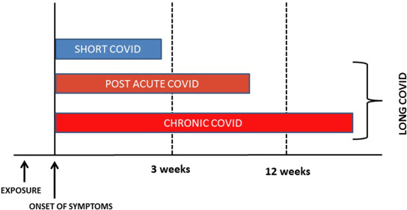 (Raveendran et al 2021)
Symptoms of long COVID
- There are lots of symptoms you can have after a COVID-19 infection.
- Common long COVID symptoms include:
- extreme tiredness (fatigue)
- shortness of breath
- chest pain or tightness
- problems with memory and concentration ("brain fog")
- difficulty sleeping (insomnia)
- heart palpitations
- dizziness
- pins and needles
- joint pain
- depression and anxiety
- tinnitus, earaches
- feeling sick, diarrhoea, stomach aches, loss of appetite
- a high temperature, cough, headaches, sore throat, changes to sense of smell or taste
- rashes
(NHS, 2022)

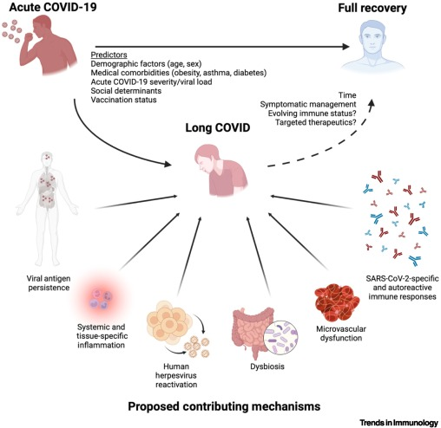
(Peluso and Deeks, 2022)
Your entire body may be affected by long COVID, so you may suffer a variety of symptoms all together or over the course of time. Some individuals may experience longer-term issues from dealing also with after effects on the respiratory system. You could discover that you need to release air from your lungs frequently. Mucus can be produced by a wet cough that is possible Asthma + Lung UK. (2022).

CARE PLAN

SOCIAL & EMOTIONAL CARE PLAN
The 3 Ps (plan, pace, and prioritize) are some recommendations to assist you handle everyday responsibilities more effectively while living with COVID:

- Plan – Make a list of your every day or week chores.
Consider the chores you perform on a daily or weekly basis. Determine which jobs must be completed and which are the most challenging for you. Distribute these duties throughout the week and schedule breaks between them. This can be your daily schedule. Ensure your plan contains both things you want to accomplish and things you have to do.
- Pace – Please take your time.
Be patient and don't think you have to complete everything at once and around the same pace you did in the past. Try not to exceed your limits do stop and relax before you take on too much and exhaust yourself. Divide jobs into smaller ones and space them out all day, something you might have to perform in a single day or across several days. Take frequent intervals to conserve energy for the following job.
- Prioritise – Determine which duties are most essential to you.
You do certain everyday duties, such as showering and clothing yourself. Other duties, such as hearing music or cooking, you do that you like them. Doing things you like will make you feel better and increase your feeling of well-being. Attempt to balance necessary responsibilities with enjoyable activities. Consider the chores you need and want to complete, and prioritize them over duties you believe you should complete.
(Covid, 2022)

MEDICAL & HEALTH CARE PLAN

It is important to carefully follow all medical advice. All Hospital and other medical professional appointments should be attended and regulated. Constant monitoring by way of tests and examinations will help the professionals to monitor progress and change plan of treatment to suite the condition as it stands at the time of consultation. This will also enable changes to be monitored and side effects to be caught early.
Tests required for maintenance:
• Oxygen saturation at rest and post exertion if safe to do so using the one-minute sit to stand test
• CXR
• ECG
• BNP
Importance of regular monitoring:
• ≥3% drop in oxygen saturation post exertion is significant and warrants acute review
• Note the risk of thrombosis and VTE is increased in patients with acute COVID-19. Patients discharged following a medical admission for sepsis or pneumonia, or requiring ICU admission are at increased risk of VTE for up to 6 weeks.
• Anyone with on-going respiratory symptoms 12 weeks after acute COVID-19 should have a CXR. Be aware that a CXR may not be sufficient to rule out lung disease- HRCT or CTPA may be indicated- consider A&G
(NHS, 2019)

ADDITIONAL INFORMATION

It's possible that you're ill or confined to your house. You should continue to incorporate regular exercise into your regimen. It's crucial to keep moving and stay out of bed for extended periods of time. You could heal both physically and psychologically more rapidly as a result. The exercises listed below can be performed in a chair, at your residence, or at a medical facility.
These are some simple exercise you could do anywhere:

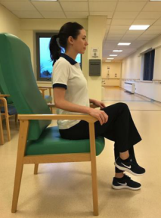
- Seated march
Sit tall
Lift your knee
Return to the floor
Repeat 20 times on each leg

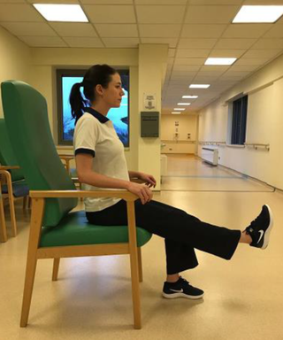
- Seated leg lift
Seated leg lift
Sit tall
Lift your foot to straighten your leg
Hold for 3 seconds
Return to the floor
Repeat 10 times on each leg

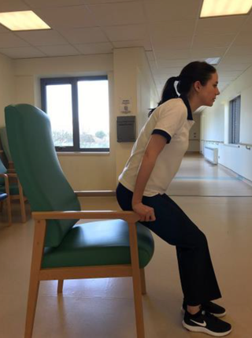
- Sit to stand

Place hands on armrests
Push to standing
Return to the seat with control
Repeat 10 times

- Rowing arms
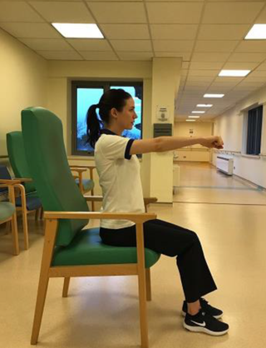
Rowing arms
Sit tall
Hold arms at shoulders
Push arms out in front

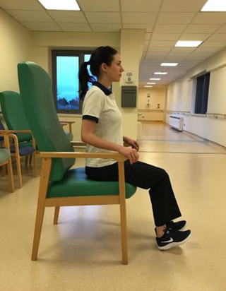
- Toe lifts
Sit tall
Keep heels on the floor
Return to start
Repeat 20 times

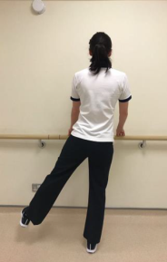
- Side legs
Side legs
Stand tall holding the bar
Lift your leg to the side
Keep your leg straight
Repeat 15 times on each leg

(HSE, 2022)

Below is an exercise which can help with breathing rehabilitation when needed or feel you are struggling to breathe:

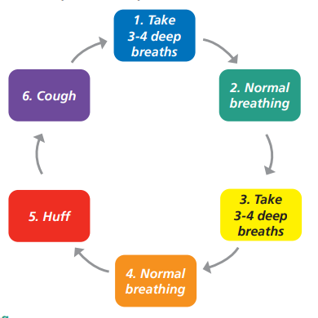 (TRUST, 2021)

RECOMMENDATION

In order to achieve the good possible individual health outcomes, recommendations are statements that are intended to assist us in making decisions about the best way to carry out specific actions, such as treatment strategies, medical tests, or medical health measures to help ourselves. (WHO, 2022). Rose needs to give importance to herself and prioritize herself and allow time to recover at a pace that suits her.

CONCLUSION

Lungs and in total the respiratory system is one on the important part of the main organs in a body. Healthy set of lungs help circulate the oxygen around the body keeping all the other organs working well. When there is an issue that directly affects the lungs and oxygen is not able to circulate properly then this starts to slowly affect the other organs which then make the body unable to function well and lead to many health conditions.
In cases such as Rose’s case, lung damage is the outcome of serious lung injury caused by the coronavirus's and its inflammatory response. Because of the lung injury, the lungs stiffen, making breathing difficult for such people. These individuals will need pulmonary rehabilitation to alleviate their shortness of breath and enhance their overall standard of living.
To save oneself from illnesses and infections, they must shield themselves from pollution, limit contaminated areas, and resist being in busy or poorly ventilated areas. They should consume nutritious foods rich in vitamins A, C, and E, so they can improve their defenses and assist their respiratory system battle illnesses. It is critical to have house plants since they may enhance the clean air in their homes by eliminating toxic vapors that can damage their respiratory system.

REFERENCES

Association, A., (2022). How Lungs Work. [online] Lung.org. Available at: <https://www.lung.org/lung-health-diseases/how-lungs-work> [Accessed 29 July 2022]. Asthma + Lung UK. (2022).
Managing lung problems - British Lung Foundation. [online] Available at: <https://www.blf.org.uk/support-for-you/long-covid/breathlessness-support/managing-lung-problems#lungdamage> [Accessed 29 July 2022].
Clinic, C., (2022). Respiratory System: Functions, Facts, Organs & Anatomy. [online] Cleveland Clinic. Available at: <https://my.clevelandclinic.org/health/articles/21205-respiratory-system> [Accessed 25 July 2022].
Covid, N., (2022). [online] Available at: <https://www.yourcovidrecovery.nhs.uk/i-think-i-have-long-covid/your-road-to-recovery/eating-well/> [Accessed 26 July 2022].
Dreamstime, (2022). [online] Available at: <https://www.dreamstime.com/photos-images/medical-check-list.html> [Accessed 26 July 2022].
(HSE, 2022). Exercise while recovering from COVID-19. [online] HSE.ie. Available at: <https://www2.hse.ie/conditions/covid19/symptoms/exercise/> [Accessed 26 July 2022].
NHS,(2019). [online] Clinical-pathways.org.uk. Available at: <https://clinical-pathways.org.uk/sites/default/files/long-covid-investigations-document.pdf> [Accessed 26 July 2022].
NHS, (2022). Long-term effects of coronavirus (long COVID). [online] nhs.uk. Available at: <https://www.nhs.uk/conditions/coronavirus-covid-19/long-term-effects-of-coronavirus-long-covid/> [Accessed 25 July 2022].
ORG, u., (2022). Respiratory Disorders | Condition | UT Southwestern Medical Center. [online] Utswmed.org. Available at: <https://utswmed.org/conditions-treatments/respiratory-disorders/> [Accessed 29 July 2022].
Paralysis, L. and conditions, S., (2022). Respiratory health. [online] Reeve Foundation. Available at: <https://www.christopherreeve.org/living-with-paralysis/health/secondary-conditions/respiratory-health> [Accessed 25 July 2022].
Peluso, M. and Deeks, S., (2022). Early clues regarding the pathogenesis of long-COVID. [online] Cell.com. Available at: <https://www.cell.com/action/showPdf?pii=S1471-4906%2822%2900047-3> [Accessed 29 July 2022].
Radchenko, C., (2020). Short & Long-term Effects of COVID-19 on the Lungs. [online] Uchealth.com. Available at: <https://www.uchealth.com/en/media-room/covid-19/short-and-long-term-lung-damage-from-covid-19> [Accessed 25 July 2022].
Raveendran, A.V., Jayadevan, R. and Sashidharan, S., (2021). Long COVID: an overview. Diabetes & Metabolic Syndrome: Clinical Research & Reviews, 15(3), pp.869-875.
Rowden, A., (2021). Normal respiration rate: For adults and all ages, and how to measure. [online] Medicalnewstoday.com. Available at: <https://www.medicalnewstoday.com/articles/324409> [Accessed 29 July 2022].
TRUST, N., (2021). [online] Hct.nhs.uk. Available at: <https://www.hct.nhs.uk/media/4529/long-covid-rehabilitation-booklet-july-2021.pdf> [Accessed 26 July 2022].
WHO, (2022). WHO Guidelines. [online] Who.int. Available at: <https://www.who.int/publications/who-guidelines> [Accessed 26 July 2022].



