UNDERSTANDING AND ENGAGING IN CUSTOMER EXPERIENCE

Executive summary
Customer experience engagement is basically a strategy for a business to grow with interaction between the customer and organization. In this context, this report has evaluated the customer experience with the assessment of ethical and sustainability and CRM policies and practices in ASDA. It has also discussed various models and theories of quality management as Juran and Deming models that help in the improvement of quality of products in the concerned company. Here, the quality management system of ASDA and its competitor Morrison have also been critically analyzed and the impact of management of quality on the CRM of the organization has also been evaluated. Lastly, it focused on the implications of sustainability and ethical policies as well as impact of such policies on the customer relationship management of the ASDA have also discussed in this report.
Table of Contents
Introduction 4
Task 1 4
1. Ethical Policies 4
Sustainability Policies 5
3. CRM 6
Task 2 7
Literature review 7
Quality models and theories 8
Quality Management 12
Impact of quality management on the improvement of Customer Relationship Management 13
Task 3 14
Implications of sustainability and ethical policies in ASDA 14
Effect of policies on CRM 15
Recommendation 15
Conclusion 16
References 18

Introduction

The main aim of doing this report is to explore the customer experience of ASDA in terms of ethics, quality or sustainability. ASDA and other super markets such as Morrison will be analyzed regarding customer relationship management. This assignment will describe the relationship between ethical or sustainability policies with the customer relationship management quality (CRM). Marketing ethics is built based on an organizational context that includes regulations and principles of operating marketing. It is considered as the process through which companies try to build value for stakeholders as well as shareholders and generate interest for customers in particular product and services. Various companies implement ethics in various fields such as marketing, operations, processes, customer services.
This is important for promoting organizational growth and better customer relationships. Policies and rules of marketing ethics help to protect customers from unethical and improper things that may occur while providing the services and products to them. This is important in retaining the existing customers as well as to attract new customer bases. Implementing ethical practices can improve the service quality which will result in an increased customer satisfaction. It is associated by identifying and dealing with the right and wrongs and choosing the right decision that will benefit the company as well as the customers. Going with the right thing even when the unethical decision will be profitable for the company is the specialty of ethical practices in customer service and other fields of the organization.

Task 1

Ethical Policies

The ethical policy is a guideline provided to employees of an organization in order to pursue things in the right way. It is a process as well to develop expectations of employees and management of the company. Business ethics policy includes each person of a company to make a good relationship.

Benefits of Ethical Policies

The main benefit a company gets by implementing ethical policy into the organization is that it builds a good reputation (McLean, 2017). Customer loyalty increases with a good ethical policy of a company as its customers are the main focus in this policy. A well-established company is situated from the trust and faith of employees thus it enhances brand loyalty and reputation. The result reflects as it helps the company to compete against other similar companies. A positive work environment is another great advantage of implementing good ethical policy into the company. Employee retention is possible with a good work environment and that can be possible with a good ethical policy. Legal problems arise when customers are not satisfied with the product or services provided from the end of the company. However, with good ethical policies, no problems arise regarding legal problems (Mosquera et al. 2017).

Drawbacks of Ethical Policies

A company is required to manage their company with a limited budget but this policy increases the cost. It is a huge drawback for startup companies as they lack enough funds. Continuous updates of consumer behaviors are required in this policy and it is hard to update all details. Apart from that, it requires costs to conduct surveys, thus several companies cannot afford such costs. It requires management support for implementing an effective ethical policy into the company but it is usually avoided by management due to personal issues.

Sustainability Policies

The word sustainability stands for how a system functions naturally thus sustainability policies is a collection of policies that helps a company to remain sustained in a crucial situation (Nasr et al. 2018). There are three development areas in the sustainability policy; these are economic, social and environmental development.

Benefits of Sustainability Policies

Focusing on economic, social and environmental areas a company easily can improve its brand image. Improvement in brand image ensures competitive advantages against other similar companies. This policy also increases the productivity of the firm as employees in the organization feel fewer boundaries and work flawlessly. Customers also used to attract companies having a great social impact. The cost of the company is reduced by implementing this policy as the policy focuses on environmental factors. The ability to retain employees is possible with this policy because the sustainability policy enables a good environment for employees. ASDA focuses on reducing the usage of plastic packages and moving towards greener approaches (Potdar et al. 2018). It aims to reuse and recycle the waste materials and puts effort to minimize the wastage of water and its over-usage.

Drawbacks of Sustainability Policies

The major drawback of this policy is that policy only can be implied if a company focuses on three areas of sustainability as components greatly relies on each other. However, social, economic and environmental factors altogether are hard to monitor by the organization. There is no specific way to measure the impact of this policy thus it often found negligence of this policy. Cost is always mattered for a company and implementing new policies comes with an increase in cost (Rosenbaum et al. 2017). Therefore, this policy is costly for various companies, especially for startup companies. Reducing the packages and implementing more sustainable approaches is proving to be more expensive for ASDA.

CRM

Figure 1: CRM
(Source: Sahu et al. 2018)
Customer Relationship management is a strategic plan to grow sales by improving the relationship with customers. The CRM policy is based on marketing skills and customer handling ability.

Benefits of CRM

Clearly this policy enhances customer support, through this policy company seeks ways to find issues of customers and tries to eliminate as far as possible. Similarly, it enables customers to have several additional facilities such as free home delivery and 24x7 helpline support. Another great benefit of this policy is it allows the marketing sector to deal with customers in a way so that deals can be made in a faster and smarter way.

Drawbacks of CRM

Due to a close connection with customers, the relationship between company and customers can be destroyed (Sahu et al. 2018). Nowadays companies are using the help of third party companies for developing CRM of the company. However, it comes with several issues such as it increases the cost of the company and there is a huge chance of losing essential records.

Task 2

Literature review

The customers are considered as one of the greatest stakeholder responsible for an organization’s growth. It is necessary to establish and maintain customer satisfaction so that the company’s targets and objectives can be met. Implementing various ethical values and techniques to satisfy the various needs and requirements of the customers is important. It can be effective in propelling the company’s sales and establishing a brand image. A company can establish customer trust irrespective of the high prices and minor fluctuations in the structure of the company by implementing ethics in its structure (Bolton et al. 2018). Adapting ethical practices and maintaining it in the long run can help a company to come under a favorable spotlight for the customers. It can significantly boost its growth and help it to survive in the highly competitive market. Implementing and fostering a positive relationship with the customers will help the company to maintain a stature and to work towards its betterment.

A lot of companies have certain written rules and policies that are needed to be maintained by the employees and managers (Bueno et al. 2019). This is done by these companies in order to ensure the maximum effectiveness regarding customer handling and meeting their expectations. An organization’s employees will learn by the examples set by the leaders and managers. Setting a wrong impression might encourage the workers to get involved in unethical and improper practices. These can be harmful for the company-customer relation and can result in serious consequences. It is more likely that a leader believing in the code of ethics will run the company accordingly. He will do so by ensuring that all the ethical policies are met along with their implications in various organizational fields (Bustamante and Rubio, 2017).

Quality models and theories

Customer service and management needs to maintain for code of ethics in order to satisfy the needs of customers. It enhances a business along with strengthening the relationship between the company and the customers. It helps to attract new and old customers, talent, helps to reduce negative feedback and bad reviews and increases customer loyalty.
Attracts customers

The company should be particular and direct in terms of providing the products and services to its customers. ASDA for instance gives importance to the quality of the products when providing them to the customers, be it frozen food, clothing, or other grocery items (Carlson et al. 2019). Honest and direct marketing strategies are used by the company to gain customer loyalty and develop trust.

Attracts talent

Implementing ethical practices also helps to attract various talents within the company. The companies having poor ethics will have difficulty in acquiring new talents, as the candidates will be aware of its reputation and the misconducts carried out by it. It will be beneficial for the company to adapt ethical approaches in order to attract new employees and work toward the company’s betterment (Zolkiewski et al. 2017).

Minimizes negative reviews

The provision of providing reviews and feedback has given the customers significant power over the company’s reputation and sales. The customers' words and sayings play a substantial role in determining the company’s growth which was not possible a few decades ago. A good reputation and a clear record helps to gain positive reviews and feedback that can help the company to a great extent (Carvalho and Fernandes, 2018).

Maximizes customer loyalty

Customers tend to go for the brand that they trust more and with which they are more satisfied. ASDA is a company that has a significantly large customer base and focuses on providing quality products and services to its customers.
There are certain principles of quality management that are being adapted by various companies to increase customer satisfaction and thus boost its sales. The companies such as Morrisons and ASDA are relatively old with a reputable brand image among the customers all over the world. ASDA was founded in 1949, whereas Morrisons was established around 1899 (Fernandes and Pinto, 2019).
Strategic Management Model
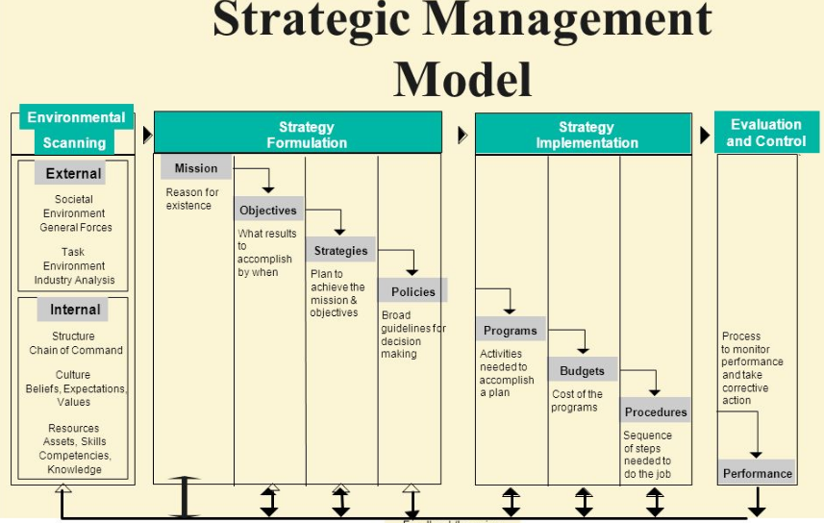
Figure 2: Strategic Management Model
(Source: Følstad and Kvale, 2018)

Juran model

Juran trilogy is a model that is based on the management of quality of products and control of quality and is represented in a graphical manner. The graph has time on its horizontal axis and its vertical axis consist cost of poor quality (Ravikumar, 2016). It helps ASDA to make initial activities as planning of quality. Its second part is the control of quality that has the approach of detecting the errors and inspection. Third phase is the improvement of quality with quality management process as lean six sigma. This model helps the company in detecting errors and carries processes for making incremental improvements.

Deming model

Deming model is also known as PDCA cycle as Plan, Do, Check and Act that consists of steps for improvement in continuous manner (Schmidt, 2019). With the utilization of this model, ASDA is able to make continuous improvement and track the errors in the entire process of operation. Plan is the first step that makes the company in understanding the area that needs change and Do is associated with starting change with small scale and implements such changes. Check is the step that is to make review the results with the expectations and Act is the implementation of entire changes and tracking of performance to improve the entire process.

SWOT analysis

Strength | Weakness
- Quality products  - Brand reputation  - Globally known  - Offers a wide range of products to choose from  - Exceptional marketing tactics and campaigns  - Various distribution centers  - Good connection with the customers  - Sustainability | - High product price  - Lacking in global presence  - Previous price-fixing schemes  - Incorrect advertising  - Presence of various scandalous events
Opportunity | Threats
- The chance to expand its business in new platforms  - The company can expand its business to other countries as well such as India and China  - Introduction of Online shopping  - Focus on long-term goals such as environmental friendly approaches to promote organizational growth | - Competition regarding price  - The continuously changing policies of government bodies  - Competition regarding price cut  - Presence of already established online retailers

Strengths

Both ASDA and Morrisons provide quality products to its customers and they are both known globally and thus have a brand image. They provide a wide range of products such as frozen food, groceries, clothing and utensils. ASDA uses exceptional marketing tactics and is somewhat better as compared to Morrisons. Similarly, the distribution centers of ASDA are of greater number than Morrisons. Both the companies maintain a healthy relationship with the customer and look for sustainable approaches.

Weakness

High product price is a concern for both ASDA and Morrisons. A lot of people from different consumer backgrounds find it difficult to bear the high expenses of the products offered by the companies. ASDA previously faced many issues and came across a lot of negative comments regarding dairy price fixing schemes. Moreover the company had to face some scandalous events such as in a time when horse meat was found in beef as claimed by the customers (Følstad and Kvale, 2018). In a certain case ASDA advertised a product, which was inaccurate and incorrect in its description due to which the company lost a large support from the customers.

Opportunity

The companies can focus on increasing and expanding its business in new domains. ASDA can work on setting up its additional domains like pharmacy and jewellery. Both ASDA and Morrisons can open its outlets and stores in other countries as well, especially in the eastern and south-eastern nations where they are lacking presence. Collaborating and acquiring other smaller companies can help them to expand their business and generate more revenue. It is possible for the company to operate its operations and processes online. This will enable them to broaden their scope and sell various products online. This will be particularly helpful to the people who are unwilling to go to the supermarket or are simply unable to move. Both ASDA and Morrisons are working on sustainable and environment friendly ways to run their business such as introducing recyclable packages, recycled waste products and minimizing the food wastages (Hashim and Fadhil, 2017).

Threats

The competition regarding price is fierce among the leading companies which forces them to cut the product costs in order to promote sales. The government policies and rules of other government bodies can cause hindrances to the company’s operations and performance. The online retailers who have already established a strong base can be a major threat to these companies when opting for online selling and service providing. Organizations like Amazon can create significant barriers for ASDA as well as Morrisons.

Mission and vision

The missions of both the companies are to establish a lifelong relationship with the customers by offering products of highest quality at a reasonable price.

Goals and objectives

ASDA focuses on providing goods and products to its customers that are affordable and has a reasonable price. One of the key objectives of the company is to reduce the packaging and work towards a more environment friendly approach.
On the other hand, Morrison’s focuses on enhancing its growth and being more competitive in the market. It promises to serve the customers better along with searching solutions that are locally available. The company aims to develop and design useful services that can be beneficial for both the company as well as the customers. It is one of the key objectives of the company to strengthen its core operations and the organizational structure (Jain et al. 2017).

Quality Management

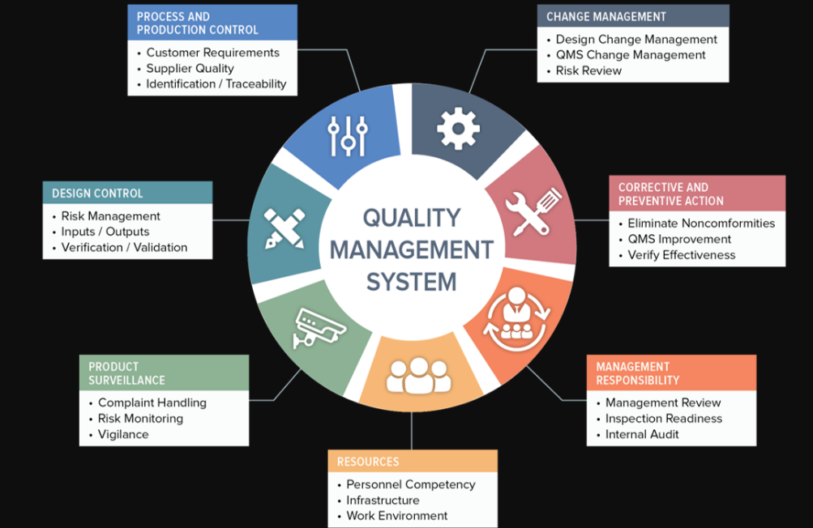
Figure 3: Quality management system
(Source: Kandampully et al. 2018)

The primary focus of an organization is to achieve its objectives along with satisfying customer expectations. In case a company is able to understand the needs and expectations of the customers and work towards it, it increases customer loyalty. The company revenue and its profit margin get increased significantly due to this. This can be effective while there is a target ahead for the organization to be met. Both ASDA and Morrison’s focus on customer welfare and continuously develop the techniques to satisfy the customers.

Providing good quality products and services is essential for a company to run successfully. A customer will naturally expect a quality product for which the appropriate price is given. Failing to provide an appropriate quality in return for a suitable amount will give rise to customer dissatisfaction. Therefore, ASDA and Morrison’s should invest a hefty amount in improving their product quality management. This can be possible by careful analysis of the current customer demands and requirements so that the profit margin can be increased (Kandampully et al. 2018).

Impact of quality management on the improvement of Customer Relationship Management

The policies regarding quality management should be met in order to come up with the appropriate quality. Quality control and quality improvements are needed to be carried out so that customer satisfaction can be increased. A customer should get what he is paying for and any kind of compromise in the field is needed to be avoided. Morrison’s and ASDA have more or less similar prices of the products, which can be considered as somewhat high as compared to other supermarkets. Both companies ensure the highest possible product quality which is reflected in the satisfaction rates of the customers. Improving the overall quality of various products can further help ASDA and Morrison’s to increase customer satisfaction, which in turn will enhance customer loyalty and trust. Selling and focusing on the product brands that have positive reviews and feedback can help to increase the company's sales and improve customer satisfaction (Kempiak et al. 2017).

Task 3

Implications of sustainability and ethical policies in ASDA
The implication of Ethical Policies by ASDA and stakeholders

ASDA implies this policy to improve customers' relationships; as a result, the company is maintaining a good profit margin in the whole year. This company is rising forward in terms of brand value because of customers' faith. It is a good example of implementing ethical policy into the company in a good way. The company faced fewer issues regarding law which are usually made by customers due to harassment. The good ethical policy of ASDA prevents the organization from this issue.

The implication of Sustainability Policies by ASDA and stakeholders

ASDA has a huge commitment over sustainability policy as they focus on environmental areas rather than making an upscale profit. Customers believe that the policy of sustainability is good for the environment, and as a result, it increases the social value of ASDA. This policy works in a cycle thus one area greatly impacts on other parts and in a way it develops the economic condition of the company (Mahrous and Hassan, 2017). The company avoids using plastic for the purpose of the package because it is harmful to the environment. Special extra protections are avoided to reduce uses of plastic packaging. Reduction of overuses of water is also maintained by the company as a part of sustainability policies. Apart from that using a recycling method the company is trying to achieve a zero-waste target.

Effect of policies on CRM
CRM in ASDA and stakeholders

The CRM policy in ASDA is a great tool as the company has obtained a great competitive advantage by analyzing customer’s data. The company not only analyses the data of customers it also focuses on shareholder’s perspectives. Customer contact integration allows ASDA to contact various channels from various resources. Data theft is one great disadvantage of this policy however ASDA has successfully protected essential data of customers and shareholders. CRM has helped the company to establish and maintain a healthy relationship with the customers thus enabling further investments and opportunities. Customer feedback and reviews are acquired by the company to improve its services and work according to the customer needs (Maklan et al. 2017).

Recommendation

The customers have become smarter, more well informed, and can sense if they are being cheated. Therefore, it is essential for ASDA to build trust with the customers and strengthen it over the course of time. The company should be able to demonstrate strict guidelines of ethics in its structure so that always the right decisions and actions can be taken. This should come naturally instead of only avoiding the legal repercussions and consequences. It is necessary for ASDA to make the customers know the fact that it is practicing as well as implementing ethical approaches to carry out its tasks and provide them with as good services as possible. This can be achieved by advertising the actual product and its features avoiding the over-hyped techniques of presenting them in front of the consumers. Exaggerations and over marketing ultimately worsens the company-customer relationship due to which the company may come across losses and other kinds of threats.
Presences of both companies are prominent in the UK and the western countries. They need to open their outlets in other countries like India and China as well to expand their business and increase the revenue generated. Implementing ethical values in a company may help to attract customers and new talents. It reduces the negative reviews and feedback along with increasing customer satisfaction, due to which their loyalty towards the company increases significantly. Choosing an ethical practice over an unethical one even when it can yield more profit is what sets an organization apart from other companies. It is associated with making the right and wrong decision and the decisions which can affect its reputation in the future.

Conclusion

It can be concluded that ASDA is maintaining a good customer relationship and is able to come up with increment in its profit margin. Being a reputable brand has enabled the company to ensure customer loyalty and to gain their trust. This is essential in expanding its business further along with making it grow. ASDA puts its customer first by providing quality services and products at reasonable prices. There are very few issues that are faced by the company regarding the complaints of the customers. ASDA considers the environmental aspects while operating its processes and customer services. It tries to reduce the packages and introduce biodegradable packages.
Various waste recycling methods are used by the company for the purpose of sustainability. Along with that, ASDA focused on minimizing over usage and wastage of water and aims to achieve a zero-waste target. The company has been able to maintain a healthy customer relationship so far by providing quality customer support and handling. It uses the method of gathering customer feedback and reviews in order to improve the organizational processes and customer services. These are useful in the scenarios where the company looks for improvements and modifications in its structure, which can be provided by the consumers.
Providing better customer services has helped ASDA to increase its sales along with its profit margin. A high reputation and brand value has been achieved due to improving the services and increasing customer satisfaction. This has enabled the company to focus on expanding the business and opt for environment-friendly ways to run the business. ASDA and Morrison’s have numerous strengths along with weaknesses. Both the companies are known globally and are of high repute. They offer a large variety of products and goods. ASDA particularly uses exceptional marketing tactics to promote the brand. It maintains a good connection with the customers through social platforms and giving them the opportunity to submit their feedback and queries. The company has numerous distribution centres aiming to increase the accessibility and availability.
However, both the companies lack certain aspects such as relatively higher product price than other local supermarkets and shops. It lacks a overall global presence on which it can work on. ASDA for instance previously came across certain scandals and price-fixing schemes that deteriorated the company’s reputation back then. Once it posted an advertisement which was incorrect and caught a lot of negative attention. Both the companies can focus on expanding its business over other countries as well such as in India and China where the majority of the people are not aware of its presence. ASDA can open its other domains in business such as jeweller and pharmacy. The companies face several threats regarding competition from other supermarket chains. The already established online sellers such as Amazon may prove to be a hindrance for ASDA and Morrisons.

References

- Bolton, R.N., McColl-Kennedy, J.R., Cheung, L., Gallan, A., Orsingher, C., Witell, L. and Zaki, M., (2018). Customer experience challenges: bringing together digital, physical and social realms. Journal of Service Management.
- Bueno, E.V., Weber, T.B.B., Bomfim, E.L. and Kato, H.T., (2019). Measuring customer experience in service: A systematic review. The Service Industries Journal, 39(11-12), pp.779-798.
- Bustamante, J.C. and Rubio, N., (2017). Measuring customer experience in physical retail environments. Journal of Service Management.
- Carlson, J., Rahman, M.M., Taylor, A. and Voola, R., (2019). Feel the VIBE: Examining value-in-the-brand-page-experience and its impact on satisfaction and customer engagement behaviours in mobile social media. Journal of Retailing and Consumer Services, 46, pp.149-162.
- Carvalho, A. and Fernandes, T., (2018). Understanding customer brand engagement with virtual social communities: A comprehensive model of drivers, outcomes and moderators. Journal of Marketing Theory and Practice, 26(1-2), pp.23-37.
- Fernandes, T. and Pinto, T., (2019). Relationship quality determinants and outcomes in retail banking services: The role of customer experience. Journal of Retailing and Consumer Services, 50, pp.30-41.
- Følstad, A. and Kvale, K., (2018). Customer journeys: a systematic literature review.
- Hashim, K.F. and Fadhil, N.A., (2017). Engaging with customer using social media platform: A case study of Malaysia Hotels. Procedia Computer Science, 124, pp.4-11.
- Jain, R., Aagja, J. and Bagdare, S., (2017). Customer experience–a review and research agenda. Journal of Service Theory and Practice.
- Kandampully, J., Zhang, T.C. and Jaakkola, E., (2018). Customer experience management in hospitality. International Journal of Contemporary Hospitality Management.
- Kempiak, J., Hollywood, L., Bolan, P. and McMahon-Beattie, U., (2017). The heritage tourist: an understanding of the visitor experience at heritage attractions. International Journal of Heritage Studies, 23(4), pp.375-392.
- Mahrous, A.A. and Hassan, S.S., (2017). Achieving superior customer experience: An investigation of multichannel choices in the travel and tourism industry of an emerging market. Journal of Travel Research, 56(8), pp.1049-1064.
- Maklan, S., Antonetti, P. and Whitty, S., (2017). A better way to manage customer experience: Lessons from the royal bank of Scotland. California Management Review, 59(2), pp.92-115.
- McLean, G.J., (2017). Investigating the online customer experience–a B2B perspective. Marketing Intelligence & Planning.
- Mosquera, A., Pascual, C.O. and Ayensa, E.J., (2017). Understanding the customer experience in the age of omni-channel shopping. Icono14, 15(2), p.5.
- Nasr, L., Burton, J. and Gruber, T., (2018). Developing a deeper understanding of positive customer feedback. Journal of Services Marketing.
- Potdar, V., Joshi, S., Harish, R., Baskerville, R. and Wongthongtham, P., (2018). A process model for identifying online customer engagement patterns on Facebook brand pages. Information Technology & People.
- Ravikumar, M.V., (2016). Application of Juran Trilogy and Triple Helix System for Successful Implementation of Service Projects–A Case of Rotary Eye-care Project. Nitte Management Review, 10(2), pp.11-26.
- Rosenbaum, M.S., Otalora, M.L. and Ramírez, G.C., (2017). How to create a realistic customer journey map. Business Horizons, 60(1), pp.143-150.
- Sahu, N., Deng, H. and Mollah, A., (2018). Investigating the critical success factors of digital transformation for improving customer experience. In International Conference on Information Resources Management (CONF-IRM). Association For Information Systems.
- Schmidt, H., (2019). Explosive precursor safety: An application of the Deming Cycle for continuous improvement. Journal of Chemical Health & Safety, 26(1), pp.31-36.
- Zolkiewski, J., Story, V., Burton, J., Chan, P., Gomes, A., Hunter-Jones, P., O’Malley, L., Peters, L.D., Raddats, C. and Robinson, W., (2017). Strategic B2B customer experience management: the importance of outcomes-based measures. Journal of Services Marketing.

