Leading and implementing workplace change

Student: Parbez Ahmed
ID: 1708935
Module: BMSW6103
Lecturer: syed jaffrey

Table of Contents
Introduction 1
Company Overview 1
Micro & Macro-Analysis 3
BREXIT 3
COVID-19 4
Resilience 4
VARIOUS APPROACHES TO CHANGE 6
Organizational Culture on Change Management: CRITICAL ANALYSIS 9
Reference 18

Introduction

Businesses and leaders often term Alvin Toffler’s quote, “Change is the only constant” with real-world scenarios and circumstances. These leaders prepare with the necessary models and strategies to manage these changes and become successful. The changes might be from external factors or internal factors. It is only the effective managers and leaders who perceive the factors, plan and implement accordingly. The acceptance of the factors is widely important to bring change and accelerate forward. Such examples of, employee dissatisfaction, minimum motivational support, less group coherence, or economic recession, natural disasters, technology innovation, maybe the various factors that require changes in an organisation. Foremost culture in an organisation decides and helps accelerate the people to perform according to the situation. Culture as defined by Henry Mintzberg, “is the soul of the organisation, the beliefs, and values in ways they are manifested.” The structure is the skeleton, flesh, and blood, where culture holds the thing together and gives it life force.

Company Overview

Ella’s Kitchen is a Small Company established in 2006 by CEO and founder Paul Lindley. Paul, a father of two daughters, dreamt of providing healthy food for his children and the next generation. The organisation’s mission is to develop a healthy relationship with food for children under 7 years old and sustainability on the planet.
Ella’s Kitchen started with squished fruits and vegetables. This idea created yummy flavours for the tummies and developed a healthy habit for children at their beginning stage. The organisation promotes healthy habits by supplying nutritious foods, creating campaigns for underprivileged children, farm and market trips for children, taking cookery classes at primary school, and promoting vegetables in weaning through national campaigns. The owner of this company waited to offer items of foods which were tasty and an exciting and delicious way for young children to eat healthy items of food. Often the items of food that are created in this company is what young children enjoy snacking on including crisps, though the company has created it in such a manner that the chips taste delicious made out of healthy vegetables with no harmful products. Everything produced with is natural therefore a healthy and safe option for children at the core stage of their life of developing into strong and progressive children.
Ella has collaborated with the government and other partners for better support in reaching the 20 targets. The targets under packaging, ingredients, people, planet, and change have been set to accomplish their dream by 2024. The organisation supports the Sustainable Development Goals and has three main focuses.
First is zero hunger by supplying nutritious food to children around the world, reducing malnutrition by 2030. The second is responsible for consumption and production, which focuses on efficient use of resources, animal welfare, reducing wastage of food, and sustainable packaging. The third is the partnership for goals, which means working together with the government and other organisations to achieve targets.
Ella’s has reached out to the government, charities, and food banks to reduce obesity and malnutrition. Ellacycle is a sustainable packaging program initiated by the organisation to develop recyclable packaging by 2024. The organisation is an active member of B Corp and U.K. Plastics Pact, in collaboration with which several nutrition campaigns, such as VEG POWER, were completed. B Corp members certify the implementation and impact of social and environmental accountability, performance, and transparency. To create a more significant impact, partnership with Terracycle, Do Nation, Fareshare, Compassion in World Farming was formed.
Since 2016, Ella’s Kitchen is consistently awarded a 3 Star Accreditation for workplace engagement and placed in the top 100 Small Companies to Work for in the United Kingdom. To get the 3 Star accreditation and a world-class reputation, a company must score above 738 in the Best Companies Index. In 2020, the company was scored 755.7 in BCI and positioned 59th among the top small companies in the United Kingdom.
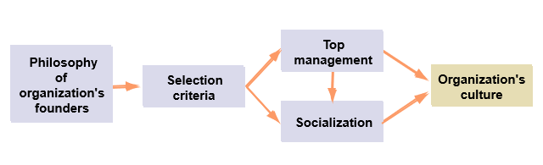
Formation of Organizational Culture. This model shows the root and foundation of an organisation’s culture. Founder of Ella’s Kitchen Paul and CEO Mark developed mission and vision for the organisation. The mission is to supply nutrition to children and a vision to achieve sustainable development goals. These criteria are assigned to the top management for strategic planning, organising, implementation and control. This is done through the socialisation process explained in the later parts. Overall, this whole process creates the organisation’s culture for a food supply company. The culture is shared among members, taught to newcomers, helps solve problems within and outside the organisation, and strongly influences behaviours. Various organisations act according to their type of business and specific industry conditions. Few important characteristics of organisational culture are innovation and risk-taking, attention to detail, outcome orientation, people orientation, team orientation, aggressiveness, and stability. The culture encourages innovation for employees, develops precision and analytical abilities, focuses on outcomes rather than techniques, decisions by management to create a proper effect on the people, ability to work in a team environment, performing aggressively, and maintaining the organisation’s outlook.

Micro & Macro-Analysis

Ella’s Kitchen has been in several precarious circumstances. Due to the fall of Britain’s membership with the European Union, the organisation had to prepare several exit strategies and still fulfil its dream of serving the European Market. Brexit is an excellent example of how the organisation has adapted to change and survive. Following the preparations for Brexit, yet another crisis has risen, the Corona Virus Pandemic.

BREXIT

Ella’s Kitchen has become a great name, as the British brand has topped the ranking for baby food products in Norway, Sweden and Denmark. The exports have risen with the consumers’ likes, and statistics showed a 15% market share in Sweden and 30% market share in Norway. It was named the top baby food brand in Ireland and Norway, heading its journey towards Germany. Exports for SMEs are consistently on the rise in the E.U. But with the news of BREXIT, the consistency seemed to be changing. The leader Paul Lindsey was still hopeful despite the loss of a big market. He mentioned that, even with the risk of losing the EU, Britain is hopeful of creating and developing new partnerships with other countries worldwide. The focus of Ella’s Kitchen remained strong with the 5 targets set to supply nutritious baby food and maintain sustainability. Even though the external factors cannot be changed, staying focus on the main purpose of the organisation and adapting to the current changes will help to grow bigger. There is a bigger market in Africa and Asia for nutritious food requirements.

COVID-19

The Corona Virus Pandemic has created a crisis for the implementation of government-based funding. Since pre-COVID-19, companies were reportedly in a negative cashflow of £180 billion, whereas the government schemes are planning to inject £90 billion. The £90 billion is the reserve amount in the government treasury. It is risky to inject the reserves, with no probability of the economy recovering. Most developed and developing countries have sought out schemes and funds of around €100 billion each in a public equity fund. The same is suggested for the UK government to follow through. With the expectation of leaving the E.U., the U.K. will lose access to European Investment Bank, which played a significant part during the previous crisis. Now, the U.K. has formed its own U.K. Infrastructure Bank, focusing on the unnecessary infrastructure project rather than the development of businesses and employment factors. One solution shown by George Dibb is long-term equity financing. Here, the U.K. government will have fair stakes in the companies in collaboration with government policies.

Resilience

Ella’s Kitchen was not a regular habit of work-from-home activities, using words such as crisis or furlough. Before the pandemic, the organisation went through various outings, colourful events, and a sustainable supply of baby food products. Catherine Allen, HR of Ella’s Kitchen, took bold steps into motivating and engaging employees during the Corona Virus Pandemic’s stressful times. The company was used to the outside world and it had a great contribution to the running of the business. As this company is a food company it is reliant on the product produced by staff, to run the business and deliver the healthy items for young children on the food store shelves.
Setting as an example of a leader, Allen took the responsibility of developing steps to tackle workplace changes. Everything had mostly gone virtual, creating increased times of solitude and family planning for home-schooling kids. It was not possible to find out who was struggling. Allen created a support group program for each category. For example, an employee was going through a marital split or a parent group adjusting to kids’ home-schooling. The support groups created a comfortable place to share and get ideas for their situations.
A full payment program was provided to the parents attending home-schooling with their children. Despite the hours worked, the parents were paid in full and increased morale. A newsletter was created for sharing the stressful situations faced by the employees during lockdown related to schedules or payments. This helped in various discussions and support provided by others.
Pre-Covid allowed better mental well-being of employees. It was easier for employees to take off some free time to walk and talk with the managers. Personable conversations are essential to understand employees and advise accordingly to boost morale. During the lockdown, Ella’s Kitchen developed therapy sessions, like yoga, watercolour painting, gardening, and sleep workshops, conducted online. A schedule was set, and employees had to come online to attend these sessions. “Water Cooler Moments” was organised by Allen by calling four employees outside the video conferences. Overall, communication is the main key to positivity by provision and reception of feedbacks.
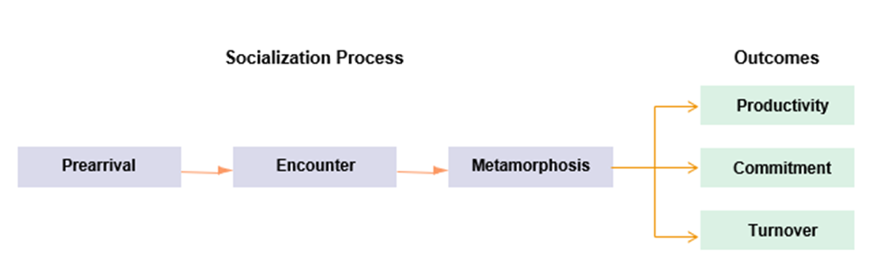
The socialisation process can be described by the activities taken by the H.R. team of Ella’s Kitchen during the lockdown. The steps taken during the virus's arrival, then maintaining and developing communication strategies to produce outcomes. The pre-arrival stage includes the unawareness of the situation. The encounter stage includes facing, understanding, and developing strategies for the crisis. The metamorphosis stage includes adapting and becoming resilient to the crisis with various change management programs. The outcome stage includes an increase in productivity of the organisation’s employees, commitment to the strategies innovated, and increase positive turnover.

VARIOUS APPROACHES TO CHANGE

A people-Centred Approach to change is required for any organisation to adapt rapidly to the growing crisis faced by the Corona Virus pandemic. It is not an easy task for managers and leaders to create and sustain new strategies and ideas for the employees from the lower level to the higher level. But it is important to build trust, empathy, and transparency within the organisational culture, to understand the highs and lows of the situation. Together, it is possible to create a new culture and apply ideas according to show resilience and move the success forward. The initial step to make this effective is understanding consumer needs and delivering to them accordingly. This strategy will produce a positive outcome, as consumers will be gaining individual attention and taken seriously. This out-of-the-box thinking will enable organisational development and apply innovative techniques related to the consumer’s preferences. There will be a newer market opportunity and newer development areas for employees. Secondly, the interest and the will of taking these opportunities must be present. During times of crisis, it is not easy to adapt to new changes quickly. The drive to change must be enabled by the leaders of the organisations to support employees and individuals to take up the new process. Supposedly, Ella’s Kitchen took a drastic change during BREXIT and Pandemic.
It is important to understand the market situation and consumer demands during these crises as well. Considering the BREXIT situation, Ella’s Kitchen has not looked backward by losing a few emerging markets and disturbance in the European Union countries' share. The organisation has already built a reputation in the culture of those consumers, which proves their value and loyalty. Thus, Ella’s has sought various contingency plans by communicating with government operatives, to create another support for serving those markets. Moreover, the leader Paul has given confidence to its growing organisational culture, to broaden their horizons. This means with the BREXIT deal, there is a sign of commencement of new deals to a broader market. These markets contain various malnutrition children’s food supply and unaware of Ella’s weaning and SDG activities' marketing strategy.
Considering the Corona Virus Pandemic, Ella’s Kitchen questioned the sustainability of its business. The employees and management faced panic and confusion. During the beginning period, the lockdown period was initiated, which meant a decrease in sales. Supply to other countries and the bigger market were losing hands. Gradually, the business shifted online. In a short time, the organisation developed the “Click and Deliver” option for the local consumers. This helped in the web development, pricing, packaging, and virus preventive measures for the employees. Specific measures for pandemic prevention were implemented. Various awareness programs led to containment and prevention. Eventually, Ella’s started taking orders online and increased sales by 4% from last year. It increased market share by 28.62% and operating profit by 6.7% in the U.K. Ella’s Kitchen ventured with a cloud-based marketing platform Mapp. This collaboration increased customer engagement and the Electronic Customer Relationship Management strategy. This will develop better communication with customers and provide Friend’s Program. Friend’s program provides important tips and knowledge about weaning, recipes, coupons, news, free weaning guides, etc. ECRM enables a strategy to understand consumer behaviour online and promotes profile personalisation. Personalisation helps creates a better interface and assistance for consumers browsing and availing Ella’s online services. Consumers’ favourite contents will be available to cater to them.
Several Job Retention Scheme, Self-Employed Income Support Scheme, Job Retention Bonus, and Kickstart Schemes were provided during the Corona Virus Crisis to the SMEs sector. The SMEs who were facing low demands, and facing several disruptions, were given several aids by the government. JRS and K.S. were provided to furloughed employees and youth employees. These programs worked as such, that various tax benefits were provided to the organisations to retain the furloughed. The government shall increase the tenures for these schemes to reduce unemployment and provide assistance to the needy.
Ella’s Kitchen did not show any news of furloughed employees or job cuts. Instead, they provided more support and consistency to encourage and motivate employees to increase performance. This was absolutely essential especially with the environment that many are living through with the pandemic, to provide the support and motivation staff need to enough of them to keep moving forward and to adapt to the unnegotiable changes that are taking place. As described by Norris (2008), resilience is the capability of firms and their management to adapt to the stress, disturbance, and adversity from the external or internal factors. It is a core component of the role of a manager to keep the internal environment of the company calm, rather than letting the external circumstances affecting the running and atmosphere of the workplace. The adversity or stress is a rapid and long-term occurrence. The ability of Ella’s Kitchen to adapt to the dynamic conditions of BREXIT and Corona Virus Pandemic shows resilience. This means the organisation is adamantly prepared to face any disaster or changes in the environment. There were willing to make any decisions that were required to make and were still determined to try their best to continue doing what they were doing but through different methods and approaches.

SME resilience model was proposed by Pal (2014). This model consists of three major enablers or three key assets: Assets & Resourcefulness, Dynamic Competitiveness, and Learning & Culture.
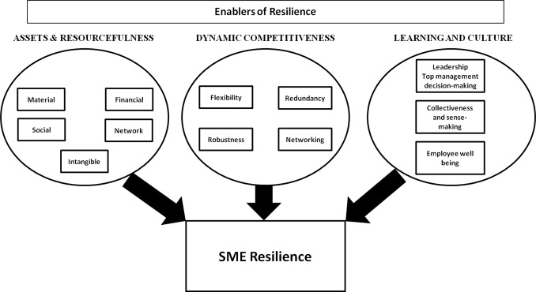

The first key asset consists of materials, tangible, intangibles, financials, networks, and social capacities.
The second key asset consists of redundancy, robustness, flexibility, and networking.
The third key asset consists of leadership & top management skills, collectiveness & sensibility, and employee well-being.
The key assets determine the resources available by the SME, the dynamic capabilities, and the learning culture in the workplace. Combining these three assets shows the capability, adaptability, and consistency of the workplace in tackling dynamic and crises.
Leaders of the organisation showed resilience, by utilising adequate resources, coping with the new environments by developing new methods and techniques for employees to learn and adapt to.

Organizational Culture on Change Management: CRITICAL ANALYSIS

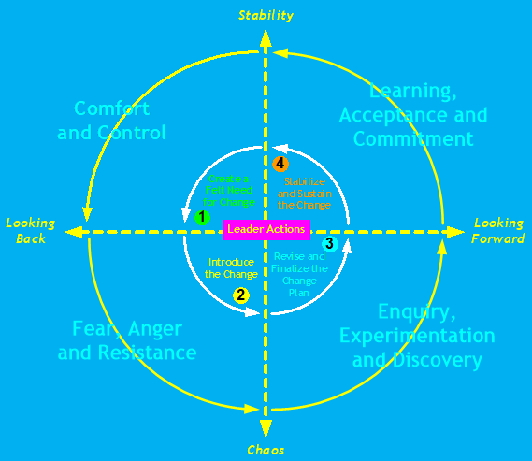
Leading Change Model for Resilience

This model by Jeff and Linda Russell (ASTD Press,2006), describes the journey of change through the various efforts and steps taken by the leaders to train employees and management in an organisation to accept the changes in the environment. This helps develop the ability to grow diversity and adapt to the changes.
In the first step, the leader creates awareness about the forces that create the need for change. The list of changes described in the workplace, may not be acceptable in the first place.
The employees may show strains of fear, anger, and resistance towards a certain type of change in the second step. This type of behaviour is common for any person or group, to accept sudden amendments in their course of daily lives. These resistors often help in revising and reinventing the ideas for change by leaders before implementation.
The third step helps the group to understand the need through experimentation and discovery. Various experimentations, failures, and succession lead to the specific changes required for the current crisis.
Which leads to the final step, acceptance, and commitment. In this stage, the leader becomes successful in convincing and adapting the workplace to the necessary changes. This leads to resilience and improves operations during micro or macro-environmental changes. If the amendments do not work and show strains of unacceptance and uncomfortableness, then the journey shall start again.
There can be a negative or positive perception towards any given circumstance. It was an applaudable decision for Paul to understand the situation's positive view and motivate his team to take the right steps.
Before the start of the pandemic, the SMEs in the U.K. showed 80% stable revenue growth. This figure is now declining, as 80% of SMEs reported so. The U.K. economy is failing for the SMEs, considering several downfalls such as, non-performing loans, sustainability in employee retention, and postponing growth projects. Most of the SMEs’ predictions said their business will close operations by the end of 2020. These firms started as early as 2019, without much cash reserves to last them at a maximum of 6 months (State of Small Business U.K.). In 2019, there was an increase in the rate of early-stage entrepreneurship in the U.K. This case was seen after 20 years. In conclusion, there was an all-time high rate of 7.7% female early-stage entrepreneurship, reducing the gap between the two genders. Among these early-stage entrepreneurs, a high number of immigrants were included. This feared a huge impact on their activities as the pandemic started in late 2019. This also harmed the employment rate, which was slightly recovering at the beginning of 2019 with 2.5%. Job creation through expansions before the crisis now led to job destruction by the closure of businesses.
The government was not prepared for any fallout plan to save the SMEs in the United Kingdom. But several political leaders and chancellors gave hope by proposing furlough programs to save the ailing SME sector. The furlough program offers 80% of the furloughed employees’ salaries up to £2,500 per month by the government. In other initiatives, SMEs are participating in various programs that are expected to grow in the future. As well as, submitted applications for tax reduction, rate reliefs, take small loans, and claimed statutory sick pays. (Maria Alboneki, Zdravko and Ruchi Sharma, 2020)
BREXIT has left the food supply industry at the brink. It is creating a huge loss in the supply of labour and constant manufacturing of food for the population. With the BREXIT to happen soon, the U.K. labour industry needs to develop strategies to acquire and employ laborers from within their country and countries they are entering into pacts. The exit deal has a tremendous loss for the food export industry which amounts to over 3 Billion Pounds. The food import percentage was 26% from E.U. countries and 4% from other Asian and African countries. These rates are predicted to change as the BREXIT took an effect from January 2021.
The food industry is hopeful, with the new pacts signed with Asia-Pacific and American countries. This has provided bigger opportunities for the British food manufacturers and suppliers to grow their business and Britain’s economy as a whole. Previously, without the trade deals with these countries, there remained fewer opportunities to benefit from increased tax barriers and lower quotas. The new destination countries have created a softer side for the British counterpart, as their European Membership barriers have come to an end. Before the Brexit deal, Britain has to maintain a standard supply of food and other products and services to the E.U. This also meant strict relationships with countries outside the E.U. There was also a pact for laborers, the employment rate in Britain was fulfilled by laborers from the E.U. countries. Even though there was a presence of laborers from outside E.U. countries, the preference was given to the E.U.
There are still uncertainties, a lack of information, and less clarity about the businesses to plan and invest in new deals. Many have called for a post-BREXIT grace period allowing compensation for businesses affected by the deal, allowing smoother passage for consignments, and add roles for remote and seasonal workers in the food and drinks sector under the Skills Shortage List.
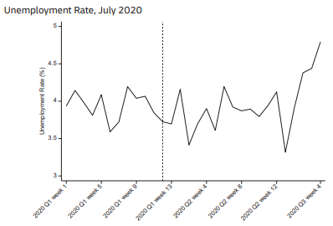
The new amendment has opened opportunities for workers from new destinations to work in British companies. With the new deal, the companies have to develop changes for the new inflow of workers from different regions. A model for the development of new employment and adaptability with crises shall be created.

- Initial Screening – This stage consists of initial verification of the worker or employee.
- Training Program – Adequate and specific training programs must be organised for new workers.
- Developing Skills and Consistency – The workers must be encouraged to develop new skills and consistently perform in their roles. This must include feedback from the managers and senior team members.
- Adaptability and Diversity – The workers must be adaptable to changes, and train to become diverse according to the changing markets, internal as well as external environment.
- Commitment – Trust and devotion for skill development, adaptability, and resilience must be present to perform with organisational culture.

It was difficult for many organisations when borders closed without notice. And has requested the government to develop a deal to incur any further losses. The new deal for the food industry consists of tax-free support for the agriculture sector but increased administrative and paper costs. Several steps shall be taken to bring back the trade and loss incurred with the E.U.
Companies must communicate with their European counterparts to make cost cuts and provide various incentives. As the companies remain consistent with their quality and the demand for the products remain the same, then the European countries must come to an accord for satisfying the needs of their consumers. As there are no offices to take authority for the supply of goods, dealership agreements and operations shall be given permission. Without such a deal, it will be difficult to meet demands and increase the price of the goods and supplies. It is important to renew the supply chain, create new values, and train workers to be susceptible to the changes coming forth. The pace of the food chain must be accelerated.
The eight steps of change mentioned by Kotter’s is as followed and shall be maintained by SMEs and other organisations:
- Establish Urgency – The urgency of the situation is understood by the U.K. government
- Create Coalition – A coalition was formed by the members of organisations and the government
- Develop A Clear Vision – Every problem and possible solutions were identified
- Share the Vision – The possible solutions were shared among the people
- Empower People to Clear Obstacles – People understood the vision and empowered themselves to act accordingly to eliminate obstacles
- Secure Short-term Wins – Several programs are being offered such as Job Incentives, Bonus and Kickstarts
- Consolidate and Keep Moving – Funded programs are initiated, with discounts on technology adoptions, and innovations.
- Anchor the Change – The changes through development and adoptions, shall be accepted, consistent, and remain constant.

A recent program initiated by Chancellor Rishi Sunak, asks the management of SMEs and other businesses to go back to kinder garden. This plan will help develop the entrepreneurial and management skills and reduce the efficiency of rival countries. Up to 130,000 individuals’ heads from the Small and Medium Enterprises will be offered a Master of Business Administration style preparation. The total cost for this program is estimated to be around £520 Million. This innovation and growth strategy will include digital software at reduced prices and technology suggestions. Sunak expects a huge number of leaders to step up and take part in this initiative. This is a very beneficial offer for small and medium industry leaders, as this will enhance Britain's opportunities to maintain stability among the leaders of G7 countries. This program will create more resilience and beneficial and strong businesses. The length of the program is 12-weeks and promises a 10% growth in productivity. This plan also includes online training for organisations, improving costs, saving time, and increasing the number of clients. The government is also offering half-cost cuts for technology implementation in business using customer relationship management. This software is predicted to increase sales within a few years of proper application.
In response to another crisis, such as the Grenfell Tower fire, it was found out that the British common sense led many tenants and immigrants in the face of discrimination. The free-market system adopted by the British people, through the government's support, branding British Everything, shall develop a proper strategy for the people in distress and marred by crisis conditions. It is unethical and unorthodox of companies, under the government's directive to dismiss people who protested during the Grenfell Tower fire. These people have been called uneducated, mannerless, and fools while pleading for welfare benefits. In return, they were deported, and several were left to the streets without any support. It is important for organisations to operate in a free-market system and democracy to use ethical means and reduce biases towards people of other origins. The British people have voted the free-market system to lose bindings and obligations from the European Union Framework. Thus, it is important to welcome new opportunities by providing support and development programs and contributing to the growth of the British Economy.
The coronavirus pandemic remains at large. Even with the effect of the vaccines provided by various scientific research and pharmaceutical companies, there is no confirmation of the immunity from the virus. SMEs such as Ella’s Kitchen have taken various precautions by providing education and campaigning about the effects of the virus. The organisation has several insurance benefits and packages for its employees. The statistics showed that the employees disagreed that working at Ella’s is affecting their mental health. Ella’s have 5 trained professionals who have expertise on the employees' various mental and stressful situations. Thus, expert support and various conversations are implemented to help motivate and engage employees. During the Brexit and post-Corona crisis, these support programs helped overcome anxiety, fear, and resistance towards the organisation's changes to maintain stability and improve performance. The total employee population agreed that they are proud and satisfied to work for this organisation. As the organisation promotes charitable activities, this gives positivity in the social environment. The number of females exceeds the number of males working here, and this shows that females are a great example of leadership and commitment in an organisation to move forward.
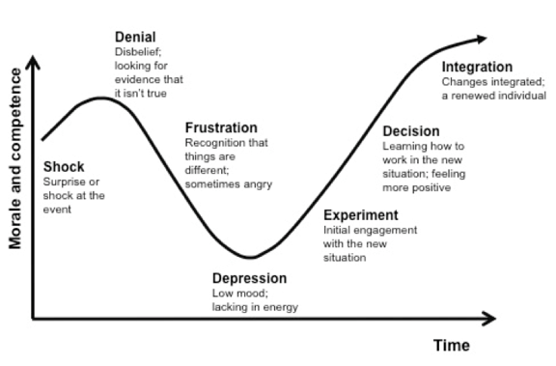
Kubler-Ross Change Curve
During the Covid-19 Pandemic, many companies came as a shock as productions and supply were at a halt. This turned to decisions for pausing the climate and sustainable initiatives. This was the case for over 70% of the business leaders surveyed during the crisis. CEO Mark’s children remained concerned about the climate impact on the planet due to reduced acts. Thus, he decided to continue the climate and sustainability acts to help build a better planet. The climate clock is running and so are the commitments for Ella’s Kitchen. The organisation has pledged to:
- Become Net-Zero by 2030
- Restore the eco-system by collaborating with the United Kingdom and International Organizations that expertise in conservation through restoration, rewilding, and protection
- Setting science-related targets to reduce carbon emissions from direct and indirect sources maintains the Green House Gas Protocols.

Romy Hughes described four points that should be considered for change management during the times of COVID-19:
1) Processes – The time to manage and improve processes
2) People & Culture – Understanding the comfort and characteristics of the people in the organisation and create a positive ambiance to cope with work
3) Technology & Tools – Invention of new tech, provision of smooth internet supply, with the adaptable process and value chain for current situations.
4) Information – Break barriers in the hierarchy for smooth flow of information, by implementing knowledge and problem-solving skills from all levels. Create better communication.

The Best Companies Index has 8 factors that deliver accurately leads to higher scores and excellent workplace engagements upon delivery. Ella’s Kitchen has adequately focused on these factors to improve workplace engagement and performance. They are:
- Leadership – The perception of employees regarding top leaders, management, and core principles
- My Manager – The perception and communication pattern with their managers
- My Company – The satisfaction with job and engagement in an organisation
- Personal Growth – The perception of personal growth and prospects
- My Team – The understanding of team and comfort in-group cohesion
- Well-Being – The perception of work-life balance and stress in the workplace
- Fair Deal – The contentment with the employee benefits and incentives
- Giving Something Back – The optimistic view of the company engaging in social acts and responsibility

Reference

1. Abel Duarte Alonso, S. K. K. A. B. M. O. N. S. A. K. M. A. B. S. L. J. S., 2020. COVID-19, aftermath, impacts, and hospitality firms: An international perspective. International Journal of Hospitality Management, p. 12.
2. Ella’s Kitchen, 2018. The Good Stuff We Do, Henley on Thames: Ella’s Kitchen.
3. Enterprise Research Centre, 2020. state of small business in uk 2020, s.l.: Enterprise Research Centre.
4. Hughes, R., 2020. ITPROportal. [Online]
5. Available at: https://www.itproportal.com/features/theres-no-time-for-change-management-during-covid-19-but-there-must-be-time-to-change-management/
[Accessed March 2020].
6. Jeffrey Russell, L. R., 2006. Leading Change Training. Alexandria: ASTD Press.
7. John M. Amis, B. D. J., 2020. Leading Change in Response to COVID-19. The Journal of Applied Behavioral Science, 56(3), pp. 272-278.
8. Maria Albonico, Z. M. a. R. S., 2020. How the COVID-19 crisis is affecting U.K. small and medium-size enterprises. Mckinsey & company, p. 5.
9. Norris, F.H., Stevens, S.P., Pfefferbaum, B., Wyche, K.F. and Pfefferbaum, R.L. (2007). Community Resilience as a Metaphor, Theory, Set of Capacities, and Strategy for Disaster Readiness. American Journal of Community Psychology, [online] 41(1-2), pp.127–150. Available at: https://onlinelibrary.wiley.com/doi/10.1007/s10464-007-9156-6 [Accessed 23 Jul. 2019].
10. Pal, R., Torstensson, H. and Mattila, H. (2014). Antecedents of organisational resilience in economic crises—an empirical study of Swedish textile and clothing SMEs. International Journal of Production Economics, [online] 147, pp.410–428. Available at: https://www.sciencedirect.com/science/article/pii/S0925527313001217.
11. Coleman and Mullin-McCandlish (2021). The Harms of State, Free-Market Common Sense and COVID-19. State Crime Journal, 10(1), p.170.
12. Alex, M. and Says, E. (2020). Rishi Sunak needs to take a stake in the survival of U.K. businesses. [online] British Politics and Policy at LSE. Available at: https://blogs.lse.ac.uk/politicsandpolicy/sunak-survival-uk-businesses/ [Accessed 6 Mar. 2021].

13. www.managementtoday.co.uk. (n.d.). Ella’s Kitchen founder: Stay focused to survive Brexit uncertainty. [online] Available at: https://www.managementtoday.co.uk/ellas-kitchen-founder-stay-focused-survive-brexit-uncertainty/smes/article/1447858 [Accessed 6 Mar. 2021].

14. Best Companies. (n.d.). Ella’s Kitchen (Brands) Ltd Have achieved a 3 star accreditation from Best Companies! [online] Available at: https://www.b.co.uk/company-profile/?Ella%27s-Kitchen-99184 [Accessed 6 Mar. 2021].

15. the Guardian. (2021). Rishi Sunak to offer “help to grow” training for SME managers. [online] Available at: https://www.theguardian.com/uk-news/2021/mar/01/rishi-sunak-to-offer-help-to-grow-training-for-sme-managers [Accessed 6 Mar. 2021].

16. www.managementtoday.co.uk. (n.d.). How to keep your employees happy during lockdown 2. [online] Available at: https://www.managementtoday.co.uk/keep-employees-happy-during-lockdown-2/leadership-lessons/article/1698495 [Accessed 6 Mar. 2021].

17. Grapevine, H.R. (n.d.). How Ella’s Kitchen cared for working parents during the pandemic. [online] www.hrgrapevine.com. Available at: https://www.hrgrapevine.com/content/article/2020-09-25-how-ellas-kitchen-cared-for-working-parents-during-the-pandemic [Accessed 6 Mar. 2021].
18.food-bev-networker. (n.d.). Ella’s Kitchen CEO urges U.K. firms to not lose sight of sustainability initiatives amidst pandemic. [online] Available at: https://www.fandbnetworker.com/news-1/ella%E2%80%99s-kitchen-ceo-urges-uk-firms-to-not-lose-sight-of-sustainability-initiatives-amidst-pandemic [Accessed 6 Mar. 2021].

19. Mapp Cloud. (2020). Ella’s Kitchen chooses Mapp to enhance its customer engagement strategy. [online] Available at: https://mapp.com/blog/ellas-kitchen-chooses-mapp-to-enhance-its-customer-engagement-strategy/.

20. Speciality Food Magazine. (n.d.). How the food industry can prepare for Brexit | News. [online] Available at: https://www.specialityfoodmagazine.com/news/how-the-food-industry-can-prepare-for-brexit [Accessed 6 Mar. 2021].

21. Speciality Food Magazine. (n.d.). What does the Brexit deal mean for the fine food industry? | news. [online] Available at: https://www.specialityfoodmagazine.com/news/brexit-deal-fine-food-industry.

