

LEVEL/ LEFEL 4

Managing Enterprise in the 21st Century
(Assessment Component 2)

Student Name: Shahanara Noor
Student ID: 1707882

Table of Contents
Introduction 3
Description 4
Feeling 4
Evaluation 5
Analysis 6
Conclusion 7
Action plan 8
Reference 10

Introduction
The idea reflection-on-practice and reflection-in-practice has produced to explain the improved process through the learner reflect the idea or methodology of better practice in him implicitly. This paper analyzes the Gibb’s model of reflection that our team has adopted to develop the idea o managing enterprise in the 21st century. David Boud, an adult education professor explained, reflection is the process by which a person recaptures the idea, thought and outcome in him to assess, evaluate and persuade go ahead. This model exactly helps to reflect facts and happenings to human character within improvised methodology, (Stephanie, 2013). This model enables the learners to adapt themselves in newer approaches of practicing various skills in his life. According to Dye (2011), this model can be unusual if there causes indefinite and unreal practice of theory. This model describes some exclusive factors those directly impact on the learning process and procedures like description, action plan, feelings, evaluation, analysis, and conclusion.
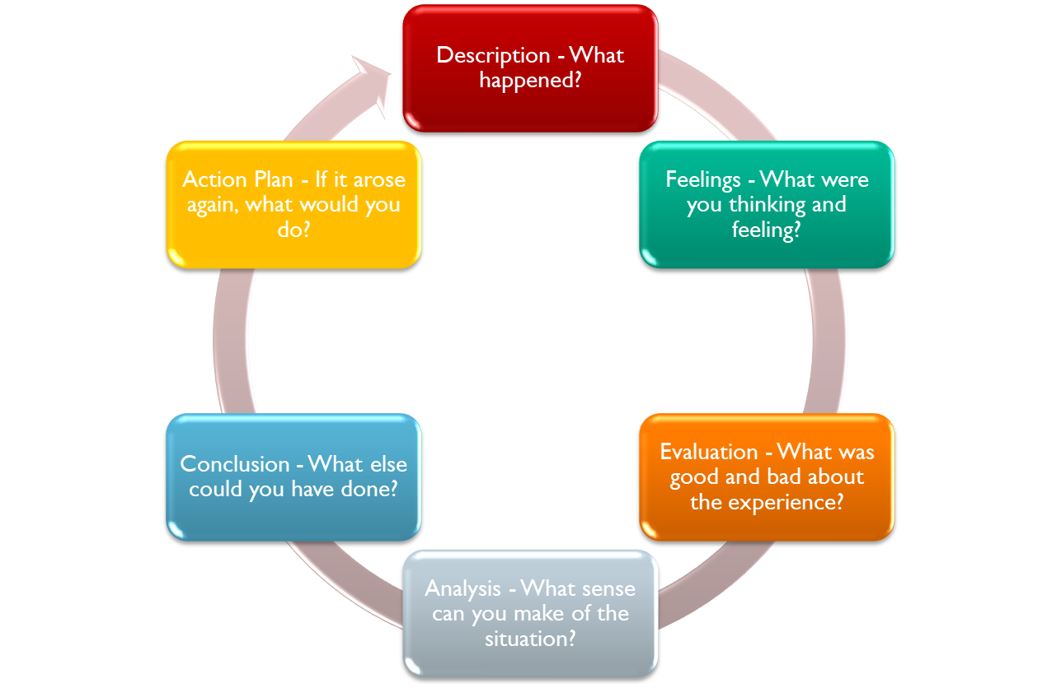
Diagram: Gibb’s Reflective Cycle Source: McGregor (2011)

Description
By this model the learner gets opportunities to reflect the learning event in him by the mentor of the event. First the mentor recognizes how the learner can be reflected through this model. We the member of our team organized to discuss the topic on ‘managing enterprise’. I am as a mentor suggests the learner to be very practical in their life so that they can recapture all the points of their learning events. Business enterprise requires some operation first the entrepreneur should adopt or plan for certain aims and goals. Business plans or strategies includes place or location determine, collects funds, collects employees, hit upon scientific plans, manage tools and equipments, advertisement event management, products patent etc. (McGregor, 2011). In the class we outlined about the 4P’s formula in business strategic plan management regarding products, prices, promotion and place. We defined the crucial factors of business strategic plan including the HR management approaches, employee relations management, business environmental factors. Most importantly, financial activities are considered as the first heeding approaches that combine financial sources, financial cash flow, financial reports, progressive report and annual report for any single business entrepreneur (Cubria, 2018).

Feeling
Feeling covers all the perceptions of personal and communal life including tam working, team managing, sharing with the team members, caring about, persuasion, imagination etc. The mentors of an earning and learning event can reform the learners through a scientific process of creating good feeling to the workshop (Cartwright, 2016). The reflectors know how to discover the inners treasures of the students. We all the team workers are very friendly that helps us to be more innovative in our deeds. At first we set the goals and visions of our workshop. This helps us to maintain the work schedule for punctual responsibilities. All efforts by our team member go for encouraging the truth and evaluate the proper strategic plans for any business institution overall. I am with poor achievement also tried to be very dedicative in my responsibility. I am learning from my team member and mentors gradually so that I can develop the proper imaginations of making strategic plans for any business industries. Our attempts are to define the actual factors that read the feeling of the customers and others perspective related to the business. In Gibb’s model of reflection, feeling discuss the instant thought and values at that times learning from the mentor. It also defines a participant’s experience having the real factors of learning periods. A better performance is mostly relied on the proper emergence of feelings that the learner thinks or imagines about the team and mentors as well the system of managing the format of learning. Our mentor is very active in his motivational speech that motivates us to innovate the newer thought regarded to pint of discussion. If there causes any dispute or conflicting situations among us, our mentor takes the subject cordially to handle. We are all grouping member debt o our mentor as he helps us with guidance, suggestion, feedback from us. Another weakness of my learning skill is of lacking of understanding the important analytical tool for discussing the real factors related to the business environment. I am unable somehow to understand the exact usages of SMART formula that is very important for achieving business goals, objectives, missions and visions. In team work, we face some difficulties of making decisions, policy recognitions, plan making because of deficiency of proper instruments and knowledge. Our mentor supports all time to develop our skill that should be reflected on us like academic skills, employability skills, persuading skills, communication skills, customer relations management skills, employees relations building skills (Paver, 2016).

Evaluation
This part is not analytical, it makes positive and/or negative judgments about an experience if a lot of different things happened during the experience, the reflectors or reporters need to focus on one or two, and they need try to choose the things that are most important, most relevant or most representative of the experience. This section of Gibb’s model of reflection discuss about the evaluation process of the performances done by the team. This process is to evaluate how the program was fit or unfit, what facilities provided, various sorts’ difficulties asses, definite strategies for the certain business company. All these things are explained in this section to justify the real factors related to business environment that directly or indirectly influence on the business affairs. We team members along with our mentor discussed more and more time to find out the hidden causes behind the difficulties of establishing newer formula and approaches in 21st century business goals achievements. Now we know the procedures that help a mentor even a reporter to detect the actual reasons behind the business plans failure. All the members attend in the evaluation meeting of the deeds are recently completed. By the sincerity of the all member inspires me to go for a long way of this learning event of business strategy planning. The evaluation methods applied in our team is so careful that the mentor asses every single performance by us. Our inspiration gets raised high. Really an inspirable attitudes by the reflector or mentor encourages the reporter and thus proper evaluation method is helpful to the business environment impacting on the promotion of their products.
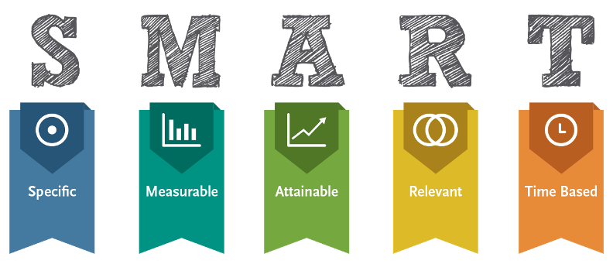
Image: SMART goals Source: Mind Tools (2018)
In accordance with Peter, (2016), this section model needs to discuss about the experience level broadly. What types of bad experience occurred during the program running. However, this program accompanied by the mentor we enjoyed very much. It gives us mental refreshment during this event. All efforts of obtaining SMART goals and objectives though failed to fulfill we were obstinate of recovering that smartly.

Analysis
This section of Gibb’s model discuss about cause of actions, consequence of action, it does not describe the pattern of the business plan but feels relax to explain cause of actions and the consequence of actions, (Peter, L. 2016). This is analytical approach to discover the real cause for why the experience went badly in the program and making business as well as entrepreneurial task for any business purposes. Analysis of any things happened in our team is very helping tool of reforming our activities and deeds what are wrong and what are right in the journey of business plan. Business plan making is very important task which requires many other skills like academic skills, writing skills, analytical skills, critical thinking skills, decision making skills, capability of writing, listening, speaking and any other expressing qualities. Sharing thoughts and idea, conceptualization, perception, imagination power can be very effective in making a business plan. We along my team members accompanied the mentors are eligible to think about the real causes happened behind bad experience in our journey of earning knowledge. Our team member expressed their thoughts and assessment on the experience why the things happened well to us why these well to us. It is the consequence of our analysis. The analysis of making proper business plan, it requires developing a number goals and objectives first. It includes the aims, visions, missions of the business company. It analyzes many other factors related to business plans like market analysis, customer’s overviews, and analysis of customer comments, customer’s relations, employee relations, employee behavior, employee customs, values, beliefs and any other stakeholder perspective related to our business objectives. We the team member uses very effective analytical tool SWOT tool to find out the real causes happened to the suffering of the reporters as well as the business plan making program. I along with my team am able to discuss the account section or financial activities like finance source, balance sheet, annual report, break-event analysis etc, for making the business plan.

Conclusion
As Bulman (2008), this section summarize what the learner have experienced in this learning events, the outcomes from the experience, realization that gained and effectiveness in personal life of these achievements. The reflector should assess whether the program was fully experienced or not. The strategic approaches whether worked properly or not proved as proper. Justification of patterns and policies, value of actions plan can be very effective procedures that make the business strategy powerful. Action plan for a business company needs to specify the training events, programs, books, policy guidelines, any other resources that help to make proficient in making strategy for business planning. We are the entire team member wish to have good practice of this Gibb’s reflection model in our life practically. This part sums up what us learnt from the experience try to be specific about what I learnt or realized about myself, give specific details (avoid making general statements like “I didn’t have the adequate knowledge”). This section emerged by Gibb to describe the conclusions summarize the experience, skills, achievements, future plans, strategies, policies. Moreover, the effectiveness of the business plans can be revised again. Our teams with mentors have discussed many more time to identify the real causes happening the suffering for making proposed business plan. The aim of our business plan requires some analytical tools management. For developing this marketing plan, we all the group member tried to develop the effective marketing plan for our proposed business group. In the circumstances stated above, I realized that the skills required for bright career can develop the interpersonal qualities and skills. Various tools like SOWT analysis, SMART analytical tools, and any other marketing tools can be applied in the journey of making business plan and approaches for marketing technique achievements. HR management department can be reformed for better improvement of business plan success. This model discussed many personal and team skills stated above of this report. Finally, we need to heed more emphasize on the approached o making strategy and business plan for improvement personal and team activities in making business plan. We should develop the stated qualifications and skills to adapt newer formula for the betterment of the proposed business plan making.

Action plan
This section states those action designed for improving abilities, knowledge, experience etc. for making business strategies being done the experience positive or negative in this perspective (Peter, 2016). Justification of patterns and policies, value of actions plan can be very effective procedures that make the business strategy powerful. Action plan for a business company needs to specify the training events, programs, books, policy guidelines, any other resources that help to make proficient in making strategy for business planning. Our team arranged for making business plan and discussing the learning outcome as well as experience wish to discuss whether the needs to do improvement for the betterment in future avoid unexpected issues occurred to the team members. Our team members are so caring and sharing mind that they feel easy to discuss what experience is positive to our business plan and what are not to be fitted. I wish to discuss the positive and the negative essence of experience I have gained in this learning period by our mentors. I need to improve many of the issues and factors related to the action plan required for our team. Like any other business strategic plan we need to heed to the disciplines in team organization, I am also try to have disciplined performance by the team work. In future, we all need to be very punctual and very practical with time sense. Some specific steps need to adopt to improve our experience level during making business plan. Self-management, self-reliance, confidence level, self-motivation, and overall efforts to acquire the required qualities should be revised at first to better in the future. I as a human being need to avoid some negative sides of my behavior like introvert tendency to communicate with the customers can be harmful to attract the customers as well as stakeholders belonged to my business. Academic skills, employability skills that requires speaking power fluently, impressing power, attracting power, managing power, writing skills, listening skills, convincing skills, critical thinking skills, decision making skills need to be revised to better in future for my business success. The team management is the very effective skills that helped us very highly in the experience learning event. This learning event developed us with some extraordinary skills but need develop more others to have the performances qualified in all tests. The other interpersonal and individual skills like formality, manners, behaviors, customs, efficiency, validity, reliability, motivational skills, high imagination power can be applied as skills development inclusions for our team members. In making of business enterprise plan our team managed to discuss the importance of HR management of an organization, filling vacancy of the office by fluent and fit person, motivational activities and respective theory in this section.

Reference

Cubria University, (2018) Reflective Cycle of Gibb. Available at: https://my.cumbria.ac.uk/media/MyCumbria/Documents/ReflectiveCycleGibbs.pdf. [Accessed on: 29 April 2018]

John E. Paver (2016) Theological Reflection and Education for Ministry: The Search for ministry. London: SAGE Publication Ltd.

Mind Tools, (2018) SMART Goals in business plan. Available at: https://www.mindtools.com/pages/article/smart-goals.htm. [Accessed on: 29 April 2018]

KCL, (2018) Reflection cycle for business plan making. https://www.kcl.ac.uk/campuslife/services/disability/onlineresources/StudyGuides/USING-GIBBS-REFLECTIVE-CYCLE-IN-COURSEWORK-DEC-2016-P-LIA.pdf. [Accessed on: 27 April 2018]

Graham, G. (1988) Learning by Doing: A Guide to Teaching and Learning Methods. Boston: Experiential learning.

Chris Bulman, Sue Schutz, (2008) Reflective Practice in Nursing. Harlow: Blackwell Publishing Ltd

