

LOCATION: Swansea | LLEOLIAD: abertawe
LEVEL 5 | LEFEL 5
EXAMINATION PERIOD | CYFNOD ARHOLIADAU
January 2023 | IONAWR 2023

MODULE CODE: ACDA5006
Transducers and Signal Conditioning
TIME: 2 HOURS
answer all questions

Equipment or materials required – Calculator
Adnoddau neu ddefnyddiau sydd eu hangen - Cyfrifiannell

ANSWER ALL QUESTIONS

- Define the following terms:
  - Repeatability
[3 Marks]
Repeatability describes the closeness of output readings when the same input is applied over a short period of time when the measurement conditions are kept the same (same: instrument, observer, location, conditions of use etc.)

  - Reproducibility
[3 Marks]
Reproducibility describes the closeness of output readings when the same input is applied when there changes in measurement conditions (different: instrument, observer, location, conditions of use etc.)

  - Accuracy
[3 Marks]
the degree to which the result of a measurement, calculation, or specification conforms to the correct value or a standard

  - Precision
[3 Marks]
Precision is a term that describes an instrument’s degree of freedom from random errors.
  - Sensitivity
[3 Marks]
Sensitivity is the ratio of change in output (or response) of the instrument to change in input or measured variable.

- For the circuit shown in Fig Q2,
  - Explain the purpose of the networks R8, R9 & D1 – D4
[3 Marks]
These components provide overvoltage protection for the input of the amplifiers. Once the input voltage exceeds the Zener voltage, it will start to conduct, maintaining a constant voltage drop. The remaining voltage will be dropped over the resistors R8 and R9.
  - Explain the purpose of U1 – U3
[1 Marks]
U1 to U3 form an instrumentation amplifier
- Explain the purpose of R7 and how this is achieved
[4 Marks]
The purpose of R7 is to set the gain of the instrumentation amplifier
- State if the filter is a high pass or low pass filter along with its order.
[3 Marks]
2nd order lowpass filter
- Calculate the cut off frequency of the filter
[4 Marks]
$$f=\frac{1}{2πRC}$$

$$R=1800Ω$$
$$C=2.2×{10}^{-6}F$$

$$f=\frac{1}{2×π×1800×2.2×{10}^{-6}}$$

$$f=40.19 Hz$$

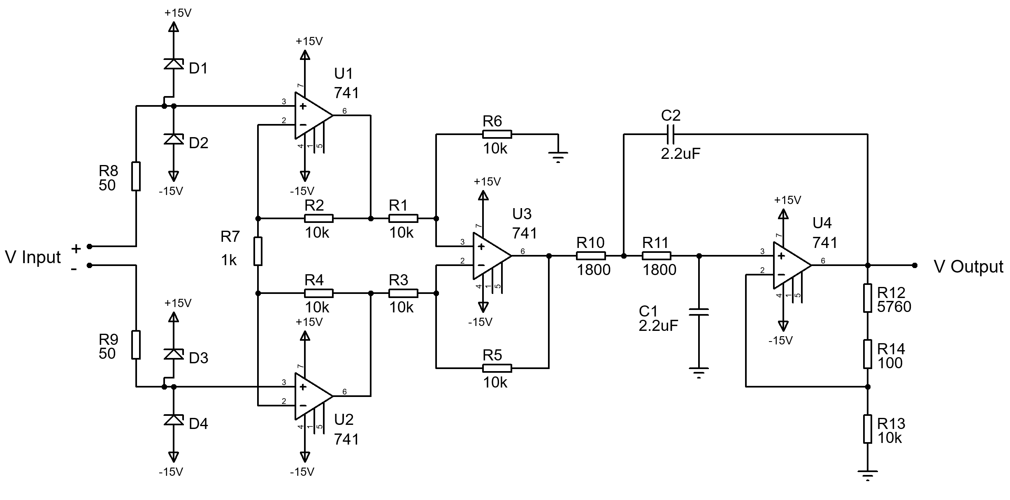
Fig Q2

- A digital voltmeter has a resistance of 500kΩ and is connected in parallel with the 2MΩ resistor in figure Q3.
  - What would the true voltage across the 1MΩ resistor be if the voltmeter was not connected?
[4 Marks]
$$V_{Out}=V_{in}\frac{R_{B}}{R_{A}+R_{B}}$$

$$V_{Out}=10×\frac{2M}{500k+2M}=8 V$$

  - Assuming the voltmeter is calibrated correctly, what is the reading shown by the voltmeter?
[5 Marks]
The voltmeter will appear as a 500kΩ resistor in parallel with the 2MΩ resistor reducing the overall resistance of the bottom resistor.

$$R_{equiv}=\frac{2M×500k}{2M+500k}=400 kΩ$$

$$V_{Meas}=10×\frac{400k}{500k+400k}=4.444 V$$

  - State one method of making the voltmeter more accurate.
[5 Marks]
Any argument to support increasing the resistance of the voltmeter thus reducing the loading on the circuit, causing the reading on the voltmeter to be closer to the actual value of voltage.
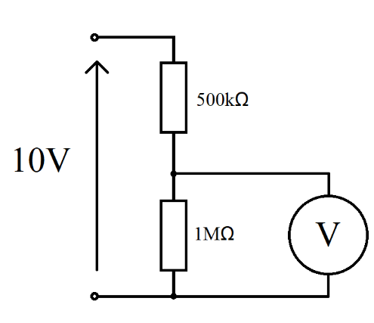
2MΩ
Figure Q3

- A load cell is calibrated in an environment at a temperature of 21 °C and has the following deflection / load characteristics:

Load (kg) | 0 | 25 | 50 | 75 | 100
Deflection (mm) | 0.0 | 1.0 | 2.0 | 3.0 | 4.0

When used in an environment at 35 °C, its characteristic changes to the following:

Load (kg) | 0 | 25 | 50 | 75 | 100
Deflection (mm) | 0.2 | 1.3 | 2.4 | 3.5 | 4.6

- Plot the load cell characteristics for both temperatures.
[6 Marks]
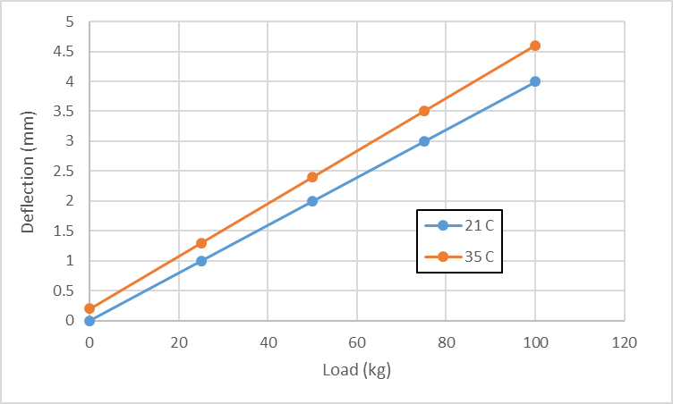
Marks awarded for: Correct data (2), appropriate scale (1), axis labels and units (3)

- Determine the sensitivity at 21 °C and 35 °C.
[5 Marks]
At 21°C:
$$\frac{4}{100}=0.04 {mm}/{kg}$$
At 35°C:
$$\frac{4.6-0.2}{100}=0.044 {mm}/{kg}$$

- Calculate the total zero drift and sensitivity drift at 35 °C in units of (µm/°C) and (µm/kg)/°C
[5 Marks]
Temperature difference = 35-21 =14°C

Change in zero = 0.2 – 0 = 0.2 mm
Zero drift coefficient = 0.2/14 = 0.0143 mm/°C = 14.3µm/°C

Change in sensitivity = 0.044-0.04 = 0.004 mm/kg
Sensitivity drift = 0.004/14 = 0.000286 (mm/kg)/ °C = 0.286 µm/kg/°C

- Explain what methods could be used to reduce noise when transmitting transducer signals using wires in a noisy environment. Give an example circuit and explain how it works.
[10 Marks]
Twisted pair cables can be used to reduce noise as any noise will be induced equally on both conductors. This common mode noise can be removed using a difference amplifier.
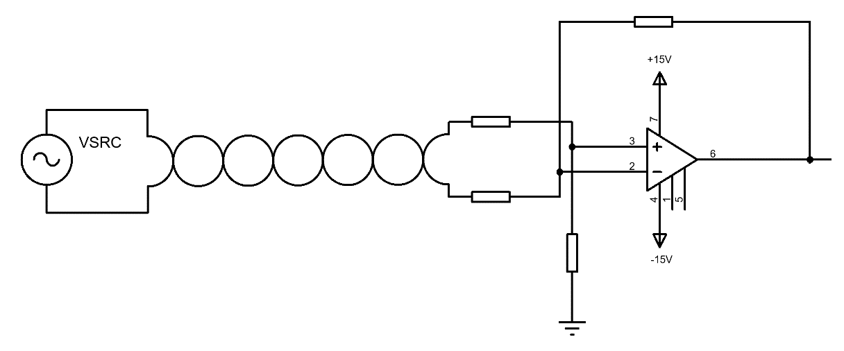

- Explain the need for and the process of calibration.
[10 Marks]
An instrument will only conform to its given specifications after it has been calibrated.
It can normally be assumed that a new instrument will have been calibrated by the manufacturer prior to sale.
Over time and through use the operating characteristics of the instrument will change causing its behaviour to gradually deviate from the specifications for a variety of reasons.
There will come a time when the instrument will have drifted from its original specification by an unacceptable amount. When this situation is reached it is necessary to recalibrate back to the standard specification.
During calibration
Calibration is usually performed by adjusting the instrument at each point in its output range until its output readings are the same as those of a second-standard instrument to which the same inputs are applied.
The second instrument is one kept solely for calibration purposes and whose specifications are accurately known.

- Compare and contrast the requirements and specifications for a temperature sensor for the following applications:
  - Air temperature measurement for a weather station
  - Coolant temperature of a car engine.
[10 Marks]
An accurate description of the specifications required for each application. These should include: measurement range, precision, sensitivity, linearity, cost, environmental compatibility, resolution, drift coefficients. The actual values given for parameter are not of absolute importance, more important is the student’s ability to discern the required differences for the transducer in each application.

Parameter | Weather Station | Car Engine
Measurement Range | -50 to +50°C | +40 to +120°C (But must be able to withstand sub-zero temperatures without providing accurate measurements)
Precision | Needs to be fairly precise as it is a scientific instrument | Does not need very high level of precision as only for indication purposes
Sensitivity | Should have high sensitivity | Sensitivity
Linearity | Should be highly linear | Linearity not as important
Cost | Medium | Low
Environmental compatibility | Must be able to measure gas temperature | Must be able to be submerged in hot non-corrosive liquid
resolution | High resolution | Low resolution
Drift coefficients | Very low drift | Low drift

Diwedd/End

