21/11/2025
University of Wales Trinity Saint David
London campus
Assignment 1
Learning in the Digital Era

E-PORFOLIO LINK:
https://25184308.wixsite.com/lde-portfolio

Module Name: Learning in the Digital Era IEEE referencing
Module Code: ACCA 4025

Student Name: Freddy Eduardo Carrion Iniguez
Student ID: 2518430
Group No: 1

Lecturer’s Name: Koushik Modak
Submission Deadline: 21st November 2025
Contents
INTRODUCTION 2
Main Body 2
Task 1: Written Summary and IEEE Referencing 2
Task 1(a): Essential Skills for study and employment with IEEE referencing 2
Task1(b): Similarity Report Analysis 4
Task 2: Collaborative Teamwork and Professional Academic poster (A3 Poster) 6
Mind map 6
https://www.mindmeister.com/app/map/3844893756 6
Task 3: Virtual Collaboration 8
Evidence of Automatic Referencing: 12
Task 4: E-Portfolio 31
Conclusion 34
References Task 1 35
References Task 3 35

INTRODUCTION

Main Body

Task 1: Written Summary and IEEE Referencing
Success in contemporary study and work depends on a small set of transferable capabilities that turn knowledge into reliable output. Four are foundational: disciplined time management, academic integrity with IEEE referencing, robust digital literacy for virtual collaboration, and precise communication in teams. Employers consistently rank these among the most valued behaviours across roles

Task 1(a): Essential Skills for study and employment with IEEE referencing

These skills focus on personal effectiveness, self-management, and academic excellence. Emphasizes the importance of reflection and experiential learning—the ability to learn from past assignments and professional experiences, which leads to continuous self-improvement. In any business role you’ll analyse situations like financial statements, market trends. You must be able to sell your ideas. Teamwork skills is a good contribution for a group [1].
[2].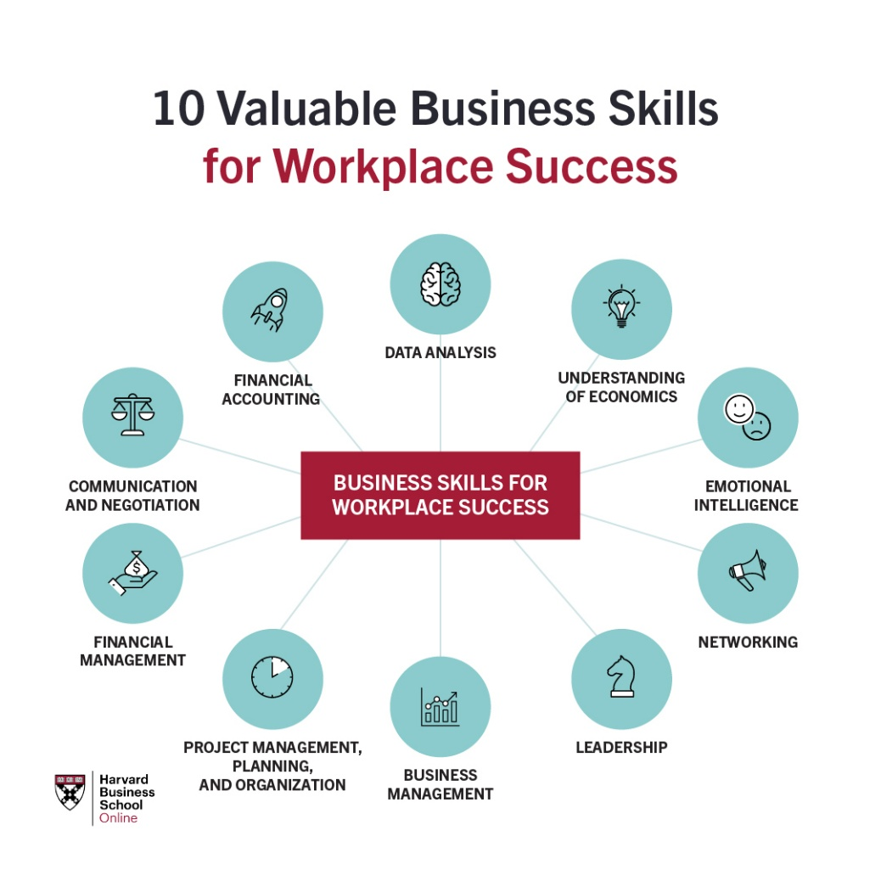
Figure 1 Essential Study and employment skills for business and management students
The Skills Imperative 2035: Essential skills for tomorrow's workforce, investigates how the UK labour market and the skills needed for success will change by 2035, driven by major factors like new technologies (AI and automation), demographic shifts, and environmental changes. The literature review and subsequent projections highlight that while foundational literacy, numeracy, and technical/digital skills remain important, it is a set of transferable human skills that will become increasingly vital for study and employment. Allows you to work with diverse teams locally and globally. These are the ultimate non-routine human tasks [2].
[4]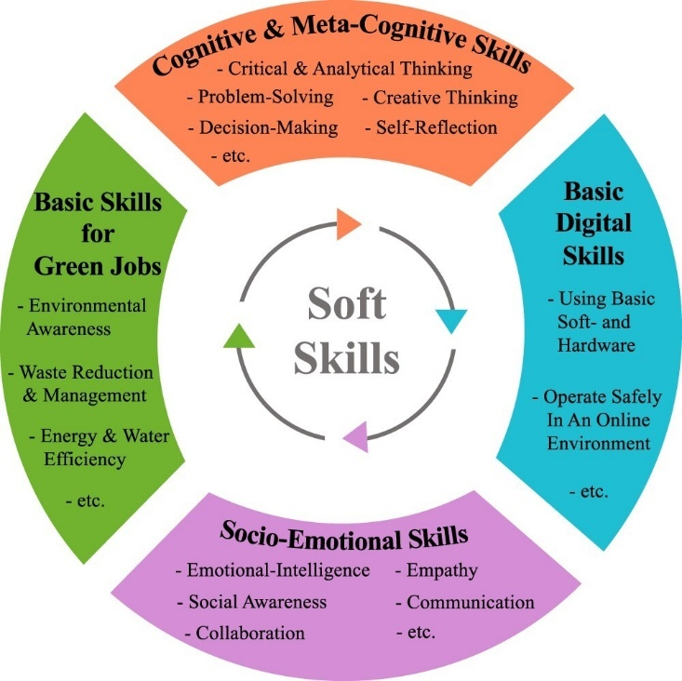
Figure 2 Soft skill framework according to ILO (Citation2021).

While employers highly value the core research and analytical abilities of social science PhD holders, along with their subject-specific knowledge. Your advanced research skills particularly the ability to draw together, analyse and evaluate the information [3].
[6]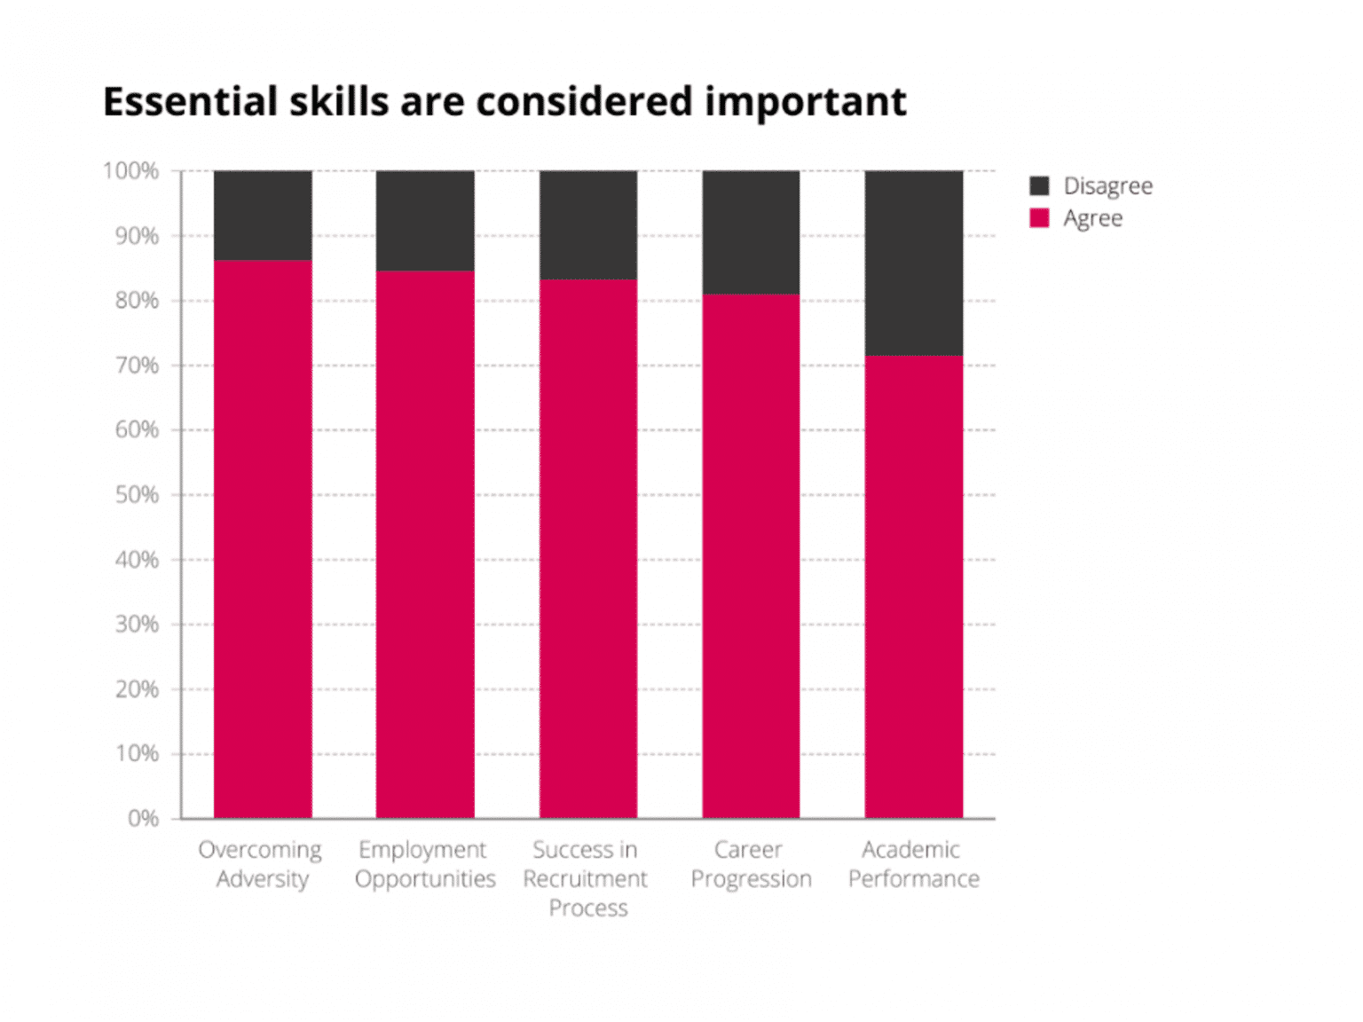
Figure 3 The employment of social science PhDs in academic and non-academic jobs.
The strong literacy and essential skills provide the versatility, clarity, and competence needed to handle both the routine and the unexpected challenges of a professional career, ensuring you can communicate complex information, solve problems, and lead effectively. The application in our chosen career is necessary for budget management to calculating resources, tracking project metrics, and managing financial forecasts. Technology to used daily for managing project software, using collaborations tolls and securing digital documents [4].
[8]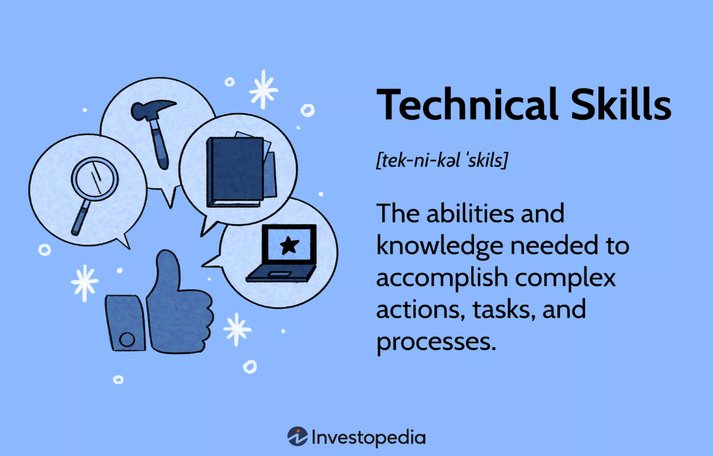
Figure 4 TheCentreforLiteracy Le centre alphabetisation,” in Embedding literacy and essential skills in workplace learning: Breaking the solitudes
Computer skills, programming languages, data analysis, and web development are considered technical skills. Joules Garcia / Investopedia.

Task1(b): Similarity Report Analysis

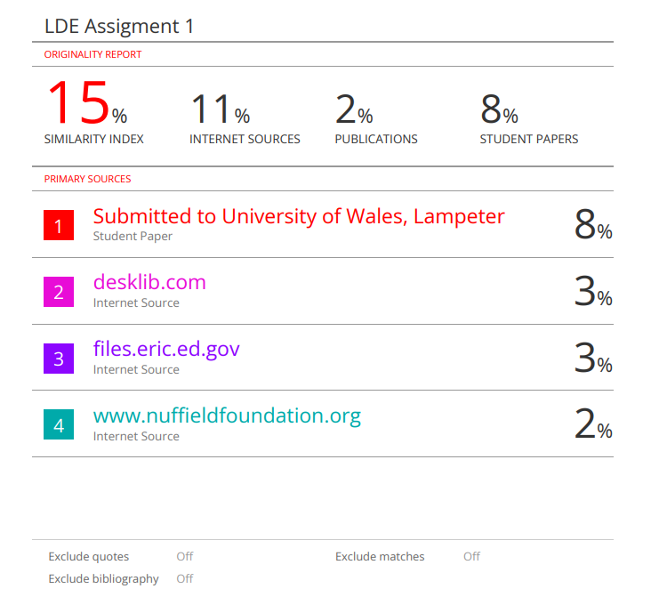

My current similarity score is 15%. This is okay, but it shows I still used some phrasing from the original text. Next time, to get a better score, I'd aim for 10% or lower. I will focus on completely changing the structure of sentences and replacing key terms with my own words, even when referencing a source. This makes sure the writing is truly independent.

Based on the Generic Assessment Criteria, I would award this submission 78% out of 100%. I chose this high mark because the summary fully answered the task, used clear language, and the IEEE citations were included correctly. To reach a higher mark (like 80%+), the writing would need to include more of my own critical thoughts and deeper analysis, rather than just summarizing the given points.

Task 2: Collaborative Teamwork and Professional Academic poster (A3 Poster)

Mind map

https://www.mindmeister.com/app/map/3844893756

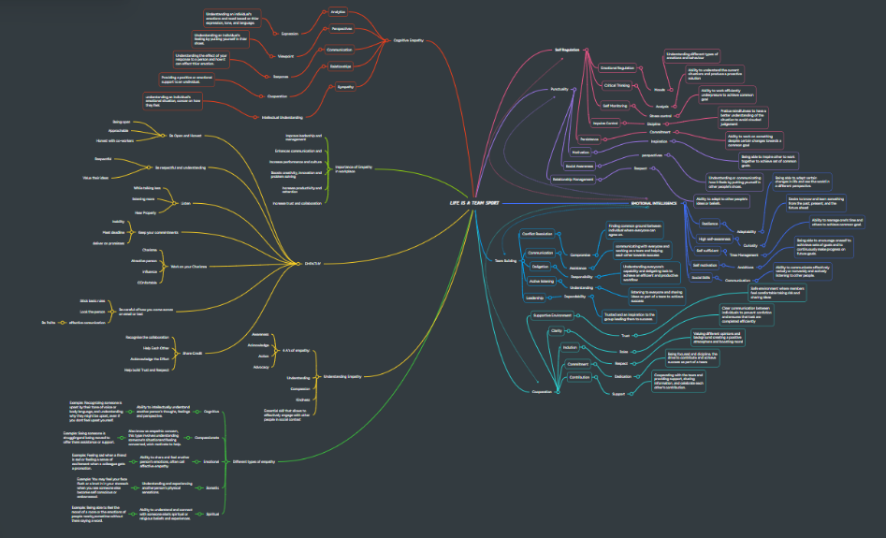

Poster A3:

https://www.canva.com/design/DAG4fzGfT6E/edmhh7bwc99kS65dxN9AOA/edit?utm_content=DAG4fzGfT6E&utm_campaign=designshare&utm_medium=link2&utm_source=sharebutton

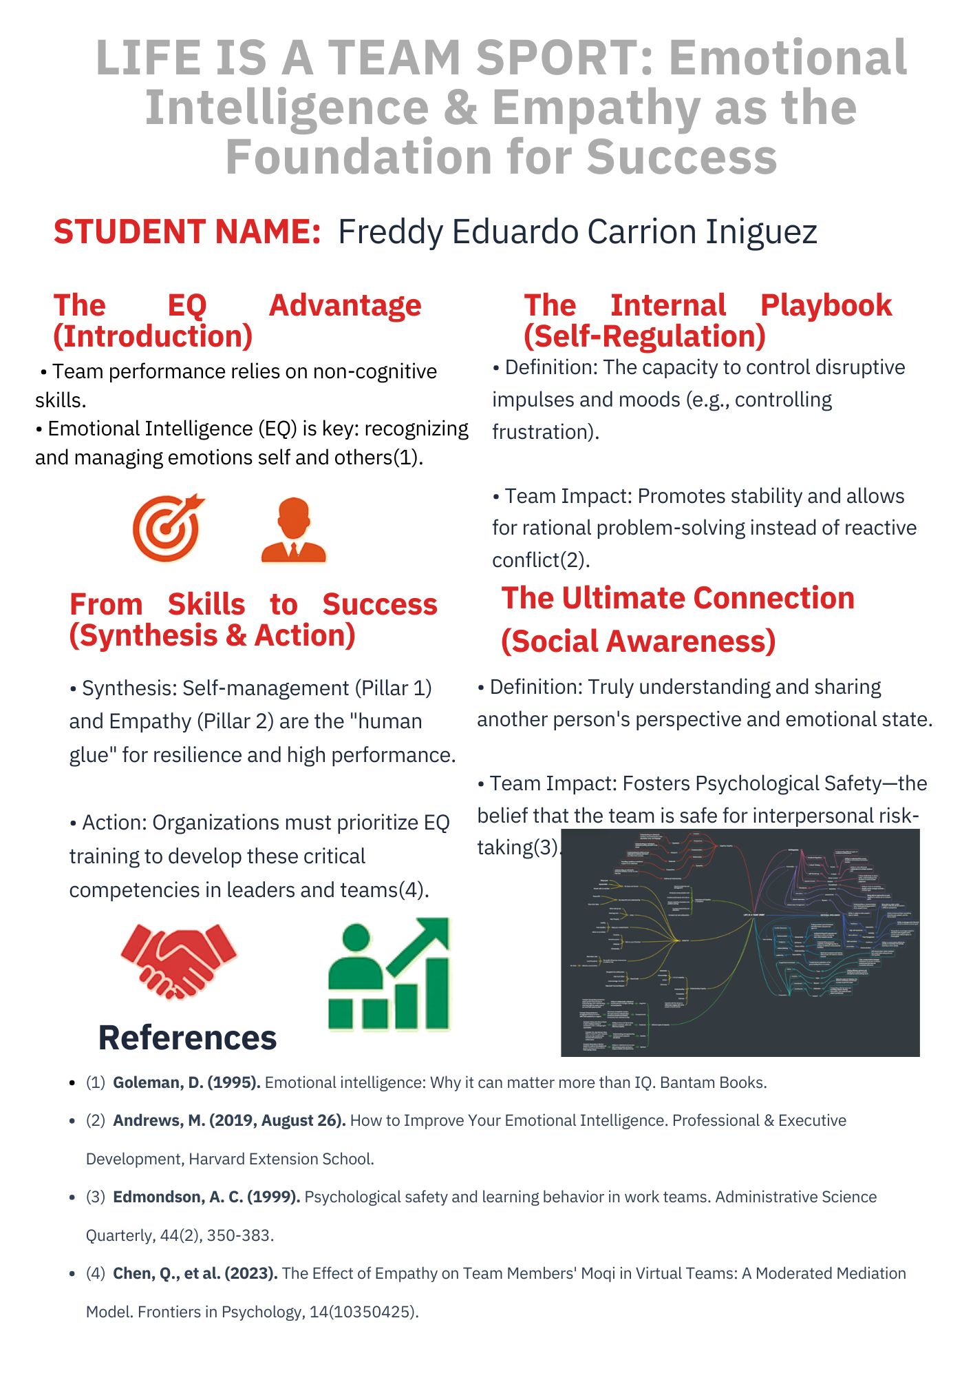

Task 3: Virtual Collaboration

The New Norming

The Norming stage is the third phase in Tuckman's Stages of Group Development (Forming-Storming-Norming-Performing-Adjourning). It marks a transition from conflict to cohesion as the team begins to establish a unified working structure and a sense of shared purpose.

- Shared Workspaces

The core function of visual information within Virtual Collaboration shared workspaces is to deliberately cultivate a sense of virtual co-presence, thereby making remote teamwork more intuitive and efficient. By providing a shared visual space—such as a persistent digital whiteboard, co-editable documents, or immersive 3D environments—collaborators gain a mutual understanding of the task's current state and a better awareness of their colleagues' activities. This shared visual context replicates the spatial and sensory cues of a physical office, enabling natural, spontaneous communication and "low friction" collaboration that is crucial for complex problem-solving, real-time feedback, and ultimately, better task performance[1].

[1]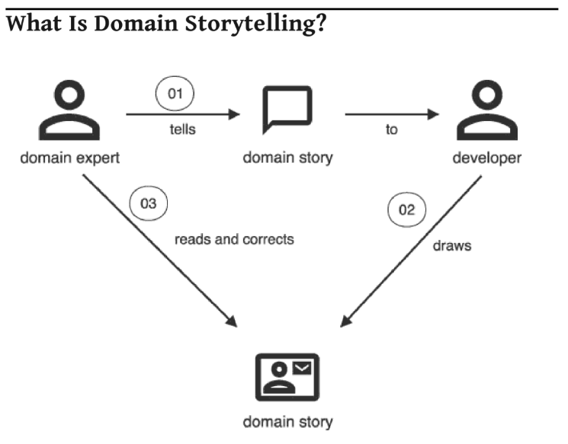

- Visual Collaboration in Meetings

Visual collaboration tools like graphics, sticky notes, and idea mapping are transforming both in-person and virtual structured meetings by making group work more engaging, productive, and clear. By externalizing ideas visually—moving beyond words alone—teams can unlock creative thinking, establish a shared frame of reference more easily, and increase participation from all members, not just the loudest voices. This visual language facilitates breakthrough thinking, helps clarify complex ideas, and accelerates decision-making, ultimately leading to better results and greater commitment from the group, whether collaborating synchronously or asynchronously[2].

[2]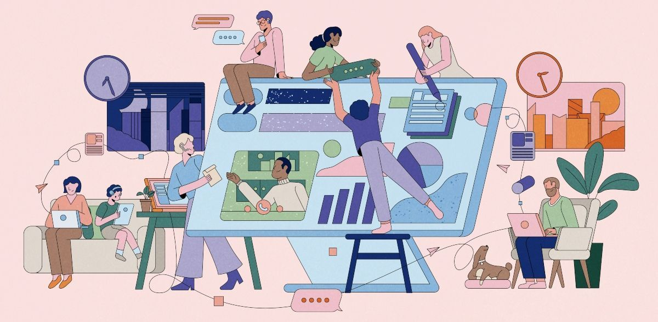

- Psychological Safety

Establishing psychological safety is paramount for overcoming collaboration barriers and fostering learning in diverse virtual teams. Psychological safety, defined as a shared belief that the team environment is safe for interpersonal risk-taking (like speaking up with ideas, concerns, or mistakes without fear of humiliation), is less likely to develop organically in virtual settings due to the lack of spontaneous, informal interactions and the absence of non-verbal cues. This safety is especially critical in diverse teams because it acts as a moderator, mitigating the potential negative effects of differences (e.g., in culture, background, or time zone) on communication and allowing team members to fully leverage their varied perspectives for enhanced collaboration, learning, and innovation. To create this safe space virtually, leaders must proactively focus on explicitly discussing ground rules, encouraging open communication, building trust, and actively modelling vulnerability and inclusion[3].
[3] 

- Tuckman Stages
The article "Virtual Collaboration Tuckman stages, Remembering the Titans: A Cinematic Pedagogy for Enhancing Understanding and Improving Performance in Tuckman's Stages of Group Development in Management Education" explores the effectiveness of using the film Remember the Titans as a cinematic pedagogy tool to teach Bruce Tuckman's Five Stages of Group Development (Forming, Storming, Norming, Performing, and Adjourning) to undergraduate management students, and its adaptability to virtual collaboration environments. The research, which utilized a quasi-experimental design over six semesters, found a statistically significant improvement in student performance on structured writing assignments after the film-based approach was implemented, compared to traditional lecture methods. The study concludes that integrating the captivating narrative of Remember the Titans, which clearly illustrates the team development stages through the formation of an integrated high school football team, is an effective multimedia strategy for enhancing student comprehension and engagement with abstract theoretical concepts like Tuckman's model[4].
[4]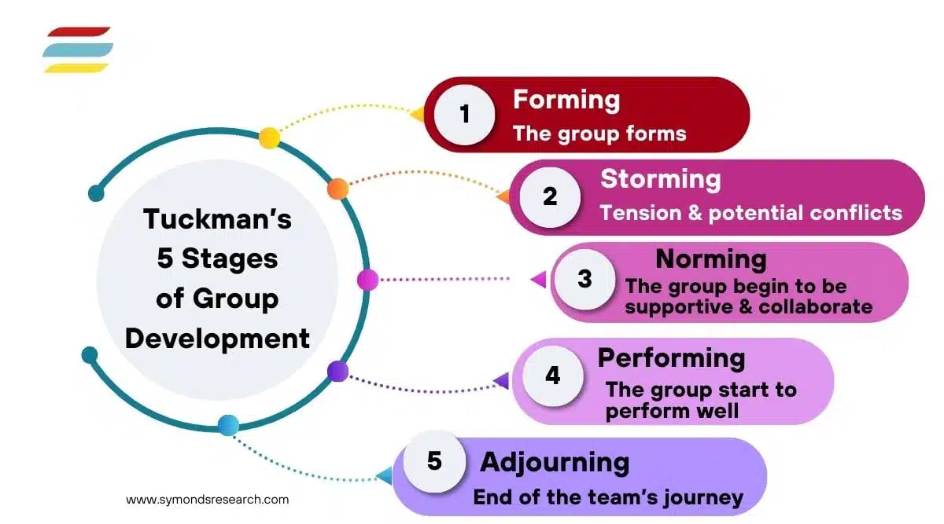

- Measure What Matters

Measure What Matters emphasizes the critical need to define and track meaningful goals within remote and hybrid team environments. Drawing on principles like the OKR (Objectives and Key Results) framework, this approach focuses on using transparent, measurable metrics to align teams, boost accountability, and ultimately drive high performance and success, even when team members are geographically dispersed.
A Powerful Toolkit for Improving Meetings, Projects, and Processes presents a systematic method for leveraging visual elements—such as drawing, diagrams, and specialized templates—to enhance teamwork. This toolkit helps teams manage complexity, translate abstract concepts into clear actions, and improve communication and engagement in meetings and projects by making ideas and processes more tangible, accessible, and inclusive for all participants[5].
[5]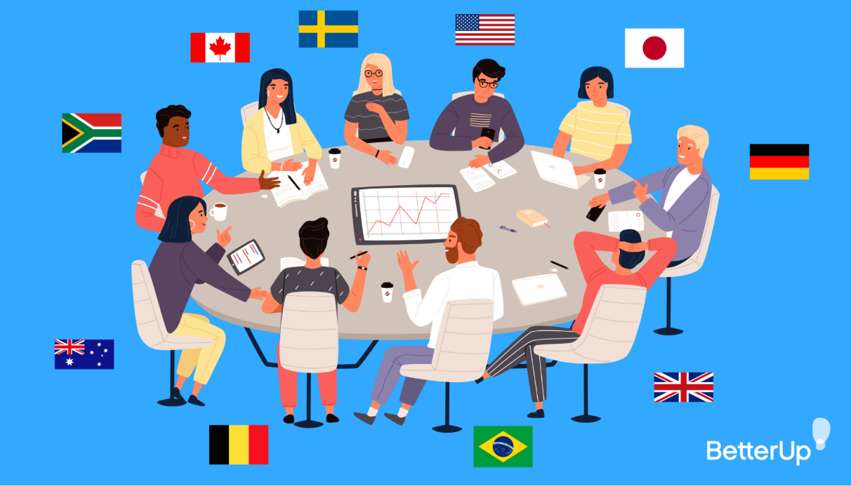

Evidence of Automatic Referencing:

First, we go to the browser and we open Google
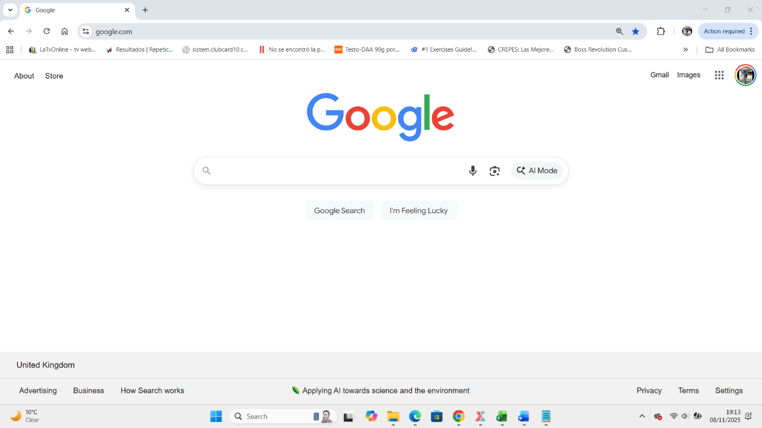

In the searcher we type RefWorks

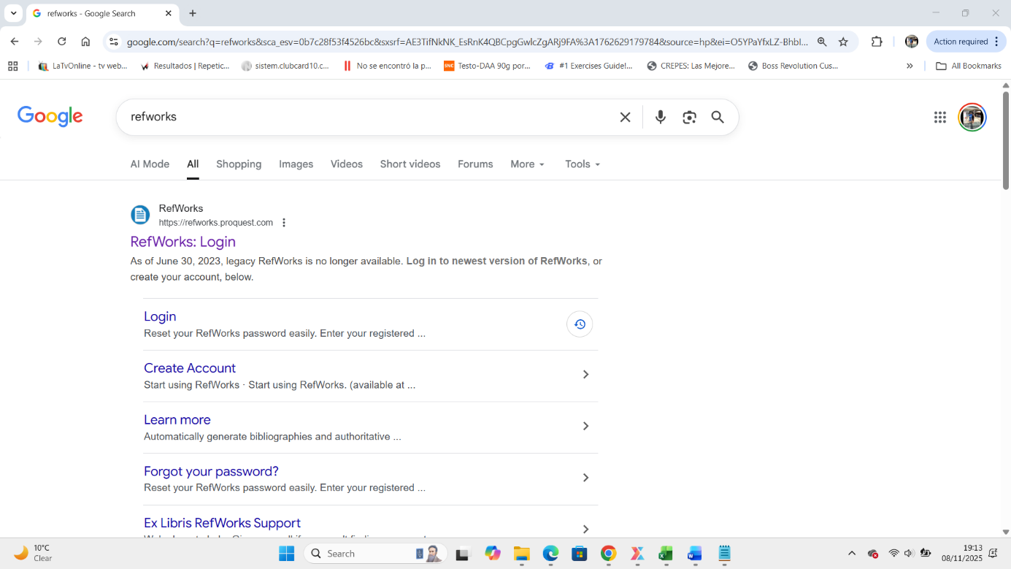

After we type RefWorks we press click in the first site

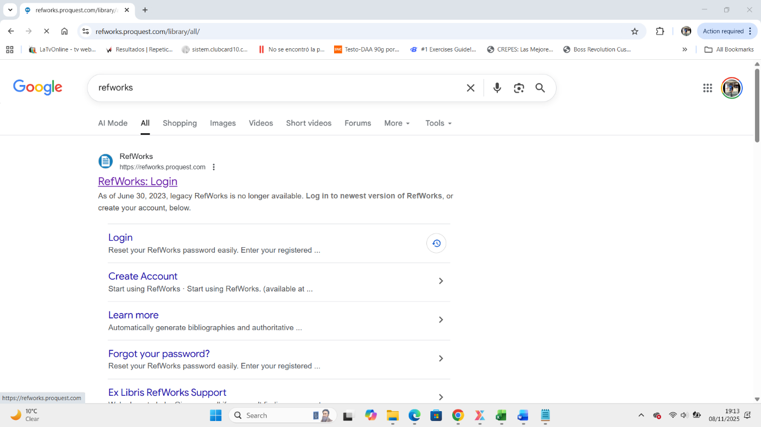

When we open the site The website open in the site

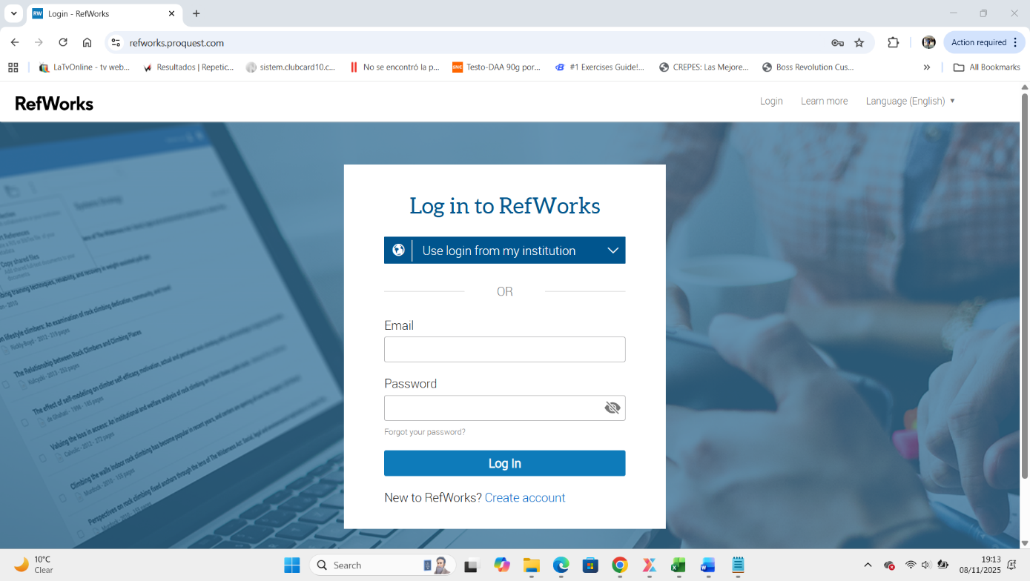

We need to put our University Email and Password

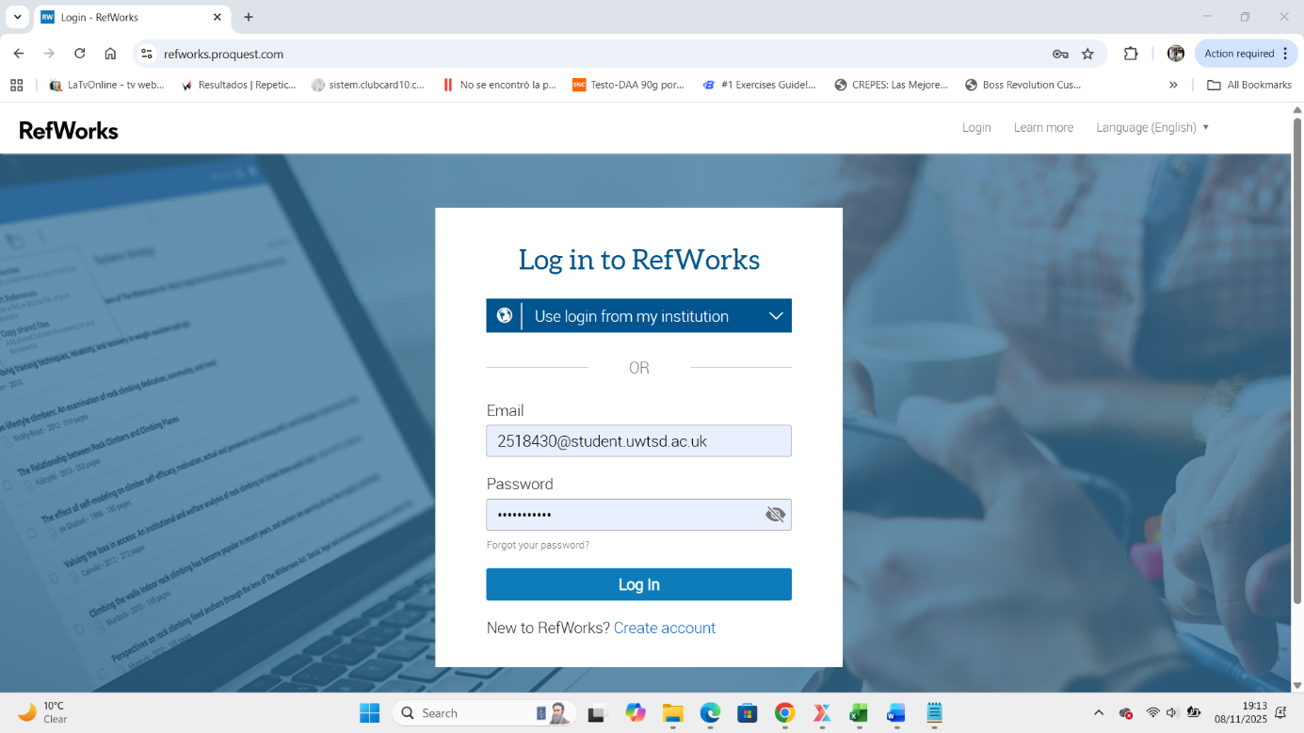

After we login we proced to open RefWorks

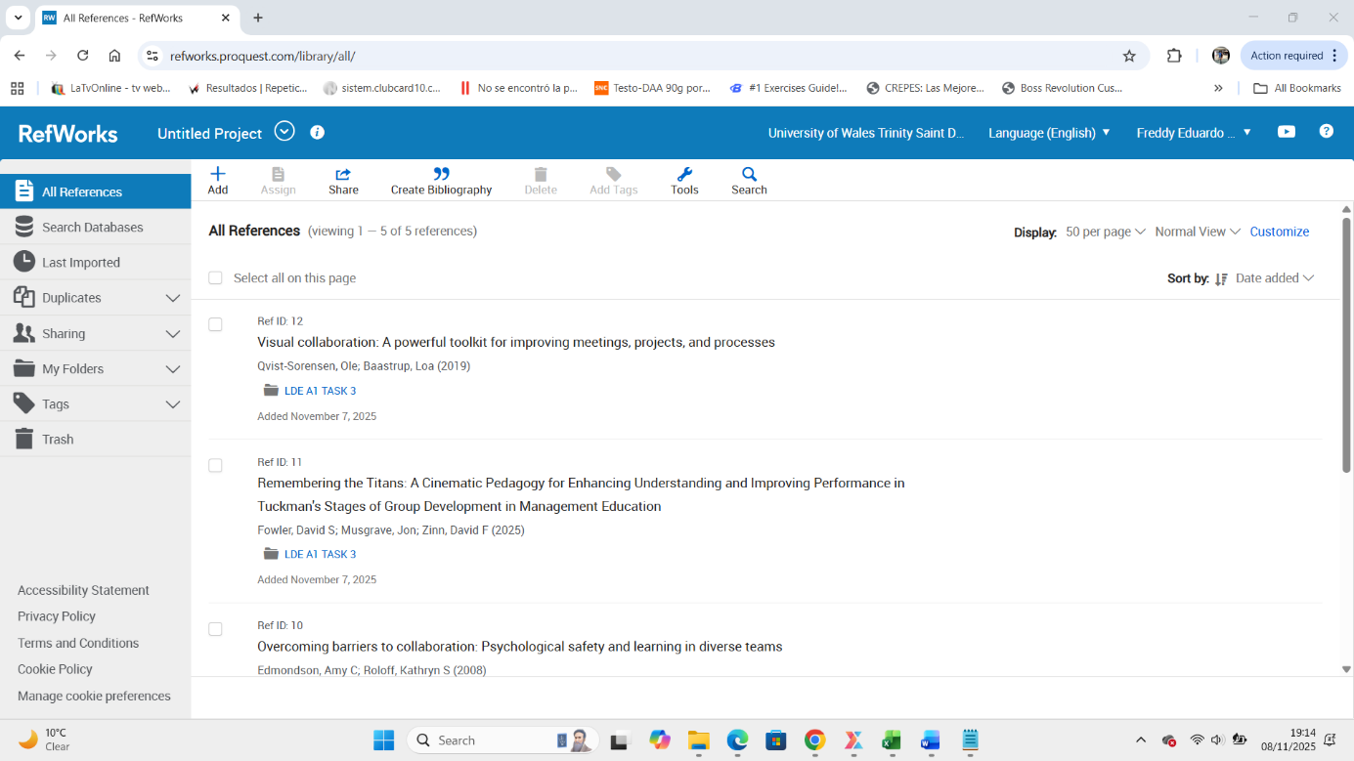
First Way

To add or create a new folder we can make by two ways, First we can press + ADD or the Second Way in the next graphic.

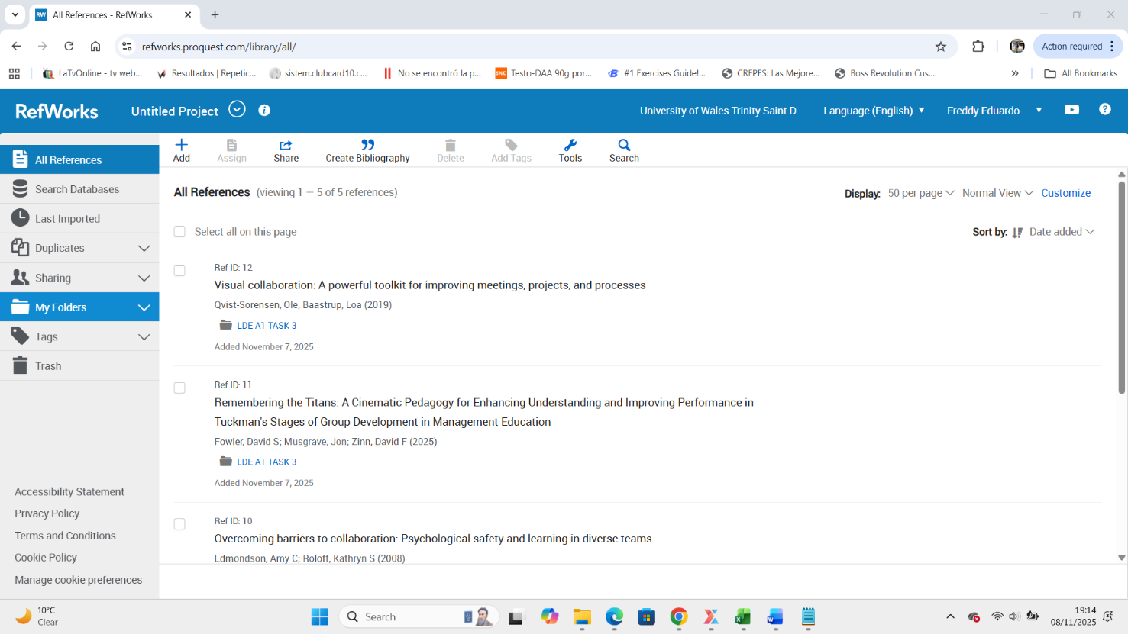
Second Way

The second way we can press into the Arrow My Folder

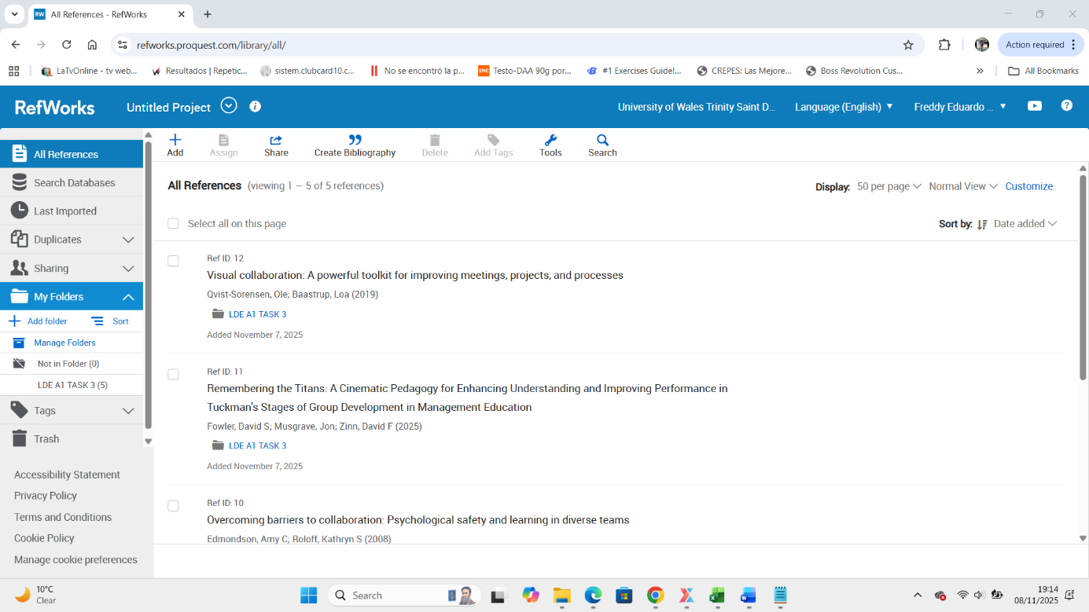

When you press add folder, you can add a name of folder

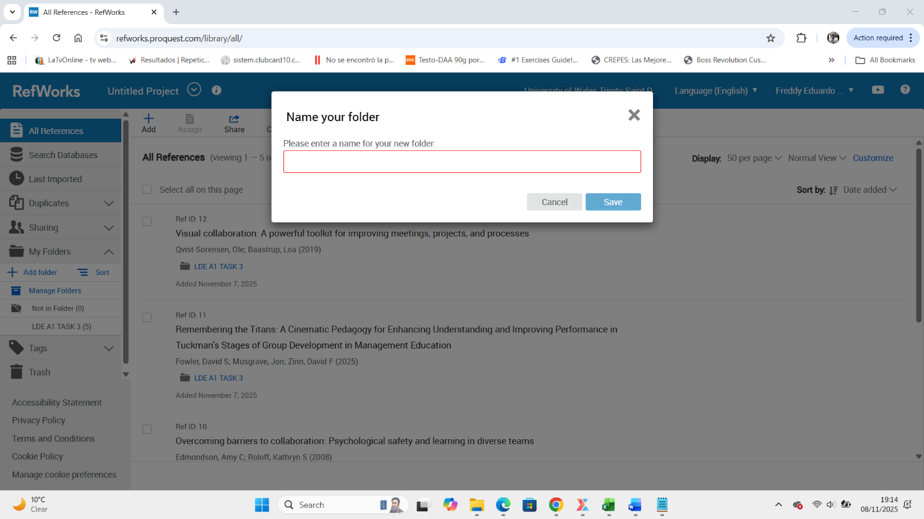

Type a name of the new folder

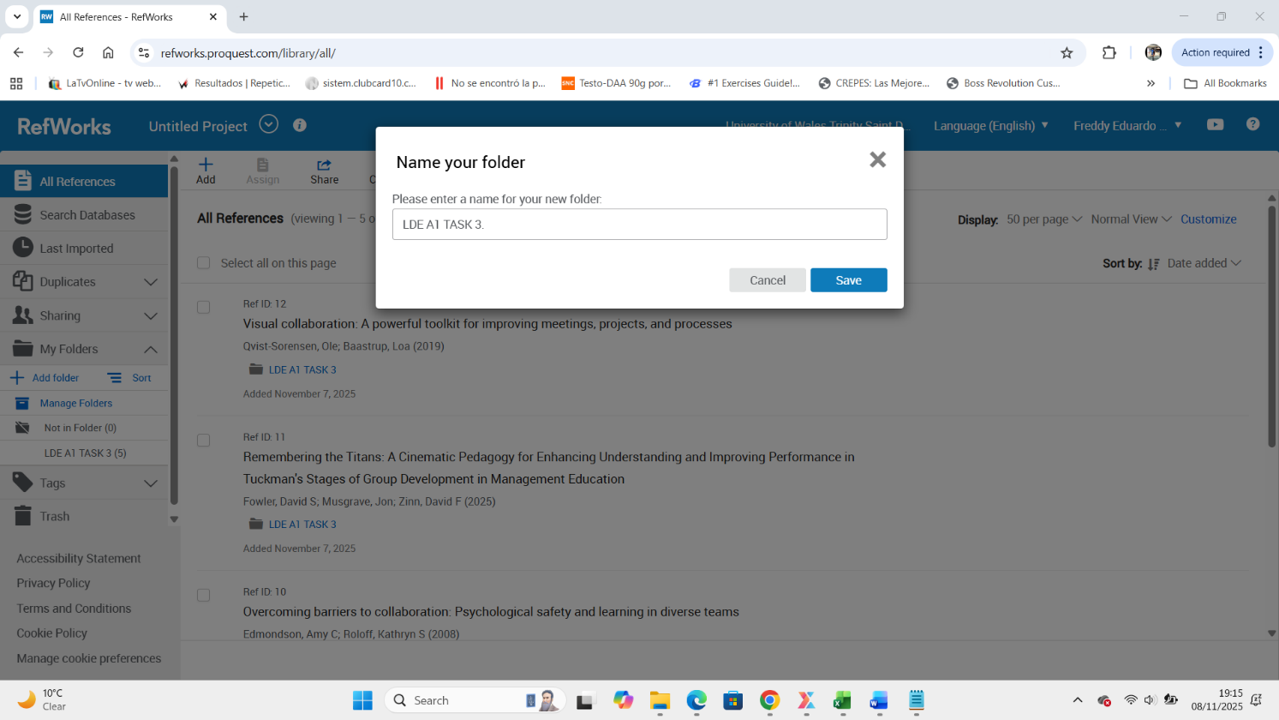

Now press Save
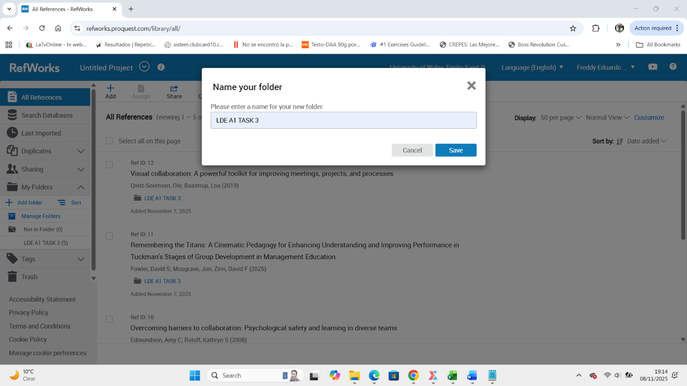

When we create a folder we can see. Now you can drop files or any kind of book from Google Scholar

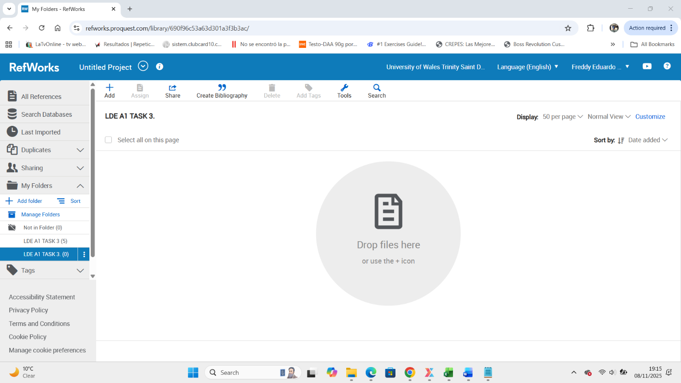
Drop from Google Scholar

Next, we will back to google and type Google Scholar in the browser

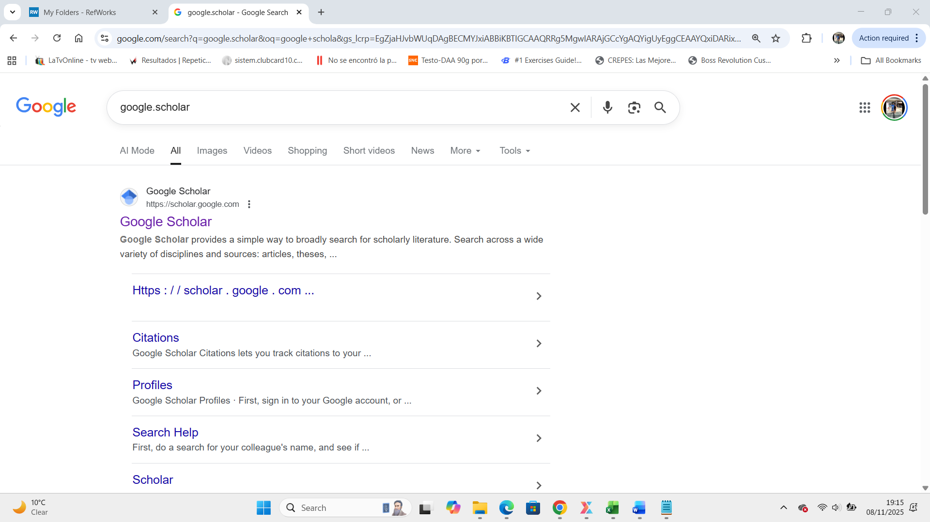

After we open google Scholar


Type book name

After type a book name.

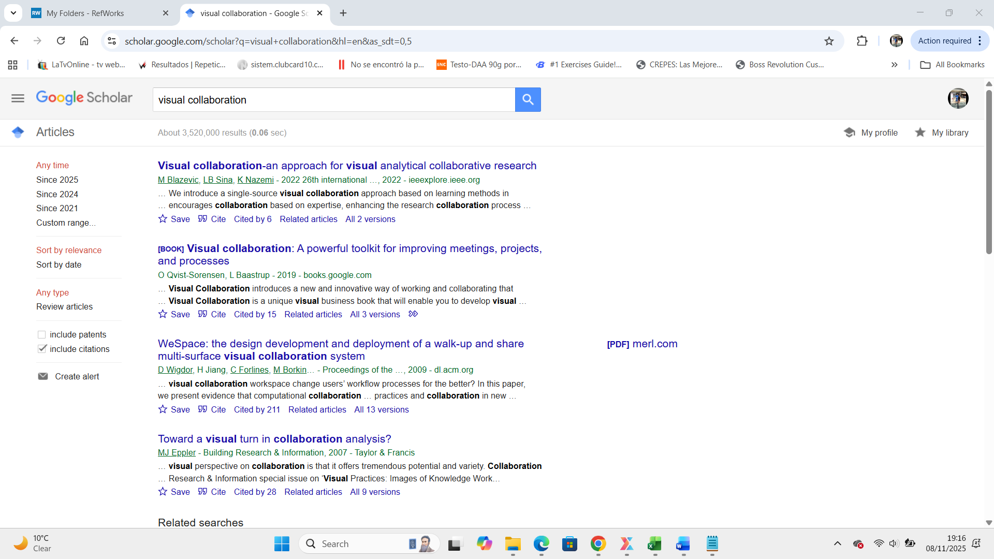

To add a book into RefWorks and click into “ Cite to open a site

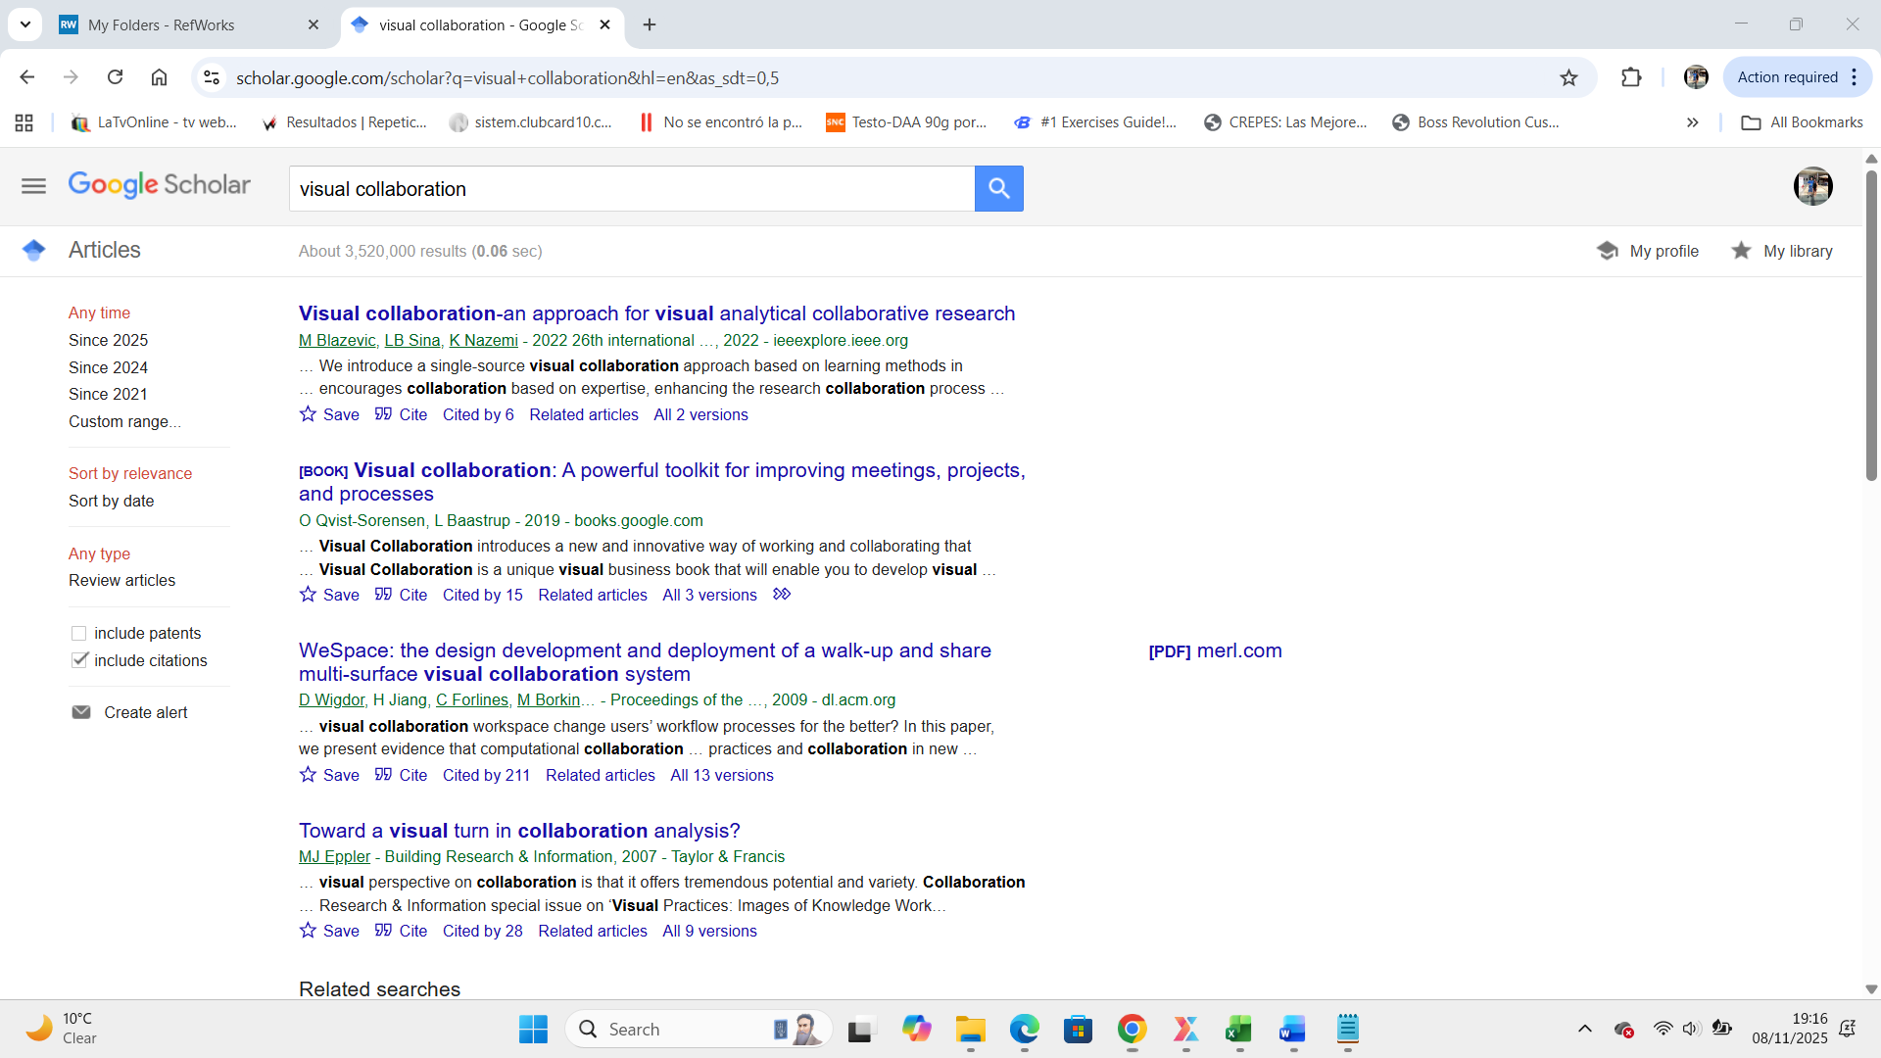

Open a new cite with names and press into RefWorks

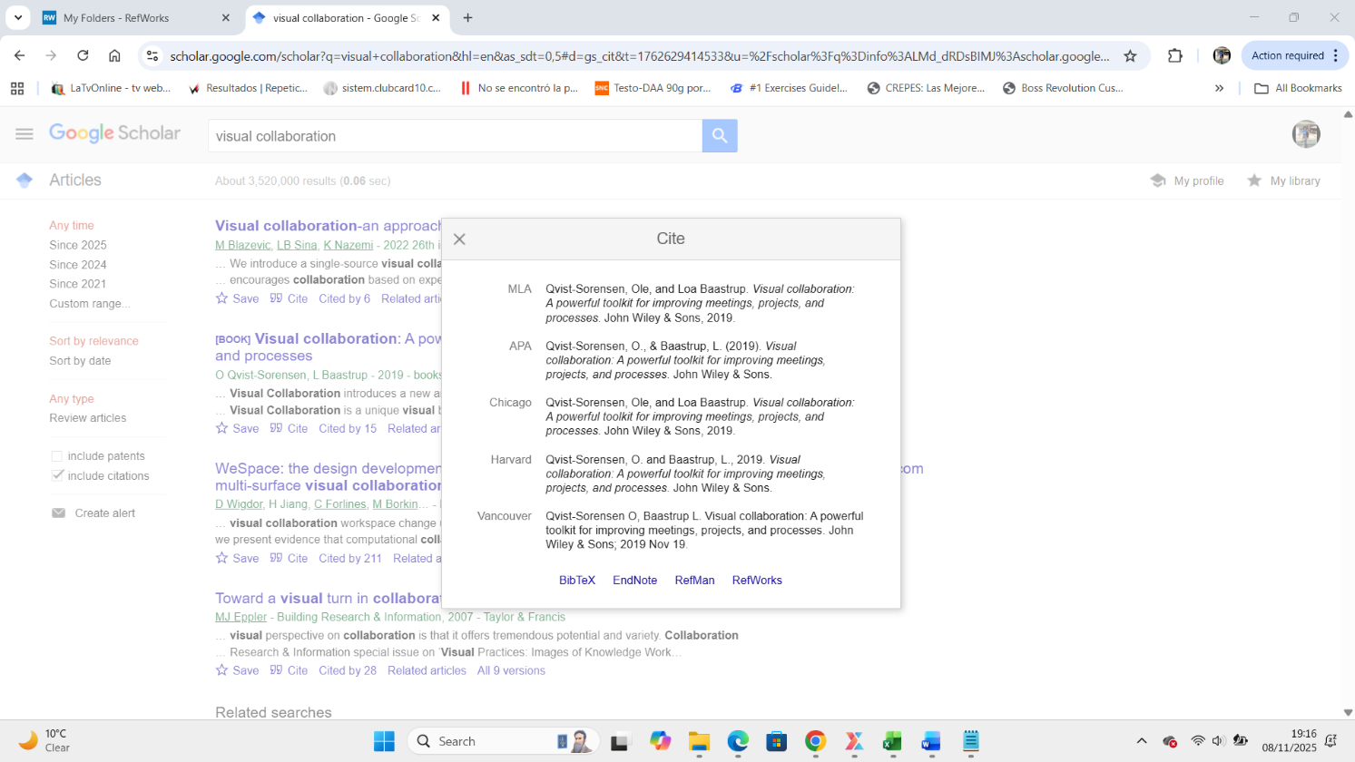

After press RefWorks open a new site

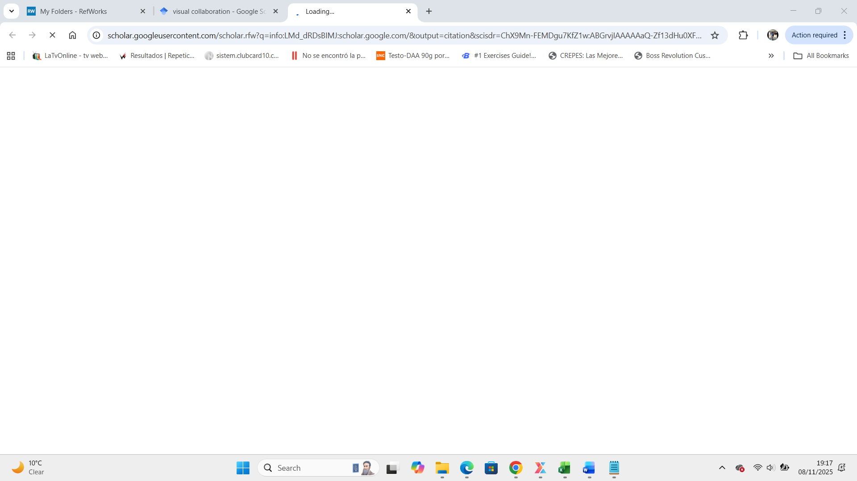

And open a RefWorks

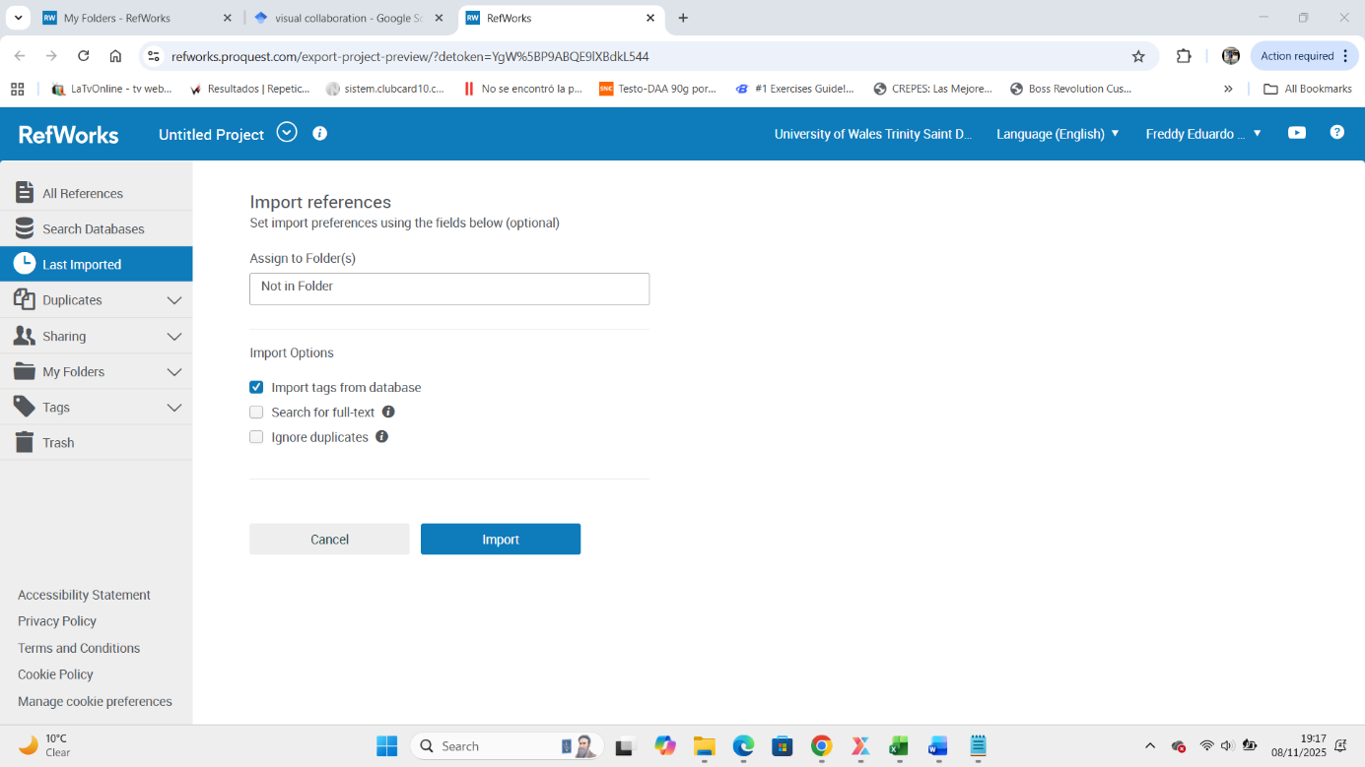

After select Folder and find folder name

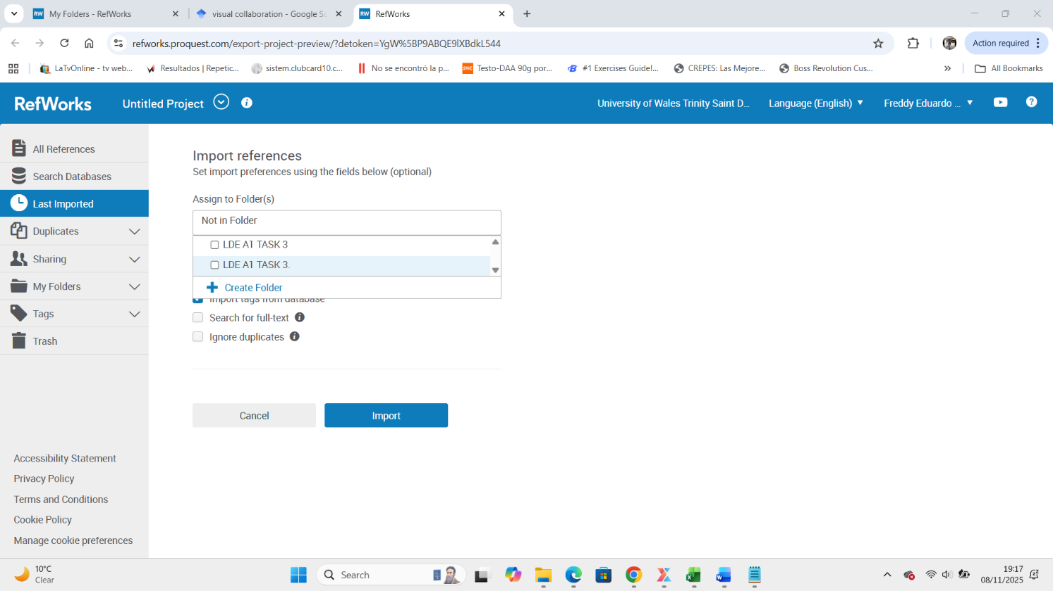
Click
Press Folder and find the folder name

After select the folder press Import
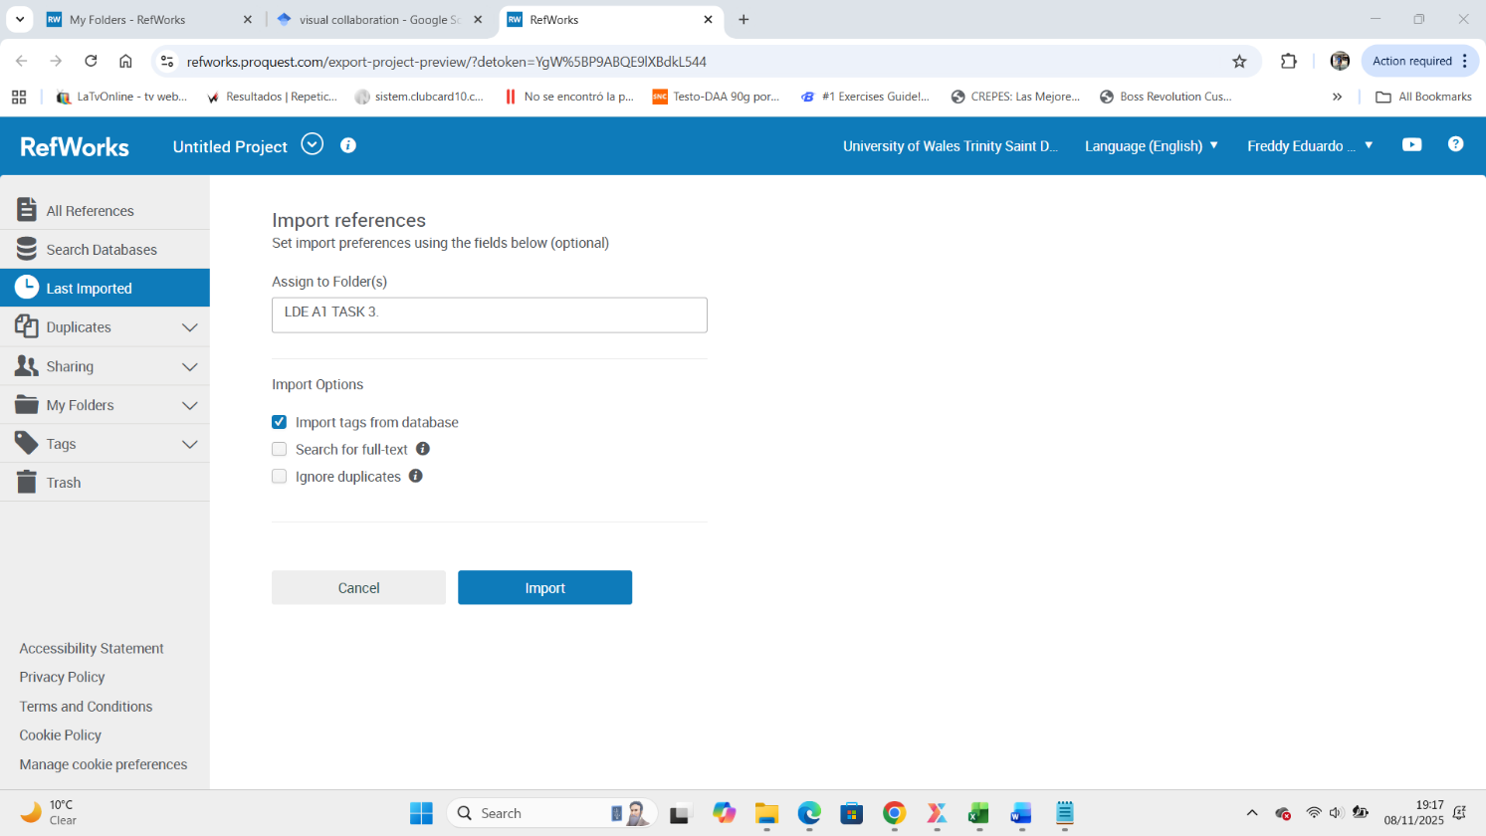
Press Import

And wait until the import complete.

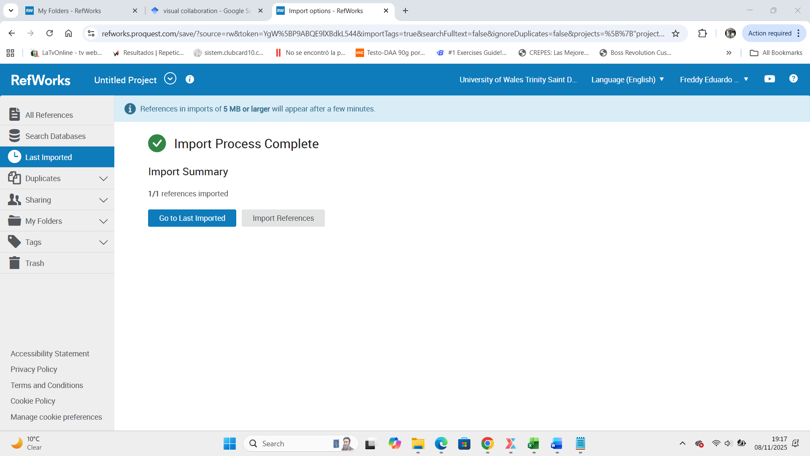

To Create a Bibliography, we select the folder

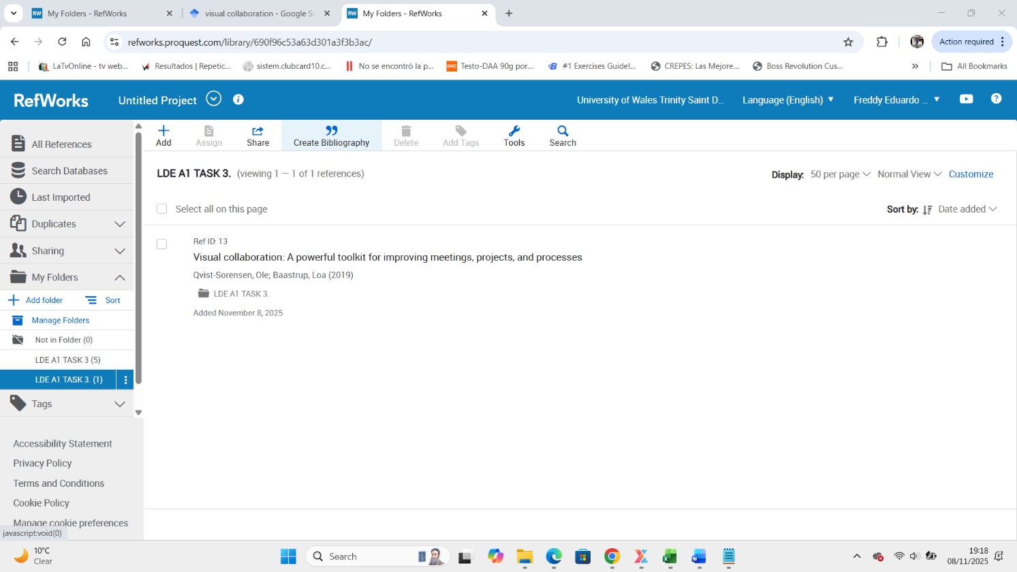
Select book
Select folder

After click into Create Bibliography, them we can select the correct type we find

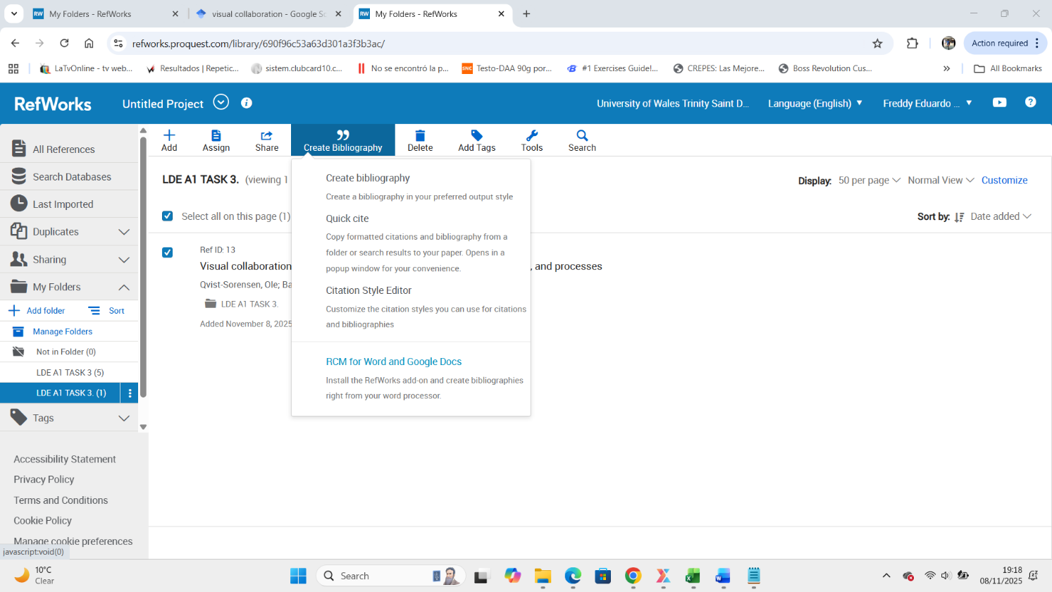
Select

Select the bibliography from select reference and click copy clipboard

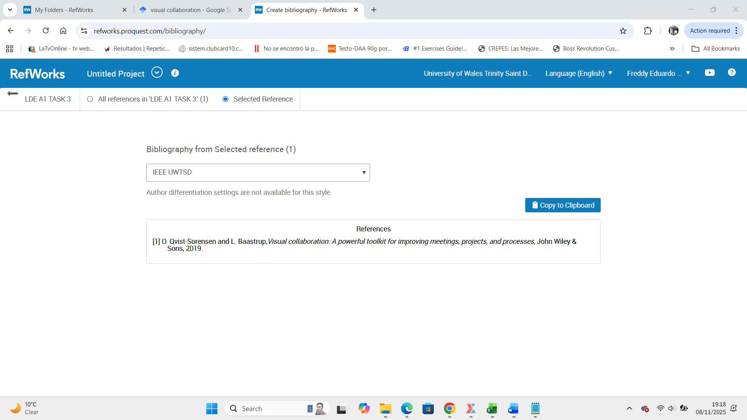
Click

And already clipboard to add paste into word.

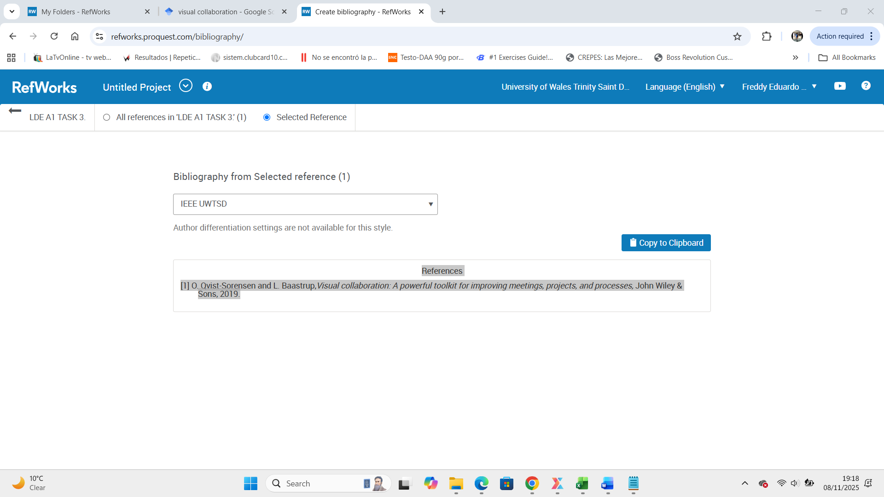

Now we open a word

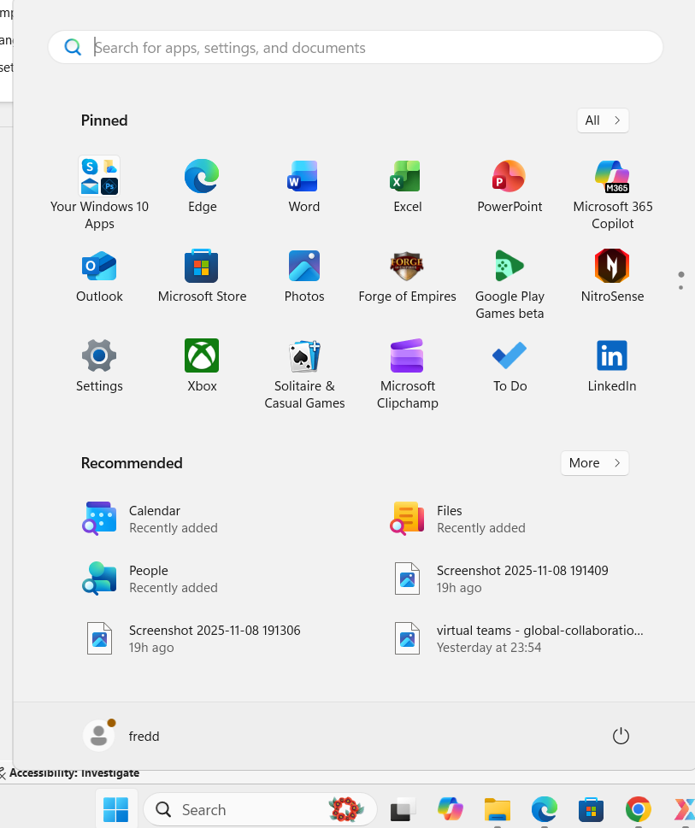
Open Word
Click Home

Open new file

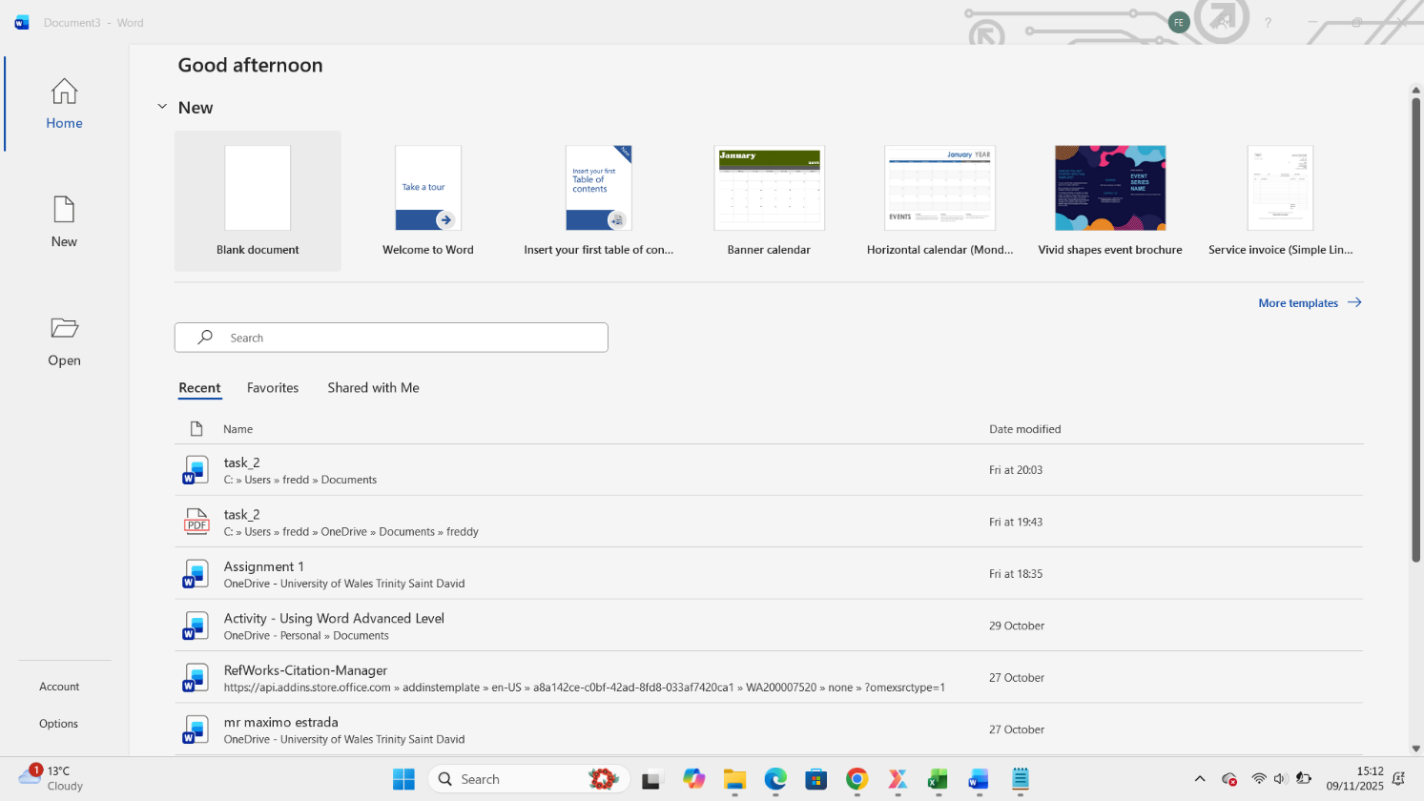
Open New Document

Now word folder is open, now press RCM
Open
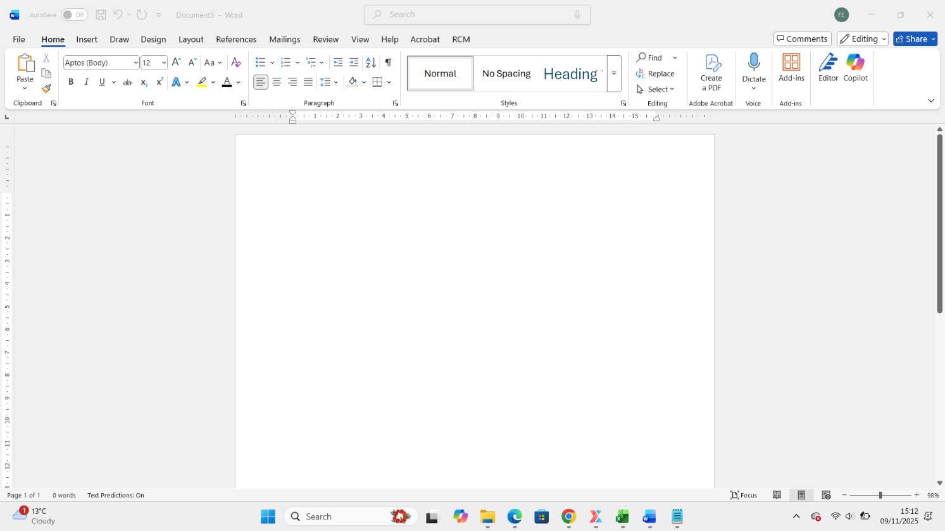

Now you can see in the corner RW RefWorks citation Manager and click

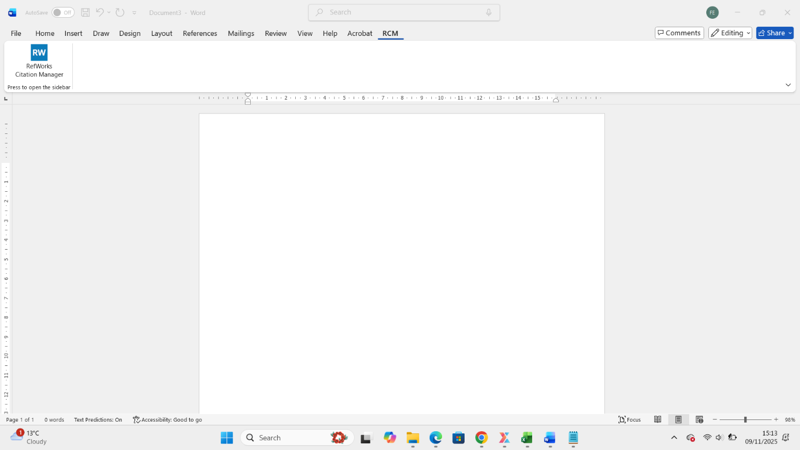
Click

After click RefWorks see in your right side and login with your email and password
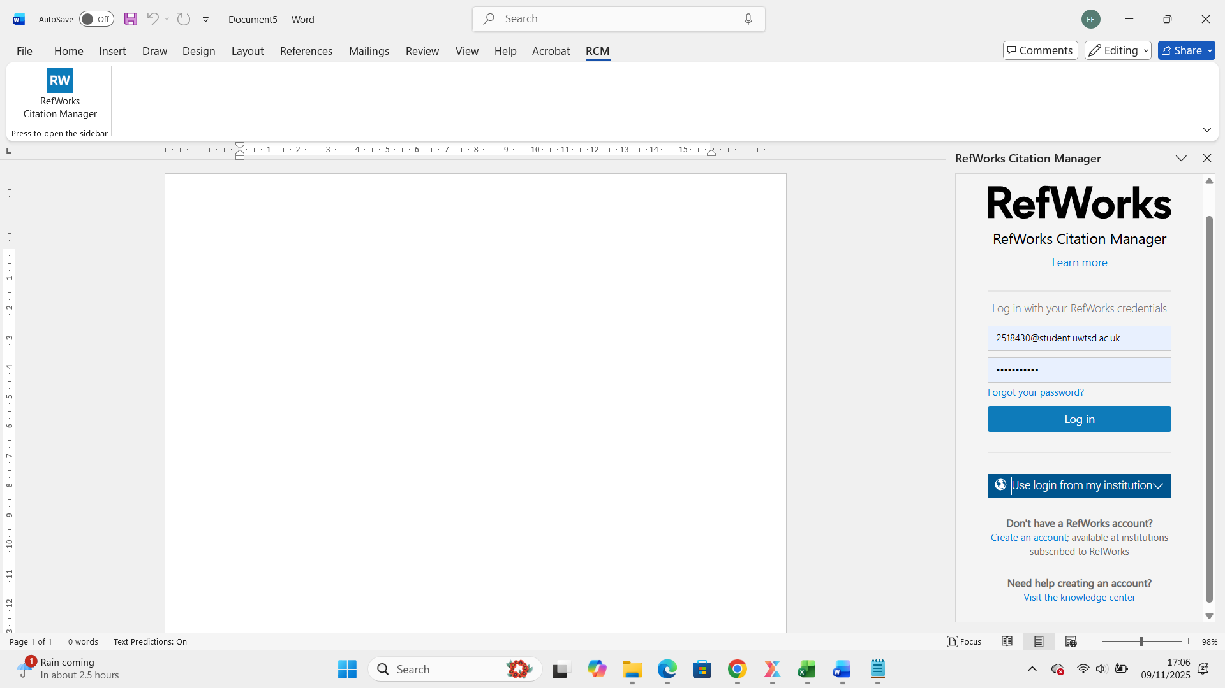
Login

Now open a RefWorks citation Manager

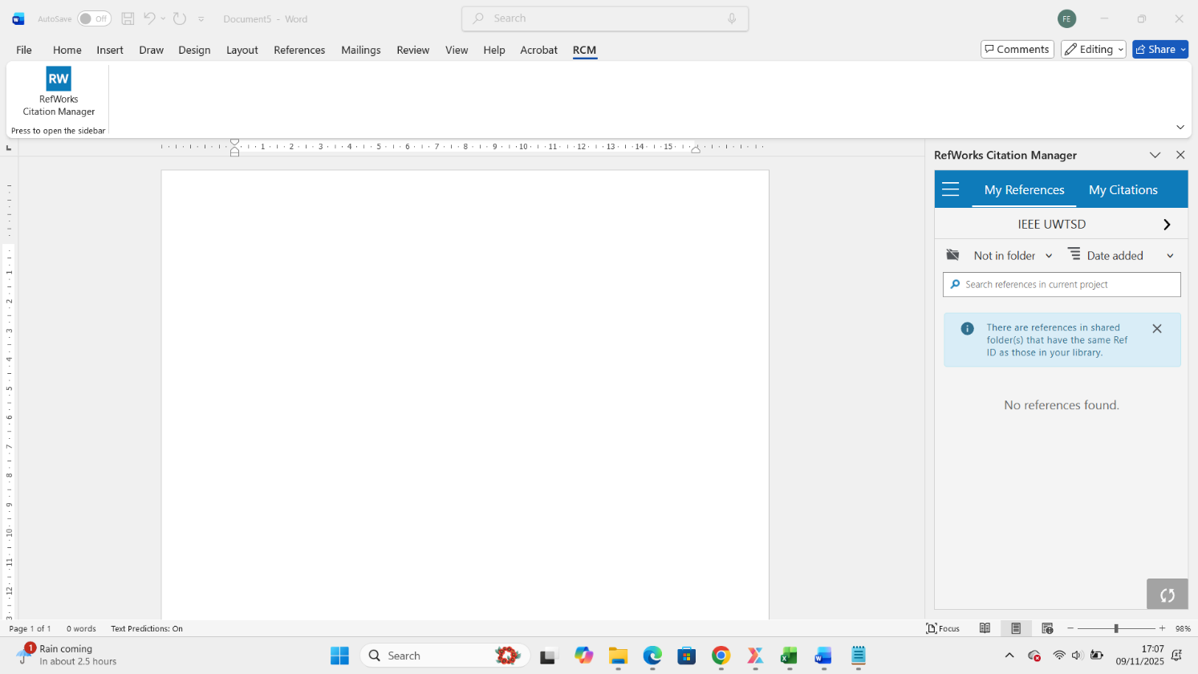
Click and find a folder and

Select

Now click, find and select the folder

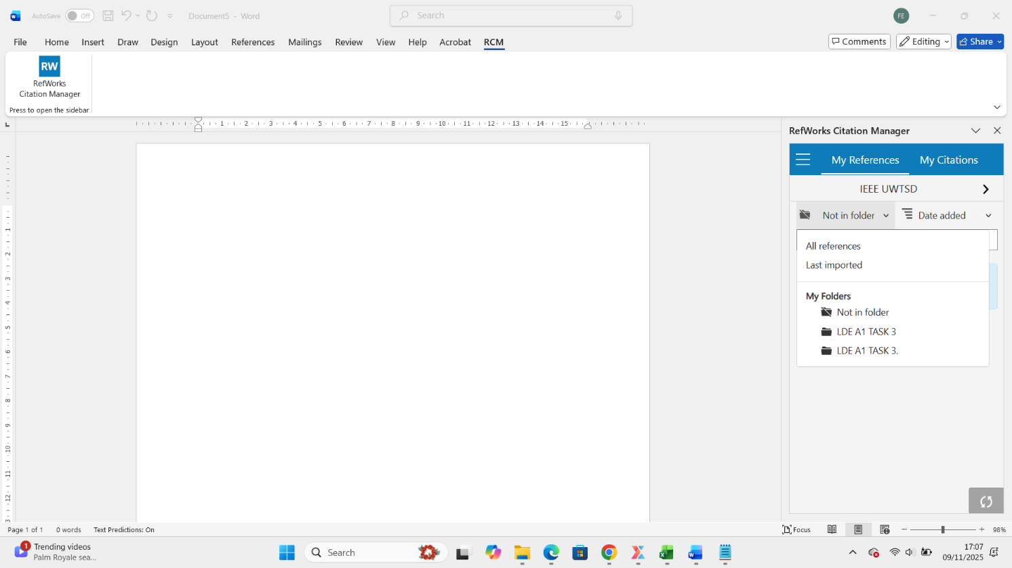

Now find the folder and create a references from references

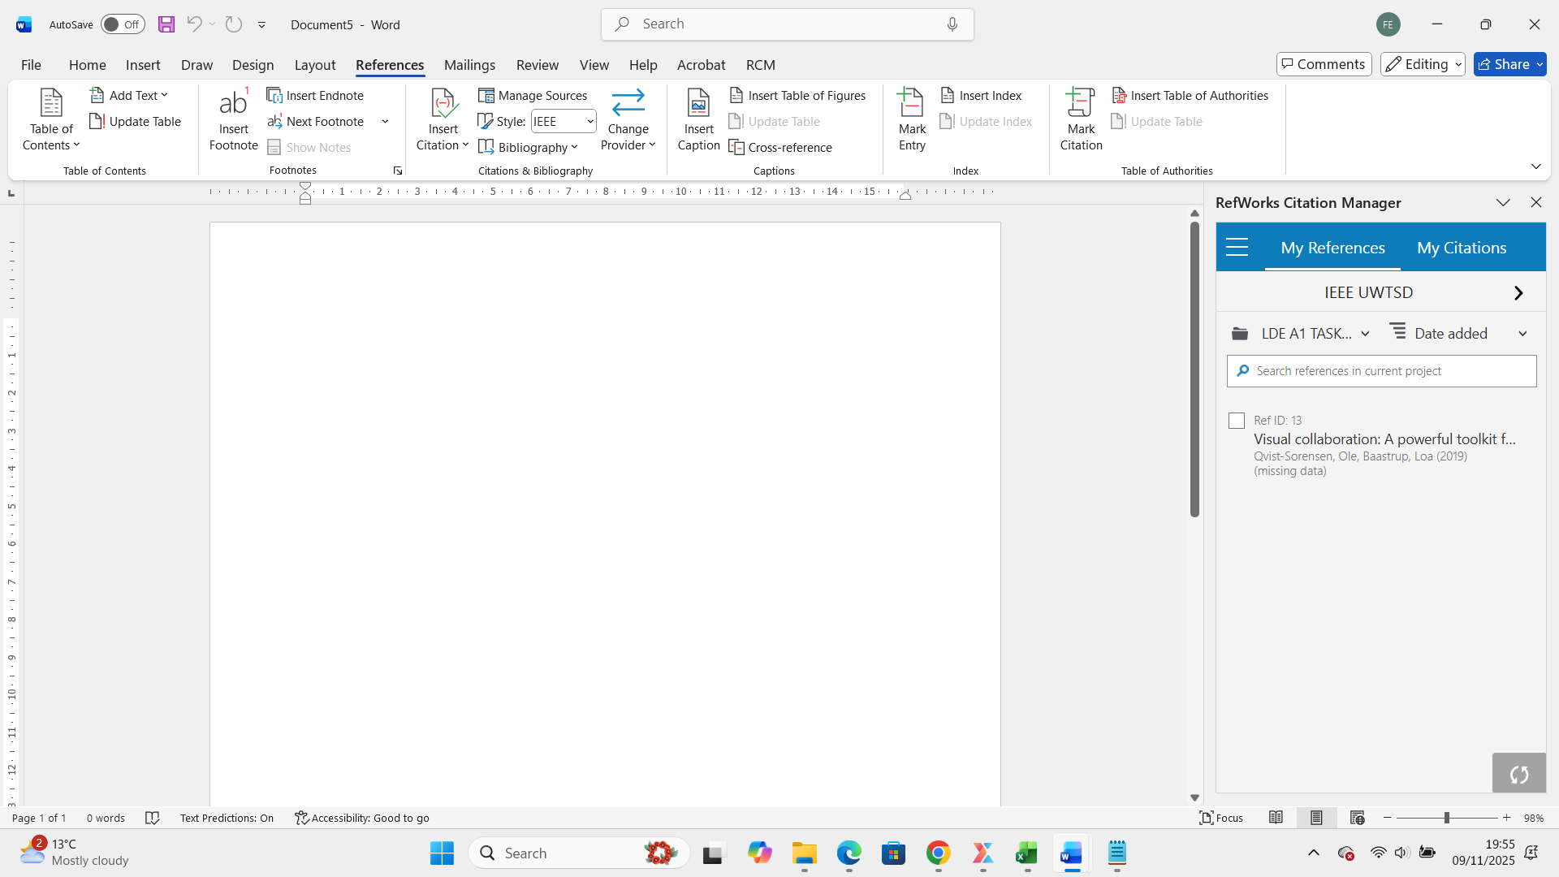

After click in references, click into bibliography and find in references to add in word

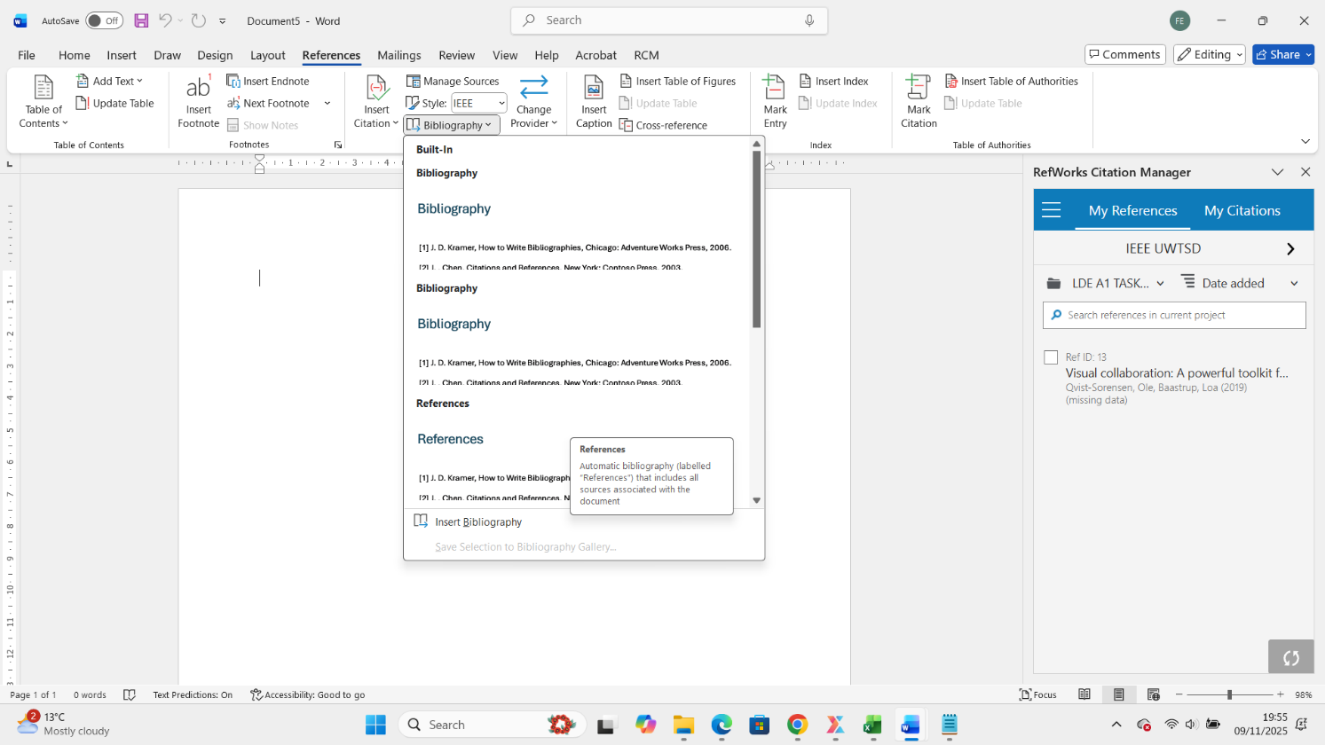

Now the references appears in word
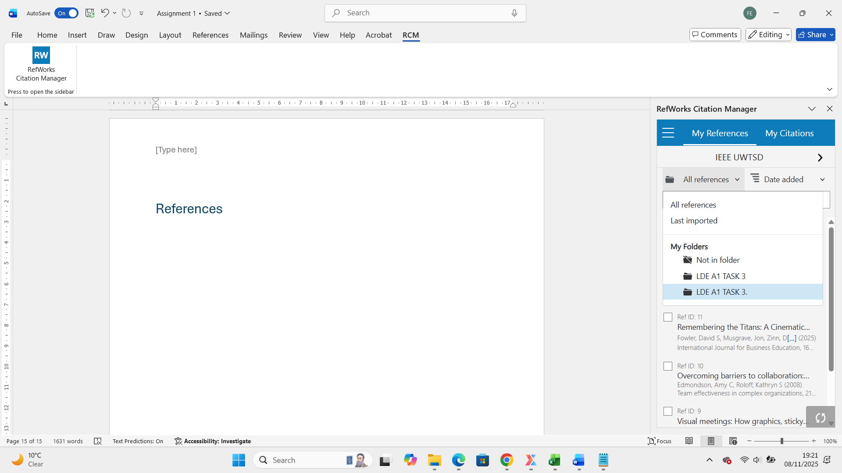

Now copy the Bibliography on RefWorks form google and drop or paste into word

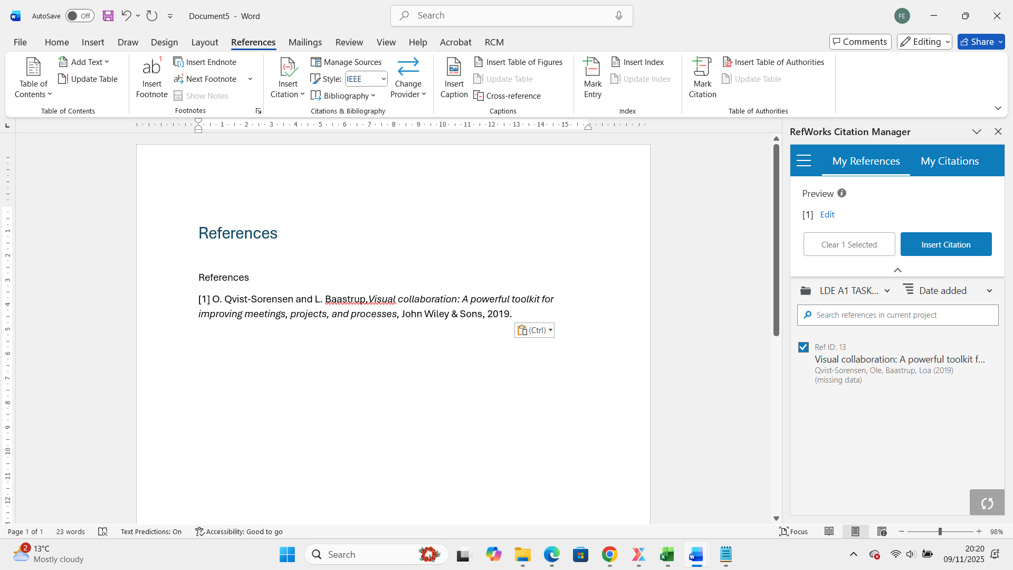
Match in both parts same book.

And you can create a citation from the icon

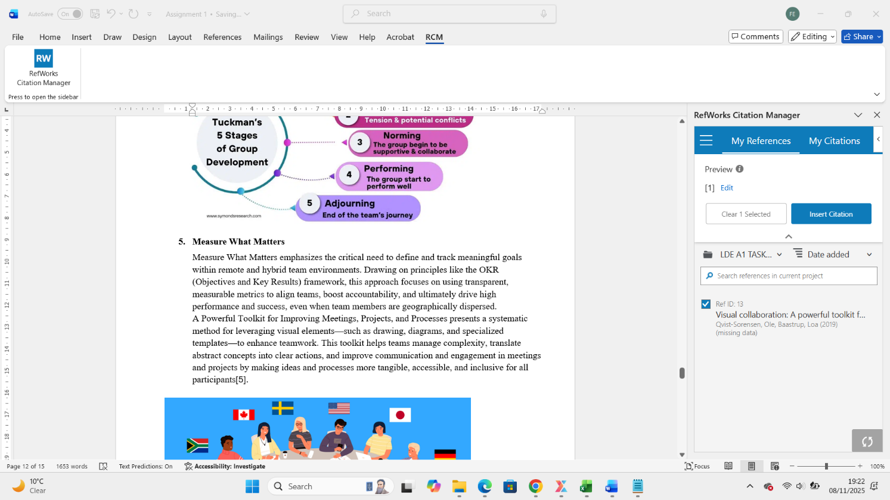
Click
Select book and create citations

And done.

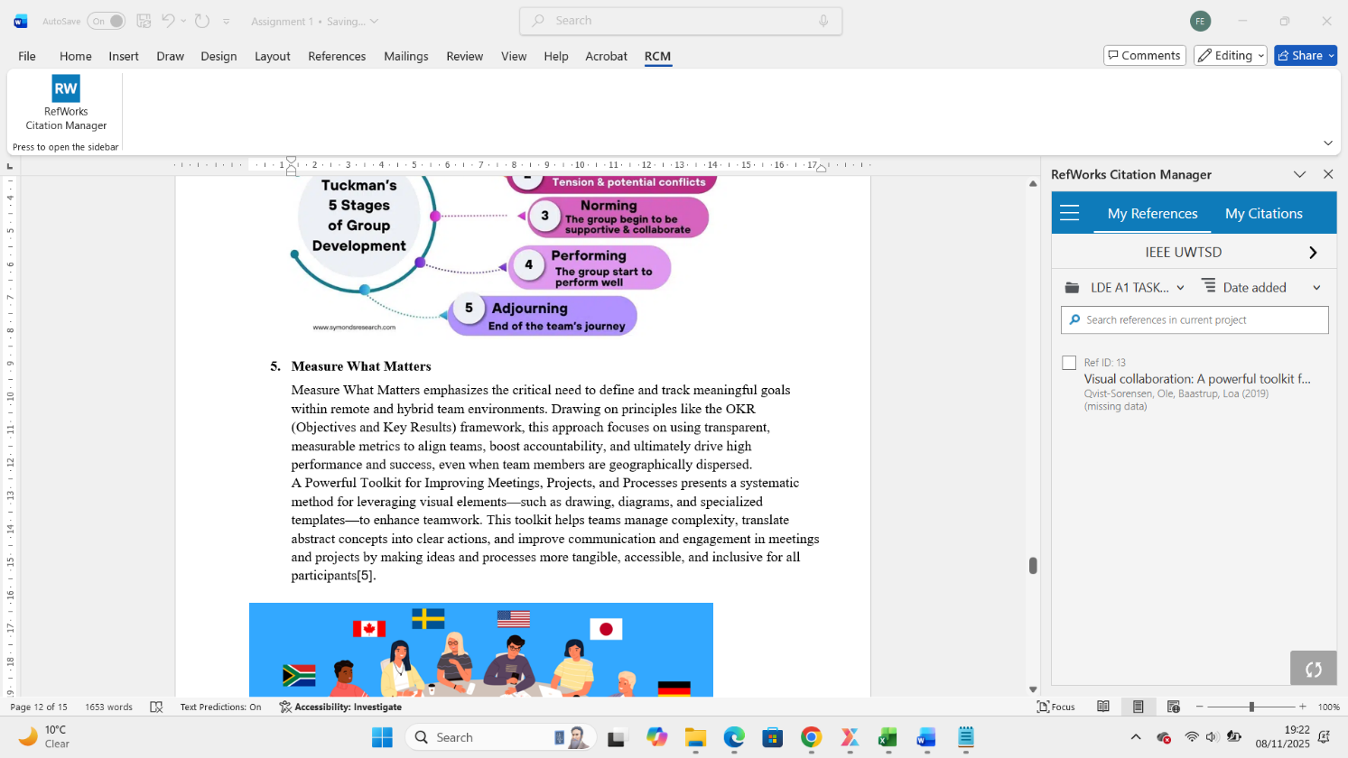

Task 4: E-Portfolio

WIX TOOL USED

The core building tool I used to create this e-portfolio was the Wix Editor (Drag-and-Drop Interface).
The primary reason for selecting the Wix Editor was its simplicity and extensive design flexibility. Unlike highly structured platforms, the drag-and-drop capability allowed me to place text boxes, images, and videos precisely where I wanted, enabling a more custom, visually appealing, and brand-aligned layout without needing to write any code.

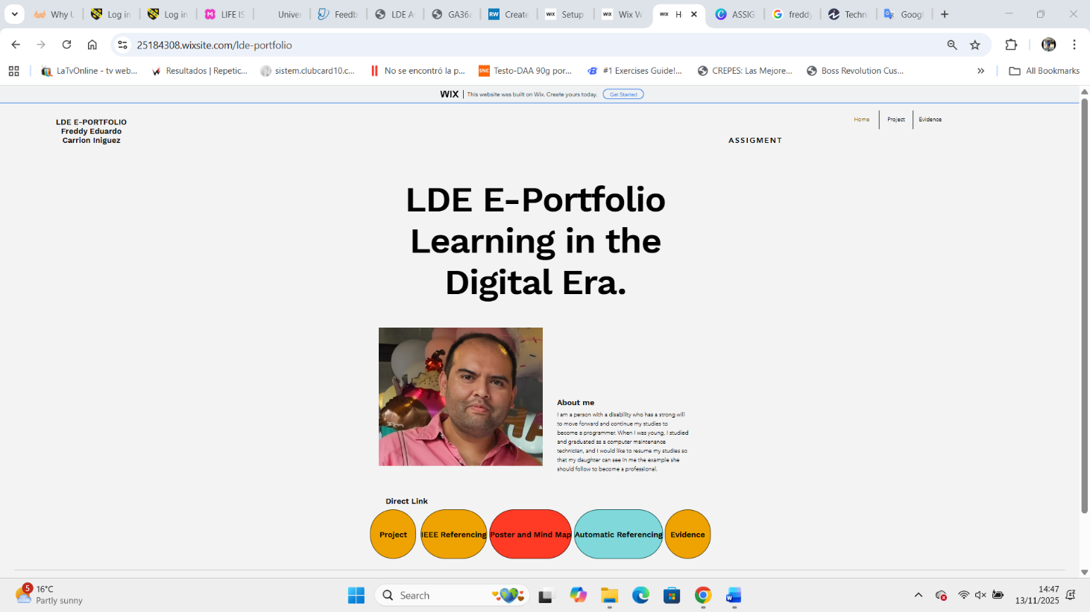

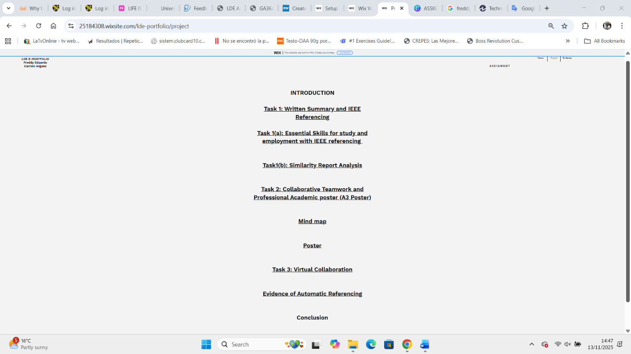

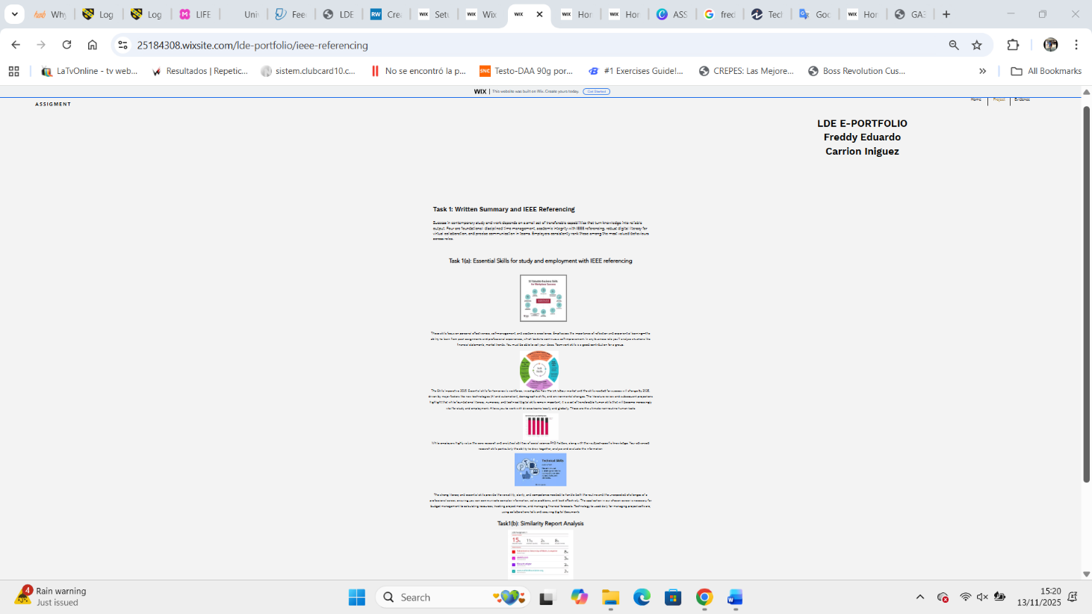

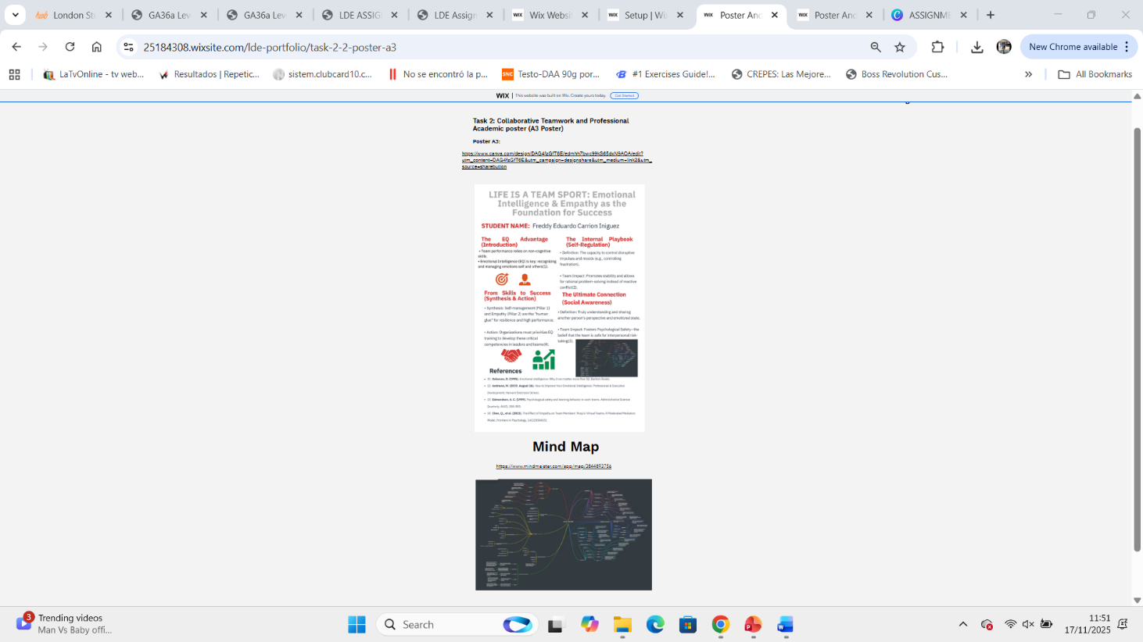

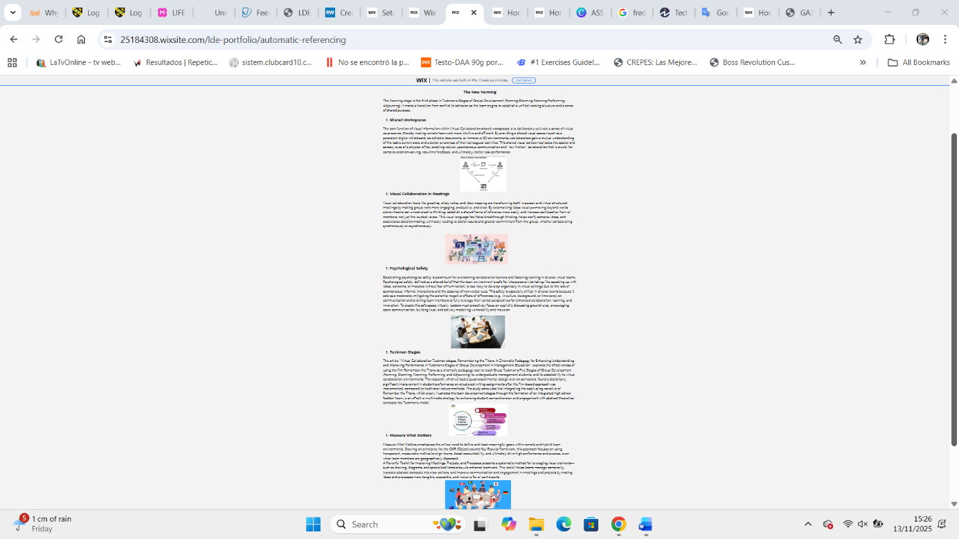

Conclusion

This report and its accompanying e-Portfolio synthesize the core learning outcomes achieved through the completion of four distinct tasks. The submitted materials include a Written Summary, an online Mind-Map and Academic Poster, evidence of using an Automatic Referencing tool, and a complete e-Portfolio creation and review. All components, including the e-Portfolio's homepage and the Mind-Map, are linked directly for review, providing a centralized and accessible demonstration of the required skills.

References Task 1

[1] | K. Gallagher, “Essential Study and employment skills for bussiness and management students,” Oxford , 2022, p. 345.
[2] | J. N. S. O. E. D. a. J. H. Amanda Taylor, “The Skills Imperative 2035,” UK, 2022, p. 59.
[3] | S. D. a. S. W. Kate Purcell, “The employment of social science PhDs in academic and non academic jobs.,” 2005, p. 114.
[4] | J. Derrick, “TheCentreforLiteracy Le centre d’alphabétisation,” in Embedding literacy and essential skills in workplace learning: Breaking the solitudes, 2012, p. 40.

References Task 3

[1] O. Qvist-Sorensen and L. Baastrup, Visual collaboration: A powerful toolkit for improving meetings, projects, and processes, John Wiley & Sons, 2019.
[2] D. S. Fowler, J. Musgrave and D. F. Zinn, "Remembering the Titans: A Cinematic Pedagogy for Enhancing Understanding and Improving Performance in Tuckman's Stages of Group Development in Management Education," International Journal for Business Education, vol. 167, no. 1, pp.1, 2025.
[3] A. C. Edmondson and K. S. Roloff, "Overcoming barriers to collaboration: Psychological safety and learning in diverse teams," in Team effectiveness in complex organizations, Routledge, 2008, pp. 217–242.
[4] D. Sibbet, Visual meetings: How graphics, sticky notes and idea mapping can transform group productivity, John Wiley & Sons, 2010.
[5] R. E. Kraut, D. Gergle and S. R. Fussell, "The use of visual information in shared visual spaces: Informing the development of virtual co-presence," Proceedings of the 2002 ACM conference on Computer supported cooperative work, 2002.

