The Assistant Director

During this module my aim is to perfect my skills by revisiting some useful tools I acquired last year and by recognising where and which areas I need to further develop by researching and reflecting on our directors’ process. This will enable me to understand the key factors of being a director – which will prepare me for my studio module – but it will also help me appreciate the key aspects of being an assistant director which will benefit me as I enter the industry after this course.
My experiences range from assisting at a drama club where I was needed as a place of comfort to assisting on a feature film with very little crew resulting in me being involved in various departments. However, I am now faced with the question of what do I do as an assistant director? Girvan (n/d) believes that an assistant director’s role is to be supportive, communicative and open for actors to approach them at any given moment. However, Gordin (2020) believes there is not a correct way of assisting and coping with one’s given responsibilities as each director’s process is different. One of Gordin’s best tips is to ‘figure out ways to be helpful’ which I often do in any production (as an actor or director), but I will further push my eagerness in this module to avoid having the director or any department feeling overworked and under helped.
Although I understood Gordin’s words, the thought of having no ‘certain way’ to assist one’s director as each director works differently, left me questioning how I would plan/prepare myself for the production. Usually, the major project involves one director only but luckily I was fortunate to receive words of advice from last year’s assistant director of ‘Education, Education, Education’, Amelia Williams (2022). I asked Williams three questions:
- How did you prepare yourself before beginning rehearsals?
Williams told me to read the chosen play multiple times prior to rehearsals and to investigate the directors’ ‘style’ of theatre they usually do, she also told me to research the time periods of the play and any other relevant topics.
- What was your biggest challenge during the production?
Williams replied stating her biggest challenge(s) was knowing when she could voice her opinion or not, both with the director and the company as she said she found it hard finding the balance between friendliness and professionalism working within the same age group as her, especially with those she considered friends outside of the rehearsal room.
- What would your advice be to any other assistant directors?
Firstly, Williams mentioned the importance of noting everything down, as it can be difficult to memorise everything mentioned which meant she felt confident in leading knowing the ins and outs of everything. Secondly she mentions that assistants should always involve themselves in the experience, especially reaching tech and show week as that is when the director will require more ideas, leadership and input. Lastly, Williams told me to never be afraid of voicing my opinion, whether the director follows your thoughts or not, keep giving your input.
Knowing that Williams had worked in a similar setting gave me the confidence that all a director wants is your support; it is not about getting your ideas chosen, it is about giving them options and being their backbone throughout the production. I do fear that I will not understand the balance of contributing too much or too little, but either way this will be a learning curve that I am ready to face.
Dan Jones is our director, and we will be working on ‘Loveplay’ by Moira Buffini, performed by UWTSD performing arts students. Loveplay is a one act play involving ten scenes within the same location, as stated by Billington (2001):
10 scenes take place in one London location: over the centuries it moves from Roman temple to medieval abbey, elegant town house, Victorian studio and 1960s squat, eventually becoming a modern dating agency. The constant factor is the quest, often doomed, for love and sex.
According to Casey (2017), this style is episodic theatre as it involves multiple characters and locations, covering a lengthy period of time. The separate scenes allow the director to be creative by including their own style which will hopefully result in creating an exciting and ambiguous production. It gives the director the freedom to explore during transitions due to location changes but I understand the challenges it brings by having to replicate each scene and atmosphere within the same four walls. It involves thirty-one characters but can be performed by as few as four actors, however our production will have eighteen actors with some playing the role(s) of two characters.
Before jumping into auditions, I took Williams’ advice to look at the directors’ previous work(s) to see if I can gauge a tone/style they usually work in. Jones is the artistic director of The Other Room (Cardiff) and has directed various productions, a few examples being:
- Co-directed ‘Constellation Street’ in 2016.
- Directed ‘BLINK’ in 2016.
- Directed ‘The Effect’ in 2018.
- Directed ‘HELA’ in 2019.
After looking at each production (see appendix 1) and having visited The Other Room in the past, their plays are much more intimate and on a smaller scale (production wise) in comparison to the University’s major projects in previous years. Otherwise, it appears that Jones is not afraid of doing nonlinear, bold and intimate pieces with his own twists during scene transitions. Sometimes The Other Room will create a series of plays that follows a specific theme and by researching into Jones’ work, love is clearly a reoccurring theme he explores and all of the plays mentioned have prominent messages to convey. As a result, I am intrigued to see what message Jones wants to put across with it being an episodic play as it could have various interpretations.
As well as exploring Jones’ style of theatre, I was fortunate to witness his auditions as I sat on the panel. I was keen to see how he worked with the actors and how to accommodate all of the creative teams’ needs/roles. The actors’ auditions are split into two: phase one presenting a monologue and phase two being a group workshop of different actor combinations. The design and production students are to present portfolios as they discuss their preferred role and ideas.
Prior to the auditions, Jones had asked Ollie Goulstone (the other assistant director) and myself to come up with a ‘rehearsal research document’ that includes a list of phrases in the script that the actors may not understand, therefore if they were unsure of a word they could ask us for clarity or confirmation. Along with some contributions by Goulstone, I created the document (see appendix 2) and quickly learned the document’s benefits as rehearsals can continue without unnecessary interruptions. However, it made me question if a document such as this is too easy for an actor to use instead of researching themselves. One could suggest that the actor will not understand their text unless every word is understood as ‘misunderstanding a tricky word can prevent you from understanding the meaning of a text’ (BBC, n/d). Therefore, although useful, we decided against forwarding the document because the actors need to work on their own craft and discoveries as it is vital for their own research, especially in and educational setting. I also curated a headshot document form/information pack of the actors and creative team for the director to use during the auditions. I printed them out and put them in chronological order (see appendix 3) of the time slots to make the process easier for Jones, already thinking of ways to support, which also meant that Jones had a name to a face, resulting in a better process.
I appreciated how prepared the design and productions students were and I learnt that allowing them to present their ideas first offers more options and covers their field of interest which means no unnecessary time is wasted in the short interview. The fact that they could discuss their preferred roles made it easier to assign them, whereas casting the actors was a harder task to accomplish. However, after both phases, the cast list was complete. I have documented Jones’ cast list as well as mine (see appendix 4) as I wanted to experience casting for myself but I struggled because I was needed to hand out different scripts, sections and to lead tasks whilst Jones took some group combinations for further explorations. I do believe some castings could have been different (see appendix 5) but I acknowledge that not every student is able to work with one another which not only is harder than industry casting but may have impacted Jones’ decisions too. I would have preferred to have less actors in the space at a time resulting in a less manic atmosphere and perhaps for the monologues I would ask them to choose a speech specifically for a certain character as it would have made casting easier by knowing which character they are most suited to. But I also understand that some actors often stay inside their comfort zones and this method only further-allows that. I will do further research on auditions prior to studio to gather which process will work best for me.
Jones kick started rehearsals with a big table read and it was clear that his vision, although the piece itself ranges over 2000 years, was to always bring it back to 2022 by implementing online dating into it. Firstly, he worked on devised pieces created by the actors inspired by their task of ‘what is love?’ which I also did (see appendix 6) as I could relate to them and perhaps implement some of my own ideas if asked to. From the beginning, I said that love cannot be summarised in a sentence because it has multiple meanings, especially in the modern age. Fugère (2019) states that ‘having a larger number of choices makes us less likely to want to commit to one person’ which I believe resonates with online dating being the biggest hurdle in modern love as it is much easier to talk online than it is in public nowadays. As complex as love is, dating is now more open and accessible (see appendix 7) which may allow us to create more diverse devised pieces which I will continue to bring forward to Jones and the creative team.
As Jones continued to separate groups to create devised pieces (of different time periods) and visited scene one to five, exploring physicality and staging, we discovered that phones and torches were being utilised in most ideas which definitely ties into our modern twist on the play and it started to serve more purpose in correlation to the online dating. Talking of phones, it was nice to collaborate with the creative team in social media, production and tinder meetings as ‘hearts international’, our dating app was confirmed to take centre focus of the play. Reiterating the fact that I am a support to everyone, my time was spent helping the creative team in meetings with the actors ensuring we were on the right track and keeping on schedule.
At the end of the week myself and Goulstone were in charge as Jones has other priorities to fulfil. As it was so early within the production, I asked Goulstone for a quick meeting to ensure we both knew what we needed to revisit/work on, which resulted in:
- Warm up – 7up, topics and a physical warm up.
- Listen and take notes of the song ‘IRON’ by Woodkid as this is a song Jones would like in our opening.
- Revisit all devised pieces:
  - Romario’s group
  - Bea’s group
  - Charla’s group
- Devise a piece that involves their entrances with the use of phones/torches to the given song.
- Revisit scene 1 to 5 if we have time.

Structure helps provide purpose to a session and I want to avoid any actor believing a day with Goulstone and myself is a day of less focus, because Jones is relying on us to keep the momentum going. Although we did not meet every task, progress was made, and their devised pieces were much stronger by adding precision, intention and specification.
Witnessing how Jones works confidently with every member of the production was really nice, and with my lack of experience with design & production students, I knew this was something I needed to develop. As good as the week was, I do not believe Jones was certain of the needs within the rehearsal room; no time was spent on table work which plays a pivotal role in any production. Similar to myself, Cook (2022) is another who believes script analysis is important as they continue to say that ‘table work focuses on building a collective understanding of the play. This usually involved “uniting” or “eventing” a script’ which allows more dramatic exploration in the rehearsal discussions. I believe due to Jones’ frequent work with professional actors, he may have forgotten that students do need to be led through most of their works. Hosting a few days of collaborative discussions on scenes, events and intentions would have resulted in better understanding of characters and their intentions throughout, which would have made the scene sessions easier to explore.
As the scenes came to life, we also started to have an understanding of the set as the model set was presented to us which was beneficial. I offered more suggestions by knowing there will be six entrances/exits on stage, the ruins of the abbey can open up and we can also utilise under the stage if necessary, giving Jones more spaces to explore. Otherwise, rehearsals were blooming quickly and scenes were being looked at with the consideration of staging, relationships, props, images, music and transitions, honing it all in together. With that being said, it was raised as a good idea that a skills audit may be advantageous to have, therefore as rehearsals continued, I created a skills’ audit (see appendix 8) that included any skills the actors felt comfortable noting. As stated by Lieberman (2013), skills’ audits are beneficial as they place the right people to the right roles and we are now in a position where the contribution from strong singers and movement leaders would be really useful for certain transitions. Hopefully, the production will benefit from the comfort of knowing the actors’ strengths. On the topic of documents, I remembered Williams’ advice of noting everything down, therefore I created a (now updated) document of the transitions (see appendix 9) as it became apparent that the transitions between scenes played such an important role in making Loveplay about the present. Not only was it useful to refresh our minds of each one (for both directors and cast), but it meant we could focus on continuity more in rehearsals, allowing us to improve each time as we could follow the document if needed.
Goulstone and I took leadership of the transitions by facilitating the actors, ensuring they were researching significant moments of certain time periods (any year between the scenes) to create a modern twist on them by bringing them back to hearts international. Our task at the end of every week was to revisit everything we had worked on, polishing and perfecting them. It was useful to have two assistants on the days we led the sessions because Goulstone could revisit some scenes whilst I took any actor that needed some assistance away (for examples, see appendix 10) to another space. The challenge I was faced with most was the fact the actors had not done their script work outside of the rehearsal room and I could have used my time more effectively if we had done collaborative table work session(s) as the beginning. I sent out an email to the actors reminding them the importance of script work (events, intentions, research) along with an example of my facts & questions inspired by Katie Mitchell in a play I explored last year. However, I slowly realised that I was a place of comfort to a few of the students and it was uplifting knowing that I could help them and they trusted me, as I do not feel that Jones asks for much from Goulstone or myself.
As comforting it was being able to help the actors, it became clear that the respect was not reciprocated at times, more so when Jones was not present in the room. Due to some actors not listening, not contributing and lacking focus, I believed it was important to have a talk with them because I would rather resolve it now, than it becoming too difficult to work with them, whereas Goulstone was not too keen. I started noticing that I was perhaps a little stricter to Goulstone as he was much more friendly but as I am within the same age group as a lot of the company, that line between friendliness and professionalism is something I always want to make clear. Therefore, I spoke to them, in a non-confrontational manner of course, and kindly asked them to keep the focus and to remember that we are all aiming for the same goal which is a completed, well-rehearsed play for audiences to view. Goulstone later did agree and Jones was glad we had had a word as in the industry you keep that focus whether close companions or not and after the discussion I did feel there was a better work ethic from a lot of the company which allowed us to progress much more quickly.
The following week we all received some feedback from Jones via Seren. As it landed on a day I was leading, I compiled a time slot document (see appendix 11) as I could work alongside that and plan my rehearsals efficiently with no interruption. My feedback at this moment (Jones, 2022) consisted of:
- Will is organised. He is calm, collected and brings a great attitude to rehearsals.
- Will is considered in the ideas and notes that he offers in the room.
- He could afford to offer more artistic suggestions.
- Will has effectively keyed into the tone and taste of the piece, and showcases this through his work with the Actors on their devised moments.
- Will is consistent in his work, and a solid team member.
Hearing Jones’ notes was refreshing as although he does not communicate as often as I would like, he clearly acknowledges that I work hard and always try to have the best attitude in the room, although tricky at times, I believe if I was to show signs of struggle or stress, Jones may feel as though he cannot rely on me when needed. I admit that I only speak when I think it is absolutely necessary to speak but perhaps sharing more of my thoughts, whether right or wrong, may make him realise that I can offer more artistic suggestions, which I know I need to develop.
Also this week I have been better at liaising more with the creative team: as I was appointed head of social media I have created TikTok, Twitter and Instagram accounts with a new email for the company, therefore if they need assistance with the bookings, I could help out if needed. I was told not to include any teasers of the play, therefore it is used solely for advertisement. I chose them three platforms as they all serve different purposes, TikTok for reels/videos, Instagram for pictures and Twitter for written information, which can all reach wide audiences. As well as the marketing aspects of the play, we now had intimacy calls with Seren Vickers for the more vulnerable scenes which I have been scheduling for Jones and will continue to help in any way possible. Creating safe spaces was at the heart of a lot of my work last year therefore having intimacy calls gives me such happiness because similar to Roach (2022) ‘Performers should be provided the tools to do their job safely and effectively’ and that is exactly the aim of these calls, for the actors to accomplish their best work in a respectful and safe environment.
There was a sudden shift in the production at this time where every scene had been looked at, half of the transitions were explored and all of the costumes and props were discussed. We were now able to perfect what we had worked on and further develop any grey areas. Although Goulstone and I contributed to the scenes, intentions and characteristics wise, the staging and everything was all down to Jones. Nonetheless, we had most control over the devised transitions as stated previously. We would ask the actors to research significant historical moments in any year(s) between each scene and create a modern twist on the most popular option. For example, between scene four and five (1584 – 1735), the Great Fire of London happened (1666) that ruined thirteen thousand houses (BBC, n/d) making it one of the most rememberable moments within that time period. Therefore, we devised the transition by having the actors walk around the space in shock and emotional despair to a soft instrumental of the infant song of ‘London’s burning’. To bring in a 2022 twist, we had James’ character receiving a tinder notification of a match full of flame emojis that transitioned into a celebration to ‘sex on fire’ with the whole ensemble dancing which I had edited myself to start giving sound ideas to consider. It was a subtle reminder that we are bringing the play into the today/now/presence. Although it was asked of the actors to research and bring in ideas, I would often assemble a list of significant moments (depending on the time period given) in case the actors could not think of different topics for the other transitions (see appendix 12 for an example) to inspire them with new ideas.
Although not completed, the transitions are fun, creative and really take you on a ride over the duration of two thousand years. As they are a mixture of the past and the now, Jones decided to do a clowning workshop with the actors. Bristol Physical Theatre Project (n/d) states:
Clowning is a rich and excellent tool for actors and performers of various disciplines. It stretches the performer’s imagination and teaches to embrace one’s truthful emotions, connecting with the silly and crazy side, celebrating mistakes and fragility.
Some of the transitions require lots of imagination on the actors’ behalf therefore experimenting with clowning will hopefully allow them to think outside of the box and the session itself seemed to have been useful for them to progress further. I believe this workshop came at the right time as it would have been overwhelming for them at the beginning of the process however I wish Jones would have asked Goulstone and myself for some inspiration as clowning is a subject I have looked at in previous years.
The balance between wanting to speak but not wanting to overstep the mark is one that I am struggling with being an assistant director as you never know how much is enough. Therefore, after the clowning session I decided that I needed to be braver and suggest more ideas and options, even if I do feel slightly overpowering. I noticed an area that needed to develop was the curtains. During each scene we had two curtains that were used to reflect a theme/time of the scene, for that reason I sent Jones diverse options to show him that I do consider options outside of rehearsals, always wanting to help. Scene five and upwards were still to be completed but after my offerings, majority of them were used to enhance each scene which gave me the confidence to trust myself and to simply suggest more. Therefore I communicated when I was not sure of something (see appendix 14) to remind him that although I will always be there to support him, I will also give new stuff to consider that I believe fits the brief.
I continued to voice my opinions as we had a costume and a prop parade. From the costume aspect, I would always quickly revisit each scene to see if any detail was missed (for example, in scene ten Rita tells Anita to take her jacket off therefore we must have a jacket) and to refresh my mind of the characters’ personality to see if the correlation between the character and costume suited correctly. For the props, again it was important to see if it suited the character, but more than anything it was to identify the practicality of each prop (for example, the fire prop for scene two was too heavy and had nowhere to grip/hold on to apart from the very flimsy sticks at the top which made it impossible to utilise without damage being caused) because as stated by Todd (2012) a prop ‘can help the actor get in to the role’ therefore if it does not work or is easily damaged, it becomes more of a hindrance than a benefit as it does not help the actor in any way.
As tech week was approaching, Jones, Goulstone and myself had a meeting as we were in charge of sound as we had no sound technician present. Luckily, as I had kept note of everything, I was able to remind Jones of any sound cues that we needed to pencil in some suggestions for before exploring all sounds and songs with him to find the right matches. I could start to feel him trust me more by asking many more questions which is what I would have liked all along. During tech week, I continued to liaise emails with any member that Jones wanted to contact and continued to raise my thoughts when needed and was on standby to assist anyone.
I believe it was apparent that I was there to help in any way I could as a lot of the company members addressed me when challenges started to occur between cast and/or crew that needed to be addressed carefully. I would listen and would liaise with members of staff if needed as maintaining that safe space is always my aim. I believe as I am the slightly more professional assistant, people may feel comfortable addressing their situations with me and therefore I do wish Goulstone could perhaps have offered to help with line runs/emails/tasks so I could pay more attention backstage. These issues were bound to happen as tech week is stressful and was the first tech experience for some actors, nonetheless I continued my work of helping wherever I could.
The social media was actively posting (see appendix 15 for examples) without showing any teasers or spoilers. It consisted of character reveals, warm ups, trigger warnings and important information for the audiences to know. I started to compile biographies from each actor and creative member in preparation for the programme as it would take some stress away from staff (see appendix 16) as tech week’s busyness took over. Due to the frantic nature of tech, I would note any important information specifically to pass onto the stage manager in case they had accidentally missed something as it is important they know the same, if not more, than the assistant directors. I often did communicate with the team throughout the production as it was important to develop the relationship(s) with the creative team as Goulstone and myself will take the role of Jones once he leaves during showings as many directors do.
As we rehearsed multiple runs in preparation for opening night, I realised the importance of only expressing the most important notes to feedback to the actors. As Jones would communicate his notes, he would also ask Goulstone and myself for ours and I could see how overwhelming that was for the actors, therefore sometimes I would quietly agree with Jones and if I had a specific note I believed to be important, I would address the actor independently to talk them through it. Horwitz (2012) believes that ‘knowing what to say and, more importantly, what not to say is what directing is all about’ and I believe in the importance of knowing which note(s) to prioritise as otherwise it does the complete opposite of boosting morale, which is never beneficial to a company.
Boosting morale was a focus of both assistants as Jones left the run, although I was never hesitant to address any issues with the company, I also wanted them to celebrate their play and to take it to its next level. We often reiterated that you can still continue to progress, even if Jones has seen the ‘completed’ version, there is always room to grow as long as it stays relevant to the story and character. Many actors felt encouraged and were willing to expand on their craft which was something I wish that Jones could have seen. I often contacted him as I thought some updates would have been appreciated. Otherwise, it was exhilarating being able to liaise with the creative team about any backstage issues or helping the actors get prepared for the audiences, embracing the role of Jones as we carried his presence throughout the shows.
The majority of the shows ran smoothly, others had a few issues and one missing an actor. Therefore, I would need to adapt confidently with the help of staff, ensuring the company were aware and understood any changes that occurred. When we had an actor absent for a run, we decided to take out a scene as although I could have jumped in, the chemistry between the characters would have been missing which would have taken its toll on the audience as it clearly would have been a rushed choice, lacking authenticity and characteristics. It was important that I showed confidence and leadership skills because I (or Goulstone) were put in charge and without that awareness, it may have raised nerves within the company which would have taken its toll on the performances. In every show, my aim was to always be better than the previous show, and it truly felt like a celebration of everyone’s work which created a journey that travelled through centuries, highlighting how certain statuses, behaviour issues and ways of living can and will always influence love and relationships. Love is a subject that is forever changing in correlation to the world we live in at the time, which currently is manipulated by social media, technology and online dating.
To summarise everything spoken about above, during this module I learned that there is no certain way of being a director, as I experienced by working alongside two different directors. I was able to further develop my language skills within the rehearsal room by always collaborating with the creative team involving industry professionals and students, staff and director(s) as well as the actors. Identifying my voice within the room was my biggest challenge, however, I believe that I turned it around by starting to express thoughts and helping any department that I could. Although I could have offered more artistic suggestions, I believe I did as much as I could to support, always wanting the best outcome for the production. I faced many challenges that I believe I addressed with understanding, professionalism and calmness which became apparent as I was a place of comfort to a lot of the company members. But more so than anything, this experience has made me realise the importance of preparation involving auditions, rehearsal structure, script work, storyline and mainly what message do I want to convey when preparing for studio – as I questioned if Jones knew where they were going and how to get there at times. If I were to do anything differently, I would have been braver with my offerings and perhaps tried to find a balance between having fun and being a professional, as sometimes I may have taken it too seriously. Overall, I am very pleased with how I embraced the role of an assistant director but I am already looking forward to preparing for the role of the director in the studio module after everything I have taken on board throughout this production.
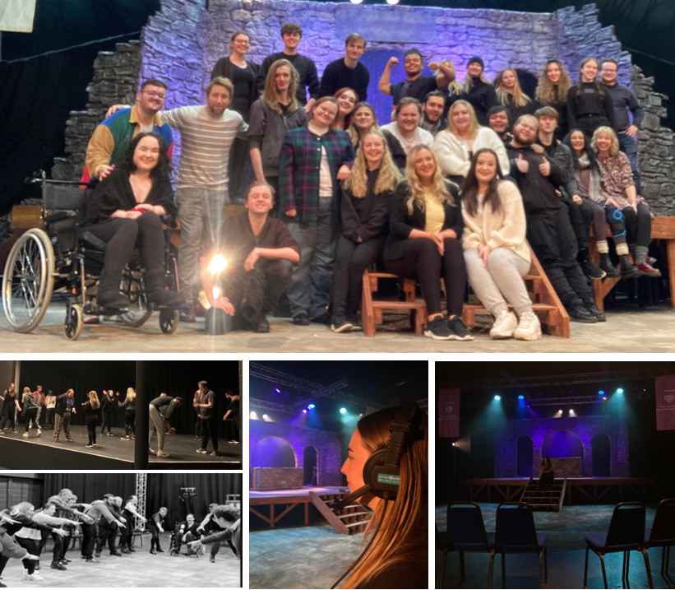

Bibliography:
BBC. (n/d) Dealing with unfamiliar words. Available at: Dealing with unfamiliar words - English - Learning with BBC Bitesize - BBC Bitesize (Accessed: 17 December 2022).
BBC. (n/d) The Great Fire of London. Available at: The Great Fire of London - BBC Bitesize (Accessed: 27 December 2022).
Beggs, J. (2016) ‘Constellation Street / Theatre’. Review of Constellation Street, directed by Dan Jones and Chelsey Gillard. Available at: Constellation Street | Theatre - Wales Arts Review (Accessed: 17 December 2022).
Billington, M. (2001) Two thousand years in 90 minutes. The Guardian. Available at: Two thousand years in 90 minutes | Theatre | The Guardian (Accessed: 15 December 2022).
Bristol Physical Theatre Project (BPTP). (n/d) THEATRICAL CLOWNING. Available at: Theatrical Clowning – BPTP (Accessed: 4 January 2023)
Brian. (2017) The Most Important Events in British History: A Timeline. Historians For Britain. Available at: The Most Important Events in British History: A Timeline - Historians For Britain (Accessed: 4 January 2023)
Casey, J. (2017) ‘The Difference Between Episodic and Climatic Structure in Theatre’ JaninaCasey [blog]. Available at: The Difference Between Episodic and Climactic Structure in Theatre | by Janina Casey | Medium (Accessed: 15 December 2022).
Cook, L. (2022) Why Script Analysis Is Important (and How To Do It Right). Backstage. Available at: Script Analysis: How Actors Get the Most Out of a Performance (backstage.com) (Accessed: 23 December 2022).
Fugère, M. (2019) The Curious Ways Dating Apps Make It Harder to Find Love. Pschology Today. Available at: The Curious Ways Dating Apps Make It Harder to Find Love | Psychology Today (Accessed: 21 December 2022).
Girvan, A. (n/d) ‘So what does an Assistant Director actually do?’ Anna Girvan RSC [blog]. Available at: What does an Assistant Director do | Blog | Royal Shakespeare Company (rsc.org.uk) (Accessed: 12 December 2022).
Gordin, S. (2020) ’10 Ways to Make the Most Out of Assistant Directing’ OnStage Blog [blog]. Available at: 10 Ways to Make the Most Out of Assistant Directing — OnStage Blog (Accessed: 12 December 2022).
Hirsh, A. (2017) Assistant Director and Theatre Duties. Career Trend. Available at: Assistant Director and Theatre Duties - Career Trend (Accessed: 8 January 2023).
Horwitz, S. (2012) How Do You Give Notes? BackStage. Available at: How Do You Give Notes? (backstage.com) (Accessed: 8 January 2023).
Jones, D. (2022) Conversation with Seren Vickers, 5 November.
Karaoke Secrets. (n/d) WHY IS DIAPHRAGMATIC BREATHING IMPORTANT WHEN SINGING?. Available at: Why Is Diaphragmatic Breathing Important When Singing? | Karaoke Secrets (Accessed: 27 December 2022).
Keegan, N. (2022) LOVE AT FIRST SIGHT 16 best online dating sites and apps to find a new date in 2022. The Sun. Available at: 16 best online dating sites and apps to find a new date in 2022 | The Sun (Accessed: 21 December 2022).
Lieberman, S. (2013) Skills Audit (1/3): The Necessity of a Skills Audit. SkillsDB. Available at: Skills Audit (1/3): The Necessity of a Skills Audit (skillsdb.com) (Accessed: 23 December 2022).
Othniel, S. (2018) ‘Blink’. Review of Blink, directed by Dan Jones. Available at: Theatre review: Blink at The Other Room at Porters, Cardiff (britishtheatreguide.info) (Accessed: 17 December 2022).
Othniel, S. (2019) ‘Hela’. Review of HELA, directed by Dan Jones. Available at: Theatre review: Hela at The Other Room Theatre, Cardiff (britishtheatreguide.info) (Accessed: 17 December 2022).
Pearce, E. (2018) ‘The Effect – The Other Room, Cardiff’. Review of The Effect, directed by Dan Jones. Available at: The Effect - The Other Room, Cardiff - The Reviews Hub (Accessed: 17 December 2022).
Photofeeler. (2022) ‘What Is Tinder Passport (And Does This Feature Actually Suck?)’ Profiled [blog]. Available at: What Is Tinder Passport (And Does This Feature Actually Suck?) (photofeeler.com) (Accessed: 21 December 2022).
Roach, K. (2022) ‘The impact of intimacy direction/choreography (or lack thereof) on students in educational theatre’ OnStage Blog [blog]. Available at: The impact of intimacy direction/choreography (or lack thereof) on students in educational theatre — OnStage Blog (Accessed: 27 December 2022).
Todd, B. (2012) ‘Time to give props to theatre props’ The Guardian [blog]. Available at: Time to give props to theatre props | Theatre | The Guardian (Accessed: 8 January 2023).
Williams, A. (2022) Text to William Kingshott, 25 November.
Yagihara, R. (2015) ‘6 tips for succeeding as an assistant director’ infocus [blog]. Available at: 6 Tips For Succeeding as an Assistant Director - InFocus Film School (Accessed: 12 December 2022).

Appendix.

Appendix 1.
Here is the information I gathered; ‘Constellation Street’ follows the journeys of four people searching for answers as they guide the audience through their very immersive experience, with not every audience member following the same stories. Each character’s journey intertwines with another as they try find purpose in this world of choices and consequences, as summarised by Beggs (2016).
‘BLINK’ follows a romantic comedy that explores the unusual relationship between two lonely youngsters who, after battling their insecurities, manage to connect as the play celebrates the confusion of relationships and life. Othniel Smith (2016) states that director Jones takes full leadership of the story by “finding humour in the frequent scene changes”.
Again, focusing on two potential lovers, Pearce (2018) tells us that ‘The Effect’ takes us on a roller-coaster of confusion as two ‘lovers’ fall in love during a drug trial which makes them question if their feelings are genuine or are they due to the effects of the drugs. Both characters figure themselves out to be a good pairing before the play takes a turn for the worse as the focus shifts to the subjects of hospitals and mental health.
‘HELA’ the last and final play in The Other Rooms ‘Violence Series’ (Smith, 2019), with a big focus on bilingualism, the production took the audience to a hi-tech world of revenge, intensity and power as Erin uses her mother-tongue to seek answers from Hugh who supposedly knows the whereabouts of her son. Overall, HELA is a clever and effective thriller with great performances as with “director Dan Jones maintaining the tension throughout”.

Appendix 2.
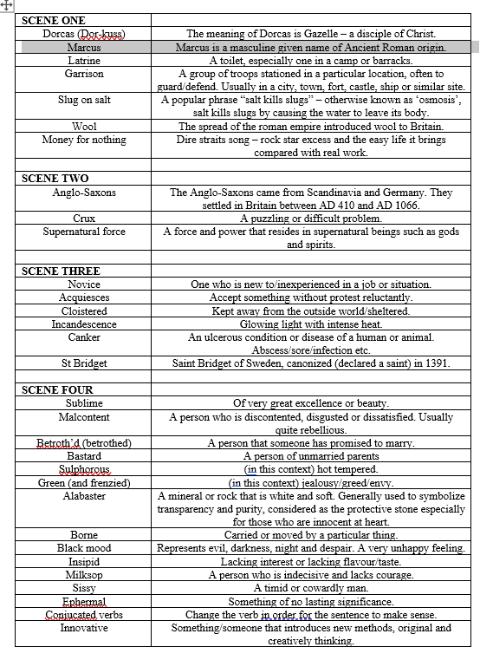
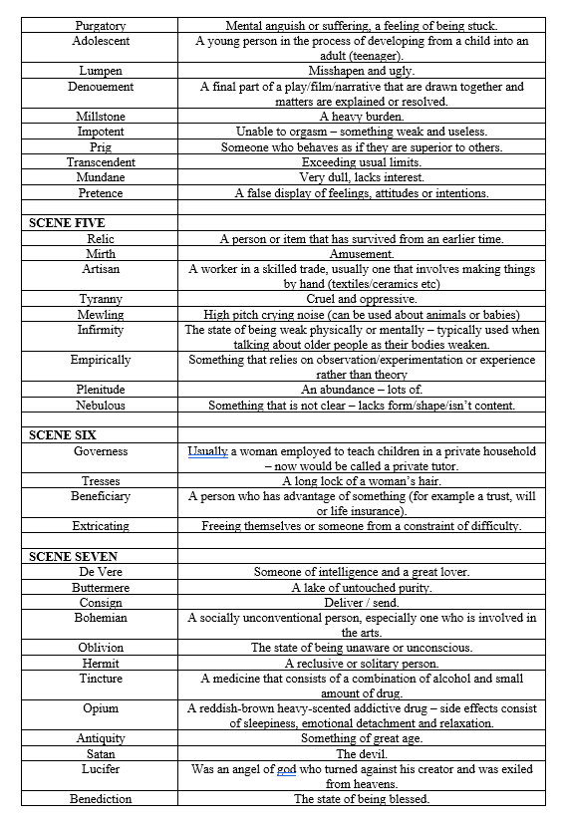
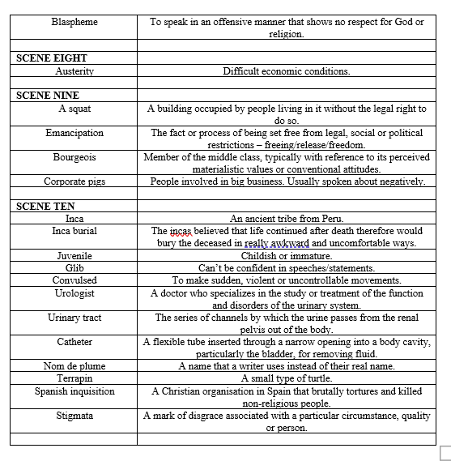

Appendix 3.
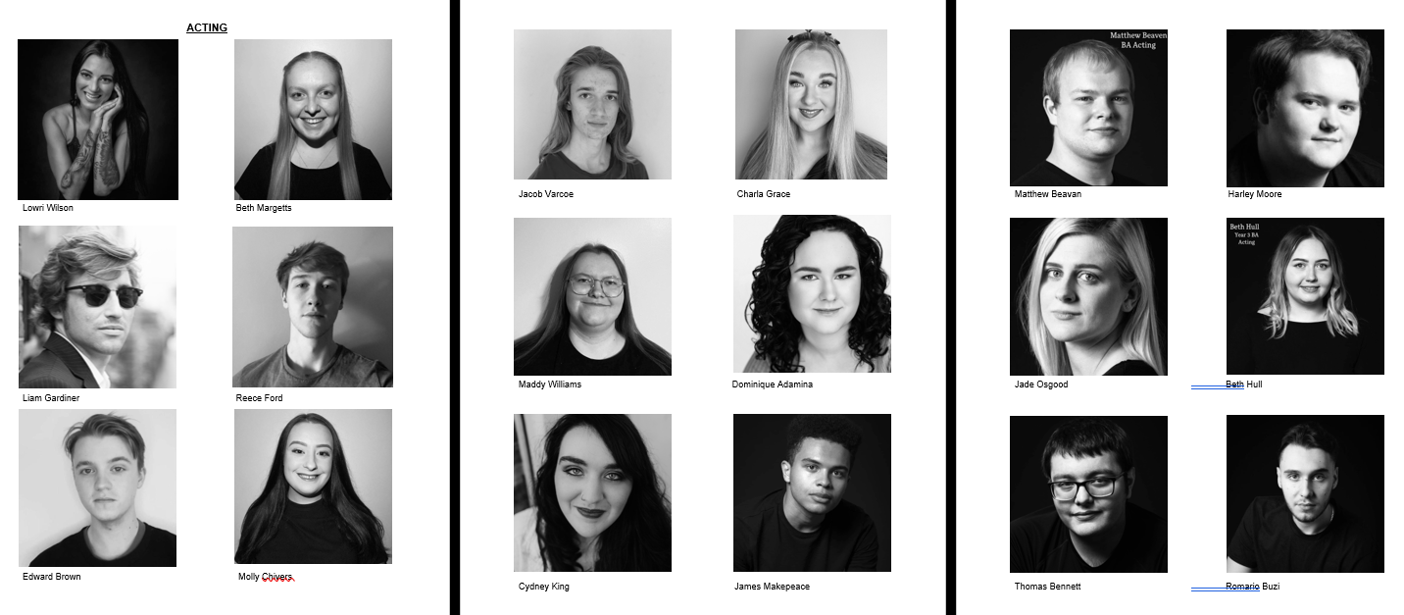
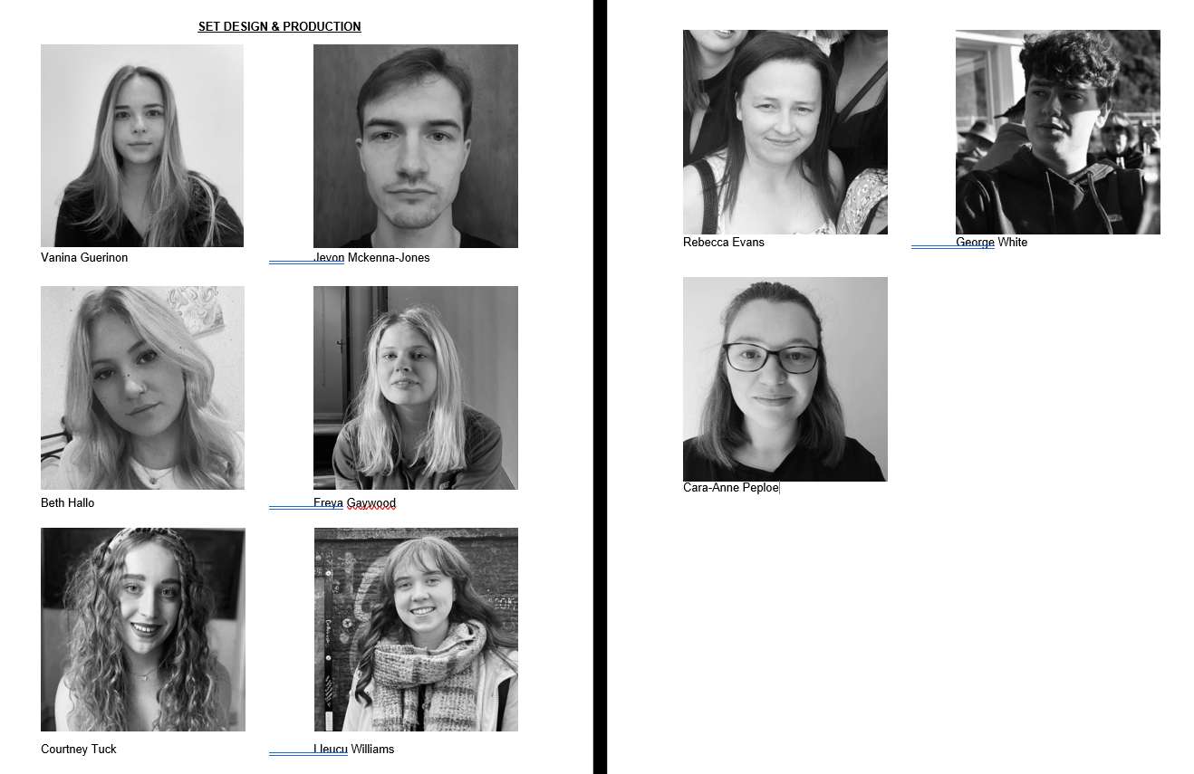

Appendix 4.
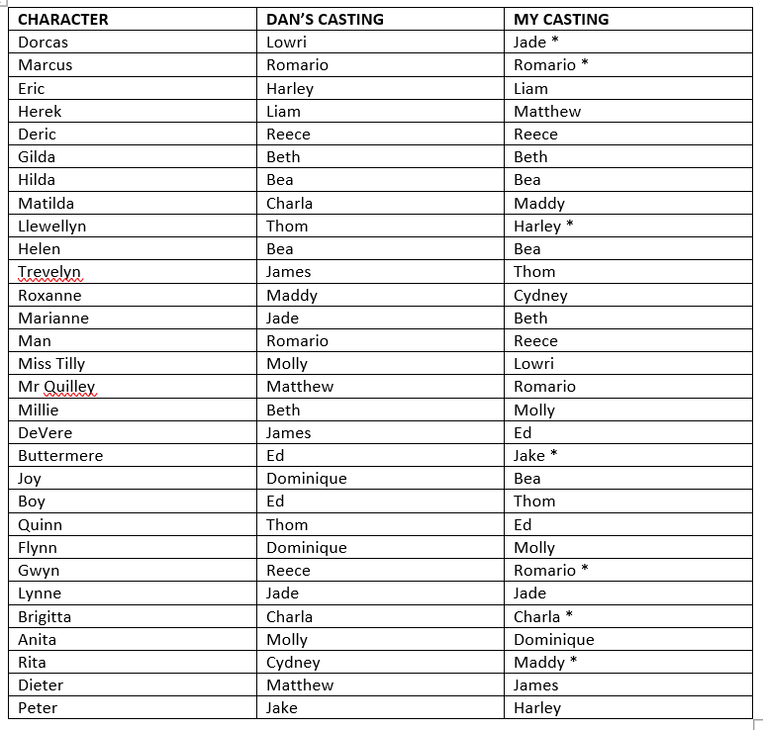

Appendix 5.
I believe scene one was perfect for Jade and Romario as Dorcas and Marcus. In the monologue, Jade played a very angry character but in the group workshop her natural curiousness of life shone through as she played Dorcas in a ditsy, giddy manner which I believed suited the character well. Romario helped drive the scene by showing that eagerness and desperation of intimacy, which is perfect for the scene. Another character I was certain of was Llewellyn, I think Harley would be great for this part as naturally he has enormous amounts of energy which is great for Llewellyn’s dramatic-self, he worked with various actors as he was asked to play Llewellyn for a while and he grew each and every time. Llewellyn goes through a big chaotic journey in the scene and I believe this character needs someone like Harley which although may be challenging, can fulfil all of emotions, not just the dramatic parts. Out of all characters, there were two that I really imagined being played by Charla and Maddy. Scene 10 opens with a hefty speech which is super charismatic, bubbly and vivacious, like the character herself Brigitta. I believe Charla would be a great fit for this character as although her speech was sad, in the group workshop she landed nicely in the character with her overly exaggerated expressions and dramatic tones of desperation which suits the character as she is a mother who lies about her age to find love. Maddy’s passive aggressiveness in her speech of ‘blush’ by Charlotte Josephine really suits the character of Rita, also in scene 10. In the speech her timing was well thought of which landed nicely within the characters’ sarcastic demeanour, which comes quite naturally to Maddy which works in Rita’s favour.

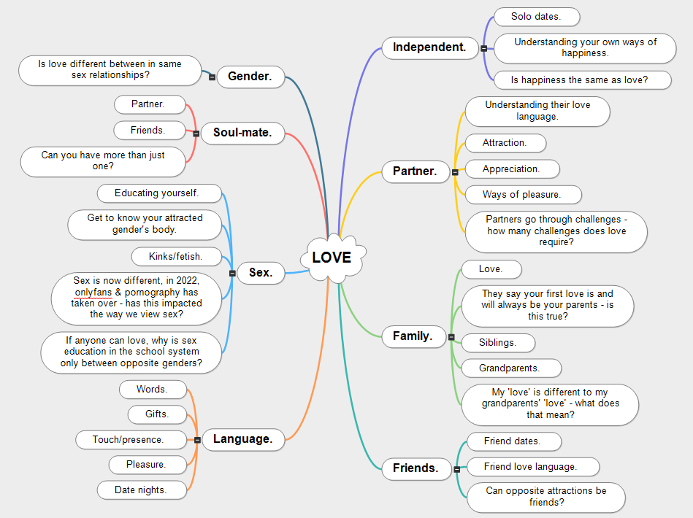
Appendix 6.

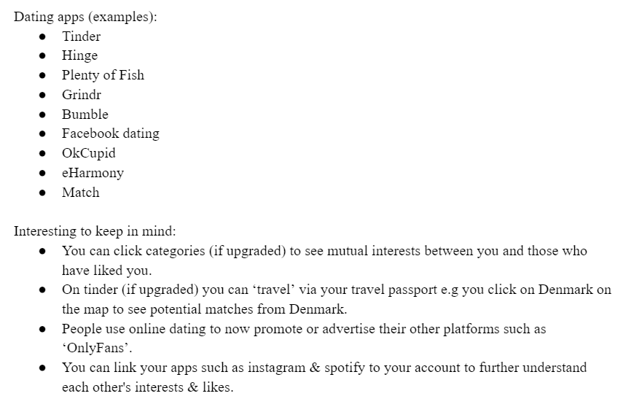
Appendix 7.

Appendix 8.
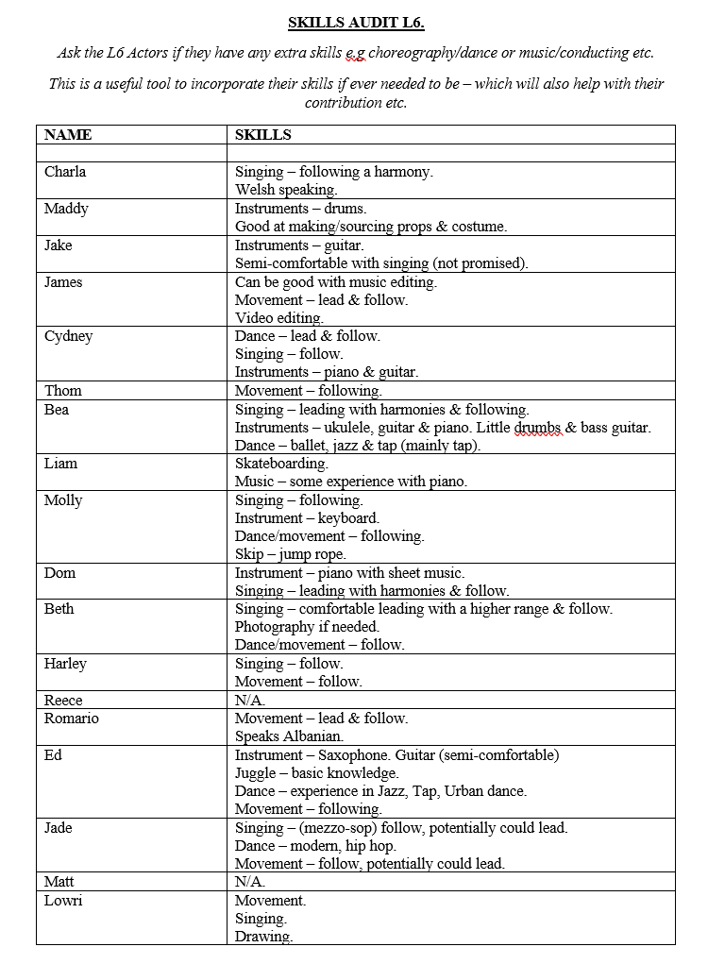

Appendix 9.

LOVEPLAY transitions.

Opening – potential installation of the app, ‘timeless hearts’ not ‘hearts international’.

Cydney downloading the app.
Warning signs.
All cast comes on stage.
Cydney gets up.
Figures out they do anything she does – she directs the phone to different heights and sides and they physicalise it.
Cydney looks for preferences (on hearts international):
Looks for strong
Looks for sensitive
Looks for sports
The clowns establish they cannot fit her preferences; therefore, they think they can help her find love – but Cydney cannot.
So, the clowns take us back in time to AD79.
The cast wave at her before stepping closer.
She swipes on hearts international and rejects all the cast.
Time flickers into AD 79.

S1 AD79 THE CLASSICAL AGE

Eyes in the woods – phone torches
In Romario and his fellow romans walking for revenge (straight when Lowri finishes “money for nothing) – Jade and Reece pre-set themselves behind the ruins.
Fellow romans: Bea, Beth, Harley, Charla, Liam, Cydney, Dom
Romario’s tinder notification goes, everyone reacts (very toxic masculinity vibes), starts flicking and matching, everyone continues to react.
AV goes tinder fast forward flicks into THE DARK AGE (everyone looks at the projection coordinated).
BLACKOUT – everyone mumbles (need variation) e.g “ohh damn”.
All exit, ends with Harley up stage by himself (injuring himself in the process) getting his torch out.
Maddy, Matt, Ed & Molly under stage (eyes in the woods) – torches on to scare Harley.
Harley tries to discover the “eyes” (by looking under the stage) until he notices Liam with the fire, and remembers (as a clown) he is needed down stage.

S2 544 THE DARK AGE

Exits Jade as she meets Jake and two clowns in cloaks (Cydney and Lowri), Jake goes on the table and the two clowns in cloaks dress the sheet over him
Enter Beth, Bea and Charla CSR (to upstage) as Thom enters CSL (to downstage) with the sound of ‘medieval slim shady’.
Thom flicks through Hearts International before throwing the phone away.
As he walks to leave the scene, the nuns (one by one) tease him before he runs off (taking the S2 fire with him).

S3 1099 THE NEW MILLENNIUM

The black death / plague
Jake comes alive to look at Charla, (Harley, Reece and Cydney enter slowly walking through the arches) Charla exits as Jake slowly rises.
Jake puts on the mask and starts walking forward slowly.
Maddy, Matt, Ed & Molly come from under the stage – crawling back to life. Jade enters also.
Reece and Harley move the table to the back of the set. Cydney brings in the wall. Then they exit.
Jake flickers through ‘dead tinder’ – sees profiles of those that crawled to life (they could pose as some images from the plague), as he visits their profile, they awaken matching the silly faces on their dead tinder profiles:
Matt - dead. Yes. And takes off the fire placed in S2.
Molly - dead. Yes.
Ed - alive wearing the mask. No, you are alive.
Maddy - dead. Yes.
Jade – she turns to look at Jake as we hear the echo of the screams, Jake exits. Time/Tinder is still scrolling into THE RENAISSANCE. Jade stays until Bea and James enter on with their Shakespeare costumes.

S4 1584 THE RENAISSANCE

London’s burning – sound recorded
James and Thom come to sense after their panic, they go to stand up.
James’s phone bings a notification for tinder – which brings a wave of fire emojis into the fire of London burning song.
James’s thought “eh what is this” changes into sex is on fire – James comes down to dance crazily.
Hearts international moving quickly taking us into THE ENLIGHTENMENT.
Rest follow in James’s lead (Cydney, Charla, Beth, Molly, Dom, Lowri) and dance crazily as Matt and Harley bring S5’s chair onto the stage (on the platform not up the stairs).
Ed, Liam, Jake and Reece come on with candles, books and a clock to place them on the box before moving it to be in line with the wall.
Thom puts chair in place after Matt and Harley puts it into place.
The music slowly fades out, everyone except James as they continue singing the lyrics as Maddie enters for S5.

S5 1735 THE ENLIGHTENMENT

Prostitution and money
Starts off Romario (switches into a clown), updating dating bio to “will do anything for money” vibes.
Loads of matches show up (shown on the AV) as he scrolls, this is when the time starts scrolling and the app quickly scrolls us into THE ROMANTIC AGE.
Enters Dom, Jade, Reece and Beth, Harley pushes through to lead the group.
Enters Liam and James stood behind Romario with crate upstage.
Enters Lowri with a pair of boots.
Enters Ed carrying the sheet folded into a bag shape upstage.
Enters Jake and Charla to join them upstage.
They all stare closely at Romario as he is scrolling through Hearts International.
Romario sees his options and asks of those down stage what they can offer:
Harley – cash – nope
Dom – cheque – nope
Jade – card – nope
Reece – only fans/bank transfer – yes!
Romario carries Reece off – Reece points as if to say, “that way!”.
As soon as he chooses Reece – Harley, Dom and Jade exits and those up stage set up for S6:
Charla and Jake set the chair.
Liam and James set the box next to the chair.
Ed and Lowri talk amongst each other before putting the sheet down.
Molly and Matt enter with pillows (for comfort) as sheet comes down on the set.

S6 1823 THE ROMANTIC AGE

Industrial transport – love bus
(stagehands will put the S8 door on top of the stairs during this transition)
Enters Dom as she judges Matt and Beth before matching – match is miles away so the app says ‘do not worry we have the love train!’ just before the app and time scrolls taking us into THE AGE OF EMPIRE.
The rest follow in Dom’s lead introducing us to the train:
Bea and Dom come in.
Jade and Cydney bring on the drinks trolley & glasses.
Romario, Harley, Jake and Reece are carrying James on the chaise long.
Charla and Lowri are behind.
Maddy and Liam brings on the easel before joining the back of the train.
Train travels until an announcement of “it has been delayed due to train strikes” comes on, they all react and exit, leaving James already set on the chaise long.

S7 1898 THE AGE OF EMPIRE

Ed in position.
Jake marches on – blows a whistle.
Enters cast as clowns (scared) ‘what is happening, something is changing’.
They all hit their positions and look at the audience for a few beats.
Bea and Harley strikes the chaise long.
Lowri strikes the glasses & drinks.
Reece strikes the drinks table.
Liam and James strikes the easel.
Enters Dom on bed (Pre-set on the bed will be Ed’s costume, smoke, lighter and ashtray) wheeled on by Romario, Cydney, Maddy and Beth (Thom opens the curtain for them to bring the bed on).
Time scrolls on the AV, bringing us into THE AGE OF AUSTERITY.

S8 1932 THE AGE OF AUSTERITY

During end of S8 is Ed’s breakdown with the sounds of world war planes overwhelmingly, in distress, Dom flips the phone, flick flick flick, and it scrolls us to 1969, music on:
Come Together Right Now The Beatles – enters Reece, Jade, Thom and Lowri (may differ depending on costumes).
They walk in a straight line and stop in the reference pause.
(Stagehands will sort out the door placed above the stairs)
They spin the bed around (four clowns).
Dom comes off the bed with the help of Beth, they have a lovely dance moment.
Molly strikes the pillows from the mattress.
Cydney strikes the smoke, lighter and ashtray.
We have three clowns coming on (Liam, James, Jake) to get the mattress off the bed.
They take the bed frame off.
Thom brings on 60s pillows.
As Thom is helping sort Dom out, Harley and Bea bring on the screen from DSL (with blindfold and pillows draping over the screen).
As Harley and Bea finish placing the screen, blindfolds & pillows, they all exit slowly as the music fades out taking us into S9.

S9 1969 THE AGE OF INNOCENCE

Matt enters with Dom’s wheelchair and takes Dom off stage.
Charla, Beth and Bea strike the mattress.
Harley strikes blindfolds and pillows.
Maddy with monitor (90s/gaming) – joined with Cydney, playing the spice girls, James and Romario changes the curtains until Cydney brings in a monitor as they all are hooked into the internet that takes a while to loads until we see “you have the internet!” it all turns into chaos before they take the power out in distress.
Beth and Bea with drinks table & nibbles (99/2000) – ‘horny’ by mousse T with plenty of dancing, finished with a happy new years countdown that turns into warning sign ‘MILLENIUM BUG’ instead of new years.
Harley with the coat hanger (80s) – ‘I want to break free’ by queen using hanger like a mic and dancing around it.
Lowri and Liam with chairs (70s) – ‘September’ by earth wind and fire with plenty of 70s fun before she pulls up her sleeve as Liam injects her arm.
Thom and Ed with chairs (1969) – 2001 the ‘space odyssey’ remake “there’s one small step for man..” cuts the song.

Ed group first
Lowri group second
Harley third
Cydney group fourth
Bea group fifth.

S10 2001 THE AGE OF EXCESS

Dieter and Brigitta enter as they dance around the stage. Whilst that is happening:
Maddie strikes chair
Romario, James, Jake and Maddy strike table and monitor
Harley strikes coat hanger
Thom and Ed strike DSL chairs
Liam and Lowri strike DSR chairs
Beth strikes drinks table
Bea and Jade strikes drinks
Reece strikes nibbles
Dieter and Brigitta (Matt and Charla) go to kiss – Cydney enters and interrupts them, before ‘having fun’ with the cast (clowns) before realising they do not want to play anymore as love is not seen as important in 2022 – in comes ‘WAP’ by Cardi B and they dance recklessly to finish the show.

Appendix 10
Assisted actors that were struggling/needed help.
- Harley – disliked the topic of ‘rape’ in his scene and did not feel comfortable playing. I reassured him and kept his mind at rest.
- S2 – often I would work with Harley, Liam and Reece as their scene was not as strong as the others to begin with, therefore I would go through the script with them (intentions/subtext/character) and also do line runs, speed runs, exaggerated runs etc. However, the most beneficial to this group was to work on emphasis. I believe because they had not done much script work, they did not know how to deliver some lines and therefore after careful consideration of words and sentences, they slowly started to understand their characters’ intentions more.
- Thom – in scene four, Thom has a big speech and although they have done marvellous work with it, there is not enough colour in it which makes it less of a journey than it should be. I worked on units and actioning with them that automatically gave it more colour prior to their own work. In scene nine, their character was desperate to have freedom of love with their partner and others, but again Thom had not done their own work on it, I asked Thom to do some events and intentions work to help with their discoveries. The character itself is overpowering, cheeky and adamant to have his own way therefore I told Thom to consider the likes of Austin Powers for inspiration.
- Molly – she was really struggling with her laugh in scene six therefore I did some breathing exercises with her to learn how to breathe from the diaphragm because as stated by Karaoke Secrets (n/d) ‘When you use diaphragmatic breathing, you maximize the air supply in your lungs, allowing enough air to blow out the vocal cords’ meaning the performer already have done half of the work by choosing to breathe via their diaphragm. Instantly, Molly’s laugh filled the room and she felt much more confident, all because I changed her breathing method.
- Charla – Charla was receiving notes that her character did not quite sit correctly in the scene (3) and she was left feeling defeated. It was important for her to show more shape to her journey in the scene. Therefore I took some time away from the class with her and asked her to reiterate any script discoveries she had of the character and played around with emphasis in sentences that would match her discoveries.
- S1 – as the first scene was the first to be looked at, it seemed that the actors had left it in the session and had not done any updated work on it. Again, I asked them to talk me through their discoveries and reminded them that you can take your characters down a new route if you have new discoveries, which comforted Lowri to make the character a bit more giddy as she plays dumb for money. I asked Romario to really hear the words he was saying e.g “aching for this” (sex), therefore show us that desperation and eagerness for intimacy, I reminded him that understanding the lines is even more important than learning them quickly.

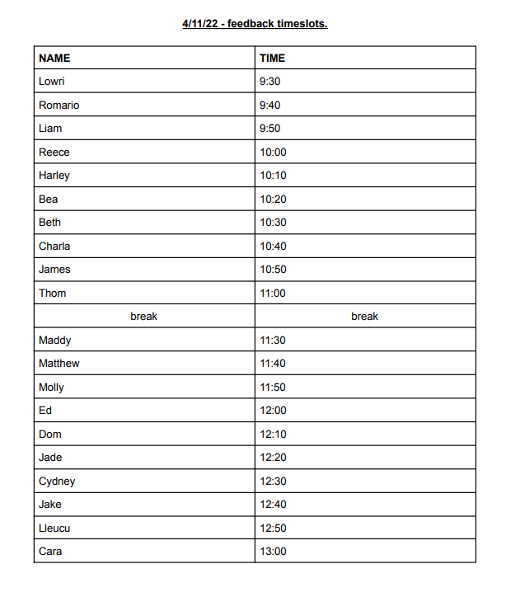
Appendix 11

Appendix 12
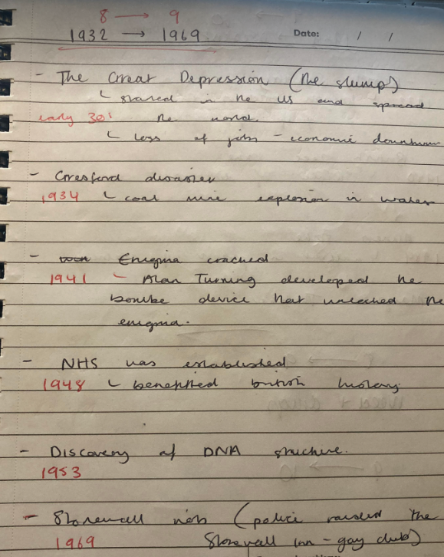

Appendix 13
Scene 5 – I included a picture inspired by the nature of man as the scene was all about the touch of a mans body and the artificial sphere as Roxanne’s character was utterly obsessed with space and the dynamics of spheres. I could have easily included philosophers, but it was nice to have variations of pictures throughout the show, not solely portraits.
Scene 7 – I included a picture of cleopatra and lucifer which helped reiterate De Vere’s passion for art and mythology.
Scene 9 – I included a self-made freedom of love graffiti poster and a freedom for nudity protest poster as the scene was all about the time of sexual liberation.

Appendix 14
- Three to four transition – this transition (as you can see in appendix 9) involves Jake rising up as the dead body, revealing a plague mask before scrolling on tinder, only liking those with no covid mask, before being scared away by Jade’s woman character. The gag was to have the plague meet covid, but it never read like that as only half of the audience could see Ed’s covid mask. I thought it was have been better to have all of the cast, following Jade, scroll out in a covid mask before ripping them off and repeating Jade’s reoccurring scream. This would have incorporated both the plague meets covid but also the fact that the woman is an untouchable presence within the location.
- W.A.P – the tinder aspect takes us through a journey of matches which leads to the modern age being glued to their phones. At the start we acknowledge that Cydney has full control over the clowns, whereas at the end they do not listen to her at all as it has all become digital (love, life and relationships). After that, the song W.A.P comes on and they all dance recklessly. I do not think this is necessary and I am not sure what this says, whereas the phones should have been enough due to the use of the phones throughout the play.
- Opening – the show opens with Cydney downloading an app called ‘hearts international’ that asks her some subjects she may have a mutual interest to a potential partner in, as this sets the tone of the whole clowning aspect of the show, it needs to register to the audience by having more energy and intention. But Jones appreciates and enjoys the subtle nature to it, I think the more energy we would have had from Cydney, the better the clowns’ reactions would have been, making it clearer for the viewers.

Appendix 15
TikTok:
- Meet the cast: https://vm.tiktok.com/ZMFEAv56Q/
- Meet the crew: https://vm.tiktok.com/ZMFEACsWt/
- Describe Loveplay in one word: https://vm.tiktok.com/ZMFEApkYx/
- Cast ready: https://vm.tiktok.com/ZMFEA3Men/
- Crew pre-show hype: https://vm.tiktok.com/ZMFEAsrMb/

Instagram:
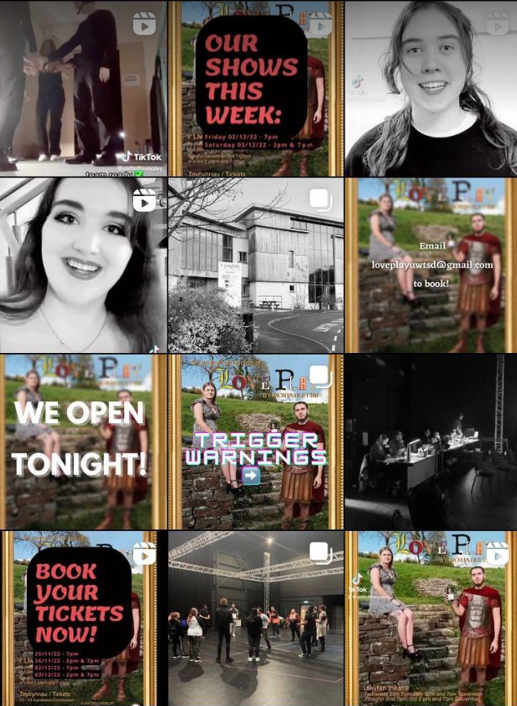

Appendix 16


