Dylan Martin (1802020)

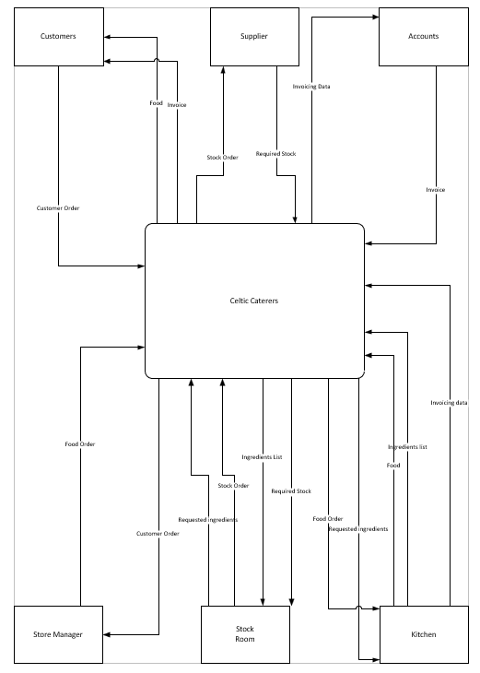
This is my context level DFD for the Celtic Caterers system.

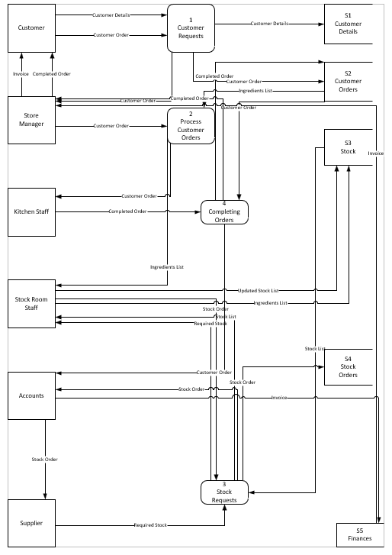
This is my Level 0 DFD for the system.

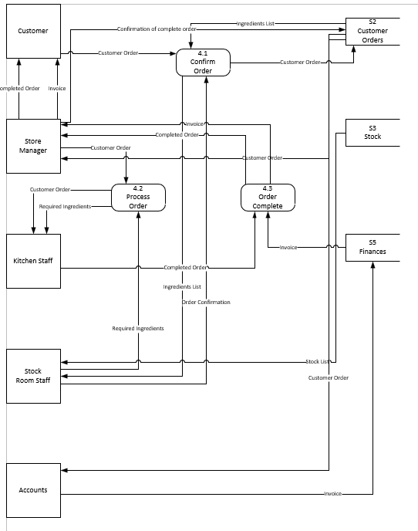
This is my level 1 DFD for the system

This is my ERD for the system


