- Summary

- Lampeter, the town and its data

- Population, density and groups

- Lampeter and its religious history

- Religious architecture in Lampeter

- Preservation of religious architecture

- Bibliography

- Conclusion
Variety in Christian Buildings in Lampeter
2025
Presented 16/02/2025

Summary
With the aim of analysing the broadness of Christian building in Lampeter, this report investigates the archaeological and historical sites of the town, using a number of surveys such as the Ordinance Survey records, and visits to local buildings in order to draw a conclusion. The primary findings of this report show a vast populus of religious buildings within the town despite its small size and population, and indicates that the Christian religion has held, and continues to hold a great significance within Lampeter. While the population of the town and the religious population do not appear synonymous, presence of religion in the town and a general population in Lampeter appear to be interlinked, and there is a clear historical connection between the two.
Lampeter, the town and its data
Located in the county of Ceredigion, the OS grid reference of Lampeter is SN 57752 48120 (Grid Reference Finder | OS Map, 2017), with its postcodes starting with the digits SA48. In the case of the Halls of Residence of the University Campus for example, the post code is SA48 7ED (Bing Maps, 2025). Lampeter is a small town, comprised of several main streets, with smaller streets adjoining to the high street. On the outskirts of the town is the Lampeter Industrial Estate, containing small agricultural shops, car garages, and an organic greengrocer, Wattson & Pratt’s. Very little industry can be seen within the town, and its retail is limited to the Co-Operative, Sainsbury’s, and several small local shops and charity shops.
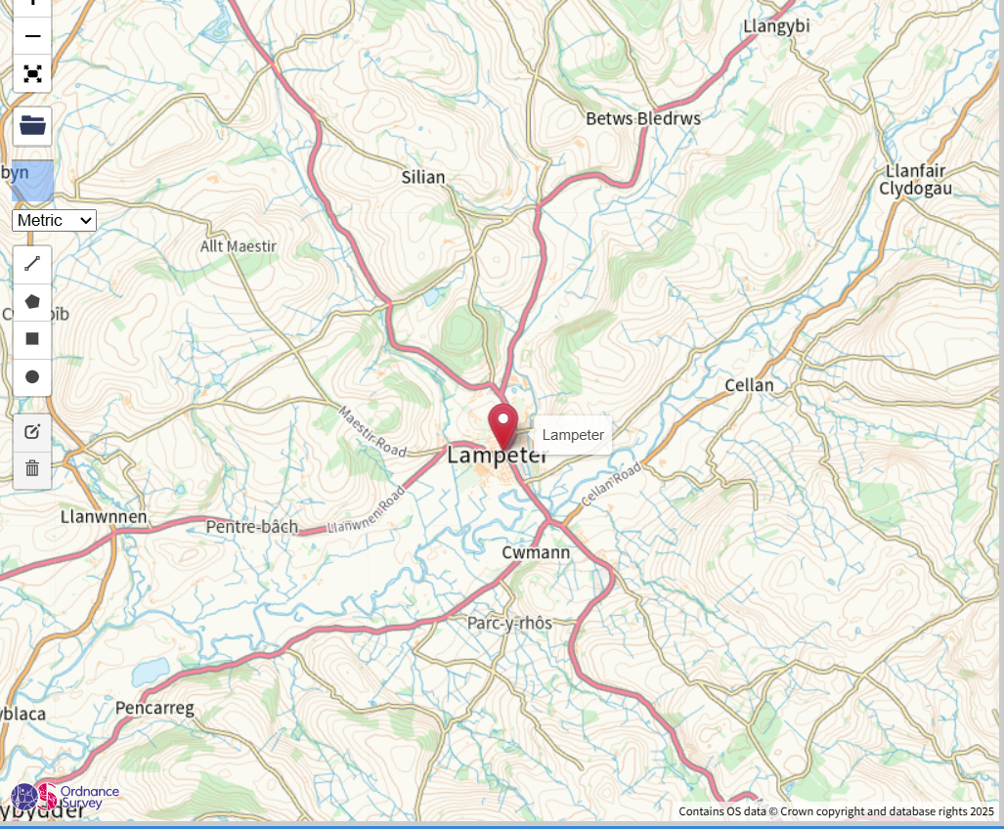
(Above, OS Grid Map, Gridreferencefinder.com, 2025)
Particularly in the 19th century, the town was a largely agricultural one, surrounded even to this day by fields which contained a multitude of different livestock such as cattle and sheep. Little evidence of this time remains, as locations such as the cattle market have since been dismantled and repurposed. Despite its small size., the town is rich in a broad history, with a number of SAMS buildings, such as the Lampeter Pill Box, dating to the Second World War, and situated in a field opposite the Co-Op (Admin, 2022). Much like the Grade Listed buildings, SAMS sites bear a significant historical or archaeological history and are therefore protected, further demonstrating the ample history contained within the market town, and the diversity of this history – while this report will fixate on the religious sites of the town, there is undeniably a vast history in general within the town that could be further explored in additional reports.
Population, Density and Groups
As of the 2021 census, the population has been recorded to be 2,504 residents, however the number of people living within the town itself fluctuates with the number of students attending the University (Lampeter (Community, United Kingdom) - Population Statistics, Charts, Map and Location, n.d.). In 2025, the decision was made by the university to close its doors to students, and therefore this number will no longer affect the population density of Lampeter town. Several cultural groups can be seen within the town, with a wide range of UK students attending the university, as widespread as the North of England to the South of Wales. The town also has a thriving number of Chinese residents, as the university has an exchange programme with a Chinese university, the Confucious Institute (University of Wales Trinity Saint David, 2025). There is also a diverse religious community within the town, even in regard to varying Christian denominations. The town contains a multitude of different Christian buildings, pertaining to groups such as the Baptists, Jehovah’s Witnesses, Catholics, and Quakers (Places of Worship, 2023). Within this broad variety of denominations there is a clear distinction of different groups of worship within the town, and many choose to present themselves within different buildings – however, that is not to say that the town is solely Christian, or religious at all. There is also a large population of atheists and followers of other religions, and there are neutral spaces such as libraries and non-religious buildings to cater to all residents of the town.
Lampeter and its religious history
With evidence of its building dating back to the Taxation of 1291, St Peter’s Church, a Church In Wales building, is the oldest surviving and known religious building in Lampeter (English – Coflein, 2021). Its grid reference number on the OS site is
SN1552014440, and the surviving elements of the site consist of a 5-bayed chancel/nave, without structural division, a 5-bayed south aisle, a single-bayed north transept and a south porch, though these are not the original buildings of the church. Restorations on the church continued through the centuries up to 1867, with the full roof being restored at this time. The original church building dates roughly to the same time period as the nearby Motte Castle, roughly 100 metres apart from each other.
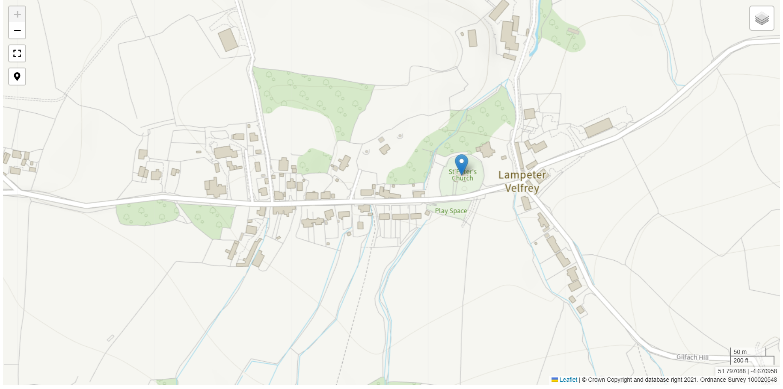
(Above, OS Survey Map denoting the location of St Peter’s Church, Coflein.com, 2021)
Early evidence of Christianity in Lampeter is attributed to the arrival of the patron Saint of Wales, St David, who allegedly brought the religion to the town in the 6th Century AD (Studman, 2023).
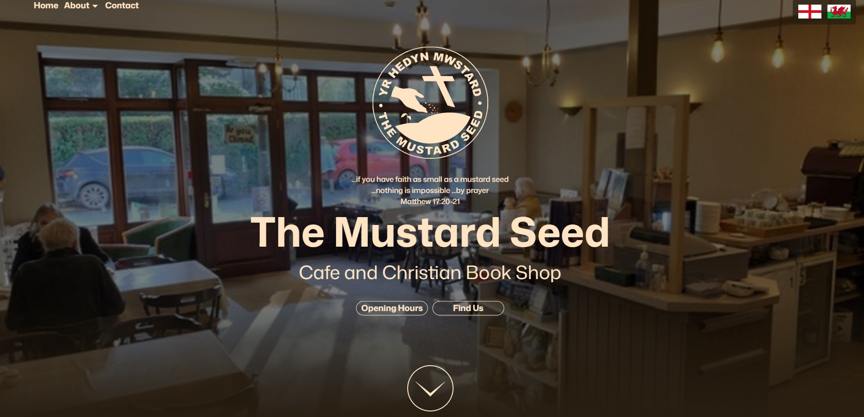
(Above, screenshot of the Mustard Seed café’s web-page, taken by Lexin Jessopp, 2025)

Religious architecture in Lampeter
Throughout the entire town there re a vast number of religious buildings, both places of worship and buildings interlinked with the religious community of Lampeter. The Mustard Seed Café, for example, is a Christian-led coffee shop, which can be rented as a meeting space, alongside selling small local gifts in the back of the shop, beside the books for sale (Lampeter21, 2023). Cafes such as this demonstrate the interlinked relationship between the active church and the local community, and its position on the road opposite the university gives it an accessible location to receive customers. Opposite the café, within the Old Building of the university is the University Chapel of St David, another Church in Wales establishment, which is led by the Church in Wales rather than being controlled by the university administration. Like the Old Building, it dates to the 19th Century, and contains a number of oil paintings depicting religious scenes along the chapel walls.
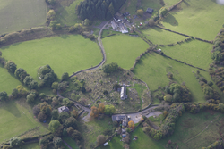
(RCAHMW colour oblique aerial photograph of St Peter's Church and Lampeter Velfrey. Taken on 14 October 2009 by Toby Driver)

Preservation of religious architecture
St Peters is now a Grade II Listed building in Lampeter, offering it some protection from demolition or removal from its site (English – Coflein, 2021). Grade II listed buildings attain their status by hav9ing some form of cultural or historical significance linked with them, in the case of St peters this would be the extensive history of the building and its longstanding connections to religion in Lampeter (Grade 2 Listed Building Restrictions, n.d.). In order to protect these buildings, explicit permission must be received by relevant local authorities and therefore protects the buildings from being altered or damaged by the present owners. While not a direct form of preservation, local groups such as the Teifi Faith Trail offer guides for people wishing to partake in a religious pilgrimage of some form, therefore creating a demand for such churches to be preserved and protected in order to maintain their status on such lists. Although incomplete, the site aims to launch this year (2025), and will offer historical information of each of the churches in Lampeter and the surrounding Teifi Valley, offering people a more guided tour of these churches and parish buildings (Teifi Faith Trail – Lampeter Ministry Area Churches, n.d.).
Conclusion
Conducting this study has provided valuable insights into the evolution of religious sites in Lampeter, and shown that they were not consistent in their nature – places of worship are ample but there are also areas such as social buildings and coffee shops. This will be beneficial for future research and practice within further undergraduate archaeological research, and has allowed for a deeper understanding of the religious sites within the town, in manners I had previously not observed.
Bibliography
Grid Reference Finder | OS Map. (n.d.). 2017. https://gridreferencefinder.com/os.php#gr=SN5775248120|Lampeter|1
Bing Maps. (n.d.). Bing Maps. https://www.bing.com/maps?&mepi=127~~Unknown~Address_Link&ty=18&q=University%20of%20Wales%20Trinity%20Saint%20David&ss=ypid.YN1029x4987576726056240166&ppois=52.113895416259766_-4.075921058654785_University%20of%20Wales%20Trinity%20Saint%20David_YN1029x4987576726056240166~&cp=52.113895~-4.075921&v=2&sV=1&FORM=MPSRPL
Lampeter (Community, United Kingdom) - Population statistics, charts, map and location. (n.d.). https://www.citypopulation.de/en/uk/wales/admin/ceredigion/W04000370__lampeter/
University of Wales Trinity Saint David. (n.d.). Confucius Institute. https://www.uwtsd.ac.uk/confucius-institute
Places of worship. (2023, June 23). Lampeter Town Council. https://lampeter-tc.org.uk/index.php/en/community/places-of-worship
English – Coflein. (2021). https://coflein.gov.uk/en/site/103762/#:~:text=St%20Peter%27s%20Church%2C%20Lampeter%2C%20stands%20within%20a%20curvilinear,was%20first%20mentioned%20in%20the%20Taxation%20of%201291.
Studman, C. (2023, August 13). The history of Lampeter. Lampeter21. https://lampeter21.co.uk/the-history-of-lampeter/#:~:text=The%20origins%20of%20Lampeter%20can%20be%20traced%20back,Wales%2C%20established%20a%20religious%20settlement%20in%20the%20area.
Lampeter21. (2023, October 22). The Mustard Seed Cafe, Lampeter - Lampeter21. https://lampeter21.co.uk/organisations/the-mustard-seed-cafe-lampeter/#:~:text=The%20Mustard%20Seed%20%2F%20Yr%20Hedyn%20Mwstard%20is,books%20and%20cards%20as%20well%20as%20local%20crafts.
Grade 2 listed building restrictions. (n.d.). https://www.heritage-house.org/stuff-about-old-buildings/legal-and-insurance/grade-2-listed-building-restrictions.html
Teifi Faith Trail – Lampeter Ministry Area Churches. (n.d.). https://teififaithtrail.wales/
Admin. (2022). Lampeter History. CEREDIGION HISTORICAL SOCIETY. https://ceredigionhistory.wales/lampeter/

