Adriana Ghiocel Ioaniciu
student number :2127376
premier inn hotel

Contents
1.INTRODUCTION 1
2. SITUATION ANALYSIS 1
2.1 Company 1
2.2 Customer 2
2.3 Competitors 2
2.4 Collaborators 2
2.5 Climate -Pestle Analyse and Marketing Mix 3
3. OBJECTIVES 4
4. STRATEGY 4
5. TACTICS 5
6.ACTION 5
7. CONTROL 5
8. CONCLUSION 6
9. APPENDIX 6
9.1 Appendix 1 6
9.2 Appendix 2 7
9.3 Appendix 3 8
9.4 Appendix 4 9
9.5 Appendix 5 10
10. REFERENCES 11

1.INTRODUCTION

One definition of a marketing plan is "an operational document that outlines an advertising strategy that an organization will implement in order to generate leads and reach its target market outlined in the plan."[Chen,J,2023]
Through the implementation of this marketing strategy, the Premier Inn Hotel located in Port Talbot is the intended target. According to the hotel's strategic approach to overcoming the challenges, this marketing plan is built on that method. Price, product, space, and promotion are the primary areas of concentration for the marketing plan.
Initially known as Travel Inn, the company began operations in the year 1987. The first location opened next to the Beefeater restaurant "The Watermill" in Basildon. Premier Travel Inn bought 11 Holiday Inn hotels in England and Wales at the beginning of 2006. Up until that point, rooms had stayed the same, and all new hotels were made to look like "Travel Inns. “
Visit the Premier Inn Hotel Port Talbot for a convenient Southwest Wales stay. Business places and Gower holiday hotspots are nearby between Swansea, Neath, and Port Talbot. Zip into the city to shop or watch a game at Liberty Stadium. Theatre stars perform at the Princess Royal Theatre. Visit Brecon Beacons National Park's magnificent highlands.
[Anon,2023]

2. SITUATION ANALYSIS

2.1 Company

I will do a small analysis of the company using SWOT analysis.
A SWOT analysis is a way to plan that looks at a project or group to find its Strengths, Weaknesses, Opportunities, and Threats. It's a way for a company to make sure that its plans, goals, and abilities are all in line with the conditions in which it works. [CIPD,2023]
An importance strength is a strong presence in UK and a weakness is the refund issue .
SWOT analysis can be found in Appendix 1.

2.2 Customer

Customers are those who buy from businesses. The customer is the business king. Everything the company does is customer focused. The firm relies on customers. Companies fail without consumers. [Sandra,2022]
According to similar web, demographically speaking we can see the age and gender of people who prefer accommodation at premier inn hotels. The evidence can be found in Appendix 2.

2.3 Competitors

Competitors are other companies that possess the ability to provide your consumers with the same or comparable products and services. [CCNZ,2018]
The first three competitors of the premier inn hotel in Port Talbot are: Best Western Aberavon Beach Hotel, Blanco's Hotel & Restaurant, and The Grand Hotel. [ TripAdvisor,(n.d) ]
To have a clear view of Premier Inn Hotel competitors, I will use Bowman Strategy Clock and Positioning Map.
On the positioning map, the Premier Inn hotel has more pricing than other hotels, but its services are better and on the bowman strategy clock. I placed it on position 3—hybrid—because it keeps pricing low even while adding more services.
The evidence can be found in Appendix 3.

2.4 Collaborators

Collaborators share resources, knowledge, and duties to achieve project goals. Collaboration includes parties with complementary abilities or resources working together to complete activities or projects that would be difficult or impossible alone. Business collaborators may be partners, stakeholders, or organisations with which a firm or organisation collaborates. Joint ventures, strategic alliances, and partnerships can achieve common goals, increase market reach, pool resources, or stimulate innovation. Collaboration improves project success by bringing varied viewpoints, talents, and resources.
The Premier Inn hotel collaborators are:Costa,Nuevo and Mr Toad’s Pub &Kitchen.
  - Climate -Pestle Analyse and Marketing Mix
A PESTLE study examines the most significant external factors affecting a company. This includes political, economic, societal, technical, and legal elements. It may aid senior managers and HR professionals in making strategic decisions in many scenarios.[M, Battista 2023]
The UK hotel business is heavily impacted by parliament. Immigration, taxation, and competition affect Premier Inn. Covid-19 travel warnings hurt hotels. Move limitations Tourists and locals avoid the motel because of COVID-19. Low taxes help Premier Inn Hotel COVID-19.
Poor economy, strong British Sterling Pound, lower Premier Inn reservations due to COVID-19. Many high-end hotel guests booked owing to UK government eased travel advice. The strong pound hurts Premier Inn Hotel expenditure.
Private rooms are preferred over hotels in the UK due to socioeconomic issues. Airbnb stole Premier Inn customers. Hotels supplied services to gratify guests. Gyms and massage parlours draw young people to hotels.
Premier Inn Hotel has everyday legal issues. Fines for hotel online data breaches are widespread. Customers are concerned about General Data Protection Regulation Act data breaches, which protect UK citizens and tourists. The hotel's Gas Safety Act and Health and Safety Act compliance and excellent service attract tourists.
Premier Inn Hotel's smart tech saves UK resources. Green features include solar power, water-saving showers, and energy-saving lighting. Our green energy attracts visitors. Climate change impacts the hotel, not operations. [Anon,2022]
The 7 Ps of marketing are product, price, location, promotion, people, process, and physical evidence. Product rules the seven. Physical and internet marketing might share a blend. Below, we explore each P and how it helps marketing. [V, A 2023]. Below is Premier Inn's marketing mix.
Free parking, a restaurant, Wi-Fi, accessible rooms and restrooms, and family rooms are available at the Port Talbot Premier Inn Hotel.
Premier Inn Hotel offers three rates: Flex Rate: pay at arrival, free cancellation, full refund.
Standard Rate—Nonrefundable, due upon booking.
No changes, Flex Rate-Pay upon booking.
Near the highway, shops, and public transit, the Premier Inn Port Talbot is handy.
Premier Inn Hotel promotions were few. Premier Inn adult meals are 20% off. Accommodation costs are lower on Friday and Sunday nights, two youngsters enjoy free breakfast,
Amazon lockers are Process-Premier Inn-only.
Purple logos indicate Premier Inns. Since it's neither modern nor old, design is fundamental.

3. OBJECTIVES
Goals might indicate your company's growth and success. The SMART concept is most popular and simplest to use in IT businesses. Specific, measurable, attainable, realistic, and timely specified constitute SMART. [A\Z\non, Nd]
SMART can be found on Appendix 4.

4. STRATEGY
After everything found in connection with Premier Inn Hotel, we could see that it needs a very well-designed strategy to be able to grow on the market. They need something unique that will bring satisfaction to current and potential customers. to create a strategy, the manager together with the staff trains to follow very carefully the needs of the customers, which most of the time are written in the review. I noticed that the premier inn hotel needs some major changes in terms of the marketing mix, namely: to implement new services, to introduce more offers, to adjust prices, and to be open to new partnerships.
I will use the Ansoff Matrix to be able to determine the strategy that we can implement for the Premier Inn hotel. Thanks to Ansoff Matrix , we were able to determine that the best strategy that the Premier Inn hotel can use is to market penetration , because the introduction of as many offers, promotions, services as possible can attract many more customers from the same market segment in Port Talbot.

5. TACTICS

After all the examinations are done, the premier hotel needs a lot of improvements to be able to grow on the market. According to SimilarWeb, we could see that most of the guests are aged between 25-34, the majority being men. To be able to grow on the market and to attract guests of older ages, I think that the first thing they should implement would be the establishment of clubs with certain themes, the organization of excursions, the organization of festive meals and the introduction of live music.

6.ACTION

A marketing channel is a specific kind of media that is utilised for the purpose of advertising your organisation.[Mailcimp,nd]
Premier Inn makes use of social media in order to promote new hotels and existing destinations. In addition to email newsletters, specials, and an outstanding website, Premier Inn makes effective use of all channels, maintaining a strong brand presence throughout the whole organisation.[Linkedin,nd]
Grant table can be found on Appendix 5.

7. CONTROL

My decision to embrace social media was based on the fact that Premier Inn Hotel could concentrate on engagement strategies in order to develop a lively online community. It is necessary for a firm such as Premier Inn to make use of measures such as reach, impressions, and sentiment analysis in order to take into account its online image and reach effectively. It is going to be helpful in determining how the general public perceives it and where modifications are required.

8. CONCLUSION

After all the searches and analyses done, I concluded that the premier hotel is a hotel that is still on the guest list, the prices being affordable, and the services offered being qualitative. with guest reviews being mostly positive, I believe the hotel will be a favorite hotel for many guests. The marketing plan that was developed for Premier Inn is a comprehensive approach that aims to strengthen the hotel's brand presence, improve customer interaction, and drive revenue development. The strategy intends to capitalize on growing trends while maintaining the hotel's established reputation for quality and reliability. By using both conventional and digital channels, the plan will prioritize the use of both.

9. APPENDIX

9.1 Appendix 1
Strengths | Weaknesses | Opportunities | Threats
Occupancy rate | Limited global presence | New markets | Competitors
Strong presence in the UK | Refund Issues | Further growth in Germany | Legal threats
Locations | Big issues with hygiene | New decor | Lockdowns
Brand Image
Commitment to sustainability

9.2 Appendix 2

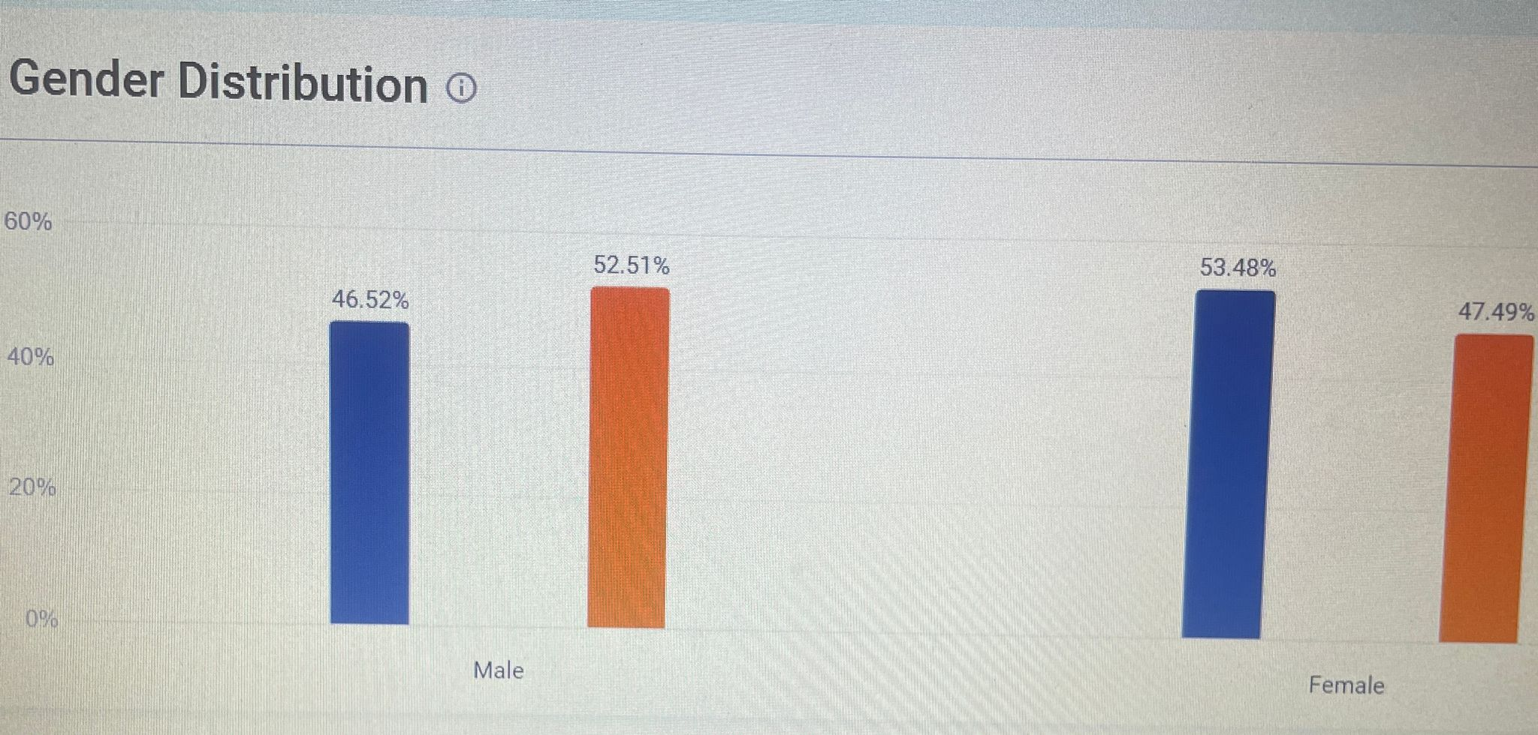

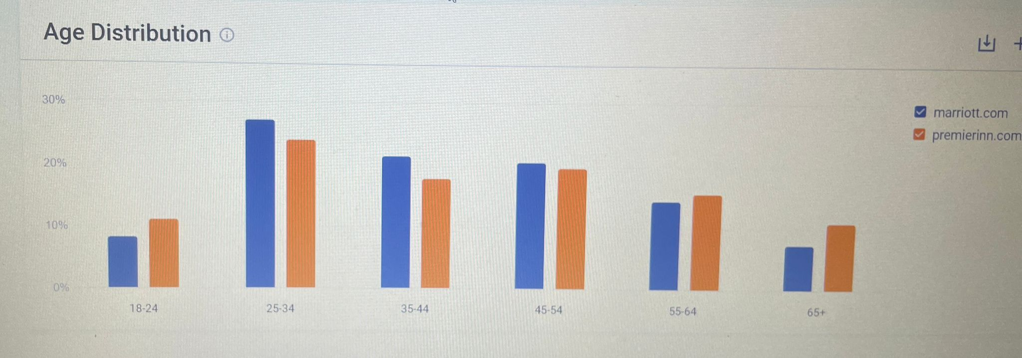

9.3 Appendix 3

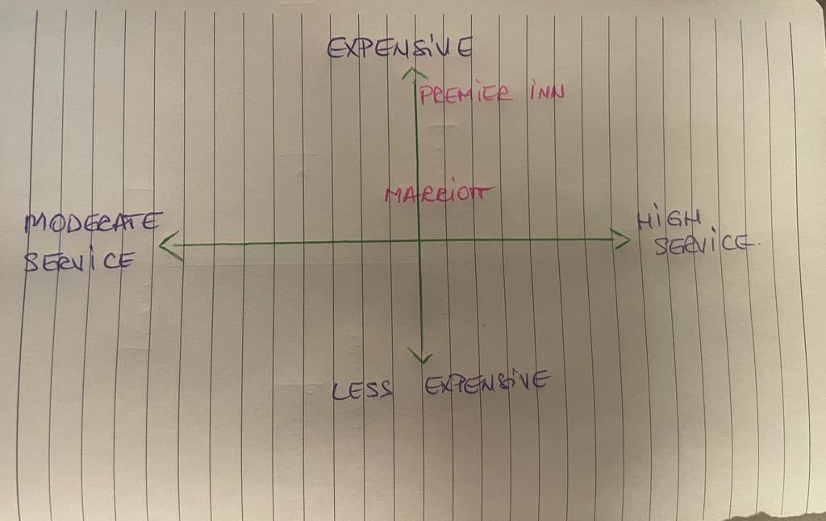

9.4 Appendix 4
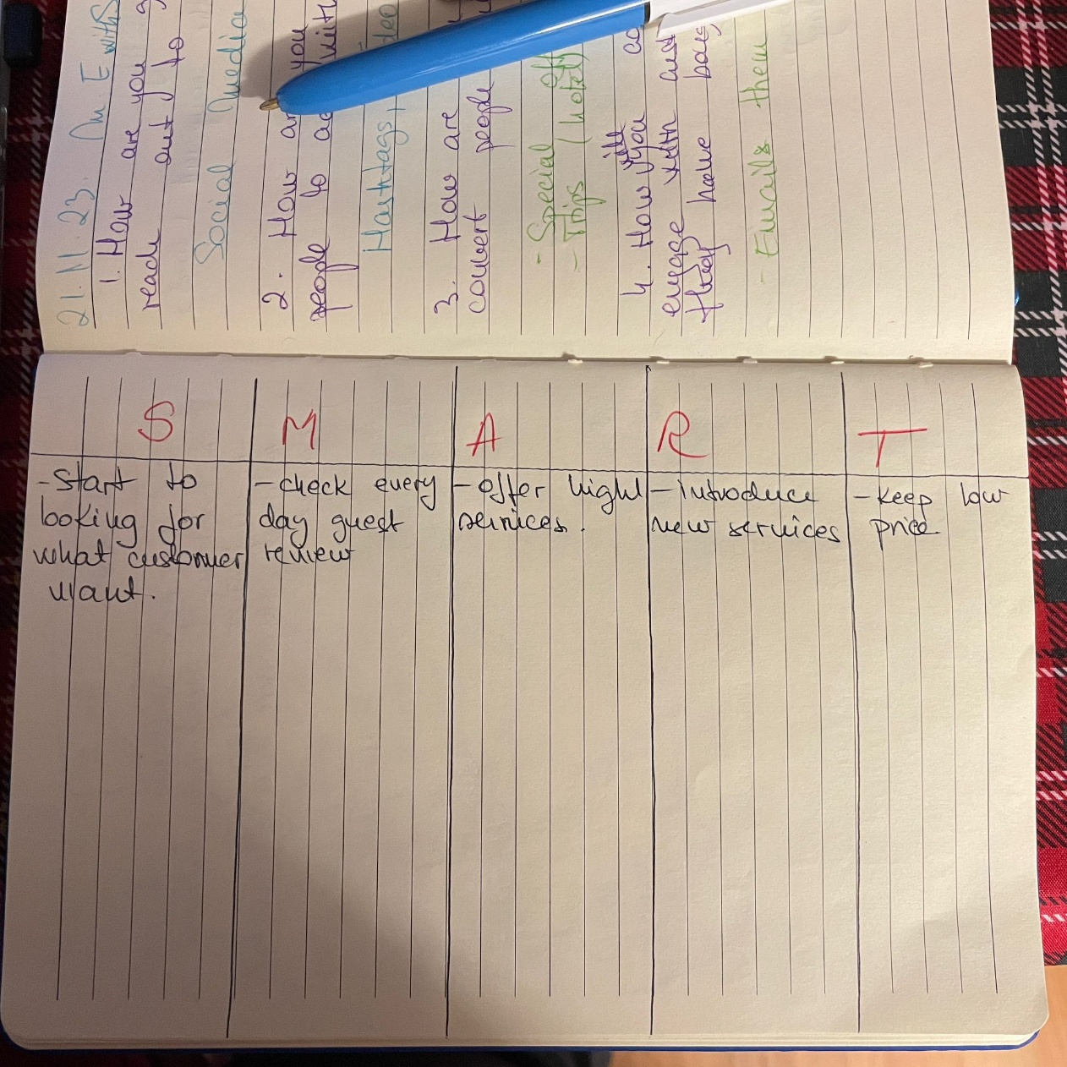

9.5 Appendix 5

Marketing activties | Marketing channel | Month 1 | Month 3 | Month 6
Social media | Facebook  Instagram
Email marketing | Promotional emails

10. REFERENCES

Anon, (n.d.). 5 values of the SMART rule - Black Cliff Media Ltd. [online] Available at: https://blackcliffmedia.com/blog/5-values-of-the-smart-rule/#:~:text=SMART%20Definition&text=the%20SMART%20principle.- [Accessed 2 Dec. 2023].
Anon, (2022). Premier Inn Hotel SWOT and PESTLE Analysis | Free Essay Examples. [online] Available at: https://samples.freshessays.com/premier-inn-hotel-swot-and-pestle-analysis.html.
ANONIMUS (2023). Port Talbot Hotels | Book Cheap Hotels In Port Talbot | Premier Inn. [online] Premier Inn. Available at: https://www.premierinn.com/gb/en/hotels/wales/glamorgan/port-talbot/port-talbot.html?ARRdd=02&ARRmm=12&ARRyyyy=2023&NIGHTS=1&ROOMS=1&ADULT1=1&CHILD1=0&COT1=0&INTTYP1=DB&BRAND=PI [Accessed 2 Dec. 2023].
Battista, M. (2023). PESTLE Analysis. [online] CIPD. Available at: https://www.cipd.org/uk/knowledge/factsheets/pestle-analysis-factsheet/.
Chen, J. (2023). How Marketing Plans Work. [online] Investopedia. Available at: https://www.investopedia.com/terms/m/marketing-plan.asp#:~:text=The%20marketing%20plan%20details%20the.
CIPD (2023). CIPD | SWOT Analysis | Factsheets. [online] CIPD. Available at: https://www.cipd.org/uk/knowledge/factsheets/swot-analysis-factsheet/#:~:text=A%20SWOT%20analysis%20is%20a.
Commerce Commission New Zealand (2018). What is a competitor? [online] comcom.govt.nz. Available at: https://comcom.govt.nz/business/avoiding-anti-competitive-behaviour/what-is-a-competitor#:~:text=Competitors%20are%20other%20businesses%20who.
Mailchimp. (n.d.). What Are Marketing Channels? Definition, Types, & Examples. [online] Available at: https://mailchimp.com/resources/what-are-marketing-channels/.
Sandra (2022). WHAT IS A CUSTOMER? DEFINITION, TYPES AND CATEGORIES. [online] Apptivo. Available at: https://www.apptivo.com/blog/what-is-a-customer-definition-types-and-categories/#:~:text=A%20customer%20is%20an%20individual.
Tripadvisor. (n.d.). THE 5 BEST 3 Star Hotels in Port Talbot (2023). [online] Available at: https://www.tripadvisor.co.uk/Hotels-g681385-zfc3-Port_Talbot_Neath_Port_Talbot_South_Wales_Wales-Hotels.html [Accessed 2 Dec. 2023].
V, A. (2023). The 7 Ps of marketing mix model. [online] Online Manipal. Available at: https://www.onlinemanipal.com/blogs/the-7ps-of-marketing-mix#:~:text=Product%2C%20Price%20Place%2C%20Promotion%2C.
www.google.com. (n.d.). job premier inn port talbot - Google Search. [online] Available at: https://www.google.com/search?q=job+premier+inn+port+talbot&rlz=1C1CHBF_en-GBGB1014GB1025&oq=job+premier+inn+port+talbot&gs_lcrp=EgZjaHJvbWUyBggAEEUYOTIICAEQABgWGB4yDQgCEAAYhgMYgAQYigUyBggDEEUYPNIBCDUzODFqMGo3qAIAsAIA&sourceid=chrome&ie=UTF-8&ibp=htl [Accessed 2 Dec. 2023].
www.linkedin.com. (n.d.). What can brands learn from Premier Inn’s marketing masterclass? [online] Available at: https://www.linkedin.com/pulse/20141011134315-45850910-what-can-brands-learn-from-premier-inn-s-marketing-masterclass/.

