University of Wales Trinity Saint David

B.A. (Hons) Leadership and Management Skills for the Workplace

Managing Projects in the Organisation

BMSW5104
Rexon Nting

Jesica Mora 2010296

Contents
Task 1 Project Management Plan 3
Section 1 3
1.1Reiss Vago Street 3
1.1.1 New Avatar store try Buy Go 3
Section 2 6
2.1 WBS COST 6
Benefit Analysis 7
Section 3 7
3.1Risks 7
3.1.2 Planning Risks 10
Section 3 10
Work Breakdown Structure 10
Section 4 11
4.1Milestones 11
4.1.2Gant Chart 12
4.1.2.3Project Control 12
Communication with stakeholders. 13
4.1.2.3.4Quality Control 13
Task 2 Evaluation of Project Management Plan 14



Task 1 Project Management Plan

Section 1

1.1Reiss Vago Street

1.1.1 New Avatar store try Buy Go
We will be public on the 16th of January with the new project plan. We will use these platforms for marketing Facebook, Instagram, twitter, promotional videos and 160 stores in UK. We will have the publicity of avatar in Vago street. Two big digital billboards will be outside of the store with the information for the New Avatar store.
The new avatar store.
The customer will have to register in the Reiss app via the website or on the mobile through the app. When you login there will be a scanner so once you have the app, you can scan your QR code. The doors will automatically open and once you go in you will see the new avatar shop floor with new technology. This technology will work with smart sensors and if you want to try one off the new Avatar mirrors then you touch the mirror in front of you. Once you touch the mirror in front of you it will then create an avatar of you, it will move to the side, and you can choose what clothing you want. You will see yourself on there and then it will automatically put the clothing onto your Avatar, and you can choose any clothes, shoes, accessories, colours, and different wallpapers. Also, the price will show sales or promotions that will use marketing preferences of your previous visits to the store.
You will be able to pick up the product that you purchase from the front desk, or you can ask for it to be delivered to your address which is already saved on your profile. You can also use our gift service which we provide so that we wrap and deliver it to a different address. Once you have chosen your order then you just press ok, and the payment will be taken automatically from your account.
We have chosen our Store in Vigo Street as the store needs to undergo an IT upgrade to the tills and general technical support, as well as lighting and light redecorations, so the store will be closed for 10 days anyway.
Project Budget
This content marketing and technology project is being undertaken for Reiss company for the purpose of creating new store to be posted on their site to create brand awareness. The company will invest £250,000.00
Planning
We need 12 weeks to fully design, produce samples, conclude the approval process, and produce then be in the position to place and the order with the manufacturers, the procurement will be a further 8 weeks. A further detailed breakdown of the times is shown in the programme. There will need to be a 20-week lead in period before the refurbishment can commence. The installation period is 2 days for the 8 Interactive screen, plus one day for the testing process.
The digital interactive screens will require power and data, the access flooring in the current store means the floor can be lifted and data and power can be pulled in from the nearest location. The electrical and data contractor needs a 2-week lead time before they commence on site. To extend and test the circuits they will need 3 days.
The IT upgrade requires new computers including software, the Reiss IT team need 8 weeks to procure, install the software and test prior to commencement on site. The IT team need 3 days to install and test on site.
Erco Minirail Track lighting is to be installed throughout the shop in place of the outdated system. Erco have a 20-week lead time. This will have to be procured at the start of the pre-construction phase. The existing lighting rail is a smaller size so the making good to the ceilings will be minimal. The lighting will take 5 days to install and test.
The decorating contractor is on a 4-week lead time, the paints are on a 5-day lead time, colour sample pallets will need to be chosen by our interior design team 2 weeks before commencement on site. The decoration will take 4 days working day and night.
We allowed a further two-week contingency pre commencement to minimise the impact of any unknown issues and to manage the ongoing time delay risk due to Covid restrictions and ongoing issues with materials delay and shortage of staff, this is detailed further in our risks section.
Existing staff will be relocated to the surrounding stores. There are 5 stores within a 3 miles radius of the store. The staff rota will be scheduled and planned for sign off 4 weeks before commencement on site.
Signage for the store will be as per our standard store closed for refurbishment, with the dates. This procurement process is 2 weeks before commencement on site. 1 day to install.
A small number of staff will still be at the store to oversee deliveries into store and stocking.
Loss of turnover for the period has been considered below. Its therefore important to ensure the project does not overrun. We go into how we will minimise this risk, in the coming sections.
We have chosen January to carry out the works for several reasons:
- Quietest month- After Christmas and the sales week (December), the shop turnover is the lowest in January, so it will mean the effect on the loss of profit will be minimised.
- The highest % of staff take holiday in January. We have also asked Staff they wish to take holiday during the temporary closure to minimise the number of staff that need to be redistributed to other stores.

CDM regulations
Our CDM coordinator and our interior design team will review the work to ensure compliance with the regulations.
We will produce a CPP (construction Phase Health and safety Plan) 2 weeks before commencement on site.
RAMS (Risk Assesment and method statements) will be produced by the subcontractors and submitted for review and paroral 2 weeks before commencement.
The existing Asbestos refurbishment and demolition survey will be included as part of the CPP and given to the Sub contractors for review prior to working on site, and a copy will always remain on site.
Health and Safety and Environment
- Management of Health and Safety Regulations 1992
- Control of Asbestos at Work Regulation’s 1987
- Noise at work 1989
- Personal Protection Equipment Regulation 1992
- Manual Handling Operation Regulations 1992
- Fatal Accident Act 1976
- Corporate Manslaughter Act 2007
- Architectures and designs.
- Environmental.

Section 2

2.1 WBS COST

Budget £250,000 .00
Planning the project Cost
Installing
2 People x 2 days @ £180 per day = £720.00
Contractors
8 people x 10 days @ £420 (average) = £33,600.00
Marketing
1 person x 6 months @ £800 =£146,400
Ing. Software
1 person x 3 days @ £250= £750
Store Designs
2 people x 2 days @ £200= £400
Parking
3 vehicles x 10 days @ £31= £310
Inspect Quality
2 people x 3 days @ £120 = £360
Training
3 people x 2 days @ £31= £93.00

Benefit Analysis
The store makes around £40,000.00 in 7 days (1 week) x 52 weeks (1 year) = £2,080.000.00
Budget £250,000.00 – Loss £40,000.00 for the time closed (1 week)
£250,000.00 - £40,000.00 = £290,000.00
After renovation the new Avatar store Try, Buy and Go, we expect an average of £60,000.00 sales a week x 52 weeks a year= £3,120.000.00
Making a profit of £ 1,040.000.00 more that previews year.
Less the £290,000.00 investment and loss the week.
Making £750,000.00 Profit in the same year.
The plan is to recover the budget and the money lost for the 10 days of closure. We will use every social media platform offering a promotional 10% discount for the first 12 months. This promotion we will send buy email to every customer.

Section 3

3.1Risks
Reiss Ne Avatar store
Risk number | Risk name | Risk Plan | Plan Location | Responsible party | Probability
1 | Lockdown / Covid Risk | Y | Project Manager | Angie Butler | Med
2 | Employees show up | N | Project Manager | Angie Butler | Med
3 | Cost Risk | Y | Project Manager | Angie Butler | High
4 | Technology Risk | N | Technology Manger | Amy Cano | High
5 | Construction Risk | Y | Project Manager | Angie Butler | Low

- Lockdown/ Covid restrictions/ isolations
Covid restrictions/ Isolations- Staff shortages during both phases could be an issue. So, for the pre-construction phase we have built in contingency within the procurement stage to allow for slower working due to a lack of staff. It’s also means that it’s imperative that contracts are signed early, and deposits are paid, and decisions are made quickly to minimise down time whilst waiting for sign off. The Sub contractor have been selected that have many staff to minimize the impact should some of their staff have to isolate or catch Covid/ illness, they also have a proven track record in the last lockdowns of continuing to work with limited disruption, because of their good planning and H& S practices.
Pre construction Risks
Notwithstanding the above Covid Risks, the following risks have been identified and the mitigation/ reduction in risk is detailed below:
- Delays in the manufacturing periods- Medium initial risk, Orders to be signed off in good time and deposits paid. Contracts signed with manufactures stipulating critical dates, including liquidated damages applied if they are late. Weve extended the pre-construction phase to include a contingency period.
- Costs- Raw material and labour increases- Contracts need to be signed early and provisions for cost increases removed from the contract. The provisions would also allow for the costs to go down should materials and labour take a sudden nosedive; however, we feel this is unlikely and the greater risk is a cost increase than decrease.
- Technology not working as intended- The IT team will have the computer software during the pre-construction phase to programme and integrate into existing system. This will therefore be tested prior to installation on site, minimising the risk of issues. The Avatar digital screen technology is a fairly new technology however, therefore the company we have chosen is the leader in this technology field and have been successfully using this in stores in the Middle east for the last 18 months.
Conctruction Risks
Again, notwithstanding the covid risks detailed above the following risks have been identified and the mitigation/ reduction in risk is detailed below:
Asbestos- Full survey was carried out last month in anticipation of the project. Small amount of asbestos has been identified within the high-level ceiling voids only. Our work is limited to the floor and the suspended ceiling so this should not cause an issue.
- Project not completing in time and shop having to delay reopening- We have the option to work double shifts if required, and all subcontractors will be signed up to the contract stipulating damages due to late completion, we will manage the process on an hourly short-term basis to catch any slippage early and the necessary provisions can then be made, for example extra labour or working through the night. We have given a looper construction phase to minimise the risk of unknows on site, with the high-risk items being ordered well in advance prior to commencement on site.

Cost Risks
As mentioned above contracts will be in place quickly with no provisions for cost increase. The technology is already in place in this application, so the risk is relatively low on the technology side. However, there is no guarantee that once the technology is installed, the customers will take to it. Our marketing team will work on a campaign for this. Staff will also be trained, and staff will have allocated time to show customer how it works in every shift, to help customers get to grips with the new technology.
The store will be closed for 10 days. This is projected to lose the store in turnover approx. £40,000.00 per week, our marketing team will send emails, messages and update the website directing our customers to the nearest stores. The only element of work that would stop the store reopening if it was delayed would be the lighting in theory, So we have agreed a process with the electrical contractor that they will not remove all the lighting before the new is ready to go up, therefore if they couldn’t complete, we could still run some of the old system and some of the new together, to enable the store to open. They also have the option to work 24 hours if necessary to mitigate any delay.
There is a high probability of another Lockdown in January. The company will have to work with to the new policies establish for the government.
You will find all the essential guidelines which employees and managers should follow during the coronavirus pandemic, including information regarding temporary alterations of existing absence.
You are kindly requested to follow all these rules diligently, to maintain a healthy and safe workplace in this unique environment. It’s important that we all respond responsibly and transparently to these health precautions. Due to the changing circumstances surrounding COVID-19, some of the information in the policy may always not be relevant to all territories and is, therefore, subject to changes with the introduction of additional government guidelines.

3.1.2 Planning Risks
The risks are identified we play some positive action. The first objective is to identify ways to preventing them from happening. Monitoring and controlling it is something that is part and parcel of day-to-day project management.
We will make standing agenda for check point meetings, review risks and issues already logged, assess anything new identified by you or your team.
Project managers understandably respond to the pressure to deliver on time and somewhere close to budget, quality and on time. However, we believe that the quality of delivery is by far
to the most important dimension.

Section 3

Work Breakdown Structure

Section 4

4.1Milestones

Milestones
Task | Star | End Project | Days | weeks
1.Plan Stage |  |  |  | 12 weeks
1.1Designed stage |  |  |  | 20 weeks
1.1.1Procurament Stage Suppliers |  |  |  | 20 weeks
2.1 Installation Period | 16/01/2022 | 17/01/2022 | 2
2.1.1Testing Process | 17/01/2022 | 17/01/2022 | 1
3 Construction | 17/01/2022 | 21/01/2022 | 5
3.1Electrical installation | 18/01/2022 | 20/01/2022 | 3
3.1.1 Light installation and testing | 19/01/2022 | 23/01/2022 | 5
3.1.1.1 Decoration | 19/01/2022 | 23/01/2022 | 5
3.1.1.1.1 Designed | 20/01/2022 | 23/01/2022 | 4
4 IT upgrade Installation | 21/01/2022 | 24/01/2022 | 3
4.1 Training Managers and staff | 24/01/2022 | 24/01/2022 | 2
5 Testing technology | 21/01/2022 | 23/01/2022 | 3
5.1 Control quality | 21/01/2022 | 23/01/2022 | 3
5.1.1 Complete Final Evaluation | 24/01/2022 | 24/01/2022 | 1
Open store to the Public | 25/01/2022

4.1.2Gant Chart

Human Resources
Support Staff
The staff will be trainings for 2 days.

4.1.2.3Project Control
The project control system will control the technical team leaders, Construction, Finance, Cost control, Estimating and Scheduling.

Communication with stakeholders.

Stakeholder Analysis for Project Communication
Stakeholders | Document Name | Document Format | Contact Persone | Due
Project Manager | Daily status report, Planning, Emails. | Hard copy and meeting | Angie Thore | First day
 | Daily status report | Hard copy and meeting | Julia Mena, Miguel Torre | First day
 | Daily status report | Meeting | Diana Page | First day
 | Software implementation plan | Intranet | Amy Cano | First day
 | Training plan | Hard copy | Lewis Dangle | December 16
 | Weekly status report | Intranet | Alex Paz | First day
 | Weekly status report | Emails |  | First day

The project manager will send reports and feedback every week to the stakeholders. The communication channels that we will choose are e-mails, online plataforma, phone call, report or text message, social media, meetings.

4.1.2.3.4Quality Control
The Quality Control inspection is part of our proposal, and it is part of the scope of works, the project schedule and design. The Project manager will use templates and guidelines to inspect the quality of everyone’s work and to make sure that everyone knows the latest issue and is aware of the latest decision, instruction, or action.
The objective of the inspection is to have a look at the quality of the work.
The management of Health & Safety at Work Regulations 1999.

Task 2 Evaluation of Project Management Plan

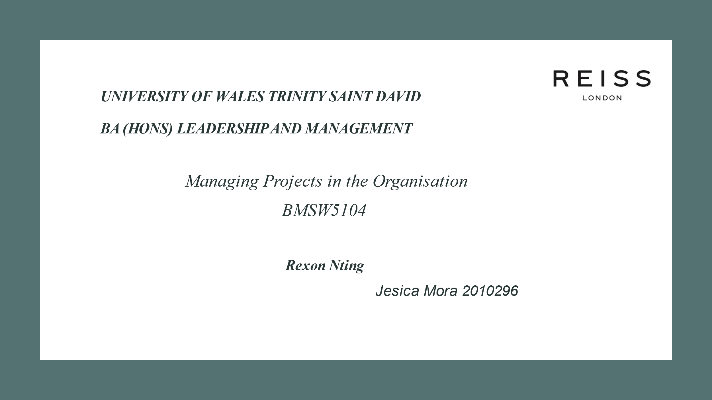

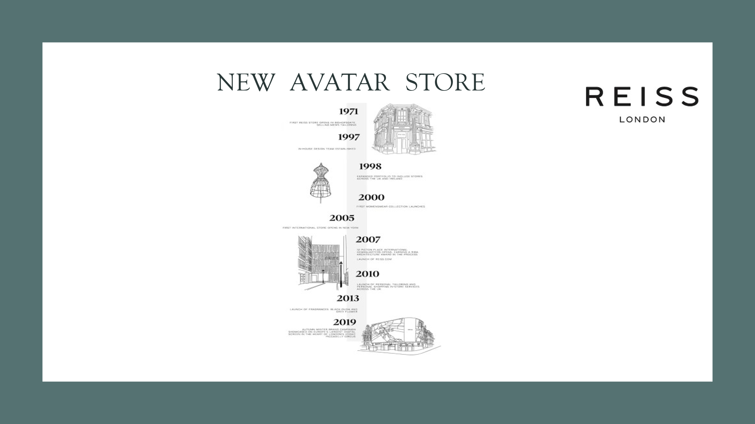
Reiss is a company that has been around since 1971 and is a luxury high street company in the UK for almost 50 years with 160 stores globally. They are a fashion retail company that focuses on the best customers service with unique values and focuses on personal style.
The new Avatar store Try, Buy and Go are focused on customer satisfaction. This project is focused to increase sales by examining its customers data and allowing sales team members to use the information to improve the numbers of sales.

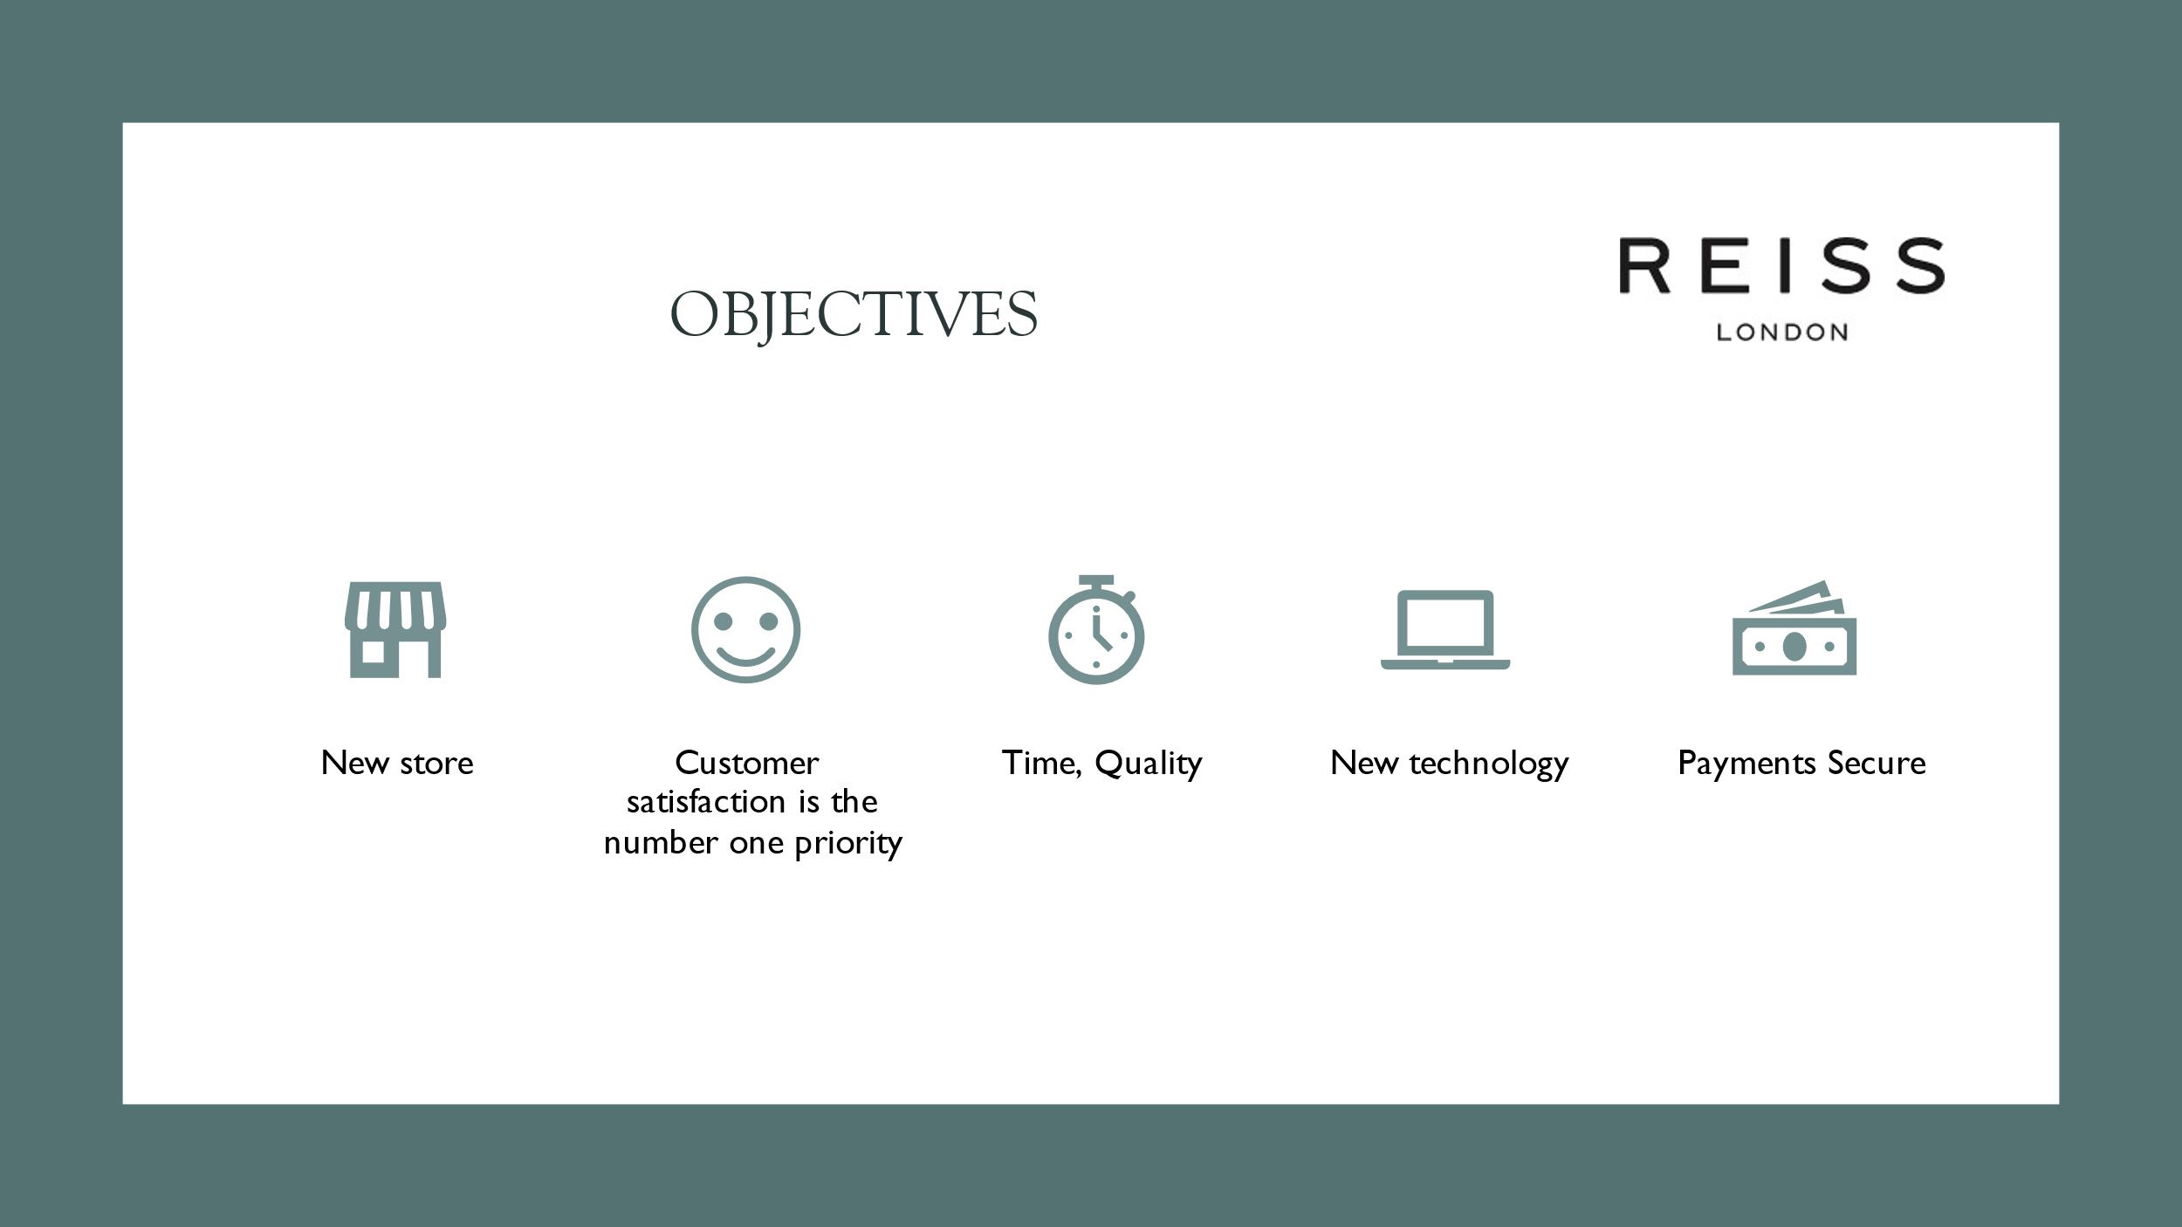

Objectives
We are ensuring the Quality control
New Avatar store,
Customer Satisfaction.
Customers are the number one priority at Reiss.
This project is focus on time, budget, technology and quality.

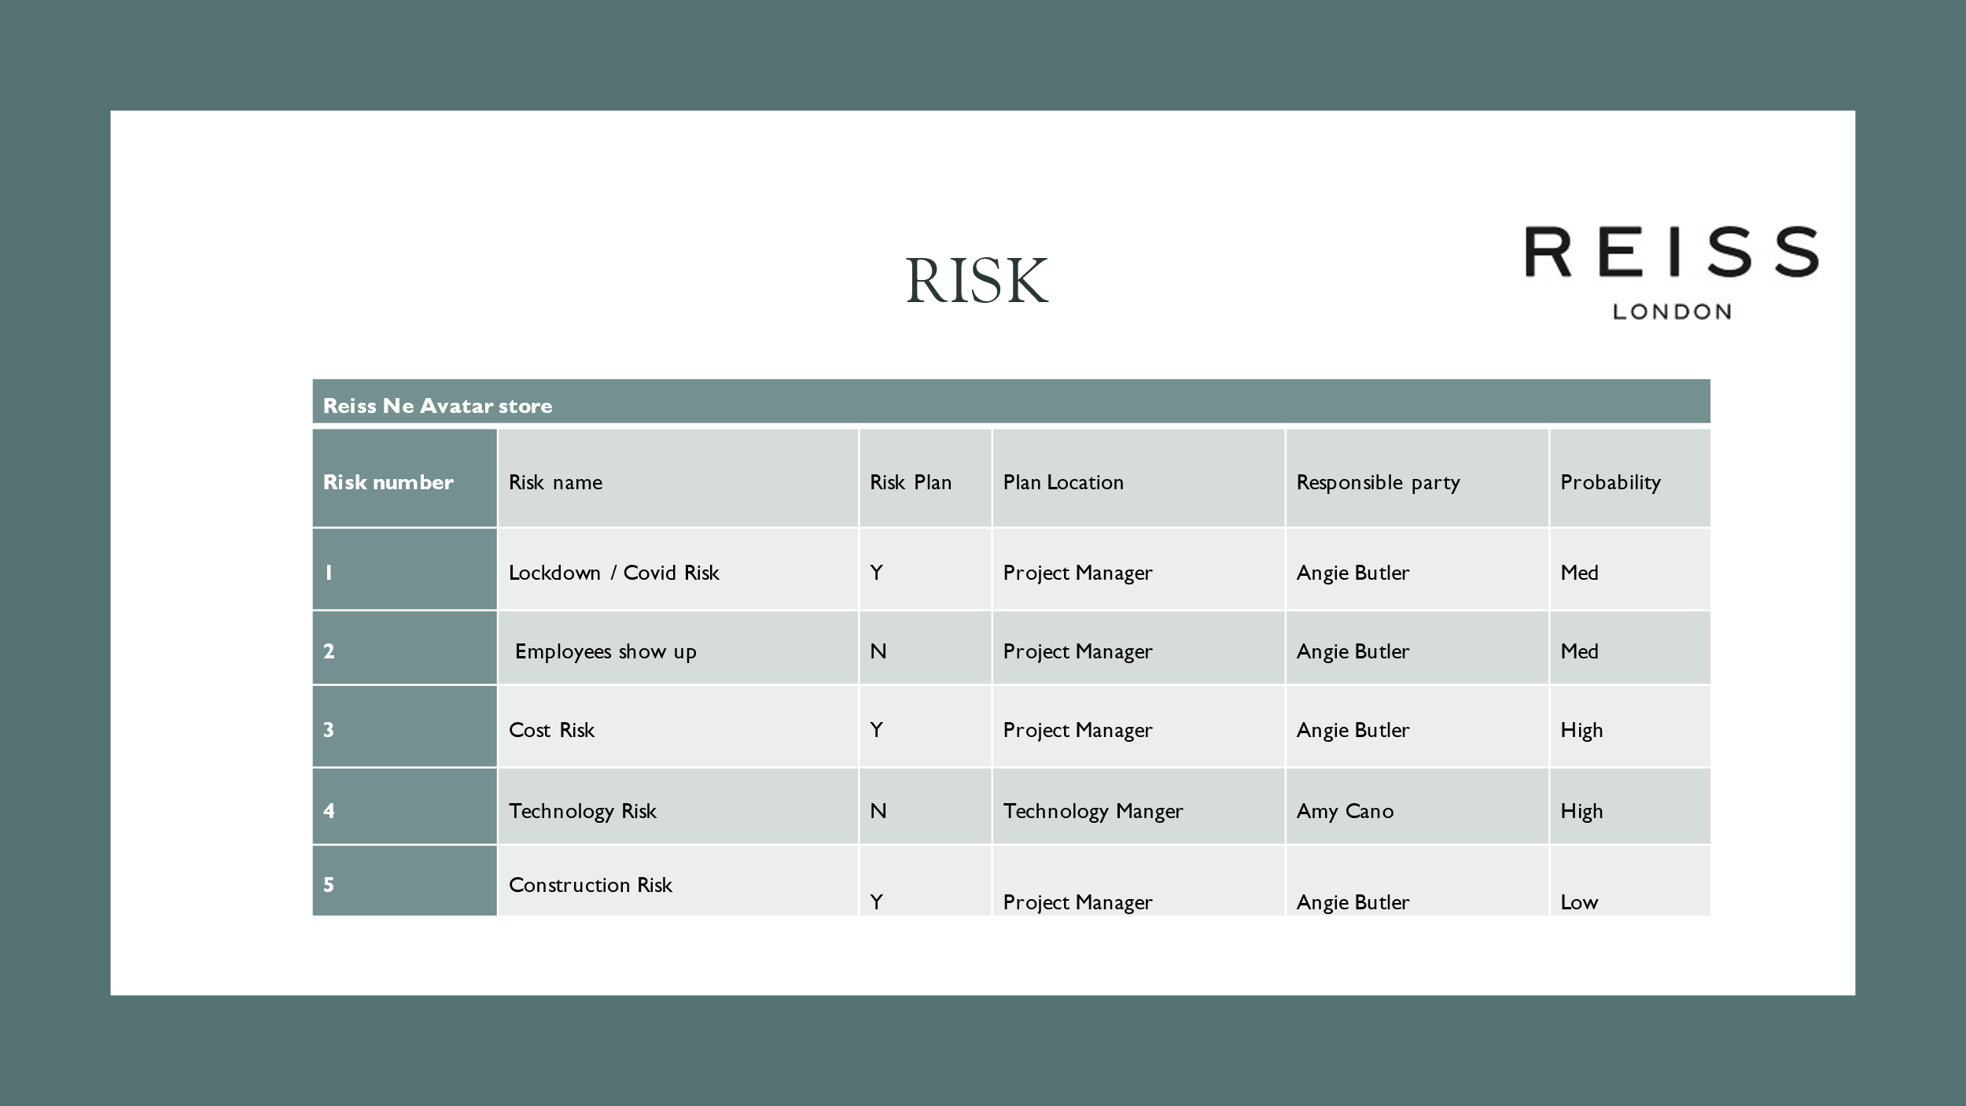
- Lockdowns- Uncertainty around lockdowns are a real risk both to the project procurement and construction phase but also to Reiss as a business, as lockdowns will affect turnover. Having safe methods of work designed in at the design phase including our CPP will mean we minimise the risk of not being able to work during another lockdown, as construction should be able to remain open, assuming the restrictions are no more severe than last ones.
- Cost risk
- Technology risk
- Construction Risk
- Plan risk
- Management risk

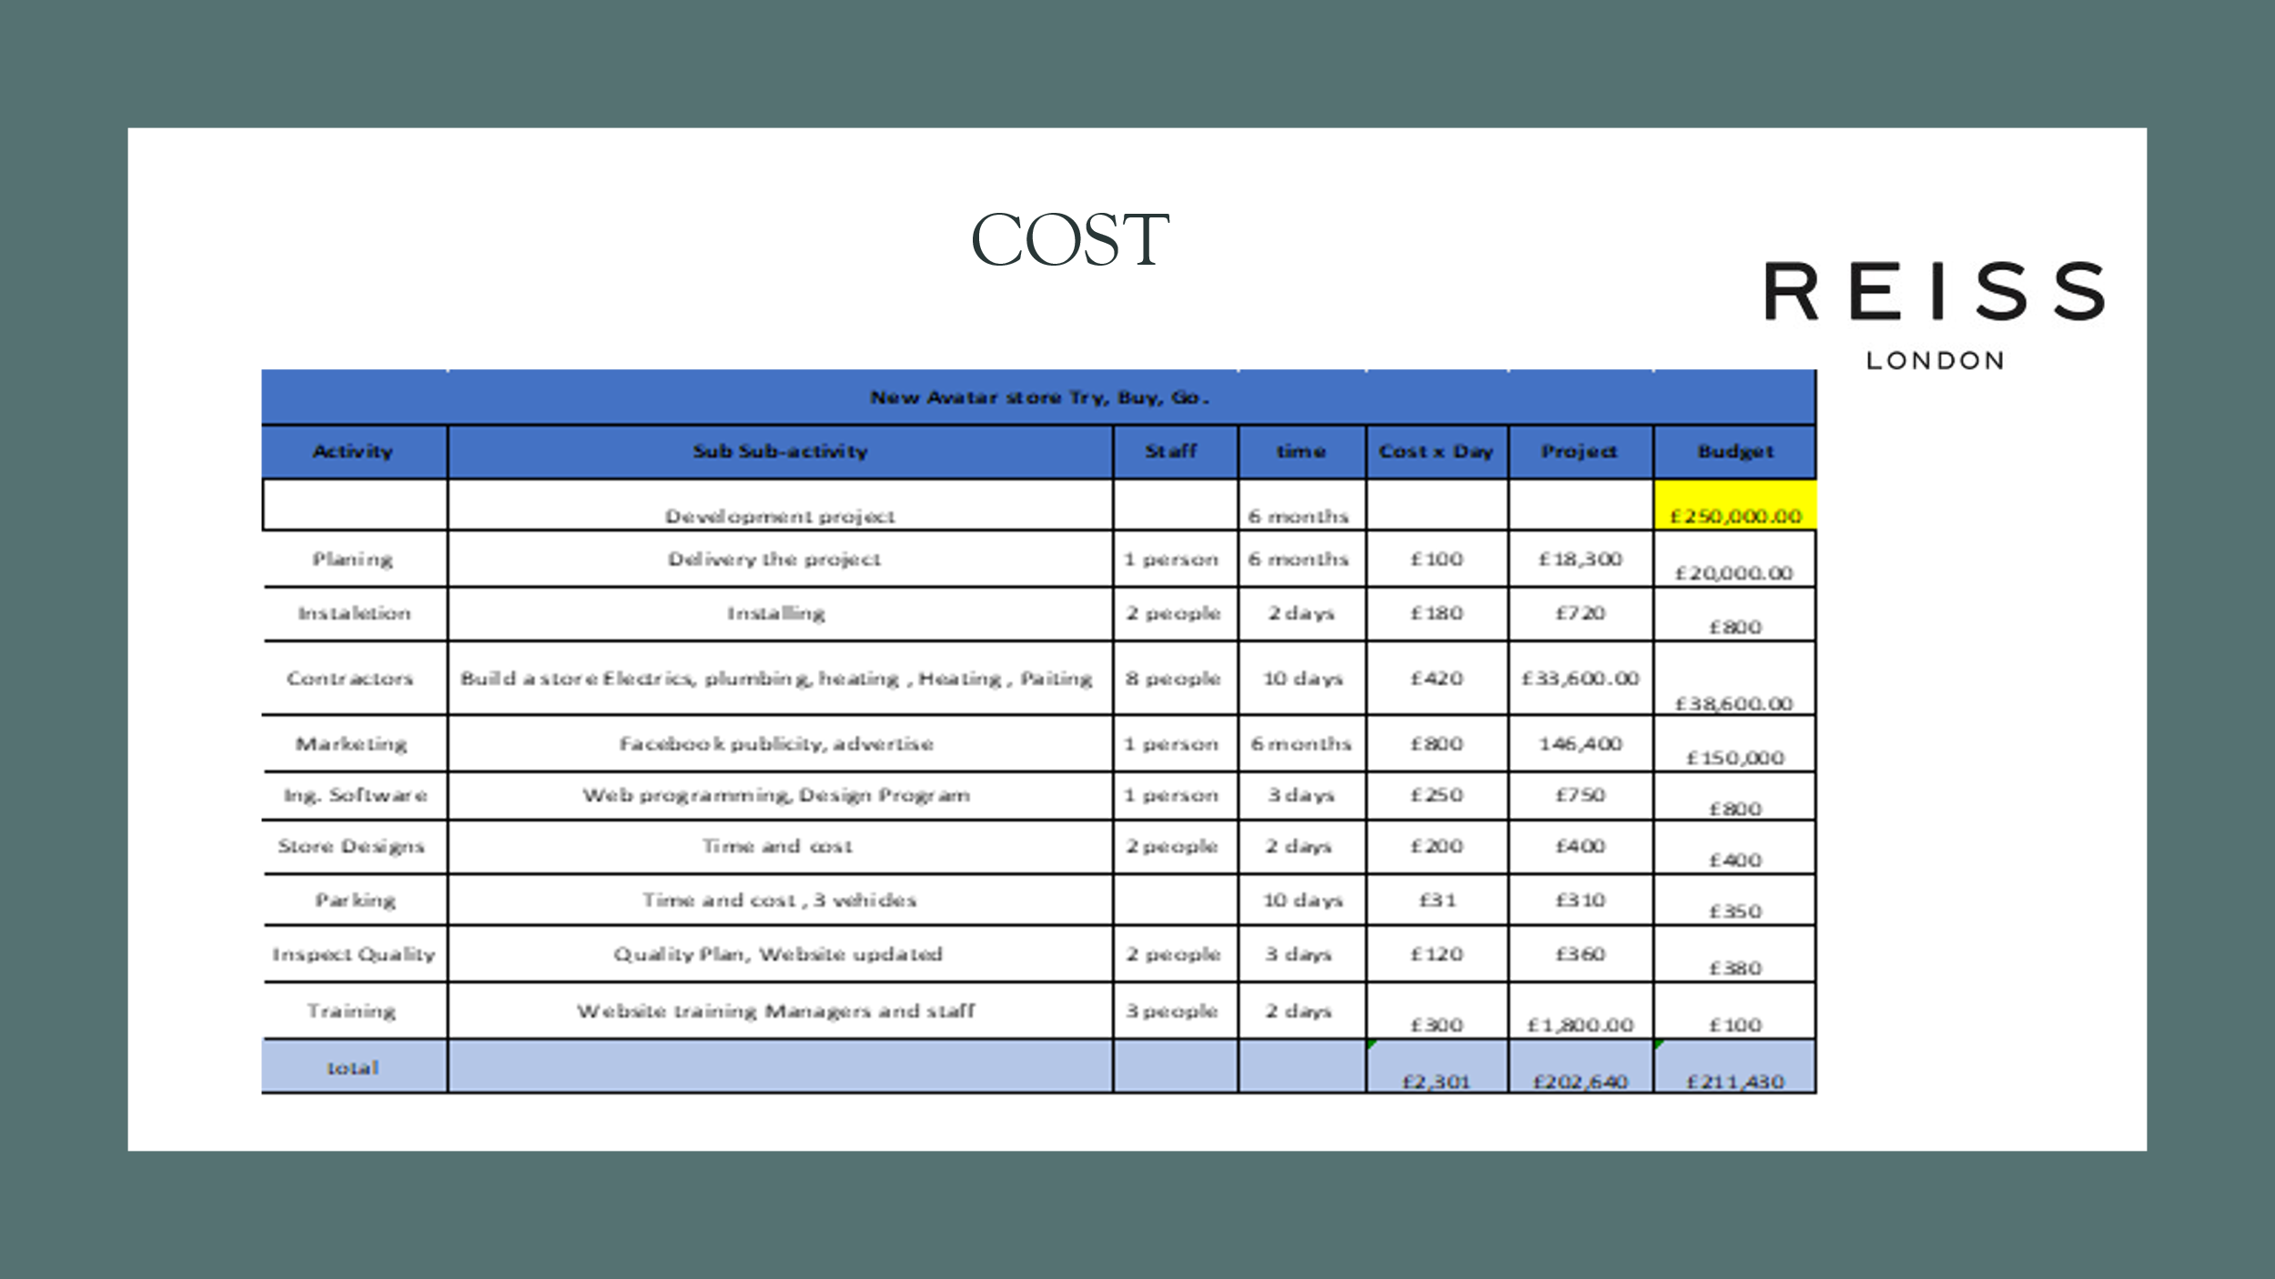

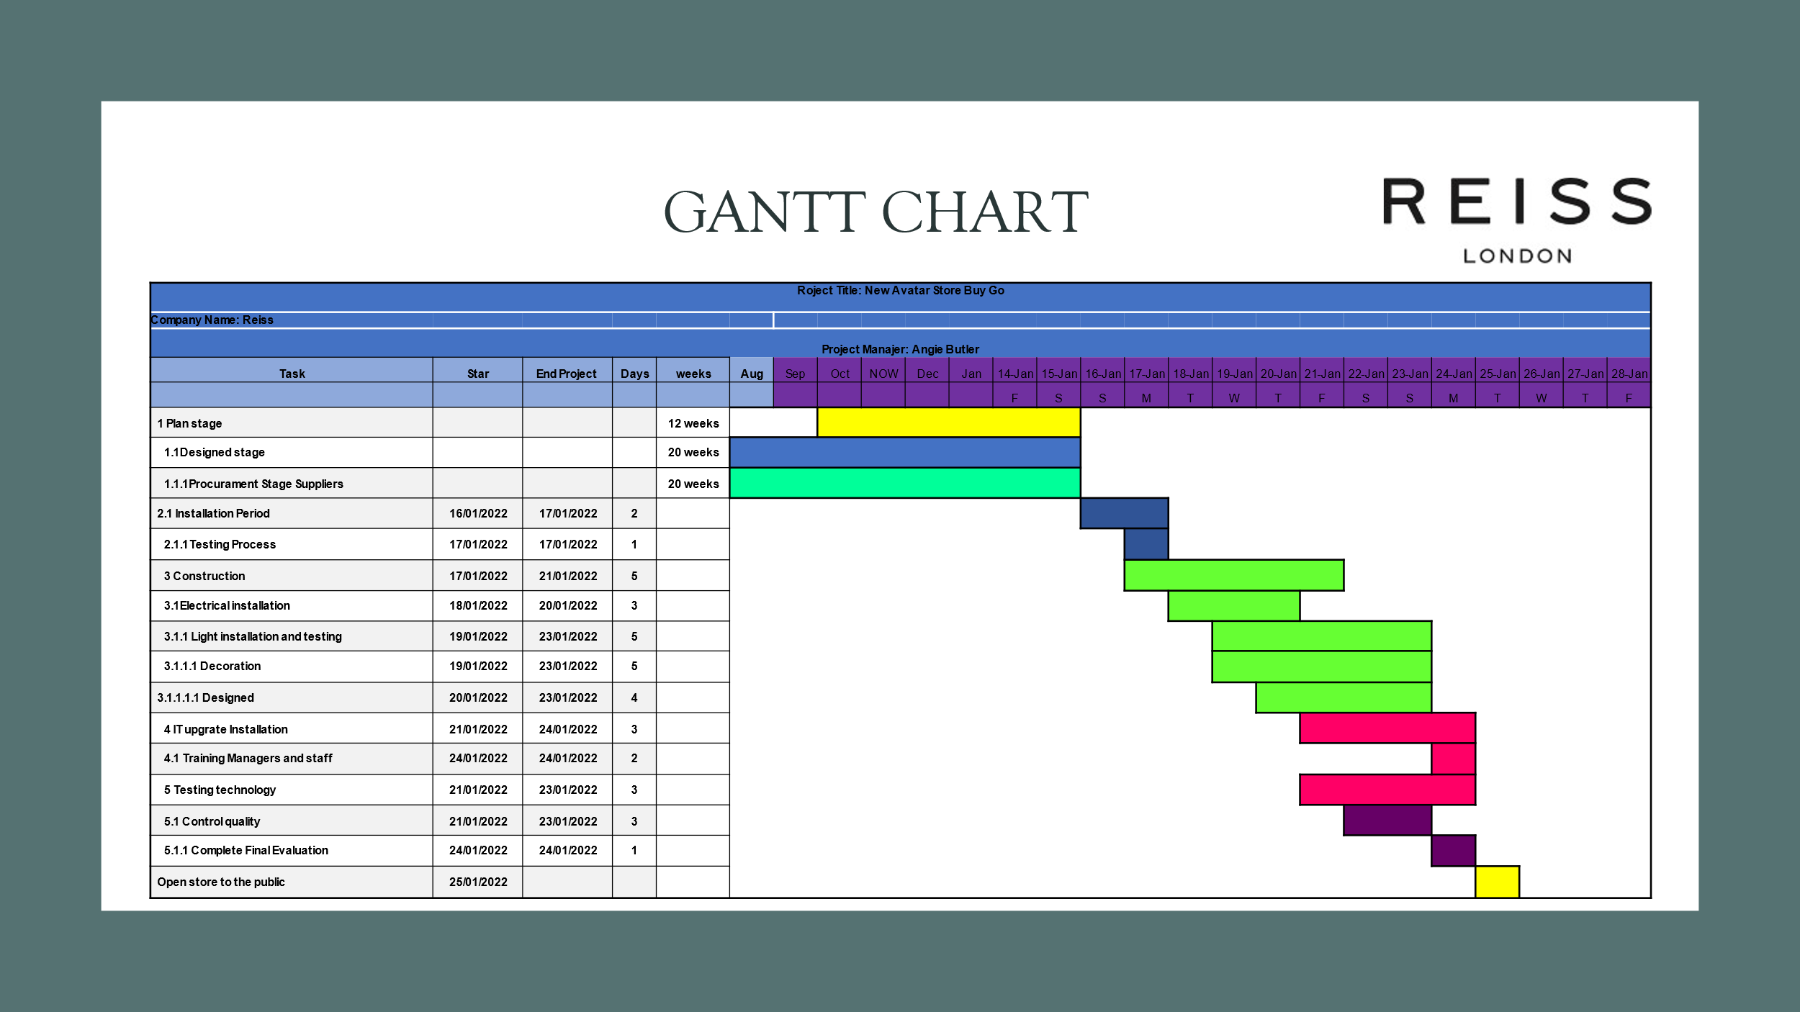

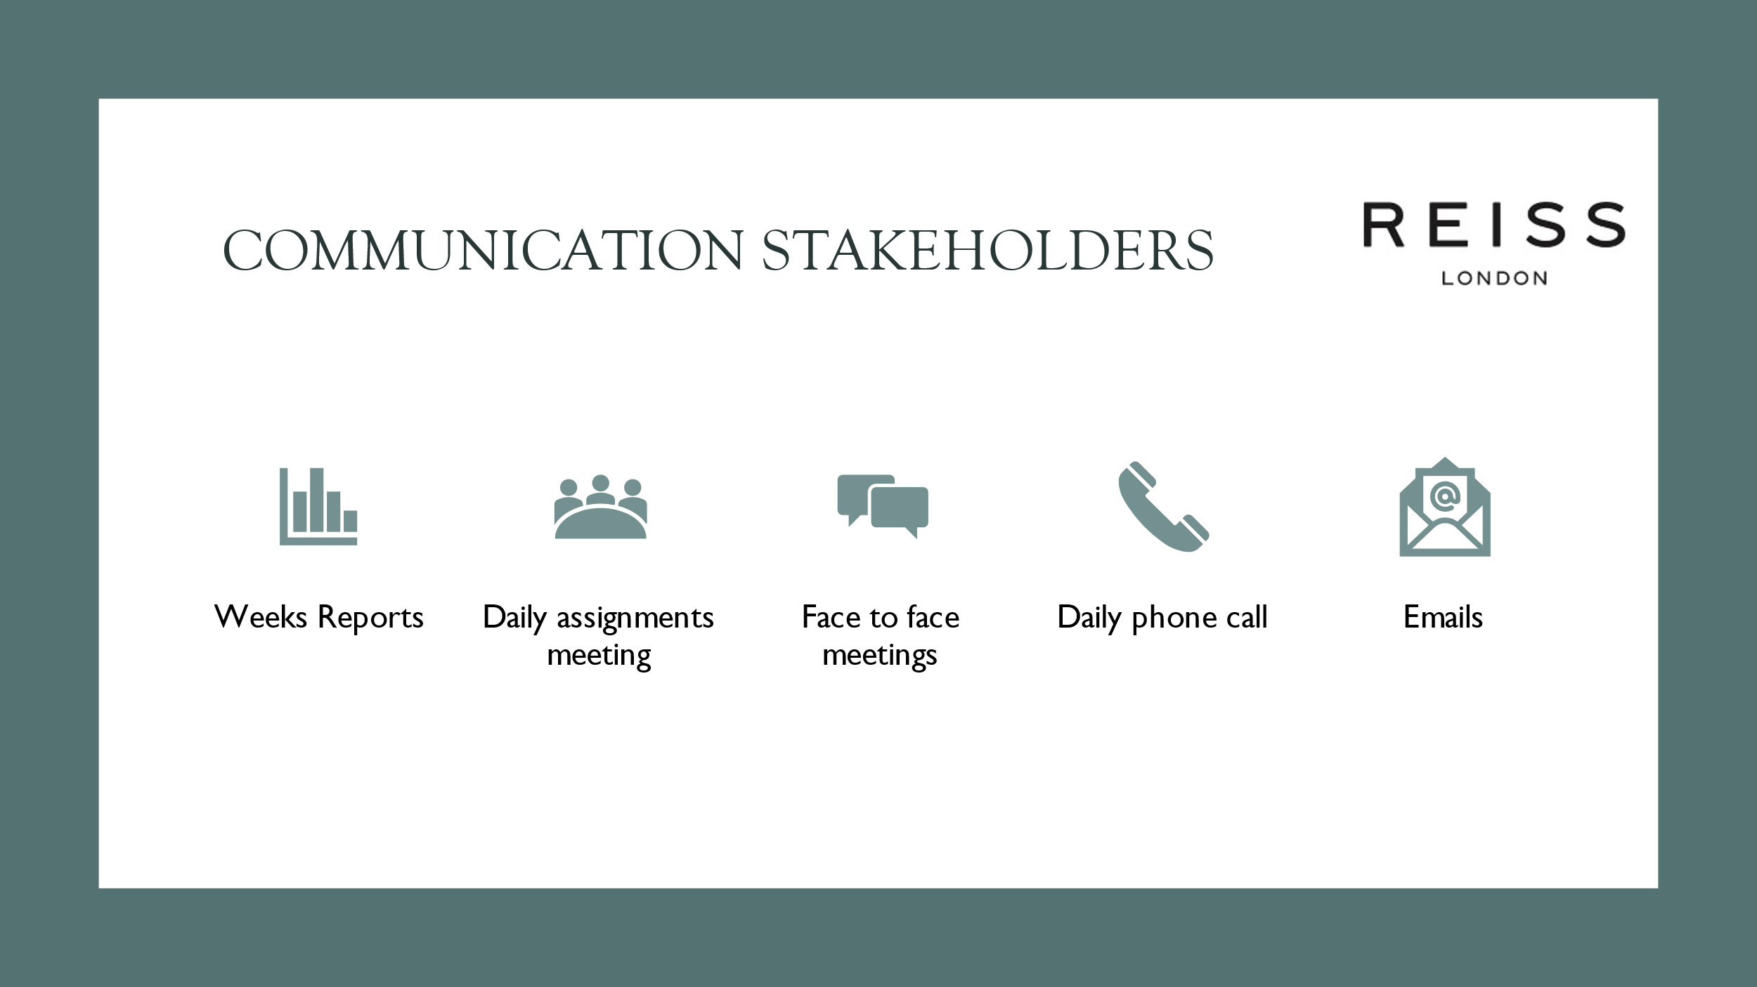

Communication is between two or more people verbally or non-verbally. We will use emails, reports, letters, audio visual, presentations and videos to communicate to the stake holders.

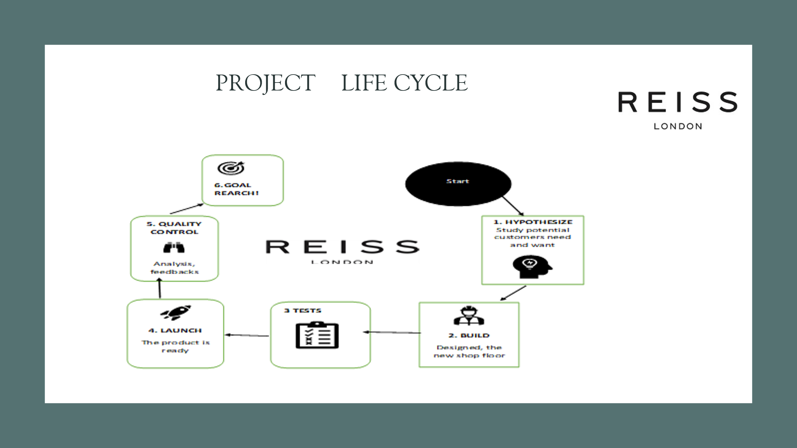

Project Life Cycle


6.GOAL REARCH!
Start

5. QUALITY CONTROL

Analysis, feedbacks

1. HYPOTHESIZE Study potential customers need and want

2. BUILD
Designed, the new shop floor

3 TESTS



4. LAUNCH
The product is ready

