Module: Management Accounting for Managers
Assignment Title: Component 1: Coursework: Individual Report
Student Name: Kiren Nisar
Student ID:2220781

Introduction
Figure: ASDA
Source: (ASDA, 2026)

Asda is a supermarket store in the United Kingdom and a component of the competitive grocery retailing business. The company was started in 1949 and has grown to become a country-wide chain with hundreds of stores and has a strong online grocery presence. It has an extremely diversified product range, like food, clothing (George brand), homeware, fuel, and financial services. The reason behind the organisation's operating on price leadership is that it is a value retailer, and positioning is built around cost-conscious customers (ASDA, 2026). Its low profit margins and severe competition with Tesco, Aldi and Lidl make it competitive and hence demands effective financial management.
This report entails an examination of management accounting regarding Asda, which is a large supermarket in the UK with a cost-leadership retailing strategy. The section has outlined the high-volume-low-margin type revenue model of the company, which requires it to be extremely attentive regarding cost and operational efficiency. It makes comparison with fixed and variable cost setup, inventory management and labour planning. Another facet which is investigated in the report is budgeting practices and identifies the impact of inflation, wage increases and strategic investment on increasing operating expenses. Also, management accounting plays a part in terms of pricing, performance monitoring, and planning the financial performance.
The report has evaluated how the management accounting tools have been used to support the financial decision-making of Asda. It has considered cost structure, revenue model, budgeting and financial planning and their effects on the operational efficiency. KPIs have been considered and the way Asda has empowered the management to enact a strategy of the nature of pricing, promotions and inventory. Financial approaches have been met sustainably and with ethical concerns that enhance brand reputation and sustainability in the long run. It has had recommendations that aim at increasing cost effectiveness, budget flexibility, and sustainability investments.

Significance of Management Accounting

Management accounting plays a crucial role in the communication of made internal decisions within retail organisations. It is opposed to financial accounting as this is focused on planning, control and performance improvement. The retailers are characterised by low profit margins and high inventory turnovers. Also, managers use the cost reports, budgets and variance analysis to be aware of the pricing strategies, bargaining with the suppliers, and how effectively they are running. Management accounting helps in controlling stock, minimising waste, organising, and promotional arrangements in the supermarkets (Schmidt, 2026). It directly impacts profitability, competitiveness and long-term sustainability.

Analysis of the costs and Business model

Revenue Model
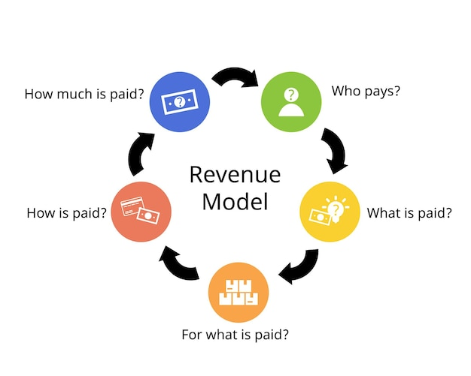
Figure: Business revenue model
Source: (altexsoft, 2026)

Asda possesses a low-volume and high-margin retailing model. It is a company that principally derives revenue by selling groceries such as fresh food, packaged food and household goods. Other revenue sources include clothes sold under the George brand, fuel stations, in-store delivery services and concessions such as pharmacies, opticians and other online delivery services.
The business model is dependent on the economy's scale. Asda can bulk the number of products from suppliers, which lowers the unit price and is transferred later to the customers in the form of a low price. Basket size and customer loyalty are encouraged through promotions such as price matching and multi-buy offers. Online grocery delivery is proven crucial, as the incomes of service fees are also generated, and the value of orders grows (altexsoft, 2026). The company has been geared towards high sales volume. Therefore, the growth in revenues is done through the customer flow and the size of the basket as opposed to the increase in price.

Cost Structure: Variable Costs and Fixed Costs

The fixed cost that is large in nature and the variable cost that is variable exist in the cost structure of Asda, as it is typical of large supermarkets.

Fixed Costs

Asda has many stores, which is a major drawback to the company as it has high fixed operating costs. They have store rented, distribution centre facilities, refrigeration and technological platforms such as internet ordering systems. Also, fixed cost incorporates the management staff through considering salary, security systems and long-term logistics contracts. These expenses are relatively stable regardless of the sales amount, and to become profitable, they should be significantly higher in terms of the turnover.

Variable Costs

Every variable cost is correlated to sales. The highest variable cost is the cost of goods sold (purchases of stock goods made by suppliers). Additional variable costs comprise salaries, electricity, packaging, fuel utilised in delivering and making payments. The variable costs are waste and spoilage, particularly for fresh food items. Moreover, all these expenses are reduced through stock level, which is well managed and increases gross margin (Foret, 2026).
Since supermarkets earn their profit margin, which is normally less than 5%, ineffectiveness in the variable costs selection can significantly lessen profit. Consequently, the management accounting system, such as standard costing and variance analysis, ought to be employed in the monitoring of wastages, shrinkage and labour efficiency.

Budgeting and Financial Planning

Budgeting and its importance

Figure: Importance of budgeting
Source: (Milano, 2026)

Budget plays a significant role in the operational planning of Asda, as the supermarket retailing processes entail fundamental cost control and adequate demand forecasts. The sales budgets are planned and aligned with the seasonal demands pattern, inflation trends and consumer expenditure behaviour. These predictions are employed to establish purchasing budgets, staff planning and distribution.
The operations departments employ the use of budgets to eradicate wastage and overstocking of food. Capital expenditure budgets determine store refurbishment, installation and investment in digital technology as well as self-checkout (Milano, 2026). The comparison of the performance is done by calculating the variance analysis, which helps the managers to view the actual performance relative to the planned performance and take corrective actions.

Operating Expenses Annual Change

The operating expenses have been higher in the previous financial year, according to the financial results published recently through Google Finance. The rise is largely predetermined by wage bills increase, energy and supplier chain aspects following the UK economy growth inflation.

Internal Administrations

The stringent labour market had seen the management resorting to salary growth to keep employees, which increased the operating costs. The company invested to some extent in store development, automation and online fulfilment capability to rival the discounting retailers, as well as e-commerce grocery suppliers. These tactical investments raise the short-term operating expenses and are expected to boost the long-term efficiency and customer experience.
The promotional price campaigns are prolonged to secure the market share through the cost-of-living crisis. These promotions required more marketing and operational costs even though they are covering volume in terms of revenue.

Extrinsic economic factors

The most important external factor is the UK inflation, particularly the distribution costs of energy and food. Increasing fuel prices increased the cost of logistics at distribution centres. Electricity is used in fridges and lighting and contributes a lot to the operating cost of the store. The disruption in the supply has increased the operating expenditure and price increment for the suppliers.
Overall, the increase in the cost of operation on an annual basis show that the management has established strategic investment and the economic pressure that has caused inflation, rather than inefficiency (UNCTAD, 2026). The budget system allows the managers to analyse the variances and rectify the pricing, staffing and acquisition policies depending on the variances.

Performance Measurement and Decision-Making at Asda

Financial Performance Indicators
Revenue Growth
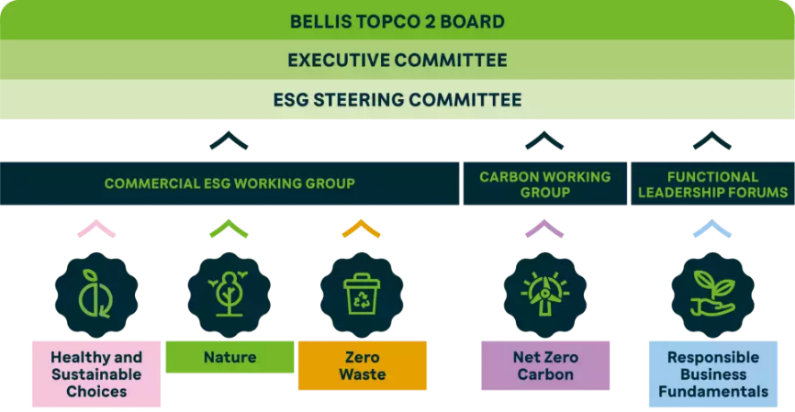
Figure: Asda governance
Source: (Jones, 2023)
The growth of revenue illustrates the effectiveness with which Asda can increase its sales within the span and in response to the demand of the customers (Mio et al., 2022). The recent sales performance indicates that the trading solutions are improving over the previous times and that the customer can be attracted by the value-based pricing and promotion despite the competitive pricing. The increase in revenues does not guarantee profitability, though. The financial performance may be low in case the costs are rising faster than the sales. The management must also be skilled in the aspect of balancing growth and good cost management to protect the collections and guarantee sustainable profitability.

Gross Margin

Gross Margin means the profit that is left behind after the cost of the goods sold. An increase in the margin demonstrates that it can control its pricing, supplier terms and its product mix. This helps in terms of profitability and to cushion the increase in expenses (Tudose et al., 2022). The increase in margins, however, must be at the cost of the customer. The high prices would reduce loyalty and volumes of sales. Thus, to maintain the market position, Asda must ensure that the gross margin increment is maintained and in line with the competitive pricing policy.

Operating Profit

The profit-generating strength of the company from core activities and operating costs is measured using operating profit. An operating profit growth is a sign of good cost management of labour, logistics and store operations areas. Over-cutting, however, may have an undesirable impact on the service level and store excellence, reducing the performance in the long run. The management needs to balance efficiency and customer experience as one of the ways of protecting their profitability and brand image (Budding and van Schie, 2024).

Non-Financial Performance Indicators

Customer Satisfaction Scores

An important measure that is not financial but highly critical is customer satisfaction. The higher scores indicate that they are satisfied with the store environment, services, and product availability, which is the foundation of repeat purchase and developing the brand reputation. However, the indicators of satisfaction may be subject to change, and they may not be directly connected with the sales growth soon. Combined with financial KPIs, such insights enable Asda to make balanced strategic decisions.

Stock Turnover Rate

A stock turnover is the percentage of the rate at which the inventory is sold and transformed. High turnover can reduce the holding cost and wastage, particularly for perishables. The supply chain can be seen as having a better improvement in inventory planning and coordination (Jones, 2023). However, a turnover obtained by means of the discounting can be debilitating to profits. Asda must ensure that its turnover is based on the actual demand rather than the spikes of promotion at a particular time.

Strategic Decisions Guided by KPIs

Asda has non-financial KPIs, which are used in the decision-making of the strategy. The information concerning revenue and margin was employed to adopt strategies of further lowering prices to attract the concern of the price-sensitive consumers. Yet margin pressure is an unavoidable threat unless the expenditure is well curbed. Operation profit and satisfaction measures made the extension of store time and improved services profitable in helping to generate loyalty without control of costs. The lessons learned during the stock turnover led to a better inventory management system to reduce stockouts and maintain operations both in the short run and long run in an efficient and capital management system (Jones, 2025).

Sustainability and Ethical Considerations at Asda
Integration of Sustainability into Cost Management
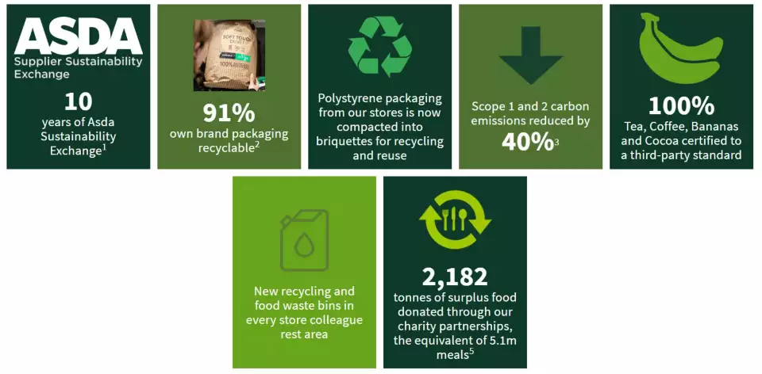
Figure: Sustainability and Ethical Considerations at Asda
Source: (Jones, 2025)

The concept of sustainability has been included in the financial strategies adopted by Asda, resulting in the company investing in energy-efficient stores, minimising waste and a sustainable supply chain. The company claimed that its stores realised a reduction of 15% in the energy that they consumed per square foot in the previous years because of the implementation of LED lights and effective heating systems (Newborne, 2025). This is aligned with Stakeholder Theory as it believes that businesses must create value for shareholders in view of the environmental and social impact, and for the other stakeholders. Sustainable investments reduce the utility cost in the long run and reduce carbon emissions but involve high costs at the start-up point. Reduction of packaging saves money in raw materials and lowers the level of waste of fresh produce, yet it needs product plans in the inventory to avoid spoilage. The supply chain risk reduction and guarantee that the environmental standards are being satisfied are also provided by suppliers' sustainability audits. According to the Resource-Based View (RBV), if such peculiarities as a high level of sustainability have become a competitive advantage, these exceptions result in unique capabilities. However, the financial rewards of such programs would be easily overshadowed by the costs, and it is difficult to find a balance between the short-term budget and the long-term revenue as the managers take both into account (Mio et al., 2022).
Ethical Considerations in Pricing and Labour

Basically, when the inflation level is on the increase, Asda focuses on making sure that prices are affordable, especially. Ethical pricing can assist in creating customer confidence, yet in periods of tension on prices, it can squeeze profits. The Asda ethical behaviour strategy is based on fair labour practices. Competitive salary and good working conditions are more costly to run but reduce turnover and morale. Ethical sourcing is likely to add costs in the supply chain, yet it safeguards the brand image and limits the chances of lawsuits.

Impact on Profitability and Reputation

The brand image and profitability are influenced by the concept of sustainability and ethical practices. It boosts expenditure in the short term, and the stability of the long-run revenues is sustained with the enhanced reputation and retention of the customers (Tudose et al., 2022). The skill to match ethical and sustainable decision-making with financial gain comes feasibly in the development of resiliency and sustainable shareholder and stakeholder value.

Conclusion and Recommendations

Asda's management accounting practices indicated that the financial decision-making process has a close relationship with the strategic decision-making process. The balance of the fixed and variable costs in terms of the cost analysis is the key to business success and profitability. Both budgeting and financial planning imply the existence of internal and external forces on the business. Pricing, promotional and operational decisions have been made through KPI that include revenue increase, gross margin, operating profits, customer satisfaction and stock turnover. Consolidated cost control is required in its successful stores, decent labour regulations, and its checks on its suppliers, which makes the image of the company sustainable and gives it a successful succession and downturn over time, but makes the company less profitable.

Recommendations

- It should be recommended that Asda implement activity-based costing to understand the degree of profitability of its products better and rolling budgeting to react to the changing conditions in the market quickly (Jones, 2023).
- This is also to make more sustainability-based investments that reduce the cost of its operations without affecting the perception of its customers or its competitive advantage.

References

Altexsoft, (2026). Revenue Model Types in Software Business: Examples and Model Choice. [Online] Available at: https://www.altexsoft.com/blog/revenue-model-types/ [Accessed 11 February 2026].

ASDA, (2026). Online Food Shopping - ASDA Groceries. [Online] Available at: https://www.asda.com/ [Accessed 11 February 2026].

Budding, T. and van Schie, V., (2024). The use of non-financial performance indicators in the budgeting process of hybrids. In Handbook of accounting and public governance (pp. 129-140). Edward Elgar Publishing.

Foret, W., (2026). Four Tips To Help Reduce Your Fixed IT Costs. [Online] Available at: https://www.forbes.com/councils/forbesbusinesscouncil/2020/04/02/four-tips-to-help-reduce-your-fixed-it-costs/ [Accessed 11 February 2026].

Jones, P., (2023). Corporate social responsibility and the sustainable development goals: the UK’s four largest retailers. In BEYOND THE DARK ARTS: Advancing Marketing and Communication Theory and Practice (pp. 97-121).

Jones, P., (2025). Sustainability and the UK’s Leading Clothing Retailers. Athens Journal of Business and Economics, 11(1), pp.9-24.

Milano, S., (2026). The Advantages of Budgeting in a Business. [Online] Available at: https://smallbusiness.chron.com/advantages-budgeting-business-21740.html [Accessed 11 February 2026].

Mio, C., Costantini, A. and Panfilo, S., (2022). Performance measurement tools for sustainable business: A systematic literature review on the sustainability balanced scorecard use. Corporate social responsibility and environmental management, 29(2), pp.367-384.

Newborne, P., (2025). Crossed wires: Public regulation and private action for water stewardship and sustainable farming. In Tony Allan (pp. 313-330). Routledge.

Schmidt, J., (2026). Managerial Accounting: Key Techniques and Decision-Making Tools. [Online] Available at: https://corporatefinanceinstitute.com/resources/accounting/managerial-accounting/ [Accessed 11 February 2026].

Tudose, M.B., Rusu, V.D. and Avasilcai, S., (2022). Financial performance–determinants and interdependencies between measurement indicators. Business, Management and Economics Engineering, 20(1), pp.119-138.

UNCTAD, (2026). Global economy under pressure could slow to 2.3%, signals UN Trade and Development. [Online] Available at: https://unctad.org/news/global-economy-under-pressure-could-slow-23-signals-un-trade-and-development [Accessed 11 February 2026].

