Curtis Grant – BMSN7002 Assignment 2 - Client Nutrition Strategy

- Introduction

This assignment will assess the nutritional needs of a sports participant and their sport before creating an individualised nutrition strategy that supports their performance, recovery, and overall health. This will be achieved through the collection and interpretation of relevant physiological and performance data, including Resting Metabolic Rate (RMR), total energy expenditure (TEE), body composition, and sport-specific performance parameters. These assessments will inform the development of a comprehensive nutrition plan, which will be critically justified using contemporary scientific literature and established dietary guidelines.

The chosen client is a 34-year-old dedicated runner who is aiming to complete his first marathon in Valencia in December. The aim is to achieve a sub-3-hour marathon, which has been selected after several successful half-marathon performances, most recently finishing in 1 hour and 21 minutes. The client has developed the capacity to run five times a week, which is usually executed through three long, easy runs, one interval-based session and one run targeting ‘threshold pace’. His running schedule is often supplemented with one or two gym-based sessions each week, which focus on maintenance, strength and injury prevention. This frequency of running produces approximately 40 miles per week. The client has had to be disciplined in managing his mileage over the past two years, following several injuries from semi-professional football, namely three anterior cruciate ligament ruptures and one patellar tendon operation. Furthermore, the client works as a university lecturer and coaches a football team three times a week. This information will be useful when calculating TEE.

As the client is training to run a marathon, a VO₂ max test was selected as the most appropriate measurement of current capabilities. A VO₂ max test was selected due to its ability to identify: An absolute and relative VO₂ max, data at thresholds and exercise intensity domains, substrate utilisation, TEE and Maximum Fat Oxidation (MFO). Additionally, the client underwent two body composition tests, a skinfold calliper assessment calculated through the Durnin and Womersley (1974) method and a Bioelectrical Impedance Analysis (BIA). Therefore, informing the development of an appropriate nutritional strategy. The client completed an informed consent form and a PAR-Q before any tests took place, both forms can be found in the appendix.

- Nutritional and physiological demands of marathon racing

Marathon running is one of the biggest physical challenges the human body can face. Throughout the 26.2-mile (42.195km) race, the body undergoes several physiological changes to cope with the physical demands of the event.

Due to the duration of running a marathon, the aerobic energy system is the primary provider of energy throughout the race (Alghannam, Ghaith and Alhussain, 2021), whilst type I muscle fibres are predominantly utilised due to their high aerobic capacity and fatigue-resistant qualities (Westerblad, Bruton and Katz, 2010). It’s essential to understand what substrates are being utilised at specific paces when creating a nutritional intervention for an endurance athlete. Carbohydrates and fat are the main substrates used for energy production during prolonged exercise, although carbohydrates cost 11% less oxygen during steady-state exercise (Alghannam, Ghaith and Alhussain, 2021). Therefore, the reliance on carbohydrate breakdown increases significantly as the exercise intensity increases (Jeukendrup et al., 1997). Therefore, it is important to understand the highest rate at which the body can utilise fat for energy, which is termed ‘Maximum Fat Oxidation’ (Jeukendrup & Achten, 2001). Carbohydrates are stored in the body as muscle and liver glycogen, although 79% of stored glycogen can be found in skeletal muscle (Alghannam, Ghaith and Alhussain, 2021). On average, the body can store 300-400g of carbohydrate in skeletal muscle, although this depends on muscle mass and can be as much as 900g (Jeukendrup & Gleeson, 2019). Additionally, the liver can store 80-110g of glycogen while fat stores can exceed 100,000 calories, depending on the body weight and composition of the athlete (Jeukendrup & Gleeson, 2019). Loftin et al. (2007) studied twenty recreational marathon runners and found that males expended 2,792 ± 235 kcal during a marathon. Highlighting the importance of fat oxidation for energy during prolonged exercise, as well as ‘loading’ carbohydrate stores effectively before a race and replenishing them appropriately during marathon running.

There are three main predictors of marathon performance: VO₂ max, running economy, and fractional utilisation of VO₂ max (Sjödin and Svedenhag, 1985). VO₂ max refers to the highest rate at which the body can utilise oxygen during intense exercise and is measured in either L/min (absolute) or ml/kg/min (relative) (Bassett and Howley, 2000). Furthermore, when the concept was first established by Hill and Lupton (1923), it was suggested that a high VO₂ max is a foundation for success in middle- and long-distance running. Bassett and Howley (2000) further explain that each athlete has a physiological upper limit in their capacity to consume oxygen. Although the upper limit can be increased through a well-calculated endurance programme (Jones, 2006). Sjödin and Svedenhag (1985) suggest that large variations in VO₂ max have been observed among runners with a similar endurance capacity, by as much as 30% (Daniels, 1985). Therefore, measuring an athlete’s running economy and fractional utilisation of their VO₂ max are important additions to understanding their performance capacity more accurately.

Running economy is defined as the steady-state oxygen uptake (VO₂) at a specific running speed and represents the energetic cost of maintaining a constant submaximal velocity (Barnes and Kilding, 2015). The authors further explained that runners with good economy use less oxygen at the same running speed than those with poor running economy and are therefore, more economical with their use of oxygen. Furthermore, running economy can be influenced by various metabolic, cardiorespiratory, biomechanical and neuromuscular components (Saunders et al., 2004). According to Prampero et al. (1993), a 5% increase in running economy was associated with a 3.8% improvement in distance running performance.

Fractional utilisation can be defined as the percentage of VO₂ max that an athlete can sustain during prolonged exercise (Vikmoen et al., 2016). This percentage often varies depending on the duration of the race, as well as the level of the athlete being referred to (Bassett and Howley, 2000). Sjödin and Svedenhag (1985) found that elite runners can sustain 86% of their VO₂ max at race pace across the duration of a marathon, whilst this does not apply to sub-elite or recreational runners.

In addition to these useful predictors of marathon performance, Sjödin and Svedenhag (1985) argue that the measurement of the ‘Anaerobic Threshold’ is a better indicator of endurance exercise capacity than the measurements of maximal oxygen uptake, which is also known as the ‘Aerobic Threshold’. The threshold’s title can be amended depending on which physiological markers are observed and are present, the most common description is the second Lactate Threshold (LT2), which can be identified through a significant increase in blood lactate (MacIntosh et al., 2021). By measuring blood lactate, it's possible to observe the threshold for Maximal Lactate Steady State (MLSS) or the Onset of Blood Lactate Accumulation (OBLA), when blood lactate reaches 4mmol (Svedahl and MacIntosh, 2003). As blood lactate levels were not taken in this instance, the most appropriate term is the Ventilatory Threshold (VT2), where ventilation increases disproportionately to both VO₂ uptake and VCO₂ output (MacIntosh et al., 2021). Peronnet et al. (1987) performed a study that measured thresholds of trained marathon runners and found VT2 was observed at 76.1 ± 5.5% of VO₂ max.

It is necessary to conclude this chapter by highlighting some factors that may limit marathon performance. Fatigue happens during prolonged or intense exercise, which can force an athlete to reduce their workload or stop completely (Ament and Verkerke, 2009). The authors believe that this sensation aims to protect the physical integrity and prevent any potential harm or organ damage. Although it is well established that fatigue is a complex subject, there are many conflicting views. Hill (1927) first established the theory, stating that fatigue was very much a physiological sensation, particularly in relation to the ‘oxygen consumption plateau’. This theory was challenged by Noakes (1997) on several occasions, on the basis that exercise performance is regulated by the central nervous system to ensure that no catastrophic physiological failures occur. As research continued to develop, Gibson, Swart and Tucker (2018) presented ‘The Integrative Governor Theory’ which suggests that fatigue is neither a psychological nor physiological concept in isolation, but the brain acts as a control centre for all fatigue-related signals.

Burke and Hawley (2018) have suggested that some of the most common fatigue factors during prolonged exercise are muscle acidosis, gut disturbances, hyponatremia, hypohydration, muscle damage, suboptimal CNS activity, carbohydrate depletion and PCr depletion. Burke and Hawley (2018) continue to offer solutions to overcoming fatigue factors, which will be further explored later.

- Physiological assessments and interpretation of results

The client (34 yrs, 72.8kg, 178cm) underwent a VO₂ max test, which was performed through an incremental step test on a motorised treadmill (HP Cosmos Pluto Med, HP Cosmos Sports & Medical GmbH, Nussdorf - Traunstein, Germany). The incremental step test began at 6km/h (10:00 min/km) and increased by 1km/h every minute until the treadmill reached the maximum speed of 21km/h (2.51 min/km). The test was performed at a 1% incline for the entirety of the test. Ventilatory gas exchange was calculated using a calibrated breath-by-breath system (Servomex miniHF 5200, Servomex, Bristol, UK) providing consistent measurement of gas variables: VO₂, VCO₂, minute ventilation, and Respiratory Exchange Ratio (RER). Heart rate was also monitored using a heart rate monitor and strap (Polar H10, Polar Electro, Warwick, UK). The test was terminated when the client reached voluntary exhaustion, although this coincided with a VO₂ plateau following a VO₂ peak of 62 ml/min/kg. There are secondary criteria to determine test interruptions, which are: RER values between 1.10 – 1.15, age-predicted HR values (220-age ± 10 bpm) and blood lactate levels of 8mM or above (Poole et al., 2008). Although blood lactate levels were not measured, the client achieved an RER value of 1.15 and a maximum heart rate of 183bpm (220-34=186bpm), therefore determining a true VO₂ max score and a correct test interruption.
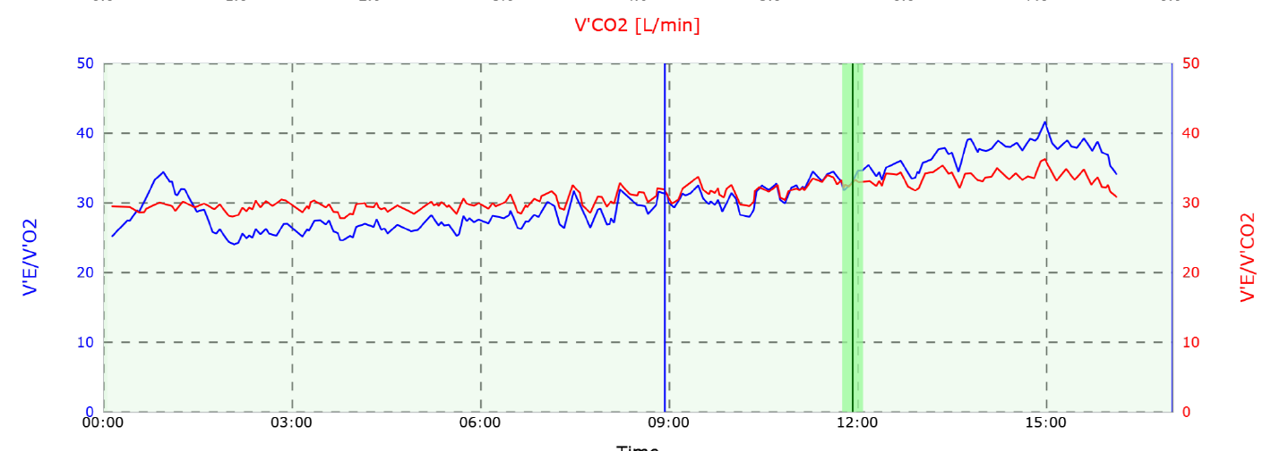

Figure 1 – Identifies the clients VT1 and VT2 in relation to VO₂ and VCO₂.

Ventilatory threshold 1 (VT1) was identified in Figure 1 when ventilation began to rise disproportionately to VO₂ (Nuuttila et al., 2025). At this threshold, the client's VO₂ was 45 ml/min/kg (72% of VO₂ max), Heart Rate (HR) was observed at 150bpm, and RER presented a value of 0.96. Figure 2 confirms that carbohydrate (CHO) was the predominant fuel source at this threshold, providing 196 g/hr (approximately 806 kcal/hr), whilst fat provided 8 g/hr (approximately 75 kcal/hr). VT1 was achieved when running at a 4.17 min/km pace.

It is important to note that Maximum Fat Oxidation produced 22 g/hr, providing approximately 201 kcal/hr from fat of the total expenditure of 500 kcal/hr. This resulted in FatMax being observed at 40.3% of VO₂ max, which occurred at a 7.30 min/km pace. The reliance on fat as a fuel source continued to drop until the ‘crossover point’ was reached at a 4.37 min/km pace, where fat produced 13 g/hr (124 kcal/hr), and CHO provided 171 g/hr (703 kcal/hr).

Ventilatory threshold 2 (VT2) was identified in Figure 1 when ventilation increased disproportionately to both VO₂ uptake and VCO₂ output (MacIntosh et al., 2021). At this
threshold, the client's VO₂ was 54 ml/min/kg (87% of VO₂ max), HR was observed at 168bpm, and RER presented a value of 1.02. This RER value represents CHO as the only fuel provider due to the speed at which ATP is required, confirmed in Figure 2. At VT2, fat is providing 0g/hr, whilst CHO is producing 253 g/hr, equivalent to 1040 kcal/hr. This threshold was achieved at a running pace of 3.32 min/km.
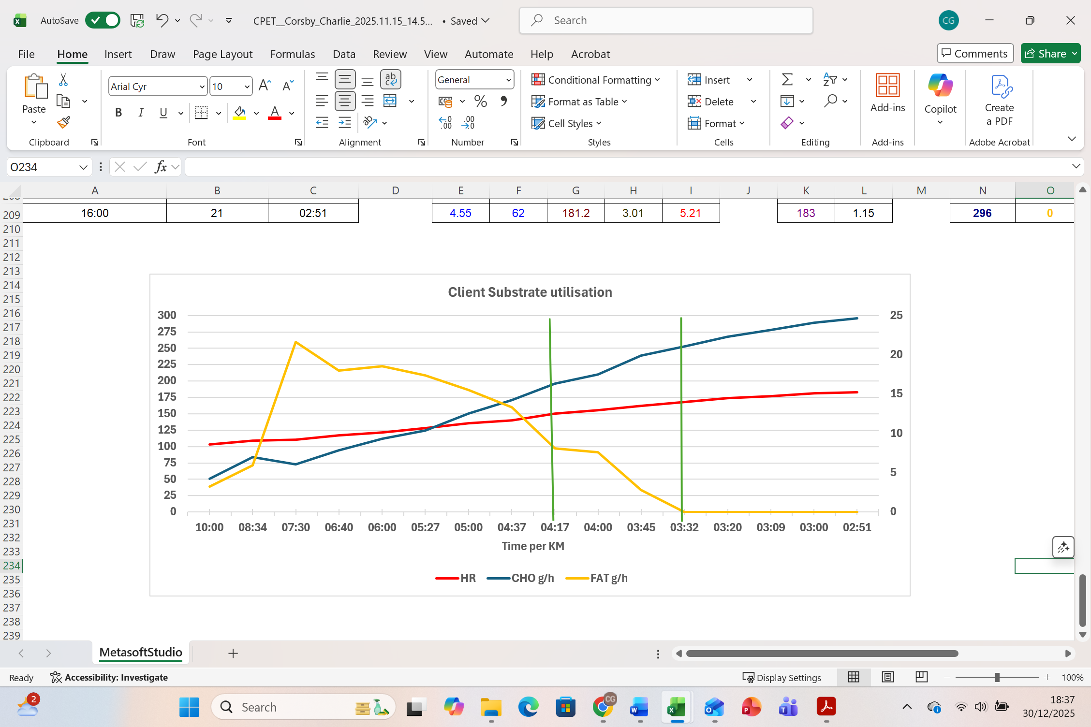

Figure 2 – Highlights the client's HR and substrate utilisation at each pace during the VO₂ max test.

The client also performed two body composition tests, a skinfold caliper (Harpenden Skinfold Caliper, Baty int, West Sussex, UK) assessment was calculated through the Durnin and Womersley (1974) method. This method required measuring subcutaneous fat at four sites on the right side of the body: bicep, tricep, subscapular, and suprailiac. Each site was measured three times, and the mean figure was recorded and inputted into the equation to calculate a body fat percentage of 14.8%. The second body composition test that the client performed was a Bioelectrical Impedance Analysis (BIA) (Inbody 380, Inbody, Seoul, South Korea). The BIA highlighted the client had 35.9kg of Skeletal Muscle Mass, Body Fat Mass of 9.5kg, a body fat analysis of 13%, a BMI of 23.0, as well as an RMR of 1738 Kcal.

- Individualised nutrition strategy

  - Daily nutritional advice

Calorie recommendation – 3,016 - 3,184 kcals
Carbohydrate recommendation - 511g - 876g
Protein recommendation - 88g-103g
Fat recommendation – 83g – 88g

These requirements have been created to maintain your current body weight, fuel your increased training load and minimise the risk of injury from under-fuelling. It is important to understand these figures are not fixed and they will be regularly reviewed based on changes to your body weight, your training load and your personal feedback.

You should gradually increase your daily carbohydrate intake until you reach the recommended minimum figure of 511g. This increased level of carbohydrate intake will provide you with ample energy for your sessions, replenish your energy stores, and enhance your body’s capacity to store large amounts of carbohydrates in preparation for your marathon. Fibre is also considered a carbohydrate, and I recommend consuming 30g per day.

Protein is important for repairing muscle damage caused during exercise, which emphasises the importance of achieving your protein range of 88-103g per day. Your protein intake would be best divided into 25-35g servings every 3-4 hours, which will maximally stimulate muscle protein synthesis.

Fat is a key macronutrient that should be consumed in moderation and restricted around your training times. You should also aim to keep your saturated fat intake below 10% of total energy intake, which is approximately 33g (301 calories) and your trans-fat intake below 1%.

  - Training-specific nutritional

2-4 hours before

I recommend drinking approximately 350-500ml of water and sports drinks 4 hours before exercise and a further 200-350ml 2 hours later if your urine is dark or highly concentrated. You mustn't exceed this level of fluid intake.

0-60 minutes before

As caffeine intake can decrease perceived exertion and increase alertness during exercise, I suggest consuming 200-250mg 60 minutes before the start of each session.

I recommend consuming 30g of fast-releasing carbohydrates, such as a sports drink or a carbohydrate gel, just before you begin your interval and ‘threshold’ sessions. It’s just as important to limit fat, protein and fibre consumption around your training times as they can slow down digestion and cause gastrointestinal discomfort.

There is less requirement to fuel your long, slow runs, as this has been proven to enhance the aerobic adaptation of the session. The benefits of this training approach are initiated from training with ‘low glycogen’, which needs to be depleted beforehand. Therefore, this is accomplished by performing an intense session one evening, restricting carbohydrate intake that night and performing a long, easy run the next morning on an empty stomach. Caffeine alone can be consumed that morning. I would recommend performing a ‘low glycogen long run’ once per week initially, to allow your body to adapt, and potentially increase the frequency over time. Until then, your other long, slow runs can still be completed fasted on an empty stomach, but will not have the same aerobic adaptations.

During training

It would be advantageous to ‘train your gut’ during some sessions. Your gut will have to adapt to the large amounts of carbohydrates required on race day to maintain energy stores, mainly through gels. The closer you get to race day, the need to train with low glycogen stores will be reduced. Therefore, I would suggest gradually increasing your carbohydrate intake during your long runs 4-6 weeks out.

It is important to maintain fluid balance during exercise and replenish some of the fluid lost by consuming a fluid that contains 4-8% of a carbohydrate solution and electrolytes during training. If your session exceeds an hour, you should look to consume a further 600-1200ml of a carbohydrate drink each hour.

Within 60 minutes after

Ideally, one of your 25-35g protein servings would be consumed within 60 minutes post-exercise, although this is not essential.

It would be recommended to pair this protein source with approximately 75g of fast-absorbing carbohydrates every hour up to 4 hours, depending on the duration and intensity of your session. Some examples may include potatoes, white rice, watermelon, cereal, sweets and sports drinks.

  - Race day nutritional advice

6 days before the race

I recommend supplementing dietary nitrate in the form of ‘‘Beet It Nitrate 400 shots’ from 6 days before your race. You should take 1 shot each day before the race, and 2 shots on the day of the race.

48 hours before the race

To load your carbohydrate stores effectively, I recommend consuming approximately 730g of carbohydrates per day for 48 hours before your race. It would also be advantageous for you to begin tapering your training duration and intensity from 6 days out of competition. Carbohydrate loading is likely to increase your body weight, as each gram of carbohydrate is likely to hold 3g of water. The positives of carb loading outweigh the negatives of carrying additional body weight.

Race day

Hydration advice remains consistent with training days, you should drink approximately 350-500ml of a fluid that contains 4-8% of a carbohydrate solution and electrolytes 4 hours before the race and a further 200-350ml, 2 hours later if your urine is dark or highly concentrated. This is followed by a further 500ml of fluid 1-2 hours before the session.

You should consume a high-carbohydrate meal (73-146g) 3-4 hours before your race, this meal should be low in fat, fibre and protein. Examples of this may include porridge with honey or white bread with jam. Just before the race commences, I suggest consuming 30g of a carbohydrate gel or sports drink.

During the race, I suggest consuming up to 60g of carbohydrate per hour, which is likely to be through a combination of gels and sports drinks. You should aim to consume approximately 600-1200ml of fluid per hour, although the difficulty of this is understood.

- Justification of nutritional strategy

  - Daily nutritional advice

Accurately predicting Total Daily Energy Expenditure (TDEE) can be a complex process due to the number of variables associated with accurate predictions, which include resting metabolic rate (RMR), diet-induced thermogenesis (DIT) and physical activity energy expenditure (PAEE), which can be further divided into exercise-induced energy expenditure (EXEE) and non-exercise activity thermogenesis (NEAT) (Ohkawara et al., 2012). The authors continue to explain that approximately 60% of TDEE is comprised of RMR, approximately 30% is PAEE, and the remaining 10% is DIT. To add complexity to the prediction, other factors can contribute to inter-individual variability in the outcome, such as age, sex, body size, meal size and composition (for DIT), while body composition provides the greatest variation (Ohkawara et al., 2012). Furthermore, there is conflicting evidence on the effects of Excess Post-Exercise Oxygen Consumption (EPOC) on TDEE. Whilst it is widely considered that EPOC increases energy expenditure in the rapid component (up to 1 hour), Ohkawara et al. (2008) found that EPOC did not significantly increase energy expenditure over 24 hours.

Taking all the above into consideration, there are several equations available to predict BMR if indirect calorimetry is not available. Amirkalali et al. (2008) found that there was no statistical significance in the results of the Harris-Benedict (1918) method and the Mifflin-ST Joer method (Mifflin et al., 1990), whilst Luy and Dampil (2018) found that the Harris-Benedict and BIA methods both overestimated their calculations in comparison to the indirect calorimetry. Therefore, the Mifflin-ST Joer method will be used in this instance.

The Mifflin-ST Joer method calculated a BMR of 1676 kcal/day.
The Harris-Benedict method calculated a BMR of 1725 kcal/day.
The Bioelectrical Impedance Analysis calculated a BMR of 1738 kcal/day.

To translate a BMR figure into a TDEE figure, it must be multiplied by a Physical Activity Level (Shetty, 2005). In this instance, the PAL descriptor of ‘significant amount of sport or strenuous leisure activity (4-5 times per week)’ with a multiplier of 1.8-1.9 seemed the most appropriate. This figure also aligns with the client's Garmin data, which shows an average of 3,073 calories expended per day over the last year, as shown in Figure 3.

TDEE = 1676 kcal/day x 1.8-1.9 = 3,016-3,184 kcal/day

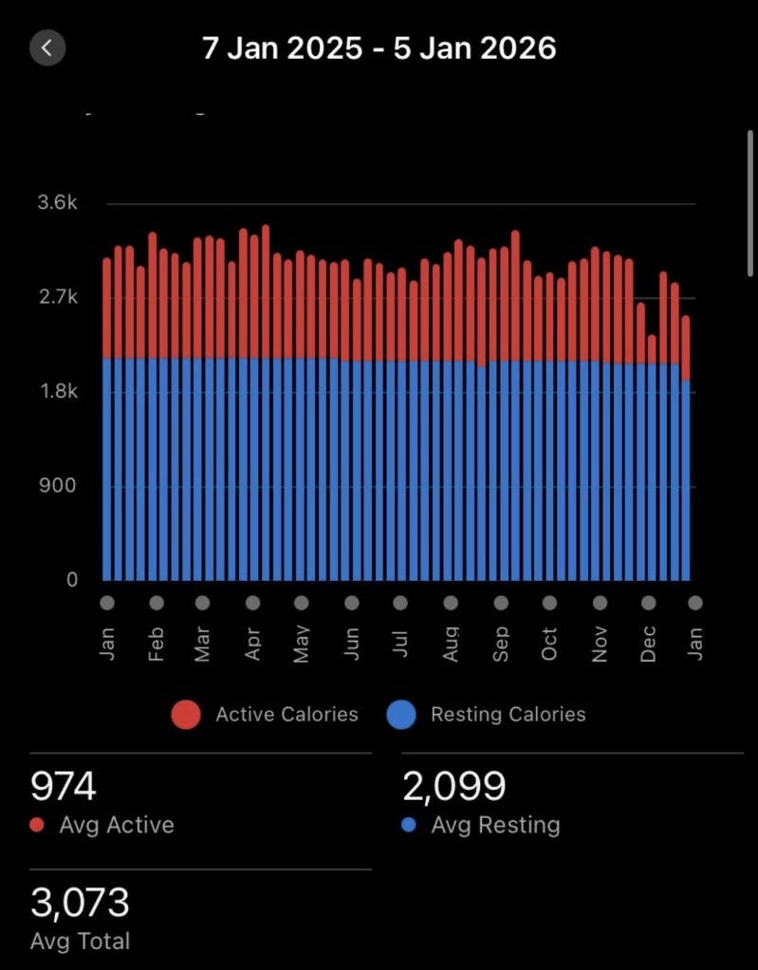

Figure 3 – Shows the client’s Garmin data of average calories expended per day, over the last year.

A large proportion of the calorie intake of a marathon runner should be made up of carbohydrates. Burke (2007) suggests that a marathon runner should consume 7-12g/kg/day of carbohydrates, depending on the volume and intensity of the training block. The minimum range has been recommended as the client’s weekly mileage (40 miles/week) is towards the lower end of a marathon runner's weekly average, which Doherty et al. (2020) found that marathon runners' mileage ranged from 18-132 miles per week. Fibre is described as ‘the forgotten carbohydrate’ by Mancin, Burke and Rollo (2025), who recommend an intake of approximately 30g of fibre per day.

Endurance athletes should consume 1.2-1.4g/kg/day to offset muscle damage and maximise recovery (Zhao et al., 2024). Furthermore, Jäger et al. (2017) explain that athletes should consume 0.25g/kg or 20-40g of protein per serving, evenly distributed every 3-4 hours across the day.

It is recommended that athletes consume approximately 30% of their daily calorie needs through dietary fat, due to additional energy demands, the need to replenish intramuscular triacylglycerol stores and adequate consumption of essential fatty acids (Kreider et al., 2010). Whereas Thomas, Erdman and Burke (2016) suggest athletes should consume no less than 20% of their intake from fats. This data has informed a modest recommendation of 25% (83g – 88g) of daily calorie needs through fat intake for the client. Furthermore, dietary guidelines indicate saturated fat intake should be below 10% of total energy consumption and trans fats should be less than 1% of energy intake (de Souza et al., 2015).

  - Training-specific nutritional advice

Interventions used during training and competition should be implemented to either improve exercise capacity or combat fatigue. Burke and Hawley (2018) suggest several strategies for overcoming fatigue, with many discussed in further detail below.

2-4 hours before

Athletes must begin exercise in a hydrated state, which is achieved by slowly drinking approximately 5-7ml/kg at least 4 hours before each session (Jeukendrup, 2011). The author continues to explain that if the athlete's urine is dark or highly concentrated, they should continue to drink a further 3-5ml/kg about 2 hours before. This translates to 365-511ml 4 hours before exercise and a following 219-365ml 2 hours later, if required. Von Duvillard et al. (2004) add that athletes should drink a further 500ml of fluid solution 1-2 hours before the session. Although Montain, Cheuvront and Sawka (2006) express the risk of hyperhydration, which can dilute and lower plasma sodium before exercise and, in turn, increase the chance of dilutional hyponatraemia.

0-60 minutes before

As caffeine intake can decrease perceived exertion and increase alertness during exercise, Jeukendrup (2011) suggests consuming 3mg/kg 60 minutes before starting exercise. This dose translates to 219mg for the client, but due to difficulty in accurately measuring caffeine intake, a range of 200-250mg will be suggested.

There has been conflicting research on the effectiveness of carbohydrates within the 60-minute window before exercise. Koivisto, Karonen and Nikkila (1981) observed hyperglycaemia, a rapid decline in blood glucose levels 15-30 minutes after glucose was ingested within the hour before exercise, whilst Jeukendrup & Killer (2011) suggest that an early race rebound hypoglycaemia does not affect exercise performance. Jeukendrup (2011, s. 92) summarises that “there is no need to avoid carbohydrate intake in the hour before exercise”, thus advising the ingestion of 30g of a carbohydrate gel or sports drink just before the start of an event (Jeukendrup and Gleeson, 2025).

Although long easy runs are advised to be completed in a lowered muscle glycogen state, as this “results in greater transcriptional activation of enzymes involved in carbohydrate and fat oxidation, as well as greater mitochondrial biogenesis” (Burke and Hawley, 2018, p. 2).

During training

As the body can only absorb a limited amount of exogenous carbohydrates, it is important to ‘train the gut’ to oxidise more exogenous carbohydrates, as Cox et al. (2010) found that the gut was adaptable when it was exposed to a higher intake of carbohydrates during training.

Endurance athletes must replace fluid lost through sweating by drinking a fluid that contains 4-8% of a carbohydrate solution with electrolytes (Von Duvillard et al., 2004).

Within 60 minutes after

As Jäger et al. (2017) advise, athletes should consume 0.25g/kg or 20-40g of protein per serving, evenly distributed every 3-4 hours across the day. In addition to Phillips and Van Loon (2011), who state that the optimal time to consume protein is after exercise, although it is unclear how long the ‘window of anabolic opportunity’ exists.

To begin replenishing depleted glycogen stores, Jeukendrup and Gleeson (2025) recommend consuming 1g/kg/hr of high GI carbohydrates for 4 hours post-event.

  - Race day nutritional advice

6 days before the race

Introducing dietary nitrate 6 days before an event was found to increase the bioavailability of nitric oxide, which can enhance muscle oxygenation, improve mitochondrial efficiency, and enhance contractile function (Poon et al., 2025). The author continues to explain that multi-day supplementation has seen the greatest benefits, while a dosage of at least 310mg/day is recommended for performance benefits. ‘Beet It Nitrate 400 shots’ are advised due to its 400mg dietary nitrate content. Interestingly, dietary nitrate was utilised by Eliud Kipochoge in his sub-2-hour marathon attempt (Burke and Hawley, 2018).

48 hours before the race

Due to the duration and intensity of marathon running, carbohydrate loading is essential to maximise performance. Jeukendrup (2011) confirmed the relevance of Hawley et al. (1997) findings that super-compensating muscle glycogen stores can improve race times by 2-3%. When the client is targeting a 3-hour marathon, a 2-3% improvement can translate to a 3 minutes 36 seconds – 5 minutes 24 seconds improvement. Burke (2007) suggests carbohydrate loading phases require 10-12g/kg/day intake during the 36-48 hours before a marathon, in addition to tapering exercise intensity and duration from 6 days out (Jeukendrup and Gleeson, 2025). Therefore, as the client will already have a high daily carbohydrate intake, an increase of 3g/kg/day is appropriate to maximise glycogen storage, resulting in 10g/kg/day and a carbohydrate intake of 730g for 36-48 hours before competing. Jeukendrup (2011) also highlights that increased carbohydrate storage is associated with temporary weight gain, as each gram of glycogen is likely to hold 3g of water.

Race day

The day of the race would require a high-carbohydrate meal (1-2g/kg – 73-146g) 3-4 hours before the start time (Jeukendrup and Gleeson, 2025). The authors further advise the ingestion of a 30g carbohydrate gel or sports drink just before the start of an event. Furthermore, during exercise lasting between 2-3 hours, Burke and Hawley (2018) suggest consuming up to 30-60g of carbohydrate per hour, in the form of rapidly oxidised glucose or maltodextrin, to supplement diminishing glycogen stores.

Identical hydration protocols have been advised to training, with the addition of Von Duvillard et al. (2004) suggestion that athletes should look to drink 600-1200ml per hour of exercise, although Burke et al. (2019) acknowledge that athletes running quickly find it difficult to drink large volumes.

  - Body composition review

There are many ways to assess body composition, each with its own strengths and weaknesses. Mazic et al. (2014) found the most accurate indirect body composition assessment to be hydrodensitometry, but this method is expensive, complex and time-consuming. BIA was one of the methods selected for the athlete due to its rapid, non-invasive properties. Although BIA does come with its scrutiny, Mazic et al. (2014) compared 16 studies that implemented BIA, with only 19% highlighting the relative reliability of this method. The client also underwent a skinfold caliper assessment, for which Ostojic (2006) found no statistical difference between the results of both methods. Although the athlete displayed body fat percentages of 13% (BIA) and 14.8% (skinfold calipers), the measurement of improvement should be performed through a single method with the same individual performing the assessment.

  - Limitations

The study presented several limitations that may have improved the relevance of the tests or the research. Firstly, the inclusion of a running economy and fractional utilisation test would have been advantageous to further develop the physiological profile of the client, which may allow for more specific advice. Additionally, the client was required to complete a 15-minute VO₂ max test to help inform a 3-hour marathon performance. Whilst the test itself is seen as a gold standard measurement of VO₂ max, it is just a snapshot of the physiological challenges the client will have to overcome throughout the 3-hour race.

Another limitation is the accuracy of predicting TDEE without the use of doubly labelled water. As explained, several useful equations can provide a relatively accurate prediction, but due to the variability within RMR measurements and PAL estimations, the figure must be used as a starting point and adjusted accordingly.

Word count: 4866

- Reference list

Alghannam, A.F., Ghaith, M.M. and Alhussain, M.H. (2021) ‘Regulation of energy substrate metabolism in endurance exercise’, International Journal of Environmental Research and Public Health, 18(9), p. 4963. https://doi.org/10.3390/ijerph18094963

Ament, W. and Verkerke, G.J. (2009) ‘Exercise and fatigue’, Sports Medicine, 39(5), pp. 389–422. https://doi.org/10.2165/00007256-200939050-00005

Amirkalali, B., Hosseini, S., Heshmat, R. and Larijani, B. (2008) ‘Comparison of Harris–Benedict and Mifflin–St Jeor equations with indirect calorimetry in evaluating resting energy expenditure’, Indian Journal of Medical Sciences, 62(7), pp. 283–290.

Arney, B.E., Foster, C. and Porcari, J. (2019) ‘EPOC: is it real? Does it matter?’, ACSM’s Health & Fitness Journal, 23(4), pp. 9–13. https://doi.org/10.1249/FIT.0000000000000487

Barnes, K.R. and Kilding, A.E. (2015) ‘Running economy: measurement, norms, and determining factors’, Sports Medicine – Open, 1, p. 8. https://doi.org/10.1186/s40798-015-0007-y

Bassett, D.R. and Howley, E.T. (2000) ‘Limiting factors for maximum oxygen uptake and determinants of endurance performance’, Medicine & Science in Sports & Exercise, 32(1), pp. 70–84. https://doi.org/10.1097/00005768-200001000-00012

Burke, L.M. (2007) ‘Nutrition strategies for the marathon’, Sports Medicine, 37(4–5), pp. 344–347. https://doi.org/10.2165/00007256-200737040-00018

Burke, L.M. and Hawley, J.A. (2018) ‘Swifter, higher, stronger: what’s on the menu?’, Science, 362(6416), pp. 781–787. https://doi.org/10.1126/science.aau2093

Burke, L.M., Hawley, J.A., Wong, S.H.S. and Jeukendrup, A.E. (2011) ‘Carbohydrates for training and competition’, Journal of Sports Sciences, 29(S1), pp. S17–S27.

Burke, L.M., Jeukendrup, A.E., Jones, A.M. and Mooses, M. (2019) ‘Contemporary nutrition strategies to optimise performance in distance runners and race walkers’, International Journal of Sport Nutrition and Exercise Metabolism, 29(2), pp. 117–129. https://doi.org/10.1123/ijsnem.2019-0004

Cox, G.R., Clark, S.A., Cox, A.J., Halson, S.L., Hargreaves, M., Hawley, J.A., Jeacocke, N., Snow, R.J., Yeo, W.K. and Burke, L.M. (2010) ‘Daily training with high carbohydrate availability increases exogenous carbohydrate oxidation during endurance cycling’, Journal of Applied Physiology, 109(1), pp. 126–134. https://doi.org/10.1152/japplphysiol.00950.2009

Daniels, J.T. (1985) ‘A physiologist’s view of running economy’, Medicine & Science in Sports & Exercise, 17(3), pp. 332–338.

de Souza, R.J., Mente, A., Maroleanu, A., Cozma, A.I., Ha, V., Kishibe, T., Uleryk, E., Budylowski, P., Schünemann, H., Beyene, J. and Anand, S.S. (2015) ‘Intake of saturated and trans unsaturated fatty acids and risk of all-cause mortality, cardiovascular disease, and type 2 diabetes’, BMJ, 351, h3978. https://doi.org/10.1136/bmj.h3978

Di Prampero, P.E., Capelli, C., Pagliaro, P., Antonutto, G., Girardis, M., Zamparo, P. and Soule, R.G. (1993) ‘Energetics of best performances in middle-distance running’, Journal of Applied Physiology, 74(5), pp. 2318–2324.

Doherty, C., Keogh, A., Davenport, J., Lawlor, A., Smyth, B. and Caulfield, B. (2020) ‘An evaluation of the training determinants of marathon performance’, Journal of Science and Medicine in Sport, 23(2), pp. 182–188. https://doi.org/10.1016/j.jsams.2019.09.013

Durnin, J.V. and Womersley, J. (1974) ‘Body fat assessed from total body density and its estimation from skinfold thickness’, British Journal of Nutrition, 32(1), pp. 77–97. https://doi.org/10.1079/BJN19740060

Economos, C.D., Bortz, S.S. and Nelson, M.E. (1993) ‘Nutritional practices of elite athletes’, Sports Medicine, 16(6), pp. 381–399.

Harris, J.A. and Benedict, F.G. (1918) ‘A biometric study of human basal metabolism’, Proceedings of the National Academy of Sciences, 4(12), pp. 370–373. https://doi.org/10.1073/pnas.4.12.370

Hawley, J.A., Schabort, E.J., Noakes, T.D. and Dennis, S.C. (1997) ‘Carbohydrate loading and exercise performance: an update’, Sports Medicine, 24(2), pp. 73–81.

Heart rate chest strap (Polar H10, Polar Electro, Warwick, UK). https://www.polar.com/uk-en

Hill, A.V. (1923) ‘Muscular exercise, lactic acid, and the supply and utilisation of oxygen’, Quarterly Journal of Medicine, 16(62), pp. 135–171.

Hill, A.V. (1927) Muscular movement in man: the factors governing speed and recovery from fatigue. New York: McGraw-Hill.

Inbody Body Comp (Inbody 380, Inbody, Seoul, South Korea). https://uk.inbody.com

Institute of Medicine (2005) Dietary reference intakes for energy, carbohydrate, fibre, fat, fatty acids, cholesterol, protein and amino acids. Washington, DC: National Academies Press.

Jäger, R. et al. (2017) ‘International Society of Sports Nutrition position stand: protein and exercise’, Journal of the International Society of Sports Nutrition, 14, 20. https://doi.org/10.1186/s12970-017-0177-8

Jeukendrup, A.E. (2011) ‘Nutrition for endurance sports’, Journal of Sports Sciences, 29(S1), pp. S91–S99. https://doi.org/10.1080/02640414.2011.610348

Jeukendrup, A.E. and Achten, J. (2001) ‘Fatmax: a new concept to optimise fat oxidation during exercise?’, European Journal of Sport Science, 1(5), pp. 1–13. https://doi.org/10.1080/17461390100071507

Jeukendrup, A.E. and Gleeson, M. (2019) Sport nutrition. 3rd edn. Champaign, IL: Human Kinetics.

Jeukendrup, A.E. and Gleeson, M. (2025) Sport nutrition. 4th edn. Champaign, IL: Human Kinetics.

Jones, A.M. (2006) ‘The physiology of the world record holder for the women’s marathon’, International Journal of Sports Science & Coaching, 1(2), pp. 101–116. https://doi.org/10.1260/174795406777641258

Koivisto, V.A., Karonen, S.L. and Nikkila, E.A. (1981) ‘Carbohydrate ingestion before exercise’, Journal of Applied Physiology, 51, pp. 783–787.

Kreider, R.B. et al. (2010) ‘ISSN exercise & sport nutrition review’, Journal of the International Society of Sports Nutrition, 7(7), p. 7. https://doi.org/10.1186/1550-2783-7-7

Loftin, M. et al. (2007) ‘Energy expenditure during marathon running’, Journal of Strength and Conditioning Research, 21(4), pp. 1188–1191.
Luy, S.C. and Dampil, O.A. (2018) ‘Comparison of methods for basal metabolic rate’, Journal of the ASEAN Federation of Endocrine Societies, 33(2), pp. 152–159. https://doi.org/10.15605/jafes.033.02.07

MacIntosh, B.R. et al. (2021) ‘What is moderate to vigorous exercise intensity?’, Frontiers in Physiology, 12, 682233. https://doi.org/10.3389/fphys.2021.682233

Mancin, L., Burke, L.M. and Rollo, I. (2025) ‘Fibre: the forgotten carbohydrate’, Sports Medicine, 55, pp. 1067–1083. https://doi.org/10.1007/s40279-024-02167-1

Mazić, S. et al. (2014) ‘Body composition assessment in athletes’, Medicinski Pregled, 67(7–8), pp. 255–260.

Mifflin, M.D., St Jeor, S.T., Hill, L.A., Scott, B.J., Daugherty, S.A. and Koh, Y.O. (1990) ‘A new predictive equation for resting energy expenditure’, American Journal of Clinical Nutrition, 51(2), pp. 241–247.

Montain, S.J., Cheuvront, S.N. and Sawka, M.N. (2006) ‘Exercise-associated hyponatraemia’, British Journal of Sports Medicine, 40, pp. 98–105.

Noakes, T.D. (1997) ‘Challenging beliefs’, Medicine & Science in Sports & Exercise, 29(5), pp. 571–590. https://doi.org/10.1097/00005768-199705000-00001

Nuuttila, O.P. et al. (2025) ‘Accuracy of fixed intensity anchors’, European Journal of Applied Physiology, 125(8), pp. 2161–2171. https://doi.org/10.1007/s00421-025-05748-8
Ohkawara, K. et al. (2008) ‘Twenty-four-hour analysis of elevated energy expenditure’, American Journal of Clinical Nutrition, 87(5), pp. 1268–1276.

Ohkawara, K. et al. (2012) ‘Variable factors of total daily energy expenditure’, Journal of Physical Fitness and Sports Medicine, 1(3), pp. 389–399.

Ostojic, S.M. (2006) ‘Estimation of body fat in athletes’, Journal of Sports Medicine and Physical Fitness, 46(3), pp. 442–446.

Phillips, S.M. and Van Loon, L.J.C. (2011) ‘Dietary protein for athletes’, Journal of Sports Sciences, 29(S1), pp. S29–S38. https://doi.org/10.1080/02640414.2011.619204

Poon, E.T.C. et al. (2025) ‘Dietary nitrate supplementation and exercise performance’, Sports Medicine, 55, pp. 1213–1231. https://doi.org/10.1007/s40279-025-02194-6
Saunders, P.U., Pyne, D.B., Telford, R.D. and Hawley, J.A. (2004) ‘Factors affecting running economy’, Sports Medicine, 34(7), pp. 465–485.

Servomex Gas Analyser (Servomex miniHF 5200, Servomex, Bristol, UK). https://www.servomex.com/

Shetty, P. (2005) ‘Energy requirements of adults’, Public Health Nutrition, 8(7A), pp. 994–1009.

Sjödin, B. and Svedenhag, J. (1985) ‘Applied physiology of marathon running’, Sports Medicine, 2(2), pp. 83–99. https://doi.org/10.2165/00007256-198502020-00002

Skinfold Calipers (Harpenden Skinfold Caliper, Baty Int., West Sussex, UK). http://www.harpenden-skinfold.com/

St Clair Gibson, A., Swart, J. and Tucker, R. (2018) ‘The integrative governor theory’, European Journal of Sport Science, 18(1), pp. 25–36. https://doi.org/10.1080/17461391.2017.1321688

Svedahl, K. and MacIntosh, B.R. (2003) ‘Anaerobic threshold’, Canadian Journal of Applied Physiology, 28(2), pp. 299–323. https://doi.org/10.1139/h03-023

Thomas, D.T., Erdman, K.A. and Burke, L.M. (2016) ‘Nutrition and athletic performance’, Medicine & Science in Sports & Exercise, 48(3), pp. 543–568. https://doi.org/10.1249/MSS.0000000000000852

Treadmill (HP Cosmos Pluto Med, HP Cosmos Sports & Medical GmbH, Nussdorf-Traunstein, Germany). https://www.hpcosmos.com

Vikmoen, O., Ellefsen, S., Trøen, Ø., Hollan, I., Hanestadhaugen, M., Raastad, T., and Rønnestad, B. R. (2016) ‘Strength training improves cycling performance’, Scandinavian Journal of Medicine & Science in Sports, 26(4), pp. 384–396. https://doi.org/10.1111/sms.12468

Von Duvillard, S. P., Braun, W. A., Markofski, M., Beneke, R., and Leithäuser, R. (2004) ‘Fluids and hydration in prolonged endurance performance’, Nutrition, 20(7–8), pp. 651–656. https://doi.org/10.1016/j.nut.2004.04.011

Westerblad, H., Bruton, J.D. and Katz, A. (2010) ‘Skeletal muscle: energy metabolism, fibre types, fatigue and adaptability’, Experimental Cell Research, 316(18), pp. 3093–3099.
Zhao, S., Zhang, H., Xu, Y., Li, J., Du, S. and Ning, Z. (2024) ‘The effect of protein intake on athletic performance’, Frontiers in Nutrition, 11, 1455728. https://doi.org/10.3389/fnut.2024.1455728

- Appendices

Appendix A – Informed consent

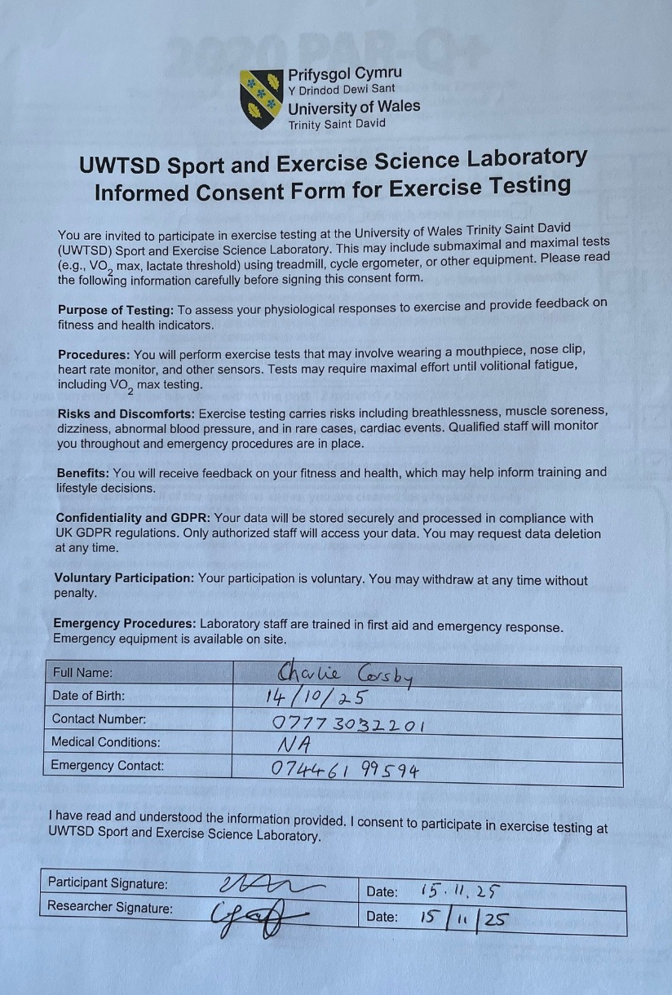

Appendix B – PARQ





