Managing Guest Service Operations Learning Log
Ibis Budget Heathrow Central

Student name: CRISTINA ILIUTA
Student number: 2212526
Module: Managing Guest Service Operations BMIH6003
Word Count: 1250 Words
Lecturer name: JESSICA NEWPORT

I acknowledge the use of Microsoft Editor (https://support.microsoft.com/) and Grammarly (https://www.grammarly.com/) on 07 and 08 March 2025 to check my work using the prompt(s):
- Please check the following text for readability, grammar and syntax.
- I confirm that I have not presented any AI generated text as my own work. I confirm I have copies of my drafts, notes, and other resources I used before, and after the use of AI tools which I may be asked to provide in evidence.
Managing Guest Service Operations Learning Log
Ibis Budget Heathrow Central

Introduction to placement
The Guest Service Operations department guarantees that a hotel runs effectively and that the customers enjoy a pleasant stay. While front-facing departments such as reception and restaurant service handle direct client interactions, Housekeeping and Maintenance work behind the scenes to keep the hotel clean, comfortable, and in good condition; without appropriate management and structure, guest satisfaction can quickly deteriorate.
During this job, I spent most of my time in housekeeping and maintenance without directly engaging in meetings and events. The experience revealed significant operational issues regarding cleanliness standards, staff coordination, and inter-departmental communication. Some areas of the job provided excellent learning opportunities, while others showed substantial inefficiencies and poor management methods.
This reflection uses Gibbs' Reflective Cycle (1988), which divides the experience into six stages: description, feelings, evaluation, analysis, conclusion, and action plan. This organised approach aids in assessing the learning experience by focussing on how work-based skills, technical knowledge, and real-world difficulties influence professional development.
Learning Objectives in Placement
- Understand how Housekeeping and Maintenance contribute to guest satisfaction.
- Learn how tasks are assigned and completed within these departments.
- Observe how communication between departments affects operations.
- Identify common challenges in cleanliness, hygiene, and maintenance.
- Examine how poor management impacts team efficiency and morale.
- Analyse an issue related to guest service and propose practical solutions.

Reflection on Experience and Personal Development
Description
The Housekeeping and maintenance staff ensured the rooms were clean, the equipment worked adequately, and guest complaints were resolved. While these departments were essential to the hotel's success, the reality of their operation was far from perfect.
Housekeeping's cleaning process was frequently rushed, with variable sanitary standards. It was shocking to discover that the same pillow cover had been used to wipe sinks, coffee mugs, tables, and mirrors. This violates hygiene and safety requirements but is common practice among employees.
The Maintenance department faced various but equally frustrating challenges. Basic repairs were frequently delayed due to a lack of resources or because employees were not sufficiently trained to address technical issues. Guest complaints regarding heating, plumbing, and room fixtures were common, but rather than being resolved immediately, they were frequently ignored or handled with temporary remedies.
A particularly challenging circumstance occurred when a guest claimed their bathroom had flooded due to a plumbing issue. Instead of prioritising the repair, the complaint was ignored for several hours. The visitor was understandably frustrated, and when the Maintenance team arrived, they lacked the essential instruments to resolve the issue. The problem might have been fixed quickly, but misunderstanding and poor organisation made it unnecessarily complicated.
Feelings
These departments provided an eye-opening and disappointing experience. The lack of hygienic standards in housekeeping was impossible to overlook. It was profoundly troubling to watch compromises being taken, especially when they endanger guest health. It was sad to observe how these practices were commonly accepted rather than corrected.
The most frustrating aspect of Maintenance was its slow pace and continual delays. Rather than resolving concerns immediately, they were postponed or disregarded, leaving guests disappointed. Many of these difficulties resulted from poor management and a lack of accountability. Staff did what was asked of them, but there was no genuine initiative to go above and beyond the requirements.
While there were learning moments, such as understanding how rooms are inspected and repair requests are handled, it was difficult to ignore the obvious problems in how the departments were organised.
Evaluation
Observing how Housekeeping and Maintenance manage guest service standards taught us some valuable lessons. The value of clear communication, teamwork, and task prioritisation became apparent. A well-run hotel should have mechanisms that ensure hygiene, maintenance, and customer issues are addressed quickly and effectively (Juwaheer, 2007).
However, many of these methods were ineffective or non-existent. Rather than using a planned approach to problem-solving, employees frequently responded to concerns at the last minute. This caused unnecessary tension for both staff and guests.
One positive lesson was recognising the significance of time management in these professions. Housekeeping workers had to clean a large number of rooms within a limited time frame, while Maintenance had to balance various repair requests at the same time. Despite the broken nature of the departments, learning how to prioritise duties properly was beneficial.

Analysis of Work-Based Skills and Technical Knowledge
Analysis
To correctly manage guest service operations, Housekeeping and Maintenance must be efficient, communicative, and problem-solving experts (Wilson-Wünsch et a., 2015). The placement found serious deficiencies in the following areas:
- The use of the same cloth to clean multiple surfaces violated industry best practices. Studies suggest appropriate cleanliness instruction greatly minimises health risks (Shin and Kang, 2020).
- Delayed or poorly done repairs resulted in guest displeasure. Proper preventative maintenance procedures help to avert such issues (Michel et al., 2009).
- Poor communication between housekeeping, maintenance, and front desk workers led to customer confusion and frustration. Effective internal communication is essential for effective hotel operations (Frapin-Beaugé et al., 2008).
- Lack of urgency in addressing guest issues resulted in avoidable service failures. Good leadership guarantees that guests' requirements are met and operations run effectively (Swanson and Hsu, 2011).
Despite these problems, the experience provided a realistic grasp of hotel operations and demonstrated the value of decisive leadership, standard processes, and proactive problem-solving.

Reflection on Organisational Issues
Issue: Delayed Guest Complaint Resolution
One of the most important difficulties was the slowness in responding to visitor complaints. A guest's bathroom flooded once, but it took hours for Maintenance to respond. This led in:
- Guest frustration, leading to negative feedback.
- Operational delays, as Maintenance staff had to deal with multiple complaints simultaneously.
- A risk to the hotel’s reputation, as slow service damages customer trust (Browning et al., 2013).

Proposed Solutions
- Hotels should have clear protocols for dealing with guest issues quickly (Tantawy and Losekoot, 200).
- Housekeeping, Maintenance, and the Front Desk must work together efficiently to avoid delays (Frapin-Beaugé et al., 2008).
- Employees should be trained to handle guest concerns proactively rather than waiting for instructions (Huang and Miao, 2016).

Conclusion and Action Plan
This placement provides insight into how guest service operations should work and what happens when they don't. It became evident that hygiene, maintenance efficiency, and good leadership are all critical for running a successful hotel.
- Moving forward, the following actions will be taken:
- Improve leadership and decision-making abilities for better guest service management.
- Receive further instructions on hotel maintenance and sanitary requirements.
- Suggest improved staff training to prevent service failures in future workplaces.
The quality of guest service at a hotel determines its reputation. Even the best hotels may fail to provide exceptional service if sufficient organisation, communication, and responsibility are not in place.

References
Browning, V., So, K.K.F. and Sparks, B., 2013. The influence of online reviews on consumers' attributions of service quality and control for service standards in hotels. Journal of Travel & Tourism Marketing, 30(1-2), pp.23-40. https://doi.org/10.1080/10548408.2013.750971
Frapin-Beaugé, A.J.M., Verginis, C.S. and Wood, R.C., 2008. Accommodation and facilities management. The Sage Handbook of Hospitality Management, Sage, New York, NY, pp.383-99. https://doi.org/10.4135/9781849200417.n18
Gibbs, G., 1998. Learning by doing: A guide to teaching and learning methods, Furter Education Unit, London.
Huang, Z. and Miao, L., 2016. Illegitimate customer complaining behavior in hospitality service encounters: A frontline employee perspective. Journal of Hospitality & Tourism Research, 40(6), pp.655-684. https://doi.org/10.1177/1096348013515916
Juwaheer, T.D., 2007. Using service quality expectations as a criterion to segment international tourists in the hospitality industry: an outlook of hotels of Mauritius. Journal of travel & tourism marketing, 21(2-3), pp.1-18. https://doi.org/10.1300/J073v21n02_01
Michel, S., Bowen, D. and Johnston, R., 2009. Why service recovery fails: Tensions among customer, employee, and process perspectives. Journal of service management, 20(3), pp.253-273. https://www.proquest.com/scholarly-journals/why-service-recovery-fails/docview/233644030/se-2?accountid=130472
Shin, H. and Kang, J., 2020. Reducing perceived health risk to attract hotel customers in the COVID-19 pandemic era: Focused on technology innovation for social distancing and cleanliness. International Journal of Hospitality Management, 91, p.102664. https://doi.org/10.1016/j.ijhm.2020.102664
Swanson, S.R. and Hsu, M.K., 2011. The effect of recovery locus attributions and service failure severity on word-of-mouth and repurchase behaviors in the hospitality industry. Journal of Hospitality & Tourism Research, 35(4), pp.511-529. https://doi.org/10.1177/1096348016671394
Tantawy, A. and Losekoot, E., 2000. An assessment of key hotel guest contact personnel in handling guest complaints. Journal of Quality Assurance in Hospitality & Tourism, 1(4), pp.21-43. https://doi.org/10.1300/J162v01n04_02
Wilson-Wünsch, B., Beausaert, S., Tempelaar, D. and Gijselaers, W., 2015. The making of hospitality managers: The role of knowledge in the development of expertise. Journal of Human Resources in Hospitality & Tourism, 14(2), pp.153-176. https://doi.org/10.1080/15332845.2015.955562

Appendix
Level 6 Hotel Placement – Weekly Progress Tracker
Task: Maintain a weekly progress tracker documenting your experiences, tasks performed, challenges faced, and lessons learned. Bullet points format is welcome. You must submit this document to the designated Turnitin link by [Friday 7th March 2025] at 23:59pm.

Week 1
Experiences/Tasks/Challenges/Lessons  (outline hotel department) | Shift  (Date/Time) | Student Signature | Hotel Mentor Signature
Induction day,  Sarah, HR Manager, gave a warm welcome. She explained the hotel rules to me, I signed some papers, and I completed two training sessions online on the PERCIPPIO account. (Health and Safety Level 2 Highfield and Fire Safety Level 2).  Placement started. My first day should have begun with a hotel tour, but it never happened.  - Just came in, and after 10 minutes, one of the front desk employees sent me to bring some luggage, but I didn’t accept it because I didn’t know the location and had no access key. She started to behave with an attitude and was very rude.  - The Duty Manager on duty was also very arrogant and rude, talking to me only from above her shoulder.  - I was sent to the BAR area for surveillance and to inform the front desk staff if guests requested something.  - I informed the Assistant Manager, Bruna, about the situation, but she wasn’t pleased. The excuse was: "The girl is from the agency and is unaware of hotel standards."  - Employees communicate with each other most of the time in their native language, even in front of the guests. I asked for  English, please. Only one person apologised and explained that they use a foreign language because they don’t want the guests to understand them.  - Guests look confused, I am confused, we don’t understand what is happening.  - With the shift change, other staff members come on duty together with the Front Desk Manager.  - Nice people, warm welcome, and training started properly.  - Check-in done.  - Charging cards redeeming money from the booking agency.  - Busy evening: British Airways flight was cancelled because of the storm.  - I filled out all the paperwork with details for the guests and attached it to the voucher they received.  - Gave guests the key to their room and informed them about dinner and breakfast times.  The hotel was overbooked (6). | 17.01/10:00-18:00  24.01/14:30-23:00
- Front desk area, same afternoon shift, friendly people.  - Welcoming guests.  - Charging cards from the booking agency.  - The Anatolian group arrived, gave the key to the guests, set up their Wi-Fi on their phones, and informed them about dinner and breakfast times.  - Carry luggage from the storage room or bring luggage into the storage room for a few hours.  - Created some itineraries for guests on how they can visit Central London.  - Listened to some guest complaints about heating or bathroom issues.  - Informed the manager on duty about room numbers and complaints.  - The hotel doesn’t have too many hair dryers in good condition, guests are complaining.  - Carried hair dryers to the rooms where guests requested them; not enough were available at reception.  - Irons are also leaking or damaged.  - Hotel management is trying to reduce costs, even on the small towels allocated for four people in a family room. "They can use the small towel left for the bathroom floor."  - For any issues employees discuss, they only talk in their native language; guests wait and look at them confused.  On my second day here, I haven’t seen the restroom for employees yet, and I haven’t received any lunch for what I signed. | 25.01/14:30-23:00

Week 2
Experiences/Tasks/Challenges/Lessons  (highlight hotel department) | Shift  (Date/Time) | Student Signature | Hotel Mentor Signature
I started my shift with a different Duty Manager, Tasneem. She was pretty rude and arrogant on my first day of placement.  Front desk jobs, AM shift.  - Charging cards for the booking agency.  - Check-out.  - Departure.  - One of the bar staff requested help during breakfast time. I went there to help her with hosting guests.  - Created keys for the arriving groups.  - Dealing with some guest requests and complaints.  - Informed the Duty Manager about room numbers and guest complaints.  - Most of the complaints were about heating and bathroom issues.  - I was sent again for a few hours to the Bar area for surveillance.  - The front desk staff stopped training me; everyone pretended to be busy, saying they had personal training to do. If I shadowed them and tried to look at their PC screens to learn, they would quickly scroll and change pages.  In the same situation, employees speak mostly Konkani or Hindi, even with the manager.  I don’t understand what they are discussing, and I feel bad. | 31.01/06:30-14:30
I started my day with the same AM shift employees. One of the employees from the night shift gave a handover to the morning shift and started verbally explaining the situations she encountered during her working hours. She also shared pictures from her phone of a guest who had slept on a floor different from the one he was staying on.  I am speechless. The hotel has CCTV, so I don’t think using a personal phone for pictures is necessary.  I performed the same tasks for a few hours as the previous day.  Not too many cards to charge.  - Dealing with guest questions and requests.  - Creating keys.  - Check-out.  - Departure.  Again, I was isolated in the Bar area for surveillance.  The staff don’t share much information and has wholly stopped training me. | 01.02/06:30-14:30

Week 3
Experiences/Tasks/Challenges/Lessons  (highlight hotel department) | Shift  (Date/Time) | Student Signature | Hotel Mentor Signature
I started the shift in the Bar/Restaurant for breakfast. I'm confused. According to the placement plan, for weeks 2-5, I should only be at the front desk and in administration.  I asked about it, and the explanation was that front desk employees also replace those in the Bar and Restaurant. Strangely, I didn't see anyone even helping for a few minutes.  One of the employees was laid off, and I was told to replace him. I have no experience in this field, and I am confused. The bar employee showed me how to use the cash register and told me what to do.  - Hosting guests.  - Presenting to guests what types of breakfast they can choose.  - Selling breakfast and other products.  - In the breaks between customer arrivals, clearing tables, cleaning tables, separating dishes, cutlery, leftover food, and trash, and taking the cart to the kitchen.  - The hotel employee continuously called me to show me how to stir the beans to look nice or where to refill milk and bread slices.  - I am confused again. I don’t have any skills in food service. From sorting dirty dishes and garbage, I must touch guest food.  - No food hygiene  - One of the guests was allergic and asked what we could offer him. I called the chef to present and explain what each product contained.  - I needed employee support for a guest’s request. I went after her into the kitchen and found her eating there.  - From 6:00 to 10:00 am, I had to manage breakfast alone. The hotel employee supervised me from behind the bar and continuously told me what to do without offering the slightest support.  At 10:00, the employee told me I could start mopping in the restaurant. I explained nicely that I was a student in training and that this was not the purpose of my presence there. He spoke to me very rudely, telling me: "Even if you are a student, you have to do it, and if you don't like it, talk to Bruna, the Assistant Manager."  I refused and informed Sarah about the situation. After four hours of handling breakfast alone, I left for a break.  - Upon returning from my break, I vacuumed the bar area, after which Duty Manager Tasneem asked if I wanted to stay in the bar while the employee left for a break. I agreed.  At 12:00, the bar employee informed me she was on a zero-hours contract and had finished her shift. I had to stay in the bar. She left her Accor account logged in so I could sell products. | 07.02/06:30-14:30
I started the shift in the Bar/Restaurant for breakfast with a different Bar/Restaurant employee.  - Again, I replaced one of the employees.  - Hosting guests.  - Presenting to the guests what types of breakfast they can choose.  - Selling breakfast and other products.  - In the breaks between customer arrivals, cleared tables, cleaned tables, separated dishes, cutlery, leftover food, and trash, and took the cart to the kitchen.  - The hotel employee was only loitering from one side to the other, checking how much food the guests took on their plates. They also interacted with guests and told them they could not take more coffee or food.  - Breakfast is buffet-style, £13.50 per person.  - Around 8:00 am, the restaurant started running out of stock—not enough beans, sausages, hash browns, or yoghurt.  - Prepaid breakfast was 30, but I sold 45 more.  - With £5 in hand, I went to the neighbouring store and bought three cans of beans.  - 10:00 am, the last two breakfasts sold; guests waited about 15 minutes before the hot food area for scrambled eggs and a few sausages.  - 10:30 am, breakfast finished, my lower back hurt severely, and I asked the Duty Manager for a break.  - 11:00 am, I came back from break, but my back pain was severe—I couldn’t stand properly. When I sat in the back office, Tasneem, the Duty Manager, suggested I go home if I was in severe pain so she could allocate my hours to the hotel employee, who was supposed to leave at 11:00 am and was also on a zero-hours contract.  - I called an Uber and went home; the employee was happy—he gained a few more hours.  I am confused because of the lack of leadership and teamwork attitude. The duty manager’s solution for the stock shortage was to blame and criticise the food and beverage manager for his lousy management and accuse him of sending unnecessary emails regarding stock issues.  Also, Waaqas, the General Manager, was blamed, as he was aware of the situation and agreed to operate like this—out of stock.  I am speechless. | 08.02/06:30-14:30

Week 4
Experiences/Tasks/Challenges/Lessons  (highlight hotel department) | Shift  (Date/Time) | Student Signature | Hotel Mentor Signature
No attendance.  I haven’t received the rota from the hotel. | 14.02.2025
I was allocated to the Bar Area.  - Bar tasks: selling drinks, cleaning tables, collecting empty glasses and bottles, and selling food. The kitchen is running out of stock again. I am dealing with the chef to find out what I can sell. The bartender showed me how to restock the bar and complete the paperwork.  - The afternoon shift employees arrived—very friendly and good people, everything went smoothly.  My lower back hurt severely, and I started using my walking stick again. | 15.02/14:20-23:30

Week 5
Experiences/Tasks/Challenges/Lessons  (highlight hotel department) | Shift  (Date/Time) | Student Signature | Hotel Mentor Signature
I was assigned to the housekeeping department.  The housekeeping department is provided by an external cleaning agency: Hotel Care.  - I accompanied the supervisor on the room inspection tour for a few hours.  - She explained the hotel's standards regarding the rooms and how the activity is carried out.  - She introduced me to the cleaning products and explained how they allocate staff in low- and high-business situations.  - After a few hours, she left me with one of the employees to shadow her and observe how she performed her tasks. She later talked to Bruna, the assistant manager, saying I was slowing her down because I walked slowly and used a walking stick.  - I am totally shocked—the housekeeper uses a pillowcase to dry everything. The same pillowcase is used to dry the sink and clean coffee cups, TVs, tables, kettle, and mirrors. No comments. | 21.02/09:00-17:30
My assignment has been changed, and I’m back in the bar/restaurant helping with breakfast.  - Hosting quests.  - Present to the guests what types of breakfast they can choose.  - Seals breakfast and other products.  - Helping to clean the Restaurant after breakfast.  - Break  - After the break, Tasneem, the duty manager, explained to me their daily task as a duty manager; I tried to ask some questions that could help me with my Student Log regarding Hotel Administration, but not too many answers.  - Back to the Bar Area, similar tasks, seals and collect after guests.  - The 5th week of my placement was already finished, and I didn’t learn much; I often asked busy people or told me, “We will talk later”.  The placement plan that I received was not respected at all. There are not too many ticks there. Even though I was asked by Winnie, the Front Desk Manager, to tick everything that I learned, I don’t have too much. | 22.02/09:00-17:30

Week 6
Experiences/Tasks/Challenges/Lessons  (highlight hotel department) | Shift  (Date/Time) | Student Signature | Hotel Mentor Signature
No attendance. I was allocated to the maintenance department.  Sick leave. My lower back hurt badly. I called the hotel and also informed Bruna Val Verde through WhatsApp about my physical condition. | 28.02/09.00-17:30
No attendance. I was allocated for breakfast again.  Sick leave. My lower back hurt badly. I called the hotel and also informed Bruna Val Verde through WhatsApp about my physical condition.  I have a medical appointment at Acton Hospital for my back issues regarding an MRI scan. | 01.03/07:00-15:30
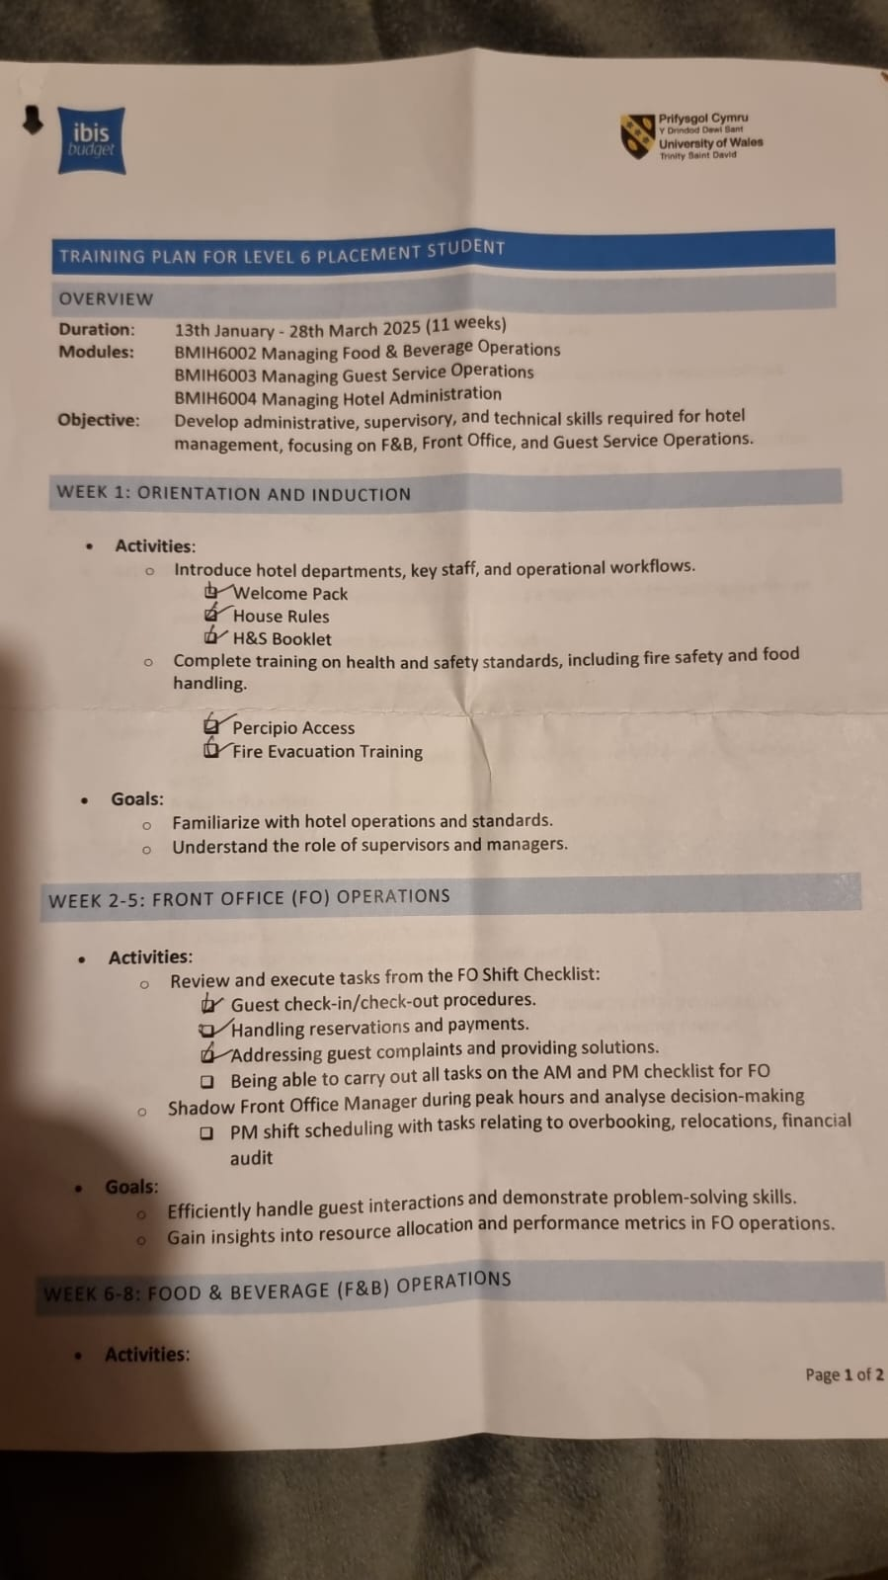  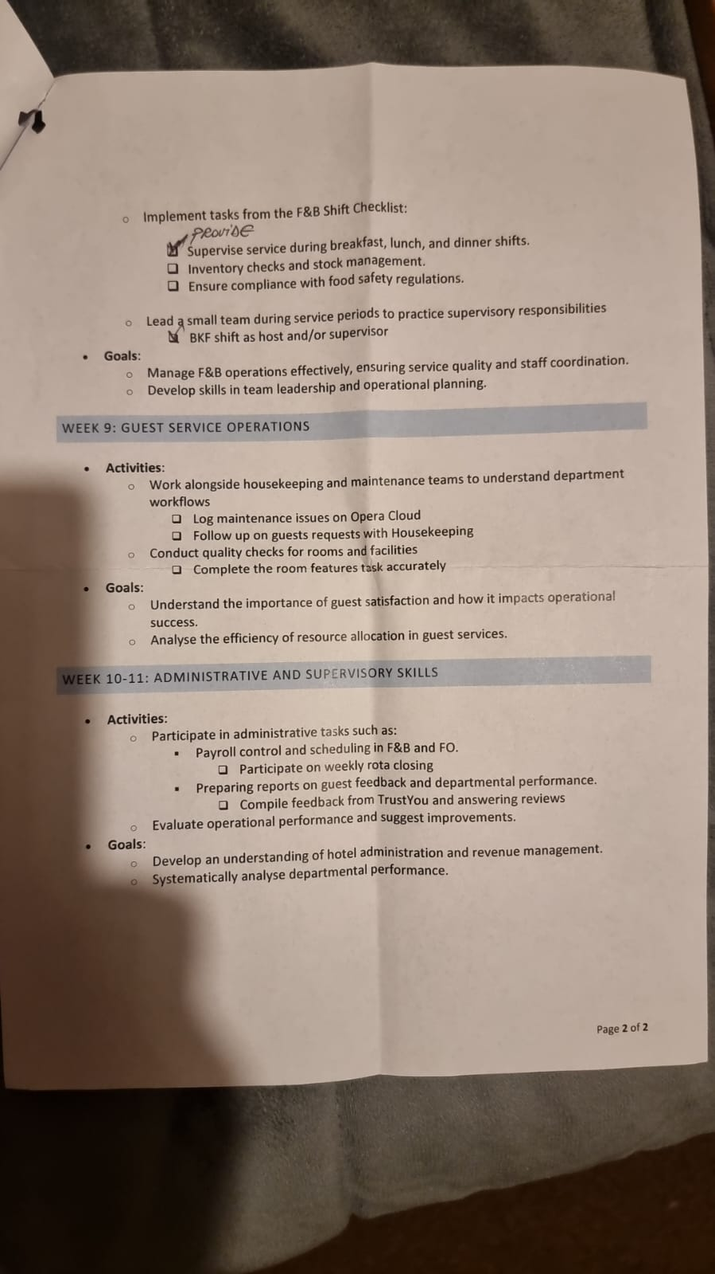 |  |  | Training

