Module: Learning in the Digital Era
Module code: BMPS4009 & BMPL4007
Evidence of Learning(E-Portfolio)

Student’s Name: Alondra Burkevica
Student's ID:2243585

Table of Contents
Introduction 3
Summary on Preparing Higher Education 4
A Mind Map on Becoming a Digital Learner 6
Presentation on Becoming a Team player 8
Reflection using Gibbs Reflection tool 9
Personal Development Plan-PDP 13
Conclusion 17
References 18

Introduction
The "Evidence of Learning" e-portfolio provides a detailed account of one’s growth as a student in the digital era. In this report, details about my first semester at university is shared, including the experience with online learning and the first papers that has been completed. The most formative experiences, challenges, and how to overcome them are all summed up in one document. The report also has a PDP with attainable goals to help fill any knowledge gaps identified through introspection. This online resume showcases my academic growth and the commitment to lifelong learning in the current day.

Summary on Preparing Higher Education
Preparing for higher education is a crucial element of any student's formal education (Grubb, 2019). As the world becomes more digitised, recognising the need to adapt to the digital era and having the right skills and knowledge is essential. This summary is an effort to condense the fundamentals of college readiness for the digital era.

Figure 1: Summary of Preparing Higher Education (Gilmore, 2021).
Importance of Digital Skills:
Having proficiency with digital resources is not a nice-to-have in today's highly technical environment; it's a must (Gilmore, 2021). Universities currently demand that incoming freshmen have a high level of technology literacy in areas like as research, communication, collaboration, and content production. How to discover and assess information, how to interact successfully online, how to think critically, and how to solve issues are just some of the digital literacy skills that today's students need to acquire. Students benefit academically from developing these skills, and they also prepare them for the demands of the modern job.
Research and Information Literacy:
A key component of being ready for college is developing strong research and information literacy abilities (Johnston-Guerrero, 2021). Today's learners require skills in both using and assessing the credibility of online resources, including digital libraries and databases.
Digital Communication and Collaboration:
Email, video conferencing, and other types of online cooperation are all heavily emphasised in today's universities (Nash, 2015). Students should develop strong verbal and written communication skills in addition to learning appropriate digital communication etiquette. For success in college and a career thereafter, it's crucial to develop collaborative abilities such as virtual teamwork and the capacity to participate in online debates and group projects.
Adapting to Online Learning:
Students today need to be flexible enough to study well in both traditional classroom settings and newer, more technologically advanced online settings (Gilmore, 2021). Students should be able to use LMSs with ease, contribute meaningfully to online conversations, prioritise their work, and set and stick to realistic learning goals.

A Mind Map on Becoming a Digital Learner
Becoming a Digital Learner is crucial in today's technological age since it provides one with the tools to succeed in any field of study (Atack, 2017). This synopsis will investigate the linked topics and ideas of digital education and how they contribute to career readiness.
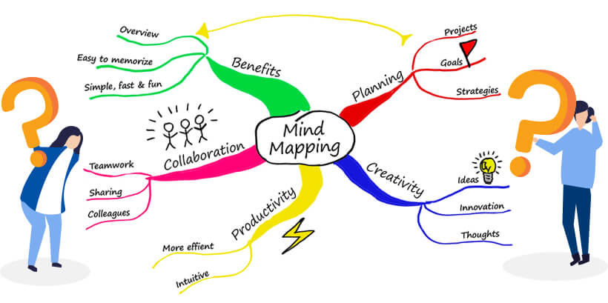
Figure 2: Mind Map on Becoming a Digital Learner (Eguara, 2022).
Digital Literacy: Literacy in the use of digital technologies is the cornerstone of the modern education system (Eguara, 2022). Learning how to use digital tools, analyse digital material, assess the reliability of information found online, and safeguard one's own data are all part of this process. Success in any field requires strong information retrieval, analysis, and synthesis skills, all of which may be improved by training in digital literacy.
Information Management: The ability to manage and organise digital resources is crucial in today's information-rich digital environment (Atack, 2017). File management, cloud storage, and effective digital processes are all examples of such competencies. Information that is easily accessible, useful, and conducive to teamwork is the result of efficient information management.
Online Research: Researching topics and information online is crucial in today's academic and professional environments (Nash, 2015). One of the requirements of being a digital learner is mastery of sophisticated search strategies and the ability to locate and evaluate the reliability of online content.
Digital Collaboration: Collaboration in the digital realm is crucial in the modern, interdependent society (Gilmore, 2021). Collaboration in this context is working together on a project utilising online resources and apps. Learners in the digital era need to acquire competencies including virtual teamwork, project management, and online communication.
Digital Creativity: Inventiveness in the Digital Age Many fields now rely heavily on digital inventiveness (Grubb, 2019). It entails making use of digital media and systems for the purpose of communication, artistic expression, and the generation of novel answers to problems. Students who take the time to develop their creative potential in the digital realm are better able to demonstrate their mastery of subject matter, convey intricate ideas clearly, and actively participate in the study of their chosen field.
In conclusion, becoming a "digital learner" requires mastery of information management, online research, digital collaboration, digital creativity, and responsible technology use.

Here is my link to the video: https://youtu.be/pw8DwtDC4io

Presentation on Becoming a Team player
Learning to function effectively as a member of a team is a skill that will serve us well in One’s personal and professional life (Scarnati, 2021). One’s capacity to make meaningful contributions to a team is strongly influenced by the unique combination of factors that make up One’s personal identity.
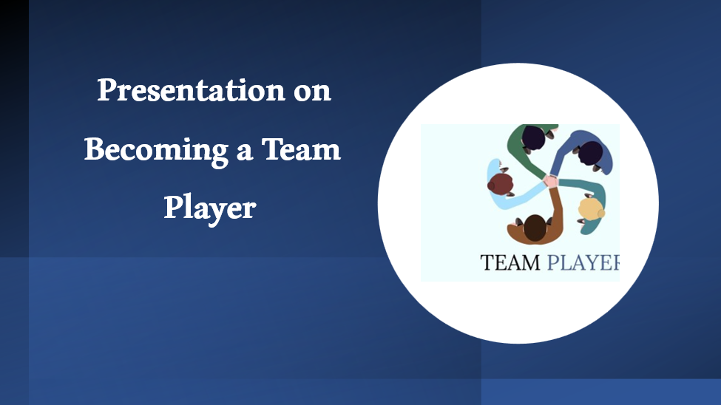

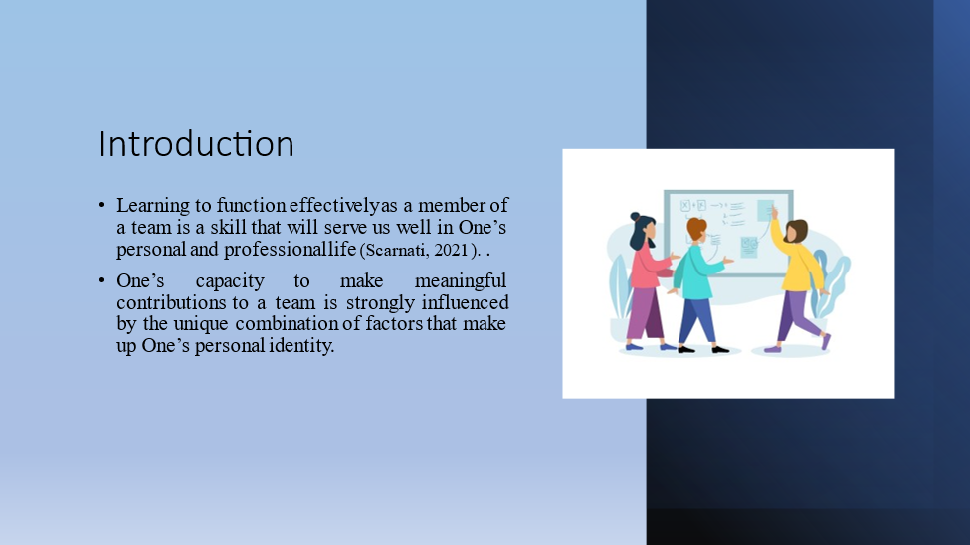
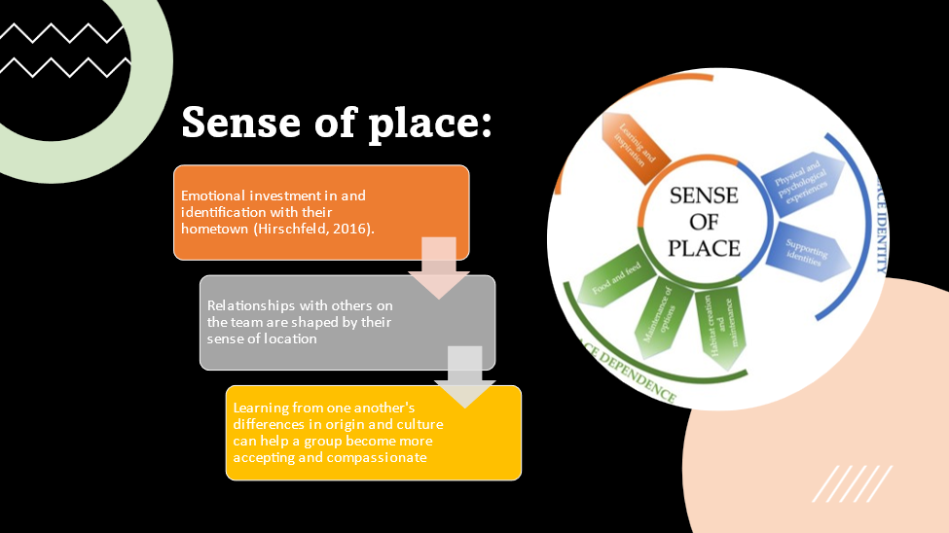
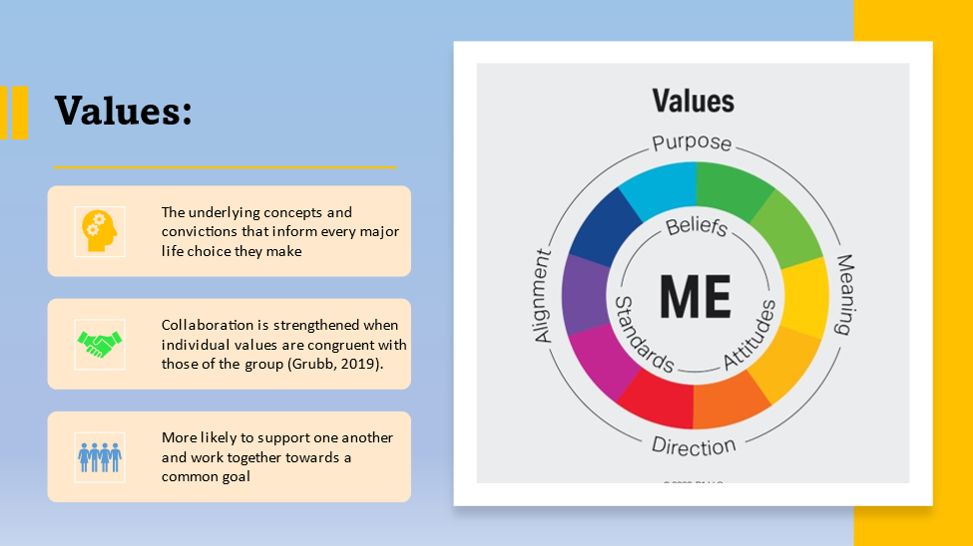
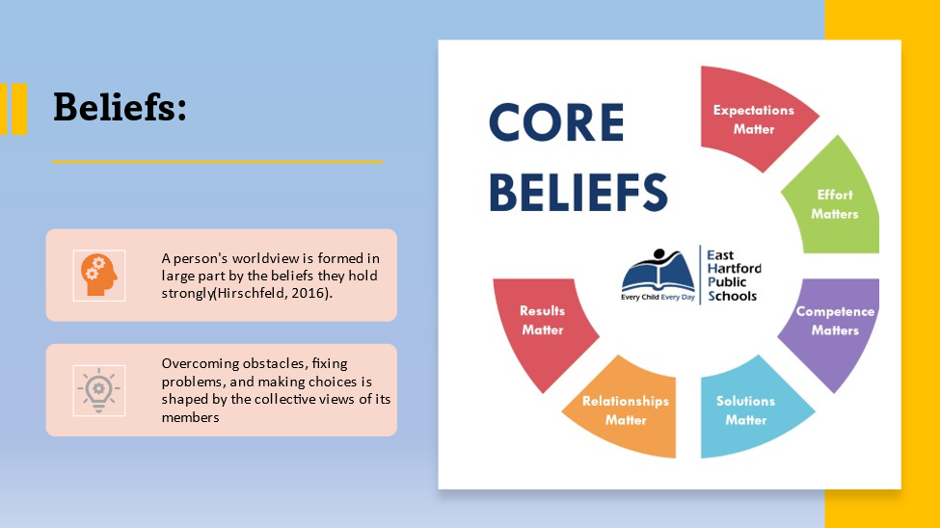
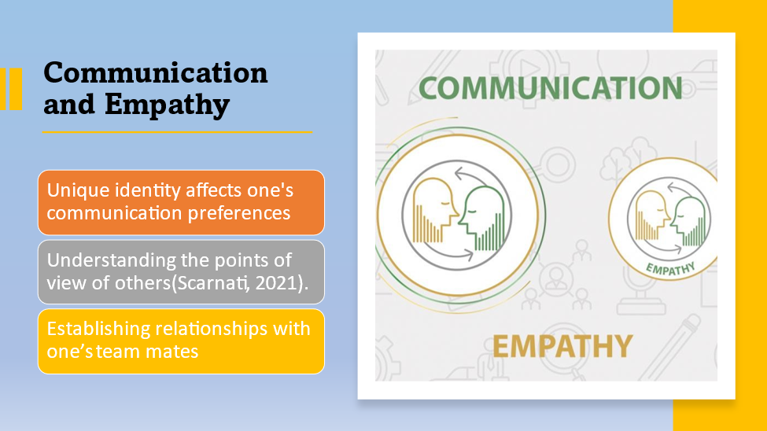
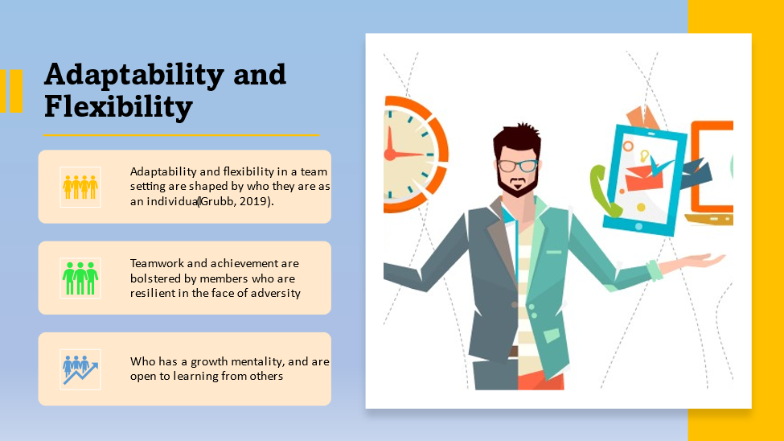
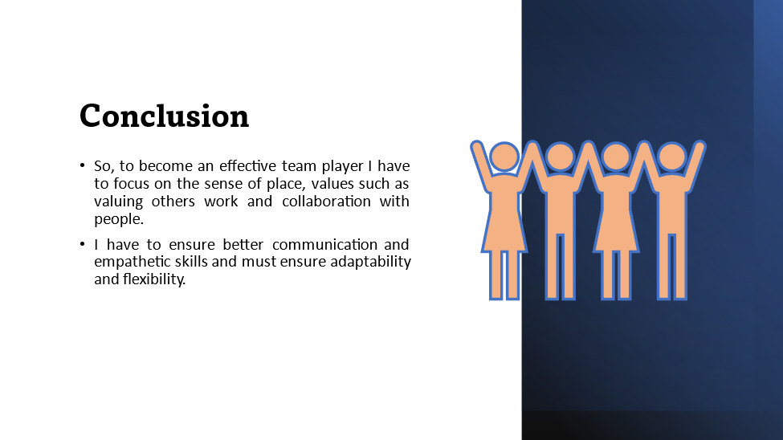
Sense of Place: My "sense of place" is my emotional investment in and identification with their hometown or other local community (Hirschfeld, 2016). My viewpoint and relationships with others on the team are shaped by the sense of location. Appreciating and learning from one another's differences in origin and culture can help a group become more accepting and compassionate.
Values: One's values are the underlying concepts and convictions that inform every major life choice they make (Grubb, 2019). Collaboration is strengthened when individual values are congruent with those of the group. When team members have values in similar, they are more likely to support one another and work together towards a common goal.
Beliefs: A person's worldview is formed in large part by the beliefs they hold strongly (Hirschfeld, 2016). The team's approach to overcoming obstacles, fixing problems, and making choices is shaped by the collective views of its members. To work well together, people must be able to put aside preconceived notions and be open to new ideas.
Communication and Empathy: One of the most important characteristics of a team player is the ability to communicate and empathise with others (Scarnati, 2021). One's unique identity affects one's communication preferences and one's comfort level voicing opinions and providing criticism. Understanding the points of view of others and establishing relationships with One’s team mates requires attentive listening and empathy.
Adaptability and Flexibility: One's adaptability and flexibility in a team setting are shaped by who they are as an individual (Grubb, 2019). The qualities of a good team member are adaptability and willingness to try new things. Teamwork and achievement are bolstered by members who are resilient in the face of adversity, have a growth mentality, and are open to learning from others.

Reflection using Gibbs Reflection tool
In this reflective essay, I will apply the Gibbs Reflective Cycle to analyse my first semester at college, including how I found my way around the library's digital resources and completed my first writing tasks (Stuart, 2014). The purpose of this introspection is to look into my internal and external experiences throughout these big transitions, highlight difficulties I had, and suggest ways I might overcome them in the future.
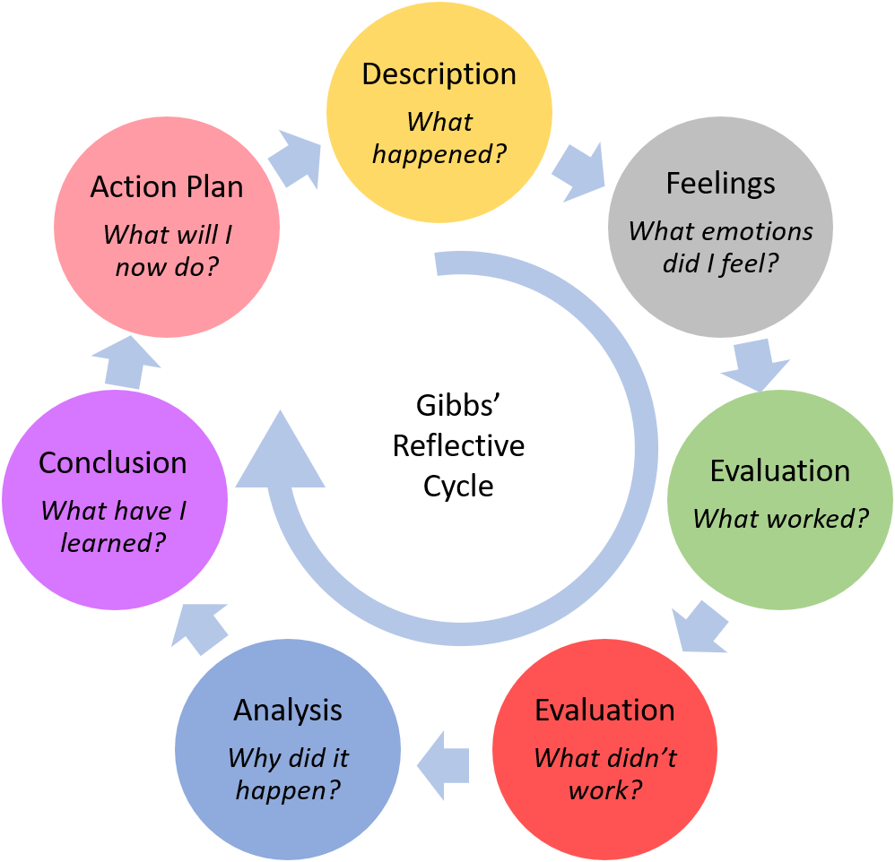
Figure 3: Reflection using Gibbs Reflection tool (Coleman, 2020).
Description:
The decision to attend college marked an exhilarating and, at the same time, terrifying new chapter in my life (Coleman, 2020). The transition to online learning has its own challenges, including the need to quickly adapt to new digital platforms and virtual classrooms. At first glance, the almost infinite number of available internet materials can be overwhelming; yet, they also present an opportunity for independent learning. E-books, academic journals, and MOOCs were just some of the ways I deepened my understanding of this material.
Feelings:
There was a wide range of feelings I went through when I began this journey. I was excited to meet new people and expand my knowledge, but I also felt nervous about the future (Otienoh, 2020). When I first started taking classes online and interacting with my professors and classmates through virtual means, I experienced a roller coaster of mixed feelings. Students felt awkward and alone when online sessions were abruptly terminated due to technical issues. But as I grew more comfortable with the online platforms and learned how to deal with technical challenges, I got more invested in my education and felt like a part of the online learning community.
Evaluation:
When I first started college, I was able to take advantage of online courses at my own speed, within the constraints of my own timetable. The convenience of the online format allowed me to work around my other obligations and study at my own pace (Otienoh, 2020). However, being cut off from my other students and teachers in this way might make me feel lonely and isolated. Unlike in a traditional classroom, where conversations and exchanges happen organically, connecting with others in a virtual one takes more work. Getting started using internet materials was difficult at first since there was simply so much to take in. My search strategies, ability to recognise quality sources, and proficiency in using digital libraries all improved with time. The quality of my research and writing improved as a result of my ability to analyse sources critically, taking into account criteria like reliability, relevance, and currency.
Analysis:
In retrospect, I saw that I needed to take initiative in order to successfully adjust to online learning and make good use of available resources. I overcame obstacles and gained insights through participation in online discussion groups, virtual office hours, and conversations with peers. Group work and virtual teams were made possible by collaborative platforms, which encouraged interaction and the growth of important soft skills like communication, negotiation, and cooperation (Scarnati, 2021). Finding a middle ground between classwork and self-study while still completing homework on time required careful time management. Keeping up with coursework and turning in assignments on time while taking classes online takes dedication and initiative. Writing the initial tasks required more than simply familiarity with the material. It required knowing what was expected of you, organising One’s thoughts in a logical fashion, and backing up One’s claims with facts. I was able to hone my abilities in areas like thesis statement development, analysis, and citation and reference creation thanks to the insightful comments of my teachers and classmates.
Conclusion:
Beginning university, learning to use online courses, and completing the first tasks have all been life-altering events. Through introspection, I was able to better understand my feelings, the obstacles I faced, and the ways in which I might improve. Learners who struggled to make the transition to online education lacked the patience, fortitude, and resourcefulness necessary to succeed (Johnston-Guerrero, 2021). Improving research methods and making full use of digital libraries were essential components of an efficient online resource management strategy. Writing projects tested students' ability to think critically, arrange their thoughts logically, and express themselves clearly. Going forward, I plan to make the most of these insights, hone my abilities, and make the most of any academic resources made accessible to me.
Action Plan:
I have developed a strategy to improve my time at university:
1. Participate in group chats and share One’s work with others on the internet to build a sense of belonging and overcome feelings of loneliness (Beausaert, 2019). Initiating discussions, posing challenging questions, and offering useful criticism will all help me achieve my goal among my peers.
2. Make use of One’s professors' office hours online to have One’s questions answered, voice One’s concerns, and develop closer relationships with the teaching staff (Coleman, 2020). I commit to attending all scheduled virtual office hours, thinking carefully about the questions I want to ask in advance, and actively engaging in all sessions.
3. Create a plan that works for me to manage One’s time wisely and get the most out of One’s schoolwork, studying, and homework. I'll use time-management strategies like making lists, establishing achievable objectives, and chunking large projects into more manageable chunks.
4. Participate in virtual workshops and consult with library staff to hone One’s ability to locate relevant information and conduct effective searches. In an effort to make my research more efficient, I plan on becoming acquainted with sophisticated search tactics, specialised databases, and citation management software.
5. Write often, get feedback from teachers and classmates, and make use of the university's writing tools to hone One’s craft (Eguara, 2022). In order to hone my academic writing skills, I will make use of writing centres, online writing guides, and peer editing sessions.
By following this strategy, I hope to improve my learning environment, increase my self-efficacy as a student, and ultimately lead to my academic achievement.
In conclusion, adjusting to university life and completing those first tasks has been an educational and personal adventure. I have learned so much about myself and the world around me via introspection and analysis that I am better equipped to face obstacles and seize chances. I plan to carry the knowledge I have gained with me as I advance in my studies, welcome the opportunity for continuous growth, and confidently face any obstacles I may encounter along the way.

Personal Development Plan-PDP
This Personal Development Plan (PDP) will detail the steps I will take to close the skill gaps I discovered via introspection, and how doing so will help me achieve my long-term goals (Strivens, 2019). The strategy will include SMART goals, which require goals to be specific, measurable, attainable, relevant, and have a deadline.
Skill Gap Analysis:
After giving it some thought, I've come up with a list of various areas in which I feel I might use improvement, both academically and personally. Among these are:
1. Effective Time Management: Maximising efficiency by improving my time management skills, including setting priorities, setting deadlines, and allocating work time effectively.
2. Research Skills: Developing my research abilities has involved honing my search tactics, learning to critically appraise sources, and becoming proficient with niche databases and citation management software (Webb, 2015).
3. Academic Writing: Specifically, I want to work on my academic writing by refining my essay structure, thesis statement, evidence backing, and citation and reference abilities (Otienoh, 2020).
4. Collaboration and Communication: Learning to work well with others and express oneself clearly and concisely is essential for success in today's increasingly virtual classrooms.
5. Self-motivation and Discipline: Learning to motivate and discipline myself so that I can make steady progress, handle assignments on my own, and keep my mind on my studies is a top priority.
Personal Development Plan:
Objective | Specific | Measurable | Achievable | Relevant | Time-bound
Enhance Time Management Skills | Make a detailed weekly plan for studying that includes blocks of time for each class, homework, and review sessions | Keep tabs on how well you're sticking to One’s study plan and how productive he is as a whole. | Study for longer periods of time and adjust One’s study plan as needed (Hirschfeld, 2016) | The ability to manage my time efficiently will help me meet deadlines, have a good work-life balance, and lessen my stress levels | Use the study plan for at least one month of the semester before judging its efficacy.
Improve Research Skills | Attend online seminars on in-depth reading strategies and niche resource collections specifically (Beausaert, 2019). | Conduct research making use of the improved abilities, and assess the reliability and applicability of the sources used | I can achieve this goal if I commit to using more sophisticated search terms and asking for help from librarians | I can improve my grasp of the material and my performance on assignments by sharpening my research abilities. | Use what I learn from at least two online seminars to complete research projects throughout the upcoming semester
Enhance Academic Writing Skills | To hone down on specifics like essay format, thesis creation, and referencing, make use of internet writing tools and writing centres. | Have the teachers and classmates critique my writing to help me figure out where I stand and how to get better (Beausaert, 2019). | Practising writing on a regular basis, setting aside time for self-editing, and using criticism to improve writing are all realistic goals. | To successfully convey ideas and provide well-structured arguments, one must have excellent academic writing abilities. | By the conclusion of the school year, I will have submitted at least one written project to the writing centre for evaluation and shown that I have improved as a writer
Develop Collaboration and Communication Skills | Contribute meaningfully to online class discussions, work well with others on group assignments, and get input from classmates on my communication skills | Keep tabs on comments made on group efforts and assess the value of online discussions (Webb, 2015) | Participate in group conversations, pay attention when others talk, and refine my ability to express myself clearly and concisely | The ability to work together effectively and communicate effectively are fundamental to achieving success in school and in my career (Strivens, 2019) | At the end of each semester, evaluate my contributions to online forums and group assignments measuring development in working together and talking to others
Foster Self-motivation and Discipline | Set both short-term and long-term objectives, break them down into manageable tasks, and check in frequently to see how you're doing | Keep tabs on what is done, how often objectives are met, and how self-disciplined the person is (Webb, 2015) | To-do lists, motivating approaches, and accountability partners are all examples of strategies that fall into the "doable" category | Self-motivation and discipline are essential for staying on task, dealing with setbacks, and realising long-term goals | Goals must be time-bound, so check in every three months

My goals for the future are detailed in my Personal Development Plan (PDP), which details the steps I will take to fill in my skill gaps. In order to improve my time management, research, academic writing, teamwork, and self-motivation, I have decided to create some SMART goals and work towards them. I will work hard, think deeply, and evaluate my progress in order to improve myself, my academic performance, and the skills I need to achieve my goals.

Conclusion
The digital learning experience is documented in an impressive E-portfolio. By completing and reflecting on a variety of courses, I was able to demonstrate growth in important areas including flexibility, research competence, clear writing, and teamwork. The mind map shows how my chosen field is related to my goal of being a digital learner. The obstacles and successes encountered throughout the transition to university and online study were detailed in the reflective essay. In addition, the PDP reflects my determination to fill in any knowledge gaps and realise my long-term goals. The E-portfolio attests to my dedication to lifelong education in the digital age, enabling me to adapt to and thrive in today's competitive and dynamic business environment.

References

Atack, L. (2017). Becoming a web-based learner: registered nurses’ experiences. Journal of Advanced Nursing, 44(3), pp.289–297. doi:https://doi.org/10.1046/j.1365-2648.2003.02804.x.
Beausaert, S. (2019). The Use of Personal Development Plans (PDPs) in the Workplace: A Literature Review. Building Learning Experiences in a Changing World, [online] pp.235–265. doi:https://doi.org/10.1007/978-94-007-0802-0_14.
Coleman, D. (2020). Reflective writing: The student nurse’s perspective on reflective writing and poetry writing. Nurse Education Today, 35(7), pp.906–911.
Eguara, O. (2022). Becoming a networked learner: Unpacking identity development in networked learning communities. Studies in Technology Enhanced Learning. doi:https://doi.org/10.21428/8c225f6e.7bfafd3c.
Gilmore, J. (2021). Preparing for College and University Teaching. Stylus Publishing, LLC.
Grubb, P. (2019). Preparing For Higher Education Study. 6th ed.
Hirschfeld, R.R. (2016). Becoming team players: Team members’ mastery of teamwork knowledge as a predictor of team task proficiency and observed teamwork effectiveness. Journal of Applied Psychology, 91(2), pp.467–474. doi:https://doi.org/10.1037/0021-9010.91.2.467.
Johnston-Guerrero, M.P. (2021). Preparing for Higher Education’s Mixed Race Future. Springer Nature.
Nash, R.J. (2015). Preparing Students for Life Beyond College. Routledge.
Otienoh, R.O. (2020). Reflective practice: the challenge of journal writing. Reflective Practice, 10(4), pp.477–489. doi:https://doi.org/10.1080/14623940903138332.
Scarnati, J.T. (2021). On becoming a team player. Team Performance Management: An International Journal, [online] 7(1/2), pp.5–10. doi:https://doi.org/10.1108/13527590110389501.
Strivens, J. (2019). An overview of the development of Personal Development Planning (PDP) and e-Portfolio practice in UK higher education. Journal of Learning Development in Higher Education. doi:https://doi.org/10.47408/jldhe.v0i0.114.
Stuart, K. (2014). Activity theory as a reflective and analytic tool for action research on multi-professional collaborative practice. Reflective Practice, 15(3), pp.347–362. doi:https://doi.org/10.1080/14623943.2014.900007.
Webb, L. (2015). Enhancing Employability through Professional Experience and Personal Development Planning (PDP). The International Journal of Learning: Annual Review, 15(10), pp.191–196. doi:https://doi.org/10.18848/1447-9494/cgp/v15i10/45979.

