Code of Ethical and Professional Practice

Case Study
Inter Luxe Hotel Group is a multinational hotel chain with 800 properties in 25 countries. The hotels are based in coastal resorts and cities. In coastal resorts, customers are mainly those on holiday. In cities, the customer base is more diverse and includes sightseers and business customers. Both groups of customers have high expectations. You work as a People Advisor in the People Function of a cluster of eight hotels. Inter Luxe Hotel Group employs graduate trainees who spend time in different functions to enable them to develop knowledge and understanding of the whole business. A graduate trainee will soon be starting their placement in your function, and you are responsible for their learning during this placement.
Task One – Written advice

1) Please explain:
a) You feel a good starting place is to learn about the employee lifecycle. You decide to explain the stages of the employee lifecycle and how a people practitioner could contribute to each stage (AC 1.1)

Figure 1 Employee Lifecycle
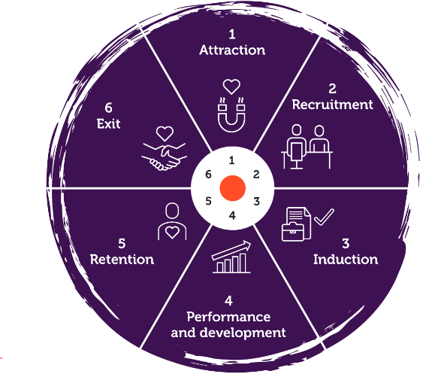
The employee lifecycle is effectively illustrated in Figure 1 by CIPD (2021, p. 94), which outlines six key stages: Attraction, Recruitment, Induction, Performance and Development, Retention, and Exit.
1. Attraction
This stage focuses on drawing suitable candidates to the organisation. A key tool is the Employee Value Proposition (EVP), which communicates the company’s identity and values. As explained by CIPD (2022a, p. 135), the EVP should align with what potential candidates seek in an employer. It can include visual branding such as the company logo and HR written content that reflects corporate values and behaviours. Marketing teams often assist in crafting this message to ensure it resonates with the desired talent pool.
2. Recruitment
Recruitment encompasses attracting and selecting the right people both internally and externally. According to Graham and Bennett (1998, p. 163), this process should be efficient, cost-effective, and aligned with organisational needs. HR plays a central role in human resource planning (HRP), designing fair recruitment strategies, and training hiring managers to minimise unconscious bias, which helps widen and diversify the talent pool. A positive candidate experience is crucial in converting interest into employment.
3. Induction
A well-structured induction process is essential for setting a strong first impression. HR is responsible for delivering a consistent message about the company’s core values, behaviours, and expectations. Induction should cover practical areas such as payroll, internal systems, and policies, while also introducing the employee assistance programme (EAP) and health and safety protocols. Regular updates ensure legal compliance via HR. Creating psychological safety from day one helps reduce new-starter anxiety. HR provided mandatory training, such as safeguarding, sets the tone for company-wide conduct expectations.
4. Performance and Development
HR oversees employee performance through probationary reviews and performance metrics. These reviews assess training completion, conduct, attendance, and punctuality. HR advises managers on performance frameworks, ensuring compliance and consistency. Supporting employee growth through development opportunities promotes retention. Where possible, career progression pathways help reduce turnover of newly skilled staff by providing internal advancement opportunities.
5. Retention
Understanding why employees stay or leave is crucial. HR tracks attrition rates and conducts analysis to inform retention strategies, such as performance management processes (PMP), as described by Harrison (2022, p. 243). Both qualitative and quantitative tools—like annual surveys—help uncover internal and external factors influencing turnover. Internal issues may include low pay, lack of recognition, or inconsistent management. External influences range from childcare constraints and health challenges to broader economic factors. HR Investment in providing Equity, Diversity, and Inclusion (ED&I) training also fosters a more supportive and inclusive workplace.
6. Exit
The final stage may occur voluntarily (e.g. resignation, retirement) or involuntarily (e.g. redundancy, dismissal). HR must manage departures professionally, ensuring processes are legally sound and fair to protect both the departing employee and the organisation. Exit and stay interviews offer insights for improvement. While some departures may be disruptive, others can create positive change within teams.

Employee turnover is high for Food and Beverage Assistants, and you are about to recruit and select new employees for this role. You decide to advise the graduate trainee on how to recruit and select Food and Beverage Assistants.
Q.2 Explain the purpose and key content of a job description and person specification. Explain how job analysis can be used to decide on the content of these documents. (AC 1.2)

A job description is essential for clearly setting expectations and outlining the purpose of a role. By translating the core responsibilities into values-driven tasks, the organisation ensures candidates fully understand the role at the point of application. This transparency helps avoid misunderstandings during onboarding and training, supporting employee retention, reducing recruitment costs, and enhancing the employer brand. The description should realistically reflect the duties and be aligned with the offered pay, avoiding the misallocation of higher-level tasks to lower-paid roles, which could otherwise fall under managerial responsibilities.

Following the job description, the job specification defines the qualifications and experience required. It’s crucial to avoid indirect discrimination—for instance, requesting GCSEs from older candidates who may not have studied them—unless they are genuinely essential to the role. For some positions, such as a Finance Manager, formal qualifications are necessary, while others, like Food and Beverage Assistants, may rely more on on-the-job training.

Job analysis plays a key role once a vacancy arises. Reviewing current duties, expectations, skills and health surveillance ensures the role remains relevant. Input from current employees adds value, helping identify redundant tasks and improve efficiency. Aligning the role with organisational values and realistic operational demands supports long-term workforce sustainability explained by (CIPD, 2024) as well as adhering to company policies and procedures.

Q.3 Explain two different recruitment methods that Inter Luxe Hotel Group could use for the Food and Beverage Assistant vacancies and why the two methods are appropriate for the role. (AC 1.3)

For an entry-level role such as a Front of House Assistant, recruitment is typically straightforward as the position often does not require formal qualifications. The key requirements are usually basic experience in table service and the ability to work independently. However, a potential barrier may be the need for reliable transport to remote locations. To overcome this, the company could consider providing transport solutions, enhancing accessibility and improving candidate reach.
To further widen the talent pool, essential certifications such as Basic Food Hygiene could be offered through company-funded training. Covering this cost within the training budget removes financial barriers for applicants and supports inclusive hiring.
One effective recruitment method is advertising the vacancy with the above benefits on the company intranet. This approach allows current employees to apply for additional hours, saving time and reducing external advertising costs and potential resignations. It also ensures the vacancy is communicated instantly across the organisation.
Another valuable method is using social media platforms like Facebook, which offer broad reach—including to passive candidates—at no cost. Posts can be created quickly and shared to hospitality-focused job boards, connecting employers with a large, relevant audience. As noted by CIPD (2022b, p. 102), such platforms effectively link job seekers with suitable roles in a time-efficient manner.

Q.4 Explain factors to consider when deciding on the content of copy used in the recruitment methods you have explained above. You could consider factors such as budget, balance between providing an accurate and positive image, space available, corporate image. (AC 1.4)

When using recruitment methods such as the company intranet and social media platforms like Facebook, both brand identity and demographic factors play a significant role in shaping the content and tone of the job advertisement.
Brand consistency is crucial; the language, imagery, and values reflected in the advert should align with the company’s culture and reputation. For example, if the brand is known for being professional and service-oriented, the job copy should convey reliability, team spirit, and customer focus. On the other hand, if the brand promotes a fun, youthful, and dynamic environment, the tone can be more relaxed and engaging to reflect that personality. This consistency helps attract candidates who are more likely to align with the company’s values, leading to better cultural fit and employee retention.
Demographic considerations influence both the platform and the message. For intranet postings targeting current staff, the tone can be more direct and familiar, with a focus on flexibility and internal progression. For social media, especially Facebook, the content should be inclusive, visually appealing, and easily digestible. Since Facebook has a wide user base, including older and more passive job seekers, the copy should avoid jargon and emphasise practical benefits such as transport support, paid training, or flexible hours to resonate with a broader audience.

Q.5 Explain two different selection methods that Inter Luxe Hotel Group could use for the Food and Beverage Assistant vacancies and why the two methods are appropriate for the role. (AC 2.1)

For a Food and Beverage Assistant role, selection methods should be practical, cost-effective, and focused on assessing key competencies such as customer service, teamwork, and the ability to work under pressure. Appropriate selection methods include:

Application Screening. This role could encounter higher volume of applications therefore a quick screening process using personal statement and CV would quickly determine who matches essential criteria. Everflow adopt (HR Grapevine, 2025) a blind sifting screening process. Their belief is attracting the right talent. Hiring processes stripped back to basics, hire right at right time removing bias, speeding up selection and recruitment with less rejections. Removing biases by removing names, addresses. Helps by selecting on skills, screen for right reasons.

Structured Interviews. Short, structured interviews with standardised questions assess interpersonal skills, attitude, and customer service mindset. These could be in-person, phone, or video-based.

The above methods are low resources, quick, only a couple of managers are required, time efficient, controllable time allocation, Teams interviews reduce travel time and can be accessible for most, provides cultural fit and communication skills which is crucial for the Food and Beverage role which can have more attrition.

Q.6 Explain what selection records Inter Luxe Hotel Group should retain and why they should retain these records. (AC 2.4).

Following the guidance provided by ACAS (2024) on the General Data Protection Regulation (GDPR) and the Data Protection Act 2018, it is essential for employers to protect and respect individuals’ privacy throughout the recruitment process. These regulations ensure that all personal data is collected, stored, used, and disposed of in a lawful, fair, and secure manner, safeguarding both the individual and the organisation.
Recruitment-related data includes personal information from customers, suppliers, and both current and former employees. Specifically, this covers application forms, CVs, equal opportunities monitoring forms, interview notes, assessment results, DBS checks, immigration status documents (e.g., right to work checks), and employment references.
Complying with GDPR helps demonstrate transparency and accountability in hiring practices. For example, retaining interview records and assessment scoring sheets provides evidence that candidates were selected based on merit and objective criteria, which is crucial if the business needs to defend against claims of discrimination or unfair treatment.
Additionally, anonymised equal opportunities data supports the company’s ability to monitor and report on diversity and inclusion, ensuring recruitment aligns with equality policies. Proper handling of this data not only supports legal compliance but also enhances the employer’s reputation for fairness and trustworthiness.

Q.7 Write letters of appointment and non-appointment for the Food and Beverage Assistant role. (AC 2.5)

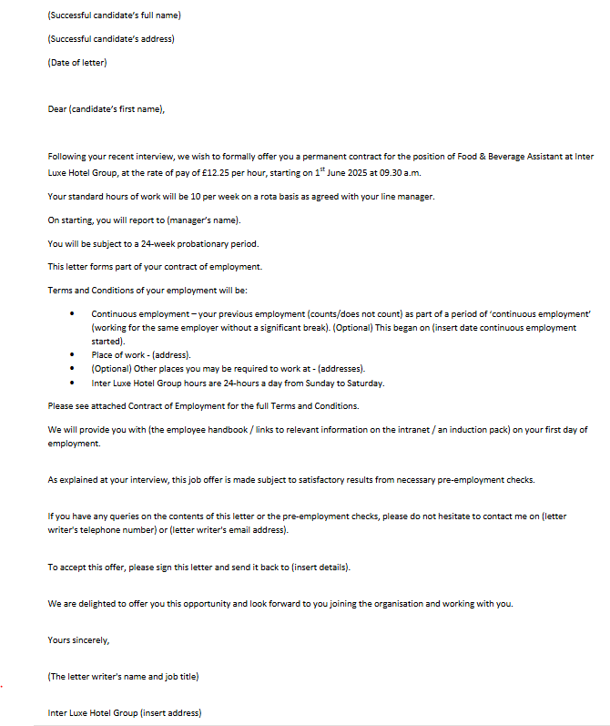

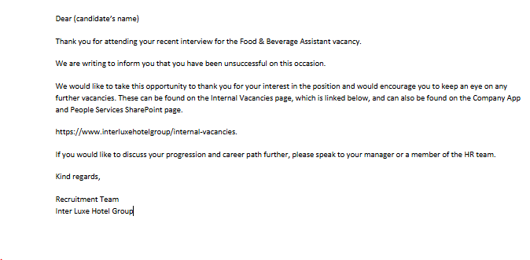
Bibliography

ACAS (2024) General Data Protection Regulation (GDPR). Available at: https:// www.acas.org.uk/archive/gdpr (Accessed: 17 April 2025).

CIPD (2024) Job Design. Available at: https:// www.cipd.org/uk/knowledge/factsheets/job-design-factsheet/#what-is-job-design (Accessed: 8 April 2025).

Graham, H. T. and Bennett, R. (1998) Human Resources Management. 9th edn. London: Pearson Professional Limited.

Harrison, R. (2022) Learning and Development. 3rd edn. Wiltshire: The Cromwell Press.

HR Grapevine (2025) People Director, Everflow – blind hiring at one of Europe’s fastest growing firms: episode 8 (Podcast). 16th April. Available at: https:// soundcloud.com/user-851225096/people-director-everflow-blind-hiring-at-one-of-europes-fastest-growing-firms?utm_source=www.hrgrapevine.com&utm_campaign=wtshare&utm_medium=widget&utm_content=https%253A%252F%252Fsoundcloud.com%252Fuser-851225096%252Fpeople-director-everflow-blind-hiring-at-one-of-europes-fastest-growing-firms. (Accessed: 17 April 2025).

Taylor, S. (2022a) Resourcing and Talent Management. 8th edn. London: Kogan Page.

Taylor, S. (2022b) Resourcing and Talent Management. 8th edn. London: Kogan Page.

Waite et al. (2021) People Practice a Complete Guide. 1st edn. London: Kogan Page.

Figure 1 is the Employee Lifecycle.

