Virtual delivery system

Student name: Doru-Sorin Stavru
ID Number: 1922008
Module Title: Project Management

Contents
Project Management; Virtual Delivery System Project 3
1. Project Initiation Document 3
1.1 Introduction 3
1.2 Project Scope 3
1.3 Project Assumptions 3
1.4 Project Organization Structure, Roles and Stakeholders 3
1.5 Project Delivery and Communication and Reporting Framework 4
1.6 Project Critical Success Factors 4
1.7 Benefits Realization 4
1.8 Project Constraints 4
2. Virtual Delivery System Project 4
2.1 Project Introduction 4
2.2 Project Scope; Goal, Objectives and Parameters 5
2.3 Project Assumptions 6
2.4 Project Organization; Structure, Roles and Stakeholders 7
2.5 Project Delivery; Communication and Reporting Frameworks 8
2.6 Project Critical Success Factors 9
2.7 Project Benefits 10
2.8 Project Constraints 11
References 12

Project Management; Virtual Delivery System Project

Project Initiation Document

Introduction
The primary objective is to develop a synchronous instructional virtual delivery hybrid system for the University of Wales Trinity Saint David (UWTSD), London campus, for February 2022. The system will enable students to transition smoothly from pure online delivery of lectures to a hybrid system where some students join online. In contrast, others come to the campus for face-to-face delivery.

Project Scope
The goal is to set up four Hyflex classrooms for about 25 students at each UWTSD level. Microsoft technology teams will set up classrooms by the end of January 2022 to promote hybrid learning. The technological components required for successful installation include computers, speakers, microphones, cameras and control panels with embedded HDMI and USB cables. The synchronous approach will enable students the flexibility to choose a learning path and improve engagement in real-time.

Project Assumptions
The estimated budget for the project is £200,000, including the purchase of technical resources and human resource acquisition costs. The budget projection may increase by about 10%, given unforeseeable circumstances. After successful installation by the end of January, students should be able to experience more flexibility and engagement in instructional learning by the end of the semester commencing February 2022.

Project Organization Structure, Roles and Stakeholders
Given the increasingly elaborate nature of the project, it is imperative to include internal and external stakeholders affected by the project. Internal stakeholders are university members, students, and the project team, while external stakeholders are the Microsoft Teams and state representatives.

Project Delivery and Communication and Reporting Framework
The institution owns the project through state sponsorship for about 100 students in each level for five levels. Communication and reporting will flow hierarchically from the school, state representatives and project manager to team leaders and members.

Project Critical Success Factors
Some of the project’s critical success factors include project mission, managerial support, communication and feedback, monitoring, troubleshooting, stakeholder involvement and risk management.

Benefits Realization
The central tenet of Hyflex classrooms is to promote flexibility in learning and choosing their learning paths. Still, the project aims to deliver student-centered learning, improve student engagement and interaction with university and collect formative and summative assessment data to promote course offerings.

Project Constraints
Some of the foreseen constraints are technical support and instructional difficulties in the event of failed collaborative frameworks.

Virtual Delivery System Project

Project Introduction
The coronavirus pandemic disrupted human and organizational ventures across the globe. Learning institutions resulted in innovative technologies to support rapid-learning recovery and reinstate critical stakeholders, especially students and university members. However, the transition to online-only modes causes self-regulated learning challenges for students and instructional difficulties for teachers leaving most stakeholders unsatisfied with learning (Kohnke and Moorhouse, 2021). The Hyflex classrooms approach is a best-practice alternative approach to fully online or offline studying to help UWTSD students switch to a hybrid system. The objective is to create a smooth transition such that some learners can join classroom sessions online while others come to campus for face-to-face delivery in preparation for full-time offline learning. The system will be implemented in January 2022 and kick off during the semester commencing in February 2022. The project team will evaluate benefits realization after the end of the semester in June 2022.
Although Hyflex classrooms have been around for over a decade, their application has become more prevalent during the onset of the post-Covid era. As a hybrid system incorporating online and offline learning, the model allows students to participate either fully online or physically in the classroom (Verrecchia and McGlinchey, 2021). In UWTSD, one classroom ideally accommodates about 25 to 30 students, but due to social distancing regulations, protocols only allow for about 15 students in the physical classroom. Hyflex classrooms will allow students to join classrooms online or physically simultaneously in real-time hence promoting content delivery and progressive learning. Videoconferencing software and tools will support synchronous lessons before students return to full face-to-face delivery (Kohnke and Moorhouse, 2021). Communication and reporting frameworks will be established to support effective project management.

Project Scope; Goal, Objectives and Parameters
UWTSD has about 100 students at each level; hence each classroom will accommodate about 25 students. About 10-15 students will come to campus for face-to-face delivery, and the rest will join online. The end goal is to create satisfactory outcomes for learners and lecturers while preparing for full traditional physical instructional learning next semester. The central tenet of this hybrid system is to enhance learning efficiency while increasing socialization opportunities with digitally enhanced teaching features (Singh, Steele, and Singh, 2021). However, the unique distinction of the hyflex classrooms is that course offerings can be accessed in classrooms or online, giving students the autonomy to choose ideal learning paths flexibly. The interactions will be synchronous using real-time meetings, thereby attaining the objectives of student-centered teaching, more interactive opportunities with faculty members and feedback on formative and summative assessment techniques (Singh, Steele, and Singh, 2021).
Technological innovations are particularly critical in hybrid learning models. A Microsoft Teams technology will be brought in to support the standard configuration of Hyflex teaching in physical lecturer halls. The team will participate in setting up and training internal and external stakeholders on videoconferencing software, visual collaboration tools like digital noticeboards, student response systems and platforms for asking and responding to queries (Kohnke and Moorhouse, 2021). The Microsoft Team’s primary task is to implement and support the institution’s leverage of technological affordances to increase student-centered teaching and provide learners with more opportunities to interact with teachers, collaborate with peers and reflect on course offerings. A virtual delivery system is an evidence-based approach combining the best offline and online teaching worlds to offer more engaging and effective learning experiences (Singh, Steele, and Singh, 2021).

Project Assumptions
Human and technical resources are required to complete the virtual delivery system project. The project’s estimated total cost is £200,000 with a 10% increase likely margin. The technical resources needed include computers, speakers, microphones, cameras and control panels with embedded HDMI and USB cables. The Microsoft Teams forms part of the human resources to train and develop the faculty and students on how to carry out synchronous real-time learning. The project team will implement Microsoft-enabled videoconferencing software and tools and offer technical support throughout the semester. The budget also accounts for purchasing software and applications required to support learning and engagement. Hardware, software and storage tools for audio-visual presentation are necessary to facilitate a synchronous mode of interaction (Kohnke and Moorhouse, 2021).
Training and development will be critical for the success of this project for learners and teachers. For instance, using the Microsoft Teams platform requires learning to use various features to interact with lecturers and peers, post queries and access classroom content. University members must learn how to combine online applications and create audio-visual presentations for students. For instance, Google Docs enables teachers to post class materials, attendances, assessments, and assignments and respond to students’ questions. Google Docs must hence be used in collaboration with the Microsoft Teams platform during class sessions so seamless that students joining on-campus and online do not experience any variation in content delivery, quality and satisfaction (Kohnke and Moorhouse, 2021). The software and hardware used to support Hyflex classrooms should merge to create a sense of community, engagement, and successful interaction between teachers and learners.

Project Organization; Structure, Roles and Stakeholders
The relationship between stakeholders in this project is particularly elaborate given the varying needs of both internal and external parties. The power-interest matrix below indicates that different stakeholders have varying authority and interest levels in the project outcomes and will be managed differently. Different communication and reporting strategies will be employed for different stakeholders because their involvement forms a crucial part of successful project implementation. Additionally, students, learners, and the institution have varying expectations, especially regarding eliminating challenges posed by the online-only learning approach. The government has been keen to promote successful learning amidst the pandemic and forms part of the project sponsors. Consequently, state representatives have high authority and interest and should thus be managed closely (Moreno-Marimbaldo and Manso-Callejo, 2020).
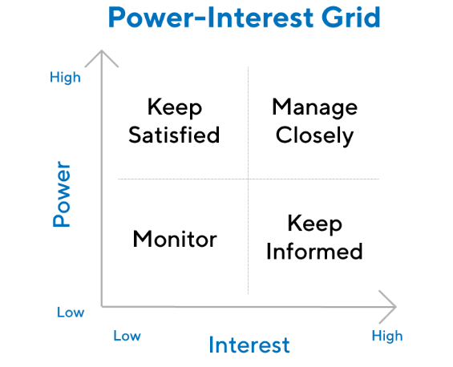
(Source: https://www.productplan.com/glossary/stakeholder-analysis/)
The end goals of the Microsoft team, students and the faculty vary, as do their power and interest in the project. The Microsoft Teams has the least power and interest in the project seeing as they are neither sponsors nor will not participate in the teaching activities. However, their activities will be monitored as they are responsible for implementation, training and development. The university has the highest interest in the project as they are responsible for content preparation and delivery. Successful learning depends on how well Hyflex classrooms will enable lecturers to teach, and they must be kept informed at every implementation phase. On the other hand, students have high power as they are the project’s target audience and should remain informed on how the project will aid and improve their learning processes and outcomes (Moreno-Marimbaldo and Manso-Callejo, 2020).

Project Delivery; Communication and Reporting Frameworks
Student attraction and retention in the post-Covid era are becoming increasingly critical for the long-term success of the traditional university models. Online learning changed the perspective of teachers and learners, and universities must be able to compete in the rapidly shifting educational landscape, particularly due to digital technologies (Bashir et al., 2021). This project aims to promote learning and course offerings at UWTSD as supported through effective communication and feedback. The project hierarchy to de adhere to in communication is as depicted below. The structural delivery of the project entails varying roles and responsibilities aimed at completing a common goal. The institution is the overarching project owner and manages most project aspects from sponsorship, teams and delivery.
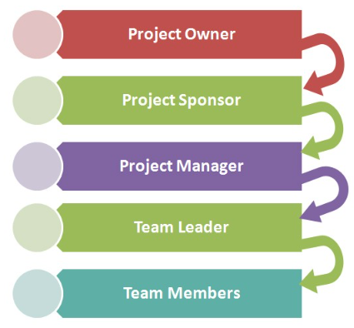
(Source: https://www.hierarchystructure.com/project-management-hierarchy/)
Effective communication in the demonstrated project structure will support successful project completion. The Project Management Institute describes communication as a project’s lifeblood fulfilled in steps including identifying communication requirements, answering the 5Ws questions, identifying and accommodating enterprise and environmental factors and identifying the organizational process assets. The 5Ws detail why, what, when, where and who and are often used with the how question. In answering these questions, team members can define the intention, source, message, channel, place, and timeline aspects of communication. Consequently, all stakeholder needs can be met efficiently to promote effective collaboration and team success. Enterprise and environmental factors also affect project success, and attributes like the urgency of information, diversity of teams, technology involved, and project staffing and timelines should be accounted for in delivery. In light of the project concept, communication and reporting should be online and face-to-face (Rajkumar, 2010).

Project Critical Success Factors
Different factors lead to the success and failure of projects depending on their influence on project success. The factors that bear the most substantial influence, as depicted below, are the critical success factors, and they vary from project to project. Different authors have identified and investigated varying success factors, and some, including the project mission, managerial support, communication and feedback, troubleshooting, stakeholder involvement and risk assessment, affect this project significantly. However, others have less substantial but small to the large impact that should also be paid attention to. Such include experience, management styles, motivation and meetings. The critical success factors should be prioritized as risk components whose impact and severity could be terminal to the project’s successful completion (Spalek, 2005).
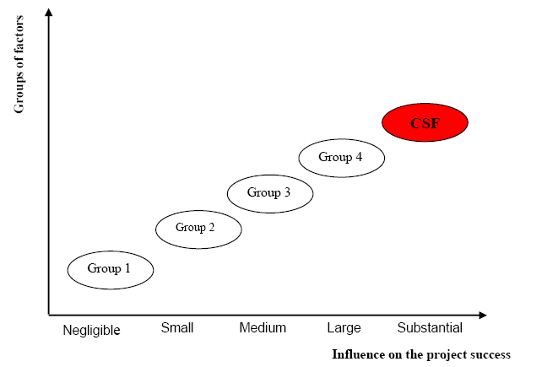
(Spalek, 2005)
The project’s critical success factors consider the nature of the project life cycle. Understanding the project mission is particularly important for all involved stakeholders. Scholars had raised awareness of the unmet needs of stakeholders in blended-learning approaches before the coronavirus pandemic (Alvarez, 2020). Accommodating such needs harmonizes the common objectives which form the project’s mission. Ultimately, government and universities want to ensure that students get flexible, student-centered, and satisfactory learning. However, university member needs like hardware for online learning were not always provided, impeding online-only learning approaches. With the COVID-19 pandemic, institutions had to adopt online teaching methods to fulfil mandatory social distancing regulations. All stakeholders must understand the project’s end goal, and managers must offer the required support and communication and feedback maintained at all levels. Risk assessment and troubleshooting must be robust and constant monitoring (Uluocak, 2013).

Project Benefits
Hyflex classrooms combine the benefits of hybrid learning with flexibility such that teaching designs accommodate students through integrated classroom and online-based components. One of the vital benefits that this project will help realize is supporting students in choosing learning paths that accommodate their needs, schedules and preferred outcomes (Verrecchia and McGlinchey, 2021). Such flexibility improves self-regulated learning because learners choose between in-person or online instruction in real-time. The project is part of bettering future learning methods by filling literature gaps concerning students’ perception of offline or online only techniques that affect their motivation and satisfaction. Understanding student and university members’ perspectives and developing a suitable pedagogical approach to meet students’ needs, improve learning, and facilitate a return to traditional physical learning (Kohnke and Moorhouse, 2021).
The challenges of the raging coronavirus pandemic posed difficulties for higher learning institutions and impeded learning in diverse ways. Online learning was less optional and more mandatory in the wake of the virus’ spread, and students who struggled with accessing online learning experienced poor outcomes. Other students accessed online learning but received poor educational outcomes. Although face-to-face interactions primarily offer the best teaching and learning experiences, most students demonstrate a need for more flexibility in choosing their learning paths. Teaching is more effective when tailored to learners’ needs. Hyflex classrooms provide in-person interaction opportunities that build a sense of community, increase motivation, and increase engagement during content delivery. Additionally, hybrid learning allows universities to collect data on formative and summative assessments as part of strategically improving their product offerings (Singh, Steele, and Singh, 2021).

Project Constraints
Anticipating all future project events with certainty is nearly impossible. Even with a robust project plan, successful delivery still faces risks from unforeseen factors. Consequently, risk assessment and troubleshooting are critical success factors that help identify and eliminate blockages as they appear (Uluocak, 2013). Technical support frameworks are a likely constraint. Even with the advent of digital technologies in all aspects of social organizations, not many people possess the required computer skills and resources to participate in Hyflex classrooms. Consequently, training and development will be crucial to eliminate technical support challenges. For instance, loss of power or connectivity can interrupt learning and provoke negative attitudes among learners and teachers who already support fully online or offline learning.
Different mediums of instruction have different techniques and outcomes, and lecturers and students refer to different reasons for preferring one over the other. Instructional difficulties can be a constraint in Hyflex classrooms where teachers struggle with remaining attentive to the needs of students attending in class and from remote locations. For instance, it may be easier to respond to and engage students in physical classrooms than to have an exchange with students online. Such instructional difficulties can trigger resistance in different stakeholders. However, with adequate training and development, the benefits of Hyflex classrooms outweigh their less desirable impacts (Boelens, Wever and Voet, 2017).

References
Alvarez, A.V., 2020. Learning from the Problems and Challenges in Blended Learning: Basis
for Faculty Development and Program Enhancement. Asian Journal of Distance Education, vol. 15, no. 2, pp.112-132.
Bashir, A., Bashir, S., Rana, K., Lambert, P. and Vernallis, A., 2021. Post-COVID-19
Adaptations; the Shifts Towards Online Learning, Hybrid Course Delivery and the Implications for Biosciences Courses in the Higher Education Setting. In Frontiers in Education (p. 310). Frontiers.
Boelens, R., De Wever, B. and Voet, M., 2017. Four key challenges to the design of blended
learning: A systematic literature review. Educational Research Review, vol. 22, pp.1-18.
Kohnke, L. and Moorhouse, B.L., 2021. Adopting Hyflex in higher education in response to
COVID-19: students’ perspectives. Open Learning: The Journal of Open, Distance and e-Learning, vol. 36, no. 3, pp.231-244.
Moreno-Marimbaldo, F.J. and Manso-Callejo, M.Á., 2020. Methodological Approach to
Incorporate the Involve of Stakeholders in the Geodesign Workflow of Transmission Line Projects. ISPRS International Journal of Geo-Information, vol. 9, no. 3, p.178.
Rajkumar, S., 2010. Art of communication in project management. Paper presented at PMI®
Research Conference: Defining the Future of Project Management, Washington, DC. Newtown Square, PA: Project Management Institute.
Singh, J., Steele, K. and Singh, L., 2021. Combining the Best of Online and Face-to-Face
Learning: Hybrid and Blended Learning Approach for COVID-19, Post Vaccine, & Post-Pandemic World. Journal of Educational Technology Systems, vol. 50, no. 2, pp.140-171.
Spalek, S., 2005. Critical success factors in project management. To fail or not to fail, that is
the question! Paper presented at PMI® Global Congress 2005—EMEA, Edinburgh, Scotland. Newtown Square, PA: Project Management Institute.
Uluocak, B., 2013. Critical success factors (CSFs) affecting project performance in the Turkish
IT sector. Paper presented at PMI® Global Congress 2013—EMEA, Istanbul, Turkey. Newtown Square, PA: Project Management Institute.
Verrecchia, P. J. and McGlinchey, M.J., 2021. Teaching During Covid: The Effectiveness of the
Hyflex Classroom in a 300 Level Statistics Class. Journal of Education and Training Studies, vol. 9, no. 3, pp.23-27.

