

Design of a Prototype Bicycle Computer

BEng Electrical & Electronic Engineering
ACDA5002 – Electronics 1

Prepared by:
Mr Aaron Hillam
P141233

Submitted to:
Mr Gareth Jones
School of Computing
19/07/2021

Abstract
This report explores the designs of a bicycle computer, with the intention of designing an improved prototype bicycle computer. The research provides much insight into the current designs, features and demands of the consumer. It has been identified that additional features can be added with the intention of improving the overall performance and posture. This can be accomplished by collecting and displaying additional data, which the consumer can use to improve their posture and performance. The prototype design provides innovative possibilities for improved functionality. However, due to the limitations of the software package used, some features have been neglected. As such, these are yet to be added to the final design.

Declaration
‘This report is the result of the author’s original research. It has been composed by the author and has not been previously submitted for examination which has led to the award of a degree.’

Signed: Mr A. Hillam Date: 19/07/2021

Contents
1.0 Introduction 6
1.1 Wheel Performance 6
1.2 Brake Performance 6 1.3 Performance Monitoring 6
1.4 Cadence 7
1.5 Speed 7
1.6 Distance 7
1.7 Elapsed Time 7
1.8 Current Time 7
1.9 GPS 7
1.10 Weather Information 8
1.11 Heart Rate / Calorie Counter 8
1.12 Strava Compatibility 8
1.13 User Friendly 8
1.14 Specifications 8
2.0 Block Design 9
2.1 Circuit Design 10
2.2 Pseudocode 12
3.0 Discussion 14
4.0 Conclusion 15
5.0 Reference 16

Figures and Tables
Figure 1: Block Diagram 9
Figure 2: Circuit Diagram 10

- Introduction
A bicycle computer is a product designed to help cyclists to monitor their performance, during their journeys. As standard, these computers include: The current average speed, the total distance covered, elapsed time, the current time. There are non-standard features which vary for each bicycle computer. which include: a GPS, cadence, maximum speed, weather information, heart rate, calorie counter and Strava compatibility. This report focuses on an innovative prototype design of a bicycle computer. In addition to the features listed above, the prototype will also include a gyroscope for the purpose of monitoring performance at varying inclines; a braking sensor, to monitor braking performance; a strain gauge to monitor wheel performance.
1.1 Wheel Performance
The effects on the bicycle wheel influences the overall riding experience and can result in premature damage to the bike. The intention of the wheel performance monitor is to inform the cyclist of how the environment influences the journey, this can include riding over potholes, sharp inclines / declines, jumping on or off of curbs, harsh braking and the stress/strain caused by high velocities. [1] [2] [3] [4]

By monitoring the wheel performance, the cyclist can prevent the need to replace components and make an informed decision regarding the terrain they intend to traverse. [1] [2] [3] [4]

1.2 Brake Performance
The monitoring of the braking performance falls in line with the wheel performance. Quick / harsh braking can result in fast degradation of the brake pads, added pressure to the wheels and tyres. By providing this information to the rider, they can make an informed decision to help improve their overall riding performance. [1] [2] [3] [4]

1.3 Performance Monitoring
For professional and hobbyist cyclists, performance is of high value. By providing performance data to the rider, it will enable them to understand where they can improve. Correct posture affects all physical activities. However, this is not currently an available option to monitor. By applying a gyroscopic feature, it will enable the rider to understand how their posture is changing during the ride. If the rider tends to place more weight forward or to the rear during certain inclines or shift more weight to one side than the other. Whilst this data is neglected, riders can be at risk of injury, strains and poor performance. [1] [2] [3] [4]
1.4 Cadence
Cadence is a rhythm that enables harmonisation. With respect to cyclists, cadence is monitored by the number of revolutions the bicycle pedal undergoes within a minute. Once the base cadence for an individual has been established, any significant changes to that base cadence, can inform the rider that they may need to adjust their cycling performance, which may include the increase or decrease of gears. The core principle of this feature is to inform on the riding performance. [1] [2] [3] [4]

1.5 Speed
The speed / current velocity provides the rider with an understanding of how fast they are traversing the current terrain, this is important to improving the performance during the journey. [1] [2] [3] [4]

1.6 Distance
The distance enables the rider to track their progress through the journey. In addition, the distance travelled is also used in the calculation of speed and the GPS. [1] [2] [3] [4]

1.7 Elapsed Time
Elapsed time is a method of planning the time it should take to complete a journey, or it can be used to monitor how long a journey has taken to complete (planned journey vs actual journey). This is useful for riders to understand their overall performance when attempting to meet a certain goal. [1] [2] [3] [4]

1.8 Current Time
The current time is essential for many functions, which include: braking performance; posture performance; cadence; speed; distance; elapsed time; GPS; Weather Information; heart rate / calorie counter. Much of the data which informs the rider, for the purpose of performance, is reliant on this factor. [1] [2] [3] [4]

1.9 GPS
The GPS is an advanced feature for bicycle computers. The feature enables the rider to track their location, their journey; obtain live updates that may affect the intended route and provide trackable data to Strava. [1] [2] [3] [4]

1.10 Weather Information
Weather information in a novelty feature, which provides a rider with live updates regarding the weather in their current area. This enables the rider to make informed decisions regarding potential routes and terrains prior and during the journey. [1] [2] [3] [4]

1.11 Heart Rate / Calorie Counter
The feature of monitoring the heart rate is a trend which increases throughout many sporting activities. This feature enables the rider to monitor their progress and focus in specific areas such as cardiovascular by riding at a high cadence, or by focusing on muscle growth with a low cadence. In addition, the heart rate monitor provides a health safety feature, which is essential for novice riders. [1] [2] [3] [4]

1.12 Strava Compatibility
Strava is a social media website, which is focused toward sporting activities, including cycling. Strava enables members to upload data from their journeys, track/monitor and share experiences. The data can be used collectively to benefit likeminded members who will benefit from the information. Strava is also used as a hub of sporting events and activities, providing a social aspect, group interactions and competitiveness. Strava compatibility is a feature that reassures quality data collection and simplifies the process of uploading and downloading data, to and from Strava. [5]

1.13 User Friendly
Although there are many features and new trends available. The primary specification required by a cyclist is the ability to read and interact with the computer with easer and haste. Cyclists conform to an objective time frame and route. As such, a single push of a button is required to reduce any interruptions to the activity. [1] [2] [3] [4] [5]
1.14 Specifications
Cycling places riders and the computers in many terrains, environments and weather conditions. As such, the computer must be compact and compatible to be attached to the handlebar; be resistant to shock/impacts, humidity, heat, UV, rain, water, dust/debris; hold enough charge to ensure the completion of the full journey and the upload of the activity. [1] [2] [3] [4]

2.0 Block Design
Figure 1 depicts the proposed circuit design through the use of block components. In principle, the pic is at the heart of processing the various input circuits and transferring the processed instructions to the relevant output circuits. The input circuit includes any hardware required for the collection of data needed in calculating the output variables. The output circuit consists of any hardware and software required for computing and displaying various aspects of data, which will be required by the rider. The flash memory, LCD display and GPS will be discreet components interfaced directly with the pic with the purpose of influencing the output data. The battery supply will have two target to charge. The pic which in turn will power the LCD display, flash memory and access the GPS and WIFI. The secondary target is the input hardware required for operating and generating the intended output data. [2] [6] [7] [8] [9] [10]

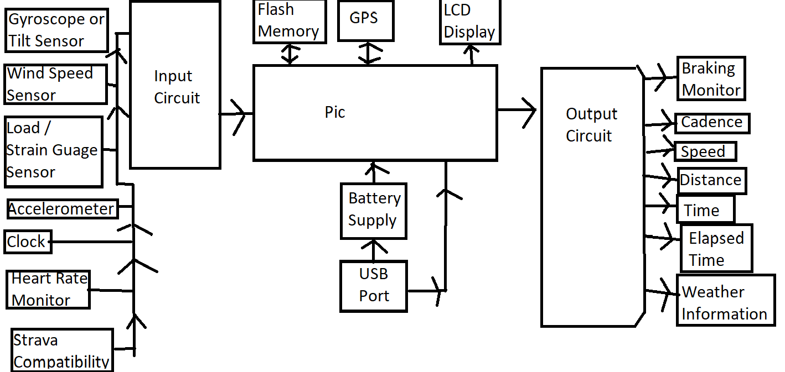
WIFI
Figure 1: Block Diagram

2.1 Circuit Design

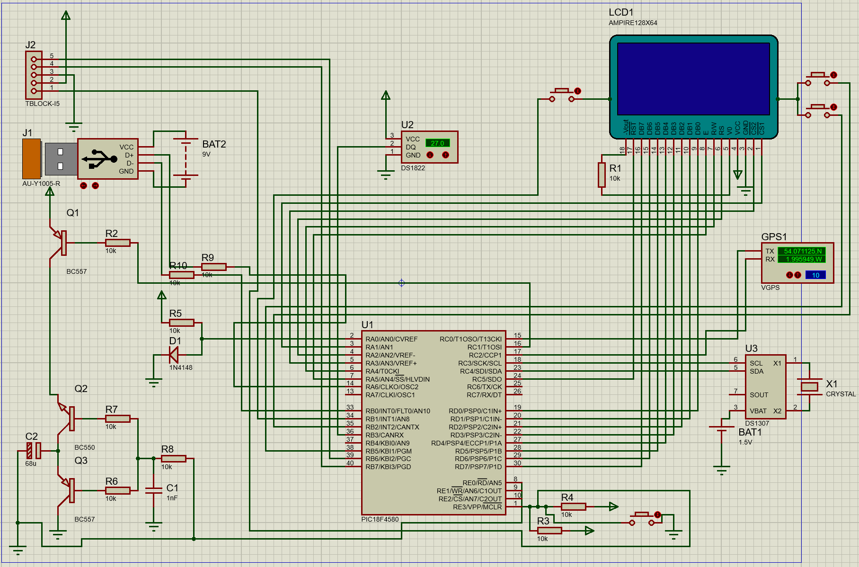
Figure 2 depicts a prototype circuit diagram of a bicycle computer. The microcontroller PIC18F4580 has been selected as an appropriate component, for the purpose of hosting the vast range of inputs and outputs. Although there are some ports still available, these are a technical redundancy, due to certain aspects of the software package being unavailable. Thus, the few ports are left unused. [2] [6] [7] [8] [9] [10]

For the purpose of displaying information. The Ampire128X64 screen has been selected. This component hosts 8 digital input ports which are used for the accumulation of various data from the PIC. In addition, the screen also has additional ports for the integration of buttons for the purpose of modifying the selected data displayed. [2] [6] [7] [8] [9] [10]

A GPS module has been added for the purpose of displaying live data and tracking of the cycling journey. In addition, the GPS supports the display of weather information within the vicinity of the rider. [2] [6] [7] [8] [9] [10]

Section U3, is the build of a real time clock, which is used to display and calculate the actual time, the cadence, speed/velocity, and distance. [2] [6] [7] [8] [9] [10]

Section U2 is a digital thermometer setup, this further complements the weather conditions and compliments the tracking of the riders physical condition. [2] [6] [7] [8] [9] [10]

Section J1, is a USB connected to a rechargeable battery pack (recharging modules unavailable), in addition the USB interfaces directly with the microcontroller. [2] [6] [7] [8] [9] [10]
Sections Q2 and Q3 focus on power regulation and protection to the circuit. [2] [6] [7] [8] [9] [10]

2.2 Pseudocode

: Power button on.
: Pic is powered on.
: GPS is powered on.
: WIFI is powered on.
: LCD display is powered on.
: Clock set.
: Memory Accessed / processed.
: Strain gauge calibrated.
: Gyroscope calibrated.
: Heart rate monitor calibrated.
: If all primary hardware is powered and all calibrations are complete; proceed to call starting data.
: Set speed to 0.
: Display speed.
: Set distance to 0.
: Display Distance.
: Set Cadence to 0.
: Display Cadence.
: Set Elapsed time to 0.
: Display Elapsed time.
: Display Remaining Power.
: Display brake monitor.
: Display Weather monitor.
: Display Heart Rate monitor.
: Request user input elapsed time
: apply user input to elapsed time.
: Display elapsed time.
: Request user input GPS destination / journey.
: Apply user input to GPS.
: Display GPS Journey.

3.0 Discussion
This report explores the designs of a bicycle computer, with the intention of designing an improved prototype bicycle computer. The research provides much insight into the current designs, features and demands of the consumer. It has been identified that additional features can be added with the intention of improving the overall performance and posture of the rider. This can be accomplished by collecting and displaying additional data, which the consumer can use to improve their posture and performance.
The prototype design provides innovative possibilities for improved functionality and benefit to the rider. However, due to the limitations of the software package used, some features have been neglected. As such, these are yet to be added to the final design.
An innovative method involves the monitoring of braking performance. This can be accomplished by applying a strain gauge to the wheel rim and the central spindle. As the rider brakes, the strain gauge will detect and display the rate of compression of the wheel. The harder the braking and the higher the moment will increase the rate of compression. Due to restrictions of the software, the strain gauge is not accessible.
A secondary innovation involves the monitoring of the rider’s posture. This can be accomplished by introducing a tilt monitor / gyroscope system. The gyroscope will be synchronised prior to use. As the rider places bias weight in a certain axis, the gyroscope will generate the data to inform the rider of the posture and how to improve. As further data is collected and correlated, an ideal posture performance will be identified as the base model. Due to restrictions of the software, the gyroscope / tilt monitor is not accessible.
Overall, the current design provides a strong foundation for the prototype. However, it still requires working progress to ensure it meets all of the requirements.
In addition to the brief’s requirements, the pseudocode is fairly brief and requires refinement and completion. However, there is enough present to provide a rough understanding of the functionality, which includes: powering the primary hardware units; calibrate all primary sensing units; power up secondary hardware units; compute the base data; display data. Upon this success, the software coding needs to be designed and tested prior to the completion of the prototype.

4.0 Conclusion
The research demonstrates a demand for bicycle computers and a competitive requirement of improve technology to benefit the sporting individual. It can be concluded that, in order to improve the riders experience, the data provided needs to be interpreted and displayed to the rider, with simplicity and ease.
Due to the environmental factors that the cyclist endures, equally the technology must endure them too. As such, the design must be resistant to most weather conditions, including raid, sun, wind / dust. An important factor to a cyclist is the power supply available. As the technology available within the bicycle computer increases, the power usage also increases. The creates a trade-off: increase the power supply, thus increase the bulkiness of the computer; or reduce what technology is available; or limit the use of each technology. As the demand for increased technology / improved performance takes priority, many cyclists are resorting to power banks, to counter the power consumption.
Based off the increased usage and popularity of Strava, it can be concluded that the demand for cycling equipment, including advanced cycling computers will increase for the foreseeable future. It shows that the top performers for cyclists do use to bicycle computers, thus a worthwhile investment.
Although the software used is limited for the intended circuit design, much of it has been completed. The circuit demonstrates functionality, innovation and the potential for further improvement. It can also be concluded that the design will be satisfactory for a prototype design. Thusly, it is likely that cyclists who are interested in purchasing a bicycle computer would find this innovative approach a worthwhile investment.

5.0 References

[1] | A. Baker, Bicycling Medicine Cycling Nutrition, Physiology, Injury Prevention and Treatment For Riders of All Levels, New York: Simon & Schuster, 1998.
[2] | J. Avison, The World of Physics, Second ed., Middlesbrough: Nelson, 2014.
[3] | T. Schneider, Triathlon Revolution, Seattle: Mountaineers Books, 2008.
[4] | M. P. Tom Hammell, Best Bike Rides Philadelphia, Guilford: Falcon Guides, 2012.
[5] | Strava, “Strava,” 2021. [Online]. Available: https://www.strava.com/. [Accessed 17 07 2021].
[6] | P. Horowitz and W. Hill, The Art of Electronics, New York: Cambridge University Press, 2015.
[7] | E. O. Hwang, Digital Logic and Microprocessor Design with Interfacing, Riverside: Cengage Learning, 2016.
[8] | N. Kularatna, Electronic Circuit Design, Boca Raton: CRC Press, 2008.
[9] | P. Simon, Electrochemical Capacitors and Hybrid Power Batteries 2008, Electrochemical Society, 2008.
[10] | M. Thompson, Intuitive Analog Circuit Design, Elsevier Science, 2013.
[11] | E. Burke, High-tech Cycling, Campaign: Human Kinetics, 2003.
[12] | D. Boyce, Engineering, Lulu.com, 2018.
[13] | N. S. Sutil, Motion and Representation The Language of Human Movement, MIT Press, 2015.

