Name: Nicoleta Briceag
Student number: 1914033
Module: LCBB4005 The Global Business Environment
Assignment 2: Electric Car Industry - Tesla
Lecturer: Syed Jaffery

Table of Contents
Introduction 3
Background to the organisation 3
Application of Porter’s value chain 3
Conclusion 8
Appendix: PESTEL analysis of electric vehicle industry 9
Reference List 10

Introduction
The electric car industry has been growing rapidly over the past few years, specifically in the last decade. Traditionally, cars had internal combustion engines, also referred to as ICEs, and while these were available easily and hence affordable, the long-term impact has always been hazardous since these vehicles used fossil fuels to function, thereby contributing to massive levels of air pollution. As a solution to this, electric cars were proposed, which are run with the help of rechargeable batteries that typically source their power from alternative energy supply, such as solar or hydroelectric. Electric cars have been specifically chosen for this assignment since they are clean and easy on the environment, thereby paving the way towards sustainable development. The Porter's value chain analysis as utilised in this essay shall also be helpful in analysing the various functions that the chosen company, Tesla, participates in while analysing the manner in which the organisation can deliver the maximum possible value while incurring the least levels of costs.

Background to the organisation
Tesla is an American electric vehicle company based in California. Alongside cars, the company has been currently venturing into alternative energy solutions as well, such as solar panels and solar roofing (Tesla, 2020). In fact, as Wagner (2020a) reports, Tesla’s Model 3 is among the best-selling electric car models in the plug-in vehicle category, accounting for nearly 80 per cent of the company’s sales. In 2019, Tesla’s revenue was at an all-time high at $24.5 billion (Wagner, 2020b), and due to the unprecedented success, the company has been spending more than ever on the Model 3 design, including a land purchase in China where the electric vehicle giant seeks to construct a new factory for increasing the production.

Application of Porter’s value chain
Value chain analysis is essentially a concept in business management that refers to those activities that an organisation undertakes to ensure that it can create value for the customers (Porter and Kramer, 2019). This new value that is added or created also increases the profitability levels of the company in the process. Porter’s value chain analysis as a concept is a strong approach since it allows marketers and researchers to be focused on the various activities and systems that are essentially centred on the customer instead of the business departments and other elements. This framework also links the various activities to one another and gives a good idea of how the profit and costs would be impacted, thereby making it easy to understand the source of loss and the source of value right within the organisation (Zhang and Gregory, 2011).
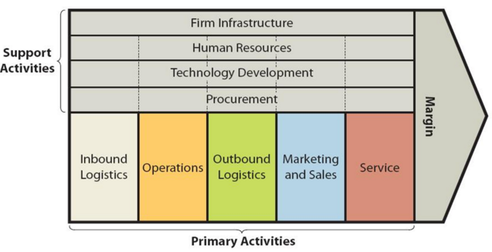
Figure 1: Porter’s value chain

Porter’s value chain framework has two categories of activities or elements, the primary and the support. While the primary activities can directly impact the maintenance, sales, production and the support systems of the services and products, the support activities make it convenient for the organisation to maintain its everyday activities, while creating value within the business. With regard to the electric car industry and its major player Tesla, the primary and the support elements of Porter's value chain approach can be further explained below.
Inbound logistics: This refers to those processes that are necessary for the reception, storage and the internal supply and allocation of the raw materials or the technical parts that are required for assembling a product or service (Simić, et al., 2015). This aspect takes into consideration the relationship that a company has with its suppliers. The current market trends indicate that the traditional car companies might be in a bit of a problem since most suppliers are suspending the production of the car parts that are used in internal combustion engines since the popularity of electric vehicles have increased manifold due to concerns over sustainability and pollution levels, as understood from the Appendix. This has made it easier for electric car manufacturers like Tesla to have access to quality suppliers who provide them with the required parts and components necessary for manufacturing the vehicles. Also, the company has numerous warehouses all over the US and also in countries such as Taiwan, and while these are leased facilities (Pratap, 2019), they are fundamental to allowing the company in carrying out its storage operations.
Production: These are those activities that deal with the final output or creation of the products and services by utilising the raw materials. The production processes are responsible for the conversion of these raw materials into the finished or semi-finish products, and the guiding principles lie in the organisation’s operational systems which help create value. The continuing developments and inventions in the field of electric cars have made it easier for companies like Tesla to cut down on their production costs, as indicated in the report by the Amsterdam Roundtables (2014), which suggests that the costs of manufacturing and procuring battery packs and various other car parts required for the manufacture of electric vehicles have reduced considerably, making it easier for the industry to incur profits (also see Appendix). Moreover, the charging equipment for the cars has also been further standardised, which once again encourages more buyers to invest in these vehicles. Tesla even plans to have dedicated charging points for its vehicles all across the US. Overall, the company has numerous production units on a global scale, and a new factory has come up even at Shanghai (Pratap, 2019), China, which would most likely stir up the market demand in the Asian region.
Outbound logistics: These are the activities that are concerned with the delivery of the finished products or services to the end-users in the concerned market space. They include but are not limited to, distribution, storage and transport systems (Hiremath, et al., 2013). The increasing popularity of electric cars indicates that once the demand reaches its peak, it will get significantly cheaper to distribute the vehicles across global markets since bulk shipping costs are relatively lesser as compared to the expenses associated with the shipment of just a small number of cars. Tesla currently supplies cars in the US, Mexico, Canada and Belgium. The facility in Fremont at California is one of the most important manufacturing hubs since it assembles the final products and conducts the end-of-line testing operations (Pratap, 2019). As already mentioned, the company owns warehouses all over the country, and they not only help with storage but also with the delivery operations once the products are manufactured.
Marketing and sales: These refer to those processes and activities that allow the product or the service to make a mark in the concerned markets, and also takes care of the customer relationship management functions. The most important factor that must be considered here is that the company needs to set itself apart from the competitors and create multiple advantages that would encourage the customer to choose them over others (Wang and Miao, 2015). Electric cars being a continuously developing industry have the urgent need to be pushed forward through appropriate and powerful marketing and sales initiatives. Companies such as Tesla often invest massively in the promotion of the products, so that the target consumers can get to know about their cars and learn about the benefits in order to make the best choice as per their requirements. The company has a massive network of galleries and stores which are all owned by Tesla directly. These not only act as the perfect outlets for the promotion of the cars but also allow for the collection of relevant consumer feedback (Pratap, 2019), which in turn helps the company to make relevant changes and modifications in their portfolio.
Service: This element includes the activities that help maintain the value of the services or the products that are being offered to the customers since they develop a relationship with the firm once they avail their goods. The market demand with respect to the electric vehicle industry has been increasing gradually, since people are becoming more aware of the repercussions of traditional vehicles, and therefore investing in the alternative options. Companies such as Tesla currently do have access to the resources which enable it to provide robust customer service to the existing as well as the prospective buyers. These activities, in turn, have added to the massive profit levels of the company, which have been clearly reflected in their annual revenues over the past few years (Wagner, I., 2020b).
Firm infrastructure: This support element refers to those activities within the organisation that help maintain the daily work and operations, including line management, financial management, and the administrative responsibilities since they help create value. Most companies within the electric car industry have very high-end facilities that help manufacture and assemble cars. At Tesla, the firm infrastructure is of two types – energy production, and the electric vehicle segments. The administrative decisions are made on the basis of the suggestions that Musk provides, while the CFO, Zachary Kirkhorn, is in charge of the finance and other departments (Pratap, 2019).
Human resource management: This support element includes the activities and functions that are concerned with the development of the employees and also the recruitment and selection of the necessary workforce members. Tesla had more than 45,000 employees at the beginning of 2018, and the number has since grown since the company is dependent majorly on the talent pool it has access to. This has made the HR department one of the most important areas of focus for the manufacturer since there is the urgent need to procure and retain the best kind of talent in order to maintain the topmost market position (Pratap, 2019). This not only allows Tesla to pave the way for more innovative ideas but also increases the overall competitive strength.
Technology development: The development of the technology that can help improve the products and services within a business organisation is important to support functions that impact the processes from both the internal and the external aspects. Optimisation and innovation are involved intricately when it comes to the development of new products (Ghaffari, et al., 2017). The electric car manufacturing industry has been growing at an unprecedented rate and has become increasingly competitive over the past few years. In case of Tesla, its competitors such as BMW, Nissan and Toyota have launched numerous electric and hybrid vehicles to counter their market growth, which has been possible mainly due to the rapid development of technology, as also understood from the Appendix.. In fact, Tesla has been at the helm of the research and development activities on a global scale, judging by the massive investments that the company has made in its R&D expenses (Pratap, 2019). This has essentially allowed the company to explore greater arenas and increase its attractiveness on a global scale, and it is currently the most valuable car company in the world (Klebnikov, 2020)
Procurement: This support activity helps businesses in numerous ways, starting from the finalisation of the deals with suppliers to managing customer service functions. Electric vehicle manufacturers are in the best possible market space right now, since a majority of the suppliers now are switching to providing only those components and car parts that are exclusive to electric vehicles over concerns regarding sustainability. In the case of Tesla, Panasonic has been one of the most noteworthy suppliers, especially for the battery cells (Pratap, 2019). Moreover, the company has been able to establish strong, profitable ties with not just the suppliers but also the customers, which has accounted for its rapid market growth and immense sales volume.
From this analysis, it is easy to understand that the costs associated with the procurement of raw materials and car parts for manufacturing electric vehicles are steadily decreasing, which benefits companies like Tesla massively. As suggested in the report by Amsterdam Roundtables (2014), any increase in the price of the raw materials with automatically fuel the recycling of the car components that have been discarded, which would then solve the issues with waste management. While the increasing popularity and adoption of electric cars can be helpful with reducing pollution, it must also be noted that additional sources of power, especially in public spaces, would become mandatory. The best part lies in the fact that the heavy reliance of the car industry on the highly polluting fossil fuels would decrease, thereby allowing for the reduction of greenhouse gas emissions, which would contribute to a cleaner, greener and more balanced earth.

Conclusion
This essay makes it evident that the various primary and support activities as demanded by any company in the electric car industry are successfully integrated by Tesla, which has allowed the company to become the market leaders in such a short period of time. On the basis of Porter's value chain analysis model, Tesla has been successful in building a robust collection of not just warehouses but also production units, not to mention the investments in the company's R&D sector. The value creation of the company lies in the fact that it is dedicated to serving the customers even after they have bought the cars, and they also recognise the need for a skilled workforce in order to nurture talent and innovation.

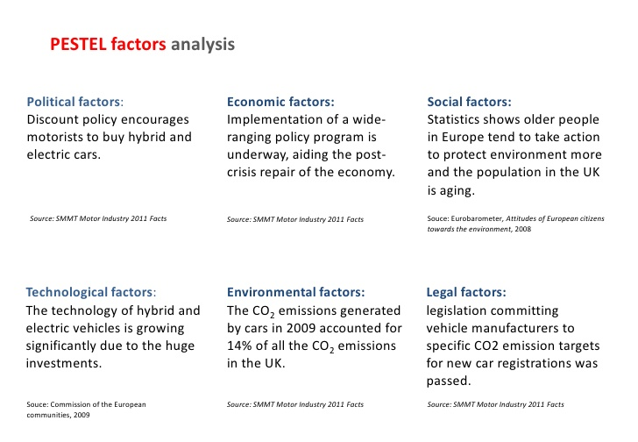
Appendix: PESTEL analysis of electric vehicle industry

Reference List
Amsterdam Roundtables, 2014. Electric vehicles in Europe: Gearing up for a new phase?. [pdf] Available at: <https://www.mckinsey.com/~/media/McKinsey/Locations/Europe%20and%20Middle%20East/Netherlands/Our%20Insights/Electric%20vehicles%20in%20Europe%20Gearing%20up%20for%20a%20new%20phase/Electric%20vehicles%20in%20Europe%20Gearing%20up%20for%20a%20new%20phase.ashx> [Accessed 23 July 2020].
Ghaffari, S., Arab, A., Nafari, J. and Manteghi, M., 2017. Investigation and evaluation of key success factors in technological innovation development based on BWM. Decision Science Letters, 6(3), pp.295-306.
Hiremath, N.C., Sahu, S. and Tiwari, M.K., 2013. Multi objective outbound logistics network design for a manufacturing supply chain. Journal of Intelligent Manufacturing, 24(6), pp.1071-1084.
Klebnikov, S., 2020. Tesla Is Now The World’s Most Valuable Car Company With A $208 Billion Valuation. [online] Forbes. Available at: <https://www.forbes.com/sites/sergeiklebnikov/2020/07/01/tesla-is-now-the-worlds-most-valuable-car-company-with-a-valuation-of-208-billion/#42e6cad05334> [Accessed 23 July 2020].
Porter, M.E. and Kramer, M.R., 2019. Creating shared value. In Managing sustainable business (pp. 323-346). Dordrecht: Springer.
Pratap, A., 2019. Tesla value chain analysis. [online] Medium. Available at: <https://medium.com/@abhijeetpratap/tesla-value-chain-analysis-f572c834fd39> [Accessed 23 July 2020].
Simić, D., Svirčević, V. and Simić, S., 2015. A hybrid evolutionary model for supplier assessment and selection in inbound logistics. Journal of Applied Logic, 13(2), pp.138-147.
Tesla, 2020. Solar for existing roofs. [online] Available at: <https://www.tesla.com/solarpanels> [Accessed 23 July 2020].
Wagner, I., 2020a. Tesla – Statistics & Facts. [online] Statista. Available at: <https://www.statista.com/topics/2086/tesla/#:~:text=Globally%2C%20Tesla's%20vehicle%20deliveries%20reached,leading%20producer%20of%20electric%20vehicles.&text=Tesla%20is%20expected%20to%20add,its%20ccurrently%20existing%20model%20lineup.> [Accessed 23 July 2020].
Wagner, I., 2020b. Tesla’s revenue from FY 2008 to 2019. [online] Statista. Available at: <https://www.statista.com/statistics/272120/revenue-of-tesla/> [Accessed 23 July 2020].
Wang, G. and Miao, C.F., 2015. Effects of sales force market orientation on creativity, innovation implementation, and sales performance. Journal of Business Research, 68(11), pp.2374-2382.
Zhang, Y. and Gregory, M., 2011. Managing global network operations along the engineering value chain. International Journal of Operations & Production Management, 31(7), pp.736-764.

