Targed/Target 1 | Be more tentative.
Targed/Target 2 | Check over for any spelling, punctuation and grammar mistakes.

Choose an intervention that supports the learning and development of a pupil/ group of pupils. Reflect critically on its potential for ensuring pupil progression and the possible challenges that may arise.

Throughout this assignment, the writer will choose an intervention that targets an area of learning and discuss how it supports the learning and development of a pupil. Also, a critical reflection on the potential for progression will be provided through identifying the benefits and possible limitations. An academic intervention can be described by Wright (2012) as a strategy used to aid in the improvement of a pupils’ learning or development within an educational setting. Similarly, Tassoni (2003) suggests that an intervention is put in place when a child’s needs are not being met within their current situation. An intervention supports the promotion of the UNCRC’s Rights of the Child Article 23, which is highlighted by the Children’s Commissioner for Wales (2020) as a right to special care and support to ensure that children lead a full and independent life.

Firstly, the intervention chosen for this assignment targets a nine-year-old male pupil, who is currently in a year four class within key stage 2 (KS2). This pupil, will be referred to as Child A throughout this assignment, has shown signs of social, emotional and behavioural difficulties (SEBD). Child A demonstrates outbursts of anger and defiance which results in violence, swearing and refusal to complete classroom tasks. Child A is currently being assessed by outside agencies, in order to determine if a diagnosis of SEBD is appropriate. Breen et al (2014) suggests that pupils with SEBD may fail to meet expectations in school and these difficulties may result from abuse, neglect, physical and mental illness and/ or psychological trauma. Therefore, outside agencies have suggested strategies and interventions that the school can try before diagnosis. This child has been identified as showing symptoms of attachment which is an aspect that plays a vital part in SEBD.
Attachment theory can be referred to as developmental trauma and described by Bretherton (1992) as the disruption of a child’s connection to their parents through separations, deprivation and bereavement. Similarly, Marshall (2014) described attachment as the separation from primary caregivers and the emotional attitudes of parents towards the children. Therefore, resulting in life-long struggles and life-shaping effects for the children who have experienced these. Child A has been identified as having avoidant and ambivalent attachment due to the types of behaviour being shown (see appendix 1). CCEA (2016) suggests that avoidant attachment behaviours stem from the caregiver rejecting the child by being withdrawn. Furthermore, they suggest that ambivalent attachment behaviours stem from the caregiver providing an inconsistent response to a child’s needs. Child A’s individual circumstances has affected his social, emotional and behavioural development, resulting in an intervention being put in place to aid in the progression of his development.
Secondly, the intervention chosen is a nurture group, which is described by Sloan et al (2016) as a short-term and focused intervention to address barriers to a child’s learning, that arise from unmet attachment needs. Nurture groups focus on children with SEBD, especially those with attachment difficulties. This intervention aids in the progression of the child’s social, emotional and behavioural development. A nurture group hopes to provide Child A with a positive attitude towards school, while being in a class with a smaller group of children (all of whom have been assessed at different stages) and two consistent, reliable adults. The ALNCO and both outside agencies believe that a nurture group will help Child A “develop strategies which help them to regulate their emotions” (Welsh Government, 2020a, p2).

During this part of the essay, the writer will; discuss how children learn and develop; define progression and identify the importance in regards to learning; provide a more in-depth look at the chosen intervention; and evaluate the intervention by identifying it’s benefits and possible limitations.

Firstly, children develop through a holistic approach. NEL (2019) suggests that holistic development should be recognised and valued in order to maximise a child’s potential, as it incorporates every aspect of a child’s development. Similarly, MoE (1996) suggests that holistic development encompasses all dimensions of children’s learning and development allowing teachers to see the child as a whole. This suggests that by looking at more than one area of development it allows teachers to gather a better picture of the child. Children develop in several ways, the main areas in which children develop are physically, emotionally, linguistically, cognitively, socially, spiritually and behaviourally. For this assignment, it will be discussed how children develop socially and emotionally while referring to Child A.

Furthermore, social and emotional development is described by UCI (2020) as the change over time in a child’s ability to react and interact with their social environment. There are many different areas of growth within social and emotional development, these are identified by UCI (2020) as, temperament, attachment, social skills/competence and emotion regulation. However, Smith (1982) believes there are five key themes regarding social and emotional development; affiliation and friendship; conflict and cooperation; and kindness and affection (fig 1.)

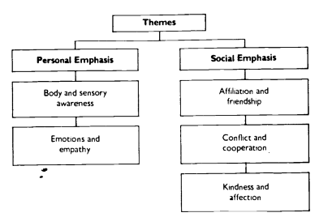
Fig.1

(Smith, 1982)

Given this, three common themes of social and emotional development have been identified such as, relationships, communication and the ability to understand and cope with one’s emotions. The main relationships children use when developing socially and emotionally are those with their parents, peers and teachers. Also, communication plays a vital role in a child’s social and emotional development, it is believed by Vygotsky that “children’s language was social in origin because it arose in interaction between the child and others” (Pound 2014, p52). Emotional regulation is the ability to understand and cope with one’s emotions. Pound (2014) suggests that emotions are they ignition switch for learning for everyone. In addition, children develop their social and emotional skills by interacting with others, their social environment and through language. Pound (2014) states that Vygotsky believed that social influences allow children to construct new understanding and conceptual insights. Therefore, putting social and emotional development at the heart of child development and learning.

Also, Erikson believes that children develop and learn through stages of psychosocial development (fig.2). McLeod (2018) states that each stage requires a psychosocial crisis to happen which either has a positive or negative outcome for a child’s psychosocial development, therefore affecting a child’s emotions. If a child has a negative outcome from one of these crisis’, it can affect the child throughout their life. In addition, fig.2 shows that the crisis that happens during stage one is ‘Trust vs Mistrust’. This crisis revolves around the consistency of care given to them by their primary caregiver. Therefore, McLeod (2018) suggests that if a child’s need does not get met consistently this can result in the child developing a mistrust, suspicion and anxiety towards present and future relationships. Similarly, stage one of Erikson’s psychosocial development (fig.1) can be related to John Bowlby’s attachment theory, as they both identify that if the needs of the child are not consistent, it could have a negative effect on the child.

Fig.2
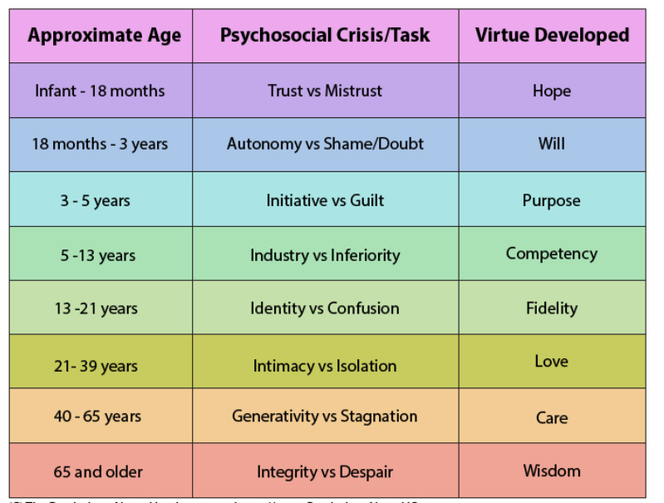

(Psychology Notes HQ)

Moreover, Child A’s social and emotional development has not developed at the same rate as his peers due to factors such as his attachment difficulties and behaviour. Therefore, he can come across to an unfamiliar face as immature for his age, but at the same time Child A’s development in other areas may exceed that of his peers. For example, physically he is very active during school time and outside of school, as he enjoys being outdoors.

Furthermore, children learn and develop new social and emotional skills throughout their time at primary school. Currently, these skills have been incorporated into the ‘Foundation Phase Framework’ and the ‘Personal and social education framework for 7 to 19-year olds’ in Wales.

Children from the age of three to seven develop their social and emotional skills through the Personal and Social Development, Well-being and Cultural Diversity area of learning from the Foundation Phase framework. However, the skills within this area of learning are being developed through all seven areas of the Foundation Phase (FPh). Welsh Government (2015) agree stating that these skills are developed across all Areas of Learning through participation in experiential learning activities. In addition, the personal and social development, well-being and cultural diversity area of learning plays a vital role in the FPh. Welsh Government (2015) state that these skills are at the heart of the FPh. This suggests that while creating the FPh, it was important that a child’s personal, social, emotional and well-being were taken into consideration from the first instance. Also, Welsh Government (2015) believe that when children leave the FPh and move on to KS2, they should have already learnt about themselves and their relationships with others, while beginning to express their feelings and empathise with others.

Similarly, to the FPh, pupils from the ages of seven to nine-teen develop their social and emotional skills through the ‘Personal and social education framework for 7 to 19-year-olds in Wales’. Welsh Assembly Government (2008) suggests that this subject specific framework prepares learners to be personally and socially effective, while exploring their personal attitudes and values. The framework highlights five key themes which pupils will develop; active citizenship; health and emotional well-being; moral and spiritual development; preparing for lifelong learning; and sustainable development and global citizenship. Welsh Assembly Government (2008) implies that this framework builds upon the Personal and social development, well-being and cultural diversity area of learning from the FPh.

However, Donaldson (2015) suggests that the improvement of health and well-being was an important part of curriculum reform in Wales. Since the development of Curriculum for Wales 2022, Health and Well-being has been highlighted as one of the six ‘Areas of Learning and Experience’ (AOLE). Welsh Government (2020b) states that the Health and Well-being AOLE will provide a holistic structure for understanding health and well-being, and that engagements with this AOLE will help develop a whole-school approach to pupils’ health and well-being. Children from the ages of three to fourteen will develop their social and emotional skills through this AOLE’s ‘What Matters Statements’. Welsh Government (2020c) incorporates; physical health and well-being; mental health and emotional well-being; decision making; engaging with social influences; and healthy relationships into the Health and Well-being ‘What Matters Statements’.

In addition, it is important to remember that children do not learn or develop at the same age or stage as their peers. Kim and Care (2018) agree stating that not all learning develops in a predictable linear pathway. Similarly, this statement is echoed by the Welsh Government (2020e) as they suggest that a pupil’s learning may take place at different rates and times than their peers.

Furthermore, progression in a child’s learning is described by Popham (2007) as a sequence of building blocks that pupils must master, which include skills and knowledge in different curriculum subjects. Similarly, Kim and Care (2018) agree stating that progression happens when complex skills are built upon foundational skills. However, Welsh Government (2020d) argues that progression is a process of increasing sophistication, rather than being about a body of content. This statement is echoed by Mosher (2011), stating that progression allows children to become more sophisticated. Progression in a classroom setting is usually assessed by the class teacher in order to influence their planning. Heritage (2008) suggests that progressions can provide the clarity teachers need in order to plan their lessons. Welsh Government (2020d) agree stating that progression supports the teaching and learning of pupils, while informing curriculum design. It is important that teachers can identify where the children are within their learning in order to support future learning and development. Welsh Assembly Government (2010a) suggest that teachers must have a sound knowledge of progression routes to move learners towards the achievement of concepts and skills. Again, Welsh Government (2020d) echoes that progression can support pupils’ continued progress throughout their learning. Therefore, implying that a teacher’s knowledge of progression has been an important factor to teaching and learning in Wales for over ten years.

In recent years, Estyn (2012) stated that planning for progression in Wales was weak. This suggests that progression was not an important aspect for schools to consider, as they focused more on the teaching of content rather than assessing progression. This resulted in progression becoming a vital part within the Curriculum for Wales 2022. Donaldson (2015) suggested that one of the criteria for curriculum structure for the future was to promote progression in children and young people’s learning. This recommendation influenced the design of Curriculum for Wales 2022 as progression has been incorporated into each AOLE. Welsh Government (2020d) highlights that one of their key principles of Curriculum for Wales 2022, is to ensure that the purpose of assessment is to support the progression of pupils’ learning from the ages of three to sixteen. In addition, progression within Curriculum for Wales 2022 is an important characteristic as pupils will develop their learning through each AOLE’s what matter statements. Welsh Government (2020d) agree stating that the AOLE’s statements of what matters are the basis of pupil progression.

Moreover, the nurture group intervention chosen for this assignment will support the ‘Health and Well-being’ AOLE from Curriculum for Wales 2022. Progression within this AOLE is measured differently than the others, as there are several factors that can have an impact on the timescale of learning. Welsh Government (2020e) states that a pupil’s personal concerns, interests and circumstances could have an impact on the pathway in which pupils progress, making progression within Health and Well-being non-linear. This shows that personal aspects as well as background of a child’s life will have an influence in their progression. Progression within Health and Well-being are linked to the ‘what matters statements’ as they focus on developing different aspects of a child’s personality. Welsh Government (2020e) suggests that the health and well-being ‘What Matters Statements’ focus on developing pupils’ appreciation and understanding of making informed decisions with their physical, emotional and mental health and well-being.

In addition, within each AOLE there are steps of progression which allow teachers to assess children’s learning and aid in the planning of lessons. These progression steps include the learning of foundational skills which are then built upon in later years. Welsh Government (2020e) states that the initial progression step will focus on the awareness and recognition of personal, physical, emotional and social skills and will move towards more accuracy and mastery of these skills in future years. These steps of progression have been introduced to allow children to build on prior knowledge and hopefully understand all aspects of health and well-being. Welsh Government (2020e) agree with this statement as they believe that pupils will become more sophisticated, and effectively identify and balance some of the tensions that exist. This shows that progression within health and well-being is important, as it allows children to develop holistically and make better life choices and decisions.

Nurture groups originated in 1969 by an educational psychologist: Marjorie Boxall. Boxall (2002) describes nurture groups as an in-school intervention for children whose social, emotional and behavioural learning and development cannot be met in mainstream classes. Hasakayne, Rose and Bennathan (2009) suggest that nurture groups were started as large numbers of children were entering school with severe emotional, social and behavioural difficulties. The rise in children with SEBD meant that children would be removed from mainstream schools and sent to pupil referral units. Hasakayne, Rose and Bennathan (2009) states that Boxall identified these difficulties as an outcome of impoverished early nurturing. This implies that impoverished early nurturing could be referred to a child’s early childhood experiences and their relationships to the primary caregiver, commonly known as attachment. Bennathan and Boxall (1996) agree, stating that these children lived in overburdened and fragmented families where relationships were eroded.

Furthermore, Hasakayne, Rose and Bennathan (2009) states that the aim of a nurture group is to provide a structured day, where there is a balance of teaching and learning, and affection and structure within a home-like environment. In order to achieve this aim, nurture groups try to; support the learning of a child depending on their stage of development; offer a safe place where children feel comfortable and secure; develop children’s self-esteem; develop language skills; identify behaviours and reasons for them; and show children the importance of transition. Hasakayne, Rose and Bennathan (2009) agree by highlighting the six principles of nurture groups as; children’s learning is understood developmentally; the classroom offers a safe base; the development of self-esteem; language is an important part of communication; all behaviour is communicated; and the importance of transitions.

Additionally, nurture groups use Maslow’s hierarchy of needs (fig.3) in order to gain an understanding of which basic needs must be met. Therefore, establishing the foundational needs of a child’s development. As shown in fig.3, there are five stages, which are based on each need. The hierarchy provides teachers with the ability to identify which stage each child is at and therefore, motivate the child to meet the next stage. Once children have met each of the needs, hopefully they become motivated to be the best person they can be. Similarly, McLeod (2020) suggests that once the growth needs have been satisfied, a child is then able to reach the highest level: self-actualization.

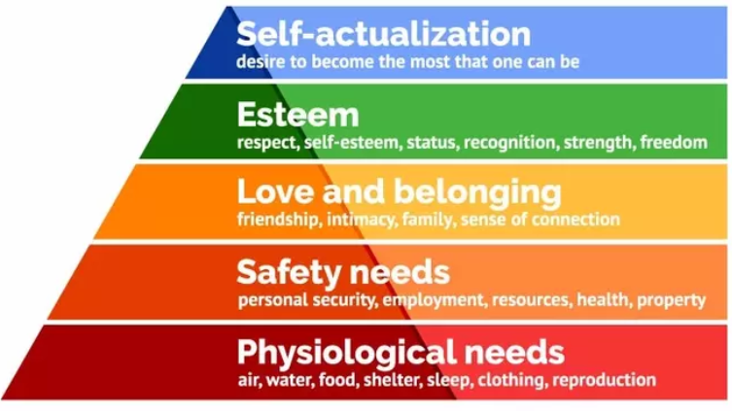
Fig.3

(McLeod, 2020)

Moreover, before the nurture group commences it is important to assess the child’s areas of difficulty, in order to provide a structured and effective intervention that meets the needs of the learners that attend. The ‘Boxall Profile’ was created to assess the areas of difficulty for each child. These areas of difficulty are divided into two sections: Developmental Strands and a Diagnostic Profile. Both sections enable teachers and learning support assistants to identify where the child is developmentally and behaviourally. Bennathan and Boxall (1984) describes the profile as a way of assessing the areas of difficulty of disadvantaged and deprived children and for teachers to plan a focused intervention. This is echoed by Evans (2006) stating that the profile is a unique way of allowing teachers at mainstream schools to understand the emotions behind a child’s difficult behaviour.

Therefore, a nurture group is a suitable intervention to improve Child A’s learning and development. Child A’s completed Boxall Profile (see appendix 2) shows several areas of difficulty for both the developmental strands and diagnostic profile. These being attention, emotional security, empathy towards others, makes undifferentiated attachments, and shows negativism towards others. Child A’s profile supports the recommendation of a nurture group, for him to develop.

Furthermore, the nurture group will run for a period of two terms, where Child A will be reassessed to see if he is able to reintegrate back into his mainstream class. The nurture group will take place for four mornings a week (Monday to Thursday), where the other children will attend their mainstream class for the afternoon period. Initially, Child A will be given the opportunity to integrate back into his mainstream class in the afternoons with the support of his one to one, or he will have the opportunity to go home. However, over time this opportunity will be taken away in order to reintegrate Child A back into his mainstream class every afternoon and Friday morning. The nurture group will be run by a teacher and a learning support assistant, who are both trained in delivering the nurture provision. The teacher will plan the activities based on the children’s needs, identified from the Boxall Profile. Also, for the nurture provision to be effective, the responsibility of the intervention lays between both the staff and pupils.

In addition, two main activities that will be carried out throughout every session are circle time and mindfulness. These activities are tailored to Child A’s needs as they will help in improving the areas of difficulty highlighted in his Boxall Profile (see appendix 2).

Circle time is an extremely important strategy to use within a nurture group as it allows the children to contribute to group discussions and feel they are in a safe place. Likewise, Glazzard (2016) suggests that circle time can create an emotionally safe space for pupils to explore their thoughts and feelings. In the same manner, Kibble (2016) states that circle time gives children the opportunity to share their thoughts and ideas in a safe and encouraging environment. In addition, circle time will provide Child A the opportunity to develop his social, emotional and communication skills by communicating with peers about his thoughts and feelings every day.

Nevertheless, some professionals believe circle time is an ‘escape route’ for curriculum work. Lown (2002) believes that circle time is special as it allows children the chance to escape form curriculum work. This activity will help develop three out of the five prioritised areas of difficulty identified from the Boxall Profile such as, gives purposeful attention, emotional security, empathy towards others and improve his negativism towards others.

Additionally, mindfulness activities are important to use within a nurture group as it allows children to understand and develop strategies to cope with their emotions, while supporting their attachment difficulties. Also, it gives the children the opportunity to develop their social, emotional and behavioural skills. Kibble (2016) describes mindfulness as an essential strategy to develop pupils’ skills that they need to be able to function both socially and emotionally. This is echoed by Professor Mark Williams of the NHS (2018) stating that mindfulness allows people to become more aware of the thoughts and feelings they experience. In addition, mindfulness activities will provide Child A the opportunity to develop his social, emotional and behavioural skills by allowing him to develop strategies to regulate his emotions. Kibble (2016) describes that mindfulness will ensure; children learn to balance their emotions and lower stress and anger; increase level of trust between them and the supporting adult; develop their emotional and cognitive understanding and interpersonal awareness skills; and become less reactive and more compassionate towards others. Some mindfulness activities that will be carried out, within the nurture group, are mindfulness colourings, creating a worry monster, yoga and sensory games.

Moreover, there have been an increasing number of benefits on the effectiveness of Nurture Groups in primary schools. Haskayne, Rose and Bennathan (2009) identify these benefits as; reducing exclusion; raising academic standards; increasing social inclusion; reducing truancy; and improving behaviour within the school. Equally, Bennathan and Boxall (1996) identified the benefits of a nurture provision as developing self-confidence, greater trust in others, improved behaviour, develop their ability to understand emotions and, at the end of the intervention, were ready for formal learning. This implies that nurture groups have a range of benefits for the pupils that participate in them, with the end goal of reintegrating them back into their mainstream class. Pyle (2014) highlights that parents, of children who attended nurture groups, believed that their child had lower anxiety, grew in confidence, there was an improvement in their interactions at home and they became more communicative, affectionate and independent. This shows that not only does a nurture group have benefits for the child, but it could have a positive impact on the relationship between parents and children.

Alternatively, there are several limitations when conducting the nurture group intervention in primary schools. One of the main limitations is a teacher’s knowledge and experience in running a nurture group. Cherry (no date) identifies that a teacher’s knowledge, experience and expertise could become a major limitation to the effectiveness of the intervention. This suggests that if a teacher or member of staff, that run the nurture intervention, has not had the appropriate level of training in regard to the setting up and running of nurture provisions, this could result in the intervention not being effective for the children. Despite there being little research into the limitations of nurture groups, a few that were identified by the writer during their time on Professional Teaching Experience (PTE) were time and cost. During the writer’s time on PTE it was observed that some of the children who attended the nurture group were at a lower level in their numeracy and literacy work than their peers due to the time of the nurture group. Also, it was identified that cost was an issue, as the members of staff did not have their own school budget to buy equipment and resources. Therefore, staff would spend their own money to obtain these essential items.
Nurture groups are recognised to be extremely effective in primary schools. Bennathan and Boxall (1996) states that nurture groups have been recognised by every major ALN policy as they provide effective early intervention for pupils with SEBD. The effectiveness of this provision has been identified in case studies (see appendix 3). Estyn (2010) suggests that in one school the outstanding provision caters particularly for social and emotional development. Similarly, Estyn (2016) identifies that a school’s nurture group improves children’s self-esteem and confidence to support their education. This supports Welsh Assembly Government’s (2010b) statement that nurture groups provide an inclusive education to increase the access to learning of marginalised children.

To conclude, a nurture group provision will be suitable for Child A’s individual needs, as it can help develop many aspects of his social, emotional and behavioural development. As seen above, there are many benefits of nurture groups in primary schools, where it is believed that they are extremely effective in supporting children with SEBD/ attachment difficulties, allowing them to feel included within a school environment. Welsh Assembly Government (2010a) states that all children have a right to be included in every aspect of school. However, it is important to remember that an effective nurture group requires all staff involved to receive the appropriate training. Once this intervention has been carried out, it is believed that Child A will be able to reintegrate back into his mainstream class feeling safe and secure. Recommendations for schools could include adopting a whole school nurture approach, which provides “unconditional and positive regard to all members of the school community with respect for individuals” (Haskayne, Rose and Bennathan, 2009, p24). Also, parental involvement could aid in greater support and development of the child. It is believed by Haskayne, Rose and Bennathan (2009) that involvement of parents forms a consistent approach which may result in a greatly enhanced and dramatic development of the child. Lastly, nurture groups provide schools with the opportunity to support the progression of a child’s social, emotional and behavioural development as well as their health and well-being.

Word count excluding title, reference list and appendices: 4,369.

Reference List
Bennathan, M. and Boxall, M. (1984) The Boxall Profile Handbook: A Guide to Effective Intervention in the Education of Pupils with Social, Emotional and Behavioural Difficulties. London: Inner London Education Authority.

Bennathan, M. and Boxall, M. (1996) Effective Interventions in Primary Schools: Nurture Groups. 2nd edn. London: David Fulton Publications.

Boxall, M. (2002) Nurture Groups in School: Principles and Practices. London: SAGE Publications.

Breen, M. et al. (2014) Guidance on Identifying and Supporting Learners with Social, Emotional and Behavioural Difficulties. Belfast: CCEA Publications.

Bretherton, I. (1992) The Origins of Attachment Theory: John Bowlby and Mary Ainsworth. Available at: http://www.psychology.sunysb.edu/attachment/online/inge_origins.pdf (Accessed: 5th April 2020).

CCEA – Council for the Curriculum, Examinations and Assessment (2016) Young Learners and Social, Emotional and Behavioural Difficulties (SEBD). Belfast: CCEA Publications.

Children’s Commissioner for Wales (2020) UNCRC Right’s of the Child. Available at: https://www.childcomwales.org.uk/uncrc-childrens-rights/uncrc/ (Accessed: 18th April 2020).

Donaldson, G. (2015) Successful Futures: Independent Review of Curriculum and Assessment Arrangements in Wales. Available at: https://gov.wales/sites/default/files/publications/2018-03/successful-futures.pdf (Accessed: 14th April 2020).

Estyn (2010) A Report of the Quality of Education in: Gors Community Primary School. Available at: https://www.estyn.gov.wales/sites/www.estyn.gov.wales/files/documents/Inspection%20Report_Gors%20Community%20Primary%20School_ENG_2010_0.pdf.pdf.pdf.pdf.pdf.pdf.pdf.pdf.pdf.pdf.pdf.pdf.pdf.pdf.pdf.pdf.pdf.pdf.pdf.pdf.pdf.pdf.pdf.pdf.pdf (Accessed: 18th March 2020).

Estyn (2012) Priorities and provision: Annual Report. Available at: https://www.estyn.gov.wales/sites/www.estyn.gov.wales/files/documents/Section_1_Priorities_and_provision.pdf (Accessed: 15th April 2020).

Estyn (2016) A Report on: Gnoll Primary School. Available at: http://d6vsczyu1rky0.cloudfront.net/31593_b/wp-content/uploads/2019/11/Gnoll-Primary-School-Inpection-report-2016.pdf (Accessed: 18th March 2020).
Glazzard (2016) The value of circle time as an intervention strategy. Available at: https://research.leedstrinity.ac.uk/files/258880/circle_time_for_Journal_of_Educational_and_Developmental_Psychology.pdf (Accessed: 18th April 2020).

Haskayne, M. Rose, J. and Bennathan, M. (2009) The nurture group network: The Theory and Practice of Nurture Groups Part 1 (Introduction). London: The nurture group network.

Heritage, M. (2008) Learning Progressions: Supporting Instruction and Formative Assessment. Available at: www.renlearn.co.uk/wp-content/uploads/2014/03/learning-progressions-supporting-instruction-and-formative-assessment.pdf (Accessed: 14th March 2020).

Kibble, K. (2016) Beyond the Boxall Profile: Strategies and Resources. London: The nurture group network.

Kim, H. and Care, E. (2018) Learning progressions: Pathways for 21st century teaching and learning. Available at: https://www.brookings.edu/blog/education-plus-development/2018/03/27/learning-progressions-pathways-for-21st-century-teaching-and-learning/ (Accessed:15th April 2020).

Lown, J. (2002) ‘Circle time: The perceptions of teachers and pupils’. Educational Psychology in Practice. 18, (2), 93-102.

Marshall (2014) The Teacher’s Introduction to Attachment. London and Philadelphia: Jessica Kingsley Publications.

McLeod, S. (2018) Erik Erikson’s Stages of Psychosocial Development. Available at: https://www.simplypsychology.org/Erik-Erikson.html (Accessed: 12th April 2020).

McLeod, S. (2020) Maslow’s Hierarchy of Needs. Available at: https://www.simplypsychology.org/maslow.html (Accessed: 16th April 2020).

MoE – Ministry of Education (1996) Te Whàriki – Early Childhood Curriculum. Wellington, New Zealand: Learning Media Limited.

Mosher, F. (2011) The Role of Learning Progressions in Standards- Based Education Reform. Available at: https://pdfs.semanticscholar.org/cba2/e5ce3e0438e09e04089b10cbe625f04c7103.pdf?_ga=2.88951835.1882759257.1587160065-789490472.1583962198 (Accessed:14th March 2020).

NEL – Nurturing Early Learners (2019) Holistic development: What does it mean? Available at: https://www.nel.sg/teaching-and-learning/iteach-principles/holistic-development (Accessed: 9th April 2020).

NHS - National Health Service (2018) Mental health and wellbeing: Mindfulness. Available at: https://www.nhs.uk/conditions/stress-anxiety-depression/mindfulness/ (Accessed: 18th April 2020).

Popham, J. (2007) Education Leadership: All About Accountability/ The Lowdown on Learning Progressions. Available at: http://www.ascd.org/publications/educational-leadership/apr07/vol64/num07/The-Lowdown-on-Learning-Progressions.aspx (Accessed: 15th April 2020).

Pound, L. (2014) How Children Learn: Educational theories and approaches. London: Practical Pre-School Books.

Psychology Notes HQ (2020) Erik Erikson’s Stages of Psychosocial Development. Available at: https://www.psychologynoteshq.com/erikson-stages/ (Accessed: 12th April 2020)

Pyle, A. (2014) Exploring Parents’ and Children’s Perceptions of Nurture Groups and the Ways in Which They Impact Upon Parent-Child Relationships. Available at: https://repository.uel.ac.uk/download/9455a420d07f251b8b45fd08042e13e4d9d7d9d81916a8d15cab467d0eda3e2d/3528687/FINALTHESIS-_ALI_PYLE%255B1%255D.pdf (Accessed: 18th April 2020).

Sloan, S. et al. (2016) The impact and cost effectiveness of Nurture Groups in Primary Schools in Northern Ireland. Belfast: Centre for Effective Education, Queen’s University Belfast.

Smith, C. (1982) Promoting the Social Development of Young Children: Strategies and Activities. California: Mayfield Publishing Company.

Tassoni, P. (2003) Supporting Special Needs: Understanding Inclusion in the Early Years. Oxford: Heinemann Educational Publishers.

UCI – The Urban Child Institute (2020) Social and Emotional Development in Early Childhood: The first years last a lifetime. Available at: http://www.urbanchildinstitute.org/resources/publications/good-start/social-and-emotional-development (Accessed: 11th April 2020)

Welsh Assembly Government (2008) Personal and social education framework for 7 to 19-year-olds in Wales. Available at: https://hwb.gov.wales/storage/35fae761-054b-4e9b-928c-03e86b3e207f/personal-and-social-education-framework.pdf (Accessed: 13th April 2020).

Welsh Assembly Government (2010a) A curriculum for all learners: Guidance to support teachers of learners with additional learning needs. Cardiff: Welsh Assembly Government.

Welsh Assembly Government (2010b) Nurture Groups: A handbook for schools. Available at: https://gov.wales/sites/default/files/publications/2018-12/nurture-groups-a-handbook-for-schools.pdf (Accessed:18th March 2020).

Welsh Government (2015) Foundation Phase Framework. Available at: https://hwb.gov.wales/storage/d5d8e39c-b534-40cb-a3f5-7e2e126d8077/foundation-phase-framework.pdf (Accessed: 13th April 2020).

Welsh Government (2020a) Curriculum for Wales: Health and Well-being – Statements of what matters. Available at: https://hwb.gov.wales/curriculum-for-wales/health-and-well-being/statements-of-what-matters/ (Accessed: 8th April 2020).

Welsh Government (2020b) Curriculum for Wales: Health and Well-being: Area of Learning and Experience. Available at: https://hwb.gov.wales/curriculum-for-wales/health-and-well-being/ (Accessed: 14th April 2020).

Welsh Government (2020c) Curriculum for Wales Health and Well-being: Statements of what matters. Available at: https://hwb.gov.wales/curriculum-for-wales/health-and-well-being/statements-of-what-matters/ (Accessed: 14th April 2020).

Welsh Government (2020d) Curriculum for Wales: Supporting learner progression: assessment guidance. Available at: https://hwb.gov.wales/curriculum-for-wales/supporting-learner-progression-assessment-guidance (Accessed:15th April 2020).

Welsh Government (2020e) Curriculum for Wales: Health and Well-being – Principles of progression. Available at: https://hwb.gov.wales/curriculum-for-wales/health-and-well-being/principles-of-progression/ (Accessed:16th April 2020).

Wright, J. (2012) Response to Intervention: A Model to Help Struggling Students in General Education. Available at: http://www.jimwrightonline.com/mixed_files/greenville/wright_RTI_Keynote_Greenville_Schools_19_Oct-2012_Handout.pdf (Accessed: 5th April 2020).


APPENDIX 1 – Pupil Profile (Created by Joshua Phelps).

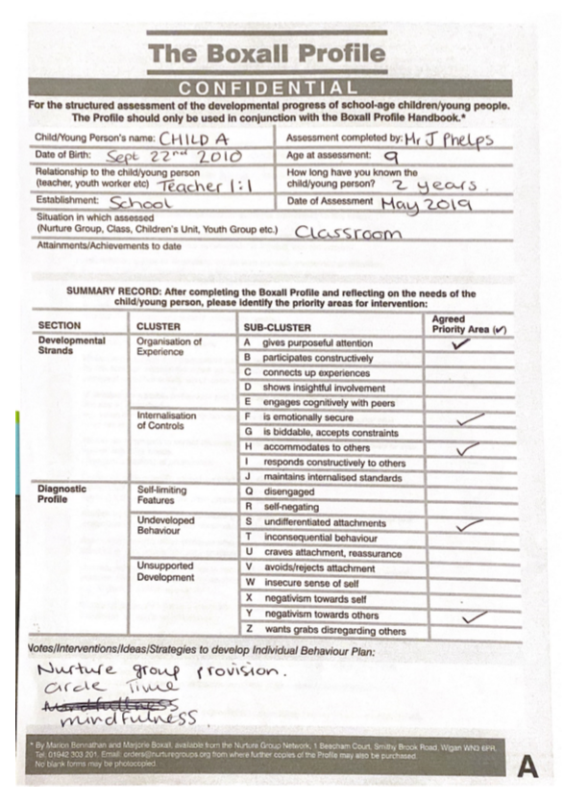
Appendix 2 – BOXALL Profile - Completed by Joshua Phelps (Bennathan and Boxall, 1984)

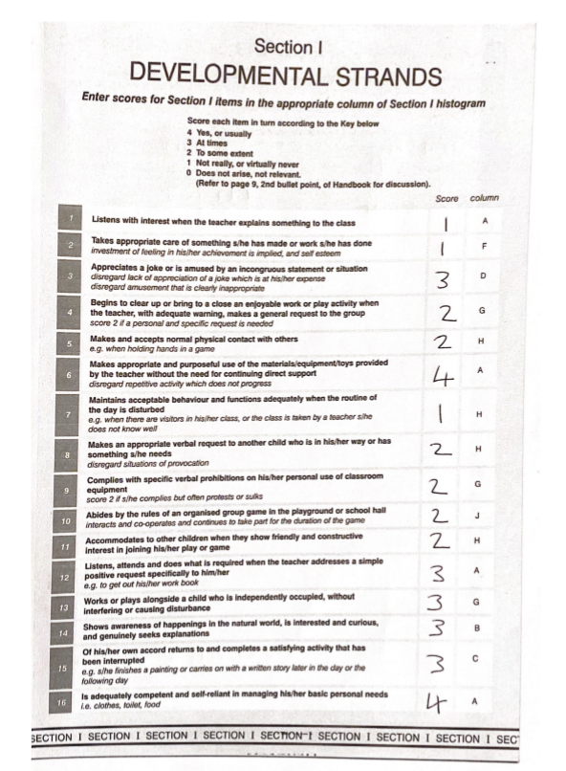
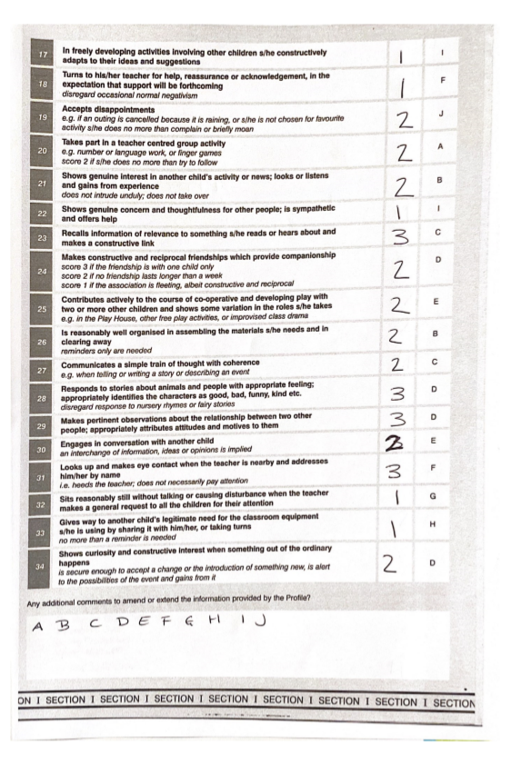
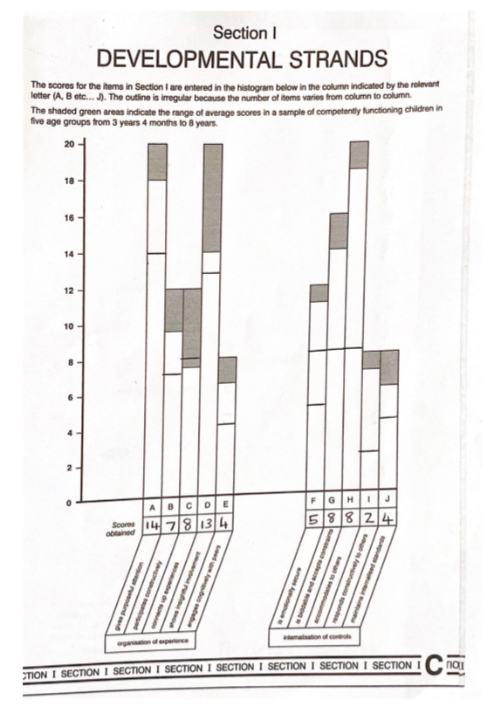
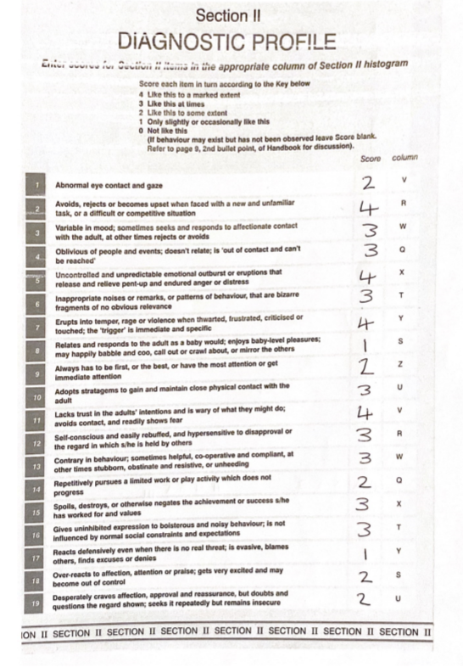




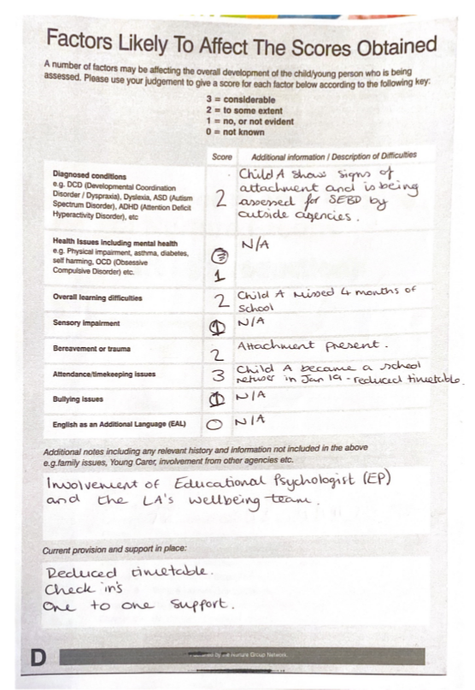

Appendix 3 – Case studies. (Welsh Government, 2010b)

Case Study 1.
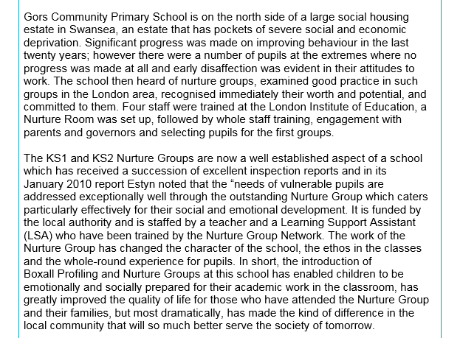

Case Study 2.
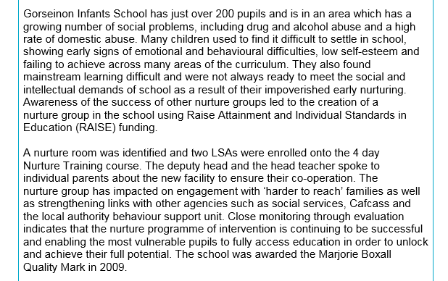

Case Study 3.


