Rebecca Smith (2206923)

Attitude differences towards feminism between males and females

Attitude Differences Towards Feminism Between Males and Females

Abstract
The aim of this study was to find if there is a difference in attitudes towards feminism between male and female participants. Previous studies have found that females are more likely be feminist than males and that females are more likely to have positive attitudes towards feminism than males. The hypothesis of this study was that females would have significantly higher scores from the social roles questionnaire, which indicates more feminist attitudes than males. Twenty-seven participants were recruited through the experiment management system at UWTSD university: 18 were female and 9 male. The age range was between 18-58. Thirteen questions from the social roles questionnaire were answered by all participants. Answers were measured using a 5-point Likert scale, rating from strongly disagree to strongly agree. Higher scores showed a more positive attitude towards feminism. Data analysis was carried out using an independent samples T test. The results showed that there was no significant difference in attitude towards feminism between males and females and the hypothesis was rejected.

Introduction
Women have been oppressed in many ways and often treated as lower in status than men; with lower pay at work, less access to education and having less political status. Women have been told what to do with their bodies and how they should behave sexually; often being ostracized if they do not behave as expected (Srivastava et al, 2017). Women have also been expected to take up a female gender role, to be a caregiver and home keeper for men and their families (Srivastava et al, 2017). Feminism can be considered to be a movement that seeks to bring equal rights between the sexes; to give women the same opportunities and resources that are available to men in areas such as politics, economics, social standing, education, justice and other areas of life where there are inequalities (Raina, 2020). ). Feminism is commonly thought to have come in three waves. In the early 19th century women campaigned for the right to vote and to have equal status in parliament. The second wave came in the 1960s, where women fought for equal legal and social status also campaigning for domestic violence to be recognised as a criminal offence. The third wave started in the 1990s where people campaigned for social justice for women. It was only during the 1990s that it was recognised and made illegal for husbands to sexually assualt their wives. The latter, third wave, movement progressed into the 2000s with the Me Too movement which highlighted how often women are assaulted by men, particularly those in power (Raina, 2020). Feminism can look different for different people depending on their culture, religion, beliefs, values, how they consider gender roles as well as the persons gender (Ogletree et al, 2019). Studies exploring attitudes towards feminism between males and females have shown significant differences (Ogletree et al, 2019). A study exploring how males and females view feminism found that the sexes have different beliefs about what feminism is, the study found that females had a more liberal view on what feminism is - believing that females and males have similarities and that there should be more equal rights, However, the men in the study felt that feminism was about hating men and pointed out the differences between men and women (Ogletree et al, 2019). Liberal views were associated with non-traditional gender roles and associated with less sexism, whereas viewing feminists as man-haters was associated with more traditional gender roles and greater sexism (Ogletree et al, 2019). A study exploring feminist attitudes showed that men who scored high in feminine traits on the sexual identity scale would be more willing to join feminist movements, whereas men with higher masculine traits would be less likely to identify as feminist (Toller et al,2004). The same study found that females who scored high in masculine traits on a personal attributes questionnaire would be less likely to take up traditional gender roles and females who scored low on masculine traits on the same questionnaire showed mixed results as to whether they would take up a traditional gender role (Toller et al, 2004). Gender roles have been shown to strongly contribute to whether a person is likely to be feminist or support feminism. Traditional gender roles include the expectation for women to stay home and look after the family whilst the men go out and provide for the family (Dicke et al, 2019). People with more egalitarian feminist views, however, do not designate such specific roles to either sex. This could provide women with the time to explore their education and careers (Dicke et al, 2019). A study carried out on university students found that men had more traditional role beliefs than females in areas such as in marriage and working life but more egalitarian views in social roles (Unutkan et al, 2016). This study also found that students had different views depending on their course choice and class. For example, midwifery students and upper-class students had more feminist views. This study also explored the participants understanding of feminism and found that many did not understand the concepts of feminism (Unutkan et al, 2016). Traditional gender roles are considered outdated, and socially constructed, the core belief being that there are real differences between the sexes, for example men being better leaders, however, men are more often given opportunities to become leaders (Baber & Tucker, 2006) . There are not many differences between the sexes that aren’t socially constructed, traditional roles thinking has divided daily responsibilities such as work and family between two genders instead of exploring these roles as social roles - which considers all roles as equally important, which can be designated to either sex - the social roles questionnaire was created and used by Barber & Tucker 2006, to explore existing gender role beliefs and to explore gender transcendence attitudes in participants. This questionnaire is more likely to capture covert sexism than more traditional gender roles questionnaires (Baber & Tucker, 2006). A study using the social roles questionnaire showed women were more likely to have egalitarian beliefs and to explore gender transcendence than men (Baber & Tucker, 2006).
The aim of this study is to find if there is a difference in attitude towards feminism between males and females in a sample of university students. Based on the literature above it is hypothesized that females will score significantly higher than males in feminist attitudes.

Method
Participants
27 university participants were recruited via the experiment management system (EMS), 18 female, 9 male. The age range was 18-58 years (M=26.46, SD=10.790)
Design
An independent - samples T test was used to find if there was a difference in attitudes between female and male participants towards feminism. All participants answered the same 13 questions from the gender role questionnaire. The continuous dependent variable was feminist attitude score from the gender role questionnaire and the categorical independent variables were male and female participants.
Materials
The social roles questionnaire (Baber & Tucker, 2006) was used to measure feminist attitudes between male and female participants. The social roles questionnaire consists of 13 questions such as “people can be both aggressive and nurturing regardless of sex.” Reponses were given on a 5- point Lickert scale (Likert, 1932). This scale is anchored from 1 - strongly disagree, to 5 - strongly agree. Eight of the questions (6 to 13) were negatively worded toward feminist attitudes and needed reverse scoring before analysis. Scores could range from 13 to 65, Higher scores were considered to indicate a more feminist attitude.
Procedure
University students were recruited via EMS, to take part in either an in labs study or online study. Both studies consisted of answering the same 13 question social roles questionnaire and credited with 1 EMS credit on completion. Participants who took part in labs were greeted in labs and shown to a computer where they were given information about the study. They were then asked to electronically consent to taking part and were also made aware of their right to withdraw. Participants were then asked to fill in a demographics form stating their gender and age. Following filling in demographics, participants were asked to answer 13 questions from the social role questionnaire via Qualtrics. Once they had completed the questionnaire, participants were debriefed and thanked for their participation and credited with 1 EMS credit. Online participants joined the study via EMS. They were given the study information and made aware of their right to withdraw. Participants were asked to electronically consent and filled in their demographics. Following demographics, participants answered 13 questions from the social roles questionnaire. Once complete, participants were given a debrief form and credited 1 EMS credit.
Results
An independent - sample T test was conducted to assess any difference of attitude towards feminism between female and male participants. Results show that there was no significant difference between male and female attitudes. Females scoring (M=53.05, SD=7.02). Males scoring (M=50.4, SD=5.85); t (25) =.960, p>.05.
The hypothesis that females would score significantly higher than males in feminist attitudes is not supported so can be rejected.

Discussion
The results from this study showed that there was no significant difference in feminist attitudes between males and females. This contrasts with the literature discussed previously that showed many studies found that females hold more feminist attitudes than men. Higher scores from the social roles questionnaire showed more feminist attitudes. The mean score for men was 50.4 and the mean score for women was 53.05, 65 being the highest score participants could have. This shows that males and females scored relatively high in attitudes towards feminism, which could be due to many reasons. Previous studies have shown that there is a difference between feminist views and a participant’s class and chosen university course (Unutkan et al, 2016). This study explored the views of university students on a small number of participants. The class and university course of participants was not defined so it is unclear whether participants in specific courses or of a certain class would be more likely to have feminist attitudes. It has also been shown that religious beliefs and a persons culture can strongly influence a participant’s attitude towards feminism (Ogletree et al, 2019). This study did not explore individual differences of participants other than whether they were male or female. Exploring participant’s other beliefs may also show where feminist attitudes are supported or not. The study using the sexual identity scale also found that males who scored highly on feminist traits were more likely to have feminist attitudes and women who scored high on masculine traits on the personal attributes questionnaire were also more likely to have more feminist attitudes (Toller et al, 2004). This study did not explore feminine or masculine traits in participants, so it is unknown if this knowledge would have had an influence on the results. Feminine and masculine traits could have been explored in this study using the Bem sex role inventory (Bem, 1974). Traditional gender roles can be broken down into subcategories, such as social roles, work roles and family roles. One of the studies that explored these sub-categories and found that males had more traditional views in work and marriage roles but more feminist views in social roles (Unutkan et al, 2016). This study may have seen a difference in feminist attitudes between males and females in the different subcategories, but this was not measured. Other issues that were spoken about in other studies were that many of the participants did not have a clear understanding of what feminism is (Unutkan et al, 2016). Women also had a different understanding of what feminism is to men. Women had more liberal views; believing that there are many similarities between men and women and that there should be more equal rights. Men, however, thought feminism was about hating men. These beliefs were associated to men holding more traditional role values and being more sexist, whereas women held more egalitarian, feminist views (Ogletree et al, 2019). This study did not explore participants understanding or explicit beliefs about feminism. If more individuals understand what feminism is, there would potentially be more support for the cause (Ogletree et al, 2019). A lack of understanding of the definition of feminism was shown in the study by Unutkan et al, 2016, with students being uncertain of what feminism is. Studies have shown that some men hold the belief that feminism is about hating men, which was shown to be connected to higher levels of sexism. Education on what feminism is may support more individuals to support women’s equal rights (Ogletree et al, 2019).
References
Baber, K. M., & Tucker, C. J. (2006). The Social Roles Questionnaire: A New Approach to Measuring Attitudes Toward Gender. Researchgate, 459-467.
Bem, S. L. (1974). The Measurement of Psychological androgyny. American Psychological Association, 155-162.
Dicke, A.-L., Safavian, N., & Eccles, J. S. (2019). Traditional gender role beliefs and career attainment in STEM : Gendered story. Frontiers, 10-30.
Likert, R. (1932). A Technique for the Mesurement of Attitudes . Archives of Psychology, 22-140.
Ogletree, S. M., Diaz, P., & Padilla, V. (2019). What is Feminism? College Students Definitions and Correlates. Springer, 1576-1589.
Raina, J. A. (2020). Feminism: An Overveiw . Researchgate, 3372-3376.
Srivastava, K., Chaudhury , S., Bhat, P. S., & Sahu, S. (2017). Misogyny, feminism and sexual harassment. PMC, 111-113.
Toller, P. W., Suter, E. A., & Trautman, T. C. (2004). Gender Role Identity and Attitudes Toward Feminism. Springer, 85-90.
Unutkan, A., Guclu, S., Emel, E., & Yilmaz, S. (2016). An Examination of the Opinions of the University Students About Feminism and Gender Roles. Dergipark, 317-325.

Appendix
‹ 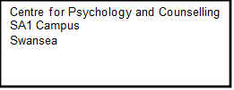

Study Debrief Sheet

Exploring the differences in attitudes towards feminism between Males and Females

Thank you for taking part in this study.

The aim of this study was to explore attitudes towards Feminism. We specifically wanted to explore whether there was a difference in attitudes and responses between males and females towards social roles. Feminism, defined as a movement advocating for equal rights for women alongside men in various domains such as politics and economics, was explored within the context of gender differences. Previous research has suggested that societies with greater gender equality tend to exhibit better social and economic well-being, with women who hold feminist views being more likely to engage in political affairs. Research has revealed that men are often less supportive of feminism, associating it more with females. At the same time, younger adults tend to hold more liberal views on feminism compared to older generations, with women generally expressing more positive attitudes. It's important to note that cultural differences may influence these attitudes, underscoring the significance of diverse study samples in understanding gender differences in attitudes toward feminism.

If you wish to withdraw your data from the study you must tell the researcher now. After this point, all of your data will remain confidential, and we will not trace it back to you.

If taking part in this study has raised any questions, please speak to the researchers or contact the academic supervisor lead Judith Marshall on judith.marshall@uwtsd.ac.uk

Thank you once again for taking time to participate in this study.

Level Five Students

Alisha Syaid (2210323@student.uwtsd.ac.uk)
Angharad Kissick (2204898@Student.uwtsd.ac.uk)
Rebecca Smith (2206923@student.uwtsd.ac.uk)
Rebecca Suter (0252227@student.uwtsd.ac.uk)

BSc Psychology
BSc Psychology and Counselling

University of Wales Trinity Saint David, Swansea

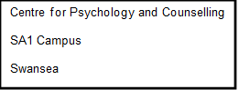

Study Information Sheet

This document provides key information regarding the study and provides details about what will be expected of you as a participant. Therefore, please read this information carefully before providing your consent to take part.

The purpose of this study is to explore attitudes towards Feminism.

During this study, you will be required to do the following:

- Fill out an online demographic questionnaire asking you for basic demographic information.
- Completing the social role questionnaire
- This will involve you responding to 13 questions using a scale of 1 (strongly disagree) to 5 (strongly agree).

At the end of the study, you will be provided with the study debrief.

If you have any questions or concerns about this study, please contact the research supervisor, Judith Marshall, on Judith.marshall@uwtsd.ac.uk

If you are happy to take part in this study, please sign the consent form provided.

If you feel you want to leave the study, you can do so at any time by closing the browser on your computer or notifying the researcher. Once the study has ended, you will be asked if you want your data to be saved as part of the study. If you agree, your data will be anonymised and therefore untraceable to later delete. If you do not wish for your data to be used, please ensure you inform the researcher.

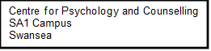

Study Consent Form

I understand that this research study is being carried out by a group of 2nd year Psychology Students for the purpose of a module assessment and that taking part in this study will involve completing a social role questionnaire.

I understand that this study will take approximately 20 minutes to complete.

I understand that participation in this study is voluntary, and I am free to withdraw participation at any time during or before the end of the study without giving a reason.

I understand that once I complete the study, my data will remain confidential and will not be traced back to me, as a code will be assigned in place of my name and unique EMS identification number. The data collected will be stored in accordance with the Data Protection Act, and all data will be anonymised.

I am aware that if I have concerns about the study, I can contact the researchers at any time during or after the study on Angharad Kissick (2204898@student.uwtsd.ac.uk), Rebecca Suter (0252227@student.uwtsd.ac.uk), Alisha Syaid (2210323@student.uwtsd.ac.uk) Ember Smith (2206923@student.uwtsd.ac.uk). Or the module lead , Judith Marshall, at judith.marshall@uwtsd.ac.uk (should I have any concerns).

I also understand that I will be provided with a debrief form at the end of the study.

Please tick the boxes below to confirm:

¨ I am aged 18 years of age or over

¨ I understand I can withdraw at any time without penalty

¨ I understand my data will be held confidentially with a code assigned in place of my name

¨ I understand all the above information on this consent form

¨ I consent to take part in this study

APPLICATION FOR ETHICAL APPROVAL

In order for research to result in benefit and minimise risk of harm, it must be conducted ethically. A researcher may not be covered by the University’s insurance if ethical approval has not been obtained prior to commencement.

The University follows the OECD Frascati manual definition of research activity: “creative work undertaken on a systematic basis in order to increase the stock of knowledge, including knowledge of man, culture and society, and the use of this stock of knowledge to devise new applications”. As such this covers activities undertaken by members of staff, postgraduate research students, and both taught postgraduate and undergraduate students working on dissertations/projects.

The individual undertaking the research activity is known as the “principal researcher”.

Ethical approval is not required for routine audits, performance reviews, quality assurance studies, testing within normal educational requirements, and literary or artistic criticism.

Please read the notes for guidance before completing ALL sections of the form.

This form must be completed and approved prior to undertaking any research activity. Please see Checklist for details of process for different categories of application.

SECTION A: About You (Principal Researcher)
1 | Full Name: |  | Alisha Syaid, Angharad Kissick, Rebecca Suter, Rebecca Smith
2 | Tick all boxes that apply: |  | Member of staff: | ☐ | Honorary research fellow: | ☐
 | Undergraduate Student | ​​☒​ | Taught Postgraduate Student | ​​☐​ | Postgraduate Research Student | ​​☐​

3 | Institute/Academic Discipline/Centre: | Institute of Education and Humanities/Psychology and Counselling
4 | Campus: | Swansea
5 | E-mail address: | 2206923@student.uwtsd.ac.uk  2204898@student.uwtsd.ac.uk  0252227@student.uwtsd.ac.uk  2210323@student.uwtsd.ac.uk
6 | Contact Telephone Number:
 | For students:
7 | Student Number: | 2206923, 2204898, 0252227, 2210323
8 | Programme of Study: | BSc Psychology and BSc Psychology & Counselling
9 | Director of Studies/Supervisor: | Dr Judith Marshall

SECTION B: Approval for Research Activity
1 | Has the research activity received approval in principle?  (please check the Guidance Notes as to the appropriate approval process for different levels of research by different categories of individual) |  | YES | ​​☒​ | NO | ​​☐​
 |  |  |  |  | Date
2 | If Yes, please indicate source of approval (and date where known): Approval in principle must be obtained from the relevant source prior to seeking ethical approval | Research Degrees Committee |  | ​​☐​
2 |  | Institute Research Committee |  | ​​☐​
2 |  | Other  Judith Marshall – Lecturer |  | ​​☒​

SECTION C: Internal and External Ethical Guidance Materials
 | Please list the core ethical guidance documents that have been referred to during the completion of this form (including any discipline-specific codes of research ethics, location-specific codes of research ethics, and also any specific ethical guidance relating to the proposed methodology). Please tick to confirm that your research proposal adheres to these codes and guidelines. You may add rows to this table if needed.
1 | UWTSD Research Ethics & Integrity Code of Practice | ​​☒​
2 | UWTSD Research Data Management Policy | ​​☒​
3 | British Psychological Society. (2021, 12). Code of ethics and conduct. Retrieved from The British psychological society: https://doi.org/10.53841/bpsrep.2021.inf94 | ​​☒​
4 | British Psychological Society. (2021). BPS code of human research Ethics: https://www.bps.org.uk/news-and-policy/bps-code-human-research-ethics-2021 | ☒

SECTION D: External Collaborative Research Activity
If there are external collaborators then you should gain consent from the contact persons to share their personal data with the university. If there are no external collaborators then leave this section blank and continue to section E.
1 | Institution
2 | Contact person name
3 | Contact person e-mail address
4 | Is your research externally funded? |  | YES | ​​☐​ | NO |  | ​​☐​
5 | Are you in receipt of a KESS scholarship? |  | YES | ​​☐​ | NO |  | ​​☐​
6 | Are you specifically employed to undertake this research in either a paid or voluntary capacity? | Voluntary | YES | ​​☐​ | NO | ​​☐​
7 |  | Employed | YES | ​​☐​ | NO | ​​☐​
8 | Is the research being undertaken within an existing UWTSD Athrofa Professional Learning Partnership (APLP)? | If YES then the permission question below does not need to be answered. | YES | ​​☐​ | NO |  | ​​☐​
9 | Has permission to undertake the research has been provided by the partner organisation? | (If YES attach copy)  If NO the application cannot continue | YES | ​​☐​ | NO |  | ​​☐​

Where research activity is carried out in collaboration with an external organisation
10 | Does this organisation have its own ethics approval system? | YES | ​​☐​ | NO | ​​☐​
 | If Yes, please attach a copy of any final approval (or interim approval) from the organisation (this may be a copy of an email if appropriate).

SECTION E: Details of Research Activity
1 | Indicative title: |  | Exploring the differences in attitudes towards feminism, between Males and Females
2 | Proposed start date: |  | March 2024 | Proposed end date: | 30th April 2024
Introduction to the Research (maximum 300 words per section)
Ensure that you write for a Non-Specialist Audience when outlining your response to the points below:
- Purpose of Research Activity
- Proposed Research Question
- Aims of Research Activity
- Objectives of Research Activity
Demonstrate, briefly, how Existing Research has informed the proposed activity and explain
- What the research activity will add to the body of knowledge
- How it addresses an area of importance.
3 | Purpose of Research Activity  The purpose of this study is for a level 5 assignment to explore differences in attitudes between Male and Female participants towards feminism.  Feminism has been described as a movement to provide equal rights for women in conjunction with men in areas such as politics, economics and social standing (Bettencourt et al., 2011). Women who have equal rights are more likely to have better social and economic well-being and societies who have more equal rights are shown to have more productivity within workforces (Belingheri et al., 2021) studies have also shown women who hold feminist views are more likely to engage in political affairs (Hedger & Hoffmann, 2019)  Many studies have explored the differences in attitudes towards feminism One study by Toller et al. (2004) explored the relationship between gender identity, gender roles and the willingness to identify as a feminist or support feminism. Findings showed that men identified feminism as belonging to females and were less likely to support it (Toller et al.,2004). Findings from other studies have explored attitudes between older and younger generations and found that younger adults identifying as female or male were more liberal with their views on politics, religion and women, with women holding significantly more positive views on feminism than males in both younger and older generations (Bettencourt et al.,2007). This study was carried out in the US over a decade ago, and participants who chose to do this study may be distinct from others (Bettencourt et al.,2007). As many cultures have different views on economics, social standing and politics, t's important to involve a diverse understanding by conducting studies with different cohorts (Reohr et al.,2022).  Belingheri, P., Chiarello, F., Fronzetti, A., & Rovelli, P. (2021). Twenty years of gender equality research: A scoping review based on a new semantic indicator. PMC, 1-16.  Bettencourt, K. E., Vacha-Haase, T., & Byme, Z. S. (2011). Older and younger adults' attitudes toward feminism: The influence of religiosity, political orientation, gender, education and family. Springer, 863-874.  Hedger, K., & Hoffmann, C. P. (2019). Feminism! What is it good for? The role of feminism and political self-efficacy in women's online political participation. SAGE, 226-244.  Reohr, P., Irrgang, M., Watari, H., & Kelsey, C. (2022). Considering the whole person: A guide to culturally responsive psychosocial research. ScienceDirect, 2-5. Retrieved from https://doi-org.ezproxy.uwtsd.ac.uk/10.1016/j.metip.2021.100089  Toller, W. P., Suter, E. A., & Trautman, T. C. (2004). Gender role identity and attitudes toward feminism. Springer, 85-90.  (this box should expand as you type)
4 |  | Research Question  Is there a difference between male and female attitudes towards feminism.  There will be a significant difference between male and female attitudes towards feminism.
5 |  | Aims of Research Activity  The aim of the research is to determine whether there are differences between males and females in relation to attitudes towards feminism.
6 |  | Objectives of Research Activity  To investigate the hypotheses...  To investigate if there is a difference between male and female attitudes towards feminism
 |  | Proposed methods (maximum 600 words)
7 |  | The proposed research study will use a quantitative questionnaire as its primary data collection method. This approach will involve administering a set of standardised questions to all participants in a structured format, which will allow for the collection of numerical data. The study will also incorporate a between-subjects design, which involves assigning participants randomly to different groups or conditions. This design will help control for extraneous variables and maximise the study's internal validity. Additionally, only, male and female participants will be included in the study to ensure the findings can be generalised to the broader population.  The survey selected for this investigation is The Social Roles Questionnaire (Baber & Jenkins Tucker, 2006), a robust tool comprising of thirteen questions to assess attitudes towards feminism. Participants will express their opinions using a Likert scale ranging from 1 (strongly disagree) to 5 (strongly agree). This scale is instrumental in enabling a nuanced evaluation of perspectives, a key aspect of our research.  A demographics form will be included supplementary to the questionnaire to gather essential participant information. An information sheet will provide a comprehensive overview of the study's purpose and procedures. A dedicated consent form will be used to obtain informed consent, emphasising voluntary participation and confidentiality assurance.  Data collection will occur both online, using Qualtrics to automatically anonymise responses, and in a lab-based setting, where group members will physically gather data. Participants will be debriefed after survey completion and receive additional information about the study's objectives.  Subsequent data analysis will employ SPSS and a t-test, a robust statistical method, to discern potential differences in attitudes towards feminism between male and female participants. The study's inclusivity is emphasised by recruiting participants using the Experimental management System (EMS), fostering a diverse and representative sample. This methodology aligns with ethical standards by prioritising informed consent, participant confidentiality, and transparent communication throughout the research process.  BABER, K. M., & JENKINS TUCKER, C. (2006). The social roles questionnaire: A new approach to measuring attitudes toward gender. Sex Roles, 54(7–8), 459–467. https://doi.org/10.1007/s11199-006-9018-y  (this box should expand as you type)
Location of research activity
Identify all locations where research activity will take place.

8 |  | Ems – Qualitrics – level 2 of IQ building  Same as above - How are we going to collect data – two ways – online and lab based. Members of the group will be physically going into collect data. Purpose of online is for other people to participate on other courses  (this box should expand as you type)
Research activity outside of the UK
If research activity will take place overseas, you are responsible for ensuring that local ethical considerations are complied with and that the relevant permissions are sought. Specify any local guidelines (e.g. from local professional associations/learned societies/universities) that exist and whether these involve any ethical stipulations beyond those usual in the UK (provide details of any licenses or permissions required). Also specify whether there are any specific ethical issues raised by the local context in which the research activity is taking place, for example, particular cultural and/or legal sensitivities or vulnerabilities of participants. If you live in the country where you will do the research then please state this.
9 |  | (this box should expand as you type)

10 | Use of documentation not in the public domain: Are any documents NOT publicly available? | NO | ​​☒​
10 |  | YES | ​​☐​
11 | If Yes, please provide details here of how you will gain access to specific documentation that is not in the public domain and that this is in accordance with the current data protection law of the country in question and that of England and Wales.  (this box should expand as you type)

 | Does your research relate to one or more of the seven aims of the Well-being of Future Generations (Wales) Act 2015? | YES | NO
12 | A prosperous Wales | ​​☐​ | ​​☒​
13 | A resilient Wales | ​​☐​ | ​​☒​
14 | A healthier Wales | ​​☐​ | ​​☒​
15 | A more equal Wales | ​​☒​ | ​​☐​
16 | A Wales of cohesive communities | ​​☐​ | ​​☒​
17 | A Wales of vibrant culture and thriving Welsh language | ​​☐​ | ​​☒​
18 | A globally responsible Wales | ​​☐​ | ​​☒​
19 | If YES to any of the above, please give details:
The study could be connected to a more equal Wales due to Feminism being strongly associated to women's equal rights.

(this box should expand as you type)

SECTION F: Scope of Research Activity
 | Will the research activity include: | YES | NO
1 | Use of a questionnaire or similar research instrument? | ​​☒​ | ​​☐​
2 | Use of interviews? | ​​☐​ | ​​☒​
3 | Use of focus groups? | ​​☐​ | ​​☒​
4 | Use of participant diaries? | ​​☐​ | ​​☒​
5 | Use of video or audio recording? | ​​☐​ | ​​☒​
6 | Use of computer-generated log files? | ​​☐​ | ​​☒​
7 | Participant observation with their knowledge? | ​​☐​ | ​​☒​
8 | Participant observation without their knowledge? | ​​☐​ | ​​☒​
9 | Access to personal or confidential information without the participants’ specific consent? | ​​☐​ | ​​☒​
10 | Administration of any questions, test stimuli, presentation that may be experienced as physically, mentally or emotionally harmful / offensive? | ​​☐​ | ​​☒​
11 | Performance of any acts which may cause embarrassment or affect self-esteem? | ​​☐​ | ​​☒​
12 | Investigation of participants involved in illegal activities? | ​​☐​ | ​​☒​
13 | Use of procedures that involve deception? | ​​☐​ | ​​☒​
14 | Administration of any substance, agent or placebo? | ​​☐​ | ​​☒​
15 | Working with live vertebrate animals? | ​​☐​ | ​​☒​
16 | Procedures that may have a negative impact on the environment? | ​​☐​ | ​​☒​
17 | Other primary data collection methods. Please indicate the type of data collection method(s) below. | ​​☐​ | ​​☐​
 | Details of any other primary data collection method:  (this box should expand as you type) | ​​☐​ | ​​☐​
If NO to every question, then the research activity is (ethically) low risk and may be exempt from some of the following sections (please refer to Guidance Notes).

If YES to any question, then no research activity should be undertaken until full ethical approval has been obtained.

SECTION G: Intended Participants
If there are no participants then do not complete this section, but go directly to section H.

 | Who are the intended participants: | YES | NO
1 | Students or staff at the University? | ​​☒​ | ​​☐​
2 | Adults (over the age of 18 and competent to give consent)? | ​​☒​ | ​​☐​
3 | Vulnerable adults? | ​​☐​ | ​​☒​
4 | Children and Young People under the age of 18? (Consent from Parent, Carer or Guardian will be required) | ​​☐​ | ​​☒​
5 | Prisoners? | ​​☐​ | ​​☒​
6 | Young offenders? | ​​☐​ | ​​☒​
7 | Those who could be considered to have a particularly dependent relationship with the investigator or a gatekeeper? | ​​☐​ | ​​☒​
8 | People engaged in illegal activities? | ​​☐​ | ​​☒​
9 | Others. Please indicate the participants below, and specifically any group who may be unable to give consent. | ​​☐​ | ​​☒​
 | Details of any other participant groups:  (this box should expand as you type) | ​​☐​ | ​​☒​

Participant numbers and source
Provide an estimate of the expected number of participants. How will you identify participants and how will they be recruited?
10 | How many participants are expected? | 30 participants  (this box should expand as you type)
11 | Who will the participants be? | Participants will be gathered via the university’s Experiment Management System (EMS), where students will be able to sign up anonymously in exchange for course credits.  Undergrad students from psychology and counselling – level 4/level5 in the centre for psychology and counselling  (this box should expand as you type)
12 | How will you identify the participants? | Each participant will be assigned a unique ID by the EMS, which will be used to identify participant during the study. Participants names will not be shared with the researchers. After the experimental phase of the study has been completed, each participant will be assigned a study ID unique to them to further anonymise their data. This will mean that any data collected cannot be traced by to any individual participant.  (this box should expand as you type)

 | Information for participants: |  | YES |  | NO |  | N/A
13 | Will you describe the main research procedures to participants in advance, so that they are informed about what to expect? |  | ​​☒​ |  | ​​☐​ |  | ​​☐​
14 | Will you tell participants that their participation is voluntary? |  | ​​☒​ |  | ​​☐​ |  | ​​☐​
15 | Will you obtain written consent for participation? |  | ​​☒​ |  | ​​☐​ |  | ​​☐​
16 | Will you explain to participants that refusal to participate in the research will not affect their treatment or education (if relevant)? |  | ​​☒​ |  | ​​☐​ |  | ​​☐​
17 | If the research is observational, will you ask participants for their consent to being observed? |  | ​​☐​ |  | ​​☐​ |  | ​​☒​
18 | Will you tell participants that they may withdraw from the research at any time and for any reason? |  | ​​☒​ |  | ​​☐​ |  | ​​☐​
19 | With questionnaires, will you give participants the option of omitting questions they do not want to answer? |  | ​​☐​ |  | ​​☒​ |  | ​​☐​
20 | Will you tell participants that their data will be treated with full confidentiality and that, if published, it will not be identifiable as theirs? |  | ​​☒​ |  | ​​☐​ |  | ​​☐​
21 |  | Will you debrief participants at the end of their participation, in a way appropriate to the type of research undertaken? |  | ​​☒​ |  | ​​☐​ |  | ​​☐​
22 |  | If NO to any of above questions, please give an explanation
 |  | (this box should expand as you type)

 | Information for participants: | YES | NO | N/A
24 | Will participants be paid? | ​​☐​ | ​​☒​ | ​​☐​
25 | Is specialist electrical or other equipment to be used with participants? | ​​☐​ | ​​☒​ | ​​☐​
26 | Are there any financial or other interests to the investigator or University arising from this study? | ​​☐​ | ​​☒​ | ​​☐​
27 | Will the research activity involve deliberately misleading participants in any way, or the partial or full concealment of the specific study aims? | ​​☐​ | ​​☒​ | ​​☐​
28 | If YES to any question, please provide full details
 | (this box should expand as you type)

SECTION H: Anticipated Risks

Outline any anticipated risks that may adversely affect any of the participants, the researchers and/or the University, and the steps that will be taken to address them.

If you have completed a full risk assessment (for example as required by a laboratory, or external research collaborator) you may append that to this form.
1 | Full risk assessment completed and appended? |  | Yes | ​​☐​
1 |  |  | No | ​​☐​
2 | Risks to participants  For example: sector-specific health & safety, emotional distress, financial disclosure, physical harm, transfer of personal data, sensitive organisational information
 | Risk to participants:  Participants may feel concern about what the experiment is for and feel worried about criticism.  Confidentiality - Participants may be concerned that data will be traced back to them.  Participants may have further quires about the experiment and not know where to go with them.  Participants may want to leave the study before completing it. | How you will mitigate the risk to participants:  Participants will be debriefed and informed in line with the BPS guidelines to ensure they are not leaving the experiment unsure on what they have taken part in. They will be informed that they have the right to withdraw at any time without penalty.  Participants be informed that data collected is anonymous and will only be identifiable via their unique study code. This is to keep within the guidelines of GDPR and the BPS guidelines on how to store participant data. Data will be stored on one drive, which is password-protected by the university. It will be kept until the exam board final assessment grades.  A University Email will be provided so participants can get in contact with any queries.  The study will have an exit page and participants will be informed of the right to leave the study at any time
3 | If research activity may include sensitive, embarrassing or upsetting topics (e.g. sexual activity, drug use) or issues likely to disclose information requiring further action (e.g. criminal activity), give details of the procedures to deal with these issues, including any support/advice (e.g. helpline numbers) to be offered to participants. Note that where applicable, consent procedures should make it clear that if something potentially or actually illegal is discovered in the course of a project, it may need to be disclosed to the proper authorities
N/A

(this box should expand as you type)
4 | Risks to the investigator  For example: personal health & safety, physical harm, emotional distress, risk of accusation of harm/impropriety, conflict of interest
 | Risk to the investigator:  The researcher may be accused of misconduct or inappropriate behaviours if the participant does not feel comfortable about something in the study.  The researcher may receive unwelcome communications from the participant.  The student researchers may be asked questions they don’t know the answers to.  (this box should expand as you type) | How you will mitigate the risk to the investigator:  The student researcher will follow all UWTSD and BPS research codes of conduct and research guidelines, the study will not take place until all elements have been approved by the supervisor (module lead). Participants will have information on EMS before the study begins. An information sheet will provide them with a brief understanding of what the study entails and its aims. Participants will also be provided with a consent form and a debrief sheet.  Only university student email address will be provided, not personal ones. If the researcher does receive any unwelcomed emails from a participant, it will be reported to the module lead Judith Marshall.  If participants have questions out of the researcher's knowledge the questions will be passed on to the module lead.
5 | University/institutional risks  For example: adverse publicity, financial loss, data protection
 | Risk to the University:  The reputation of the university may be at risk if codes and conducts are not followed  Confidential information could be leaked | How you will mitigate the risk to the University:  The above will be adhered to  All information will be stored using cloud data storage, information will only be used for its intended purpose. Data will be used as stated by the UWTSD research data management system.  Investigators will follow and adhere to the BPS codes of ethics and conducts. Students will behave in a responsible and professional manner.
6 | Environmental risks  For example: accidental spillage of pollutants, damage to local ecosystems
 | Risk to the environment:  Risk of damage to computers if used inappropriately.  Noise pollution, disturbing other students in lectures or other experiments. | How you will mitigate the risk to environment:  Participants will be instructed on how to use computers appropriately.  Notices will be in place to politely ask to keep noise to a minimum, investigators will behave appropriately.

 | Disclosure and Barring Service
 | If the research activity involves children or vulnerable adults, a Disclosure and Barring Service (DBS) certificate must be obtained before any contact with such participants. | YES | NO | N/A
7 | Does your research require you to hold a current DBS Certificate? | ​​☐​ | ​​☒​ | ​​☐​
8 | If YES, please give the certificate number. If the certificate number is not available please write “Pending”; in this case any ethical approval will be subject to providing the appropriate certificate number.

SECTION I: Feedback, Consent and Confidentiality

1 | Feedback  What de-briefing and feedback will be provided to participants, how will this be done and when?
After the questionnaire is completed, the participants will be verbally debriefed and given a form explaining that the study was to explore attitude differences between male and female participants.

(this box should expand as you type)
2 | Informed consent  Describe the arrangements to inform potential participants, before providing consent, of what is involved in participating. Describe the arrangements for participants to provide full consent before data collection begins. If gaining consent in this way is inappropriate, explain how consent will be obtained and recorded in accordance with prevailing data protection legislation.
Participants will be given an information sheet explaining what the study is for before completing the questionnaire, they will be informed of their right to withdraw at any time, and that information collected is anonymous.

(this box should expand as you type)
3 | Confidentiality / Anonymity  Set out how anonymity of participants and confidentiality will be ensured in any outputs. If anonymity is not being offered, explain why this is the case.
Participant data will be stored in a locked cupboard in labs by the lecturer or kept in a password protected file on a computer in labs, the only personal data collected will be of gender and participant identifying number.

(this box should expand as you type)

SECTION J: Data Protection and Storage

 | Does the research activity involve personal data (as defined by the General Data Protection Regulation 2016 “GDPR” and the Data Protection Act 2018 “DPA”)? | YES | NO
1 | “Personal data” means any information relating to an identified or identifiable natural person (‘data subject’). An identifiable natural person is one who can be identified, directly or indirectly, in particular by reference to an identifier such as a name, an identification number, location data, an online identifier or to one or more factors specific to the physical, physiological, genetic, mental, economic, cultural or social identity of that natural person. Any video or audio recordings of participants is considered to be personal data. | ☐​☒​ | ☐
 | If YES, provide a description of the data and explain why this data needs to be collected:
2 | Paper forms for signed consent will be collected from participants and handed back to the lecturer who will store them in a locked cupboard in labs. All data collected from computer studies will be stored with password protection.  (this box should expand as you type)
 | Does it involve special category data (as defined by the GDPR)? | YES | NO
3 | “Special category data” means sensitive personal data consisting of information as to the data subjects’ –  (a) racial or ethnic origin,  (b) political opinions,  (c ) religious beliefs or other beliefs of a similar nature,  (d) membership of a trade union (within the meaning of the Trade Union and Labour Relations (Consolidation) Act 1992),  (e) physical or mental health or condition,  (f) sexual life,  (g) genetics,  (h) biometric data (as used for ID purposes), | ☐ | ​​☒​
 | If YES, provide a description of the special category data and explain why this data needs to be collected:
4 | (this box should expand as you type)

 | Will data from the research activity (collected data, drafts of the thesis, or materials for publication) be stored in any of the following ways? | YES | NO
5 | Manual files (i.e. in paper form)? | ​​☒​ | ​​☐​
6 | University computers? | ​​☒​ | ​​☐​
7 | Private company computers? | ​​☐​ | ​​☒​
8 | Home or other personal computers? | ​​☐​ | ​​☒​
9 | Laptop computers/ CDs/ Portable disk-drives/ memory sticks? | ​​☐​ | ​​☒​
10 | “Cloud” storage or websites? | ​​☒​ | ​​☐​
11 | Other – specify: | ​​☐​ | ​​☒​
12 | For all stored data, explain the measures in place to ensure the security of the data collected, data confidentiality, including details of backup procedures, password protection, encryption, anonymisation and pseudonymisation:
Data collection on attitudes towards feminism will be conducted using Qualtrics, with the gathered data stored securely on cloud storage until the final assessment grades are released by the exam board. Access to Qualtrics will be granted exclusively to the lead researcher, ensuring confidentiality through password protection. Yr Athrofa holds the license for the data collected via Qualtrics, with all personally identifiable information, such as IP addresses and GPS positions, disabled prior to data collection to adhere to the ethical guidelines outlined by the British Psychological Society for Internet Mediated Research (2021). Once extracted from Qualtrics, the raw data will be transferred to SPSS and saved within a private Microsoft Teams group for sharing within the research group. Subsequently, the data will be securely deleted from the storage location.
Paper consent forms will be given to lead lecturer Judith Marshall and they will be kept in a locked cupboard.

 | Data Protection
 | Will the research activity involve any of the following activities: | YES | NO
13 | Electronic transfer of data in any form? | ​​☒​ | ​​☐​
14 | Sharing of data with others at the University outside of the immediate research team? | ​​☐​ | ​​☒​
15 | Sharing of data with other organisations? | ​​☐​ | ​​☒​
16 | Export of data outside the UK or importing of data from outside the UK? | ​​☐​ | ​​☒​
17 | Use of personal addresses, postcodes, faxes, emails or telephone numbers? | ​​☐​ | ​​☒​
18 | Publication of data that might allow identification of individuals? | ​​☐​ | ​​☒​
19 | Use of data management system? | ​​☐​ | ​​☒​
20 | Data archiving? | ​​☐​ | ​​☒​
21 | If YES to any question, please provide full details, explaining how this will be conducted in accordance with the GDPR and Data Protection Act (2018) (and any international equivalents, where appropriate):
 | From Qualtrics to one drive, data will be transferred with password protection
22 | List all who will have access to the data generated by the research activity:
Angharad Kissack
Rebecca Suter
Rebecca Smith
Alisia Syiad
Judith Marshal

(this box should expand as you type)
23 | List who will have control of, and act as custodian(s) for, data generated by the research activity:
Angharad Kissack
Rebecca Suter
Rebecca Smith
Alisia Syiad
Judith Marshal

24 | Give details of data storage arrangements, including security measures in place to protect the data, where data will be stored, how long for, and in what form. Will data be archived – if so how and if not why not.
 | Initially stored on Qualtrics, online data will only be accessible to the lead researcher, who holds exclusive knowledge of the password. Upon readiness for analysis, the data will be downloaded in its original form and securely saved to an SPSS file on the researchers’ devices, within a password-protected folder. Microsoft Teams will facilitate data sharing among research groups. Given the experimental nature of the module, which isn't anticipated to yield research-grade data, archiving for public use or extended maintenance isn't necessary. Therefore, the data will be securely destroyed following review by External Examiners of research reports and assessment by the examination board.
25 | Please indicate if your data will be stored in the UWTSD Research Data Repository (see https://researchdata.uwtsd.ac.uk/ ). If so please explain. (Most relevant to academic staff)
 | N/A
26 | Confirm that you have read the UWTSD guidance on data management (see https://www.uwtsd.ac.uk/library/research-data-management/) | YES | ​​☒​
27 | Confirm that you are aware that you need to keep all data until after your research has completed or the end of your funding | YES | ​​☒​

SECTION K: Declaration
The information which I have provided is correct and complete to the best of my knowledge. I have attempted to identify any risks and issues related to the research activity and acknowledge my obligations and the rights of the participants.

In submitting this application I hereby confirm that I undertake to ensure that the above named research activity will meet the University’s Research Ethics and Integrity Code of Practice which is published on the website: https://www.uwtsd.ac.uk/research/research-ethics/
1 | Signature of applicant: | Rebecca Smith, Angharad Kissick, Rebecca Suter, Alysha Syaid. | Date:  11.03.2024

For STUDENT Submissions:
2 | Director of Studies/Supervisor: |  | Date:
3 | Signature: |  | Date:

For STAFF Submissions:
4 | Academic Director/ Assistant Dean: |  | Date:
5 | Signature: |  | Date:

Checklist: Please complete the checklist below to ensure that you have completed the form according to the guidelines and attached any required documentation:
​​☒​ | I have read the guidance notes supplied before completing the form.
​​☒​ | I have completed ALL RELEVANT sections of the form in full.
​​☒​ | I confirm that the research activity has received approval in principle
​​☒​ | I have attached a copy of final/interim approval from external organisation (where appropriate)
​​☐​ | I have attached a full risk assessment (where appropriate) ONLY TICK IF YOU HAVE ATTACHED A FULL RISK ASSESSMENT
​​☒​ | I understand that it is my responsibility to ensure that the above named research activity will meet the University’s Research Ethics and Integrity Code of Practice.
​​☒​ | I understand that before commencing data collection all documents aimed at respondents (including information sheets, consent forms, questionnaires, interview schedules etc.) must be confirmed by the DoS/Supervisor, module tutor or Academic Director.

RESEARCH STUDENTS AND STAFF ONLY
All communications relating to this application during its processing must be in writing and emailed to pgresearch@uwtsd.ac.uk , with the title ‘Ethical Approval’ followed by your name.
You will be informed of the outcome of your claim by email; therefore it is important that you check your University and personal email accounts regularly.
STUDENTS ON UNDERGRADUATE OR TAUGHT MASTERS PROGRAMMES should submit this form (and receive the outcome) via systems explained to you by the supervisor/module leader.

This form is available electronically from the Academic Office web pages: https://www.uwtsd.ac.uk/academic-office/appendices-and-forms/

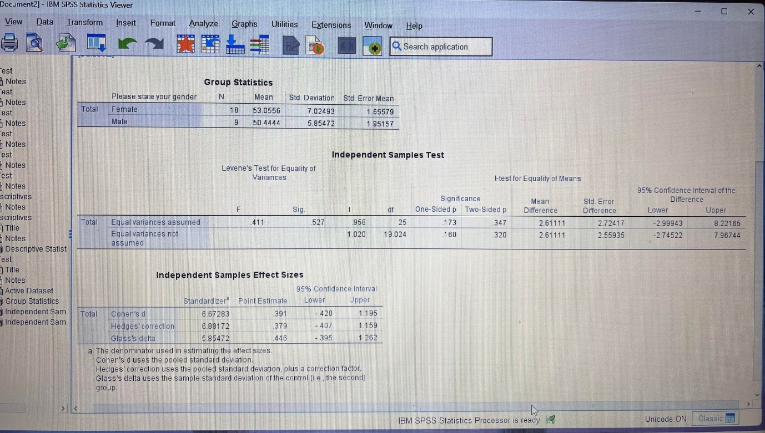

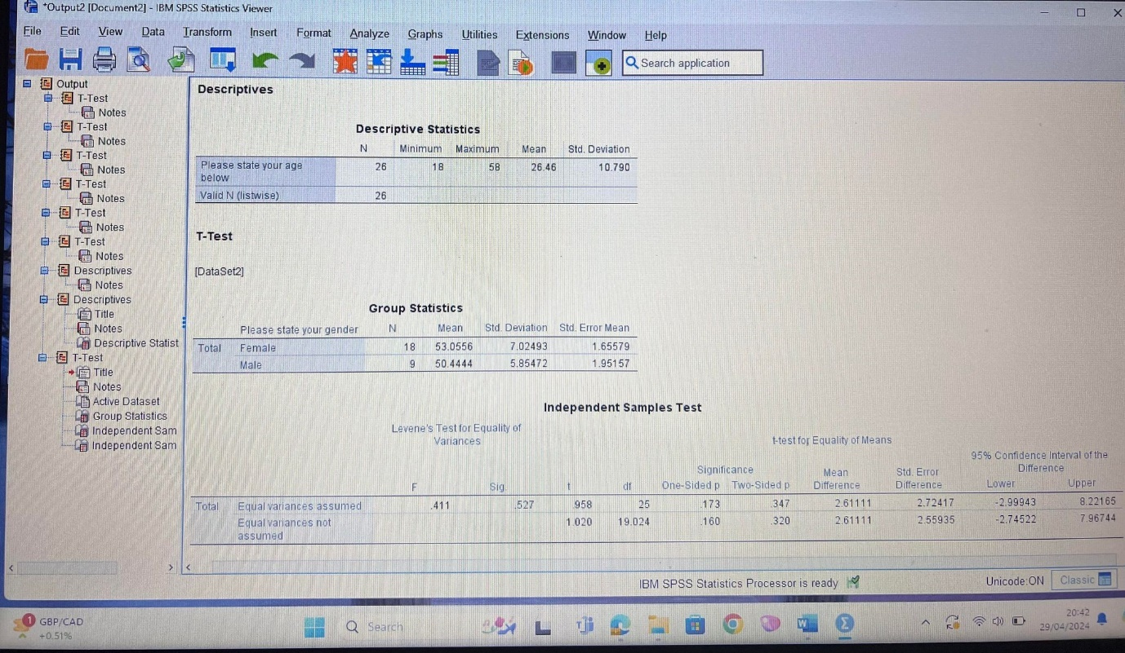

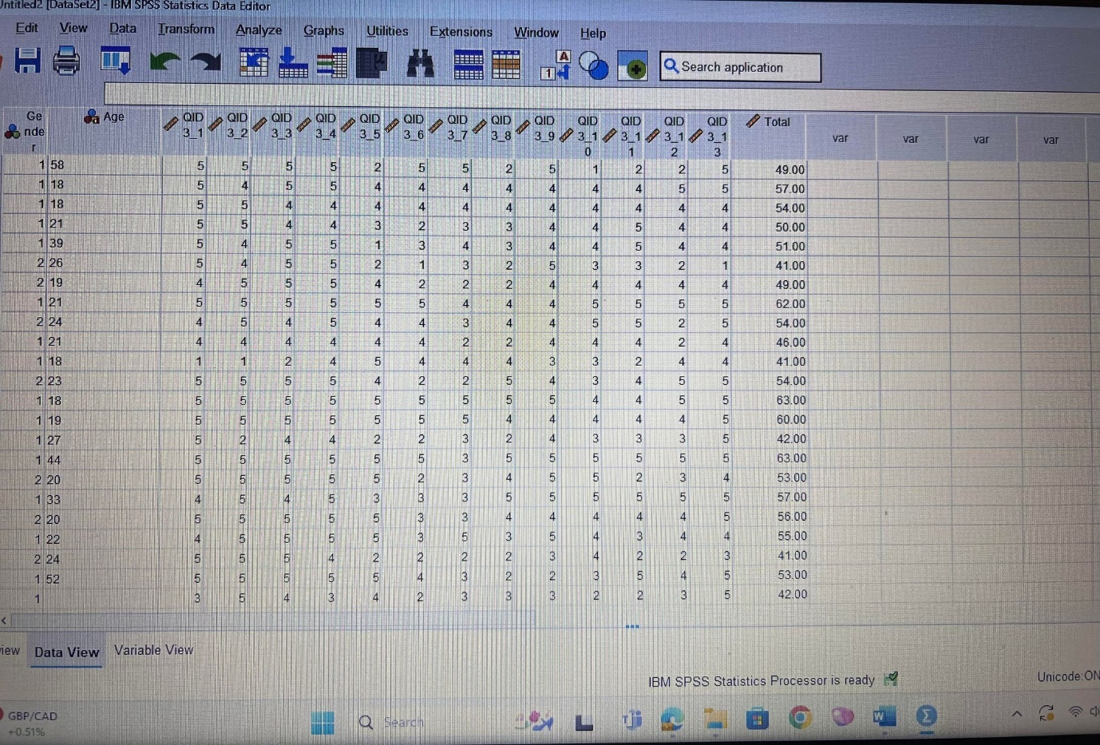
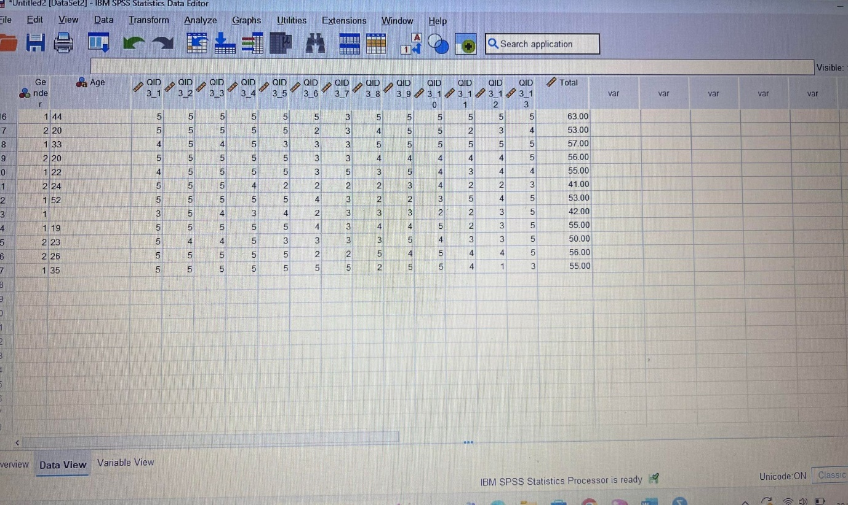

Qualtrics link to the social roles questionnaire study
https://uwtsdyrathrofa.eu.qualtrics.com/jfe/form/SV_807lPudJVuOrRWK

