
Modelling with a simulator in motorsport
M5X1280



University wales trinity st. david
Swansea, SA1
Contents

Intro

What is a sim?
In the last twenty years the use of racing simulators (Sims) has increased in both technological ability and importance. Prior to the rise in simulator usage, motor racing teams, with Formula One as a prime candidate would test extensively. Meaning that they would run cars for long periods on their own test tracks, which has a cost attached to when factoring all the fuel, spare parts, staffing and facilities. Using a simulator uses less of all of those and no fuel at all. There is also an environmental impact to take into account, less of everything mentioned means less carbon dioxide going into the atmosphere. Some teams did more testing than others, it is alleged that when he was racing for Ferrari if Michael Schumacher wasn’t particularly with how the car was performing during testing or qualifying and it was feasible he would fly back to Ferrari’s state of the art, purpose built testing facilities in Fiorino to run different set ups in an attempt to make improvements to the cards performance, before flying back to the race meet. This method must have worked to a certain degree for him since he is one of the most successful Formula One drivers in history. (Eagles, 2019)
With the cost and environmental impact of testing spiralling the Federation Internationale De L'Automobile (FIA) in 2003 placed heavy restrictions on the amount and type of testing being done. These restrictions were reviewed, modified and, in some cases added to. These new rules and regulations are some of the driving factors to the major shift towards the simulators. So to reduce the amount of time that drivers and engineers need for test almost all teams now have a dedicated simulator set up at their headquarters where both test drivers and the teams race drivers can hone their skills, test their set up and learn the track. The simulator is made of four key elements, a full-sized cockpit made to the same specification as their latest car with a fully functioning steering wheel, a 180-degree projector and screen, a high spec computer system and simulator software. Most teams run the rFactor Pro software, a highly accurate recreation software, created in the same way as high-end video games. Which is why the standard version of this type of software is available to the wider consumer market but require significant computer processing power to run. (Eagles, 2019)
The simulators are by definition modelling potential real-life situations. The driver sits in the cockpit while engineers run the software, which then projects the pre-selected track, weather, vehicle conditions and set up onto the screen. Then the myriad of sensors that are connected between the cockpit and the software read and measure the drivers input then replicate how that would affect the vehicle based on the engineer’s software setup. The software is so advanced that the engineers who run it are able to program any weather condition or mechanical failure into the system. (Sakamoto, 2014)
The software then records how the vehicle responds to the driver’s inputs and is able to display it onto computer screens. This information is called telemetry. The drivers and engineers are then able to interpret this data and see where improvements can be made, both with how the driver drives the circuit and how the set-up of the car responds to the conditions of the track and weather conditions. (Sakamoto, 2019)
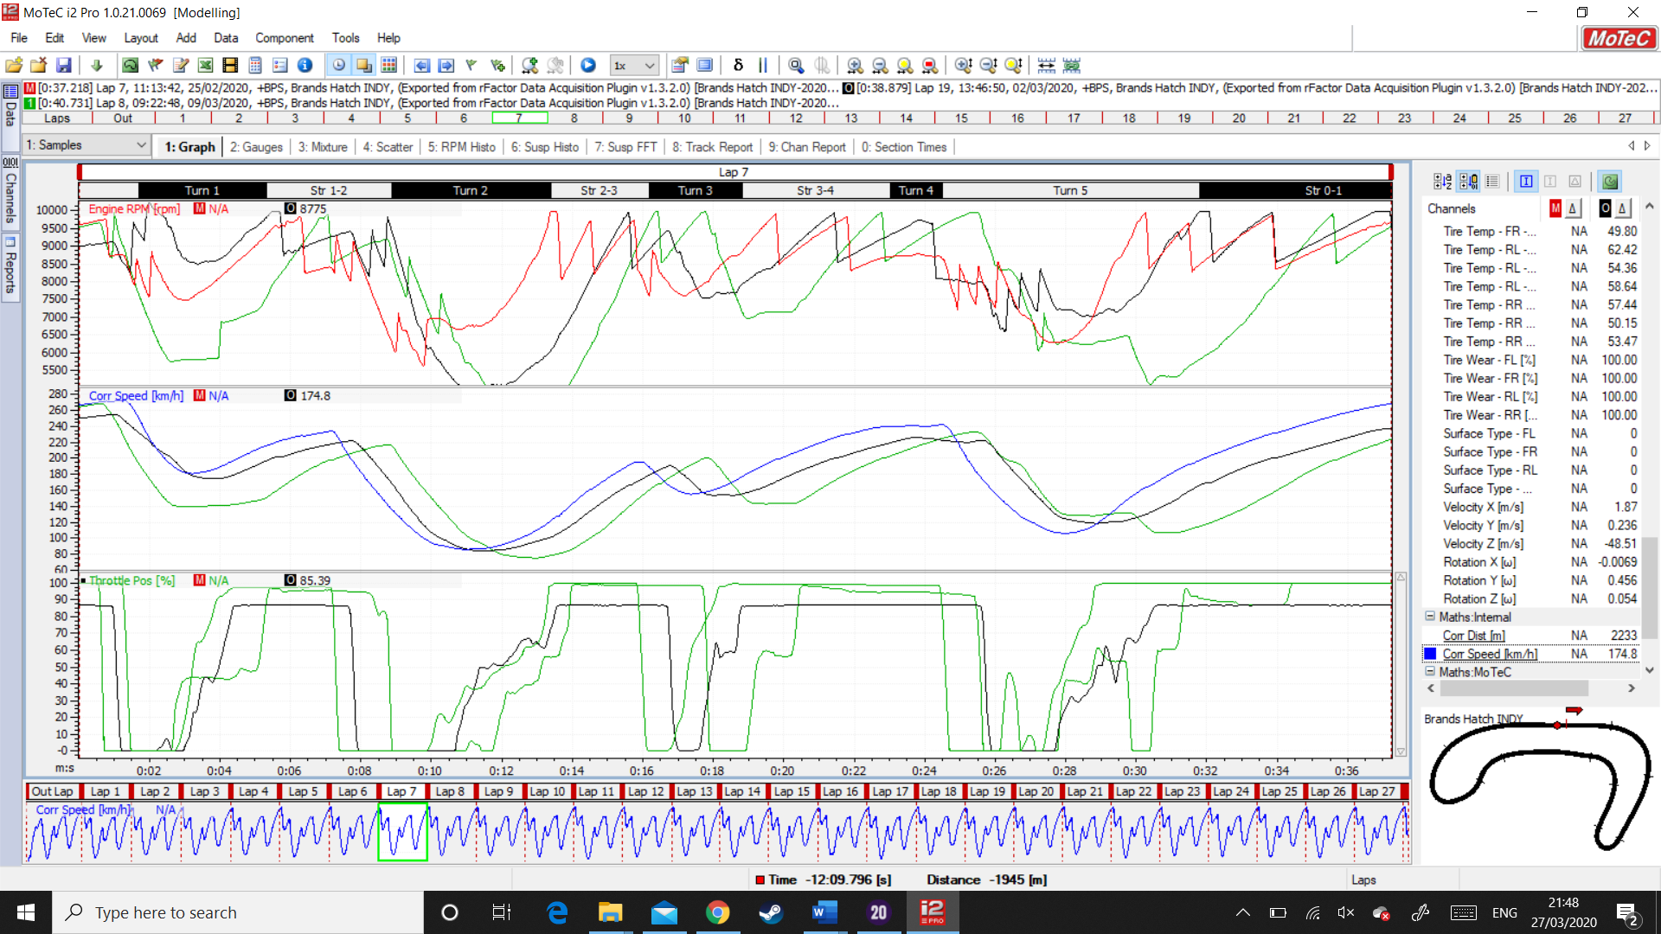
The above image is taken from the software package called Motec. This is part the software that links up to rFactor Pro. The coloured charts above show the best lap time telemetry from three different drivers. Driver one, Mark Reed, driver two Sebastian Birchmore and driver three Ian Newberry. Once this data has been interpreted it shows that Mark Reed is the faster driver, almost two seconds quicker than Sebastian Birchmore who in turn is almost two seconds faster than Ian Newberry. The data shown is taken from each driver’s fastest individual lap. It is possible to look at the total race and analyse the speed difference which shows a more complete picture. Using single lap data like above is useful in that the drivers and engineers are able to work out what Mark Reed is doing differently or better than the other two drivers. By analysing the above data it can be seen that Mark is using different braking points and getting on the power sooner, meaning he is going faster into the corner and accelerating sooner out of the corner. If this becomes a regular pattern at several virtual tracks then it would inform the team of their driver order. In that as the faster driver Mark would be ranked as driver one, Sebastian as driver two, Ian as driver three, or test driver. Once ranked in order of importance, resources would be allocated, generally driver number one would receive more resources then driver two and driver three accordingly.

