DS 1 Template

My Screenshots/Photos
- Please add 4–6 screenshots or photos of your digital life.
- You can use your phone or laptop.
- For each screenshot, write one or two sentences explaining what it shows.

Screenshot/Photo 1
[Insert Photo/Screenshot below]

I use my phone to do my university work media family calls text and internet I use it for apps and understanding my work I use maps to get to university for the trains I learn on my phone I use internet and apps all the time

Screenshot/Photo 2
[Insert Photo/Screenshot below]
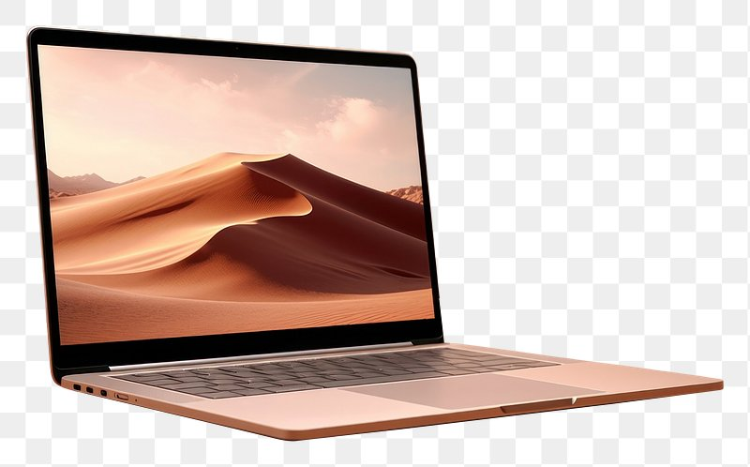
I use the laptop for university studying internet emails reading word to do all my work on upload photos and writing

Screenshot/Photo 3

Screenshot/Photo 4
[Insert Photo/Screenshot below]

[Write what this shows of your digital life]

Screenshot/Photo 5
[Insert Photo/Screenshot below]

I use my smart tv for media and films and documentaries can also join to your mobile phone it keeps me entertained

Screenshot/Photo 6
[Insert Photo/Screenshot below]
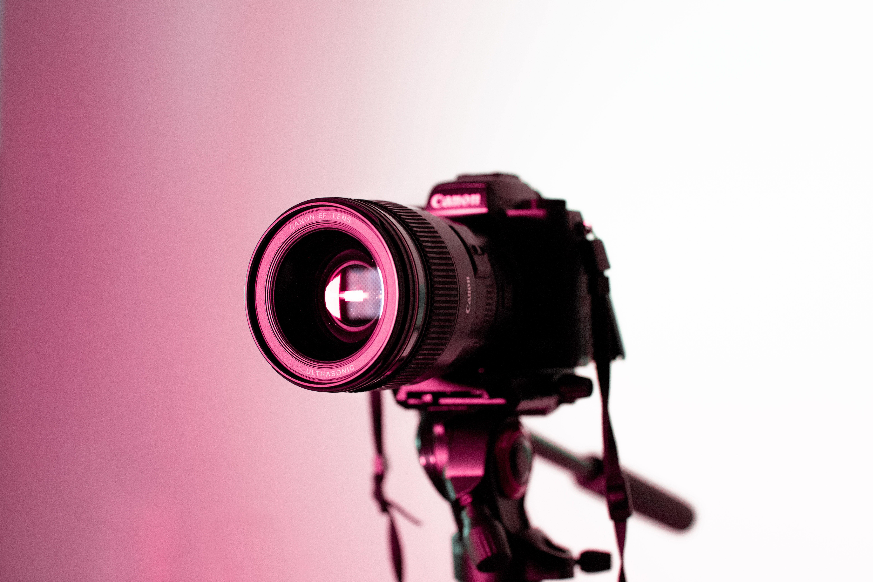
I use camera to take photos of my work emails family time internet

My Short Reflection
- Write 5–8 simple sentences about your digital life.
- You can use the sentence starters below if helpful.
I feel confident when I no what im doing with my work
I use digital tools to do my work
I want to improve my learning skills
I sometimes feel nervous when I don’t understand what im doing

1 RAC (2022) Mobile phone driving laws - what is and isn't illegal? Available at: https://www.rac.co.uk/drive/advice/legal/mobile-phone-laws/ (Accessed: 25 October 2026). [rac.co.uk]
2 Samsung UK (n.d.) What is a Smart TV? | How does a Smart TV work? Available at: https://www.samsung.com/uk/tvs/tv-buying-guide/what-is-smart-tv/ (Accessed: 25 October 2026). [samsung.com]
3 Samsung UK (n.d.) What is a Smart TV? | How does a Smart TV work? Available at: https://www.samsung.com/uk/tvs/tv-buying-guide/what-is-smart-tv/ (Accessed: 25 October 2026).
4 Canon UK (n.d.) Getting started with photography. Available at: https://www.canon.co.uk/get-inspired/tips-and-techniques/photography-for-beginners/ (Accessed: 25 October 2026). [canon.co.uk]

