Assignment 2

Submitted By:
2221048
Sohaan Sureshkumar
Module: Socket Programming & Concurrency
Lecturer: Tim Bashford

Table of Contents
TABLE OF FIGURES 1
INTRODUCTION 2
SOCKET SETUP & TCP/IP 2
HTTP PROTOCOL IMPLEMENTATION 3
FILE SERVING & MIME TYPES 4
CONCURRENCY WITH MULTITHREADING 5
REQUEST LOGGING 7
REFLECTION & FURTHER DEVELOPMENT 7
REFERENCES 8

TABLE OF FIGURES
Figure 1Server startup timestamp confirming successful compilation and launch on port 8080 3
Figure 2 - Terminal output showing raw HTTP requests logged with thread IDs across multiple pages 3
Figure 3 - curl output showing HTTP/1.1 405 response headers including Date, Allow: GET and Connection: close, followed by verbose curl -v connection attempt 4
Figure 4 - index page served at localhost:8080/index.html showing navigation and content 5
Figure 5 - about page served at localhost:8080/about.html showing server description 5
Figure 6 - Terminal output showing multithreaded server handling concurrent requests across multiple routes including /stats 5
Figure 7 - Stats page at localhost:8080/stats showing live request counter and server port 6
Figure 8 - cat log.txt output showing timestamped request log entries with thread IDs 7

INTRODUCTION

I've decided to go with a HTTP web server implemented using only raw POSIX sockets in C++. At first I thought doing a chat server would be a no-brainer to get it done first, but in the end I learned a lot more by going with a web server and it was fun to actually implement a real protocol (HTTP/1.1) as opposed to just making something up for a chat server. My server is multithreaded so it can handle many connections at the same time, it can read files off of the disk, it logs every request with a timestamp and it handles bad requests correctly (including requests that the server does not support). The rest of the report will describe my thoughts during the design and implementation of my solution as well as how it follows good practices for socket programming and concurrent programming.

SOCKET SETUP & TCP/IP

I've chosen to use TCP for the server instead of UDP because HTTP transfers HTML, which is unreliable when packets go missing. TCP provides reliable, connected delivery of a stream of data to the requesting HTTP server [1]. HTTP is a connection-oriented, handshaking transaction with the server before data is transferred.
Server Socket created at // localhost:8080 (IPv4 + TCP) sock_fd = socket(AF_INET, SOCK_STREAM, 0), // AF_INET for IPv4 and SOCK_STREAM for TCP connection. I got “address already in use” error while port testing [2].
Figure 1Server startup timestamp confirming successful compilation and launch on port 8080

HTTP PROTOCOL IMPLEMENTATION

One of the things that I struggled to get right was implementing HTTP correctly. HTTP is a simple text based request/response protocol however every single HTTP response must be in a very specific format: status line, headers and then a blank line (\r\n\r\n) followed by the body of the response. If the structure is wrong, the best that the browser will do is to display nothing at all for the page and the raw text of the response.
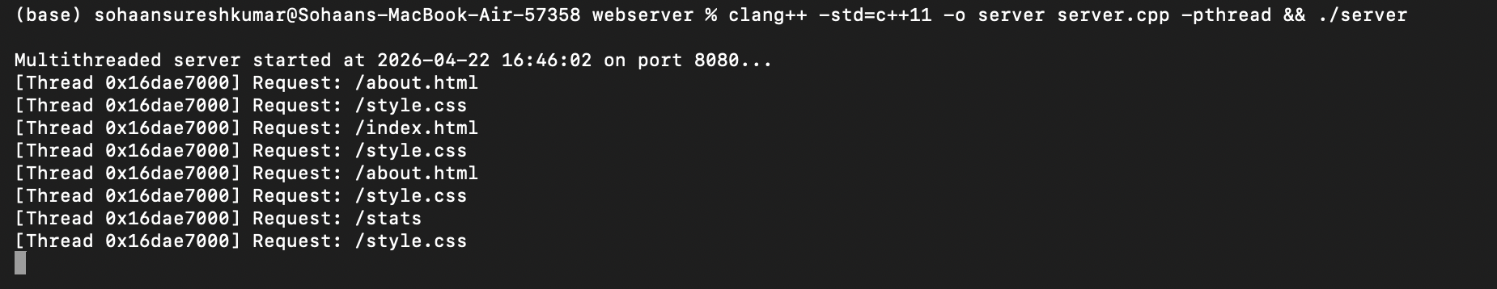
Figure 2 - Terminal output showing raw HTTP requests logged with thread IDs across multiple pages
This post shows exactly how Chrome sends requests and also explains the sec-ch-ua header. We process the request path in the same way as we process the url argument on the command line ie the second token of the first line of the request is read in a string stream and processed as if it were a command-line option.
The server supports several HTTP Status Codes. The status codes that this server supports are: 200 OK (File was retrieved successfully), 404 Not Found (File does not reside on this web server), 405 Method Not Allowed (All other HTTP commands are not allowed for this server, only GET commands are supported.). The HTTP/1.1 specification requires the server to inform the client of all supported commands in the 405 response. For this server, the 405 response is:” Allow: GET”. The HTTP/1.1 specification requires origin servers to include a Date header in all HTTP responses [3].
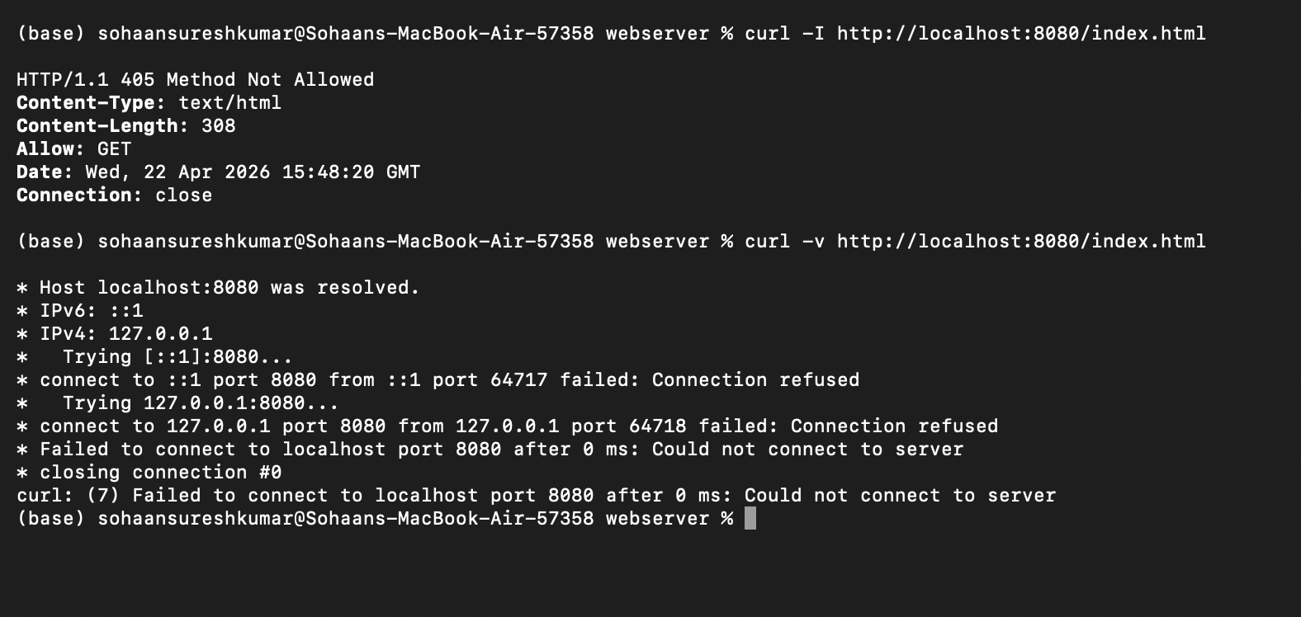
Figure 3 - curl output showing HTTP/1.1 405 response headers including Date, Allow: GET and Connection: close, followed by verbose curl -v connection attempt

FILE SERVING & MIME TYPES

Instead of server generating HTML, it can serve files from ./www directory and browser can render it like normal website. Server decodes request made by browser (e.g. GET /about.html) to local file path (e.g. ./www/about.html). Then it reads the file from that path using stream (in this example it is std::ifstream). If file does not exist then is_open() function will return false and server will serve 404 error.
After basic HTTP retrieval, I wanted to extend this to be able to properly render HTML, which the browser does by using the Content-Type header to determine how to render the retrieved data. For example, HTML and PHP files are treated as HTML, and .css files are treated as plain text. After some research, I found that most registered media types are stored in a hash table in PHP, so I made a function detectMimeType() that checks the extension of the file to be retrieved, and returns the proper content type [4].
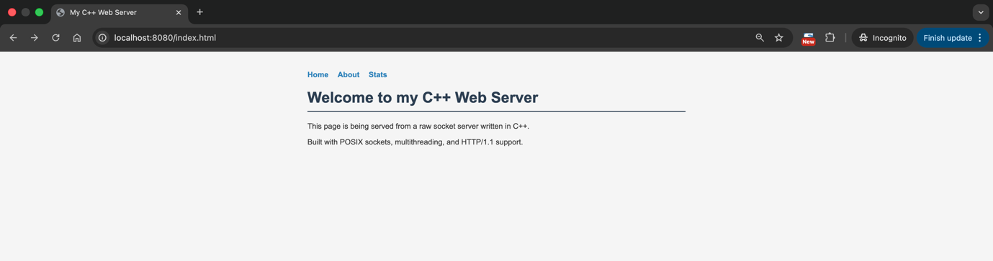
Figure 4 - index page served at localhost:8080/index.html showing navigation and content

Figure 5 - about page served at localhost:8080/about.html showing server description

CONCURRENCY WITH MULTITHREADING

In the first single-threaded server version of the code, the function handleConnection() was called for each connection. However, if one connection took a long time for some reason, all other connections would have to wait for it, which is known as I/O blocking in networked applications and is a problem that many programmers encounter [5].
So far, we have been running all of our code in the main thread, which waits until a connection has finished before accepting new connections. However, it’s also possible to run code in additional threads; in this case, we spawn a new thread for each connection, run it and then detach it, allowing the main function to return and start accepting new connections .
Figure 6 - Terminal output showing multithreaded server handling concurrent requests across multiple routes including /stats
Single-threaded is easy, multithreaded is harder still. One of the things multithreaded introduces is shared state, and in this the log file is shared state. Two threads are trying to write to it at the same time, which is a race condition. I used a std::mutex to lock the file while it was being written, and an std::lock_guard to lock the mutex. The lock guard automatically locks the mutex in its constructor and unlocks it in its destructor, which means I don’t have to explicitly unlock it, which is a lot safer [6].
The request counter on the /stats page used to be protected by a mutex, but that has now been changed to use std::atomic<int>. Atomic types allow lock-free indivisible operations, like the increment operator, which means you can never read a half-updated value, but don't require the lock to be held by all threads for the entire time. In this case, an atomic<int> is just enough [7].
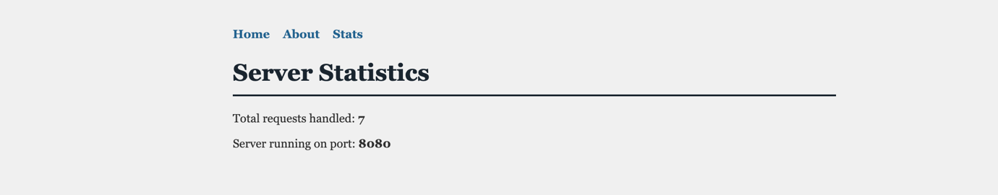
Figure 7 - Stats page at localhost:8080/stats showing live request counter and server port

REQUEST LOGGING

Each and every request is logged to disk in the file log.txt. The log contains a line for each request, which contains a timestamp and the ID of the thread that serviced the request. The ID of the thread servicing a request can sometimes help understand why a request failed. By logging each request to disk the server becomes observable, i.e. you can see what the server is doing in production. A single mutex is used to guard the file locks for all threads, which prevents any interleaved writes to disk but means that the log is always readable. The timestamp is generated by std::strftime() and the thread ID is generated by std::this_thread::get_id().
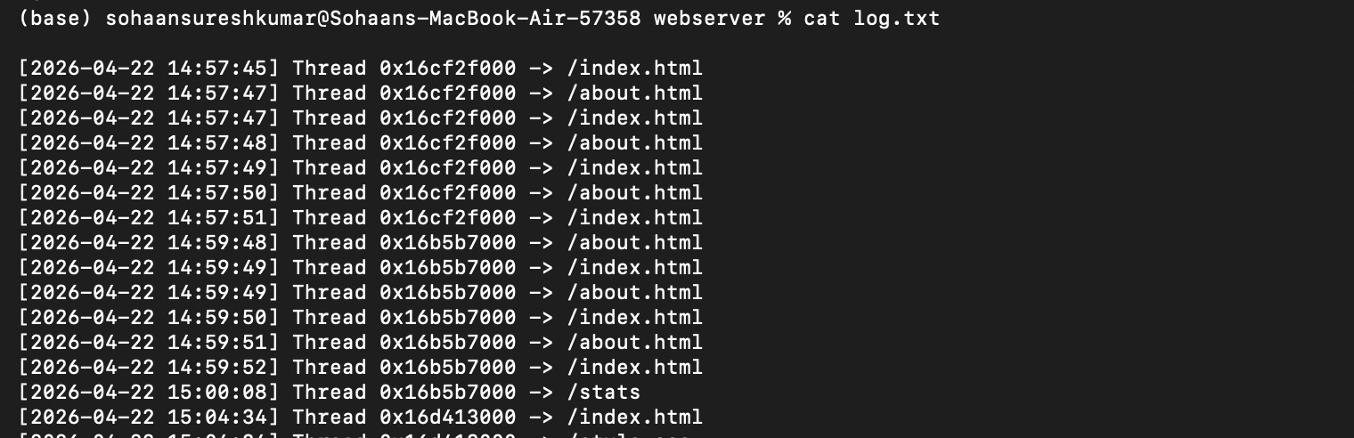
Figure 8 - cat log.txt output showing timestamped request log entries with thread IDs

REFLECTION & FURTHER DEVELOPMENT

I'd want to move to a thread pool rather than making a new thread for each connection. Unbounded thread creation is a DoS risk, and a fixed number of worker threads consuming from a shared request queue is better [8].
We could also support HTTPS, persistent connections (keep-alive) and binary file I/O for files with extensions like .jpg.

REFERENCES
[1]
A. S. Tanenbaum and D. Wetherall, Computer networks. Harlow, Essex: Pearson Education, 2014.

[2]
W Richard Stevens, B. Fenner, and A. M. Rudoff, UNIX network programming. Volume 1, The sockets networking API. Boston, Ma: Addison-Wesley, 2004.

[3]
“rfc7231,” datatracker.ietf.org. Available: https://datatracker.ietf.org/doc/html/rfc7231

[4]
“Media Types,” Iana.org, 2019. Available: https://www.iana.org/assignments/media-types/media-types.xhtml

[5]
M. Kerrisk, The Linux progamming interface : a Linux and UNIX system programming handbook. San Francisco: No Starch Press, 2010.

[6]
Bjarne Stroustrup, The C++ Programming Language, 4th ed. Addison-Wesley, 2013.

[7]
R. Terrell, Concurrency in .NET. Simon and Schuster, 2018.

[8]
D. Lea, Concurrent programming in Java : design principles and patterns. Reading, Mass.: Addison Wesley, 2008.

