UNIVERSITY OF WALES TRINITY SAINT DAVID
LONDON CAMPUS
Assignment 2
Learning in the Digital Era
Video Link: https://youtu.be/aYYO4PtReOU
Module Name: Learning in the Digital Era
Module Code: ACCA 4025

Student Name: Bonssa Abdulaziz
Student ID: 2510399
Group: 3

Lecturer’s Name: Fahad Ahmed

Table of Contents
Introduction 2
Main Body 2
Conclusion 9
References 9

Introduction
This a presentation on self-evaluation, a professional development plan, and assigned topic summary.

Main Body

Slide 1 COVER PAGE
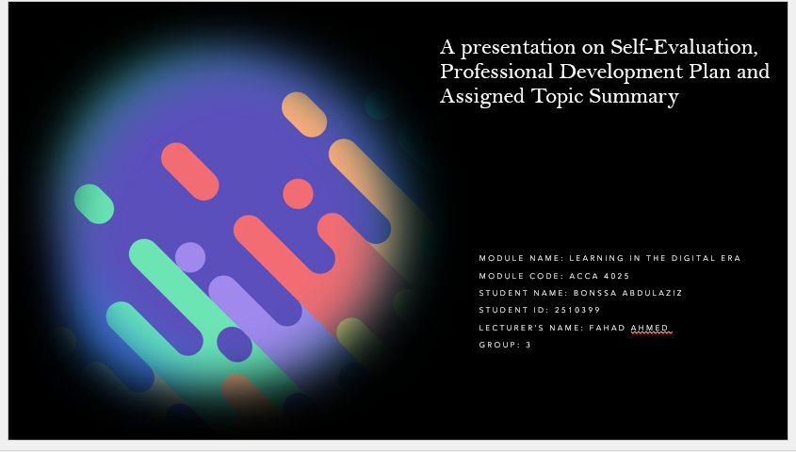

Slide 2 CONTENTS

Slide 3 INTRODUCTION
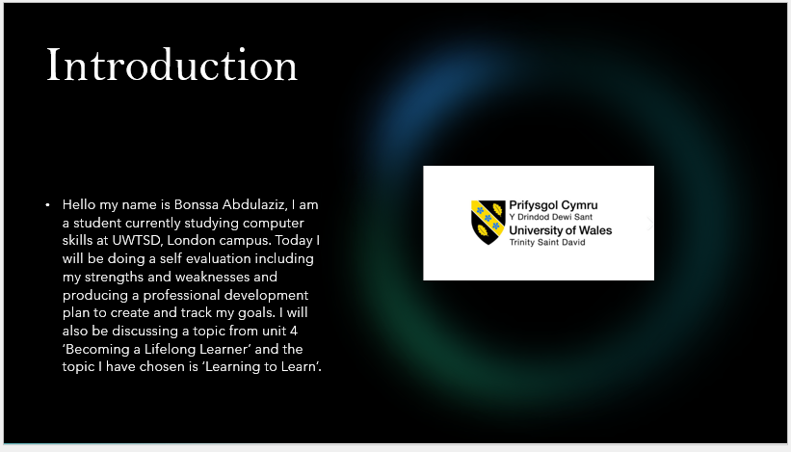

Slide 4 MAIN BODY

Slide 5 GIBB’s REFLECTIVE MODEL
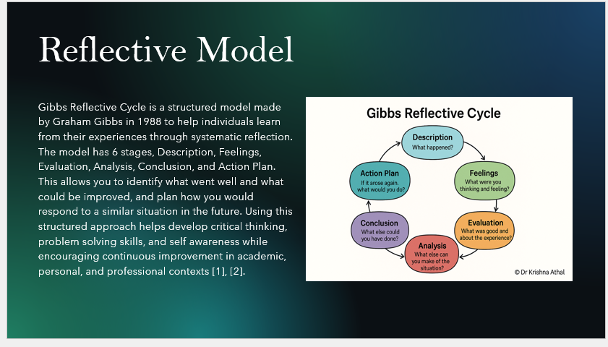

Slide 6 TASK 1: SELF EVALUATION
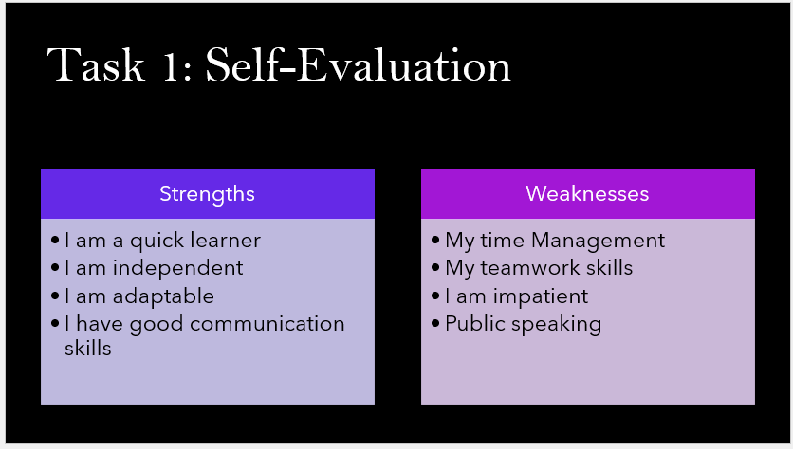

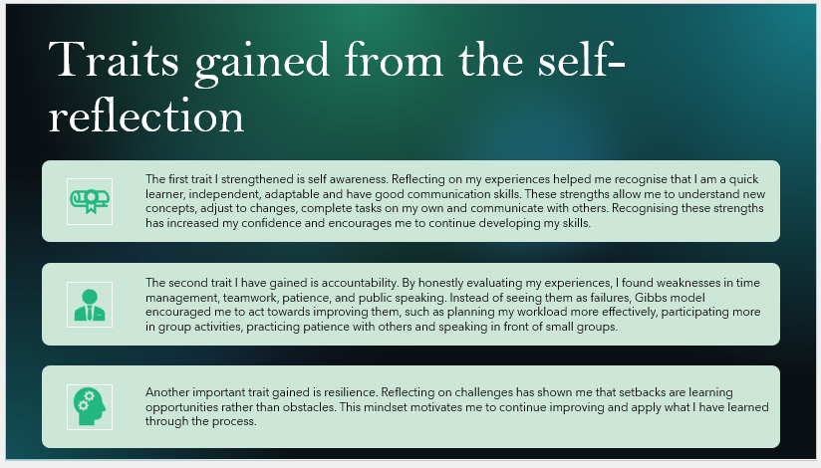
Slide 7 TRAITS GAINED FROM THE SELF EVALUATION

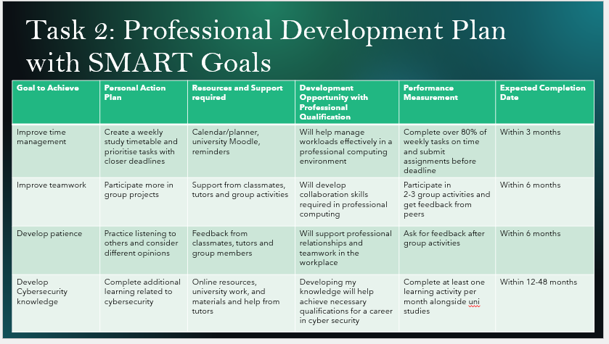
Slide 8 TASK 2 PROFESSIONAL DEVELOPMENT PLAN

Slide 9 PROFESSIONAL DEVELOPMENT PLAN
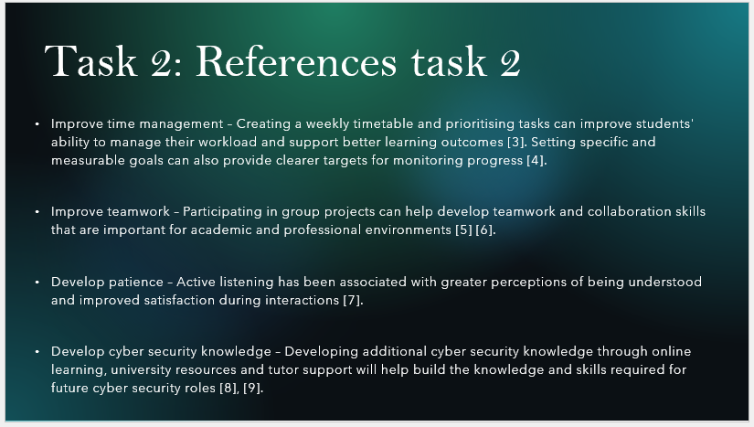

Slide 10 TASK 3 UNIT 4 TOPIC SUMMARY
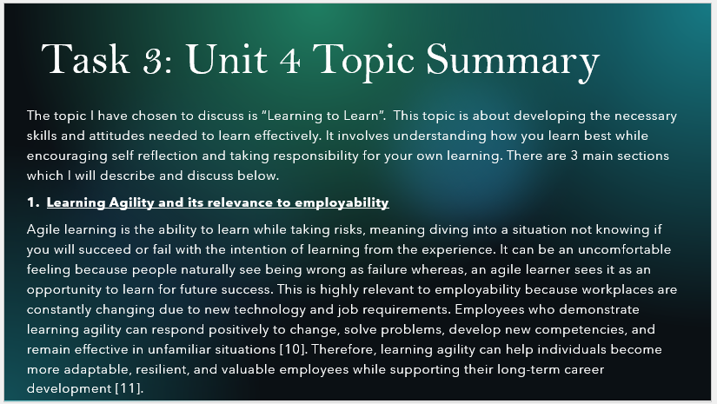

Slide 11 UNIT 4 TOPIC SUMMARY
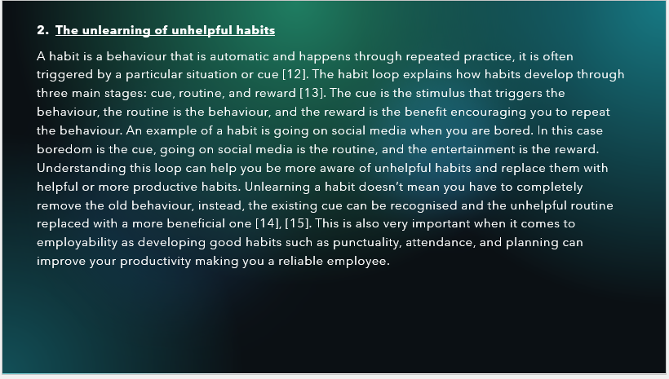

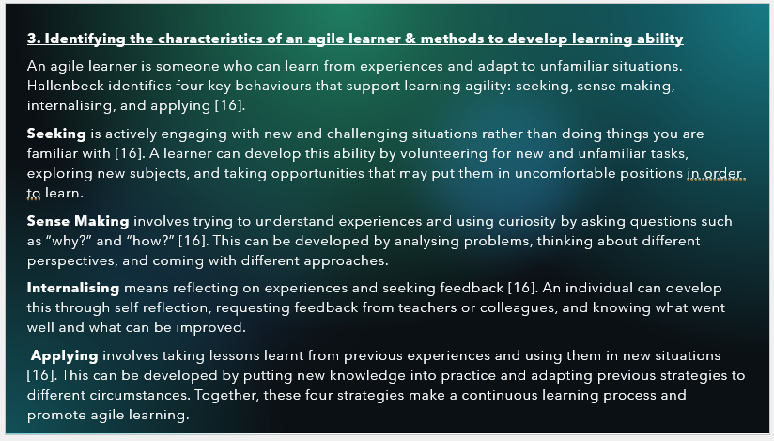
Slide 12 UNIT 4 TOPIC SUMMARY

Slide 13 CONCLUSION
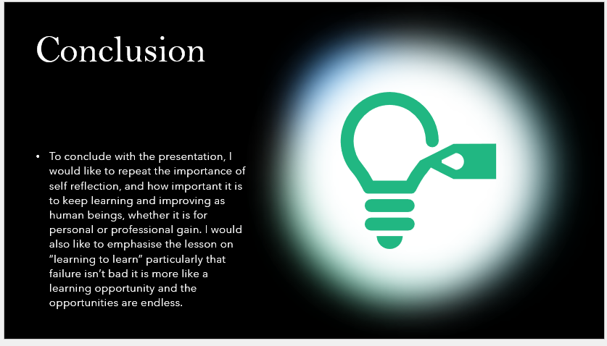

TASK 4 VIDEO PRESENTATION
https://youtu.be/aYYO4PtReOU
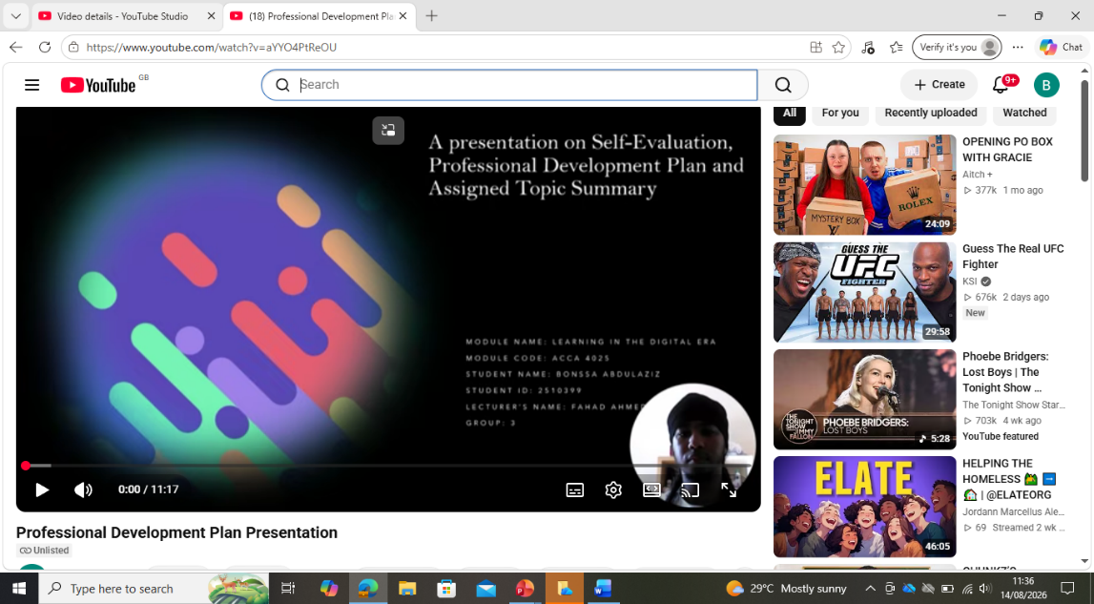

https://uowtsd-my.sharepoint.com/:p:/g/personal/2510399_student_uwtsd_ac_uk/IQBJs8XAtbRKSYeTap4v0mm4AdoFNPEG3zBlrM6Vyx8lj5o?e=R8xuah

Conclusion
This is my complete assignment including my power point presentation.

References
- [1] G.Gibbs, Learning by Doing: A Guide to Teaching and Learning Methods. Oxford, U.K.: Oxford Polytechnic, 1988.
- [2] J. Moon, Reflection in Learning and Professional Development: Theory and Practice. London, U.K.: Routledge Falmer, 1999.
- [3] B. Liu, P. Ma, and F. Jia, “Systematic review and meta – analysis of the impact of time management on college students’ learning outcomes.” Frontiers in Psychology, vol. 17, 2026.
- [4] E. A. Locke and G.P. Latham, “New directions in goal-setting theory,” Current Directions in Psychological Science, vol.15, no. 5, pp. 265 – 268, 2006.
- [5] D. McEwan, G. R. Ruissen, M. A. Eys, B. D. Zumbo, and M. R. Beauchamp, "The effectiveness of teamwork training on teamwork behaviors and team performance: A systematic review and meta-analysis of controlled interventions," PLoS ONE, vol. 12, no. 1, 2017.
- [6] S. L. Marlow, C. N. Lacerenza, J. Paoletti, C. S. Burke, and E. Salas, "Does team communication represent a one-size-fits-all approach? A meta-analysis of team communication and performance," Organizational Behavior and Human Decision Processes, vol. 144, pp. 145-170, 2018.
- [7] H. Weger, G. C. Bell, E. M. Minei, and M. C. Robinson, "The relative effectiveness of active listening in initial interactions," International Journal of Listening, vol. 28, no.1, p. 13-31, 2014.
- [8] R. Petersen, D. Santos, K. Wetzel, M. Smith, and G. Witte, Workforce Framework for Cybersecurity (NICE Framework), NIST Special Publication 800-181 Rev. 1, National Institute of Standards and Technology, Gaithersburg, MD, USA, 2020.
- [9] National institute of Standards and Technology, “Workplace skills and the NICE Framework,” NIST, 2024.
- [10] C. M. Lombardo and R. W. Eichinger, The Leadership Machine: Architecture to Develop Leaders for Any Future. Minneapolis, MN, USA: Lominger International, 2000.
- [11] Chartered Institute of Personnel and Development, “Learning and skills at work,” CIPD, London, U.K.
- [12] W. Wood and D. T. Neal, “A new look at habits and the habit-goal interface,” Psychological Review, vol. 114, no. 4, pp. 843–863, 2007.
- [13] C. Duhigg, The Power of Habit: Why We Do What We Do in Life and Business. New York, NY, USA: Random House, 2012.
- [14] A. Gardner, J. de Bruijn, and M. Lally, “Making health habitual: the psychology of ‘habit-formation’ and general practice,” British Journal of General Practice, vol. 62, no. 605, pp. 664–666, 2012,
- [15] G. Hallenbeck, Learning Agility: Unlock the Lessons of Experience. Greensboro, NC, USA: Center for Creative Leadership, 2016.

