BA Fine Art: Studio, Site and Context

Ways of Thinking (ADAD4018)

Essay: Auto-Ethnographic exploration of an exhibition

Word count: 1552 + bibliography
23 November 2021

Lines Made by Walking: Igshaan Adams and Richard Long

One of the central themes in Igshaan Adams’ recent exhibition Kicking Dust (2021) is the notion of ‘desire lines’, paths trodden over time as people go about their daily lives. Five decades earlier, Richard Long made his seminal Line Made By Walking (1967), another path trodden over ground. While both centre on the traces of walking, these works raise very different questions about the meanings and possibilities of bodies walking through space. This essay draws on insights from Michel De Certeau and Gilles Deleuze to explore these questions.

The politics and philosophy of walking
Many writers, artists and philosophers from Henry Thoreau, Jean-Jacques Rousseau and Martin Heidegger to André Breton and Guy Debord have engaged in walking as a reflective practice (Gros 2014). Walking in the countryside offers an opportunity for direct authentic experience as a counter to the commodified and mediated character of capitalist life (Gros 2014). Walking in the city as a ‘flâneur’ (Benjamin 1999) or following a Situationist ‘dérive’ (Debord 1958) offers a strategy of critical inquiry or counter-cultural resistance (Solnit 2001). However, Matthew Beaumont (2015: 117-119) cautions that the celebration of walking can become a retreat from politics.

The work of De Certeau and Deleuze avoids this by foregrounding relationships between walking and power. De Certeau’s analysis of practices of everyday life examines tactics of resistance in the face of controlling order. He explores how everyday walking counters broader systems of power enacted in space. He conceives of walking as an act of enunciation, an inventive strategy on the part of the pedestrian to negotiate, appropriate and subvert an order imposed by concentrated powers of the state and capital (De Certeau 1988). Given the concentrated administrative powers of capitalist society, he argues, spatial practices ‘structure the determining conditions of social life’ (De Certeau 1988: 96). The relationship between the body and its surroundings therefore becomes an inherent terrain of power, control and resistance. Walking is ‘an act of appropriation’, forging place through spatial practice, which ‘implies relations among differentiated positions’ (ibid.: 97-8).

In highlighting the relationship between spatial practices and the constructed order De Certeau foregrounds a dynamic process of reconfiguration, as ‘practices of space also correspond to manipulations of the basic elements of a constructed order’ (ibid.: 100). This resonates with Deleuze and Guattari’s notion of ‘deterritorialisation’. Deleuze and Guattari developed a new relational metaphysics based on process, flow, change and difference as opposed to the essences, objects and identities of western philosophy (Sweet et al. 2021). ‘Deterritorialisation’ and ‘reterritorialisation’ refer to processes of change: an unravelling of existing logics which configure a set of related entities, and a re-embedding in new configurations (Parr 2010). The notion of territory, developed in their exploration of how birds configure their surroundings through song, is not specific to land; it can apply to any structured context or milieu whose character is shaped by a configuration of relations (Bogue 1999). The concept of deterritorialisation can highlight processes of reconfiguration in numerous contexts and on different scales, from birdsong to the deterritorialising tendencies of capital (Jameson 1999).

Exploring the work of Long and Adams with these insights means asking: what is being changed by the practice of walking in the work of art? And, why and how does this matter?

Richard Long: Deterritorialising Modernism

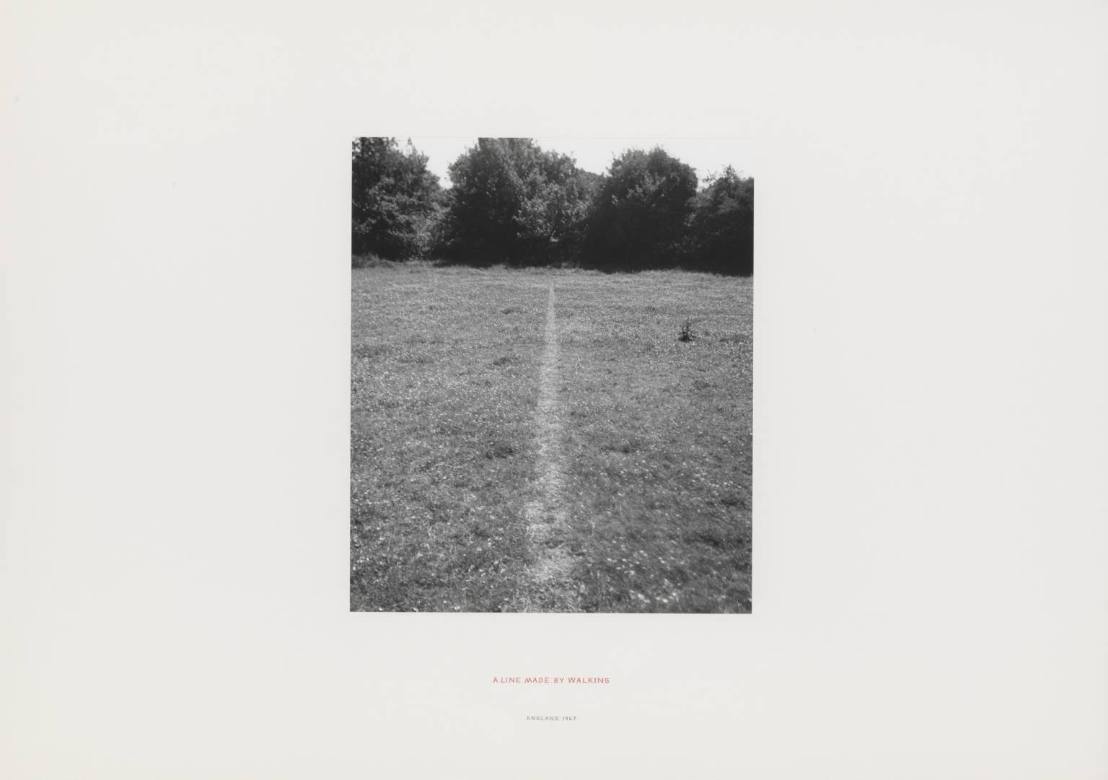
Fig 1 Richard Long A Line Made by Walking 1967
Source: https://www.tate.org.uk/art/artworks/long-a-line-made-by-walking-ar00142

One day in June 1967 a young art student, Richard Long, went by train to the countryside south of London, found a field, and walked backwards and forwards in a straight line until his footsteps had worn a visible imprint in the grass (Roelstraete 2010). He then took a black and white photograph of this trodden line, which has been exhibited in galleries and reproduced in countless books.

What is changed by Long’s act of walking? This simple work made a major contribution to mid twentieth century Western contemporary art, prompting a ‘revolutionary blurring of disciplinary boundaries between methods and forms, on the one hand, and form and content, on the other’ (Roelstraete 2010: 3). In her seminal essay ‘Sculpture in the expanded field’ Rosalind Krauss (1985: 287) argued that through ‘the application of impermanent marks’ and ‘the photographic experience of marking’, Long and others effected a historical rupture with modernism in terms of the practice of the artist and in terms of the medium. This suggests that it was the milieu of contemporary art which was deterritorialised by Long’s work.

Others have commented that his work lacks a ‘social dimension’ (Godfrey 1998: 267). Long (1991: 92) describes his works as self-sufficient, carrying no meaning beyond the marks of a body on earth: ‘my works should be completely self-contained, they shouldn’t need any explanations or references, they should be things or ideas in their own right’. This simplicity could embody a universality, as Seymour (1991: 27) observes ‘To walk a line is the easiest thing a human being can do to put his mark on a place’. However in many places across the world, access to rural or urban space is controlled and restricted by private property and borders which keep people out, enacting the race- and class-based exclusions of colonialism and capitalism.

These structures of power are not unconnected to what Jay (1993) calls the ‘scopic regimes of modernity’. Since the start of European expansion in the 1400s there has been a close relationship between Western visual practice and colonialism (Ramaswamy 2014). Technologies of vision such as cartesian perspective, scientific mapping, landscape painting and photography, though never reducible to colonial practice, developed alongside European conquest of non-European lands and peoples: ‘seeing and painting, art and science were intimately connected to knowing, possessing, and owning’ (ibid.: 29). Colonial exploration, an integral act leading to conquest, implied a visual imagination of the heroic explorer and far-away empty lands (Thomas 2015).

Elaborating Godfrey’s comment on the lack of social dimension, Iwan Bala (2002: 36) argues that Long’s practice is unwittingly characterised by tropes of the imperial vision, a ‘subliminal colonialist hangover’: the lone white male explorer walking across empty uninhabited lands with no restrictions to access. Long’s dehistoricised works in unpeopled landscapes across the world leave untouched this broader visual and political territory, silently resonating with the ‘scopic regime’ or milieu of colonial modernity.

Igshaan Adams: Deterritorialising Apartheid
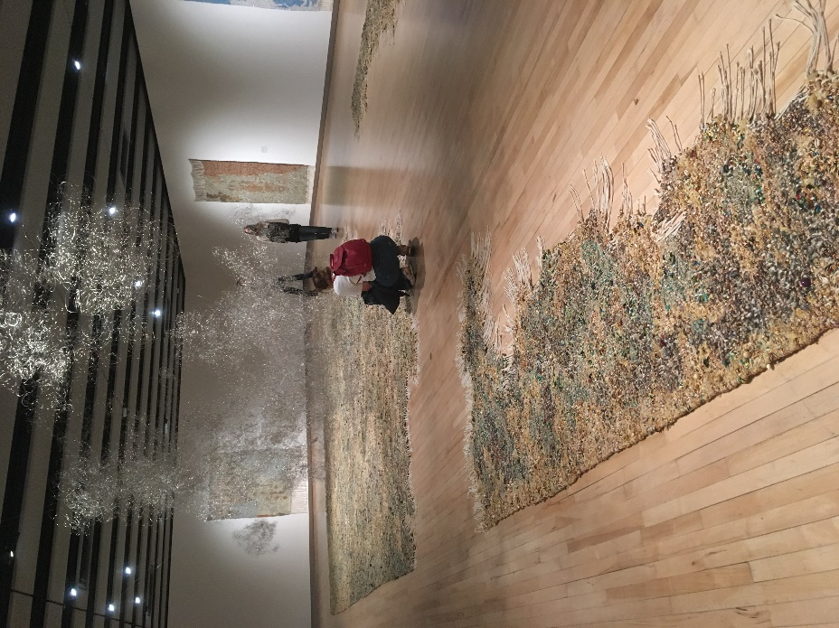
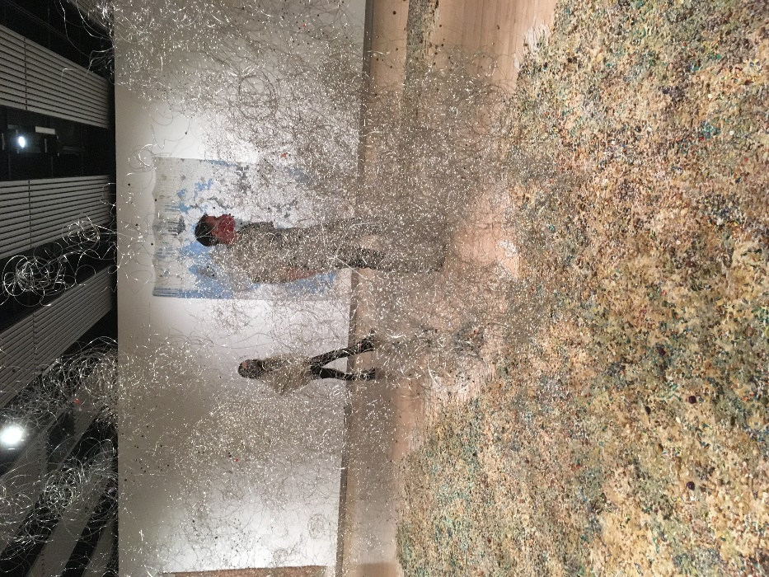
Fig 2 Igshaan Adams: Kicking Dust, Hayward Gallery, London 2021. Installation view
Source: author’s photographs

The main piece in Adams’ exhibition Kicking Dust (2021) occupies the whole of the gallery floor: a large work of intricate woven matter traversed by winding gaps through which the viewer can walk. These gaps depict ‘desire lines’, the paths trodden over time by residents of townships on the edge of Cape Town as they cross between adjacent neighbourhoods. The idea of ‘desire lines’ is used by urban planners to describe informal paths formed as people make their way through urban or rural space according to their own needs rather than following designated pathways (Malone 2019). Adams focuses on these paths because they signify practices of human connection in the face of imposed separation under apartheid.

The apartheid state employed spatial practices of separation to structure social life in the city according to race (Robinson 1996). The racial ideology of apartheid entailed a rigid classificatory system which defined all South Africans as belonging to a specific racial group – white, black, Indian, Chinese, Cape Coloured: ‘race classification and reclassification provided the bureaucratic underpinnings for a vicious racism’ (Bowker and Star 1999: 195-6). The apartheid city was designed as a set of containerised spaces built to keep racial groups separate (Coetzer 2016). However, Adams (2021) narrates how residents of neighbouring townships, categorised as Black on one side and Coloured on the other, repeatedly mixed together. Their everyday practices of walking between the separate townships created paths which disrupted the imposed order of racial separation; thus, De Certeau (1988: 97) says, the ‘long poem of walking manipulates spatial organizations, no matter how panoptic they may be’.

There are multiple layers of deterritorialisation in this work: the practice of walking, the materiality of the work, and its contribution to debates about art and history. The urban residents through their daily interactions effected a reterritorialisation of space, deterritorialising the imposed logics of racial control and instead weaving relations of connection. Adams uses recycled rope and beads to form the ground between the paths, weaving ‘the patches that had not been worn out by the pathway, and the actual pathway itself then becomes exposed gallery floor’ (Adams 2021). The very process of weaving enacts deterritorialisation: ‘weaving is just a kind of ordering of material in a particular way. With the sculptures … it’s the entanglement. It’s the unweaving, the undoing of that and then how those threads are entangled afterwards.’ (Ibid.) Finally, by inviting the viewer ‘to walk the actual path that other peoples had walked’ (ibid.), the work brings the deterritorialisation of apartheid into the Western gallery and the viewer’s embodied experience, effecting a further deterritorialisation of historical narrative, and a reterritorialisation of understanding.

Conclusion
The works of Long and Adams occupy the shared ground of lines made by walking, but differ greatly in other ways. Exploring their divergent concerns and practice offers a rich counterpoint which brings deterritorialising logics to western art and its milieu of colonial modernity through the poetry of walking. Richard Long’s seminal contribution effected a rupture in modernism with the idea that walking could be sculpture. Igshaan Adams ruptures the racialised logics of apartheid through weaving embodied paths of everyday connection.

Bibliography

Sources referenced
Books and book chapters
Bala, Iwan (2002) ‘Processes of decolonisation’ in David Alston, Iwan Bala, Susan Daniel-Mcelroy, Tim Davies, Anne Price-Owen Process. Explorations of the work of Tim Davies. Bridgend: Seren Books, pp. 19-38

Benjamin, Walter (1999) The Arcades Project. trans. Howard Eiland and Kevin McLaughlin, ed. Rolf Tiedeman. Cambridge, MA: Harvard University Press

Bogue, Ronald (1999) ‘Art and Territory’ in Buchanan, Ian (ed) A Deleuzian century? Durham, N.C.: Duke University Press, pp. 85-102

Bowker, Geoffrey C. and Susan Leigh Star (1999) ‘The Case of Race Classification and Reclassification under Apartheid’ in Sorting Things Out: Classification and its Consequences. MIT Press, pp. 195-225

Coetzer, Nic (2016) Building Apartheid: On Architecture and Order in Imperial Cape Town. London: Routledge

De Certeau, Michel (1988) ‘Walking in the City’ in The Practice of Everyday Life. Berkeley: University of California Press, pp. 91-110

Debord, Guy (1958) ‘Theory of the Dérive’ in Knabb, Ken (ed) Situationist International: Anthology. Revised and Expanded Edition, 2006. Berkeley, CA.: Bureau of Public Secrets, pp. 62-66

Gros, Frédéric (2014) A Philosophy of Walking. trans. John Howe. London: Verso

Godfrey, Tony (1998) Conceptual Art. London: Phaidon

Jameson, Fredric (1999) ‘Marxism and Dualism in Deleuze’ in Buchanan, Ian (ed) A Deleuzian century? Durham, N.C.: Duke University Press, pp. 13-36

Jay, Martin (1988) ‘Scopic Regimes of Modernity’ in Force Fields: Between Intellectual History and Cultural Critique. London: Routledge, pp. 114-133

Krauss, Rosalind E. (1985) ‘Sculpture in the expanded field’ in The Originality of the Avant-Garde and Other Modernist Myths. Cambridge, MA: MIT Press, pp. 276-290

Long, Richard (1991) ‘Fragments of a conversation V’ in Seymour, Anne and Richard Cork, Richard Long: Walking in Circles. London: Thames & Hudson, pp. 91-93

Malone, Lesley (2019) Desire Lines: A Guide to Community Participation in Designing Places. London: RIBA Publishing

Parr, Adrian (2010) ‘Deterritorialization/Reterritorialization’ in Adrian Parr (ed) The Deleuze Dictionary. 2nd edn. Edinburgh: Edinburgh University Press, pp. 69-72

Ramaswamy, Sumathi (2014) ‘The Work of Vision in the Age of European Empires’ in Jay, Martin and Ramaswamy, Sumathi eds, Empires of Vision: A Reader. Durham NC: Duke University Press, pp. 1-22

Roelstraete, Dieter (2010) Richard Long: A Line Made by Walking. London: Afterall Books

Robinson, Jennifer (1996) The Power of Apartheid: State, Power and Space in South African Cities.
Oxford: Butterworth-Heinemann

Seymour, Anne (1991) ‘Walking in Circles’ in Seymour, Anne and Richard Cork, Richard Long: Walking in Circles. London: Thames & Hudson, pp. 6-39

Solnit, Rebecca (2007) Wanderlust: A History of Walking. London: Verso

Thomas, Martin, ed. (2015) Expedition into Empire: Exploratory Journeys and the Making of the Modern World. Routledge, New York

Journal articles
Beaumont, Matthew (2015) ‘A Philosophy of Walking by Frédéric Gros, Review’ Critical Quarterly 57 (1): 116-119

Interviews and radio programmes
Adams, Igshaan (2021) Igshaan Adams: Interview with curator Tarini Malik. Hayward Gallery, London, April 26 [video]. Available at: https://www.youtube.com/watch?v=YYYIMAxEg2w (Accessed: 2 November 2021)

Sweet, Matthew, Henry Somers-Hall, Claire Colebrook and Ian Parker (2021) Deleuze and Guattari, Capitalism and Schizophrenia episode of Free Thinking, BBC Radio 3. Available at: https://www.bbc.co.uk/programmes/m000twk8 (Accessed: 18 October 2021)
Exhibitions
Igshaan Adams: Kicking Dust (2021) [Exhibition]. Hayward Gallery, Southbank Centre, London. 19 May-25 July.

List of Figures
Fig 1 Richard Long A Line Made by Walking 1967
Source: https://www.tate.org.uk/art/artworks/long-a-line-made-by-walking-ar00142

Fig 2 Igshaan Adams: Kicking Dust, Hayward Gallery, London 2021. Installation view
Source: author’s photographs

Additional sources consulted in research for the essay
Benjamin, Walter (1999) ‘The work of art in the age of mechanical reproduction’ in Hannah Arendt (ed) Illuminations. London: Random House, pp. 211–244

Debord, Guy (1992) Society of the Spectacle. Trans Ken Knabb. London: Rebel Press, first published 1967

Deleuze, Gilles and Guattari, Félix (2013) A Thousand Plateaus: Capitalism and Schizophrenia. Trans. Brian Massumi. London: Bloomsbury

Holland, Eugene W. (1991) ‘Deterritorializing "Deterritorialization": From the "Anti-Oedipus" to "A Thousand Plateaus"’ SubStance 20 (3): 55-65

Knabb, Ken ed. (2006) Situationist International: Anthology. Revised and Expanded Edition. Berkeley, CA.: Bureau of Public Secrets

Marcus, Andrew Todd (2003) ‘On Thoreau, Walking, & Nature’ Thresholds 26: 4-7

Patton, Paul (2010) ‘Deterritorialization + Politics’ in Adrian Parr (ed) The Deleuze Dictionary. 2nd ed. Edinburgh: Edinburgh University Press, pp. 72-74

Patton, Paul (2000) Deleuze and the Political. London: Routledge

Patton, Paul, ed. (1996) Deleuze: A Critical Reader. Oxford: Blackwell Publishers

Sidaway James D. (2021) ‘Psychogeography: Walking through strategy, nature and narrative’ Progress in Human Geography June 2021. doi:10.1177/03091325211017212

