Assignment Title component 1
Student Name:Mehvish Matloob
Student ID Number 2525288
Module Code and Title:LCH003 introduction to Health and Social care
Lecturer Name:Farah Islam

Task 1
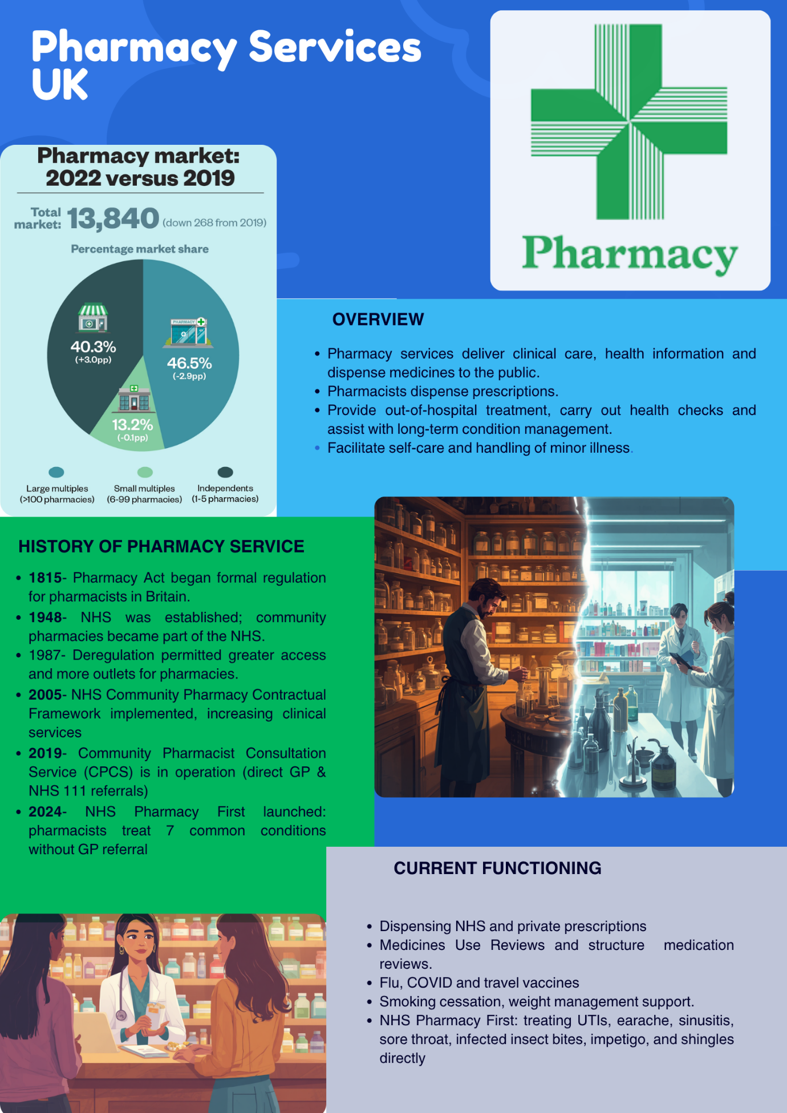

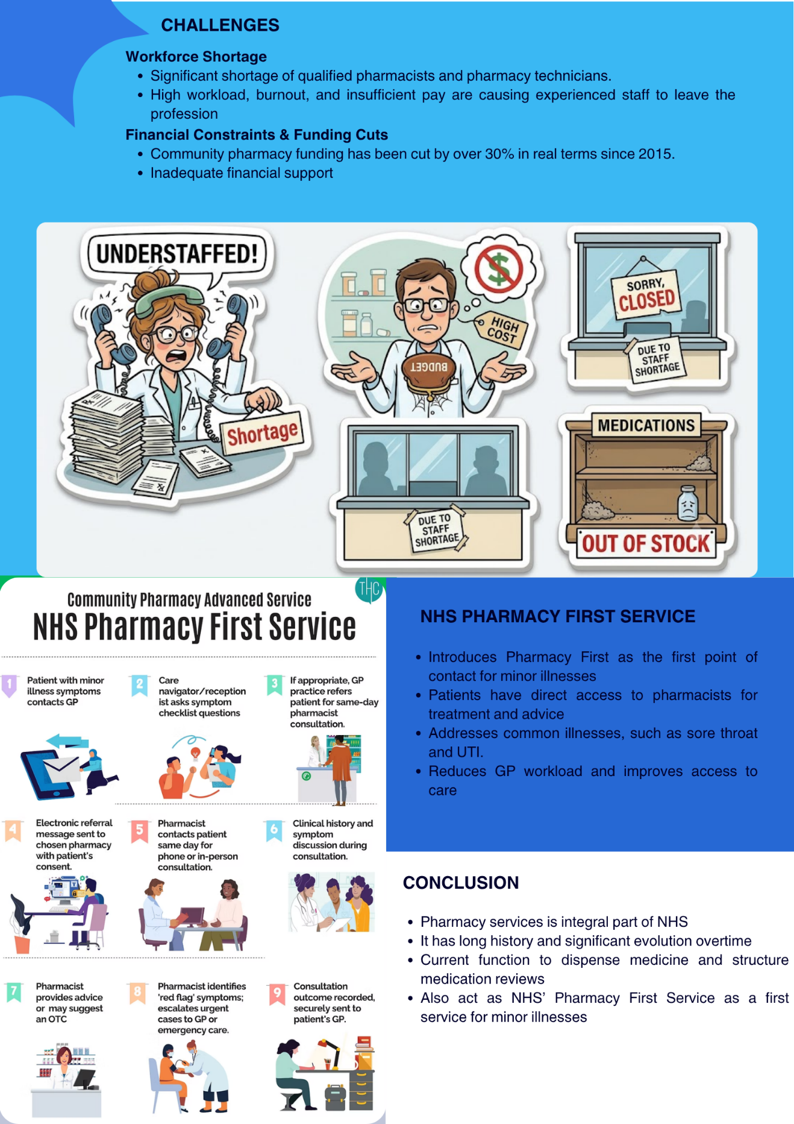

Task 2
Community mental health services are services that are provided on a multi-disciplinary basis outside the confines of long stay psychiatric hospitals. They have a core mission of integrating treatment, social support and rehabilitation to enable those with severe and enduring mental suffering to live safely, interact with others, and engage in work and/or education and citizenship. The service goes back to the mid-twentieth century when there was a transition from institutions to deinstitutionalisation in psychiatry. There is a long tradition of separation for mental illness in large hospitals, as a means of protection, but which often results in social isolation. In the 1950s and 1960s, psychotropic drugs, civil rights issues, high costs and concerns about the harm of institutionalization led to a reduction in the number of beds and development of care near people's homes. The transition was not a seamless one though: Where hospitals closed before community teams, funding for housing and crisis support were found, people could be left with unmet needs (Hook and Bogdanov, 2021; Quirke et al., 2020).
Nowadays, community mental health is a link between health and social care. This is usually but not always a combination of assessment, care co-ordination, medication management, psychological therapy, crisis planning, home visits, supported accommodation, peer support, social prescribing and assistance with employment or benefits. Furthermore, models of recovery are rooted in a shift from symptom management to personal recovery: hope, choice, identity and social participation. Community based models (e.g. intensive case management, integrated community treatment, rehabilitation programmes, supported housing, and vocational support) have been shown in a recent systematic review to facilitate clinical, functional, and personal recovery for individuals with complex needs in 2023 (Harvey et al., 2023). On the other hand, social support is also highly related to recovery as belonging and meaningful relationships diminish loneliness and boost coping (Bjørlykhaug et al., 2022).
However, there are some flaws in the service. The community services are more humane and accessible than institutional care, provided that they are effective, which is subject to staffing, funding and coordination. Collaboration, enough resources and community engagement are some of the facilitators, while stigma, lack of communication and lack of financial resources or human resources are some of the barriers identified in the study conducted by Remy et al (2024). Due to this, a service user might have a disjointed service with mental health professionals, GPs, social workers, housing teams and voluntary organisations all taking responsibility for the same service user but for different bits and pieces of it. Also, there are high thresholds for accessing secondary mental health services, meaning that people who are ‘not ill enough' for specialist teams but too complex for general services. Community mental health requires clinical interventions as well as adequate social care, safe shelter, and culturally responsive practice and hospital avoidance during crisis.
There is a great deal to be said about the importance of community mental health when it comes to a quality of life. First of all, having help within the community supports people to remain in their family roles, education, religion/community and routines. Secondly, multidisciplinary teams can help to tackle social determinants of mental health such as poverty, unemployment, isolation, symptoms and physical health issues. Thirdly, peer support and lived experience involvement can help to dismantle stigma and increase trust. Task sharing, for instance, and working together with trained non-specialists can help reach people who need psychological support but lack access to a trained specialist, provided that the task is supervised to prevent the occurrence of unsafe “task dumping” (Lange, 2021). This may happen, therefore, with the help of well-designed community services, which can help to minimize unnecessary hospitalizations and promote independence.

References
Baird, B. and Beech, J. (2020) Community Pharmacy Explained, The King’s Fund. Available at: https://www.kingsfund.org.uk/insight-and-analysis/long-reads/community-pharmacy-explained (Accessed: 16 June 2026).
Bjørlykhaug, K.I., Karlsson, B., Hesook, S.K. and Kleppe, L.C. (2022) ‘Social support and recovery from mental health problems: A scoping review’, Nordic social work research, 12(5), pp.666-697.
Community Pharmacy England (2025) Morale at breaking point as pharmacy staffing crisis deepens - Community Pharmacy England, Community Pharmacy England. Available at: https://cpe.org.uk/our-news/morale-at-breaking-point-as-pharmacy-staffing-crisis-deepens/ (Accessed: 16 June 2026).
Connelly, D. (2018) ‘NHS70: major moments in pharmacy 1948–2018’, The Pharmaceutical Journal [Preprint]. Available at: https://pharmaceutical-journal.com/article/infographics/nhs70-major-moments-in-pharmacy-1948-2018.
Harvey, C., Zirnsak, T.M., Brasier, C., Ennals, P., Fletcher, J., Hamilton, B., Killaspy, H., McKenzie, P., Kennedy, H. and Brophy, L. (2023) ‘Community-based models of care facilitating the recovery of people living with persistent and complex mental health needs: a systematic review and narrative synthesis’, Frontiers in Psychiatry, 14, p.1259944.
Hook, K. and Bogdanov, S. (2021) ‘Mental health care in Eastern Europe and Central Asia: an analysis of needs and a call for greater investment’, The Lancet Regional Health–Europe, 10.
Lange, K.W. (2021) ‘Task sharing in psychotherapy as a viable global mental health approach in resource-poor countries and also in high-resource settings’, Global Health Journal, 5(3), pp.120-127.
Kamal, S.I. and Surji, K.M. (2025) ‘Assessing the Challenges of Managing Pharmacy Services in Public Hospitals in Erbil City’, Iranian Journal of Pharmaceutical Research, 24(1). Available at: https://doi.org/10.5812/ijpr-162251.
NHS England (2022) NHS England» Pharmacy services, www.england.nhs.uk. Available at: https://www.england.nhs.uk/primary-care/pharmacy/pharmacy-services/ (Accessed: 16 June 2026).
Quirke, E., Suvalo, O., Sukhovii, O. and Zöllner, Y. (2020) ‘Transitioning to community-based mental health service delivery: opportunities for Ukraine’, Journal of Market Access & Health Policy, 8(1), p.1843288.
Remy, M.L., Blijleven, P.S., Coetzer, J.A. and Bondarenko, N. (2024) ‘Facilitators and barriers for implementation of community-based mental health interventions in Western and Eastern Europe-a systematic literature review’, European Journal of Social Work, 27(4), pp.719-732.
UK Parliament (2024) Pharmacy - Health and Social Care Committee, Parliament.uk. Available at: https://publications.parliament.uk/pa/cm5804/cmselect/cmhealth/140/summary.html (Accessed: 16 June 2026).

