MBA- Masters of Business Administration General Management
Assessment 1
LCMB7001 Marketing Management
Name :- Vijayendra Jagdishchandra Birdi
Student Id:- 2221011
Tushara Balendran

Table of Contents
Introduction 4
Background Information About the Company 4
Definition of Communication 4
Include a diagram and briefly explain a communication model 5
Integrated Marketing Communications 6
New Promotional Strategies Your Company Can Use to Raise Awareness of The Brand 7
Social Media Engagement 7
Experiential Events 7
Video Content 7
Content Marketing 7
Paid Advertising 8
Definition of Branding and Brand Equity 8
Keller’s Brand Equity Model 8
Brand Salience 9
Brand Performance 9
Brand Imagery 9
Brand Judgment 10
Advantages 10
Disadvantages 10
Customer Journey and Customer Touchpoints 10
Customer Journey Map 11
Awareness 12
Consideration 12
Decision 12
Retention 13
Advocacy 13
Customer Touch Points 13
Pre-Purchase 13
During Purchase 13
Post Purchase 13
Strengths 14
Weaknesses 14
The Total Engagement Model 14
Branding 15
Corporate Culture 15
Customer Experience 15
Customer Value Proposition 15
Recommendations For New Customer Touchpoints It Should Implement 16
Conclusion 17
References 18

Introduction
Amancio Ortega and RosalaMera established the Zara chain of stores in 1975 in Spain. Zara has come to be acknowledged as a highly respected, heavily successful fashion retail giant on an international level(Kala, 2018). The Inditex group, among the top fashion retailers in the entire world, has made the company a flagship brand in recent times. Zara is renowned for its swift production of fashion-forward clothing, along with other products, at very reasonable prices. Being renowned for its keenness on following the latest fashion trends and great cost-effectiveness, they have made huge strides in the fashion industry, with many more than 2,000 stores distributed around the world across 88 differing countries. It’s no wonder that Zara is viewed as one of the most important and successful fashion labels around.

Background Information About the Company
Amancio Ortega and RosalaMera set up the cornerstones of what would become Zara in 1975. Zara's mission statement includes the concept of providing clothing at a reasonable price for women, men, and kids alike. Thanks to its imaginative modus operandi, which concentrates on responding rapidly to customer needs, cost-effective manufacturing, and the commitment to remain in advance with the most up-to-date fashion trends, Zara has turned into a fashion giant on a global level. It is currently one of the most well-renowned and prosperous fashion firms across the world and has more than 2,000 stores in 88 countries globally (“Zara is part of the biggest fashion company in the world. Meet the other brands it owns.,” 2018).

Definition of Communication
The term 'Marketing Communication' denotes the act of conveying details from an entity to its prospective consumer-group. This practice demands utilization of two-way communication practices, including, but not confined to, public relations, advertisements, direct mail, e-marketing and social media(Writer, 2021). This process is indispensable for bolstering customer-brand affinity, generating brand-awareness, and intensifying sales. By strategically leveraging the influence of communication, enterprises can attain greater achievements in their promotional aims.

Include a diagram and briefly explain a communication model

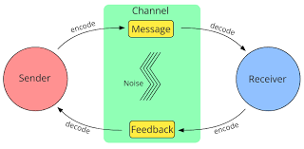
Figure 1:https://www.wikiwand.com/en/File:Common_components_of_models_of_communication.svg
A communication pattern which is based on a framework involving parties, messages, and paths of transfer, is termed a marketing communication model. Through the utilization of this model, firms have the potential to acquire insights into the complicated communication dynamics between them and the customer. This model consists of the relayed exchange, the retransmission of information, the source of the outburst, the conveyed core content, the transmission channel, and the ultimate recipient. In this reflection, the company is the originator of the message, which could include relevant data or orders. The passage through which the language is relayed is the medium, examples of which are broadcasted television, newspapers, or digital media(“Wikiwand - Models of communication,” n.d.). The person at the end of the rope, catching the information from the company, is the consumer. The feedback cycle is the answer that the individual gives to the company in response to what was previously said. Corporate entities using this methodology have the potential to develop a comprehensive and lasting relationship with their patrons. By considering all of the elements of this model, it is conceivable to make interactions between firms and customers more profitable.

Integrated Marketing Communications
Integrated Marketing Communications (IMC) refers to the coordination and integration of all marketing communication tools, channels, and sources within a company into a seamless programme that maximises the impact on consumers and other end users while keeping costs to a minimum (Shimp, 2010).
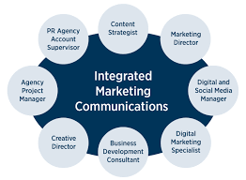
This strategy for marketing communications tries to guarantee that all modes of communication and messaging are connected together in a thoughtful and deliberate manner. Shimp (2010) explains that Integrated Marketing Communications (IMC) is commonly referred to as holistic marketing, 360-degree marketing and one-voice marketing. This includes all the efforts and activities carried out to communicate with the customer such as advertising, public relations, promotional events, direct marketing, personal selling, social media, and more.

New Promotional Strategies Your Company Can Use to Raise Awareness of The Brand

Social Media Engagement
Zara has undertaken noteworthy efforts to further their reach on social media outlets, like Instagram, Facebook and Twitter, coming up with content that is both engaging and stimulating. They are expecting this approach to positively contribute to the appreciation of their brand, while also crafting user-generated output and partaking in a high-profile collaboration with industry celebrities. Besides this, they also provide giveaways as a fundamental tool to connect with the public(Amin, 2023).

Experiential Events
Zara is renowned for its capability to craft extravagant and captivating experiences, granting purchasers an opportunity to interact with the iconography in an intimate, first-hand manner. Customers can explore the items at the delightful pop-up stalls, fashion shows, and other occasions, gleaning an intricate comprehension of the label which can’t be gained in virtual realms.

Video Content
Zara has the ability to produce content for videos that go viral, which will assist in spreading the word about their items and brand. This could take the form of short videos, critiques of products, or glimpses at their creation process from behind the scenes.

Content Marketing
Zara is able to provide material that appeals to their target audience and assists customers in becoming more educated about both the company and the things it sells. This may take the form of blog entries, podcasts, or electronic books.

Paid Advertising
Zara has the ability to reach more people and raise more people's awareness of their brand through the use of paid advertising on social media, search engines, and other digital platforms.

Definition of Branding and Brand Equity
Branding entails establishing a personalized emblem for a commodity or amenity that deviates from related ones amongst prospective shoppers. Assessing the clout and esteemed status of a brand in the commerce sphere is known as brand equity. This is imperative for enterprises, as it is capable of granting a marked advantage compared to competitors and rides largely on patrons' recognition and adherence to the brand. It is a critical instrument for ensuring that your offerings are observed and entrenched significantly in contrast to the.

Keller’s Brand Equity Model
Brand salience, brand performance, brand imagery, and brand judgement are the four primary components that make up Keller's brand equity model, which is a methodology that is used to determine the worth of a brand(Hawker, 2019).
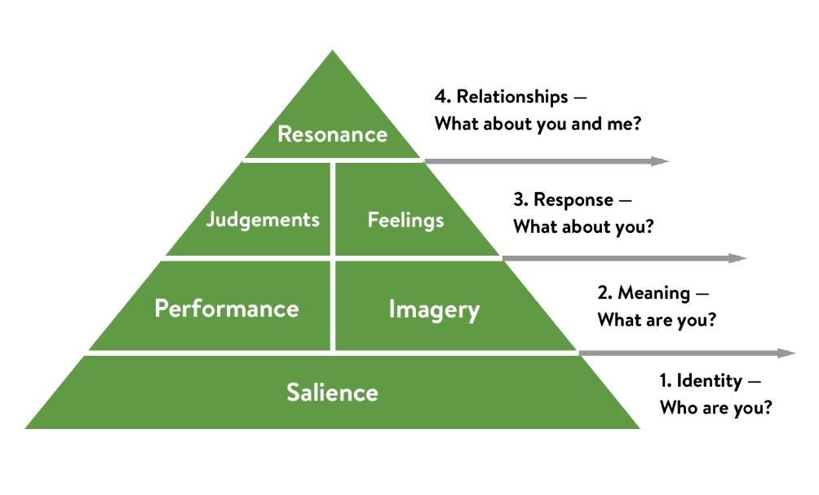
Figure 2: https://medium.com/@keatonhawker/kellers-brand-equity-model-what-it-is-how-to-use-it-84e42d562299

Brand Salience
This particular element of a company's strategy considers how recognizable and memorable the brand is to prospective buyers. With ZARA, they can be credited with a high level of brand awareness due to the wide range of items they offer plus their existence in almost 88 nations global. Moreover, ZARA is renowned for being one of the leading labels in fashion, and their name is regularly linked with top-end and trendy clothing.

Brand Performance
This component evaluated the quality, advantages, and benefits delivered by the celebrated brand called ZARA. It is renowned for upholding high-quality standards and stocking a wide range of clothing, shoes, and accessories, as well as offering extremely competitive prices, increasing the accessibility of its items to a variety of customers. By doing so, they have enabled a broad array of patrons to experience the benefits of their offerings.

Brand Imagery
With a goal to ensure it is perceived in the most favourable light by its customer base, 'ZARA' is becoming increasingly renowned for offering sleek, fashionable and quality garments that guarantee to stay on the pulse of the latest trends. To further solidify its brand image and amplify marketing techniques, the organization is committing to a heightened digital presence and a continual process of development and refinement.

Brand Judgment
This component measures the overall opinion that customers have of the brand. ZARA has a positive reputation in the fashion industry and its customers are generally satisfied with the quality and design of its products.

Advantages
The Brand Equity model developed by Keller is a helpful tool that can be used by businesses to determine the worth of their own brand. It can assist in the identification of areas in need of improvement and can inform strategic decision-making.

Disadvantages
The model is intricate, and its execution may be challenging at times. In order to measure the many aspects of the model, it is also necessary for businesses to have access to information regarding their customers.

Customer Journey and Customer Touchpoints
The introduction of customers to the ZARA brand takes many paths, with traditional and digital marketing, including TV commercials, magazine ads, online advertisements, and social media campaigns. After such introductions, customers can choose to explore the variety of products ZARA provides, reading through user reviews and comparing prices. With all the groundwork laid, customers can make their purchase, both online or in-store, submitting payment information in the former, or traveling to an actual store for the latter(Reeves, 2021). Once customers arrive, assistance is available to them, whether through discussions with staff, utilising the live chat tool or calling the customer service helpline. Finally, upon the purchase being fulfilled, customers receive their item in hand and the journey culminates in an all-important moment, where customers are able to form opinions on the product and brand.
To further this process, companies may request further information in the form of questionnaires and testimonials. Altogether, the customer journey for ZARA pieces together many stages of the customer life-cycle to create a comprehensive experience.

Customer Journey Map
The process of increasing clients' awareness of the Zara brand is outlined as the initial stage on the company's map of the customer journey. Customers are exposed to information regarding Zara through a number of distinct channels, including marketing, social media, and word of mouth. As soon as the brand is brought to their attention, people start to reflect on it and examine what Zara has to offer. Customers are given information regarding the products and services that are currently available to them, and it is at this time that they also look into customer reviews and hunt for the best deals(“What is a Customer Journey Map and Why is It Important?,” 2020).
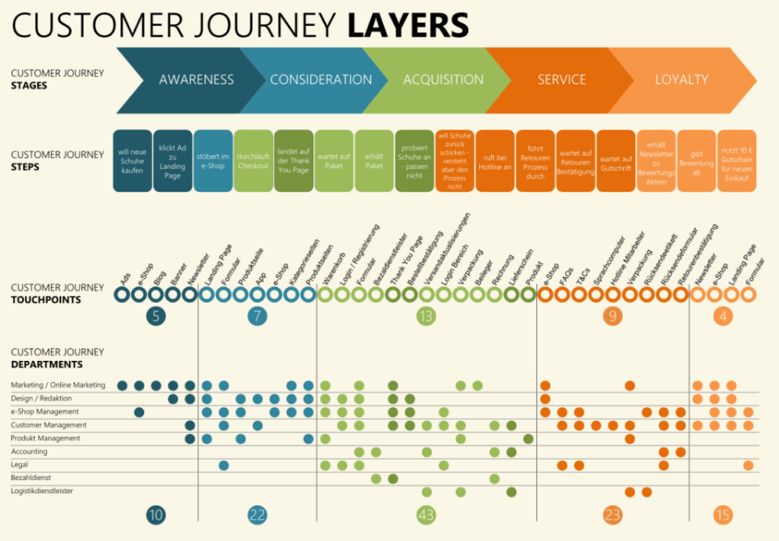
Figure 3: https://www.businessprocessincubator.com/content/do-you-need-technology-to-assist-journey-mapping/

Awareness
The first stage of the customer journey at Zara is awareness. Zara starts its customer journey off right by creating awareness. Customers become acquainted with both their offerings and brand through various marketing channels such as television commercials, print ads, online ads and sponsored events - but also through social media or other online channels such as word of mouth or word-of-mouth advertising(Incubator, 2017).

Consideration
Customers evaluating Zara products and services to determine whether or not they meet their needs should evaluate customer reviews to see what others think of the company, compare prices, browse catalogues or online stores, as well as explore loyalty programs to make an informed decision.

Decision
Customers make their purchase decision from Zara at this stage. Customers may use the loyalty program to receive discounts or sign up for their mailing list for notifications about upcoming sales and promotions.

Retention
At this stage, Customers at this stage become fully immersed in your brand, remaining engaged through ongoing loyalty. Zara offers an incentive program to thank its customers for remaining committed, as well as social media updates or mailing list signup to stay abreast of latest products and services.

Advocacy
At this stage, customers advocate for Zara by telling others about it and sharing their experiences through social media platforms or word of mouth.

Customer Touch Points

Pre-Purchase
Zara raises the level of client awareness and engagement by utilizing a number of different pre-purchase touch points. These include commercials broadcast on television and radio, print advertisements, online advertisements, sponsored events, word-of-mouth marketing, and social media.

During Purchase
Customers have the choice to join up for the mailing list or participate in the customer loyalty program while they are in the process of making a purchase. Customers who participate in the customer loyalty program will receive discounts, and customers who sign up for the mailing list will be notified of upcoming deals and promotions.

Post Purchase
Zara connects with customers on social media after a purchase has been completed, provides customers with discounts and special offers, and encourages customers to sign up for the retailer's loyalty program.

Strengths
Zara's customer journey map stands out in terms of its emphasis on customer engagement. To do so, they utilize various marketing channels - television commercials, radio commercials, print ads, online ads and sponsored events among them - in order to raise customer awareness. Customers also have access to discounts via their loyalty program, while signing up for a mailing list can notify them about upcoming sales and promotions.

Weaknesses
One of the primary weaknesses in Zara's customer journey map is its insufficient emphasis on post-purchase engagement. After making purchases, Zara engages with customers through social media posts, offers discounts or special offers, and invites customers to join its loyalty program - but there is not enough emphasis placed on customer retention and advocacy after post purchase.
Zara could improve this area by encouraging feedback on customers' experiences and creating loyalty programs that reward continued support; additionally, incentives should also be created for customers recommending Zara to friends or family.

The Total Engagement Model
For ZARA, the total engagement model is an approach to customer engagement that looks at every part of the customer journey. By understanding the customer’s experience before, during, and after the purchase, ZARA can create a more seamless and engaging experience for customers.

Branding
ZARA’s brand is built on the idea that customers should be able to find unique, stylish, and affordable fashion. Through customer touch points, the brand orients itself around customer needs and expectations, as well as its own identity. Through its branding, ZARA communicates its core value and style, making itself known and recognizable to customers.

Corporate Culture
ZARA's corporate culture revolves around fostering an atmosphere of customer-centricity. This entails providing stellar customer service, manufacturing products and services that meet and surpass client expectations, and taking customer feedback seriously in order to enhance their shopping experience. By making customers feel respected and appreciated, ZARA is able to create a working environment that puts customer satisfaction first and foremost.

Customer Experience
The total engagement concept of ZARA considers the entire consumer experience, from research to purchase to follow-up. Everything from advertising campaigns to product development to customer service to online platforms to user-submitted material and testimonials is fair game. ZARA is able to provide a more unified and exciting shopping experience for its customers with the aid of this methodology.

Customer Value Proposition
ZARA's Total Engagement Model is geared towards making the shopping experience worthwhile for customers at every stage. ZARA uses this technique to design clothes that are both one-of-a-kind and reasonably priced. The result is more devoted and committed customers. Additionally, ZARA is able to leverage client input to enhance the shopping experience and increase repeat business(“What is a Customer Value Proposition - CVP Definition | DecisionLink,” n.d.).

Recommendations for New Customer Touchpoints It Should Implement
1. Virtual Fitting Room: Zara could add a virtual fitting room feature to their website or mobile app to allow customers to virtually try on clothes before making a purchase decision and reduce returns. This would help customers make more informed purchase decisions and decrease return rates.
2. Zara could Provide Personalized Styling Service: Zara could offer customers a customized styling service whereby they could book an appointment with one of its stylists either in-store or online, further improving customer experience and helping find clothing items which meet personal style preferences and aesthetic requirements.
3. In-Store Events: Zara can create a sense of community among its customers by hosting in-store events such as fashion shows, workshops or product launch parties in its stores. This would encourage engagement beyond mere purchases made at Zara stores.
4. Product Reviews and Ratings: Zara could add a product review and rating feature to their website or mobile app, which would enable customers to share their feedback about their purchases while providing more informed purchasing decisions and bettering overall customer experiences.
5. Sustainability Initiatives: Zara could inform customers about its sustainable initiatives through various touchpoints such as social media, in-store displays or product packaging - this would appeal to customers who prioritize ethical purchasing practices over superficial factors like cost.

Conclusion
In conclusion, Zara is a successful fashion retailer that continues to maintain their competitive advantage by adapting to the changing trends in style. To uphold their status, they could implement daring marketing techniques such as inventive consumer experiences and exploiting the potential of social media platforms to enhance their brand's image and connect with their patrons. By establishing a comprehensive, integrated marketing communication plan, Zara can reduce their financial expenses while amplifying their influence among their target market.

References
What is a Customer Value Proposition - CVP Definition | DecisionLink [WWW Document], n.d. . What is a Customer Value Proposition - CVP Definition | DecisionLink. URL https://www.decisionlink.com/what-is-a-customer-value-proposition
Incubator, B.P., 2017. Do You Need Technology to Assist Journey Mapping? - BPI - The destination for everything process related [WWW Document]. BPI - The destination for everything process related. URL https://www.businessprocessincubator.com/content/do-you-need-technology-to-assist-journey-mapping/
What is a Customer Journey Map and Why is It Important? [WWW Document], 2020. . Customer Experience. URL https://www.techtarget.com/searchcustomerexperience/definition/customer-journey-map
Reeves, D., 2021. What Are Customer Journey Touchpoints & How To Use Them [WWW Document]. Zeotap. URL https://zeotap.com/blog/customer-journey-touchpoints/
Hawker, K., 2019. Keller’s Brand Equity Model — What It Is & How to Use It [WWW Document]. Medium. URL https://medium.com/@keatonhawker/kellers-brand-equity-model-what-it-is-how-to-use-it-84e42d562299
Amin, Z., 2023. Zara’s 9 Marketing Strategies That Made it a Giant Success [WWW Document]. Squeeze Growth. URL https://squeezegrowth.com/marketing-strategies-of-zara/
Wikiwand - Models of communication [WWW Document], n.d. .Wikiwand. URL https://wikiwand.com/en/Models_of_communication
Writer, P., 2021. What is marketing communication [WWW Document]. Paul Writer. URL https://paulwriter.com/what-is-marketing-communication/
Zara is part of the biggest fashion company in the world. Meet the other brands it owns. [WWW Document], 2018. . Business Insider. URL https://www.businessinsider.in/zara-is-part-of-the-biggest-fashion-company-in-the-world-meet-the-other-brands-it-owns-/articleshow/66092742.cms
Kala, K., 2018. FASHION HISTORY- ZARA [WWW Document]. Medium. URL https://medium.com/@kalyanii8927/fashion-history-zara-19ac531d9ab1
Acevedo, A. (2017). The customer journey: What it is and how to map it. Retrieved from https://www.shopify.com/enterprise/multi-channel-software-listing-selling-management
Dawson, K. (2015). The Advantages of the Integrated Marketing Communications Approach. Retrieved from http://smallbusiness.chron.com/advantages-integrated-marketing-communications-approach-65781.html
Gonzalez-Benito, O., & Almeida, T. (2019). The Zara case: Fast fashion from savvy systems. Boston, MA: Harvard Business School Publishing
Dubravka SinčićĆorić&DomagojJelić (2015) Applicability of Keller’s brand equity model in the B2B chemical market, Economic Research-Ekonomska Istraživanja, 28:1, 1006-1017, DOI: 10.1080/1331677X.2015.1100841
Hassan, R., & Farooq, M. (2017). Integrated marketing communication: A platform for success in the dynamic markets. International Journal of Management, Knowledge and Learning, 6(2), 103-117. https://doi.org/10.12735/ijmkl.v6i2.318
Inditex. (2021). About us. Retrieved from https://corporate.inditex.com/en/about-us
Kapur, K. (2017). How to map out your customer journey. Retrieved from https://www.business2community.com/customer-experience/how-to-map-out-your-customer-journey-02084426.
Kumar, A. (2014). A Study on Integrated Marketing Communication (IMC) Tools Used by FMCG Companies in India. International Journal of Research in Business Management, 2(9), 22-31. https://doi.org/10.5296/ijrbm.v2i9.5265
Leander, P. (2018). Zara’s success story: What can we learn from this fast-fashion giant?. Retrieved from https://www.digitalcommerce360.com/2018/05/22/zaras-success-story-what-can-we-learn-from-this-fast-fashion-giant/
Lesh, R., & Fontenot, B. (2019). Integrated marketing communications: A primer. Strategic Communication Management, 23(2), 41-46. https://doi.org/10.1108/SCM-04-2019-0017
McLaughlin, K. (2018). The importance of marketing communication. Retrieved from https://www.thebalancesmb.com/importance-of-marketing-communication-2295814
MindTools | Home. (n.d.). MindTools | Home. https://www.mindtools.com/ajnlcxe/kellers-brand-equity-model
Ramaswamy, R. (2020). Zara: From rags to riches. Retrieved from https://yourstory.com/mystory/8f743ef384
Rosenbloom, B. (2019). Zara: A success story in fast fashion. Harvard Business School. Retrieved from https://hbr.org/2019/03/zara-a-success-story-in-fast-fashionn
Sarma, D. (2020). Integrated Marketing Communications (IMC): Definition, Benefits & Examples. Retrieved from https://www.studica.com/blog/integrated-marketing-communications-imc
Shimp, T. A. (2010). Integrated Marketing Communications in Advertising and Promotion. Mason, OH: South-Western Cengage Learning.
Yammarino, F. J., Dionne, S. D., Chun, J. U., Dansereau, F., & Jiménez, J. C. (2001). Integrated marketing communication: A review, critique, and research agenda. Journal of Business Research, 54(3), 199-218. https://doi.org/10.1016/S0148-2963(00)00101-
Zara | Company Overview & News. (2023, April 4). Forbes. https://www.forbes.com/companies/zara/

