LCLM 5006
BA (Hons) Leadership and Management Skills for the Workplace

Developing Emotional Intelligence Skills
Component 2- Individual Written Report- The Strategic Role of Emotional Intelligence and Mindfulness in Contemporary Organisations
Analytical Report for the Senior Management Team (SMT)



Student: Marinela Matei
ID: 2409688
Lecturer: Taonga Kaonga Sobere-Snithers

Table of Contents

Task Page Number
Executive Summary 3
Introduction 4
Emotional Intelligence in the Workplace 4
- Conceptualising Emotional Intelligence 4
- Comparison of Major Emotional Intelligence Models 5
- Goleman’s Emotional Intelligence Framework 5
- Mayer and Salovey’s Ability Model 6
- Bar-On’s Emotional-Social Intelligence Model 6
- Emotional Intelligence and Employee Performance 7
- Communication and Conflict Management 8
- Leadership and Decision-Making 8
- Critical Evaluation 9
Managing a Multigenerational Workforce 10
- Gen X 11
- Gen Y 12
- Gen Z 13
- Comparative Evaluation of the Three Generations 14
- Impact on Organisational Effectiveness 14
- Using Emotional Intelligence and Mindfulness for Inclusion 15
- Recruitment, Management, and Retention 15
Conclusion 16
REFERENCES 17

Executive Summary
Recent improvements in morale, communication, and conflict resolution within the department have highlighted the practical value of emotional intelligence (EI) and mindfulness in organisational settings. This report evaluates how these capabilities can support employee development, leadership effectiveness, and workforce sustainability.
Using Goleman's competency framework, Mayer and Salovey's ability model, and Bar-On's emotional-social intelligence model, the first portion critically examines how emotional intelligence is used in the workplace. It contends that workers who possess emotional intelligence are better equipped to manage stress, work well with others, settle disputes, and reach well-rounded conclusions. But the paper also acknowledges disagreements about how to assess and define EI.
The management of a multigenerational workforce made up of Millennials, Generation Z, and Generation X is examined in the second section. It assesses the potential effects on organizational performance of disparities in values, communication preferences, career expectations, and technology confidence. The study concludes that emotionally intelligent and mindful leadership can help organisations create inclusive environments that improve recruitment, engagement, retention, and psychological safety across all age groups.

Introduction
Organisations increasingly operate in environments characterised by rapid technological change, demographic diversity, and heightened expectations regarding employee well-being. In this context, leadership effectiveness is no longer determined solely by technical expertise or cognitive ability. Interpersonal competence, emotional awareness, and the capacity to create psychologically safe workplaces have become equally important (Nguyen, 2021).
Emotional intelligence refers to the ability to recognise, understand, manage, and utilise emotions effectively in oneself and others (Mayer, Salovey and Caruso, 2008). Mindfulness, meanwhile, involves maintaining purposeful attention to present experiences with openness and without excessive judgement (Kabat-Zinn, 2015). Together, these capabilities can influence communication, collaboration, resilience, and organisational culture.
The importance of emotional intelligence and mindfulness in modern organizations is thoroughly examined in this report. It first examines how employees can apply core EI competencies to improve performance and relationships. It then analyses the challenges and opportunities associated with managing Generation X, Millennials, and Generation Z within the same workplace.
Emotional Intelligence in the Workplace

Image 1
Conceptualising Emotional Intelligence
Emotional intelligence has evolved into one of the most influential concepts in organisational behaviour because it addresses aspects of performance that traditional intelligence measures often overlook. Whereas IQ primarily reflects analytical reasoning, EI focuses on emotional awareness, regulation, empathy, and relationship management (Goleman, 1998).
Despite its popularity, scholars disagree on whether EI represents a distinct form of intelligence, a collection of competencies, or a combination of personality traits and social skills (Cherniss, 2010). This debate has produced several influential models.
Comparison of Major Emotional Intelligence Models
Table 1. Comparison of Major Emotional Intelligence Models
Model | Focus | Strengths | Limitations
Goleman (1998) | Leadership competencies | Highly practical for organisations | Conceptually broad
Mayer & Salovey (1997) | Emotional abilities | Strong theoretical foundation | Less directly applicable to management
Bar-On (1997) | Emotional-social functioning | Emphasises well-being and adaptability | Overlaps with personality traits
(Cherniss, 2010).
Goleman’s Emotional Intelligence Framework
Goleman (1998) proposes five interrelated competencies: self-awareness, self-regulation, motivation, empathy, and social skills. In workplace settings, these competencies influence how employees respond to pressure, communicate with colleagues, and lead teams.
Self-awareness enables employees to recognise emotional triggers and understand how their behaviour affects others. For example, a supervisor who notices rising frustration during a meeting may choose to pause, clarify expectations, and prevent escalation.
Self-regulation helps employees manage impulses and remain composed during uncertainty. This is particularly valuable during organisational restructuring, where emotionally reactive behaviour can damage trust.
Empathy supports inclusive leadership by encouraging managers to consider different perspectives and experiences. Empathetic leaders are more likely to identify employee concerns and foster psychological safety.
Social skills facilitate collaboration, negotiation, and relationship building across departments. In matrix organisations, where employees often work with multiple stakeholders, these competencies become critical for coordination and influence.
Mayer and Salovey’s Ability Model
Mayer and Salovey (1997) conceptualise EI as a set of emotional abilities rather than behavioural competencies. Their model includes perceiving emotions, using emotions to facilitate thinking, understanding emotions, and managing emotions.
This approach is valuable because it treats emotional intelligence as a cognitive capability that can be assessed through performance-based measures such as the MSCEIT. Employees who accurately perceive emotional cues may identify dissatisfaction, stress, or disengagement before these issues become visible in performance metrics.
However, critics argue that the model does not fully explain how emotional abilities translate into effective workplace behaviour (Zeidner, Matthews and Roberts, 2012).
Bar-On’s Emotional-Social Intelligence Model
The Bar-On Emotional-Social Intelligence (ESI) Model represents one of the earliest comprehensive frameworks for understanding emotional intelligence within organisational and social contexts. Developed by Bar-On (1997), the model proposes that emotional intelligence extends beyond the ability to perceive and regulate emotions and should instead be viewed as a broad collection of emotional, personal, and social competencies that influence an individual's capacity to cope effectively with environmental demands. Unlike Mayer and Salovey's Ability Model, which conceptualises emotional intelligence as a cognitive ability, Bar-On argues that successful performance depends upon a combination of emotional functioning, interpersonal effectiveness, adaptability, resilience, and psychological well-being (Emmerling, Shanwal and Mandal, 2008).
A distinctive feature of the model is its emphasis on emotional and social functioning rather than intelligence alone. Bar-On suggests that employees who possess high levels of emotional-social intelligence are better equipped to understand themselves, establish positive relationships, adapt to organisational change, manage workplace stress, and maintain psychological resilience. Consequently, the model has gained considerable attention within human resource management because it recognises that employee performance depends not only on technical competence but also on emotional health and interpersonal capability.

Emotional Intelligence and Employee Performance
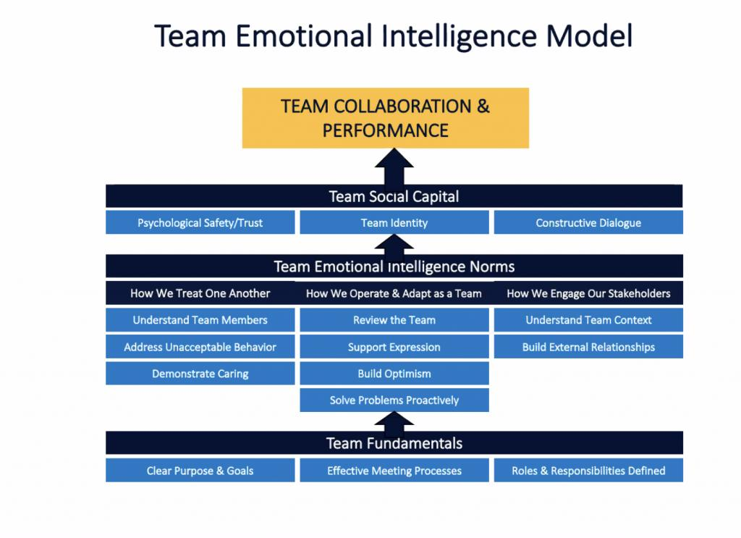
Image 2
Research consistently shows a positive relationship between emotional intelligence and job performance, particularly in roles involving teamwork, leadership, and customer interaction (Qian, Miao and Humphrey, 2024).
Emotionally intelligent employees tend to:
- Manage stress more effectively.
- Adapt to organisational change.
- Build stronger working relationships.
- Demonstrate greater resilience.
- Contribute to positive team climates.
These behaviours can improve productivity and reduce turnover costs.

Communication and Conflict Management
Effective communication requires more than transmitting information; it also involves interpreting emotions and responding appropriately. Employees with high EI are generally better at active listening, reading non-verbal cues, and adapting their communication style.
Conflict management provides a clear example of EI in practice. Rather than reacting defensively, emotionally intelligent employees are more likely to explore underlying concerns and seek collaborative solutions. Jordan and Troth (2011) found that teams with higher emotional intelligence resolved conflict more constructively and achieved better outcomes.
Leadership and Decision-Making
Emotionally intelligent leaders influence organisational culture through empathy, emotional control, and relationship management. They are also better positioned to make balanced decisions because they recognise emotional influences without allowing emotions to dominate judgement.
Importantly, EI contributes to psychological safety, a workplace climate in which employees feel comfortable sharing ideas, asking questions, and admitting mistakes (Nguyen, 2021). Such environments are associated with greater learning, innovation, and collaboration.
The Role of Mindfulness
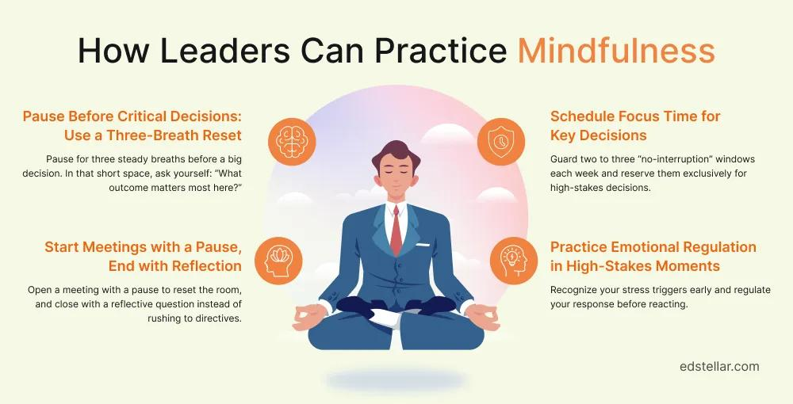
Image 3
Mindfulness complements emotional intelligence by strengthening attention, self-awareness, and emotional regulation. Employees who practice mindfulness are often better able to pause before reacting, reducing impulsive behaviour and improving interpersonal interactions (Good et al., 2016).
In organisational settings, mindfulness can support:
• Stress reduction.
• Improved concentration.
• Greater empathy.
• Enhanced resilience.
• More thoughtful decision-making.
Beyond individual benefits, mindfulness can contribute to organisational effectiveness by improving collective team functioning and supporting ethical leadership. Employees who regularly engage in mindfulness practices are often more attentive to their own emotional responses and those of their colleagues, which can reduce misunderstandings and strengthen interpersonal trust. This heightened awareness encourages active listening, respectful communication, and more constructive responses during challenging workplace interactions. In high-pressure environments, mindfulness enables individuals to remain focused on organisational objectives while avoiding impulsive reactions that may damage professional relationships (Glomb et al., 2011).
From a leadership perspective, mindful leaders are better equipped to model emotional stability, demonstrate empathy, and foster a culture of openness and psychological safety. Such behaviours encourage employees to express ideas, report concerns, and learn from mistakes without fear of criticism, thereby supporting continuous improvement and innovation (Nguyen, 2021). Mindfulness should not be regarded as a standalone solution to organisational challenges. Its effectiveness is maximised when integrated with supportive leadership, inclusive organisational cultures, and employee well-being initiatives rather than being implemented as an isolated intervention (Good et al., 2016).

Critical Evaluation
No single EI model fully captures the complexity of workplace behaviour. Goleman’s framework is highly practical for leadership development, Mayer and Salovey’s model offers stronger theoretical precision, and Bar-On’s model highlights well-being and adaptability.
Emotional intelligence should not be viewed as a substitute for technical competence, organisational systems, or effective management practices. Its value lies in complementing these factors to create more collaborative, resilient, and psychologically safe organisations.
Another important consideration is that the effectiveness of emotional intelligence depends largely on the organisational context in which it is applied. While emotionally intelligent employees may possess strong interpersonal and self-regulation skills, these competencies alone cannot compensate for ineffective organisational systems, poor leadership, or unsupportive workplace cultures. For example, highly emotionally intelligent employees may still experience stress and reduced performance if workloads are excessive or if organisational values fail to promote trust and inclusion. This suggests that emotional intelligence should complement, rather than replace, sound management practices and strategic human resource policies (Ayoko et al., 2023).
The three emotional intelligence models differ in their assumptions regarding the nature of EI. Mayer and Salovey conceptualise EI as a measurable cognitive ability, whereas Goleman and Bar-On adopt broader competency-based approaches that integrate personality characteristics and behavioural attributes. This lack of theoretical consensus has contributed to ongoing debates regarding the validity and reliability of emotional intelligence assessments (Antonakis et al., 2010). Despite these criticisms, there is substantial evidence that emotionally intelligent leadership enhances employee engagement, collaboration, and organisational resilience when supported by appropriate training, reflective practice, and mindfulness-based interventions.
Managing a Multigenerational Workforce
Image 4
Modern organisations increasingly employ individuals from multiple generations, each shaped by different economic, social, and technological experiences. While generational categories are broad generalisations, they can help managers understand common workplace expectations.
Generational Characteristics
Table 2. Generational Characteristics in the Workplace
Generation | Key Values | Communication Preference | Technology Orientation
Generation X | Independence, stability | Email, face-to-face | Competent adopters
Millennials | Purpose, development | Collaborative feedback | Highly comfortable
Generation Z | Flexibility, inclusion | Digital-first communication | Digital natives
(Twenge, Campbell and Freeman,2012).
Generation X
Generation X comprises individuals born approximately between 1965 and 1980. This generation entered employment during periods of economic uncertainty, organisational restructuring, and rapid globalisation. Consequently, many Generation X employees developed strong independence, resilience, and adaptability. Having witnessed organisational downsizing and changing employment patterns, they generally place considerable importance on job security while recognising the need for continuous professional development (Twenge, Campbell and Freeman, 2012).
One distinguishing characteristic of Generation X is its preference for autonomy. Employees within this group often value trust from managers and appreciate having responsibility for organising their own work. Unlike younger generations, they may be less dependent on frequent feedback and instead favour leadership styles that provide clear objectives while allowing flexibility in achieving them. This independence can positively influence organisational performance because Generation X employees often require minimal supervision and demonstrate strong problem-solving abilities.
Communication preferences among Generation X typically emphasise direct, professional interaction through face-to-face meetings, telephone conversations, and email communication. Although technologically competent, many members of this generation experienced the transition from analogue to digital workplaces rather than growing up with digital technology. As a result, they often combine traditional communication methods with digital tools, making them effective intermediaries between older and younger employees.
From a leadership perspective, Generation X employees frequently value fairness, transparency, and competence. They are generally motivated by opportunities for career progression, flexible working arrangements, and recognition of their expertise rather than purely financial rewards. Emotionally intelligent managers can enhance engagement among Generation X employees by demonstrating respect for their experience, involving them in strategic decision-making, and encouraging mentoring opportunities where they can share organisational knowledge with younger colleagues.
Millennials (Generation Y)
Born between about 1981 and 1996, millennials now make up one of the largest demographic groupings in many organizations. During times of fast technology advancement and growing global connectedness, this generation joined the workforce. As a result, Millennials frequently exhibit high levels of technological confidence, teamwork, and flexibility (Lyons, Ng and Schweitzer, 2012).
Millennials often seek regular performance feedback and continuous learning opportunities. They value coaching-oriented leadership rather than traditional command-and-control management structures. Frequent communication helps them understand performance expectations while supporting career development and personal growth. Organisations that fail to provide clear progression opportunities may experience reduced employee engagement and higher turnover among Millennial employees.
Millennials are also recognised for placing significant importance on meaningful work. Research suggests that many seek employment within organisations whose values align with their own, particularly regarding sustainability, corporate social responsibility, diversity, and ethical leadership. Flexible working arrangements, work-life integration, and opportunities for innovation are often considered more attractive than purely financial incentives.
Despite these positive characteristics, Millennials have sometimes been criticised for expecting rapid promotion and continuous recognition. However, empirical research indicates that many of these assumptions are based on stereotypes rather than substantial evidence (Ravid, Costanza and Romero, 2024). Instead, organisational culture, leadership quality, and career opportunities appear to exert greater influence on employee attitudes than generational identity alone.
Emotionally intelligent managers can effectively engage Millennials by practising active listening, recognising achievements, providing developmental feedback, and involving employees in collaborative decision-making. Mindfulness also supports this generation by reducing workplace stress and improving resilience within increasingly demanding organisational environments.
Generation Z
Generation Z, comprising individuals born from approximately 1997 onwards, represents the newest generation entering professional employment. Unlike previous generations, Generation Z has grown up with smartphones, social media, cloud computing, and instant access to digital information. Consequently, they are frequently described as digital natives who possess advanced technological skills and strong adaptability to digital workplaces (Zander, 2020).
This generation generally expects workplaces to embrace diversity, inclusion, authenticity, and social responsibility. Mental health awareness has also become an important priority, with many Generation Z employees expecting employers to provide psychological support, flexible working arrangements, and initiatives promoting employee well-being. As a result, organisations increasingly integrate mindfulness programmes, employee assistance services, and well-being strategies into their human resource practices to attract and retain younger talent.
Generation Z employees often prefer rapid communication through collaborative digital platforms such as Microsoft Teams, Slack, and instant messaging applications. They also expect immediate access to information and regular feedback regarding their performance. While these characteristics can improve organisational responsiveness and innovation, they may create communication challenges when working alongside colleagues who favour more traditional communication methods.
Career development is another significant consideration for Generation Z. Rather than expecting lifelong employment within a single organisation, many prioritise continuous learning, skill development, and career mobility. Employers that provide structured training, mentoring, and opportunities to develop new competencies are therefore more likely to retain talented Generation Z employees.
Emotionally intelligent leadership plays an essential role in supporting this generation. Leaders who demonstrate empathy, transparency, and authenticity can establish trust while creating psychologically safe environments where younger employees feel comfortable expressing ideas, asking questions, and learning from mistakes. Mindfulness further contributes by helping managers respond patiently to the different communication styles and expectations of younger employees rather than relying on age-related stereotypes.
Comparative Evaluation of the Three Generations
Although Generation X, Millennials, and Generation Z differ in their workplace expectations, these differences should not be interpreted as barriers to organisational success. Instead, they represent complementary strengths that organisations can leverage through effective leadership. Generation X contributes extensive organisational knowledge, professional experience, and independent problem-solving abilities. Millennials often strengthen collaboration, innovation, and organisational adaptability, while Generation Z introduces advanced digital capabilities, creativity, and fresh perspectives.
Rather than adopting a single leadership approach, organisations should develop emotionally intelligent managers capable of adapting their communication style, motivational techniques, and leadership behaviours to meet individual employee needs. This person-centred approach not only enhances employee engagement but also strengthens collaboration, knowledge sharing, and organisational resilience. Combined with mindfulness practices that encourage reflection, empathy, and emotional regulation, emotionally intelligent leadership enables organisations to transform generational diversity into a strategic advantage that supports innovation, employee well-being, and sustainable organisational performance.
Impact on Organisational Effectiveness
The coexistence of Generation X, Millennials and Generation Z in the workplace offers organisations diverse skills, knowledge and perspectives that can enhance innovation and performance. However, differences in communication styles, workplace values, motivation and technological adaptability may lead to misunderstandings if not managed effectively. Generation X tends to prefer independence and formal communication, while Millennials and Generation Z value collaboration, feedback and digital communication. Motivation also varies, with Generation X prioritising autonomy and job security, whereas younger generations seek career development and meaningful work. By adopting flexible communication, personalised reward systems and initiatives such as reverse mentoring, organisations can improve collaboration, employee engagement and organisational learning.

Using Emotional Intelligence and Mindfulness for Inclusion

Image 5
Emotional intelligence (EI) is particularly important for managers leading multigenerational teams. According to Goleman (1998), emotionally intelligent leaders demonstrate self-awareness, empathy, effective communication and relationship management, enabling them to recognise the different expectations of employees without relying on stereotypes. Managers with high emotional intelligence are better able to adapt their leadership style to individual employees, resolve workplace conflict and build trust across different generations.
Mindfulness also contributes to effective management by encouraging leaders to remain attentive, open-minded and non-judgemental when interacting with employees (Kabat-Zinn, 2003). Mindful managers are more likely to listen actively, respond thoughtfully to concerns and create psychologically safe working environments where employees from all generations feel respected and valued. This approach improves employee well-being, collaboration and organisational commitment.
Recruitment, Management, and Retention
Organisations should also adapt their human resource practices to meet the expectations of different generations. Recruitment strategies should combine traditional methods with digital platforms and employer branding that highlights flexible working, career development, diversity and organisational purpose. During employment, managers should provide personalised learning opportunities, mentoring programmes, flexible communication channels and regular performance feedback.
Retention strategies should recognise that employees are motivated by different factors rather than assuming all members of a generation share identical expectations. Flexible benefits, career progression opportunities, wellbeing initiatives and recognition programmes can improve employee satisfaction across all age groups. Ultimately, organisations that combine emotionally intelligent leadership with inclusive HR practices are more likely to retain talented employees and achieve sustainable organisational performance.

Conclusion
This report has demonstrated that emotional intelligence and mindfulness are increasingly important organisational capabilities rather than optional personal qualities. Emotional intelligence supports communication, collaboration, conflict resolution, leadership, and decision-making, while mindfulness strengthens self-awareness, resilience, and psychological safety.
The report has also shown that managing a multigenerational workforce requires leaders to move beyond stereotypes and adopt flexible, emotionally intelligent approaches that recognise individual differences. By integrating EI and mindfulness into leadership development, recruitment, and employee well-being initiatives, organisations can improve performance, engagement, retention, and long-term organisational resilience.

REFERENCES
- Antonakis, J., Bendahan, S., Jacquart, P. and Lalive, R. (2010). On making causal claims: A review and recommendations. The Leadership Quarterly, 21(6), pp.1086–1120.
- Austin, E.J. (2005). Emotional intelligence and emotional information processing. Personality and Individual Differences, 39(2), pp.403–414.
- Ayoko, O.B., Ashkanasy, N.M., Li, Y., Dorris, A. and Jehn, K.A. (2023). An experience sampling study of employees’ reactions to noise in the open-plan office. Journal of Business Research, 155(3), p.113445.
- Bar-On, R. (1997). Bar-On Emotional Quotient Inventory Technical Manual. Toronto: Multi-Health Systems.
- Boyatzis, R.E. (2018). The Competent Manager. John Wiley & Sons.
- Cherniss, C. (2010). Emotional Intelligence: New Insights and Further Clarifications. Industrial and Organizational Psychology, 3(2), pp.183–191.
- Dacre Pool, L. and Qualter, P. (2018). An Introduction to Emotional Intelligence. John Wiley & Sons.
- Emmerling, R.J., Shanwal, V.K. and Mandal, M.K. (2008). Emotional Intelligence. Nova Publishers.
- Goleman, D. (1998). Working with Emotional Intelligence. New York: Bantam Books.
- Good, D.J. et al. (2016). Contemplating mindfulness at work, Journal of Management, 42(1), pp. 114–142.
- Jordan, P.J. and Troth, A. (2011). Emotional intelligence and leader member exchange. Leadership & Organization Development Journal, 32(3), pp.260–280.
- Kabat-Zinn, J. (2015). Mindfulness. Mindfulness, [online] 6(6), pp.1481–1483. doi: https://doi.org/10.1007/s12671-015-0456-x.
- Lyons, S.T., Ng, E.S. and Schweitzer, L. (2012). Managing the New Workforce: International Perspectives on the Millennial Generation. Academy of Management Proceedings, 2012(1), p.10638.
- Mayer, J.D., Salovey, P. and Caruso, D.R. (2008). Emotional intelligence: New ability or eclectic traits? American Psychologist, 63(6), pp. 503–517.
- Mayer, J.D. and Salovey, P. (1997). What is emotional intelligence? Emotional Development and Emotional Intelligence. New York: Basic Books.
- Nguyen, N. (2021). The Fearless Organization: Creating Psychological Safety in the Workplace for Learning, Innovation, and Growth. The Learning Organization, 28(3), pp.321–323.
- Qian, S., Miao, C. and Humphrey, R.H. (2024). Entrepreneurship: An extension to anti-work perspectives. Industrial and Organizational Psychology, 17(1), pp.75–78.
- Ravid, D.M., Costanza, D.P. and Romero, M.R. (2024). Generational differences at work? A meta‐analysis and qualitative investigation. Journal of Organizational Behaviour, 46(1), pp.43–65.
- Twenge, J.M., Campbell, W.K. and Freeman, E.C. (2012). Generational differences in young adults” life goals, concern for others, and civic orientation, 1966–2009. Journal of Personality and Social Psychology, 102(5), pp.1045–1062.
- Zander, L. (2020). Research handbook of global leadership: Making a difference. Northampton: Edward Elgar Publishing.

