ECIE4012
The Principles of Learning and Teaching

Portfolio
Theresa Angier
Student Number:2417258

The Reward Revolution Bringing Skinner into the 21st century classroom

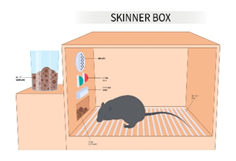

As I sat in my classroom this morning wondering what the day may bring, my mind started to drift back to my own school days and how much education seems to have changed, I thought to myself “These children these days don’t know how easy they have it”. Secondary schools in the 1970’s and 80’s were led by fear - strict discipline and the constant threat of consequences. Those immortal words “The head would like to see you” were enough to strike fear into any child. But when I really started to think about, have things really changed that much? agreed we no longer have the fear of corporal punishment which was abolished in 1987 in all state-run schools in England and Wales (End Corporal Punishment 2024) but we still use the principles behind those sanctions in our schools today.
Figure 1(Shutterstock no date)

One of the main theorists whose work supports our behaviour policy within schools today is Burrhus Frederic Skinner an American psychologist, born in 1904 (Grey and MacBain, 2025, p.55). Skinner was arguably one of the most influential theorists of the twentieth century. He believed that all actions had consequences (Porter,2020, p.28). To demonstrate his theory, in the 1930’s he developed what became known as the ‘Skinner box’. He placed small animals, such as rats inside a controlled chamber which included a lever that dispensed food. Over time, the rat learned that by pressing the lever it would receive a reward in the form of food. (Aubrey and Riley, 2022, p.91). In another experiment, skinner placed a rat in a box with a lever where they were subjected to an electrical current, the rat learnt over time by hitting the lever, it would turn the current off. The rat quickly learnt to going straight to the lever after a few times being in the box (Nickerson,2024). From this research, Skinner developed the theory of operant conditioning – the use of positive and negative reinforcement to change behaviour. The theory suggests that behaviour can be shaped on how we deal with it at that given time (Bates, 2023, p.34).
Figure 2 (simplypsychology.org 2024)
So how do we use Skinner’s theory in our schools today? I believe we use it every single day without even thinking about it. We still dangle the carrot: “If you finish your work, Jonny, you will receive a sticker.” On the flip side: “Jonny, if you do that again, your name will go on the board.” However you choose to look at it, we are still applying Skinner’s theory — rewarding the behaviour we want and putting consequences in place for the behaviour we do not.
Figure 3.(middleweb.com 2016)

Many schools use Apps now to track behaviour for example Classcharts (assets.tes, n.d.). This allows teachers student and parents to keep track on their achievements, behaviour both positive and negative throughout the day. Students can cash their positive points in the Reward store (assets.tes, n.d.) This system strongly promotes both positive and negative reinforcement, in line with Skinners Operant conditioning.
Figure 4 (assets.tes.com 2024)

But does Skinner theory really work in practice? In principle yes, however there will always be students who view punishment as a reward. Take Freddie: he hides in the toilets to avoid lessons, fully aware that this will lead to time spent in the inclusion room. Are we not giving him what he wants, removal from mainstream lessons? Skinners operant conditioning assumes that consequences discourage negative behaviour, but if the consequence function as a reward for a particular child, then the system loses its effectiveness. Should the question not be why doesn’t Freddie want to attend lesson? Without understand the root cause, behaviour is unlikely to change. The same issue applies to rewards. When a student will only help if they receive a positive point, we must ask are we truly encouraging positive behaviour, or teaching children it only matters if there is a reward? Its food for thought.
Figure 5.(shutterstock.com no date)

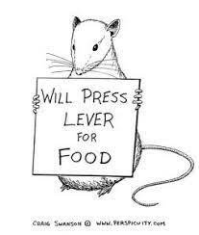

Figure 5 (simplypsychology.org 2024)

Blog 1: Reference list
Aubrey, K and Riley, A (2022) Understanding and using educational theories. 3rd edn. London: Sage.
Bates, B. (2023). Learning theories simplified. 3rd edn. London: Sage.
Classcharts. (No Date) Available at:https://assets.tes.com/marketing/s3fs-public/documents/2024-07/Class_Charts_for_pupils_guide.pdf (Accessed: 8th November 2025)
End Corporal Punishment (2024) Available at: https://endcorporalpunishment.org/reports-on-every-state-and-territory/uk/(Accessed on: 7th November 2025)
Gray, C. and Macblain, S. (2015) Learning Theories in Childhood. 2nd edn. London: Sage.
Image 1 Shutterstock. Available at: https://www.shutterstock.com/search/school-teacher-cane (Accessed on: 7th November 2025)
Image 2 Nickerson, C. (2024) Skinner Box: What Is an Operant Conditioning Chamber? Available at :https://www.simplypsychology.org/what-is-a-skinner-box.html (Accessed: 9th November 2025)
Image 3 Middle Web. (2016) Available at: https://www.middleweb.com/27351/kids-need-some-carrots-to-inspire-learning/ (Accessed: 9th November 2025)
Image 4 ClassCharts (2024) Available at:https://assets.tes.com/marketing/s3fs-public/documents/2024-07/Class_Charts_for_pupils_guide.pdf (Accessed: 8th November 2025)
Image 5 Shutterstock Available at: https://www.shutterstock.com/image-illustration/kids-who-dont-want-go-school-1812122380 (Accessed: 7th November 2025)
Image 6 Nickerson, C. (2024) Skinner Box: What Is an Operant Conditioning Chamber? Available: https://www.simplypsychology.org/what-is-a-skinner-box.html (Accessed: 9th November 2025)
Porter, A. (2020) Psychology Everything you need to know to master the subject- in one book. London: Arcturus.

Beyond the Kindergarten Froebel’s enduring Influence


Figure 6(The University of Edinburgh 2025)

Discovering Froebel: how a Theorist I nearly ignored changed my View:
Let me be completely honest: when asked to write about a theorist for my university assignment, Froebel was not my first choice. At first, I couldn’t see how his work connected to my working environment which is secondary education, or how his ideas influenced my teaching practice. But – and this is a big but – the more I started to research, the more I found myself drawn into his theories.
It started when I stumbled across the Froebel Trust website (froebel.org.uk no date), I clicked on one podcast out of curiosity and before I knew it, I was on episode three. The deeper I explored, the more I began to appreciate how surprisingly relevant Froebel’s ideas still are today.
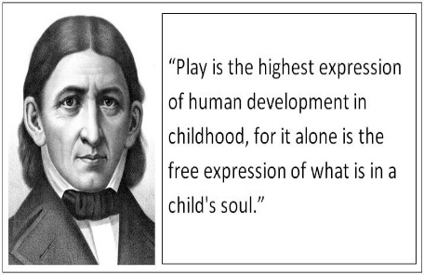
Who was Friedrich Froebel?
Figure 7(Play Create Learn 2015)
Friedrich Froebel was born 1782 in Thuringia, the youngest of five children. found his love for nature (Pound, 2005, p. 14). Froebel believed that children learnt best through nature and play, he argued that every child has the right to an education, regardless of their social background. Today, this seems obvious it is something we all take for granted as stated in Article 28 of the UN Convention on the rights of the child ‘Every child has the right to an Education’ (Senedd Cymru, 2024). But in the early 1800s, Froebel’s thinking was radical. Children were not valued, respected, or understood in the way they are now.
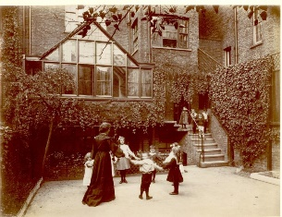
Froebel’s Theory: Nurturing the Natural Unfolding of the Child
Figure 8(Explore our archive 2015)
The key idea behind Froebel’s theory is surprisingly straightforward: education should support the natural unfolding of a child’s abilities (earlyexcellence,2025).
- Froebel believed children should be allowed to grow and develop in their own unique way, rather than pushing them into what we believe they should be.
- He strongly believed that children should express themselves through individual play as well as social play with others (Gray and MacBlain, 2015, p.34).
- While this idea feels natural to early year practitioners today, it was radically different from typical schooling in the 1800s, where many children were unhappy and often punished by teachers.
- He believed learning begins as soon as children interact with the world around them.
- Froebel viewed women as the most suitable educators for young children, referring to them as the “gardeners” who nurture children’s growth (Froebel Web, 2002).
- In 1816, Froebel put his theories into practice by opening his first school, which he named Kindergarten, meaning “Children’s garden” (Aubrey and Riley, 2022, p.35).

Froebel’s Gifts and Occupations
Froebel developed a range of playthings to encourage the children of his school to express themselves, these were called “Gifts and occupations” (Pound, 2005, p.14).
Gifts: Were simple, solid objects, such as wooden balls, cubes, and cylinders – stored in a wooden box (Hunter, no date).
- These objects could always return to their original form.
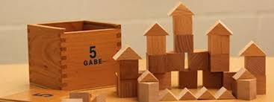
- Children were encouraged to use all the Gifts creatively, building structures and exploring patterns.
Figure 9(Community playthings 2021)

Occupations: involve transforming the material irreversibly, hands on activities developing manual dexterity (froebel.org.uk no date).
- Examples such as clay, weaving, cutting and sewing, and gardening.
- These activities help develop fine motors skills while creating something new.
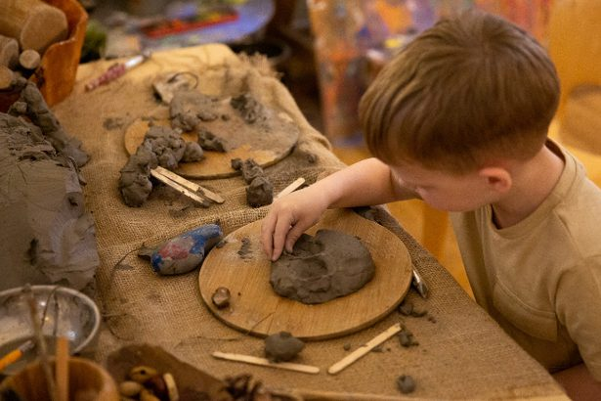

Figure 10(Froebel Trust n.d)
Together both Gifts and Occupations formed a balanced approach to early learning, blending both creativity and practical skill building and learning skills.
So, as I circle back to the beginning, I find myself asking: Are Froebel’s theories still relevant today? My answer is YES. Without his bold ideas, we might not have the creative, confident, well- rounded children we see today. and without his Kindergarten concept, our nurseries and playgroups might never have existed. Froebel planted the roots of early education – and we are still growing.
“FROM LITTLE ACORNS MIGHTLY OAK TREES GROW”

Blog 2: Reference list

Aubrey, K and Riley, A (2022) Understanding and using educational Theories. 3rd edn. London: Sage
Welsh Parliament (2024) Children’s rights: high on the political agenda again Available at: https://research.senedd.wales/research-articles/children-s-rights-high-on-the-political-agenda-again/#:~:text=A%20year%20ago%20it%20would,is%20looking%20at%20children's%20rights%2C (Accessed: 14th November 2025)
Froebel trust ( No Date) ‘Froebel’s Occupations’ Available at: https://www.froebel.org.uk/training-and-resources/froebels-occupations#:~:text=Each%20of%20the%20Occupations%20give,Find%20out%20more (Accessed on: 22nd Nov)
Froebel Web. (2022) Mothers made conscious Available at https://www.froebelweb.org/web2014.html (Accessed: 21st November 2025)
Early excellence Limited (2025) Friedrich Froebel: His Principles, Play Theory, and Legacy in Education Available at: https://earlyexcellence.com/practice-and-pedagogy/friedrich-froebel-theory/#:~:text=His%20Froebel%20play%20theory%20highlights,aspects%20of%20life%20are%20interconnected. (Accessed: 20th November 2025)
Gray, C and MacBain, S (2015) Learning Theories in childhood 2nd edn. London: Sage
Hunter, M. (no date) ‘Gifts and Occupations’ - a Froebelian dilemma? Available at:https://www.froebelnetwork.org.uk/blog/gifts-and-occupations-a-froebelian-dilema#:~:text=The%20Gifts%20are%20those%20objects,applies%20it%20to%20the%20Occupations. (Accessed: 22nd November 2025)
Image 1: Froebel for families. Available at: https://www.froebel.ed.ac.uk/children-and-families/ (Accessed: 14th November 2025).
Image 2 Froebel Available at: https://playcreatelearnblog.blogspot.com/2015/09/the-influence-of-froebel.htmlImage 2 (Accessed: 14th November 2025)
Image 3: Children playing. Available at: https://www.exploreyourarchive.org/froebel-learning-through-play/Pound,L (2005) How children learn London: Step forward publishing (Accessed: 21st November 2025)
Image 4: Child playing with clay Available at: https://www.froebel.org.uk/training-and-resources/froebels-occupations#:~:text=Each%20of%20the%20Occupations%20give,Find%20out%20more (Accessed: 22nd November 2025)
Image 5: Froebel’s Gifts Available at: https://www.communityplaythings.co.uk/learning-library/articles/froebels-gifts-and-block-play-today?srsltid=AfmBOoq2L2XV0NXOuwZDzFKUcvbdmJSGgjQh3SlODCMxkCrEDjywrQLR (Accessed:22nd November 2025)
Pound, L. (2005) How Children Learn London: Step forward publishing Limited.

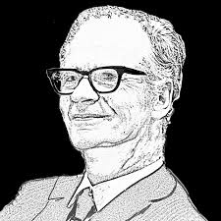
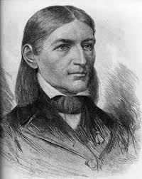
Skinner Vs Froebel
The Big Debate!
Figure 1B.F.Skinner.org 2025
Figure 2 Froebel.org 2020
In the RED corner, we have Skinner, and in the GREEN, Froebel. Two heavyweights within our educational settings, two different views on how children learn. Both theorists are widely respected – but their theories couldn’t be more different. or could they? So, do skinner and Froebel have anything in common? And more importantly are their theories still relevant in today’s classroom? Let’s dive in…….
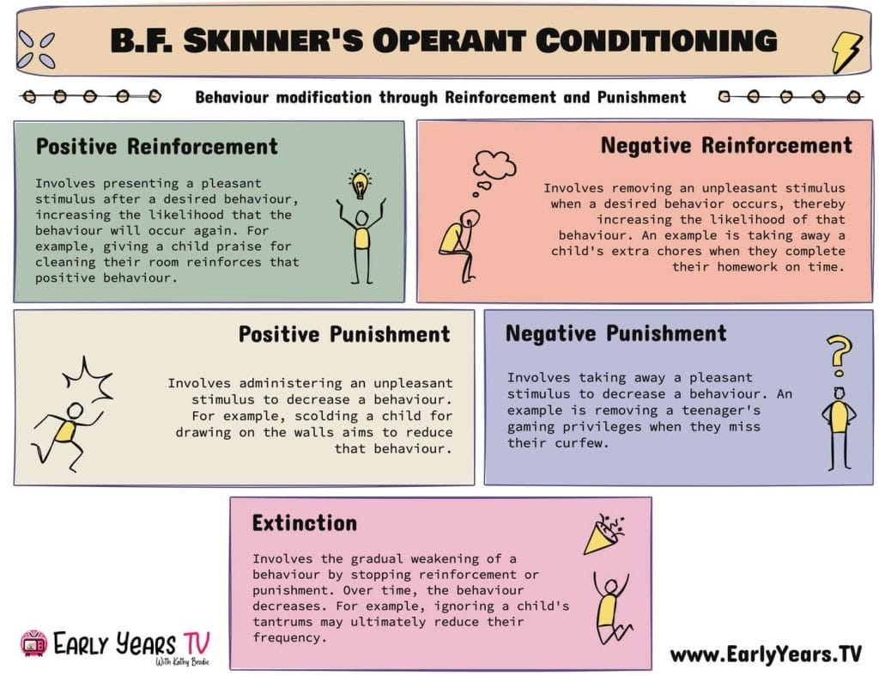
Skinners: Behaviourism
- Operant conditioning: Behaviour is shaped by consequences (Aubrey and Riley, 2022,).
- Reinforcement: Positive reinforcers (Praise) strengthen behaviour, Negative reinforcers (punishment) weaken negative behaviour (Gray and MacBlain)
- Application in Education: The Repetition of desired responses
- Rewards: positive points on classcharts, praise, stickers
- Punishment: Negative points on classcharts, warning, sanctions, removal.

Critique of His Theory:
- If the child is praised every time, the praise loses its value (Bates, 2023)
- Punishment can be seen as a reward by some children
- We are not looking at the root problem as to why a child acts a certain way.
- Rewards may isolate those children who feel do not have a chance of reward (Pritchard,201
Figure 3 EarlyYears.TV 2025

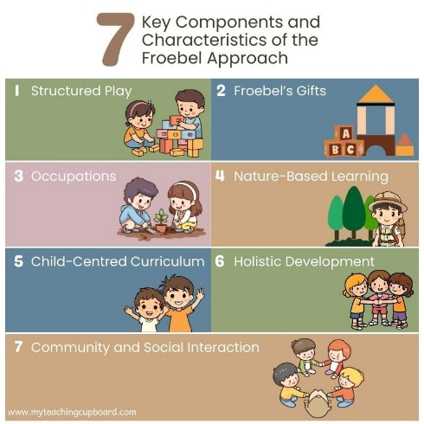
Froebel: Constructivism
- Child centred approach: Children learn best through exploration, Froebel emphasised the importance of play. (earlyexcellence,2025).
- Nature: children were encouraged to play outdoors connecting with nature and learning through play (Pound, 2005).
- Freedom and guidance: deeper understanding of self, others, nature, and the wider world. (froebel.ed.ac.uk 2025)
- Gifts and Occupations: Structured open- ended play materials for creativity (Pound, 2005).
- Kindergarten: Early Childhood education
- Application in Education: The concept of kindergarten recognised the importance of early years development. (froebel.ed.ac.uk)
- Foundation Phase
- Outdoor learning
- Parental involvement in child’s learning

Critique of His Theory:
- Overemphasis on play: Critics believed that the structure of the program was too rigid.
- Gifts and occupations: To much focus on fine motor skills, more writing and reading would benefit students. (spielgaben.com 2024)
Figure 4 (My teaching cupboard n.d)
- Difficult to put the theory into practice (Pound, 2005).
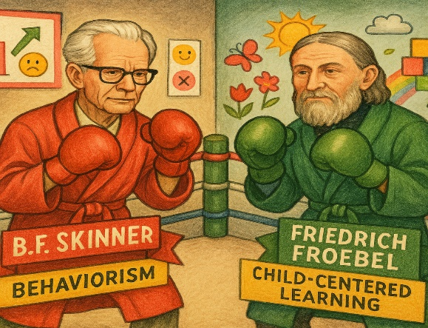
So, in the educational boxing ring, Skinner and Froebel step into opposite corners, each with different approaches to learning and behaviour. Skinner steps into the ring with his behaviourist theory delivering quick, powerful punches through reinforcement and punishment and rewards, making it effective for managing classroom behaviour in the short term. but as the round progresses we see weaknesses becoming clear. The overuse of rewards and punishments can reduce their impact, having a negative effect. (Pritchard 2014) leaving the underlying cause of the child’s behaviour unknown. In steps Froebel with his contrasting style, his holistic still focusses on learning through play and exploring the world around us. His Kindergarten idea laid the foundation for our early year’s settings. But Frobel starts to weaken, critics argue that the emphasis on play can overshadow academic skills, his gifts and occupations may be too restrictive, and the theory can be difficult to apply in a busy classroom (Pound, 2005).
Figure 5 (Copilot, 2025)


As the final bell rings, the winner is…… there is no clear winner, both have strengths. However, by blending the strengths of both contenders. We can as educators achieve the most effective outcomes. By combining Skinner’s structured behaviour management strategies with Froebel’s emphasis on play, and Childs centred learning, we can create a balanced learning environment, one that supports positive behaviour while encouraging meaningful, holistic development.

Blog 3: Reference list
Aubrey, K and Riley, A (2022) Understanding and using educational theories. 3rd edn. London: Sage.
Baes, B. (2023). Learning theories simplified. 3rd edn. London: Sage.
Spielgaben (2024) Comparison among Froebel, Montessori, Reggio Emilia and Waldorf-Steiner Methods Available: https://spielgaben.com/comparison-froebel-montessori-reggio-waldorf-part-1/#:~:text=Criticisms%20of%20Froebel%20Education,more%20free%20and%20imaginative%20play. (Accessed: 29th November 2025)
Early Excellence Ltd (2025) Friedrich Froebel: His Principles, Play Theory, and Legacy in Education. Available at:https://earlyexcellence.com/practice-and-pedagogy/friedrich-froebel-theory/#:~:text=His%20Froebel%20play%20theory%20highlights,aspects%20of%20life%20are%20interconnected. (Accessed: 29th November 2025).
The University of Edinburgh (2025) Froebel: an introduction Available at: Froebel: an introduction - Froebeliahttps://www.froebel.ed.ac.uk/froebel-an-introduction/#:~:text=Froebel%27s%20key%20principle%20was%20%E2%80%9Cfreedom,nature%20and%20the%20wider%20world.n futures (Accessed: 28th November 2025)
Image 1: Skinner’s Quote of the Day ( 2025), Available at: https://www.bfskinner.org/skinners-quote-of-the-day/ (Accessed: 28th November 2025)
Image 2: About Friedrich Froebel, who invented “kindergarten” (2020) Available at https://www.froebel.org.uk/about-us/the-power-of-play/about-friedrich-froebel (Accessed: 28th November 2025)
Image 3 : Froebel’s Theory of play for early childhood education ( no date), Available at: https://www.myteachingcupboard.com/blog/froebel-theory-of-play (Accessed: 28th November 2025)
Image 4 : B.F. Skinner: Operant Conditioning and Behaviourism Theories (2025) Available at: https://www.earlyyears.tv/b-f-skinner-operant-conditioning-and-behaviourism-theories/ (Accessed: 28th November 2025)
Image 5: Copilot. (2025). Friedrich Froebel and B.F. Skinner in a whimsical classroom arena [AI-generated image]. Microsoft Copilot. Response to Theresa Angier (Accessed: 30 Nov 2025).
Image 6: Hand bell (no date) Available at: https://www.shutterstock.com/image-illustration/hand-ring-bell-pop-art-retro-1014324409 (accessed: 27th November 2025)
Pritchard, A. (2014). Ways of Learning. 3rd edn. London: Routledge


Figure 1 Ysgol Greenhill (2025)
Putting theory into practice: Skinner and Froebel in my educational setting
When I began to write this blog, I initially could only draw on Skinner’s theory of operant condition, as his method appeared more aligned with secondary education. Skinner argued that behaviour is shaped through positive and negative reinforcement, where desirable behaviour is rewarded and undesirable behaviour is discouraged (Bates,2023).
So, how does this statement align within Ysgol Greenhill? The approach clearly reflects our schools’ rewards and sanctions policy. Our school’s ethos centres on encouraging and promoting positive behaviour. This is achieved through using strategies such as:
- Classcharts
- Verbal praise
- positive phone calls home

All of which acts as positive reinforcement (Ysgol Greenhill, 2025). Sanctions are also used to address and discourage inappropriate behaviour, Reflecting Skinner’s principles that consequences influence behaviour choices (McLeod, 2025). These include:
- the awarding of negative points on Classcharts
- where unwanted behaviour persists, time out in the exclusion room, Ready to Learn (Ysgol Greenhill, 2025).
- Excluded from taking part on school trips
Figure 2 Ysgol Greenhill (2025)
Overall, these approaches demonstrate how Skinner’s behaviourists theories are still very relevant in today’s educational settings.
I then began to explore Froebel and how his constructivism theory could be linked to teaching and learning within my own setting, and this is where it started to get interesting, initially I questioned whether Froebel’s work would be relevant to my workplace, as his theories are usually associated with early years education. And yes, you would be right to think that, without Froebel’s influences our early years settings today may look very different (Early Excellence, 2025). So how did I link his theories to our teaching and learning strategies?
Ysgol Greenhill Well-Being policy states that “Our aim is to establish and uphold a school ethos and environment that places the holistic well-being of all stakeholders at the forefront. We strive for relationships built on mutual respect, fostering cooperation between adults and pupils in an atmosphere of safety and enjoyment. As a caring school, we aspire for our students to develop in an environment that promotes honesty, trust, and the gradual assumption of responsibility.” (Ysgol Greenhill 2024). This statement not only emphasises Froebel’s holistic view that education is about total development, not just academic achievement it strives for relationships to be built on mutual respect, earlyexcellence.com), but also his vision of education as a nurturing environment, where children grow with the support of adults.
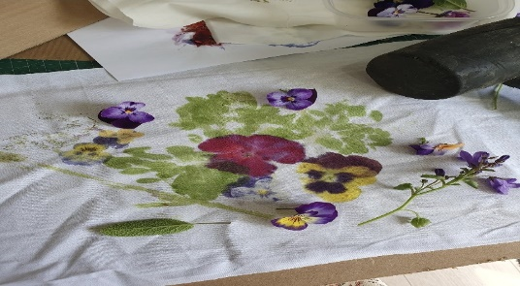
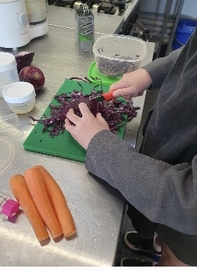
Within my department, I feel we align with Froebel’s theory strongly. As we work with students who struggle to access mainstream lessons fulltime, it has been necessary to adapt our teaching and learning approaches to meet individual needs while keeping learners engaged and on track for their GCSE and future progression.
To engage a group of textiles students, I used a hands-on, outdoor approach inspired by Froebel’s emphasis on nature (pound 2024). While learning about natural dyes, students collected flowers and leaves from our grounds and used them to print directly onto fabric. This practical, sensory activity captured their interests and supported learning through exploration – even if the enthusiastic hammering proved slightly distracting for colleague’s downstairs.
Figure 4 Image of natural dye (Angier)
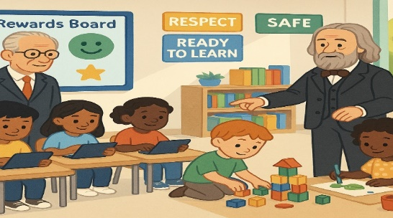
Overall, both Skinner and Froebel’s theories remain relevant in Ysgol Greenhill, though they have been adapted to our ever-changing educational setting, Elements of Froebel’s philosophy can be seen in our practical lessons, physical Education, and design and Technology, where learning through activity and experience is central. In contrast, Skinner’s behaviourist theory, shapes how we manage positive and negative behaviour through reinforcement strategies.
Figure 5 Copilot (2025)
Figure 3 Child cutting cabbage (Angier)

Blog 4: Reference list

Bates, B. (2023). Learning theories simplified. 3rd edn. London: Sage.
Early Excellence (2025) Friedrich Froebel The Pioneer of Early Childhood Education Available at: https://earlyexcellence.com/practice-and-pedagogy/friedrich-froebel-theory/#:~:text=Froebel%27s%20approach%20encouraged%20activities%20such,modern%20early%20years%20pedagogy%20today. (Accessed: 2nd December 2025)
Early Excellence Ltd (2025) The Froebelian Principles: A Child-Centred Approach Available at: https://earlyexcellence.com/practice-and-pedagogy/friedrich-froebel-theory/#:~:text=Unity%20and%20Connectedness:%20The%20Holistic,as%20the%20'whole%20child'. (Accessed: 5th December 2025)
Image 1 Ysgol Greenhill logo (2025) Available at: https://www.ysgolgreenhill.co.uk/ (Accessed: 5th December 2025)
Image 2 Ready to learn log (2025) Available at: https://ysgolgreenhill.co.uk/our-school/policies?search=policies (Accessed: 2nd December 2025 )
Image 3 Angier. T (2023) Natural dye [Photograph]
Image 4 Angier. T (2023) Child cutting cabbage [Photograph]
McLeod,S (2025) Operant Conditioning what it is, how it works and examples Available at: https://www.simplypsychology.org/operant-conditioning.html ( Accessed:1st December 2025)
Pound, L (2005) How Children Learn London: Step forward publishing Limited
Ysgol Greenhill Rewards and sanctions Policy (2025) Available at: https://ysgolgreenhill.co.uk/our-school/policies?search=policies ( accessed: 1st December 2025)
Ysgol Greenhill Well -Being Policy (2024) Available at : https://ysgolgreenhill.s3.amazonaws.com/uploads/document/Wellbeing-Policy-Jan-24.pdf?t=1705406221 (Accessed:5th December 2025)

