Manon Hazzelby John 2302337
Ysgogwyr NEwid
ADPA5003/C
portffolio

Linc ar gyfer y Wefan:
https://manonjohn.wixsite.com/my-site-2
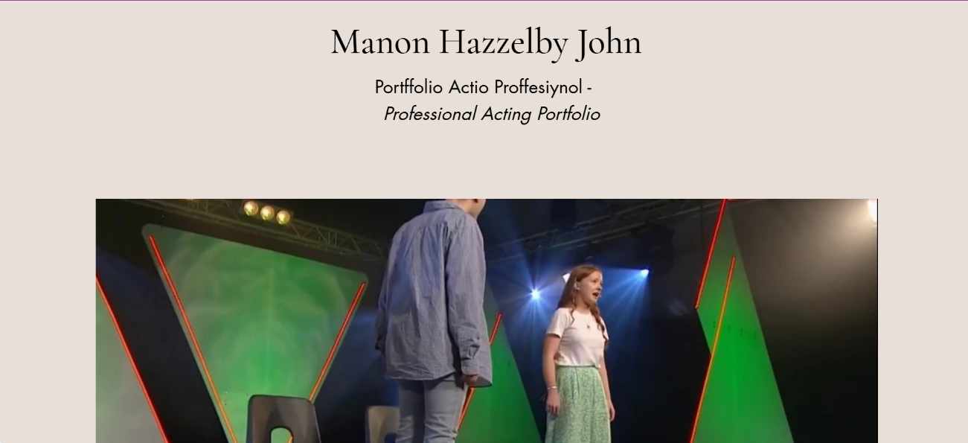
Sgrînluniau’r Wefan:

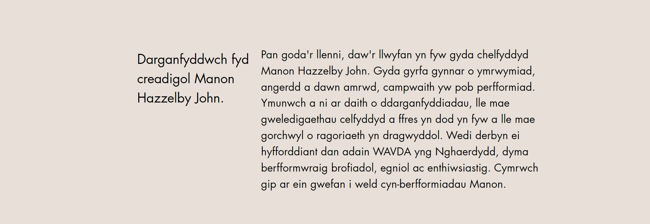

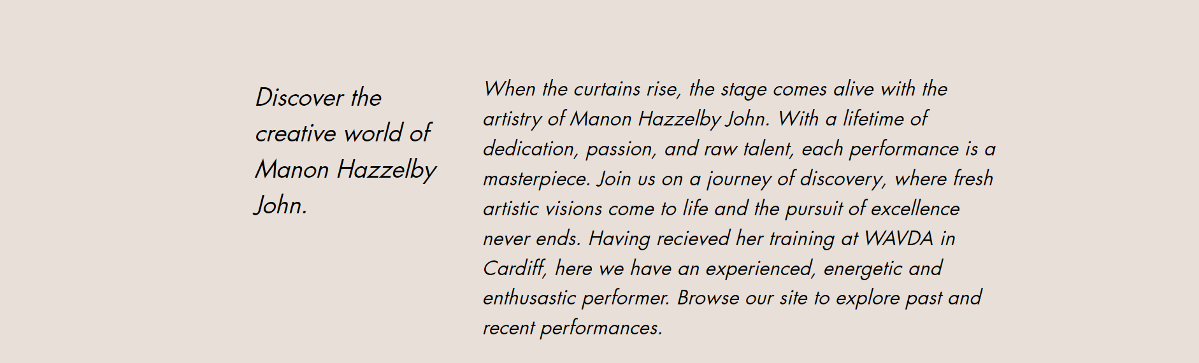

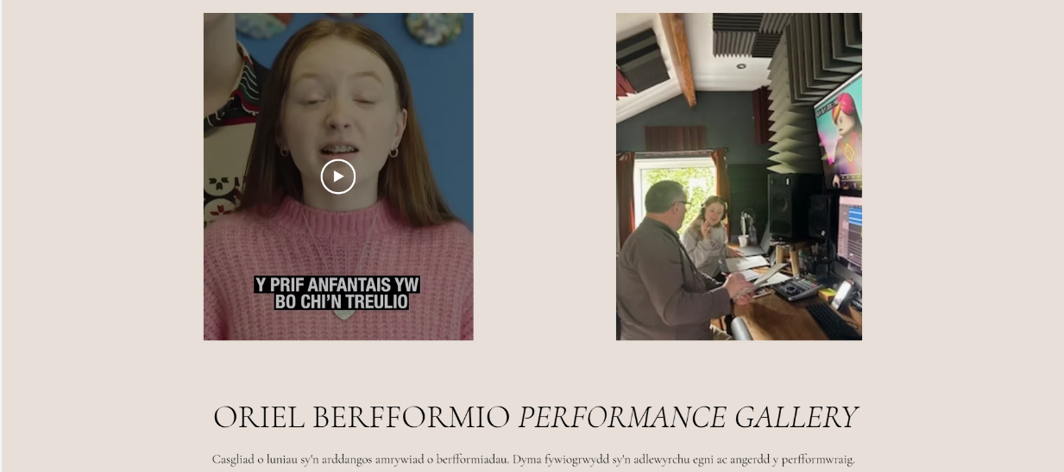

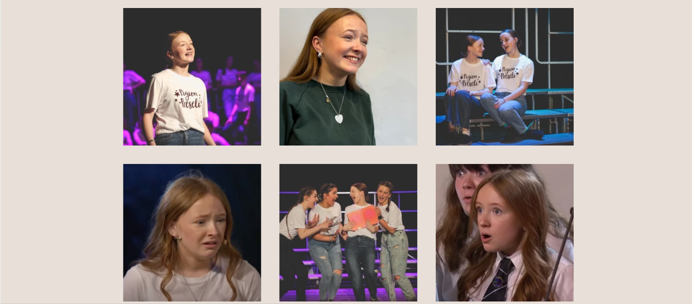

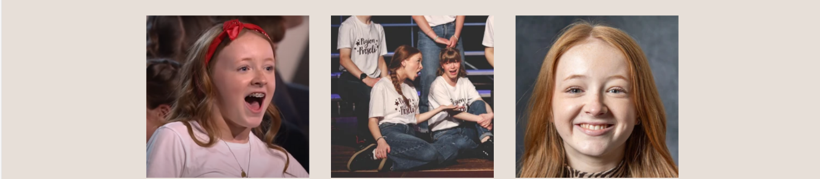

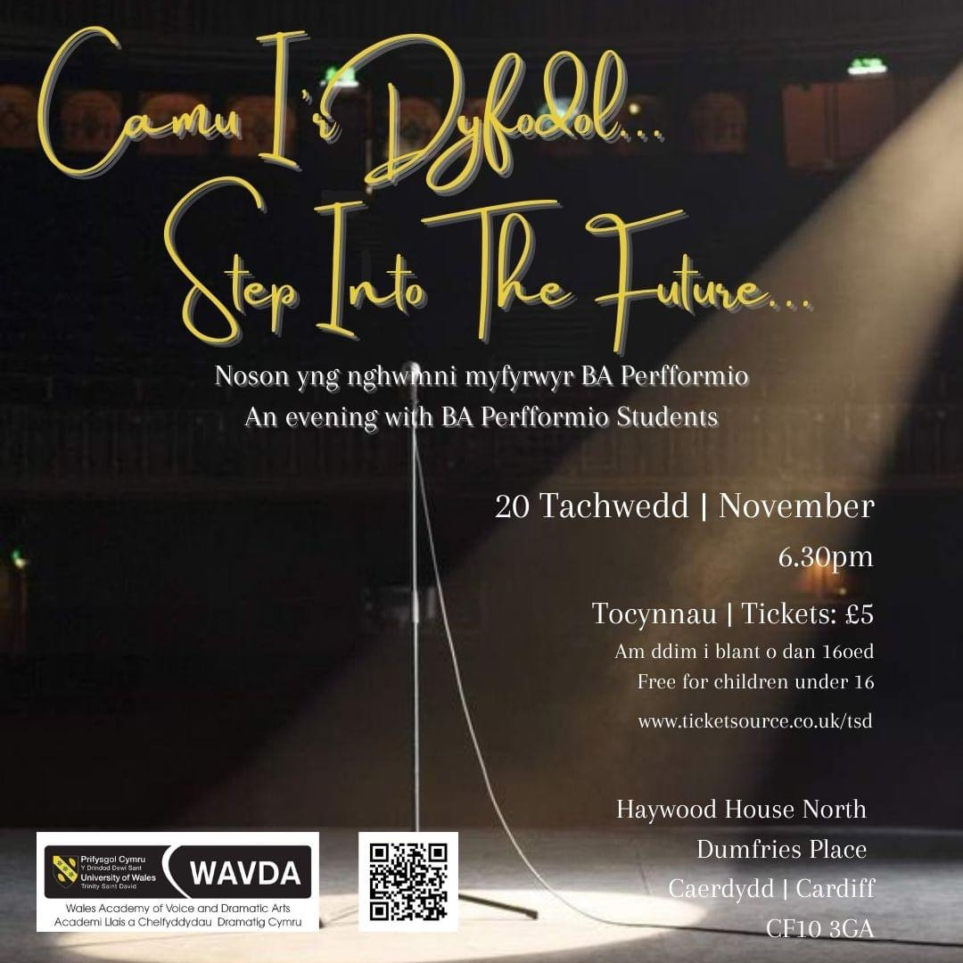
Y Poster â dewisom:

Fy mhoster i:
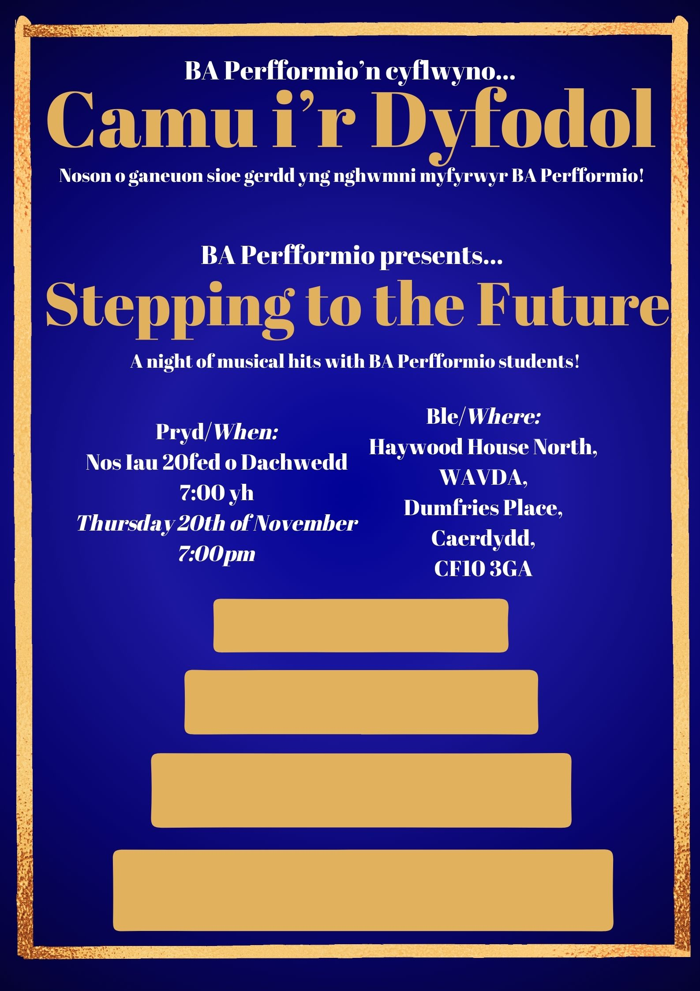

Sgrînluniau o fy ngwaith personol ar gyfrif Instagram BA Perfformio i hyrwyddo’r noson Cabaret:
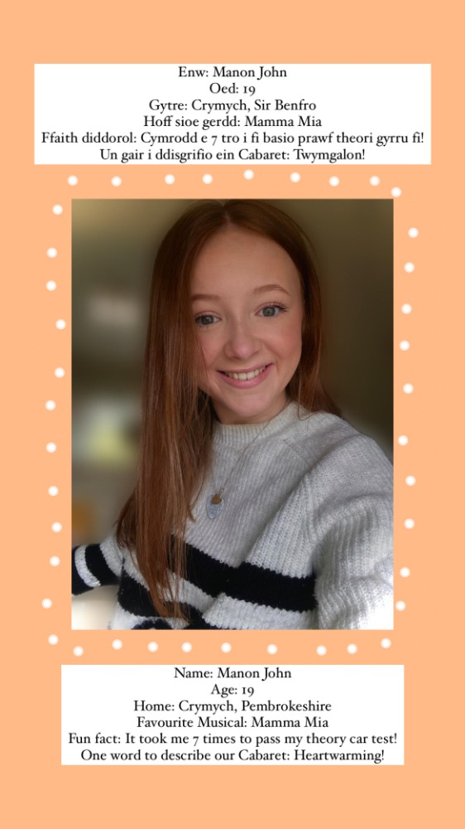

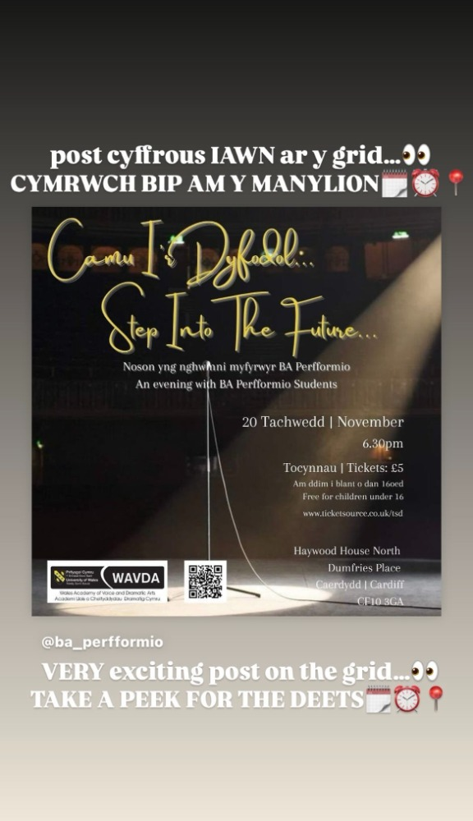

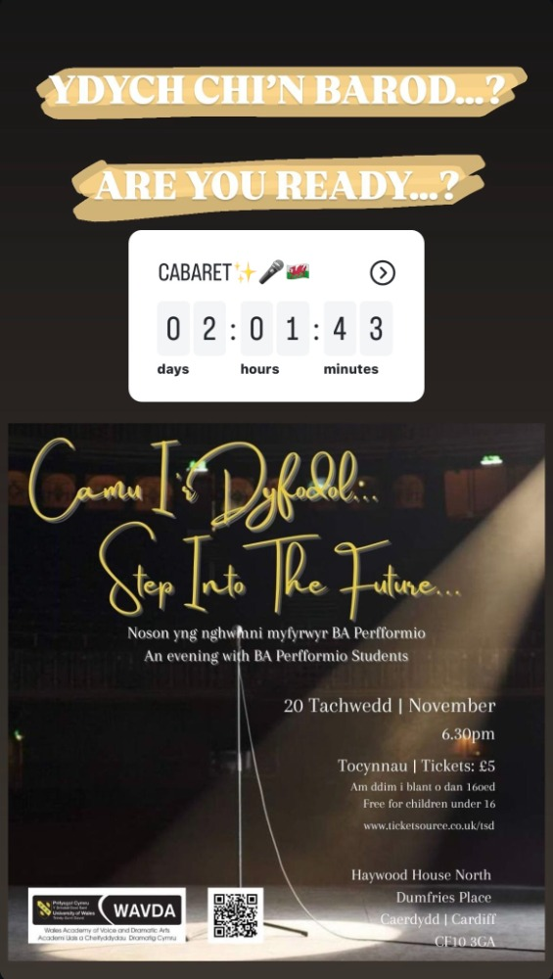
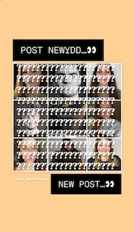

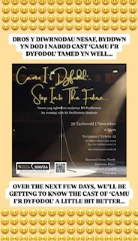

Linc ar gyfer y Rhaglen:
https://www.canva.com/design/DAGWw4yLc3M/ZU8ZMfcm2bTrcF_7GO2rlg/edit

