

Professional career in Health &Social Care
(LCHS4009_LON)

Assessment 2 : Personal Development Portfolio
Programme : Certificate of Higher Education in H & C

Name : Muhammad Zubair Hamayo
Student Id : 2514993

Lecturer Name : Christopher Mafuva
Submission Date : 16/08/26

Table of Contents Page Number

Introduction —--------------------------- 3
Task 1
Curriculum Vitae —-----—------------------- 4
Task 2
Personal Statement –Medical Assistant Application —--------- 6
Task3
- SWOT Analysis for a Medical Assistant Role —---------- 7 Strengths
b) Personal Development Plan for a Medical —--------- 8
Assistant Role

Task 4

Critical Reflection Using Gibbs’ Reflective Cycle —---------- 8

References —-------------------------------- 10

Practical Portfolio
Introduction
A structured collection of work, proof, accomplishments, and experiences that showcases an individual's knowledge, abilities, growth, and advancement is called a portfolio. Documents including assignments, projects, certificates, photos, reports, reflections, and samples of finished work may be included. In education, employment, and professional development, portfolios can be used to showcase skills and accomplishments to educators, employers, and other professionals. A portfolio can include reflections that describe what has been learned and how skills have evolved over time, in contrast to a straightforward collection of documents. A portfolio, according to Harvard University, is a collection of pieces selected and assessed to showcase an individual's greatest work or growth (Harvard University, 2026). As a result, a portfolio offers proof of education, expertise, and development on both a personal and professional level.

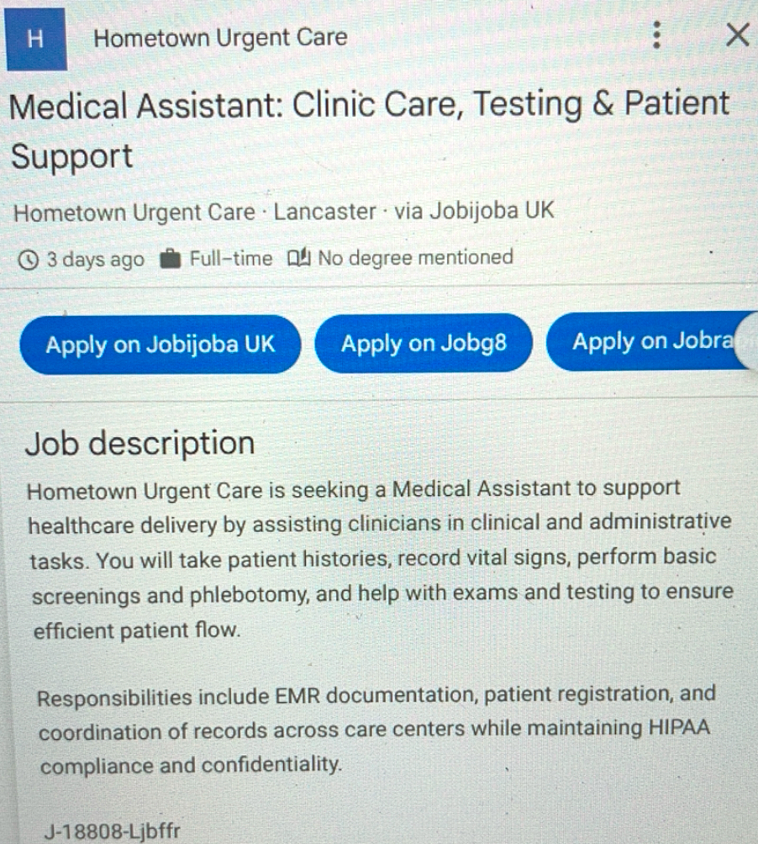

Task 1: CURRICULUM VITAE

Medical Assistant | Health and Social Care

Name: —------- Contact No: —------ Email Address: —---

PERSONAL PROFILE
With a Level 4 Certificate in Health and Social Care and a strong desire to pursue a career as a Medical Assistant in the health and social care industry, I am a driven and dedicated health and social care graduate. I now have knowledge of public health, psychology, research techniques, digital skills, health and social care concepts, and professional career development thanks to my academic education. Despite the fact that I lack professional work experience, I am eager to put my academic knowledge to use in a hospital setting and gain real-world experience through supervised training. I am a trustworthy, caring, and responsible person who recognises the value of professional conduct, good communication, confidentiality, safeguarding, and person-centred care.
QUALIFICATIONS :
Level 4 Certificate in Health and Social (UWTSD- London, 2026)
Key Skills
Communication and interpersonal skills
- Communicate simply, respectfully and professionally with people from different backgrounds.
- Show empathy and attentive listening skills.
- Recognise the significance of precise and unambiguous communication in healthcare environments.
- able to establish positive and constructive business relationships.
Person-centred treatment
- Recognise the significance of treating people with kindness, respect, and dignity.
- Acknowledge the significance of personal preferences, needs, and decisions.
- Recognise the fundamentals of person-centred methods in social and health care.
Public health and wellbeing
- Knowledge of basic public health principles and health improvement.
- knowledge of the elements that can affect a person's or a community's health.
- Awareness of the importance of prevention and encouraging healthy living.
Digital and research skills
- Capable of using digital technology both professionally and academically.
- Fundamental knowledge of information collection and research techniques.
- Able to locate, arrange, and display pertinent data.
- Gaining assurance when utilising electronic information and digital instruments

Professional skills
- Strong time-management and organising abilities.
- Trustworthy, accountable, and eager to learn.
- Capable of both solo and group work.
- Recognise the significance of professional boundaries and confidentiality.
- Ready to grow via reflective learning and accept criticism.
WORK EXPERIENCE
Right now, I am looking for my first job in the health and social care industry. My Level 4 Certificate in Health and Social Care has given me applicable academic knowledge and transferable skills. A work as an entry-level medical assistant would be especially appealing to me since it would allow me to gain real healthcare skills under the right guidance and training. I'm open to picking up organisational protocols, expanding my knowledge of patient support, and making a responsible contribution to the larger healthcare team.
VOLUNTARY EXPERIENCE
I am interested in obtaining voluntary or work-experience opportunities within healthcare, social care, community services or relevant organisations. By volunteering, I would be able to put my Level 4 certificate to practice, acquire confidence in my ability to interact with patients and service users, and learn about professional healthcare settings.I am especially eager to gain real-world experience in professional behaviour, teamwork, communication, patient support, and organization.
ACADEMIC AND PERSONAL ACHIEVEMENTS
- Successfully completed a Level 4 Certificate in Health and Social Care.
- Developed Knowledge in public health, psychology, and health and social care.
- Acquired expertise in information management and scholarly research.
- Developed digital abilities that are useful in both professional and academic settings.
- Increased knowledge of the standards for professionals in the health and social care sectors.
- Shown a dedication to advancing toward a profession in healthcare.
- Gained knowledge of professional obligations, communication, and person-centred care.
- Strong commitment to continuing professional development.
INTERESTS AND HOBBIE
I am very interested in health, wellness, and healthcare.Particularly, I want to know how social care and health services may help people and communities. Through reading and educational activities, I also like expanding my knowledge and picking up new abilities. Other hobbies consist of reading and personal growth, well-being and health, studying human behaviour and psychology, being physically fit and leading a healthy lifestyle, spending time with family and friends

REFERENCES
Available upon request
Task 2:
Personal Statement – Medical Assistant Application
I am a motivated and kind person looking to start a career in the health and social care industry as a medical assistant. My successful completion of a Level 4 Certificate in Health and Social Care has given me a solid academic basis pertinent to the practice of healthcare. I am excited to apply the information and transferable skills I have gained from my studies in a real-world healthcare setting, even albeit I do not yet have professional work experience. My long-term professional goal is to become a capable, self-assured, and accountable healthcare practitioner who enhances patient care and supports the efforts of the larger healthcare team.
I have been able to expand my knowledge in a number of areas that are pertinent to the position of medical assistant thanks to my Level 4 certificate. I gained knowledge of the ideals and tenets that guide care, such as the significance of treating people with respect and acknowledging their needs, throughout Introduction to Health and Social Care. My knowledge of human behaviour, psychological well-being, and variables that may affect people's experiences of health and sickness has improved as a result of studying psychology in health and social care. Additionally, Introduction to Public Health taught students about health promotion, prevention, and the variables that affect people's health and well-being both individually and collectively.
communication, organization, time management, and problem-solving skills have all improved as a result of my courses in Academic and Employability Skills. Additionally, Digital Skills and Research Method improved my abilities to use digital tools, find and assess information, and do methodical research. Because healthcare settings demand precise communication, organization, and responsible information processing, these abilities would be beneficial in a role as a medical assistant. In order to practise professional healthcare, people must also keep improving their knowledge and abilities and evaluate their work (GMC, 2024).
I consider communication, compassion, reliability, willingness to learn and adaptability to be my key personal strengths.I am aware that receiving medical care can cause individuals to feel vulnerable, anxious, or uncertain. As a result, I would try to speak with patients in a courteous, understanding, and patient way. Communication, teamwork, organisational skills, compassion, and problem-solving abilities are highlighted by NHS England (2023) as critical traits for healthcare support positions. These attributes closely match how I approach my own career growth.
I also recognise the value of patient dignity, professional limits, and confidentiality. Respect and decency, compassion, dedication to high-quality treatment, enhancing lives, teamwork for patients, and making sure that everyone matters are among the NHS core principles (NHS England, 2023). Through my actions and interactions with patients and coworkers, I would try to exhibit these values. I plan to continue improving my communication, digital, organisational, and patient-support skills over the next two years by attending pertinent courses and gaining relevant experience. I think my academic background, upbeat outlook, dedication to learning, and keen interest in healthcare would allow me to contribute significantly to a company while still advancing my career.
Task3 :
- SWOT Analysis for a Medical Assistant Role
Strengths

My motivation is a key personal strength to develop a career within healthcare and improve skills and practical competencies required for a medical assistant role. I show a willingness to learn and grow via education, training, and supervised practice even though I do not currently have any direct experience in this role. Because medical assistants engage with patients and support the larger healthcare team, effective communication, empathy, dependability, and teamwork are especially pertinent to healthcare practice. Communication, empathy, teamwork, and organisational skills are critical qualities for healthcare support positions, according to NHS England (2023). Another one of my strengths is that I am open to receiving constructive criticism, which can help me advance professionally and continuously.

Weaknesses

My major weakness is the absence of practical healthcare experience. I must therefore broaden my knowledge of clinical practices, infection control, patient observations, confidentiality, documentation, and professional obligations. When interacting with patients or taking on new activities, I could initially feel insecure. Because healthcare professionals have an ethical and professional obligation to preserve patient information, confidentiality is especially crucial (GMC, 2026). I also need to become conscious of my own limitations and know when to seek advice from a trained specialist. Structured instruction, supervised hands-on training, introspection, and frequent evaluation can all help to address these shortcomings.

Opportunities

There are many chances to acquire the skills needed for a position as a medical assistant. Opportunities to acquire both theoretical knowledge and practical skills can be found through relevant training programs, volunteer work, work placements, and employment in the healthcare industry. According to NHS England (2023), workplace education and training are crucial ways for people to acquire healthcare competencies. Additionally, reflective practice offers a chance to assess experiences and pinpoint areas in need of development. According to Schön (1983), reflection helps professionals learn from their experiences and enhance their work in the future. As a result, I may use input from coworkers, supervisors, and instructors to pinpoint particular areas that want improvement.

Threats

A main threat is competition for the healthcare sector because my lack of experience may initially place me at a disadvantage compared with those applicants who already have practical abilities. The demanding nature of healthcare settings can sometimes provide difficulties, especially when juggling several tasks while upholding patient safety and accuracy. Inadequate communication or a failure to acknowledge professional limitations may have detrimental effects on patient care. By completing the relevant training, adhering to organisational policies, requesting supervision when needed, and upholding professional boundaries, I will lower these risks. Safe healthcare practices require effective communication and teamwork (GMC, 2026b).

b) Personal Development Plan for a Medical Assistant Role

My first SMART goal is to improve basic medical assistant knowledge and practical abilities within the first 12 months. I will take part in appropriate training in areas including patient communication, infection prevention and control, basic observations, confidentiality, documentation, and professional conduct. I will keep a development portfolio including finished training, evaluation findings, and comments. A skills checklist will be used to evaluate progress on a quarterly basis, allowing me to pinpoint and address any areas that still require improvement.

Improving my teamwork and communication skills within 18 months is my second SMART goal. When opportunities arise, I will take part in volunteer work, placement, or other supervised healthcare activities. Active listening, professional communication, appropriate information sharing, and teamwork will all receive special attention. Safe and efficient patient care depends on effective communication (GMC, 2026b). I will use reflective narratives, supervisor input, and recurring self-evaluation to gauge my development.

Within two years, I want to be prepared for a job as a medical assistant or in a similar healthcare support role. This is my third SMART objective. I'll create a professional CV, look into suitable job openings, and prepare for interviews using job descriptions and individual requirements. Every month, I will keep track of my progress by documenting applications, interview results, and identifying skill shortages. In cases when applications are rejected, I will utilise constructive criticism to identify further areas that want improvement.

Planning, learning, application, reflection, and assessment will all be ongoing processes in my development over the course of the two years. While Schön (1983) highlights reflection as a technique for enhancing professional practice, Kolb (1984) suggests that learning emerges through the interaction between experience and reflection. As a result, I will evaluate my PDP every three months and document my successes, difficulties, and areas that still need improvement. I will be able to assess whether my goals have been met and adjust them as needed thanks to this methodical approach. In the end, the PDP will help me make the shift from having no prior medical assistant experience to being a capable, self-assured, and marketable healthcare profess

Task 4: Critical Reflection Using Gibbs’ Reflective Cycle

Reflective practice allows people to assess their experiences, pinpoint their strengths and create plans for future growth. Reflective practice is a crucial component of professional development. An organised framework with six stages: description, feelings, evaluation, analysis, conclusion, and action plan is offered by Gibbs' (1988) Reflective Cycle.

Description

I had to prepare and make an academic presentation based on the assessment topic. I arranged the information into PowerPoint slides after conducting research and choosing pertinent data. I made an effort to correctly organise the presentation and make sure the audience understood the key ideas. I tried to maintain proper professional communication while presenting the prepared content during the assessment. My lecturer gave me verbal criticism on my performance after the presentation.

Feelings

I found it difficult to present in front of others, thus I was anxious and unconfident before the presentation. I was worried that I would make mistakes, lose crucial information.My confidence at the start of the presentation was impacted by these emotions. But as the presentation went on, I felt more at ease and could carry on with the evaluation. I also realised from the lecturer's remarks that even though I had finished the evaluation, there were still significant areas that needed improvement.

Evaluation

I prepared for the test and showed that I understood the subject. Despite feeling nervous, finishing the presentation showed tenacity and dedication to my academic growth. However, my lecturer's vocal criticism brought to light my delivery and confidence issues. The comments I received from my lecturer was quite helpful since it gave me an outside viewpoint on how I performed.According to Hattie and Timperley (2007), feedback can help students detect gaps between their current performance and the required standard.

Analysis

The evaluation showed that having relevant academic information is not enough for a good presentation. Communication, self-assurance, audience participation, and the capacity to properly explain material are all necessary for a presentation to be successful. Reynolds (2019) contends that rather than merely showcasing a lot of data, effective presentations should concentrate on clearly explaining ideas. As a result, I was unable to properly express my understanding because of my reliance on the slides.

My performance was also impacted by my anxiety. Anxiety can impair focus, confidence, and communication, especially when people must speak in front of an audience.. According to Schön (1983), reflection is a crucial process that allows people to analyse their behaviour and enhance their future professional practice. Therefore, rather than being merely critical, the lecturer's comments should be viewed as a chance for constructive learning.

Conclusion

Overall , the presentation was a worthwhile educational experience. Preparation, dedication, and subject-matter expertise were among my strong points. However, I still need to work on being more self-assured, communicating verbally, engaging the audience, and being able to convey concepts without using slides. I was able to more clearly identify these areas and comprehend how they affected my overall presentation performance

Action Plan

I will start preparing earlier and practise presenting important ideas in my own words and rehearse my presentation multiple times without reading straight from the slides. In order to assess my confidence and pronunciation, I will also record myself while practicing. In order to track my development and compare feedback from upcoming presentations with the shortcomings found in this assessment, I will keep a reflective learning journal. After every presentation, I will assess my progress and pinpoint particular steps for future development. I want to improve my confidence and effectiveness as a presenter through ongoing practice and introspection. In addition to helping me advance academically, these abilities will be helpful in my future work in the health and social care industry, where effective communication is crucial.

References

General Medical Council (GMC) (2024) Good medical practice 2024. London: GMC. Available at: GMC Good medical practice 2024 (Accessed: 11 August 2026).
General Medical Council (GMC) (2026a) Confidentiality: good practice in handling patient information. Available at: https://www.gmc-uk.org/ethical-guidance/ethical-guidance-for-doctors/confidentiality (Accessed: 10 August 2026).
General Medical Council (GMC) (2026b) Good medical practice. Available at: https://www.gmc-uk.org/professional-standards/good-medical-practice-2024 (Accessed: 10 August 2026).
Gibbs, G. (1988) Learning by Doing: A Guide to Teaching and Learning Methods. Oxford: Oxford Polytechnic.
Hattie, J. and Timperley, H. (2007) ‘The power of feedback’, Review of Educational Research, 77(1), pp. 81–112.
Harvard University (2026) Portfolios. Derek Bok Center for Teaching and Learning. Available at: https://bokcenter.harvard.edu/portfolios (Accessed: 16 August 2026).
Kolb, D.A. (1984) Experiential Learning: Experience as the Source of Learning and Development. Englewood Cliffs, NJ: Prentice-Hall.
NHS England (2023) Your questions answered: a guide to becoming a healthcare support worker. Available at: https://www.england.nhs.uk/long-read/your-questions-answered-a-guide-to-becoming-a-healthcare-support-worker/ (Accessed: 10 August 2026).
NHS England (2023) Your questions answered: a guide to becoming a healthcare support worker. Available at: NHS England – Healthcare Support Worker Guide (Accessed: 11 August 2026).
NHS England (2023) NHS values. Available at: NHS values (Accessed: 11 August 2026).
Reynolds, G. (2019) Presentation Zen: Simple Ideas on Presentation Design and Delivery. 3rd edn. Berkeley, CA: New Riders.
Schön, D.A. (1983) The Reflective Practitioner: How Professionals Think in Action. New York: Basic Books.
Schön, D.A. (1983) The Reflective Practitioner: How Professionals Think in Action. London: Temple Smith.

