
KHALDOUN NABELSI 2214074 BUSINESS MODEL CANVAS
LOOP

18 May 2023
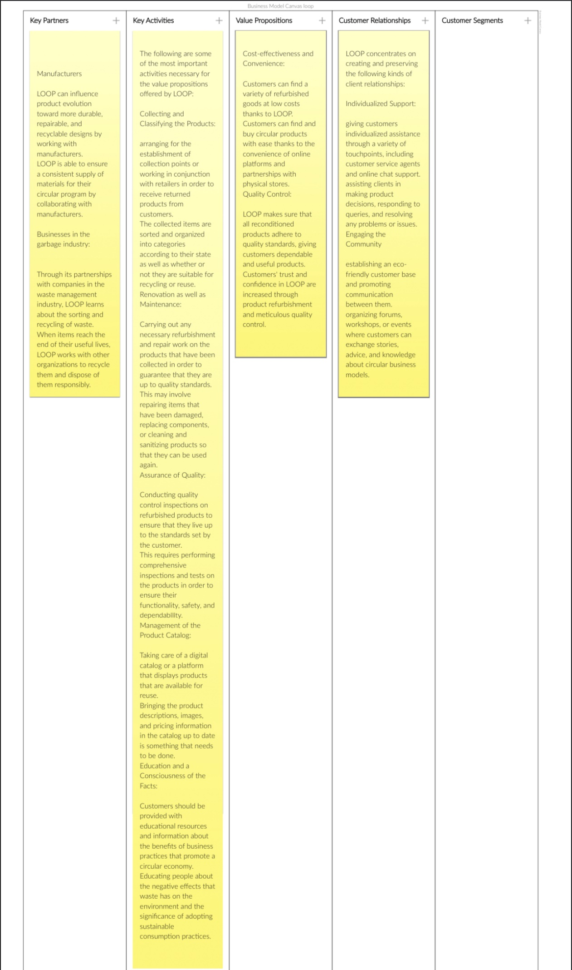
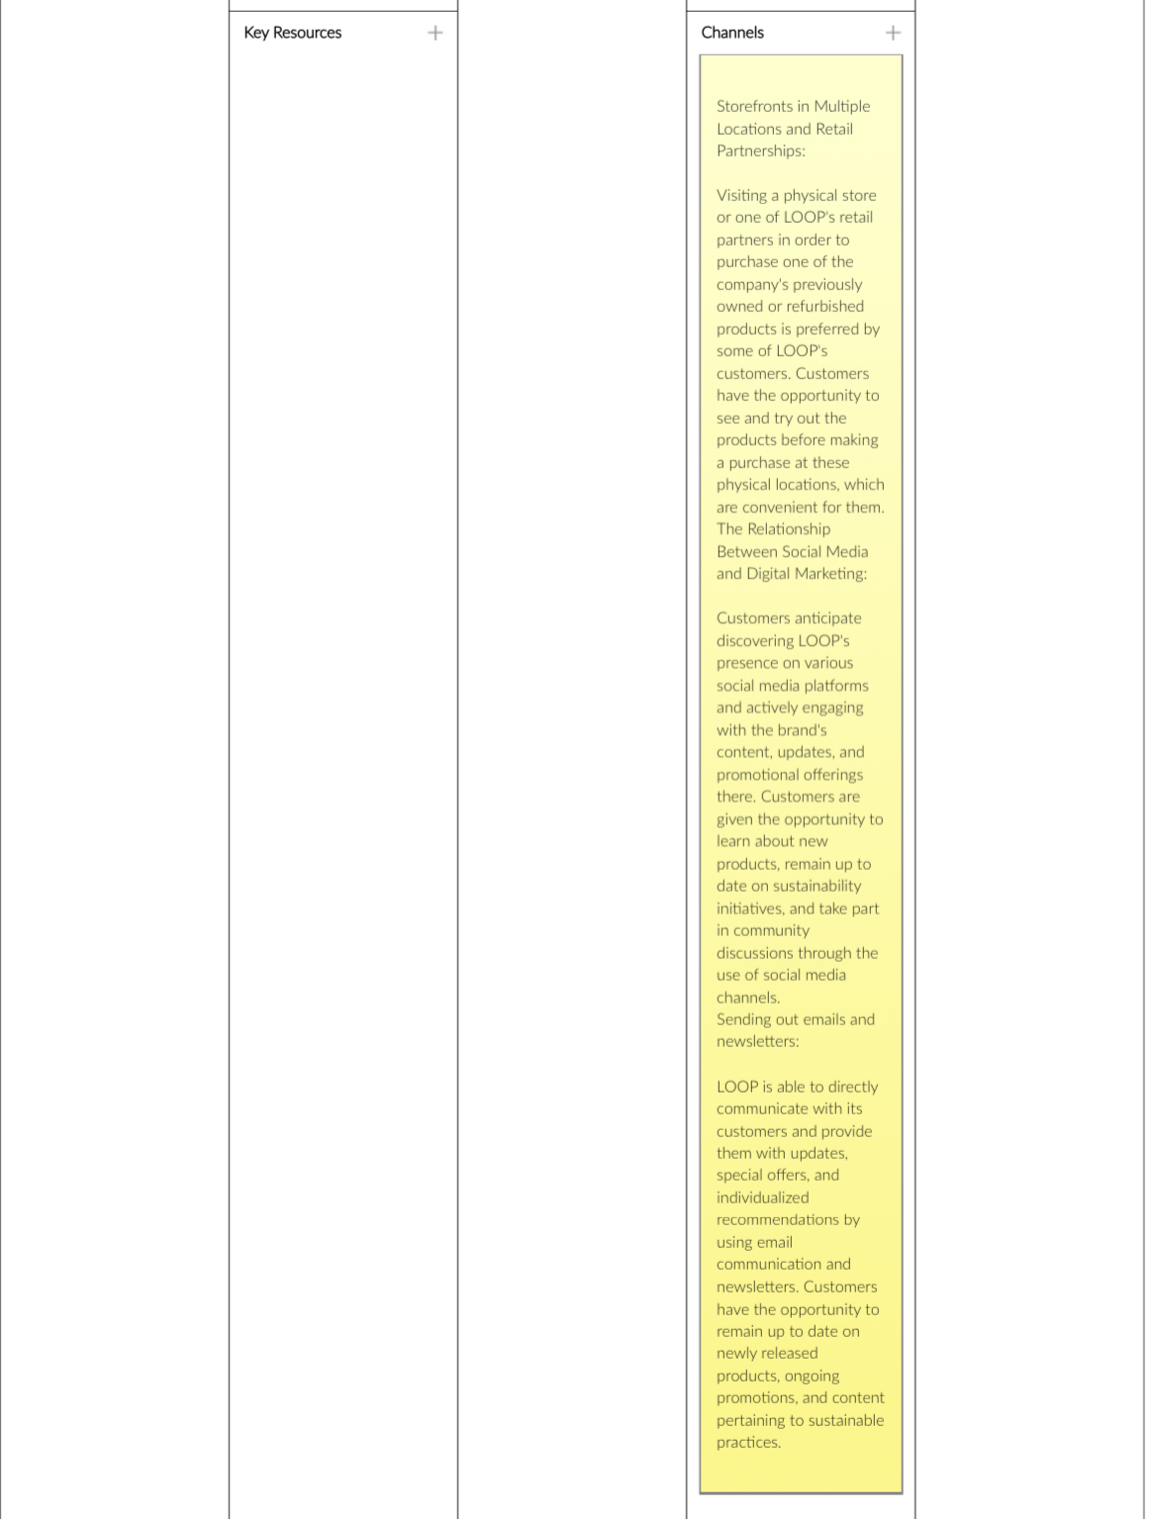

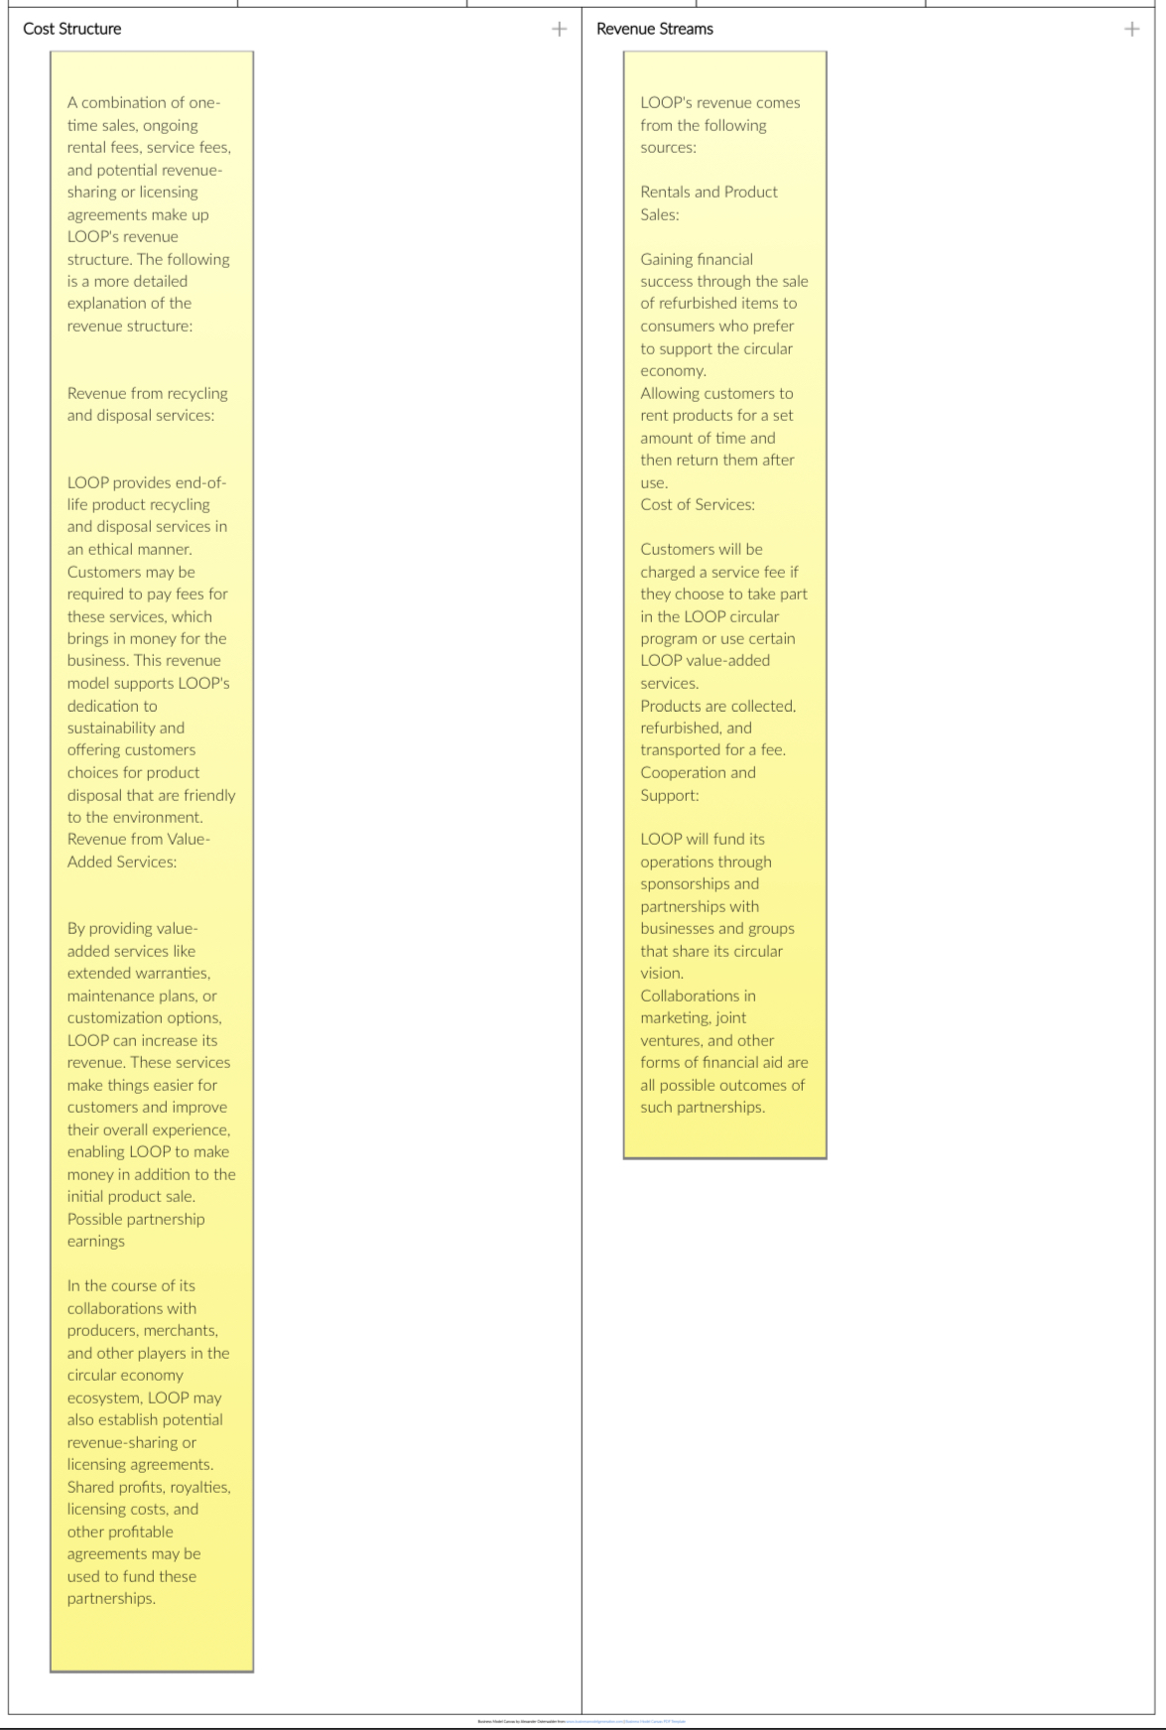

References:
Gleason, J. (2020). TerraCycle’s Loop Expands to Full US Mainland. [online] Global Cosmetic Industry. Available at: https://www.gcimagazine.com/packaging/news/21874765/terracycles-loop-expands-to-full-us-mainland
- Makower, J. (2019). Loop’s launch brings reusable packaging to the world’s biggest brands. [online] GreenBiz. Available at: https://www.greenbiz.com/article/loops-launch-brings-reusable-packaging-worlds-biggest-brands
- Mazzoni, M. (2020). 10 Brands That Embraced the Circular Economy in 2020. [online] www.triplepundit.com. Available at: https://www.triplepundit.com/story/2020/brands-circular-economy-2020/709596
- Popović, A. and Radivojević, V. (2022). The circular economy: Principles, strategies and goals. Economics of Sustainable Development, 6(1), pp.45–56.
- Wiener-Bronner, D. (2019). He convinced the world’s biggest brands to take a risk on reusable containers. [online] CNN. Available at: https://www.cnn.com/2019/10/10/business/loop-tom-szaky-risk-takers/index.html
- Yahaya, I.S., Senin, A.B.A., Yusuf, M.M.B., Khatib, S.F.A. and Sabo, A.U. (2020). Covid-19 Pandemic And Global Business Challenge’s How To Survey With Business Model’s: A Systematic Literature Review. Journal of Public Value and Administrative Insight, [online] 3(3), pp.82–91. Available at: https://www.readersinsight.net/JPVAI/article/view/1493

