UNIVERSITY OF WALES TRINITY SAINT DAVID
LONDON CAMPUS
Assignment 2
Learning in the Digital Era
Video Link: LDE Assignment 2.mp4

Module Name: Learning in the Digital Era
Module Code: ACCA 4025

Student Name: Adekunbi Alo
Student ID: 2533473
Group: 3

Lecturer’s Name: Suneth Fernando

Table of Contents
Introduction 2
Video Link 2
Slide 1 COVER PAGE 2
Slide 2 CONTENTS 3
Slide 3 INTRODUCTION 3
Slide 4 GIBB’s Reflective Model 3
Slide 5 TASK 1: SELF EVALUATION 4
Slide 6 TRAITS GAINED FROM THE SELF EVALUATION 5
Slide 7 PROFESSIONAL DEVELOPMENT PLAN 5
Slide 8 UNIT 4 TOPIC SUMMARY 6
Slide 9 CONCLUSION 7
Slide 10 REFERENCES 7
Conclusion 7
References 8

Introduction
This report includes evidence of completed work for Assignment 2, consisting of self-evaluation, a Professional Development Plan, a Unit 4 topic summary, and a link to video presentation. It shows my understanding of key personal and professional development areas, which include reflection on my skills, identification of strengths and weaknesses, and setting SMART goals for future improvement.
The report also includes a structured plan to support my goal of becoming a Cybersecurity Analyst by 2029. All required screenshots, links, and supporting materials are included as proof of completion in line with the assignment guidelines.
Video Link: LDE Assignment 2.mp4

Slide 1 COVER PAGE
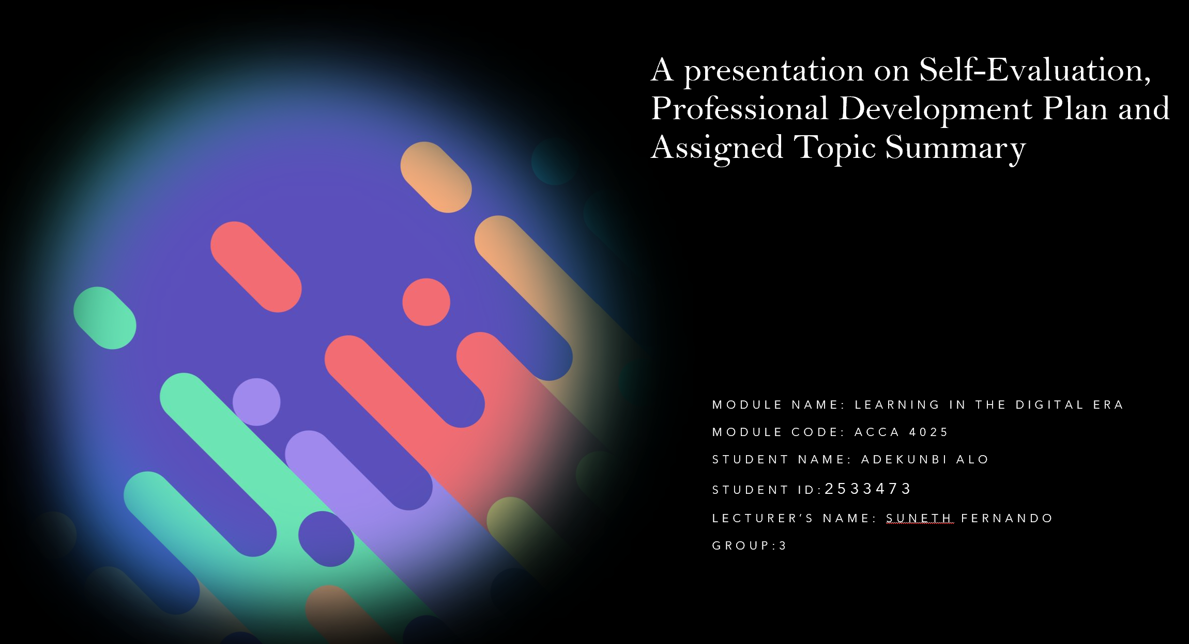

Slide 2 CONTENTS
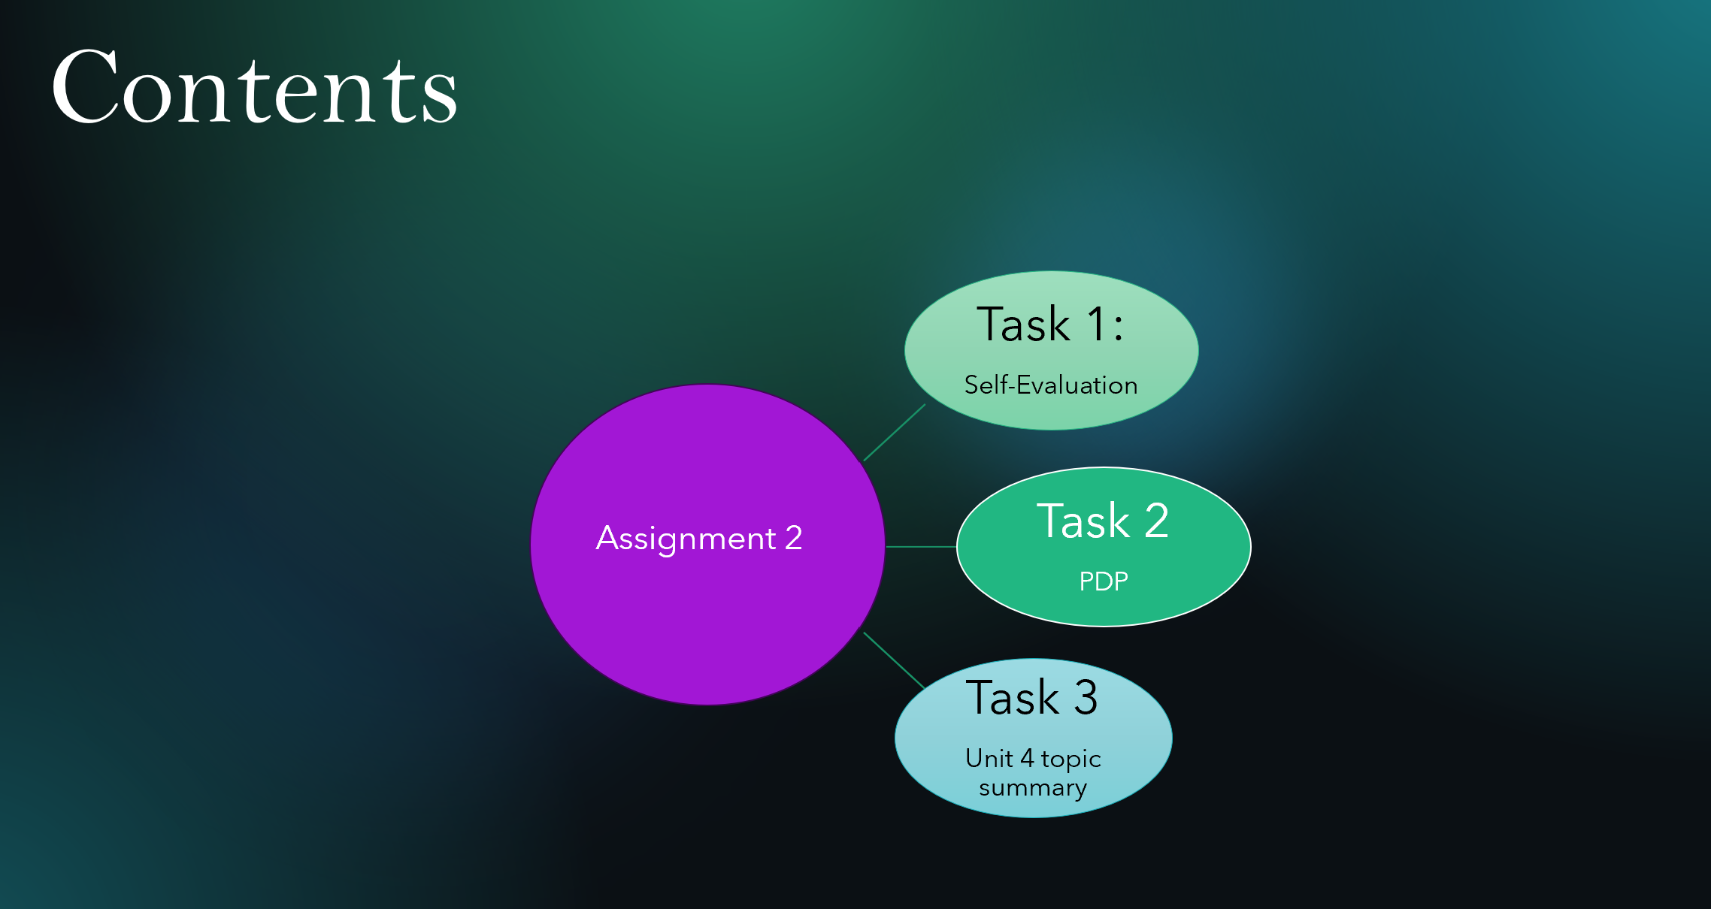

Slide 3 INTRODUCTION
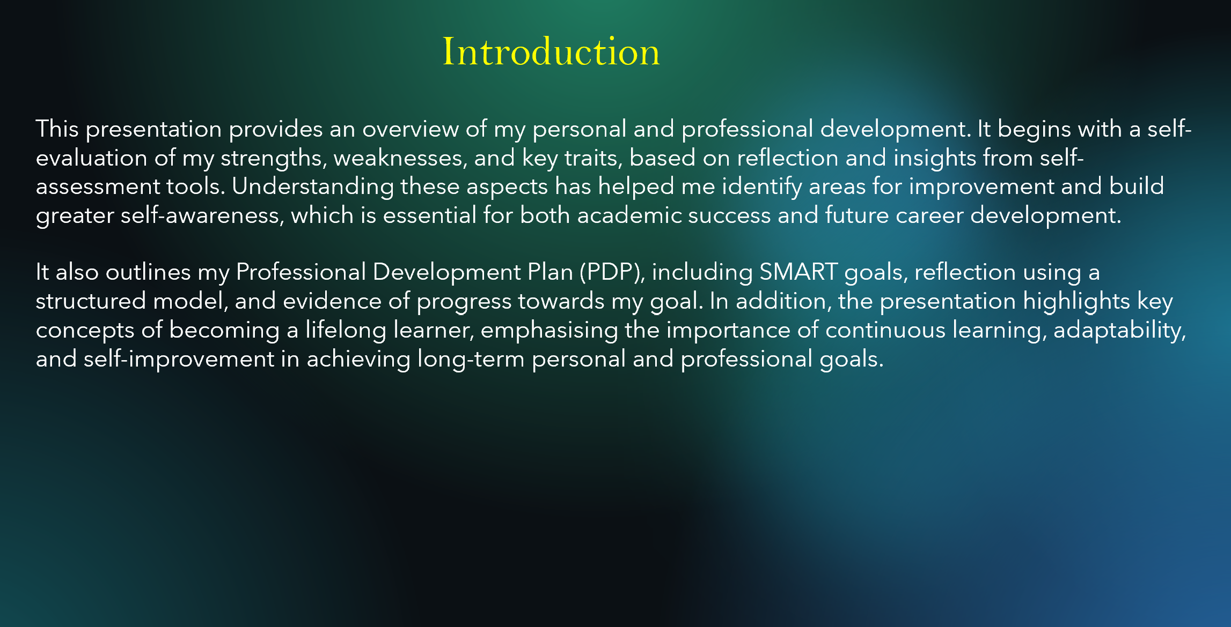

Slide 4 GIBB’s Reflective Model

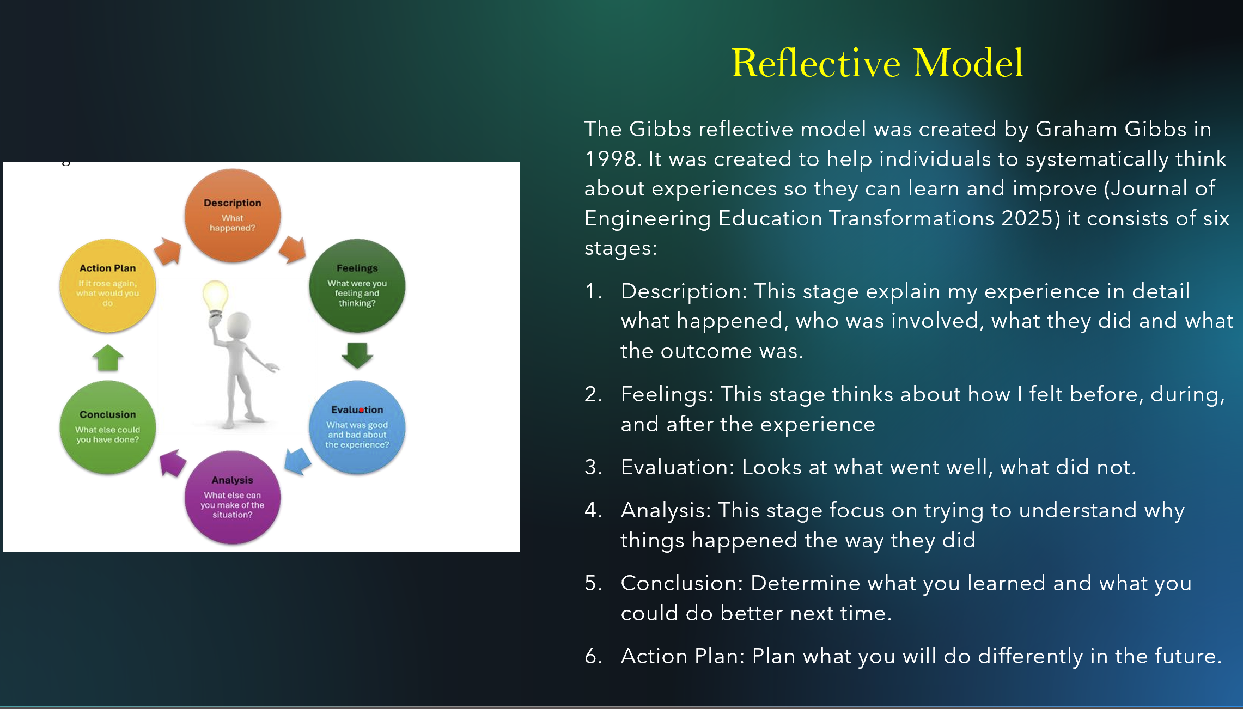
This reflective model was done using Gibbs reflective model created by Graham Gibbs in 1998 it includes six stages: description, Feelings, Evaluation, Analysis, conclusion and Action Plan, it was created to support individuals to think about their experiences so they can learn and improve (Journal of Engineering Education Transformations 2025).

This will be used to produce a self-evaluation on my strength, weaknesses and to identify traits gained.

Slide 5 TASK 1: SELF EVALUATION
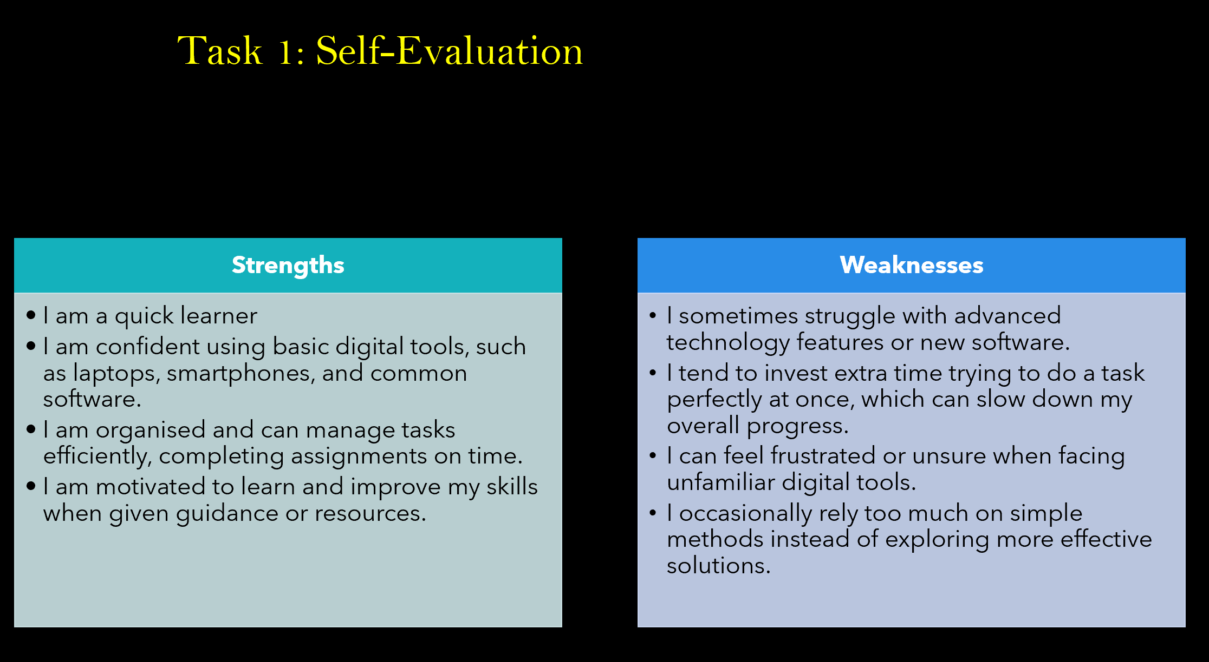
Through self-reflection and using tools like SWOT analysis and learning style assessments, I have gained a better understanding of my strengths, weaknesses, and personal traits.

Slide 6 TRAITS GAINED FROM THE SELF EVALUATION
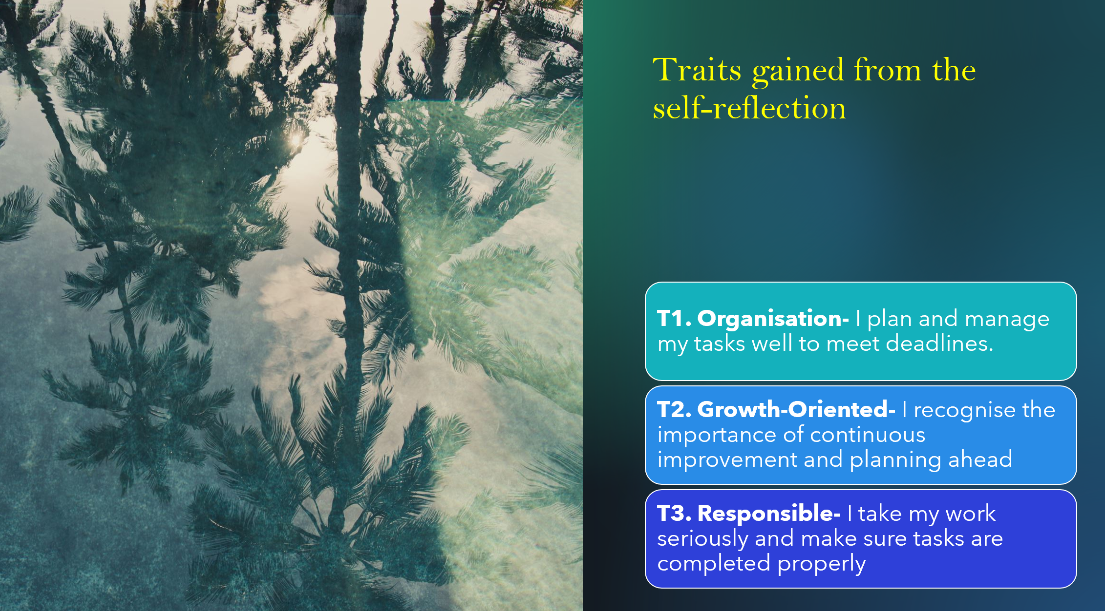
Overall, these reflections and self-assessment tools have helped me understand where I excel, where I need improvement, and how I can take steps to grow both personally and academically.

Slide 7 PROFESSIONAL DEVELOPMENT PLAN
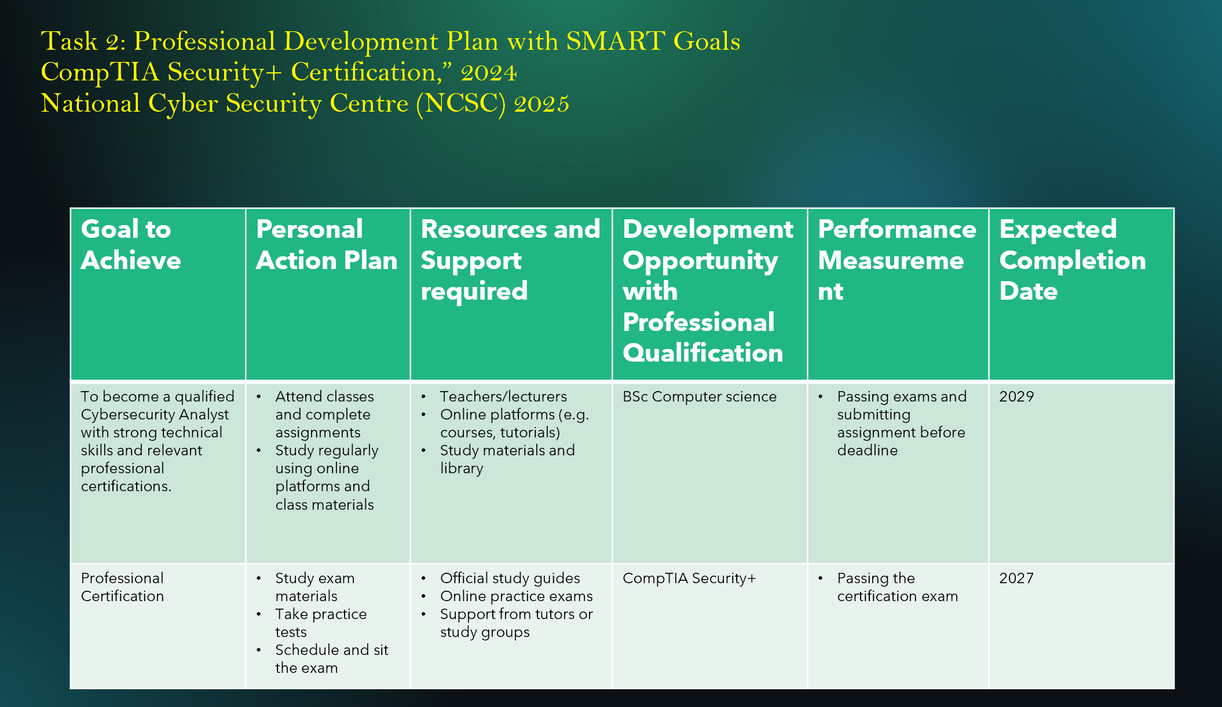
My professional development plan is to become a Cybersecurity Analyst by 2029. I will develop my knowledge in cybersecurity, improve my technical skills, and gain practical experience through projects or internships.
According to (CompTIA Security+ Certification,” 2024), I also plan to complete a recognised certification such as CompTIA Security+ to support my career goals. I will use online learning resources, teacher guidance, and regular practice to build my skills, and I will measure my progress through completed courses, certifications, and hands-on experience. Cybersecurity is a growing field that protects systems, networks, and data from cyber threats, which make it a strong and great career choice for the future (National Cyber Security Centre2025).

Slide 8 UNIT 4 TOPIC SUMMARY

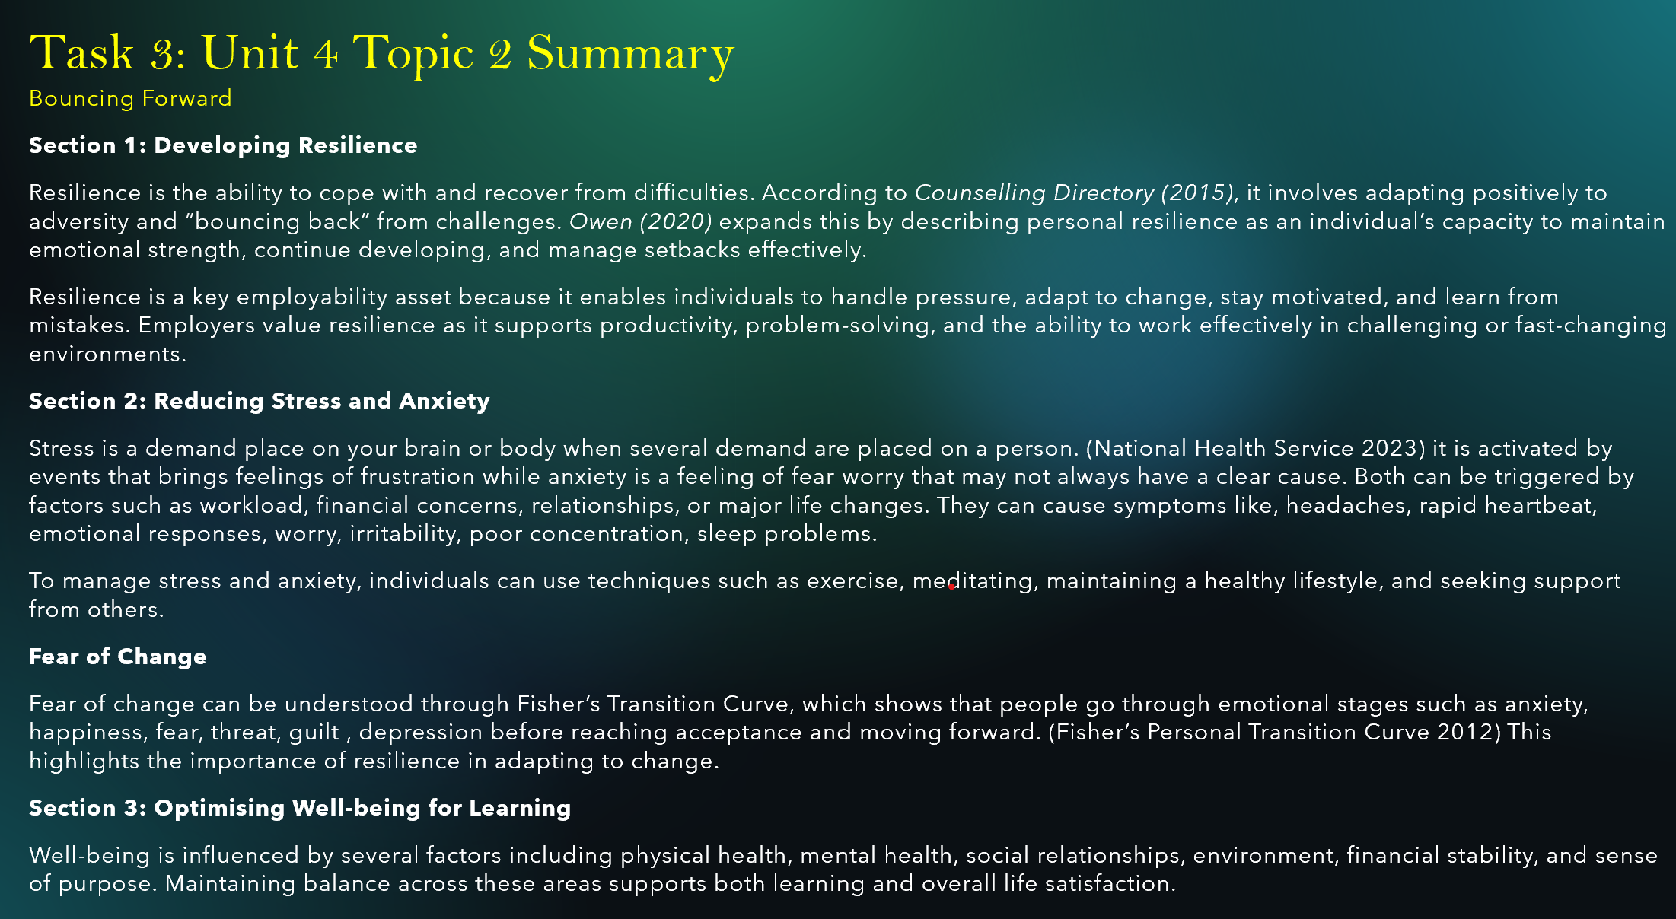
Bouncing Forward: Resilience is the ability to adapt, recover from challenges, and stay motivated, which is important for handling pressure and succeeding in work and learning environments (J. Owen, Personal resilience and coping strategies 2020).

Stress and anxiety are responses to pressure and uncertainty, but they can be managed through healthy habits like exercise, relaxation, and support, also, overall well-being depends on maintaining balance in physical, mental, social, and financial aspects of life (National Health Service 2023).

Slide 9 CONCLUSION
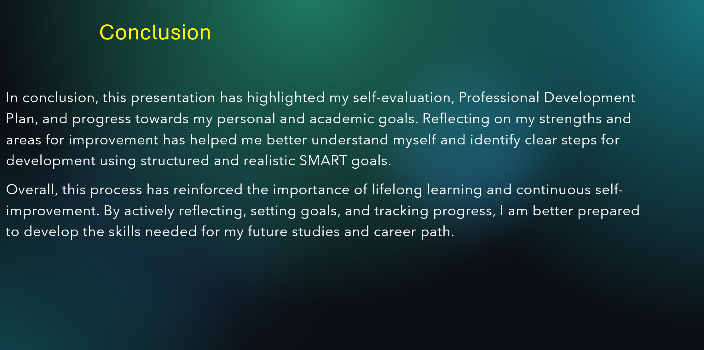

Slide 10 REFERENCES
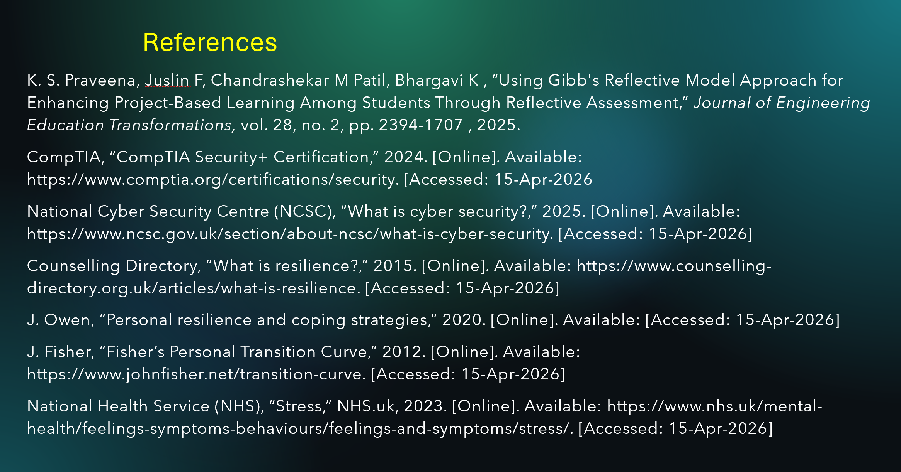
Conclusion
Finally, this report has helped me reflect on my personal and professional development by using self-evaluation, a Professional Development Plan, and related tasks which is about understanding resilience, stress and anxiety. It has helped me to identify my strengths and areas for improvement, especially in using digital technology and developing skills for a future career in cybersecurity.
By setting SMART goals and planning my development, I now have a clearer direction towards becoming a Cybersecurity Analyst by 2029. Overall, this process has improved my self-awareness and helped me know the steps required to achieving my long-term career goals.

References
K. S. Praveena, Juslin F, Chandrashekar M Patil, Bhargavi K , “Using Gibb's Reflective Model Approach for Enhancing Project-Based Learning Among Students Through Reflective Assessment,” Journal of Engineering Education Transformations, vol. 28, no. 2, pp. 2394-1707 , 2025.
CompTIA, “CompTIA Security+ Certification,” 2024. [Online]. Available: https://www.comptia.org/certifications/security. [Accessed: 15-Apr-2026
National Cyber Security Centre (NCSC), “What is cyber security?,” 2025. [Online]. Available: https://www.ncsc.gov.uk/section/about-ncsc/what-is-cyber-security. [Accessed: 15-Apr-2026]
Counselling Directory, “What is resilience?,” 2015. [Online]. Available: https://www.counselling-directory.org.uk/articles/what-is-resilience. [Accessed: 15-Apr-2026]
J. Owen, “Personal resilience and coping strategies,” 2020. [Online]. Available: [Accessed: 15-Apr-2026]
J. Fisher, “Fisher’s Personal Transition Curve,” 2012. [Online]. Available: https://www.johnfisher.net/transition-curve. [Accessed: 15-Apr-2026]
National Health Service (NHS), “Stress,” NHS.uk, 2023. [Online]. Available: https://www.nhs.uk/mental-health/feelings-symptoms-behaviours/feelings-and-symptoms/stress/. [Accessed: 15-Apr-2026]

