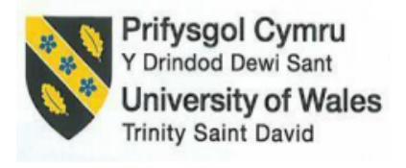
BA(Hons) International Hotel Management
Organisational Consultancy- Level 6
Consulting on Hilton London Bankside
Module Code: BMIH6005
Student Name: Sabbir Ansar Hussain
Student Number: 2233891
Lecturer: Natalie Brailsford
Module Lead: Neil Dyer
Word Count: 6000

Company Name: Insight Dynamics
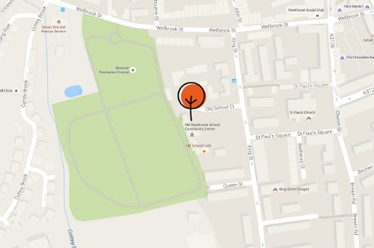

AI Declaration
I confirm that I have not used any AI tools in the research and creation of this assignment. I confirm that I have not presented any AI generated materials as my own work. I confirm I have copies of my drafts, notes, and other resources I used, which I may be asked to provide in evidence.

Table of Contents
Executive Summary: 4
Introduction: 7
High Employee Turnover: 7
Background, Age, Location, and Room Size of Hilton London Bankside: 7
Background of Insight Dynamics: 8
Theoretical Frameworks: 8
Analysis: 9
High Employee Turnover and its Impact on Hilton London Bankside: 9
STEEPLED Analysis: 11
SWOT Analysis: 13
TOWS Analysis: 15
Recommendations and Change Management: 17
Recommendations and Implementation Strategies: 17
Change Management Practices and Procedures: 18
Staff Response and Strategies for Seamless Transition: 19
Success Rates/ Impacts: 20
Potential Benefits: 21
Costs Associated with the Recommendations: 22
Action Plan: 23
Conclusion: 25
Reference: 27

Executive Summary:
This consultancy report, commissioned by Hilton London Bankside looks into the perennial problem of high rate of turnover amongst the workers in the hotel and identifies a logical approach to addressing its causes, effects and strategic solutions. Hilton London Bankside, standing at the address 2-8 Great Suffolk Street, London SE1 0UG, is one of such 5 stars hotels, offering its guests 292 rooms, famous for high-class service and modern design. Notwithstanding the firm brand identity and prime location, the hotel is experiencing a major internal problem – the consistent high rate of staff turnover in various departments, especially in the housekeeping, front office, and food and beverage services. This high rate of turnover is not only jeopardising operational continuity but also causing massive recruitment and training bills as well as crippling the deliveries of services and guest satisfaction levels.
The consultancy firm – Insight Dynamics (Birmingham, UK) – used a variety of analytics instruments in an attempt to understand this issue – STEEPLED, SWOT and TOWS frameworks. Externally, environmental factors such as post-pandemic labour shortage, inflationary pressure on wages, and changes in the expectations of staff members regarding their work-life balance were foreseen based on STEEPLED analysis. Inwards, lack of career growth paths, poor internal communications, few engagement initiatives for staff members and high work-related stress were identified as the contributing elements to the turnover problem. Insight Dynamics reviewed quantitative data (HR attrition rates, employee feedback surveys, financial reports) and qualitative sources (exit interviews, TripAdvisor reviews, industry trends) in order to have a full and unbiased perspective of the situation.
Using the SWOT analysis, the strengths of the hotel emerged, including the global brand name; the high rates of occupancy; and high-quality facilities but also weaknesses were observed, such as outdated HR approach; lack of sufficient digital HR infrastructure. The opportunities were identified and they included technology-driven employee engagement, partnership with hospitality colleges and wellness programs for the staff. Threats were both mounting competition from lifestyle boutique hotels and increased expectation among the employees in the hospitality industry. It was then that the TOWS matrix assisted in this mapping of the internal and external factors into strategic options to be implemented. It suggested offensive retention initiatives like incentives- based learning programs and specific staff incentives, enhanced internal communication avenues as a weakness mitigation and external threats mitigation strategy. Building on existing strengths, the hotel can improve its presence on employer branding as well as acquire comparative advantage in the competitive London hospitality industry.
After the analysis, Insight Dynamics proposes a package of integrated solutions. These include, among others, establishing an elaborate staff retention plan including formulated career progression plans, mentoring, and acknowledgment systems. Also is the adoption of a full onboarding and training program to help develop skills and curb an early attrition. Outsourcing to lessen the company’s financial burden is there. Such changes shall be complemented by a change management strategy that is evident with Kotter’s 8-Step Model to gain stakeholders’ buy-in, mitigate resistance, and support the culture of continuous improvement. Internal energizing activities, open communication of goals, and short-term milestones celebration will be the stepping stones to enforcing continuity after deployment.
To track and measure the success of these strategies Hilton London Bankside will utilize a mixed use of KPIs including quarterly turnover percentages, the indices for employee satisfactions, the statistics for completion of training, and the ratings for guest services. Cost-benefit annual assumption benchmarks will also help in formulation of ROI for HR investments. The implementation of these recommendations will be very beneficial for the hotel. more stability and commitment from the workforce, improved stability in the service level, higher level of satisfaction among customers, among other costs in the form of recruitment and training, in the long term. Costs relating to the suggested measures are expected to be between £120,000 and £150,000 in its first year, both of which can be justified with the reductions in attrition and the enhancements of productivity.
Finally, the present report confirms that Hilton London Bankside is equipped to undergo sustainable change, with proper support and strategic direction, despite the significant HR issue it is facing. Insight Dynamics is sure that adopting these recommendations, the hotel will not only manage to minimize the turnover of the staff but also improve the position as the employer of choice in the hospitality sector in the UK. This executive summary provides a brief but comprehensive description of the content in the report, and the client can comprehend the problem, the approach that has been adopted and the solution recommended without going through the report in detail. Consultancy needs are the particular places in which an enterprise or organization requires to seek expert advice, guidance or problem solutions from a professional consultancy firm. Such needs can emerge because of difficulties including negative trends in the performance, the personnel problem, the inefficiencies within the operating process, or external reasons, such as the market changes. A consultancy firm assists in examining the situation, identifying the roots of the problem, and working out strategic solutions that go hand in hand with the organization’s objectives. In the hospitality industry for instance, some of the consultancy needs may be boosting retention levels of employees, customer service improvement, profitability maximization and sustainability issues implementation. We sincerely appreciate that Hilton London Bankside has given us this opportunity, and we are keen to continue helping where we can with our help with implementation or consultancy needs.

Introduction:

High Employee Turnover:
Strategic management is project-oriented, and all businesses are project-oriented in managed daily operations (Buttrick, 2009). This consultancy report is undertaken on cognizance of an order placed by Hilton London Bankside, a contemporary five-star accommodation located in the newly designed 2-8 Great Suffolk Street, London SE1 0UG. The hotel, which set the doors for the first time in 2015, has gained a reputation for excellent service, premium facilities, and contemporary design. The hotel has 292 luxurious rooms, a bustling bar, and a well-stocked fitness centre along with plenty of area for events, all stamped with the internationally known Hilton brand. However the hotel continues to be successful in its operations, but it is saddled with a huge internal issue of high employee turnover with most being in core operational units such as housekeeping and food & beverage.
The employees are considered the core assets of any business (Kossivi, Xu, and Kalgora, 2016.). Still, Hilton London Bankside is facing a huge organisational obstacle: high employee turnover. In the post-pandemic world, when the maintenance of the service excellence, brand value and financial successes heavily depend on retaining the skilled staff, this challenge has become more pressing. Turnover rates that are too high lead to gaps in service delivery, incur increased costs related to hiring and training of new employees, and threaten the overall satisfaction with services. With such a challenge, Insight Dynamics, a specialist Birmingham based organisational consultancy in strategic HR solutions and change management, has been hired to carry out a full assessment.

Background, Age, Location, and Room Size of Hilton London Bankside:
This top-notch five-star hotel is located at 2-8 Great Suffolk Street in the gleaming Bankside section of London. The hotel, which opened in 2015, has 292 beautifully appointed rooms, from which 25 suites and a prestigious penthouse stand out. The innovative design and plethora of event rooms make it desirable to business travellers not only, but its proximity to attractions such as Tate Modern and Borough Market also make it one of the favourite spots for tourists. Our daily activities are becoming more focused on the pleasure aspects in life (Schlich et al, 2004).
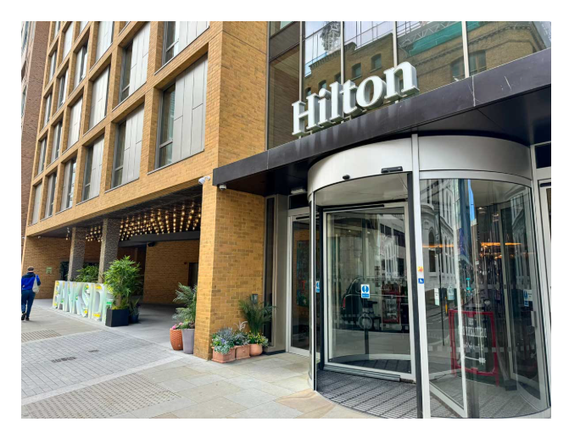
Hilton London Bankside
Source: [Jones, 2024]

Background of Insight Dynamics:
Our organisation, located in Birmingham, pays consultancy services for workforce optimisation, change management and approaches to keep knowledgeable employees. As a result of our rich experience in the hospitality sector, our committed watch will provide astrology-supported steps for enhancing operational efficiency, reducing the rates of turnovers and the ability for an excellent business in the United Kingdom to continue expanding sustainably.

Theoretical Frameworks:
In this report three strategic frameworks will be utilized in order to make a comprehensive analysis of staff turnover at Hilton London Bankside: STEEPLED, SWOT, and TOWS. Strategic External Trends and Opportunities using Emerging Issues (STEEPLED) analysis will be used to analyze external factors that include social, technological, economic, environmental, political, legal, ethical and demographics that may influence staff turnover, particularly within the hospitality industry. The internal Strengths, Weaknesses, Opportunities, Threats of the hotel will be analysed using the SWOT analysis to show how they will affect workforce strategy. The TOWS matrix will then be applied to extract realistic strategies derived from the SWOT analysis thus allowing the hotel to move the internal strengths and weaknesses there are, with external threats and opportunities. There are several reasons that SWOT analysis could be attributed to (Puyt, Lie, and Madsen, 2024). The use of the analytical tools together will yield detailed diagnostic, which informs good recommendations and makes possible the generation of a changed plan for organizations. Many practitioners, marketing specialists, and students have adopted the SWOT framework among business marketing and strategy students (Helms, and Nixon, 2010).

Analysis:

High Employee Turnover and its Impact on Hilton London Bankside:
Impact:
Rapid staff turnover at Hilton London Bankside is threatening office activities, human relations, and the level of customer service. Competent hiring practices should be closely related to the Strategic Plan’s vision delivered through hiring (CARE, 2013). Workforce loss through the regular departures of employees interrupts the regular daily activities and requires constant recruitment and preparations for new recruits. The lack of staffing could lead undeparted team members to be under-stretched which causes increase in stress, poor morale, and a clear drop in work efficiency. Frequent change of staff often causes disorientation to guests because returning clients meet less familiar faces and may notice decreasing professionalism and attention levels.
Turnover is costly to organizations, with financial losses accumulating over a period. The 2023 report by CIPD reveals that UK employers have to spend an average of £6,125 to replace a single employee. Such weight can accrue quickly for institutions that have more than 200 people in employment, reducing aggregate profitability. Profitability shows how a company’s expenditures convert to earnings (Hub, 2023). What is more, poor employee retention dashes the hotel’s ability to adhere to the standards set by Hilton, which might cause poor customer reviews and lost clients as a result. In high-competitive arenas such as, central London, a regular one, trained workers are critical as key pillars of delivering excellent service and beating larger rivals like Marriott and Hyatt.
Causes:
Feedback Culture and Poor Internal Communication: Both poor communication channels and inadequate feedback processes are well known to be a major factor. Unveiling the 2024 Hospitality Action survey, 58% of the surveyed UK hotel employees reported they felt overlooked since their feedback was inadequate, and their roles were ill-defined. Lacking repeated performance feedback and recognition, workers may feel alienated from their work and be less apt to stay with the organization. Hotel managers should utilize such insights to establish novel practices of attracting guests and investments into resources that meet the needs of changing guests (Kim et al, 2024).
Limited Career Development Opportunities: Staff at Hilton London Bankside usually have a poorer prospect of advancement in the organization than the similar staff elsewhere in the Hilton network. That’s why people who are looking for professional development often change to other companies or positions. Based on a Springboard UK 2023 report, 61% of hospitality employees said they would stay longer in their job if career development options were outlined and encouraged. Hotel workers’ work performance is one of the major ones of the research (Hosen et al, 2024).
Wage Competitiveness and Cost of Living: The industry of hotels and catering is also one of the highest employing areas in the whole of the United Kingdom (Wood, 2024). Due to its centrality in London, living costs too much. However, housekeeping, reception, and food service employed workers are also commonly paid salaries slightly over the national minimum wage. New competitors to the industry, such as The Hoxton and The Standard, have released competitive wages and benefits for which Hilton and other chains struggle to compete.
Reputational Impact and Staff Morale: An ongoing churn of employees helps create a subtle working environment that makes the workers disheartened. Bad reviews from employee sites such as Glassdoor undermine a hotel’s opportunity to attract intelligent candidates, thereby increasing recruitment problems. Financial hardships are unprecedented for firms' operatives in the UK hospitality sector (Werner, and Stephens, 2024).

STEEPLED Analysis:
Factor | Description
Social | As the shift expectations have been changing and Gen Z influences (e.g. the preference to competitive positions with purpose) the hotel workers have become discontent under the rigidity of the work plan. Work-life balance initiatives are frequently undertaken by companies to respond to employees’ desire for a balanced life (Casper et al, 2024).
Technological | Staff roles bear less weight with the automation of check-in/out therefore employees might regard frontline professions as not significant or profitably. In spite of the benefits offered by digital technology, its introduction presents challenges that need to be overcome (Sumali et al, 2024).
Economic | London’s growing inflation and rising cost of living lowers the appeal of hospitality remuneration, especially for newcomers. Changes in the commodity markets, combined with bottlenecks in upstream sectors, trigger excessive profits and a non-stop wave of inflationary pressures (Hein, 2024).
Environmental | By introducing sustainable practices into hotels there are increased demands on employees but there is often limited training or remuneration. Creating sustainability requires a synergistic approach capable of balancing the need for the environment with the objectives of economic prosperity (United Nations, 1987).
Political | ‘Brexit’ indicates the departure of the United Kingdom from the European Union (Zaken, van, 2018). Less EU workers exist in the hospitality sector since Brexit and this tight labour market is already getting tighter with pressure on the existing staff to do more.
Legal | Although National Minimum Wage increases place cost burdens, they ensure that working conditions and personal developments in careers do not improve due to it.
Ethical | Since ethical labour practices have become popular, now the employees want to be treated fairly, participate in operations, and are subjected to a friendly working environment.
Demographic | Diversity of the workforce in London demands HR policies that respect and accommodate. Ignoring this can drive away the best employees and sky-high the resignation among them.
In world practice, it is important to develop specific policies targeted at further perfection in the business environment (Saidova, and Muminjonova, 2022). External macro-environmental factors are figured out as the primary success factors of Hilton London Bankside’s high rate of employee turnover through STEEPLED analysis. Inflation-induced economic pressures reduce job appeal in hospitality, as there is also increasing preference in younger days for jobs that are flexible and meaningful in providing purposeful contentment. The political consequences of Brexit have disrupted the flow of talent as well as increased legal and ethical requirements for increased quality in employment. options STEEPLED is a versatile and multidirectional framework for analysis that is designed to explore root causes, outcomes, major benefits, these failures weaknesses and outcomes (Siakas et al, 2023).

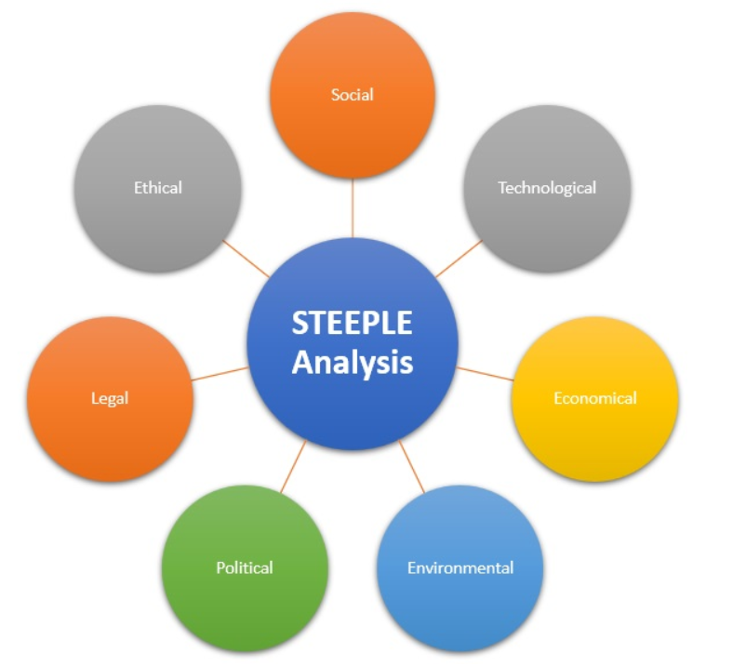
STEEPLE Analysis
Source: [Team, 2013]

SWOT Analysis:
Category | Description
Strengths | Prime location in London; Hilton integration enhances reputation plus sophisticated contemporary amenities and a premium environment. Diverse brands engage in cause involvement due to social responsibility (Holiday et al, 2021).
Weaknesses | High staff turnover; Career advancement opportunities are sorely limited; the general mood of the working staff is not happy. Organizations have efforts towards holding on to the best people so that their staff can be crowned successful in achieving the business goals (Herrity, 2023).
Opportunities | Reply flexible working programs; programs for encouraging employee engagement. The current competitive business environment puts emphasis on the central position of employee engagement in the organizational success landscape (Alabi et al, 2024).
Threats | Competitive job market in London; increasing costs of daily operations; adverse effect on the firm image by virtue of the staff evaluations. With the hostile job market, graduates with Marketing and Sales today need to have all-round technology competence (Kemp et al, 2025).
As countered by the SWOT analysis, organizations seek more and more on this as a central ration of analysis for gaining their market position (Benzaghta et al, 2021). It is through this SWOT analysis that Hilton London Bankside is found to have advantages as a result of its prime location and its use of the well-known Hilton brand, which is attractive to clients and prospective workers. Nonetheless, internal pressures such as increased employee outflow and fewer opportunities for promotion may hinder the benefits associated with these strengths. Strategic Human Resource Management (SHRM) is an important aspect in the success of an organization (Kess-Momoh et al, 2024).
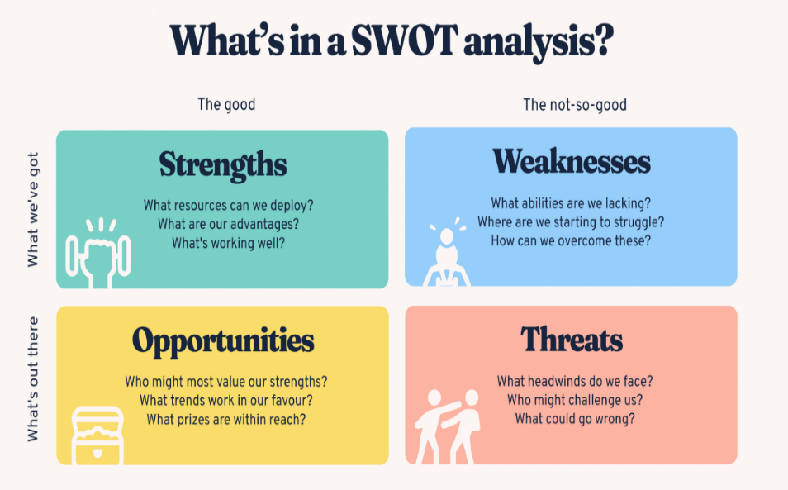
SWOT Analysis
Source: [Bitesize Learning, 2024]

TOWS Analysis:
TOWS | Opportunities | Threats
Strengths | Because organizations now concentrate more on bringing in desirable employees, the development of employer brands has become more vital than ever (Špoljarić, and Ozretić Došen, 2023). Being part of the Hilton brand name gives the hotel a noticeable advantage when attracting candidates. Utilizing the recognisability of the Hilton brand and the availability of modern conveniences, the hotel may capture and keep specialized staff by launching employer branding initiatives and sharing staff achievements. Each employee has his or her personal initiative in terms of experience (Chen, and Ahlstrom, 2024). | The talent shown by Hilton London Bankside's service teams in providing excellent standards and high customer satisfaction represents a valued asset. To defend these strengths against possible staff shortages, Hilton London Bankside should implement stronger programmes for retaining workers. In addition, Hilton’s worldwide HR networks could facilitate the exchange of proven practices across locations, helping minimize further harm to reputation or operation. A core objective of every business activity is to produce sufficient revenue for the organization to survive and prosper in a competitive market (Naini et al, 2022).
Weaknesses | Employee engagement research consistently shows that HRM practices and systems have a positive influence on employee engagement (Saks, 2022). High employee turnover and unclear career paths may be reduced by implementing both training frameworks and explicit internal promotion guidelines. Forming ties with hospitality education providers can serve to attract job seekers with high ambitions. | Rising labour and recruitment expenditures, together with frequent turnover, make the hotel vulnerable financially. Making use of improved internal hiring methods to reduce dependence on costly agencies may enhance cost efficiency. In addition, both automation and cross-training aim to plug skill shortages promptly and help avoid negative effects when staff members resign. Efforts to restore the organization’s image as an employer ought to emphasize relationships with prior staff and the local community to attract committed applicants. Recruitment is a critical step (Pinto, and Dunsiger, 2021).

With the TOWS matrix, organizations are able to translate internal resources and challenges together with external trends and risks into concrete plans for better performance and growth. The TOWS matrix was built to help create strategies (Bozac, 2008). The TOWS matrix serves as a bridge between where Hilton London Bankside is now and where it needs to be strategically. The management systems of the organisation are guided by a flow of internal and external factors (Žmegač, Čolig, and Drezgić, 2024). The process converts the company’s internal strengths and weaknesses into strategic actions that lead into the future while adapting to external opportunities and threats. It encourages Hilton to take real steps such as improving its employer image, exclusively relying on internal recruitment where feasible, and defining career paths for employees within the company. Thereby, Hilton is enabled to address competitive tensions, retain employees, and create long-term operational endurance.

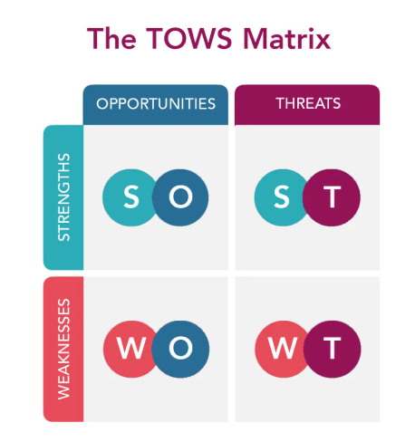
The TOWS Matrix
Source: [TOWS, 2025]

Recommendations and Change Management:

Recommendations and Implementation Strategies:
Develop a Comprehensive Employee Retention Strategy: When introducing an employee retention strategy at Hilton London Bankside, there should be keen emphasis on fair pay, recognition of employees, and opportunities for growth. Maintaining salaries at par with normal industry standards and giving the workers open ways of pay improvement might result in the diminution of the employee turnover. Offering rewards or special recognition to top performers will likely increase both morale and loyalty among employees. Mechanisms that might facilitate a quicker turnaround for investment decisions should be applied (Qadir et al, 2021).
Strengthen Training and Development Programs: It will be prudent for the hospitality industry to develop onboarding practices with clear structures and maintain training through the hospitality certifications and leadership development workshops to empower employees with skills and confidence demanded for their professional development. Staff members can enjoy flexible, self-directed, role-specific training offered by a learning management system (LMS). Learning Management System (LMS) is used extensively as a learning methodology (Prahani et al, 2022).
Foster a Positive Workplace Culture: Create an environment of inclusivity, respect, and support by ensuring the need to provide staff’s feedback and apply anonymous surveys more frequently. Establish a wellness committee that will endeavour to boost employee’s mental state with such options as counselling, flexible hours of work and special wellness days.
Improve Internal Communication and Feedback Mechanisms: The fast evolution of digital technology has utterly changed how we conduct business and live today (Fu, Avenyo, and Ghauri, 2021). Digital tools such as Slack or Microsoft Teams can be adopted by the hotel to make communication instant.

Change Management Practices and Procedures:
Hilton London Bankside should use a formal approach to change management in order to implement these suggestions well. With the ADKAR Model (Awareness, Desire, Knowledge, Ability, Reinforcement), the organization can ensure a smoother change process. At the outset, build staff awareness of the necessity for change by supplying figures on turnover and including information on comparable industry performance. After that, instil a desire for change by describing the practical benefits to employees, for example, improved working conditions, new chances to advance, and a balanced work-life routine. Change management exists in a context that is not clearly separated or confined to its own discipline (Burnes, 2014).
Knowledge and ability are conveyed to employees when the hotel holds workshops, team meetings, and training modules. By upskilling managers in people management and conflict resolution, they will be able to better help their teams. Lastly, reinforcement will manifest as ongoing follow-ups, giving attention to early adopters, and implementing ongoing feedback to measure results and adjust strategies.
Employing newsletters, staff briefings, and the use of visual dashboards in commonly visited spaces is expected to preserve the project's energy. Employees ought to take part in pilot testing modifications, for example those involving scheduling or health programs, before they are fully introduced.

Staff Response and Strategies for Seamless Transition:
Staff Reactions and Engagement:
The hotel industry is a rapidly developing one and has a huge influence on the world economy (Giousmpasoglou, and Marinakou, 2024). Staff are bound to react with an element of curiosity, fear, and optimism. Although some may embrace positive change, some, especially the long-term employees, can oppose change based on fear of losing routine or the new responsibility. Open communication at the beginning is essential in the mitigation of resistance. Conducting inclusive sessions to explain the reason behind changes and creating such opportunities in which staff members can air their concerns cultivates trust and participation. Customer engagement has positive effects on the loyalty of customers (Alam, Karim, and Habiba, 2021).
Strategy: Involve Employees in the Change Process:
The effective means of publishing contracts are used as the ways to transfer culture and knowledge to the public, especially to the intellectuals (Maabreh et al, 2024). Employee involvement in the decision making greatly helps to eliminate resistance. Developing staff-based working communities for all of the significant initiatives, like scheduling advancements or wellness programs, makes employees owners of the shift. Feedback loops on a regular basis will make it possible for employees to measure the effectiveness of new practices and provide improvements. In addition to this, peer advocates or “change champions” from the team itself can also help in promoting engagement and act as examples during periods of transition.
Strategy: Gradual Implementation and Support Systems:
Rather than abrupt changes, phase out. For example, trial modified work shifts of one department before going hotel wide. Provide coaching and mentoring to facilitate the integration of the staff in new responsibilities. Create a temporary support group from HR and management to deal with issues in a timely manner and make the employees feel tended to. Promote open interaction with the anonymous surveys and designated email addresses for receiving feedback. Advancement in technology, the dynamism of the workforce demographics, as well as the need to employ agile methods of talent acquisition, are behind the transformation of HRM (Rachmad, 2025).

Success Rates/ Impacts:
Key Performance Indicators (KPIs) and Staff Feedback:
There would be some KPIs used to measure the successfulness of the proposed strategies. For retaining the employees, the hotel will be tracking monthly turnover rates and do whatever is possible to bring them down by at least 15-20% (in 6 months). The content generated online by employees has recently gained attention in the management, finance, and tourism research (Stamolampros, and Dousios, 2024). Employee satisfaction surveys will be done every quarter and will involve such aspects as job satisfaction, efficacy of communication, and ability of the management to support. Positive feedback and increased response rate to surveys will signify the enhancement of morale. Absenteeism and lateness rates will also be tracked – the decreases in both dimensions indicate better engagement and well-being. The lack of proper KPIs, however, does not allow the managers to choose the right ones (Rasool, Greco, and Strazzullo, 2024).
Operational and Service Metrics:
Metrics that are designed to apply to the evaluation of interactive conversational models (Abbasian et al, 2024). From the quality of service, be it TripAdvisor, Google, as well as internal systems, customer reviews will be examined. Increase in service-related rating will indicate better performance of staff working. In order to evaluate service consistency and hospitality, mystery guest audits can be conducted on a biannual basis. Inside the organisation, training completion rates and assessment from training feedbacks will be used to monitor the development of skills. Also, the internal complaints and staff grievances will be documented to monitor cultural improvements. These metrics shall be monitored monthly by the HR and operations teams and updated during the management meetings for prompt measures where necessary. Tools and dashboards for data visualisation will be deployed to make it easy to monitor performance and make data-driven decisions. DDDM has become the cornerstone in current IT landscapes and businesses (Michael et al, 2024).

Potential Benefits:
Enhanced Employee Retention and Morale:
Project management is valuable to hotels (Noordzife, 2014). One of the greatest advantages of the suggested strategies is an improvement in employee retention and morale in general. Staff will be more valued and engaged through the company’s competitive remuneration, structured onboarding, clear progression routes, and positive working culture. Less turnover in the staff equates to lower recruitment and training expenses, fewer interruptions to the delivery of services, and improved cohesiveness in the team. In the long run, this stability adds to an experienced, and skilled staff supply, another aspect of bettering hotel operations. Under all the staff, individual training in behaviour analysis principles was not carried out (Slaton et al, 2024).
Improved Guest Experience and Service Quality:
Strategic management is currently a traditional characteristic in government, nonprofit, and business organisations (Slaton et al, 2024). The guests would most likely get uniform and personalised service with a better motivated and trained workforce. Staffing shortage is a severe challenge to long term care (Yan et al, 2024). Lower staff turnover means there are fewer service disruptions and increased guest satisfaction, which usually equates to online reviews and ratings, and customer loyalty. Such enhancements are positive to the brand image of the hotel, which makes Hilton London Bankside a prominent destination for leisure and business travellers in a tough market such as that of London. Increased satisfaction of the clients normally means more repeat business and referrals. There has been increased pressure on the consultancies to be innovative (Mavridopoulou, & O’Mahoney, 2020).
Financial Gains and Operational Efficiency:
There are different management consultants who form an integral part of the business world and other forms of organisation (Kipping, and Clark, 2012). Cost savings will be attained through lower expenses on turnover that include payment of recruitment agency, onboarding, and wastage of workers’ time during employee changes. In addition, a happier workforce translates to increased output, with reduced absenteeism and increased efficiency in the place of work. The bigger the operational stability, the bigger the revenue potential – from both in the form of repeat bookings, and from the opportunities of upselling. In the long-term, the hotel will be in a better position to optimize the resources strategically while delivering excellence in service, as well as maintaining profitability as the industry challenges evolve. The development of small consulting firms are vital towards development of a healthy, vibrant economy (O’Mahoney, 2021).

Costs Associated with the Recommendations:
Staff Training and Development (£35,000 annually):
If a business is not able to reinvent itself it does not stand a chance of being successful for the long run (Kotter, 2012). Roll-out of structured training and upskilling programmes will mean an upfront investment of approximately £35 000. This involves external training consultants’ hiring, buying of learning resources, and management time to be dedicated for mentorship and coaching. For a hotel that has more than 290 rooms with various dining and relaxation facilities, continued training of the staff is important in ensuring high-quality service. This cost is reasonable in the light of the volume of operations and will contribute to better efficiency and guest satisfaction in the long run. Hotel industry, which is a major contributor to the world economy, is gradually turning to sustainable practices (Akel, and Noyan, 2024.).
Recruitment and Retention Improvements:
The risk management strategies are in every organization (Subramaniam et al, 2011. Investments in recruitment advertisement, onboarding procedures, and retention compensations (like performance bonuses or convenient scheduling) are estimated to require about £20 000 in a year for controlling high staff turnover. This comprises collaborations with job boards and community universities as well as the improvement of the induction process. Such changes are aimed at attracting qualified candidates, and helping them from the very beginning – cutting future expenses and annoyances connected with the process of recruitment. In this contemporary market, it is very crucial to make the guest feel special by providing something special that makes you stand out of the crowd and go beyond their expectations (Špindler, 2024).
Staff Wellbeing and Engagement Initiatives (£15,000 annually):
Mental health workshops are vital (Terrell et al, 2025). Implementing wellbeing programmes like Mental Health Workshops, Staff Recognition evenings and Team-building activities is going to cost approximately £15,000 a year. Human management practices help in organisation success (Baron, and Armstrong, 2007). These efforts are important in raising morale and productivity. For a four-star hotel of such calibre as Hilton this kind of investment is appropriate and necessary for the establishment of a sustainable people-oriented work climate consistent with the strategic aims that are for the long term. Success goals of different businesses are different (Newton, 2010).

Action Plan:
Number | Problem | Solution | Desired Outcome | Time Scale | Completion Date | Planned Budget
1 | High Employee Turnover | Employee turnover remains the ever-present challenge for businesses around the world (Dauda, 2024). Put in place training, wellness, and retention programs. | Reduced turnover, increased productivity and guest satisfaction. | 6 Months |  | £35,000 (Annually)
  01/11/2025
2 | Low Staff Engagement | Feedback channels and recognition schemes. | Higher team performance and better communication. The aspect of business communication in the hotel and restaurant business is one of the factors that influence the manner in which services are provided (Zaichenko, and Buhaieva, 2024). | 4 Months | 01/09/2025 | £10,000
3 | Recruitment Challenges | Collaborate with nearby universities and conduct focused recruitment efforts. | Improved brand as employer, shorter hiring cycles. | 5 Months | 15/10/2025 | £20,000
Source: [Self-Made]
Stakeholders of the hospitality industry are very important success factors (Lodhi et al, 2024). This table presents a workable action plan for solution of the key workforce problems of Hilton London Bankside. It offers an organized breakdown of the problem, solution, and planned result, timelines, price for each issue. Such clarity facilitates the leadership team of the hotel to plan effectively, be accountable to the performance that is tracked. The incorporation of real-time frames and budgets appropriate for a scale of the hotel makes the suggested strategies practical and cost-efficient. This action plan is an essential instrument for making sure that improvements are being made strategically and sustainably, which is in turn crucial for long-term successful operation. Very often hotels in the ever-dynamic business environment are overcome by all sorts of crises (Ledi et al, 2024).
The desired result is to counter the unfavourable feedback on the old appearance of the hotel. With modernisation of its image, the hotel hopes to convince the existing guests that they have been taken seriously and lure new customers with a revamped and professional look. The budget that can be used for one site at the amount of £20, 000 is reasonable and demonstrates a targeted investment in the long-term brand value and conversion rates to customers. There are customer service strategies (Narayanaswamy, and Heiens, 2025).

Conclusion:
This consultancy report has thus analysed the existing status of challenges that are being faced by the hotel, especially with regards to brand image, customer experience, and operational effectiveness. STEEPLED analysis is one that reviews external factors (social, technological, economic, environmental, political, legal, ethical and demographic) that influence the performance of an organization as well as its strategic decisions. With a thorough analysis with the aid of STEEPLED and SWOT models, significant issues, including the archaic external signage, the gradual reduction in the customer’s satisfaction, ineffective delivery of service, and impacts of pressures from the external forces like economy and standards of the environment have been identified. Such issues not only restrict customer engagement and revenue generation but also create a sagging competitiveness among a hotel in a fast-changing hospitality world.
The report examined various key reasons for the difficulties, ranging from the lack of consistent feedback processing, lack of brand visibility, and internal staff communication gaps. These factors have had a great impact on the hotel’s image, the guest loyalty, and the general income generation. Although weaknesses were noticed, the analysis also indicated numerous strengths that the hotel currently possesses, such as good positioning, experienced personnel and loyal customer base. These are the strengths that the hotel can make a good foundation to rebuild and innovate from.

To resolve the questions and utilize the potential of the hotel, a set of recommendations was given. Rebranding strategies, Customer service training, Adopting sustainable practices, Increased digital presence are among them. Every solution was carefully harmonized with realistic implementation tactics and harmony with cost and time factors to make them viable. The TOWS analysis also contributed to the strategic thinking as it outlined the use of hotel’s strengths to defeat threats and weaknesses while using external opportunities.
Effective change management practices were highlighted by this report in a bid to effect control of the proposed changes. Open communication, training, and staff inclusion were some of the techniques involved to ensure that changes are smooth and morale is kept high in the employees. Furthermore, strategies on how to measure the success were given – customer satisfaction surveys, performance KPIs, feedback monitoring – so that the progress is measured in a standardized manner.
The advantages of the adopted strategies include enhanced brand recognition, customers’ satisfaction and retention, increased revenue generation, and the modern and sustainable business model. Also, a thorough action plan has been included to describe main steps, timelines and costs related to solutions, so the hotel has got a practical tool for the process direction.
We would like, at this opportunity, to sincerely thank the management and staff of the hotel for putting our consultancy firm in charge of this project. It is an honour to have been able to work together to improve your operations and strategic direction. We are therefore sure that with the deployment of the above strategies, your hotel will be in a good position to succeed in today’s competitive hospitality environment. We would love supporting you in your future success.

Reference:
Abbasian, M., Khatibi, E., Azimi, I., Oniani, D., Shakeri Hossein Abad, Z., Thieme, A., Sriram, R., Yang, Z., Wang, Y., Lin, B. and Gevaert, O., 2024. Foundation metrics for evaluating effectiveness of healthcare conversations powered by generative AI. NPJ Digital Medicine, 7(1), p.82. Available on: https://www.nature.com/articles/s41746-024-01074-z.pdf [Accessed on: 13th May, 2025].
Akel, G. and Noyan, E., 2024. Exploring the criteria for a green and smart hotel: insights from hotel managers' perspectives. Journal of Hospitality and Tourism Insights, 7(5), pp.2992-3012. Available on: https://www.researchgate.net/profile/Goekhan-Akel/publication/377410426_Exploring_the_criteria_for_a_green_and_smart_hotel_insights_from_hotel_managers%27_perspectives/links/661914c5f7d3fc28744e473d/Exploring-the-criteria-for-a-green-and-smart-hotel-insights-from-hotel-managers-perspectives.pdf [Accessed on: 13th May, 2025].
Alabi, O.A., Ajayi, F.A., Udeh, C.A. and Efunniyi, C.P., 2024. Data-driven employee engagement: A pathway to superior customer service. World Journal of Advanced Research and Reviews, 23(3). Available on: https://www.researchgate.net/profile/Olufunke-Alabi/publication/384141853_Data-driven_employee_engagement_A_pathway_to_superior_customer_service/links/66ebf3c1c0570c21fea8f2af/Data-driven-employee-engagement-A-pathway-to-superior-customer-service.pdf [Accessed on: 12th May, 2025].
Alam, M.M.D., Karim, R.A. and Habiba, W., 2021. The relationship between CRM and customer loyalty: The moderating role of customer trust. International Journal of Bank Marketing, 39(7), pp.1248-1272. Available on: https://www.emerald.com/insight/content/doi/10.1108/IJBM-12-2020-0607/full/html [Accessed on: 13th May, 2025].
Baron, A. and Armstrong, M. (2007) Human Capital Management. London: Kogan Page. Available on: https://nscpolteksby.ac.id/ebook/files/Ebook/Business%20Administration/ARMSTRONGS%20HANDBOOK%20OF%20HUMAN%20RESOURCE%20MANAGEMENT%20PRACTICE/4%20-%20Human%20Capital%20Management.pdf [Accessed on: 13th May, 2025].
Benzaghta, M.A., Elwalda, A., Mousa, M.M., Erkan, I. and Rahman, M., 2021. SWOT analysis applications: An integrative literature review. Journal of Global Business Insights, 6(1), pp.54-72. Available on: https://pdfs.semanticscholar.org/1ce6/a88073a1fedd93547b395c7b1898970736ad.pdf?_gl [Accessed on: 12th May, 2025].
Bitesize Learning (2024). How to Do a SWOT Analysis [with Examples & templates]. [online] BiteSize Learning. Available at: https://www.bitesizelearning.co.uk/resources/swot-analysis-explained-examples-templates. [Accessed 13 May 2025]
Bozac, M.G. (2008). SWOT analysis and TOWS matrix - Similarities and differences. Economic Research-Ekonomska Istraživanja, [online] 21(1), pp.19–34. Available at: https://www.researchgate.net/publication/298903599_SWOT_analysis_and_TOWS_matrix_-_Similarities_and_differences. [Accessed on: 12th May, 2025].
Burnes, B. (2014) 4th Edition, Managing Change, Great Britain, Prentice Hall. Available on: https://hoacsf.org/files/The%20Civil%20Society%20Organizations%20Leadership%20Training/Change%20management/Managing%20Change%20by%20Bernard%20Burnes%20%28z-lib.org%29.pdf [Accessed on: 12th May, 2025]
Buttrick, R. (2009) The Project Workout, London: Prentice Hall. Available on: https://www.researchgate.net/publication/327297402_The_Project_Workout_The_Ultimate_Guide_to_Directing_and_Managing_Business-led_Projects_Table_of_contents_and_Introduction [Accessed on: 12th May, 2025].
CARE, F., 2013. Recruitment. Available on: http://ngorecruitment.com/wp-content/uploads/2014/02/October-2013.pdf [Accessed on: 12th May, 2025].
Casper, W.J., Hyde, S.A., Smith, S.G., Amirkamali, F. and Wayne, J.H., 2024. How effective are work-life balance policies? The importance of inclusion. Annual Review of Organizational Psychology and Organizational Behavior, 12. Available on: https://www.annualreviews.org/content/journals/10.1146/annurev-orgpsych-110622-050544?crawler=true&mimetype=application/pdf [Accessed on: 12th May, 2025].
Chen, S. and Ahlstrom, D., 2024. Employee experiences, internal employer branding and personal initiative: the mediation effects of employee fun and growth. Journal of Organizational Effectiveness: People and Performance. Available on: https://www.emerald.com/insight/content/doi/10.1108/joepp-08-2024-0371/full/html [Accessed on: 13th May, 2025].
Dauda, A.O., 2024. Staff turnover and Retention in Hospitality Industry. Available on: https://www.theseus.fi/bitstream/handle/10024/874833/Dauda_Azeez%20Olayemi.pdf?sequence=2 [Accessed on: 13th May, 2025].
external consultants and risk management on organisational outcomes. Journal of Accounting & Organizational Change, 7(2), 132–157. Available on: https://www.researchgate.net/publication/235270002_The_effects_of_perceived_business_uncertainty_external_consultants_and_risk_management_on_organisational_outcomes [Accessed on: 13th May, 2025].
Fu, X., Avenyo, E. and Ghauri, P., 2021. Digital platforms and development: a survey of the literature. Innovation and Development, 11(2-3), pp.303-321. Available on: https://www.tandfonline.com/doi/pdf/10.1080/2157930X.2021.1975361 [Accessed on: 12th May, 2025].
Giousmpasoglou, C. and Marinakou, E., 2024. Human resources management in hotels. In The contemporary hotel industry: A people management perspective (pp. 129-158). Cham: Springer International Publishing. Available on: https://link.springer.com/chapter/10.1007/978-3-031-52803-3_6 [Accessed on: 13th May, 2025].
Hein, E., 2024. Inflation is always and everywhere… a conflict phenomenon: post-Keynesian inflation theory and energy price driven conflict inflation, distribution, demand and employment. European Journal of Economics and Economic Policies, 21(2), pp.202-231. Available on: https://www.elgaronline.com/downloadpdf/view/journals/ejeep/21/2/article-p202.pdf [Accessed on: 12th May, 2025].
Helms, M.M. and Nixon, J., 2010. Exploring SWOT analysis–where are we now? A review of academic research from the last decade. Journal of strategy and management, 3(3), pp.215-251. Available on: https://members.bestbusinesscoach.ca/wp-content/uploads/2022/11/Exploring-SWOT-analysis-%E2%80%93-where-are-we-now-A-review-of-academic-research-from-the-last-decade-2.pdf [Accessed on: 12th May, 2025].
Herrity, J. (2023). What Is High Employee Turnover? (Causes and Tips for Prevention). [online] Indeed Career Guide. Available at: https://www.indeed.com/career-advice/career-development/high-employee-turnover. [Accessed on: 12th May, 2025].
Holiday, S., Hayes, J.L., Britt, B.C. and Lyu, Y., 2021. The cause effect: the impact of corporate social responsibility advertising on cause consumer engagement behavior after brand affiliation ceases. International Journal of Advertising, 40(2), pp.199-224. Available on: https://www.researchgate.net/profile/Jameson-Hayes/publication/341590922_The_cause_effect_the_impact_of_corporate_social_responsibility_advertising_on_cause_consumer_engagement_behavior_after_brand_affiliation_ceases/links/6363da472f4bca7fd02b3155/The-cause-effect-the-impact-of-corporate-social-responsibility-advertising-on-cause-consumer-engagement-behavior-after-brand-affiliation-ceases.pdf [Accessed on: 12th May, 2025].
Hosen, S., Hamzah, S.R.A., Ismail, I.A., Alias, S.N., Abd Aziz, M.F. and Rahman, M.M., 2024. Training & development, career development, and organizational commitment as the predictor of work performance. Heliyon, 10(1). Available on: https://www.cell.com/heliyon/pdf/S2405-8440(23)11111-X.pdf [Accessed on: 13th May, 2025].
Hub (2023). Profitability. [online] DealHub. Available at: https://dealhub.io/glossary/profitability/. [Accessed on: 12th May, 2025].
Jones, R. (2024). Review: the Hilton London Bankside hotel – great for spacious rooms in central London. [online] Head for Points. Available at: https://www.headforpoints.com/2024/03/17/review-hilton-london-bankside-hotel/ [Accessed 13 May 2025].
Kemp, A.F., Fergurson, J.R., Fleming, D.E. and Butler, T.D., 2025. Building A Competitive Edge: Empowering Marketing Graduates With CRM Technology Training. Marketing Education Review, pp.1-11. Available on: https://www.tandfonline.com/doi/abs/10.1080/10528008.2025.2467138 [Accessed on: 12th May, 2025].
Kess-Momoh, A.J., Tula, S.T., Bello, B.G., Omotoye, G.B. and Daraojimba, A.I., 2024. Strategic human resource management in the 21st century: A review of trends and innovations. World Journal of Advanced Research and Reviews, 21(1), pp.746-757. Available on: https://wjarr.co.in/sites/default/files/WJARR-2024-0105.pdf [Accessed on: 13th May, 2025].
Kim, B., Kim, J., Singh, A., Erdem, M. and Hardin, A., 2024. Factors predicting hotel recommendations: A comparison of guest feedback before and after the hotel closures during the COVID-19 pandemic. International Journal of Hospitality & Tourism Administration, 25(5), pp.1038-1061. Available on: https://www.tandfonline.com/doi/abs/10.1080/15256480.2023.2213218 [Accessed on: 12th May, 2025].
Kipping, & Clark, T. (2012). The Oxford handbook of management consulting. Oxford University Press. Available on: https://www.researchgate.net/publication/293452728_Oxford_Handbook_of_Management_Consulting [Accessed on: 13th May, 2025].
Kossivi, B., Xu, M. and Kalgora, B., 2016. Study on determining factors of employee retention. Open journal of social sciences, 4(5), pp.261-268. Available on: https://www.scirp.org/pdf/jss_2016053009190527.pdf [Accessed on: 12th May, 2025].
Kotter, J (2012). Leading change. Harvard Business Review Press. Available on: https://irp-cdn.multiscreensite.com/6e5efd05/files/uploaded/Leading%20Change.pdf [Accessed on: 13th May, 2025].
Ledi, K.K., Dumeda, R.B., Bandoma, S. and Ameza-Xemalordzo, E., 2024. Strategic thinking and innovation as panaceas for hotel performance in turbulent business environments. Cogent Business & Management, 11(1), p.2328330. Available on: https://www.tandfonline.com/doi/pdf/10.1080/23311975.2024.2328330 [Accessed on: 13th May, 2025].
Lodhi, R.N., Asif, M., Del Gesso, C. and Cobanoglu, C., 2024. Exploring the critical success factors of virtual reality adoption in the hotel industry. International Journal of Contemporary Hospitality Management, 36(11), pp.3566-3586. Available on: https://www.emerald.com/insight/content/doi/10.1108/IJCHM-09-2023-1510/full/html [Accessed on: 13th May, 2025]
Maabreh, H.M.A., Sharairi, J.A., Saatchi, S.G., Al-Momani, A.A., Sarram, M., Haija, A.A.A., Anagreh, S., Al-Hawary, S.I.S., Al-Habashneh, O.A. and Alrfai, M.M., 2024. Impact of sustainability disclosure on investment decision-making: evidence from emerging economies. In Business Analytical Capabilities and Artificial Intelligence-Enabled Analytics: Applications and Challenges in the Digital Era, Volume 1 (pp. 47-61). Cham: Springer Nature Switzerland. Available on: https://www.researchgate.net/profile/Omar-Al-Makhzoumi/publication/381105239_Disarmament_Demobilization_and_Reintegration_DDR_Program/links/66baf8468f7e1236bc53d139/Disarmament-Demobilization-and-Reintegration-DDR-Program.pdf#page=59 [Accessed on: 13th May, 2025].
Mavridopoulou, & O’Mahoney, J. (2020). Elitism in Strategy Consulting: How Institutional Prestige Influences Recruitment. Management Consulting Journal, 3(1), 12–22. Available on: https://www.researchgate.net/publication/357330712_Elitism_in_Strategy_Consulting_How_Institutional_Prestige_Influences_Recruitment [Accessed on: 13th May, 2025].
Michael, C.I., Ipede, O.J., Adejumo, A.D., Adenekan, I.O., Adebayo, D., Ojo, A.S. and Ayodele, P.A., 2024. Data-driven decision making in IT: Leveraging AI and data science for business intelligence. World Journal of Advanced Research and Reviews, 23(1), pp.472-480. Available on: https://wjarr.co.in/sites/default/files/WJARR-2024-2010.pdf [Accessed on: 13th May, 2025]
Naini, N.F., Santoso, S., Andriani, T.S., Claudia, U.G. and Nurfadillah, N., 2022. The effect of product quality, service quality, customer satisfaction on customer loyalty. Journal of consumer sciences, 7(1), pp.34-50. Available on: https://journal.ipb.ac.id/index.php/jcs/article/download/38680/23106 [Accessed on: 12th May, 2025].
Narayanaswamy, R. and Heiens, R.A., 2025. Examining the presence of customer service-based strategic clusters in online retailing and the impact of service features on conversion rates. International Journal of Electronic Marketing and Retailing, 16(2), pp.159-174. Available on: https://www.inderscienceonline.com/doi/abs/10.1504/IJEMR.2025.144748 [Accessed on: 13th May, 2025]
New Hotel Openings, CreateSpace. Available on: https://www.researchgate.net/publication/297056691_Project_Management_of_New_Hotel_Openings [Accessed on: 13th May, 2025].
Newton, R (2010). The management consultant : mastering the art of consultancy. Financial Times. Available on: https://drive.uqu.edu.sa/_/icrs/files/%D9%85%D9%83%D8%AA%D8%A8%D8%A9%20%D8%A7%D9%84%D9%85%D8%B3%D8%AA%D8%B4%D8%A7%D8%B1%20%D8%A7%D9%84%D9%85%D8%AD%D8%AA%D8%B1%D9%81/The_Management_Consultant.pdf [Accessed on: 13th May, 2025]
Noordzife, G. (2014) Project Management of Hotel Opening Processes: Exploring Better Ways to Manage
O’Mahoney, J. (2021). How Small Consultancies Grow: Challenging Problem-Based Theorising. Management Consulting Journal, 4(1), 5–20. Available on: https://www.researchgate.net/publication/357330097_How_Small_Consultancies_Grow_Challenging_Problem-Based_Theorising [Accessed on: 13th May, 2025].
Pinto, B.M. and Dunsiger, S.I., 2021. The many faces of recruitment in a randomized controlled trial. Contemporary clinical trials, 102, p.106285. Available on: https://pmc.ncbi.nlm.nih.gov/articles/PMC10202098/pdf/nihms-1668583.pdf [Accessed on: 12th May, 2025].
Prahani, B., Alfin, J., Fuad, A., Saphira, H., Hariyono, E. and Suprapto, N., 2022. Learning management system (LMS) research during 1991-2021: How technology affects education. International Journal of Emerging Technologies in Learning (iJET), 17(17), pp.28-49. Available on: https://www.learntechlib.org/d/223118/ [Accessed on: 12th May, 2025].
Puyt, R.W., Lie, F.B. and Madsen, D.Ø., 2024. From SOFT approach to SWOT analysis, a historical reconstruction. Journal of Management History, (ahead-of-print). Available on: https://www.emerald.com/insight/content/doi/10.1108/JMH-05-2023-0047/full/pdf [Accessed on: 13th May, 2025].
Qadir, S.A., Al-Motairi, H., Tahir, F. and Al-Fagih, L., 2021. Incentives and strategies for financing the renewable energy transition: A review. Energy Reports, 7, pp.3590-3606. Available on: https://www.sciencedirect.com/science/article/pii/S2352484721004066 [Accessed on: 12th May, 2025].
Rachmad, Y.E., 2025. The New Era of HR Management: Prioritizing Competence Over Degrees. United Nations Development Programme. Available on: https://www.academia.edu/download/121814461/JURNAL_UN_HRM_2025_005_ACM.pdf [Accessed on: 13th May, 2025].
Rasool, F., Greco, M. and Strazzullo, S., 2024, October. Understanding the future KPI needs for digital supply chain. In Supply Chain Forum: An International Journal (Vol. 25, No. 4, pp. 550-561). Taylor & Francis. Available on: https://iris.unicas.it/bitstream/11580/101643/1/Rasool%202023%20SCF.pdf [Accessed on: 13th May, 2025].
Saidova, M.X. and Muminjonova, E.K., 2022, February. Using STEEPLE analysis in business process (in case of Uzbekistan). In International Scientific and Current Research Conferences (pp. 48-60). Available on: https://www.orientalpublication.com/index.php/iscrc/article/download/396/387 [Accessed on: 13th May, 2025].
Saks, A.M., 2022. Caring human resources management and employee engagement. Human resource management review, 32(3), p.100835. Available on: https://www.sciencedirect.com/science/article/pii/S1053482221000140 [Accessed on: 12th May, 2025].
Schlich, R., Schönfelder, S., Hanson, S. and Axhausen, K.W., 2004. Structures of leisure travel: temporal and spatial variability. Transport Reviews, 24(2), pp.219-237. Available on: https://www.tandfonline.com/doi/abs/10.1080/0144164032000138742 [Accessed on: 12th May, 2025].
Siakas, D., Lampropoulos, G., Rahanu, H., Siakas, K., Georgiadou, E. and Ross, M., 2023, August. Improvement of process and outcomes through a STEEPLED analysis of system failures. In European Conference on Software Process Improvement (pp. 193-206). Cham: Springer Nature Switzerland. Available on: https://osuva.uwasa.fi/bitstream/handle/10024/17102/Osuva_Siakas_Lampropoulos_Rahanu_Siakas_Georgiadou_Ross_2023.pdf?sequence=2&isAllowed=n [Accessed on: 12th May, 2025].
Slaton, J.D., Davis, M., DePetris, D.A., Raftery, K.J., Daniele, S. and Caruso, C.M., 2024. Long‐term effectiveness and generality of practical functional assessment and skill‐based treatment. Journal of Applied Behavior Analysis, 57(3), pp.635-656. Available on: https://practicalfunctionalassessment.com/wp-content/uploads/2024/06/j-of-app-behav-analysis-2024-slaton-longe28090term-effectiveness-and-generality-of-practical-functional-assessment-and.pdf [Accessed on: 13th May, 2025].
Špindler, T., 2024. Innovative HR Solutions: Enhancing Hotel Staff Productivity. FINIZ 2024-Social Media and Contemporary Business, pp.121-126. Available on: https://portal.finiz.singidunum.ac.rs/Media/files/2024/121-126.pdf [Accessed on: 13th May, 2025].
Špoljarić, A. and Ozretić Došen, Đ., 2023. Employer brand and international employer brand: literature review. Corporate Communications: An International Journal, 28(4), pp.671-682. Available on: https://www.emerald.com/insight/content/doi/10.1108/ccij-11-2022-0141/full/pdf [Accessed on: 12th May, 2025].
Stamolampros, P. and Dousios, D., 2024. Employee satisfaction during the pandemic in the tourism and hospitality industries. Current Issues in Tourism, 27(22), pp.3643-3657. Available on: https://www.tandfonline.com/doi/pdf/10.1080/13683500.2023.2268798 [Accessed on: 13th May, 2025].
Subramaniam, Collier, P., Phang, M., & Burke, G. (2011). The effects of perceived business uncertainty,
Sumali, R.S., Iriani, T., Brata, M.A.A.D., Sugiarti, I. and Karmila, M., 2024. ANALYSIS OF THE IMPACT OF DIGITAL TECHNOLOGY ON HOTEL OPERATIONS AND MARKETING IN THE INDUSTRIAL ERA 4.0. International Journal of Social Science, 4(4), pp.473-478. Available on: https://bajangjournal.com/index.php/IJSS/article/download/9176/7206 [Accessed on: 12th May, 2025].
Team, M.S. (2013). STEEPLE Analysis - Definition, Importance & Factors. [online] MBA Skool. Available at: https://www.mbaskool.com/business-concepts/marketing-and-strategy-terms/6814-steeple.html#google_vignette. [Accessed 13 May 2025]
Terrell, K.R., Boggs, C., Adelstein, D., Hamadi, H.Y., Kulikov, E., Martinez, V. and Borreca, M., 2025. Mental health initiatives: providing stress management, wellness, and mindfulness workshops on college campuses. Journal of American College Health, 73(1), pp.323-330. Available on: https://www.tandfonline.com/doi/abs/10.1080/07448481.2023.2222830 [Accessed on: 13th May, 2025].
TOWS (2025). 3 Mistakes You’re Making When Creating A SWOT Analysis - Work It Daily. [online] www.workitdaily.com. Available at: https://www.workitdaily.com/swot-and-tows-analysis. [Accessed 13 May 2025]
United Nations (1987). Sustainability. United Nations. [online] Available at: https://www.un.org/en/academic-impact/sustainability. [Accessed on: 12th May, 2025].
Werner, A. and Stephens, S., 2024. The real Living Wage in the London Hospitality Sector: opportunities and challenges. Available on: https://repository.mdx.ac.uk/download/6fa89c21fb1a974c05ddc1e79ab1c7b9d686a227c8d63ae083bb421e507d7dbd/821154/Werner%20and%20Stephens%20-%20The%20Real%20Living%20Wage%20in%20the%20London%20Hospitality%20Sector.pdf [Accessed on: 12th May, 2025].
Wood, R.C., 2024. Working in hotels and catering. Taylor & Francis. Available on: https://books.google.com/books?hl=en&lr=&id=VWjwEAAAQBAJ&oi=fnd&pg=PA1983&dq=food+service+in+hotels+of+london&ots=gdvjYPE5y7&sig=BxN1DGKUZVA9twJWMJkz-Jh039E [Accessed on: 12th May, 2025].
Yan, E., Wan, D., To, L., Ng, H.K., Lai, D.W., Cheng, S.T., Kwok, T., Leung, E.M., Lou, V.W., Fong, D. and Chaudhury, H., 2024. Staff turnover intention at long-term care facilities: implications of resident aggression, burnout, and fatigue. Journal of the American Medical Directors Association, 25(3), pp.396-402. Available on: https://www.sciencedirect.com/science/article/pii/S1525861023008794 [Accessed on: 13th May, 2025].
Zaichenko, V. and Buhaieva, M., 2024. Features of business communication in the hotel and restaurant business. Available on: https://dspace.kntu.kr.ua/bitstreams/d0ed4d5a-7033-4e19-b67c-653462044072/download [Accessed on: 13th May, 2025].
Zaken, M. van A. (2018). What Is Brexit? [online] www.government.nl. Available at: https://www.government.nl/topics/european-union/question-and-answer/what-is-brexit. [Accessed on: 12th May, 2025].
Žmegač, D., Čolig, M. and Drezgić, S., 2024. Simulation model of the quantified SWOT/TOWS matrix on an example of situational analysis at subnational level. Zbornik Veleučilišta u Rijeci, 12(1), pp.23-35. Available on: https://hrcak.srce.hr/file/458889 [Accessed on: 13th May, 2025].

