Nicholas Liam Gelstharp – 2211042
Industrial Based Research – Industrial Research Proposal

Predicting IT based employee attrition within central government using Machine Learning algorithms

- Introduction
Employee attrition is the rate at which employees are leaving an organisation or in this case the IT department within a central government organisation [1]. There are many reasons why an employee would leave an organisation generally include age demographic, levels of responsibility, pay and tenure [2] [3] and this becomes a problem where highly technical staff that have had significant investment in their skills development leave and the skills available within the job market are insufficient to replace those leaving. This is especially difficult in central government agencies that cannot compete with private organisation salaries which some believe is a result of government austerity measures during the 2010s [4].
Understanding employee attrition and the underlying reasons behind it is therefore vital so that the organisation can put strategies in place that will allow it to either predict who will leave and ensure skills gaps can be proactively resolved, or preventative measures can be deployed that will allow the organisation to lower the attrition rate which would mean the investments made in individuals are not lost.
With the rapid developments of Machine learning [5] and the availability of significant datasets its application in this context is now proven [6] now common for organisations to employ a machine learning solution to identify why employees may leave with many areas of research using IBM HR Analytics which is a fictional dataset created by Data scientists in 2016 [7] and with many areas of research focussing specifically on supervised models including Decision Trees, Random forest, CNN’s, SVM, XGBoost, KNN and Logistical regression [8].
This research will analyse the current landscape, with the results and evaluation of the literature review concluding in a proposal for a machine learning algorithm that could be used within the central government IT department to identify the key factors that lead to employee attrition and predict staff attrition rates based on a dataset comprised of these factors.

- Literature Review
There is a significant amount of research that has been performed in trying to leverage the advancements made within machine learning, artificial learning and predicting attrition using human resources information which peaked in 2022 [9]. A primary theme of the existing literature is that deep learning models seem to perform consistently better than any others. Each of the studies provide a key insight into the performance of different algorithms with Random Forest [10] [11] [12] [13], XGBoost [8], Decision Tree [14], SVM [15], ANN [16] [17] and Logistical Regression [18] being employed with various levels of success with the majority of current research concluding that Random Forest or Artificial Neural Networks being the most successful though all of the techniques employed always achieved a minimum of 85% accuracy. Current research shows a clear trend to employ each of these deep learning techniques in competition to provide comparative analysis of success in predicting attrition. Many studies also aim to combine the approaches of these deep learning models with some South Korean researches combining XGBoost, SVM, ANN and Logistical regression algorithms into what they term an Ensemble or stacked approach where they were able to boost the accuracy of these modals to a rate of 99.8% [12] which seems to be a newer approach also employed by researchers with Indian researchers also using a combination of RfF SVM, Decision Tree and XGBoost to achieve 95% accuracy [19]. In order to achieve an accuracy of above 91% research indicates that this combination approach would be required which the research team deep a Hybrid approach to applying deep learning algorithms to predict attrition.
A further trend that is shared between almost all of the research considered is that the IBM dataset which consists of around 1400 records, this provides some interesting points of analysis as it does mean that where Hybrid or Ensemble are providing a fair comparison between the different applications as the same information has been used. However, much of the research also describes the limitations of this with many advising that real work situations and data are rarely as easy to use [15], with some suggestion analysing specific organisational data on reasons for attrition [14] so that the context is represented and can compensate where some of the datapoints provided in the example data is missing. There are very few studies available that show the application of these techniques on real data and which data points are used on real data in comparison to the example data used. Research conducted in the Professional Academic School of Systems Engineering in Peru used real data to apply the techniques [16] and found that a significant correlation between the amount of events recorded affecting the overall outcome where 50 events trained using machine learning resulted in 65% accuracy and 100 events led to a 90% accuracy metric using the same techniques and data points. It is suggested that one reason for this lack of available research on real organisational data is in relation to the ethical implications that would come with publishing this [9] and they also experimental with analysing email sentiment in an organisation which was proven to enhance the accuracy of the models, but the significant ethical implications of this mean that it is not likely to be used despite its success.

- Research Problem

There is currently not one singular prescribed Machine Learning solution or factor that has been adopted by industry when trying to predict attrition. The majority of studies compare models with Random Forest being the most commonly adopted solution with the highest percentage of accuracy. Research gaps exist in explaining which of the attributes associated with attrition are consistently the most important in successfully using Machine Learning in predicting attrition, and which algorithm is best suited to producing a model that will consistently give the best results. Also, UK based research is limited which could also propose an issue due to the variation in culture between regions and the societal impact on factors such as tenure and pay currently not being measured.

- Aim & Objectives
The aim of this research will be to analyse the current landscape around applying machine learning algorithms to predict attrition aiming to specifically identify:
- Evaluate which machine learning algorithms can be employed to produce a predictive model of attrition based on human resources information
- Analyse relevant data points that could be used to train the machine learning model.
- Evaluate which tooling is most appropriate in using the machine learning solution applying it to real world data (i.e. Jypyter, MATLAB)
- Design a dashboard to present the information effectively (i.e. PowerBI, Tableau)
In order for the model to be considered accurate enough for use within the organisation it must be at least 70% accurate
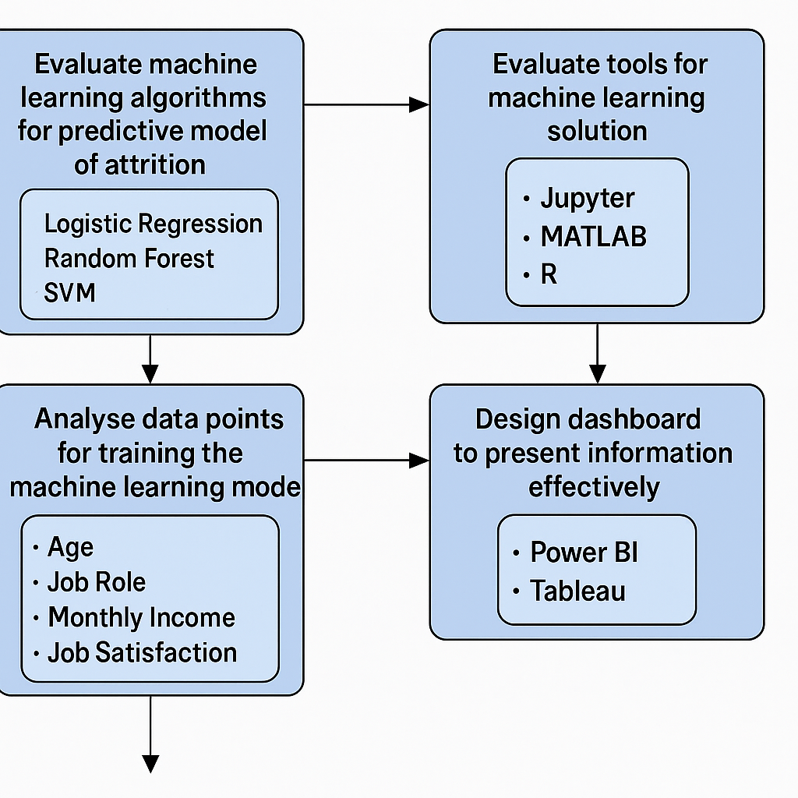

Through completion of these aims and objectives a solution can then be developed that can be employed within a real world scenario.

- Research Methodology
In order to meet these objectives a positivism research philosophy will be employed first using deductive research will first be performed to establish which machine learning algorithms are most effective in predicting attrition. This understanding of existing models will be achieved through an in depth literature review to establish which could be practically employed using a data set provided from the Civil Service, instead of the IBM data that has been widely used. This is likely to be using Random Forest algorithms as this is more often than not the most successfully employed deep learning solution. The combination of multiple models is unlikely to be practical but could also be explored.
Literature review will also be used to identify the commonly used data points and structures that have been employed to do, revealing which should be included within the project and identifying any gaps between the information that is currently available and the data that would be beneficial to have and any implications that this is likely to have in the overall ability to predict employee attrition. The tooling and outputs from all of the above will also be reviewed to identify again what can practically be employed in order to produce a tangible solution that can be used within the organisation. This is likely to be a final presentation of data that can be interpreted by Senior management in a simple diagram and list of individuals at risk, likely using PowerBI due to the ubiquity of office 365 within the Civil Service.
Quantitative Data will be gathered to measure the % accuracy of models tested through experimentation against the datasets provided by the organisation which is likely to need to be cleaned to ensure consistency and accuracy.
There are significant ethical considerations within this area of research due to the data points that will be used to evaluate the likelihood of attrition. The model will have access to information such as happiness, sex, performance metrics, salary, home post code and tenure all of which could be easily used to identify an individual and most of which are protected under GDPR regulation. This sensitive information means that the end produce will likely have to have controlled access, so that only approved personal from the organisation have access to the data and the predictive model. Also, any dashboard produced that would be shared with on a broader scale must ensure that individuals can not be identified through process of deduction as this has both ethical and legal implications.

- Project Planning

In planning this project I have designed the following 16 week timeline in both a tabular and chart format as shown below.
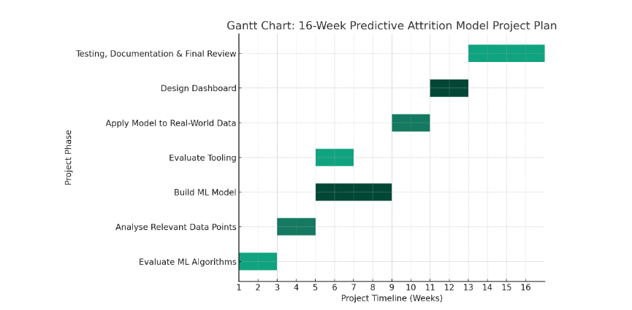
Task Description | Duration | Dependencies | Overall Timeline
Evaluation of ML Algorithms – Research classification algorithms (Random Forest etc) – Select based on Accuracy | 3 Weeks | Machine Learning Expert Support  Access to online articles (may required subscriptions) | Week 1 – 3
Analyse available data points, identify key data points such as Age, Role, Income, Tenure | 3 Weeks | Organisational Data provided in a format that can be efficiently evaluated and cleaned ready to be used with the model | Week 3-5
Evaluate Tooling to produce dashboards | 2 Weeks | Access to software to be evaluated, may required sign up and costings if not supported by the organisation | Week 5-7
Build ML Model – Train and Test algorithms, evaluate accuracy using limited data to ensure multiple models can be tested (at least 100 data points) | 4 Weeks | Hardware that is capable of training models.  Access to software  Access to multiple machine learning algorithms | Week 5-9
Train chosen ML Model on full dataset | 3 Weeks | Chosen algorithm  Hardware  Full dataset cleaned and ready to be used | Week 9 – 11
Design Dashboard visual that represents results to organisational stakeholders | 3 Weeks | Results from ML Model  Software (BI, Tableau) | Week 11 - 13
Testing, Documentation and Review – Looking at performance metrics of the models (% accuracy metrics), documenting findings and refine approach for future iterations based on lessons learned | 3 Weeks | ML Model results and dashboard  Machine Learning Expert to help review and evaluate performance and identify potential developments  Results from previous evaluations | Week 13 - 16

There will be some limitations that the plan has not highlighted. The first is availability of machine learning models to evaluate, as has been shown in the literature review that are numerous models that have all been attempted to be implemented in the past and accessing them is at this moment an unknown quantity. Further to this, there may be paywalls that limit access to presentation software such as Tableau or PowerBI. These limitations may ultimately meant that the choice of software chosen is determined by compatibility and availability within the organisation instead of performance or preference. There is also likely to be limitations within the data that is provided as it was not specifically created for this purpose there may be limited data available and the data may also be inconsistent. It may be likely that recommendations are made on tooling and data capture, but especially with data capture the recommendations may not be implemented in a time that the model produced during the project can use them as attrition data takes years to capture and this is significantly outside of the scope of the project.
From completing the industry research a personal reflection on this would be that it is incredibly exciting that as AI and machine learning is currently something that is ubiquitous within the media and the industry I am very excited to work on this developing area. I feel that I have the data for the last 6 years for the organisation due to my role within it and I am hopeful of being able to identify data points specific to central government organisations and use this research and the project itself to advise on policy and further data that should be captured to make a model such as this as accurate as it can be. It will also help to evaluate current practices for how valuable they are such as end of tenure reviews, mid tenure data capture on happiness and within IT specifically identifying key areas of concern and to be able to pro-actively tackle them would be of enormous benefit to my organisation. Building on the research that has come before, and hopefully building on it is also something I am incredibly excited to achieve though I am concerned about the timeline and how much I will be able to develop beyond an MVP.

References

[1] | C. Pietersen, “Employee Turnover in a Local Government Department,” Mediterranean Journal of Social Sciences, vol. 5, no. 2, p. 1, 2014.
[2] | C. Morelli, G. Fusai and R. Zenti, “Who and why will leave me?,” Utilizing Machine Learning-Based Models to Anticipate and Manage Employee Turnover, p. 16, 29th February 2024.
[3] | F. Lee and A. Algarra, “Leveraging Topic Modeling to Predict and Prevent Empployee Attrtion,” Information Systems Education Journal (ISEDJ), p. 76, 2025.
[4] | D. Grimshaw, “Austerity, privatization and levelling down: Public sector reforms in the United Kingdom,” in Public Sector Shock, Edward Elgar Publishing, 2013, pp. 576-626.
[5] | I. P. T. R. D. T. A. G. D. Beberly T. Calugan, “View of AI Transformation in the Workplace: A Comprehensive Review of Trends and Future Directions,” Journal of Interdisciplinary Perspectives, vol. 3, no. 6, pp. 335-344, 2025.
[6] | J. Van Reenen, “Human Resource Management and Labor Productivity: Does Industry Matter,” in Handbook of Labor Economics, 2005, pp. 135-145.
[7] | N. Khalifa and A. M.
[8] | D. P. Nagpal, D. A. Pawar and D. S. H.M, “Predicting Employee Attrition through HR,” in 4th International Conference on Innovative Practices in Technology and Management (ICIPTM 2024), Noida, India, 2024.
[9] | J. V. Kambhampati and K. Rao, “Advancing Employee Attrition Models: A Systematic Review of Machine Learning Techniques and Emerging Research Opportunities,” in International Conference on I-SMAC (IoT in Social, Mobile, Analytics and Cloud) (I-SMAC), Kiritipur, Nepal, 2024.
[10] | H. Alqahtani, “Employee Attrition Prediction using Machine Learning Models: A Review Paper,” International Journal of Artificial Intelligence & Applications, vol. 15, no. 2, pp. 29-32, 2024.
[11] | M. Z. Islam, “Employee Attrition Prediction in the USA: A Machine Learning Approach for HR Analytics and Talent Retention Strategies,” Academia, 2025.
[12] | D. Chung, J. Yun and Y. Jeon, “Predictive model of employee attrition based on stacking ensemble learning,” Expert Systems with Applications, vol. 215, 2023.
[13] | S. Sharma, “Analyzing Employee's Attrition and Turnover at Organization Using Machine learning Technique,” in 023 3rd International Conference on Intelligent Technologies (CONIT), Hubli, India, 2023.
[14] | F. Mozaffari, M. Rahimi, H. Yazdani and B. Sohrabi, “Employee attrition prediction in a pharmaceutical company using both machine learning approach and qualitative data,” Benchmarking: An International Journal, vol. 30, no. 10, pp. 4140-4173, 2023.
[15] | A. I. Al-Alawi and Y. Ghanem, “Predicting Employee Attrition Using Machine Learning: A Systematic Literature Review,” in 2024 ASU International Conference in Emerging Technologies for Sustainability and Intelligent Systems (ICETSIS), Manama, Bahrain, 2024.
[16] | D. M. Quinteros, “Predictive Modelling of Employee Attrition Using Deep Learning,” Acadlore Transactions on AL and Machine Learning, vol. 2, no. 4, pp. 212-225, 2023.
[17] | M. Nandal, V. Grover, D. Sahu and G. Noida, “Employee Attrition: Analysis of Data Driven Models,” EAI Endorsed Transactions on Internet of Things, vol. 10, pp. 1-10, 2024.
[18] | S. Gupta, G. Bhardwak, M. Arora, R. Rani, P. Bansal and R. Kumar, “Employee Attrition Prediction in Industries using Machine Learning Algorithms,” in 2023 10th International Conference on Computing for Sustainable Global Development (INDIACom, New Dehli, India, 2023.
[19] | R. Govindarajan, N. K. Kumar, S. Reddy and P. Sai, “Predicting Employee Attrition: A Comparative Analysis of Machine Learning Models Using the IBM Human Resource Analytics Dataset,” Procedia Computer Science, vol. 258, pp. 4084-4093, 2025.

