UNIVERSITY OF WALES TRINITY SAINT DAVID

Managing People

GEORGETA MARILENA GHEORGHE
STUDENT NUMBER: 2113968

Module: Managing people
Lecturer: Samuel Ofori
Module code: LCBB5004

Table of Contents
Introduction 3
Analysis and Identification 4
Issues and Challenges of Recruitment 4
Approaches to Recruitment 6
Approach to Selection 7
Performance Management 7
Employee Engagement 8
Conclusion 11
Reference List 12

Introduction
Recruitment is the action that deals with looking for suitable candidates for an organization that will be entitled to various opportunities. Therefore, recruitment is the process of selecting, training, and allotting candidates according to their suitable sectors in an organization. The department of Human resources is responsible for the process of recruitment (Yadav and Singh, 2021). The process of recruiting a candidate could be and in fact, a very challenging task to do. It takes a lot of effort to perform a recruitment process. It requires a critical analysis as to where the organization is lacking and plan a strategic plan to implement the process of recruitment which can be time-consuming.

Analysis and Identification

Issues and Challenges of Recruitment
Recruitment is the process of actions taken to select or shortlist an individual or a candidate that is suitable for performing a task for an organization according to the suitable interests and abilities of the individual. Overall, this process is the process of finding the best suitable candidate and also the most qualified candidate and giving training for a job in an organization.
An article suggests that both the process of recruitment and selection is the process of identifying the need for a job and choosing the most appropriate person for the job. In addition, this process of recruitment and selection in human resource management refers to allocating these aspiring individuals relevant to the skills and talent that they possess and to the fit position and job role in the organization. Recruitment and selection are the most important phases in the process of employment. This includes the initial stages which include job announcement, reviewing the application of the candidate, interviews, final selection, making an offer, and then hiring and giving training to the individual.
This procedure of selecting and training is one of the most challenging processes in an organization. The reason is, that this process is what will define the status of the company or the organization. The fact is, the employee of an organization is what defines the organization the best, they are the representatives of an organization, and their quality, personality, and efforts are what keeps an organization going and progressing. Now, to hunt for a candidate and an individual who has the best quality and is best suitable for the organization in itself sounds so challenging and obviously, the practical implementation of this process is a great challenge. The process needs to overcome so many barriers and issues relating to it. To again overcome these barriers in themselves is a very challenging task because these barriers are the barriers that are composed of mostly societal issues like stereotypes and inequality.
Looking on to some of the issues and challenges relating to recruitment are the barriers of culture and language. Communication is a basic necessity of all means of work, and if there is a cultural and lingual barrier, then the process of recruitment and hiring becomes difficult. Other issues similar to this is the barrier of age and gender. This is one of the main issues at the time of recruitment and also after the process of recruitment because the thought process at this point in time, between the two age groups of people or between the two different generations are different, and due to the differences in the thought process, there are high chances of clashes of ideas between the two individuals. This is also the same idea when it comes to the factor of gender too. The way men and women think could bring huge differences and so also variations in the way of doing the work too. This could be the barrier that creates an issue in the process of recruitment (Manohar et al., 2018). To find the best candidate is one of the biggest challenges that any recruiter may face. Not only the efforts made to maintain these barriers are the only issues, but the condition of the organization is also important. By the word condition, it means the financial state of the organization, and the political and also technological factors also come into consideration at this point in time. An organization needs to have adequate financial status or enough funds to implement the process of recruitment. This is because recruitment do not only take time and energy from human resource but also requires a suitable amount of money that needs to be spent on the entire procedure. Time management is also a factor that serves as a challenge to recruiting a candidate for the organization as getting the best or atleast a suitable candidate requires a lot of time, effort, and analysis of the individual. Not only this but also maintaining a good policy and building a good employee fund is crucial to attracting candidates for the post.
For Instance, Tesco faces issues and challenges, can be categorized under, that is internal factor and external factor (Jones and Comfort, 2021).
The internal factors that challenge the process of recruitment are
- company size,
- recruiting policy
- organizational image
The external factors are:
- demographic factors
- labor law and legal considerations as in the case of Tesco which operates in various countries with each country having separate labor law and legal considerations.
- labor market conditions
Recruiting and selecting the right candidate is very crucial for an organization as the future and the function of the organization are totally based on the type of employee hired. For instance, if an employee from a literature background is hired to do a job relating to accounting, it is sure enough that the employee will have the poorest performance because he or she has no knowledge of the accounting field. It is pretty obvious that they will give a bad result to the function of an organization. Therefore, it is due to this reason, that it is essential to analyze the candidate that is being hired. With this idea, there comes the concept of having an approach to implement the recruitment and selection process (Aliyu, 2022).

Approaches to Recruitment
To overcome these challenges, there needs to be strategic planning and an approach that needs to be implemented to make the entire process of recruitment much easier and faster. Recruitment is still a challenging task to do, but in today’s time, where innovation and digitalizing are in the spotlight, recruitment has become much easier.
The use of Social networks is one of the most effective ways of recruitment. It is known to all, and it is to the consciousness of everyone that most people nowadays stay on their mobile phones to do their day-to-day work hence the idea of using social networks is a great way of recruitment. A small advertisement of the organization and a description of the job can be of great help to the ones who are looking for a job. This way both the organization and the candidate who is aspiring for the job can reach out to each other, hence making the initial stage of the process much easier. Therefore, the pace of recruitment has increased with the use of social media (Arigo et al., 2018).
A good relationship with the candidate is a good way to have a positive approach to recruitment. Making the employee or the aspiring candidate feel special is a very important step because this will make them feel that they are worth it and motivate them to join the company. this can be worked out with the procedure of personalized communication with the candidate.
Having a good and especially unique organizational strategy is a go-to approach that every organization needs to look after. This is because most people like and look for a unique factor in each and everything. The same old business strategy and function becomes a common thing and most people think it is boring too, so they look for something that they can learn something new from and hence they look for an organization that practices a unique way of functioning.

For instance, Tesco’s method of recruitment uses the full advantage of social network, by posting and advertising the job vacancies on their websites, national press, and other social media platforms. Through this procedure, the organization is able to reach a huge number of aspiring candidates who are looking for a job, and hence the process of recruitment starts here.

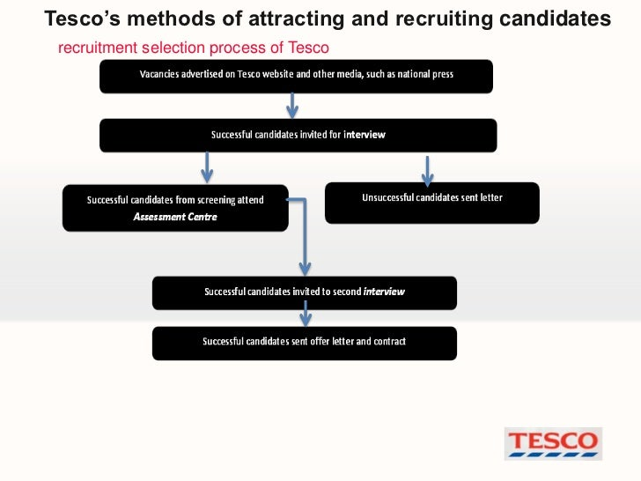
Figure 1: Tesco’s Method of Recruiting Candidates
(Source: researchgate.net, 2020)

Approach to Selection
Selection is the process of conducting a series of interviews to select the best candidate suitable for an organization. The process of selection includes a series of selection tests, a question and answer round, and a background check-up for the aspiring candidate for the job. This set of actions in the process of selecting is also conducted by the HRM who is also called an interviewer during the time of the interview. This process of selection serves as the first and one of the most important parts of the hiring or recruiting process. This is when the candidate will be judged according to the communication that they have, the personality that they possess, and also their way of perspective of looking out into the world. These are the basic things that are being checked at the time of an interview, then and then only after the interview, the selection will be brought out.
To bring about the process of selection successfully and smoothly without any chaos, the first step that needs to be taken into consideration is the step application, this is the most basic step where the essential information of the candidate is recorded. This process requires the candidate to fill up a form or make a CV or a resume with personal information and interests. Different organizations follow different ways of selecting their candidates. For instance, the organization British Red Cross, follows a series of procedure to select the right candidate to fulfill its needs as a help to the ones who are in need. For this, the organization has to follow certain procedure as mentioned earlier such as analyzing the CVs or the resume and interacting with the candidate which will help them to know deeper about the candidate. The figure below shows the entire procedure of the process of selection.
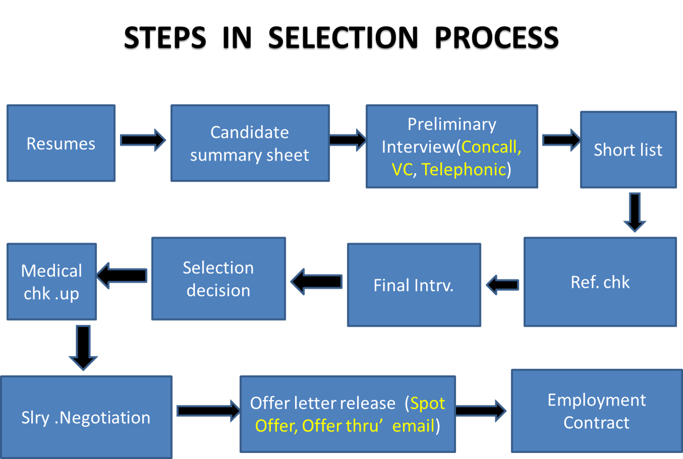
Figure 2: Steps in Selection Process
(Source: researchgate.net, 2021)

Performance Management
Performance management can be defined as the consistent process of recognizing, determining, and working for the development of the organization and the individuals or the employee working in the organization. This process of a series of actions is a crucial task that needs to be taken up in every organization. It includes the strategic planning of the performance of the employee. This process aims to transform the employee’s talents and abilities in an effective manner and motivate them into building a strategic and sustainable business firm (Aguinis, 2019).
The actions taken or included in performance management are the planning of the goals and targets of the employee. This is the first step of the process. With the help of a strategic plan on how to implement and perform, the function of the team and also the organization will go according and smoothly. To make sure that this procedure keeps its consistent nature, the next step of the process comes into action, that is the step of monitoring the function of the employees and also the organization. This step helps ensure the quality of the work being done and the things that need to be improved and taken care of in the process and the development of the organization.
After the process of monitoring, there needs to be an allotment of grades as to how good or how bad the function has been. This step is called the rating. This is essential because by rating there can be an idea in the minds of the employees to change or improve their way of working, or keep the work going as per how they are functioning. Good work without any recognition and reward is vague and lifeless. This is when the concept of reward comes into account. Rewarding is what keeps the employee encouraged and their performance enhanced. Performance management tells, teaches, or trains the employee the ways of carrying out the work of the business in an effective manner (Darino et al., 2019).
Performance management can affect an organization in many positive ways as well as a few negative ways. Focusing only on the dominant positive impact of performance management can help identify core issues of the organization and help cope with the issue with a proper solution. This process will help an organization perform better by analyzing the values and personalities of the employees and hence help the organization function better. Performance management can help bring better documentation and reduce business risk. It brings about better productivity for the organization. Overall performance management enhances better productivity of the organization and hence helps the growth and development of the organization.
If all these processes of action are taken seriously, then the organization is undoubtedly on the right track. In the case of Deloitte, the performance management process has a clear understanding of the upcoming role of the organization. The organization focuses on implementing technology so as to gain transparency and efficiency and hence the development of the organization.

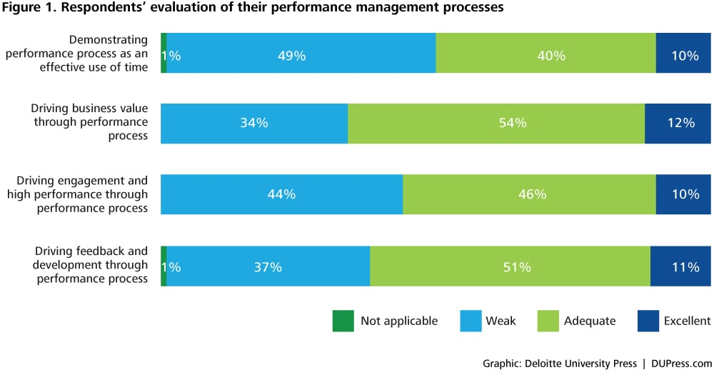
Figure 3: Performance Management Processes
(Source: dupress.com, 2022)

Employee Engagement
Employee engagement is the individual engagement or involvement of an employee toward their organization. It can also be defined as the basic workplace attitude that ensures all the support of the organization and ensures to give their best towards the contribution of excellence for the company. it is always remembered by the organization that employees who are well-engaged in the productivity of the organization always lead to the productivity and development of the organization, making the work experience and also the function of the organization satisfactory at all causes. An employee who is engaged always makes sure that are putting in their best effort in all that they do and also tend to give the best performance, making a dramatic difference for the company. They are dedicated individuals that give their all to the work they do. Engaged employees work for the development, support, and growth of the company and this etiquette can only and only be encouraged by the HRM practices which keep the employees motivated and going. The roots of employee engagement are built on the factors like communication, dedication, reliability, belief, and commitment. An organization can enhance employee engagement by giving and increasing the liberty of decision-making, free speech, and transparency from the senior authorities or the senior authorities. Employee engagement is also a level of encouragement, enthusiasm, and also commitment that an employee feels towards their organization, or it is the attachment that they have towards the organization. This attachment that is being discussed here is dominantly the mental and emotional attachment. It is the approach that is dependent on the employees of the organization to open up opportunities and chances for business achievement, growth, success, and development of the organization. It can be basically termed the gateway to the success of the organization because employee engagement focuses on keeping and working for the well-being of the organization. Employee engagement can also be used as the mediator for the development of the behavior, attitudes, and intention of an employee, helping in generating causes of certain actions or reactions that the employee might show.
The impact employee engagement in an organization has a significant positive effect it serves as the cause of an organization’s commitment. It is found that the higher the level of engagement of the employee, the lesser the absenteeism, and also lower the job stress and eventually better the well-being and health of the employee. Employee engagement is the most crucial part of an organization and without it, an organization cannot last for a longer period of time. To enhance the implementation of employee engagement during times of crisis in the organization, the organization shout and must make efforts towards the motivation of the employees, to make sure that the employees are well-to-do and that they are a special part of the organization (Chanana, 2021).
Another research article suggests that employee engagement has a wider scope than any other attitudinal constructs in the involvement of a job, the commitment of the organization, and the psychological climate, and hence, it is due to these reasons it has a wider scope and a wider range of individuals cognitive, attitudinal and behavioral results. Engaged people tend to portray a high level of energy, commitment, enthusiasm, and also productivity. This article also theorizes employee engagement as a two-way relationship which is demonstrated by the interaction between the personality traits of two individuals and also the surrounding conditions and structures of the organization (Ababneh, 2021). Burberry has an increased engagement of their employees. They claim that they are communicating daily with their teams and they have focused on the development of their people also their well-being.

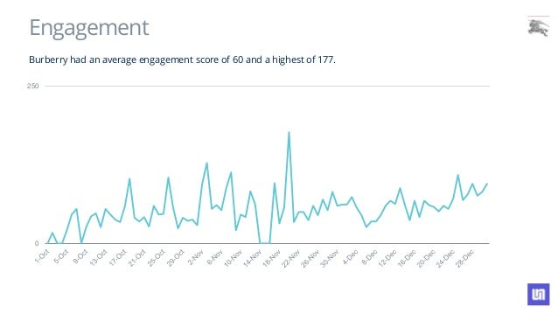
Figure 4: Burberry Engagement Rate
(Source: burberry.com, 2020)

Conclusion
Recruitment is the process of identifying, analyzing, selecting, hiring, and training candidates or individuals who are aspiring for job opportunities. Selecting is the process of interviewing candidates and hiring them according to the suitable post in the organization. Performance management is the process of critically analyzing the function of the employee’s performance and the organization. Employee engagement is the individual’s involvement in their organization or company. this report has a detailed discussion on the topics of recruitment, selection, performance management, employee management, and the approaches to recruitment and selection. Therefore, this report has all the essential information about the title managing people in an organization and also the process and approach of this management. Hence, this report has done its justice to the title Managing People.

Reference List
Ababneh, O.M.A., 2021. How do green HRM practices affect employees’ green behaviors? The role of employee engagement and personality attributes. Journal of Environmental Planning and Management, 64(7), pp.1204-1226.
Aguinis, H., 2019. Performance management for dummies. John Wiley & Sons.
Aliyu, U.L., 2022. THE IMPACT OF RECRUITMENT AND SELECTION PROCESS IN AN ORGANIZATION.
Arigo, D., Pagoto, S., Carter-Harris, L., Lillie, S.E. and Nebeker, C., 2018. Using social media for health research: Methodological and ethical considerations for recruitment and intervention delivery. Digital health, 4, p.2055207618771757.
Chanana, N., 2021. Employee engagement practices during COVID‐19 lockdown. Journal of public affairs, 21(4), p.e2508.
Darino, L., Sieberer, M., Vos, A. and Williams, O., 2019. Performance management in agile organizations. mckinsey. com.
Jones, P. and Comfort, D., 2021. Leading Retailers in the UK and Modern Slavery Statements. International Journal of Sales, Retailing and Marketing, 10(2), pp.18-26.
Manohar, N., MacMillan, F., Steiner, G.Z. and Arora, A., 2018. Recruitment of Research Participants. Handbook of Research Methods in Health Social Sciences, pp.1-28.
Yadav, P. and Singh, B., 2021. The Impact of Effective Recruitment & Selection Process on Organizational Development: An Empirical Study. Annals of the Romanian Society for Cell Biology, 25(6), pp.693-703.

