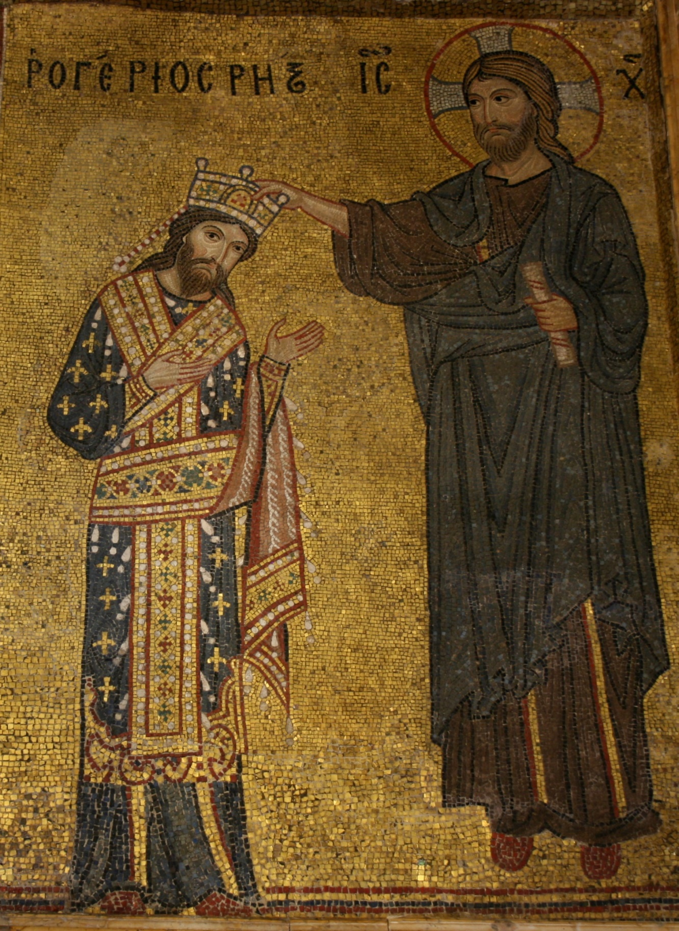
Detail from the mosaic with Roger II receiving the crown from Christ, Martorana, Palermo

The subject of this commentary is a mosaic from the Church of Santa Maria dell’Ammiraglio (often called La Martorana after a family who were later patrons of the church) in Palermo. The church was built in the second quarter of the twelfth century for George of Antioch, Roger II’s admiral (dell’Ammiraglio meaning of the Admiral), as his personal chapel in his palace and this mosaic shows Roger’s coronation at the hand of Jesus. Near to the mosaic of Roger is one showing George in a more humble position and both are now prominently sited in the portico of the church at eye leve. They had originally been positioned further inside the church and it is now hard to discover exactly where but probably at a similar level, as higher positions were reserved for more holy subjects.
The mosaic not only indicates Roger’s relationship with the papacy, as the Church is made subordinate to the state, but also underlines the Norman ruler’s aspiration to conquer the Byzantine empire.
George was a Greek born in Syria and his nationality may be one reason for the use of Byzantine craftsmen, indeed the first clergy appointed there were all Greek. George was important to Roger, leading expeditions to conquer land and to gather spoils, including silk workers kidnapped from Thebes. His position in Roger’s court clearly demonstrates the Norman ability to recognise talent from outside their own circle.

The use of gold glass tesserae in this and most of the other mosaics in Norman Sicily creates asparkling, sumptuous effect. The slight unevenness of the surface creates a more coruscating effect than a flat surface would give due to the refraction of light. The extravagance is not only an exhibition of wealth, but a way of bringing the light of Heaven into the church, displaying spiritual wealth as well as earthly riches. Sicily has several mosaics of Christ Pantocratos, that is almighty or omnipotent Christ, some of which have the inscription ‘I am the light of the world, he who follows me will not walk in darkness, but shall have the light of life’ which is taken from John 8:12. However, when the concept of Normanitas with its attributes of pride and arrogance is brought into consideration, it seems likely that the overt use of expensive materials is borne largely of those qualities. It also recalls similar mosaics found in Constantinople, perhaps a way of demonstrating Roger’s ambition to achieve power in the Byzantine empire.

In this mosaic Roger receives the crown from the hand of a very plainly dressed Jesus and with the inscription Rogerios Rex: we may wonder why he is not styled emperor. The hovering Jesus seems to focus on the moment while Roger stares out at the audience, gesticulating towards Christ. Both have similar facial expressions and features, and although all the faces in this programme of mosaics are stylistically similar, bearing a solemn and dignified expression, the likeness between these two is striking. That Roger is being crowned by the Son of God says much: a king in a Catholic country should be crowned by the Pope. Roger wears the robes of a Byzantine emperor, not a Catholic king: another facet demonstrating his superiority. Interestingly, while Jesus looks towards at Roger, Roger looks out at us, the audience. He seems to say with gaze and gesture ‘You see? Jesus approves my kingship.’

Andreas Petzold tells us that this mosaic and others in Norman Sicily were created by Byzantine mosaicists; the faces and clothing in particular support this claim, although other features of the mosaics (and much other Sicilian art) show clear Muslim influence. The hunting scenes in secular Sicilian mosaics such as those in the Sala di Ruggero in the Palazzo dei Normanii support this conclusion: this is a typical subject for Muslim art of that period. The Islamic influence is also borne out by architectural features such as the muqarnas (honeycomb or stalactite ceilings). Records and chronicles from late eleventh century Sicily tell us that not only Normans but also Greeks and Muslims held high office in Roger’s court and administration.
Roger presided over a cosmopolitan court, uniting influences from Byzantium, Islam and the West. This cultural mix is embodied in the Palatine chapel, his personal chapel in the palace at Palermo: its mosaics were made by Byzantine craftsmen; its elaborate wooden and painted stalactite ceiling by Muslims; and its imagery reflected the liturgical and political interests of the West…The region under Christian rule in which the presence of Islamic art is most evident is Sicily.
Craftsmen other than Byzantines may have worked on later mosaics, as Dummett mentions:
These dates [when Sicily was at peace with Byzantium] can be seen to correlate with the periods when the mosaics were set up. Subsequently Sicilian craftsmen learned the techniques and made their own contributions.

Roger II united Sicily and Southern Italy and was crowned first king of Sicily in the cathedral (not La Martorana) in Palermo on Christmas Day 1130. The symbolism of this date is not to be ignored, indeed William I of England was crowned on Christmas Day in 1066 and before him Charlemagne chose the same date in 800 for his own coronation. Alexander of Telese says of Roger at his coronation ‘how splendid in his richly decorated robes’, although he does not say that these were the clothes of a Byzantine emperor, as is shown in this later mosaic. Roger was a son of Roger de Hauteville, Great Count of Sicily from 1072 until his death in 1101 when the title passed to his son Simon (a minor) who died during his minority, leaving his younger brother to inherit. Roger remained Count until in 1130 Sicily was conquered completely and he was crowned King of Sicily and Southern Italy. He has been described by Dummett as more feared than loved by his people. How true this is it is hard to say. Romuald of Salerno tells us that Roger was: ‘…wise, far-seeing, careful, subtle of mind, great in counsel, preferring to use his intelligence rather than force.’
Ibn Jubayr, the Muslim traveller, was shipwrecked on the Sicilian shore in 1184. He visited Palermo, by which he was greatly impressed, and said of La Martorana that it was one of the most wonderful buildings in the world. It is not impossible that visitors from other places, including the Byzantine Empire, were equally impressed with Roger’s achievements in Sicily.

In this mosaic we see many facets of the Norman character. Roger resembles Christ and is inclined towards him, respectful yet not subservient. He is shown as more than a king although still called a king. Greek letters form the text and Byzantine craftsmen have been used to make the mosaic because they have been assimilated into the Norman world. It is a demonstration of Norman adaptability and their assimilation of existing civilizations, yet it also shows a love of luxury and of art. It shows arrogance, but the one Norman ‘quality’ it does not show is ruthlessness.

BIBLIOGRAPHY
Davis, R H C, The Normans and their Myth (London: Thames & Hudson, 1976)
Dummet, Jeremy, Palermo, City of Kings: the heart of Sicily (London & New York: I B Tauris & Co Ltd, 2015)
Holmes, George ed., The Oxford Illustrated History of Medieval Europe (Guild Publishing, 1988)
L’Orange, H P & Nordhagen, P J (Trans. Ann E Kemp) Mosaics (Methuen & Co Ltd, 1966)
Rowley, Trevor, The Normans (Stroud: Tempus Publishing Ltd, 2000)
Vaiou, Maria, ‘The church of St. Mary of the Admiral in Palermo: some recent photographs’, in Journal of Religious Culture, 210 (2015), pp. 1-22
Zalapi, Angheli, Palaces of Sicily (San Giovanni Lupatoto (Vr): Arsenale Editore Srl 20120)

Andreas Petzold, Romanesque Art (London: Weidenfeld & Nicholson, 1995) p86
Jeremy Dummett, Palermo: City of Kings (London: I B Tauris, 2015) p 169
Petzold , Romanesque Art, p56
Dummett, Palermo, p169
Ibid., 65
Petzold, Romanesque Art, p60
Petzold, Romanesque Art, p86
Dummett, Palermo, p161
Ibid., p33
Alexander of Telese, De’ fatti di Ruggero re di Sicilia, as quoted in Dummett, Palermo, p. 36
Dummett, Palermo, p33
Romuald of Salerno, Chronicon sive Annales, as quoted in Dummett, Palermo, p 37.
R H C Davis, The Normans and their Myth (London: Thames & Hudson, 1976) p72
Dummett, Palermo, p. 169

