Name : Paloma araujo
Student Number : 1907291
Moodle title : Digital Skills and Research Methods
Lecture name : Joy Botu
Module code : BMSW4003

CONTENTS

Introduction ……………………………………… 3
Background …………………………………….. 4 , 5 , 7
Aims and objetives ……………………………….. 8
Method ……………………………………………….. 9
Results ………………………………………………….10 , 11 , 12 , 13 , 14
Discussion ……………………………………………… 15 , 16
Conclusion …………………………………………………. 17
Appendix …………………………………………………….. 18 , 19
References ………………………………………………………. 20

Introduction

In this report will look at the effects of moodle. The main purpose of this report is to better undestand the impact of Virtual Learning Environment ( Moodle ) on students learning experience in the University of Wales Trinity Saint David London Campus.
It was collected primary and secondary data, and I will give the definition of each data, how they differ and how they collect data differently, will give examples and explain how I managed to collect these dates.
I send a questioner where I sent all my colleagues, only a few answered, but I got answers that made me complete this report, and understand the different choices of students. In this report, I will analyze different answers to the questions I put in the questionnaire, having a better understanding of how each student needs moodle in their life as a student.
With the results I got, I made charts to analyze the answers they gave me, will compare and explain why the answers and also how it impacts on students.

Background

For this report I had to do a questionnaire to send to my colleagues, or people who use moodle, to find out their opinion about the impact of moodle in studies. Doing the questionnaire I sent it to some people and not everyone answered but I managed to have some answers, with these results I managed to get my primary data .
Primary information is information that is gathered by a scientist from direct sources, utilizing techniques like studies, meetings, or tests. It is gathered in view of the examination venture, legitimately from essential sources (Stephanie , 2018 ).
Secondary information alludes to information that was gathered by another person. Secondary data is accessible from an assortment of sources, for example, governments and research organizations.
While utilizing auxiliary information can be progressively conservative, existing informational collections may not answer the entirety of a scientist's inquiries (Ashley C. 2019 ).
For secondary data i was doing research on moodle on websites, journal and surveys that had already been done, with that i managed to have some information about moodle, better understand how it works and how it benefits in the lives of students, with this research i managed to do the best and simple questions for my questioner.

Moodle is free to use, moodle was made to be used as a learning platform that provides education. Moodle can be downloaded for free on any type of device, such as laptops, telephones or tablets. As we already know Moodle is a service that facilitates access to university information. Moodle has its benefits and will explain them .
Open source
Moodle is an open source, this means that any student can have access to Moodle. Moodle can be used to share projects and can change to meet the final criteria .
Cost-effective
Moodle is a learning platform that is free to use. It costs nothing to access the Moodle or the information it contains. You do not need to pay any license or fee to access Moodle.
Simple Interface
You will find Moodle to be quite user-friendly. This is because of its simple interface and intuitive navigation, which consists of only three distinct columns. All you training courses can be accessed from the middle column. The good news is that, it is based on HTML5 and designed to be responsive, so you can access it on any mobile device.
Easy to Customize
Programming stages, for example, a LMS need customization to accommodate your association's necessities. You need your organization name, logo, and your image hues to make it look as your preparation the executives stage as opposed to an irregular site. Doing this with Moodle is very simple. You can contact an ensured Moodle accomplice, who will comprehend you prerequisites and alter it in like manner. Here is a free eBook that will assist you with seeing how well you can utilize Moodle to meet your preparation needs .
Offline Access
For creating nations, Internet data transmission can be a significant issue while conveying web based preparing. Indeed, even in created nations, this can be a worry in remote zones. With Moodle, you get the disconnected access highlight, which permits your remote workers to download courses to their gadgets and access them disconnected, later.

At this point you more likely than not thought about why Moodle tops the rundown of the 20 most well known Learning Management Systems on the planet. Natural route, stunning highlights, cost-adequacy, and disconnected access are a couple of the numerous reasons which cause preparing administrators to go for Moodle (CommLab India ,2017)
Within that platform will find planned classes, you can access previous classes. With moodle you can have access to the essay task, explain how to submit the essay you can see the final grade of the lecture, this helps a lot in the area of ​​education. Moodle gives a spot to students to get to the courses and appraisal exercises. ...
Having the option to unite the entirety of this substance into a unified stage to convey courses and run reliable reports from one point is fundamental (Moodle 2020 )

AIMS AND OBJECTIVES

The main objective of this report is to analyze the experience in students with moodle, what is the impact of moodle in student life. With the questionnaire we can understand who has more difficulties than others and how moodle sometimes does not help 100% in the study of some students. The purpose of this report is to understand the difficulty of some students with moodle, as for some this may be new and a little difficult to understand because it sometimes has many links together.

METHOD

Using the surveymonkey app i did my questionnaire to send it to my classmates. I chose to send it to my classmates because it would be easier because we are many and would have more answers.
To investigate this topic I had to send the questionnaire that contained eight questions and have the result of my classmates, I sent it to all my colleagues but not everyone answered, I got ten answers, and with these answers I had to make charts to analyze the answers. It was not very difficult to find the right people to send the questionnaire, because all the people who I have sent the questionnaire have already used the moodle or some are still using it .
The questions I asked in the questionnaire, were very easy, I tried to make the questions easy so that they understood what I wanted to ask, simple questions that everyone already heard, some questions I had to research on the internet but I always tried to ask simple questions and easy to understand to get more answers.

RESULTS

For this questioner I tried to choose the easiest questions for everyone to understand, simple questions so that no one would be confused or not understand something.In these results I will show my primary data from my survey, I analyzed and made a table and the results in charts.
In the charts you can see the percentage of the questions that people answered. I will present the results in a table and in charts, it was the way I analyzed the secondary data of my questionnaire.
These are my charts and my table analyzing primary data :

 | Questions
Responses | 1 | 2 | 3 | 4 | 5 | 6 | 7 | 8
20-30 | 5
30-40 | 2
40-50 | 3
yes |  | 10 | 7 | 10
no |  | 0 | 3 | 0
very easy |  |  |  |  | 3 |  | 4
no to easy |  |  |  |  | 5 |  | 5
difficult |  |  |  |  | 2 |  | 1
laptop |  |  |  |  |  | 8
tablet |  |  |  |  |  | 1
phone |  |  |  |  |  | 1
very helpful |  |  |  |  |  |  |  | 3
no to helpful |  |  |  |  |  |  |  | 6
not helpful |  |  |  |  |  |  |  | 1

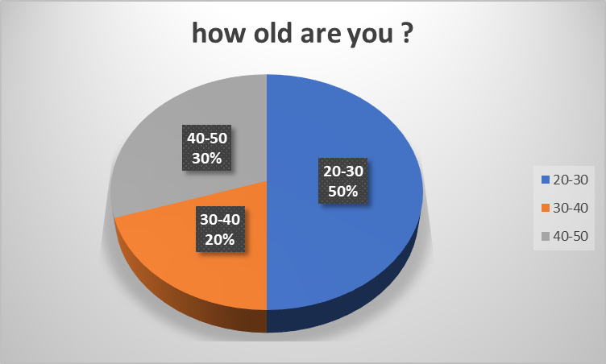
Figure 1 : how old are you ?
Source : Paloma araujo

FIGURE 2 : access to the internet ?
Source : Paloma araujo

Figure 3 : do you use moodle ?
Source : Paloma araujo

Figure 4 : Can you use moodle for free ?
Source : Paloma araujo

Figure 5 : Moodle is easy to use ?
Source from : Paloma araujo

Figure 6 : Wich device do you use to access moodle ?
Source from : Paloma araujo

Figure 7 : Is moodle difficult to learn ?
Source : Paloma araujo

Figure 8 : moodle is helpful in your studies ?
Sources : Paloma araujo

Discussion

With the results I got from the answers to the questionnaire I got secondary data. Most of the people who answered my questionnaire were between 20-30 years old, so I understood that there are more young people using the moodle app, access to the internet is also very important because without that nobody could have access to the moodle, with the results that i received all the people who answered the questionnaire have access to the internet, this makes a student's life a lot easier..
Moodle is a very effective learning platform in the life of a student, it helps to understand better about the course and how to submit works for example essays. The people I interviewed 70% of them used moodle as a way of learning, the other 30% did not use moodle, this may be because they do not know how to deal with moodle or can get information through other platforms.
Sometimes access to some information for the study is not free, so one of the questions I asked was if the moodle was free and everyone said yes, on some learning platforms they ask to leave a debit card number or something similar , but the moodle gives us all the information we need for the duration of our course and at no cost.
over time I saw that some people had difficulty accessing the moodle at times or even understanding how to deal with it, in one of the questions almost half of the people answered that the moodle is not easy to use, this may be because lack of personal use or even lack of teaching how to deal with moodle. For students to access the internet and the moodle, they must have some technology to access it, most people choose to use the laptop as a mean of study and learning, others use the mobile or tablet, its always better to use the laptop we have a better image and we can access everything we want. The last question I asked in the questionnaire 60% of people answered that moodle is not helpful in studies, this shows us that for most people moodle does not make much difference in studies, while 30% said it helps and 10% of people said which doesn’t really help, these results show that most people who answered the questionnaire don’t use moodle much and that moodle doesn’t have any impact on their studies.

Conclusion

In conclusion we can see the impact of moodle on learning in the students' lives, making a questionnaire and collecting people's question, with the answers we can evaluate each answer and make charts and tables. We were able to evaluate the results seeing that most people answered that the moodle has almost no impact on studies or learning during the course. We analyzed primary and secondary data, we managed to understand the differences of each one, examples and definition.
In conclusion, moodle is a very important learning platform in a student's life and in learning, the lack of interest or help can sometimes make the journey difficult.

APPENDIX

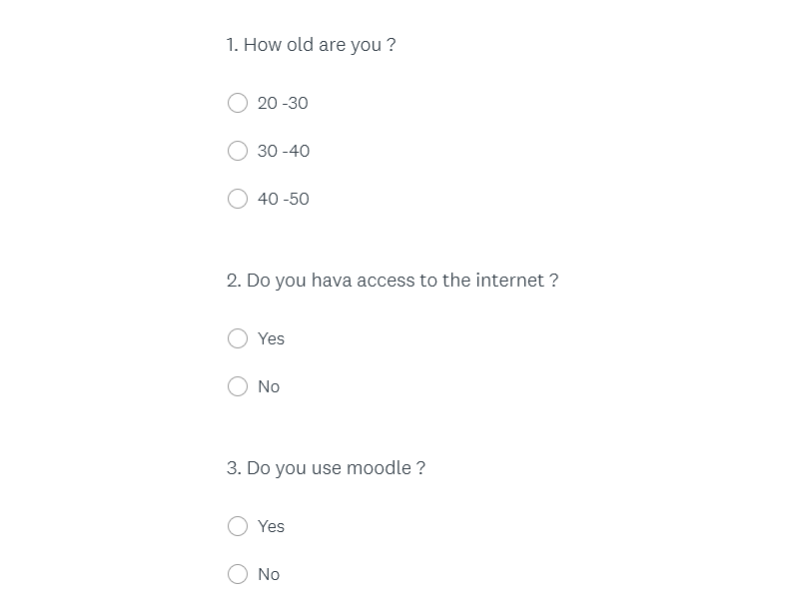
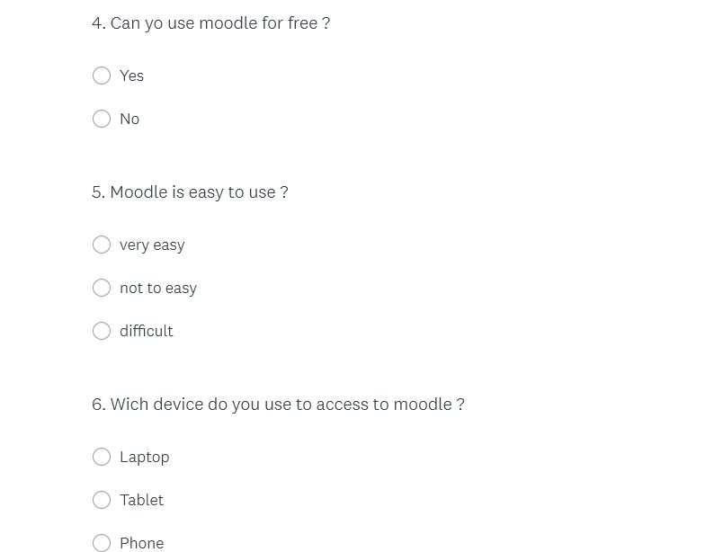
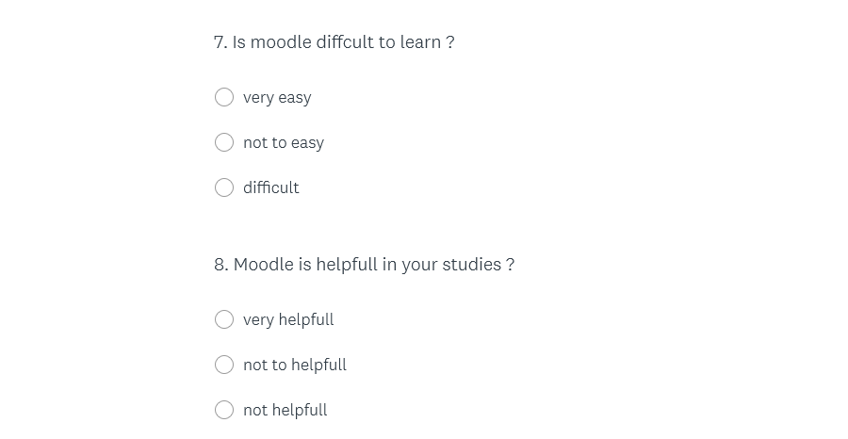

REFERENCES

Ashley C. (2019) Pros and Cons of Secondary Data Analysis (online) Available from : https://www.thoughtco.com/secondary-data-analysis-3026536 [Accessed from : 5 May 2020 ]

Moodle (2020) Why is Moodle the world’s most widely used learning platform? Available from : https://moodle.com/news/moodle-worlds-widely-used-learning-platform/ [Accessed from : 5 May 2020]
Stephanie (2018) Primary Data & Secondary Data: Definition & Example Available from : https://www.statisticshowto.com/primary-data-secondary/ [ Accessed from : 11 May 2020 ]

CommLab I. (2017) Top 5 Benefits of Moodle Learning Management System Available from : https://blog.commlabindia.com/elearning-development/moodle-learning-management-system-benefits [ Accessed from : 11 may 2020 ]

