

Student name: Biplob das
Student ID: 2424763

Programme: Master of Business Administration
Module Name: International Business Concepts
Module Code: LCMB7034

Lecturer: Balendran Kandasamy

Submission Deadline: 30.04.2026
Assignment Title: Report

Global Competitiveness and Market Expansion Strategy of Samsung Electronics: A Comparative Analysis of South Korea and Malaysia with Reflective Insights

Table of Contents
1
1. Introduction 2
2. Industry and Country Overview 2
a. Industry Introduction 2
b. Size, Scope and Economic Importance 3
c. Important Firms and Competitive Positioning 4
3. Analysis of the Diamond Model by Porter 4
3.1 Factor Conditions 5
3.2 Demand Conditions 5
3.3 Supporting and Related Industry 5
3.4 Firm Strategy, Structure and Rivalry 6
3.5 Government Role 6
3.6 Chance Factors 7
4. Samsung in Malaysia: Critical Evaluation 8
4.1 Introduction to the operations of Samsung in Malaysia 8
4.2 Political Factors 8
4.3 Economic Factors 9
4.4 Legal and Regulatory Factors 10
4.5 Cultural Factors 11
4.6 Market Attractiveness 12
4.7 Key Success Factors for Samsung 13
4.8 Risk and Challenges 14
5. Conclusion 14
Reference 16

1. Introduction
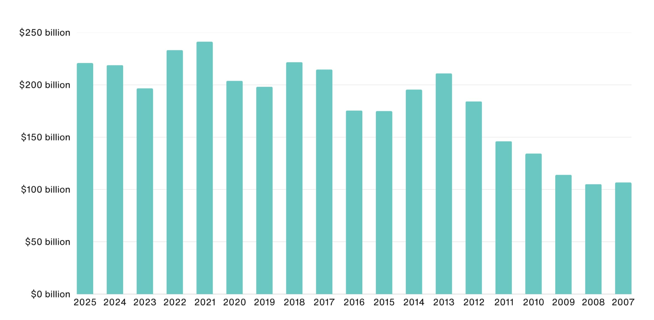
Figure 1: Samsung Statistics (2026) - Revenue & Market Share
Source: (Kumar, 2026)
Samsung Electronics is a globally dominant multinational corporation (MNC) operating across consumer electronics, semiconductors and digital ecosystems. Its competitive strength reflects not only firm-level innovation but also the structural advantages embedded within South Korea’s export-oriented industrial model. This report examines the consumer electronics and semiconductor industry across South Korea (home country) and Malaysia (emerging market), highlighting differences in innovation capacity and production roles. The report aims to critically assess industry competitiveness, apply Porter’s Diamond Model, and evaluate Samsung’s strategic positioning within Malaysia. To deepen the analysis, PESTLE and Hofstede’s cultural framework are incorporated to capture institutional and socio-cultural dynamics. The central argument is that Samsung’s global success is shaped by the interaction between home-country innovation ecosystems and host-country manufacturing advantages, demonstrating how geographically dispersed value chains underpin competitiveness in Southeast Asia (Kim and Lee, 2022; Narula and Verbeke, 2023).

2. Industry and Country Overview

a. Industry Introduction
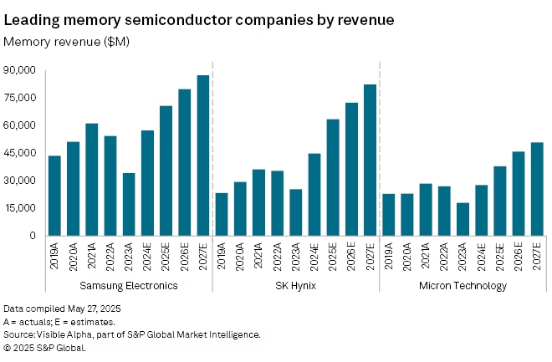
Figure 2:Industry outlook: SK Hynix set to overtake Samsung as DRAM leader amid AI-driven memory boom
Source: (Ansari and Garg, 2025)
The electronics and semiconductor industry is one of the core elements of the global digital economy, facilitating artificial intelligence, 5G connectivity and the Internet of Things (IoT). In 2024, the global semiconductor market is over 600 billion, and its growth is expected to be long-term due to the need to achieve high-performance computing and high-end consumer electronics (Varas et al., 2022). This is a very capital-intensive sector that needs to invest in research and development (R&D) on a constant basis, where major players spend billions of dollars each year to keep on the technological edge (McKinsey, 2023). The industry has been highly entrenched in an innovation-based economic framework in South Korea. Global memory markets are dominated by firms like Samsung Electronics and SK Hynix with national investment in R&D of over 4.5 % of GDP. It is the strength of this innovation that allows South Korea to gain access to premium portions of the semiconductor value chain, specifically design and fabrication (OECD, 2023). In comparison, Malaysia is a complementary partner in global value chains as a manufacturing and assembly hub. Semiconductor packaging and testing is the specialty of the country especially in industrial clusters like Penang. Although Malaysia enjoys cost efficiencies and good infrastructure, it is still reliant on foreign technology, which constrains its ability to compete at high value innovation segments (Rasiah and Yap, 2022).

b. Size, Scope and Economic Importance
Electronics is the core of the South Korean economy with about 30% of total exports and semiconductors are a significant portion of national production (Park et al., 2022). Samsung has a leading position in this system, and its revenues have a considerable impact on the country's economic performance. This concentration emphasizes the robustness of industrial policy of South Korea and its susceptibility to the changes in technology demand in the world (World Bank, 2023). The competitiveness of South Korea is supported by an established innovation ecosystem, which is characterised by good government-industry partnership, built infrastructures and long-term investment in R&D. The nation is always among the world leaders in terms of innovation, which allows companies to have competitive advantages in high-value markets, including semiconductors and advanced displays (WIPO, 2023). By contrast, the electronics and electrical (E&E) industry in Malaysia takes up about 38 % of the overall exports, hence, it is considered as one of the pillars of the national economy. The industry has been drawing huge foreign direct investment (FDI) and multinationals like Intel Corporation and Texas Instruments have set up large operations. The appeal of Malaysia is also based on its low costs of labour, well-developed supply chains and investment facilitation policies (UNCTAD, 2023 ;Zainuddin et al., 2022). Most importantly, both nations are good examples of the electronics industry making significant contributions to the economy but there is a great difference in their contribution to value creation. Innovation and high-value production is the powerhouse of the exports in South Korea, and foreign-led production is the core of the growth of Malaysia, which shows an imbalance in the structural competitiveness in the long-term.

c. Important Firms and Competitive Positioning
The global electronics and semiconductor industry is characterised by the competitive structure of various strategic orientations across firms involved in various stages of the value chain. Large companies like Samsung Electronics, SK Hynix and LG electronics in South Korea co-exist with multinational companies like Intel Corporation and Texas Instruments especially in the manufacturing ecosystem in Malaysia. Samsung Electronics uses a vertically integrated business model that enables it to have a presence throughout the entire value chain-semiconductor fabrication to finished consumer electronics (Gereffi, 2022) . This integration will allow it to have a closer control on production processes, cost structures and cycles of innovation, which will enhance its capability to react quickly to technological changes. Conversely, specialisation is being pursued by companies like Intel and Texas Instruments where they specialise in certain product lines like chip design or production. Importantly, the success of such strategies is directly associated with the national industrial backgrounds. South Korea offers a well-constructed innovation ecosystem marked by a high level of investment in research and development, the close collaboration between the government and industry, and high competition between big conglomerates internally. On the other hand, the competitive edge of Malaysia is mainly the low cost manufacturing and assembling processes which are facilitated by industrial clusters and foreign direct investment. Comparatively, this shows a structural imbalance in the semiconductor industry around the world. South Korea serves as the center of innovation and other high value activities whereas Malaysia serves as a complement in terms of production and distribution (Strange and Humphrey, 2023).

3. Analysis of Porter's Diamond Model
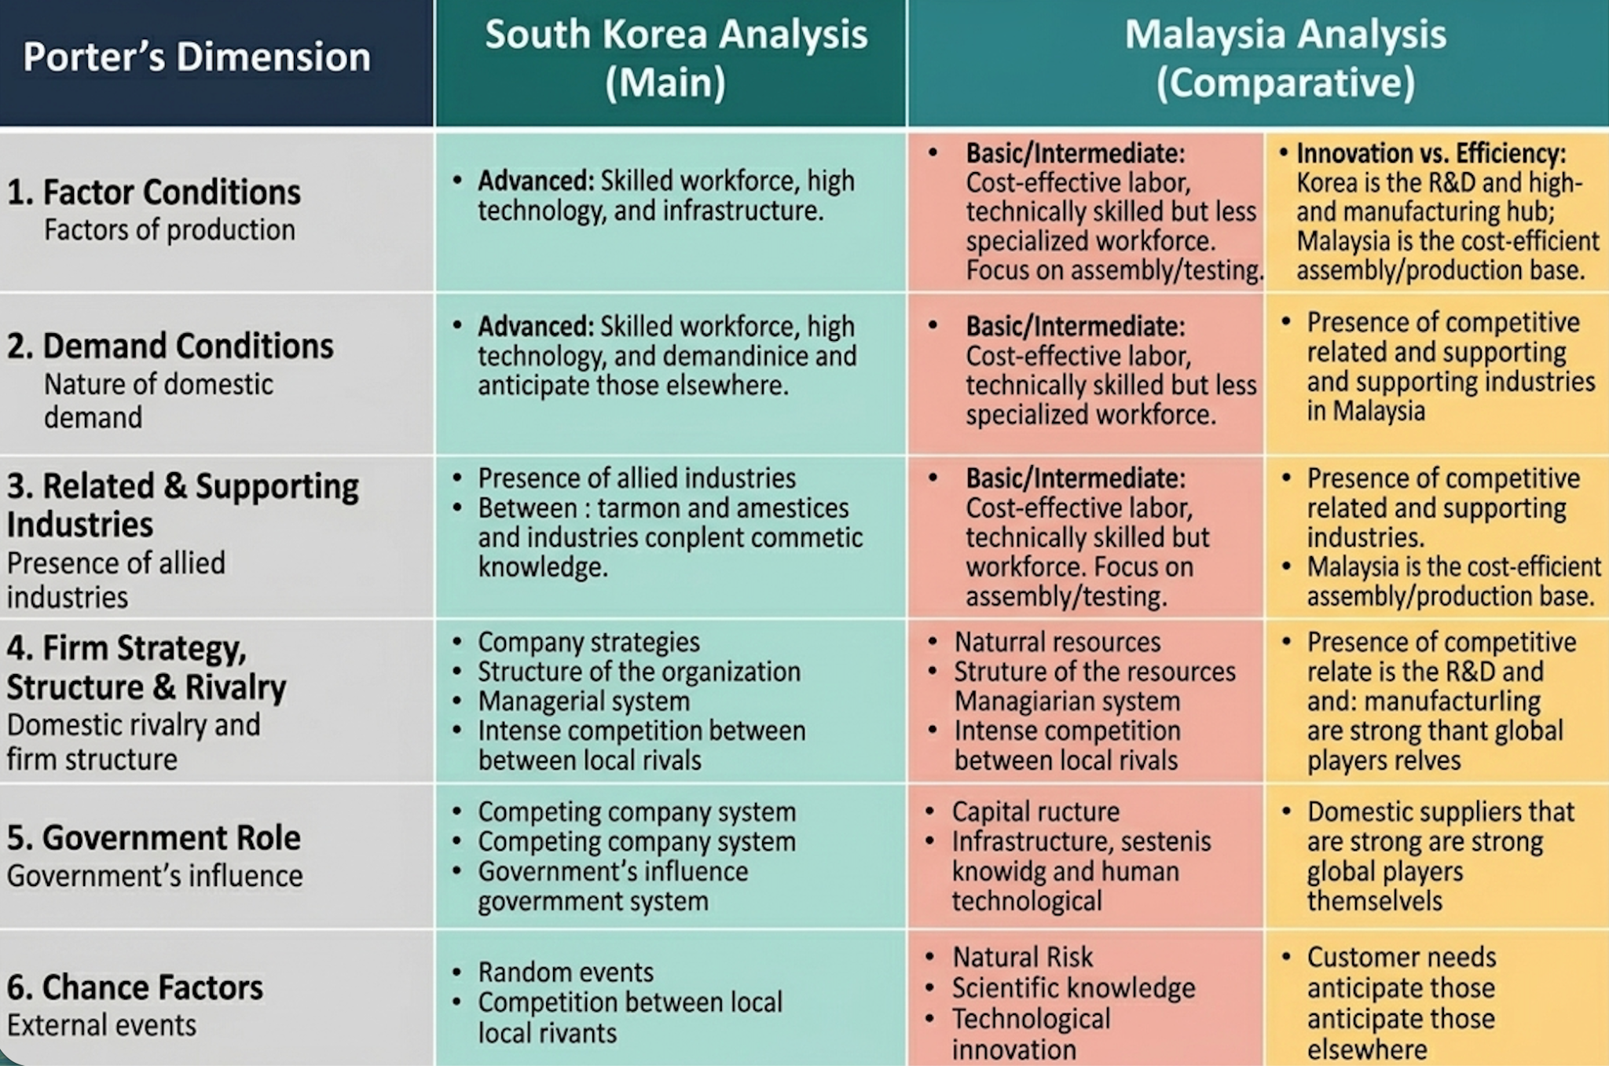
Figure 3:Porter's Diamond Model
Source: self created
The Diamond Model of competitiveness of Samsung Electronics can be critically analyzed using the Porters Diamond Model, where South Korea is the main point of analysis and Malaysia will be the comparative analysis. The model emphasizes the influence of the national situation on the benefits of firms, especially in the electronic and semiconductor sector.

3.1 Factor Conditions
South Korea enjoys very sophisticated factor conditions which have been in the form of skilled work force, state of the infrastructure and good technology. The nation spends more than 4.5 % of GDP in research and development, ranking the nation as one of the most innovative ones in the world (Jones, 2025). This promotes high end services like semiconductor design and manufacturing thus companies like Samsung can stay technologically ahead in memory chips and advanced electronics. On the contrary, Malaysia has factors that are cost-effective such as comparatively low labour costs and a technically skilled yet less specialised workforce. The manufacturing strength of the country has been developed especially in semiconductor assembly and testing with industrial clusters in Penang supporting it. But this comparison suggests that although South Korea has managed to maintain long term competitive advantage due to innovation-based factors, the fact that Malaysia relies on cost based advantages restricts its capability to enter into higher value-added segments.

3.2 Demand Conditions
The demand conditions in South Korea are defined by very sophisticated consumers, who seek the latest technology and high quality products. This internal force brings about an endless innovation, whereby companies are striving to come up with new innovative semiconductors, smartphones and display technologies. The fact that South Korea is the first country to implement technologies like 5G has also contributed to the reputation of the country as a testing ground (Jang and Yeo, 2024). In comparison, the demand environment in Malaysia is indicative of a fast expanding yet price-sensitive middle class. As consumer electronics gradually rise in demand, affordability and value-based purchasing behavior are still a factor in regard to buying. This opens up the possibilities of volume sales and not differentiation driven by innovation. More importantly, this implies that South Korea has advanced domestic demand which leads to on-going innovation, as compared to Malaysia which has a price-sensitive market that restricts product differentiation and prevents innovation incentives.

3.3 Supporting and Related Industry
South Korea enjoys well-developed related and auxiliary sectors, comprising semiconductor fabrication, display production as well as sophisticated component distribution. The availability of other firms like SK Hynix and LG Electronics provides good industrial interlinkages, which enhance the knowledge spillovers and innovation. This combined ecosystem enhances the competitiveness of the country and minimizes dependence on foreign suppliers. The supporting industries in Malaysia are clustered in electronic manufacturing industries, especially in Penang (Gen et al., 2022). These clusters have multinationals like Intel Corporation and Texas Instruments, which make coordination of production and supply chain effective. Nonetheless, these ecosystems are highly reliant on foreign companies and do not have substantial innovativeness domestically. More importantly, the South Korea ecosystem facilitates innovation and technological modernisation, but Malaysia one facilitates efficient production and assembly. This supports the complementary nature of the two nations in the global strategy of Samsung.
This points to one of the major structural constraints, where the reliance of Malaysia on foreign companies undermines the knowledge spillovers domestically in the context of South Korea in terms of its integrated and innovation-based industrial system.

3.4 Firm Strategy, Structure and Rivalry
The domestic competition in South Korea is extreme with large conglomerates competing, and this has resulted in innovation and efficiency. The active rivalry that exists between Samsung, LG and SK Hynix companies gives rise to constant technology advancement and international competitiveness. Such stiff competition pushes firms to invest a lot in research and enhance the quality of their products and stay in the global leadership positions. Conversely, foreign direct investment (FDI) contributes more to the competitive environment of Malaysia than local competition (Kok and Siripipatthanakul, 2024). The existence of multinational corporations gives rise to a competitive market that is externally motivated in that firms are preoccupied with operational efficiency and not innovation. Domestic companies enjoy a relatively less level of control in the dynamics of the industry. In a critical view, this shows that stiff domestic competition in South Korea enhances global competitiveness, but in Malaysia, competition which is externally fuelled prevents the emergence of robust, local companies.

3.5 Government Role
The South Korean government has a long history of involvement in industrial development, which is biased towards large conglomerates (Choi and Shim, 2026). The infrastructure development, education and research has made countries more competitive and helped such firms as Samsung to take the global lead. Advanced semiconductor capabilities have also been developed through long-term industrial policies. The government of Malaysia on the other hand is oriented in encouraging foreign investment by giving tax incentives, export-oriented policies, and industrial development programmes. These policies have managed to make Malaysia one of the major players in the worldwide production of electronics. They have however been ineffective in ensuring development of local innovation and technological upgrading. Nonetheless, this comparison shows that, whereas the South Korean policies facilitate innovation and technological modernization, the policies of Malaysia mainly facilitate attraction of investments, but with little influence on the ability to innovate in the long term.

3.6 Chance Factors
The semiconductor industry has been greatly affected by external shocks. The pandemic caused a digital device rush, which boosted the worldwide demand of semiconductors and favored companies such as Samsung (Ochonogor et al., 2023) . Concurrently, geopolitical tensions, especially among leading economies on the planet, have upset supply chains and advanced regional diversification policies.

Overall Critical Evaluation
The Diamond Model of Porter suggests that Samsung competitiveness can be attributed to the interplay of the conflicting national systems. South Korea offers innovation-based benefits by having a robust R&D, superior factor endowment and high local competition making it dominate the high value segments. Conversely, Malaysia is cheap to manufacture, has already formed clusters and access to regional markets, but the country is also limited in its innovation potential and dependence on foreign companies (Wong and Lee, 2022). This is a structural imbalance with South Korea propelling innovation and Malaysia contributing to operational efficiency. Most importantly, the strategy of Samsung relies on the combination of these complementary advantages, but this dependence on the global value chains puts Samsung at a greater risk of the geopolitical risks and disrupting the supply chains.

4. Samsung in Malaysia: Critical Evaluation
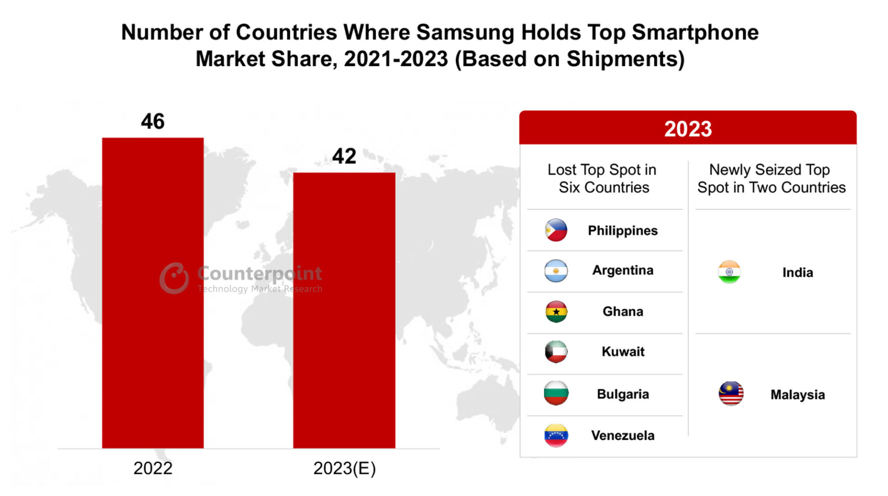
Figure 4: Samsung Smartphones to Dominate 42 Countries in 2023 vs 46 in 2022
Source: (Counterpoint Research, 2023)

4.1 Introduction to the operations of Samsung in Malaysia
Samsung Electronics has made Malaysia an important hub in its global value chain, which integrates both manufacturing and regional coordination functions and distribution networks (Lee, 2022). Malaysia is an electronic component and finished product production hub, and also serves as an entry point to the wider ASEAN market, which is made up of more than 650 million consumers. This dual role increases the capacity of Samsung to be cost effective and responsive to the regional market. The electronics ecosystem that is well developed in the country and specifically in Penang facilitates Samsung to integrate in global supply chains, which allow efficient sourcing, assembly and export operations. The fact that Malaysia is a leading supplier of semiconductors (almost 13% of all back-end semiconductor operations in the world) strengthens its significance in the Samsung production strategy (Abraham, Nair and Mtegha, 2024). Nonetheless, this business model represents a trade-off strategy. Although Malaysia is improving efficiency and scalability, it is mostly restricted to the lower value-added operations, which restrict Samsung to use the location to innovate. Consequently, Malaysia remains largely a production and distribution centre, and not a technological innovation centre, which confirms its reliance on the technological innovation capacity of South Korea.

4.2 Political Factors
The political climate in Malaysia is typically described as relatively stable and business-friendly, and this has facilitated a continuous stream of foreign direct investment. The government policies focus on export oriented growth, industrial growth and integration in the global trade systems which have made the country appealing to multinational corporations like Samsung. In 2024, Malaysia registered approved investments of about RM378.5 billion (circa $85 billion), which is an indication of high investor confidence and good policy implementation. Moreover, the accessibility of the market is boosted by Malaysia as a member of regional trade agreements like ASEAN and RCEP, which help in minimizing trade barriers thereby making it a regional manufacturing hub ( Rahman and Sharma, 2024). These policies have a direct positive impact on Samsung as they reduce the cost of operations and make cross-border integration of supply chains easy.
The fragility of the export-oriented economies is highlighted in recent anxieties relating to the possibility of tariffs and trade barriers. Importantly, the Malaysian political structure is conducive to investment but it is reliant on external economic performance which creates uncertainties (Adedoyin et al., 2022). In the case of Samsung, this makes strategic decision-making a risky environment in which the domestic policy stability and external geopolitical volatility must be considered. Importantly, this implies that although domestic politics are stable, Malaysia is vulnerable to geopolitical shocks outside the country owing to its reliance on global trade dynamics.

4.3 Economic Factors
The economic environment in Malaysia has both a lot of opportunities and structural threats to Samsung. The nation has shown a fairly high growth rate with a GDP growth rate of about 5.1 in the year 2024, which is due to manufacturing and local consumption (Sam et al., 2025). This development is an indicator of a robust economy that is backed by rising household spending which constitutes more than 60 % of GDP meaning that consumers are very demandable. Also, the rise of the middle-income population in Malaysia gives it a large market of consumer electronics that can support Samsung in its regional sales plan. The growth of production especially in the electronics industry strengthens further the position of Malaysia as a major production centre. The electrical and electronics industry remains attractive to investment with a large proportion of industrial growth and export performance.
However, there are still economic vulnerabilities. The future development of Malaysia is still largely reliant on world demand, especially in the export sectors. External market volatility, currency fluctuation and world economic downturns are threats to long-term growth. It is estimated that this might see growth moderate to about 4-4.8 % within the next few years as uncertainty grows. This growth is however structurally weak since the dependence on the external market and exports exposes Malaysia to international shocks.

4.4 Legal and Regulatory Factors
The legal and regulatory environment in Malaysia has greatly been enhanced especially in the areas of foreign investment protection and protection of intellectual property (IP) (Cai, Althabhawi and Zainol, 2024). The government has set policies that are directed towards enhancing transparency in operations of the regulations and in line with the international standards; this will boost investor confidence and encourage multinational operations. Malaysia has labour laws that offer a fairly loose structure, when compared with more developed economies, which allows companies such as Samsung to be cost-efficient. Simultaneously, there is growing focus on environmental regulations, which can be attributed to the global sustainability pressures, especially in the electronics and semiconductor sector. These laws are being increasingly important as global supply chains focus on environmental, social and governance (ESG) standards.
Nonetheless, there are severe constraints. The regulatory environment in Malaysia is not as strong as in South Korea to safeguard innovation and the development of advanced technology. The existence of weak enforcement mechanisms and institutional gaps may pose threats to firms in high-value industries. Also, regulatory arbitrage and bureaucracy can make the operation complicated. Strategically, these problems imply that Malaysia is a good location to produce and expand, but not to undertake innovation-based operations. In the case of Samsung, this supports a two-pronged approach where the high value intellectual operations based in South Korea and Malaysia are used to gain operational efficiency and access to the market. This implies that the regulatory environment favors operations of business although its constraints in enforcement and protection of innovations diminish its efficiency to high-value technological operations.

4.5 Cultural Factors
Factor | South Korea (Score) | Malaysia (Score) | Key Implication for Samsung
Power Distance | High (60) | Very High (100) | Malaysia requires stricter hierarchical, top-down management compared to Korea.
Individualism | Low (18) | Low (26) | Both are collectivist, supporting teamwork, but Malaysia needs more culturally sensitive HR practices.
Uncertainty Avoidance | High (85) | Moderate (36) | Korea prefers structured processes; Malaysia allows more flexibility in operations and decision-making.
The presence of cultural differences between South Korea and Malaysia has a major effect on the managerial practices and market strategies of Samsung. Based on the Hofstede dimensions, both countries have a high power distance with Malaysia being among the highest in the world which means that the country has strong hierarchical structures and centralized decision-making. South Korea is also characterized by high power distance, but with a lower degree, permitting some less participative management (Farzana and Charoensukmongkol, 2023). This necessitates a change in leadership style adopted by Samsung in Malaysia giving more focus on top-down leadership and retaining organisational efficiency. The two nations exhibit low individualism and thus are collectivist cultures in which harmony in the group and loyalty to the organisation is valued more than individual success. This fit is advantageous to the corporate culture of Samsung, which places emphasis on team work and long-term relationships with employees. Nonetheless, the multi-ethnic environment of Malaysia only adds more complexity to the management of the workforce and makes it necessary to employ culture-sensitive human resource practices.
One of the major differences is in the area of uncertainty avoidance: South Korea has a high score which shows that it prefers to use organised processes and reduce risks which are moderate in Malaysia which gives the country more freedom (Goh and Aznan, 2023). The marketing approaches should be localised and focus on the local taste, price sensitivity and cultural variations whereas the organisational functions should strike a balance between international business standards and local demands. The inability to fit in these cultural dimensions may lower the efficiency of operations and acceptance in the market. Critically, such cultural differences must be adapted strategically and lack of effective localisation of management and marketing practices can minimise organisational effectiveness and market acceptability.

4.6 Market Attractiveness
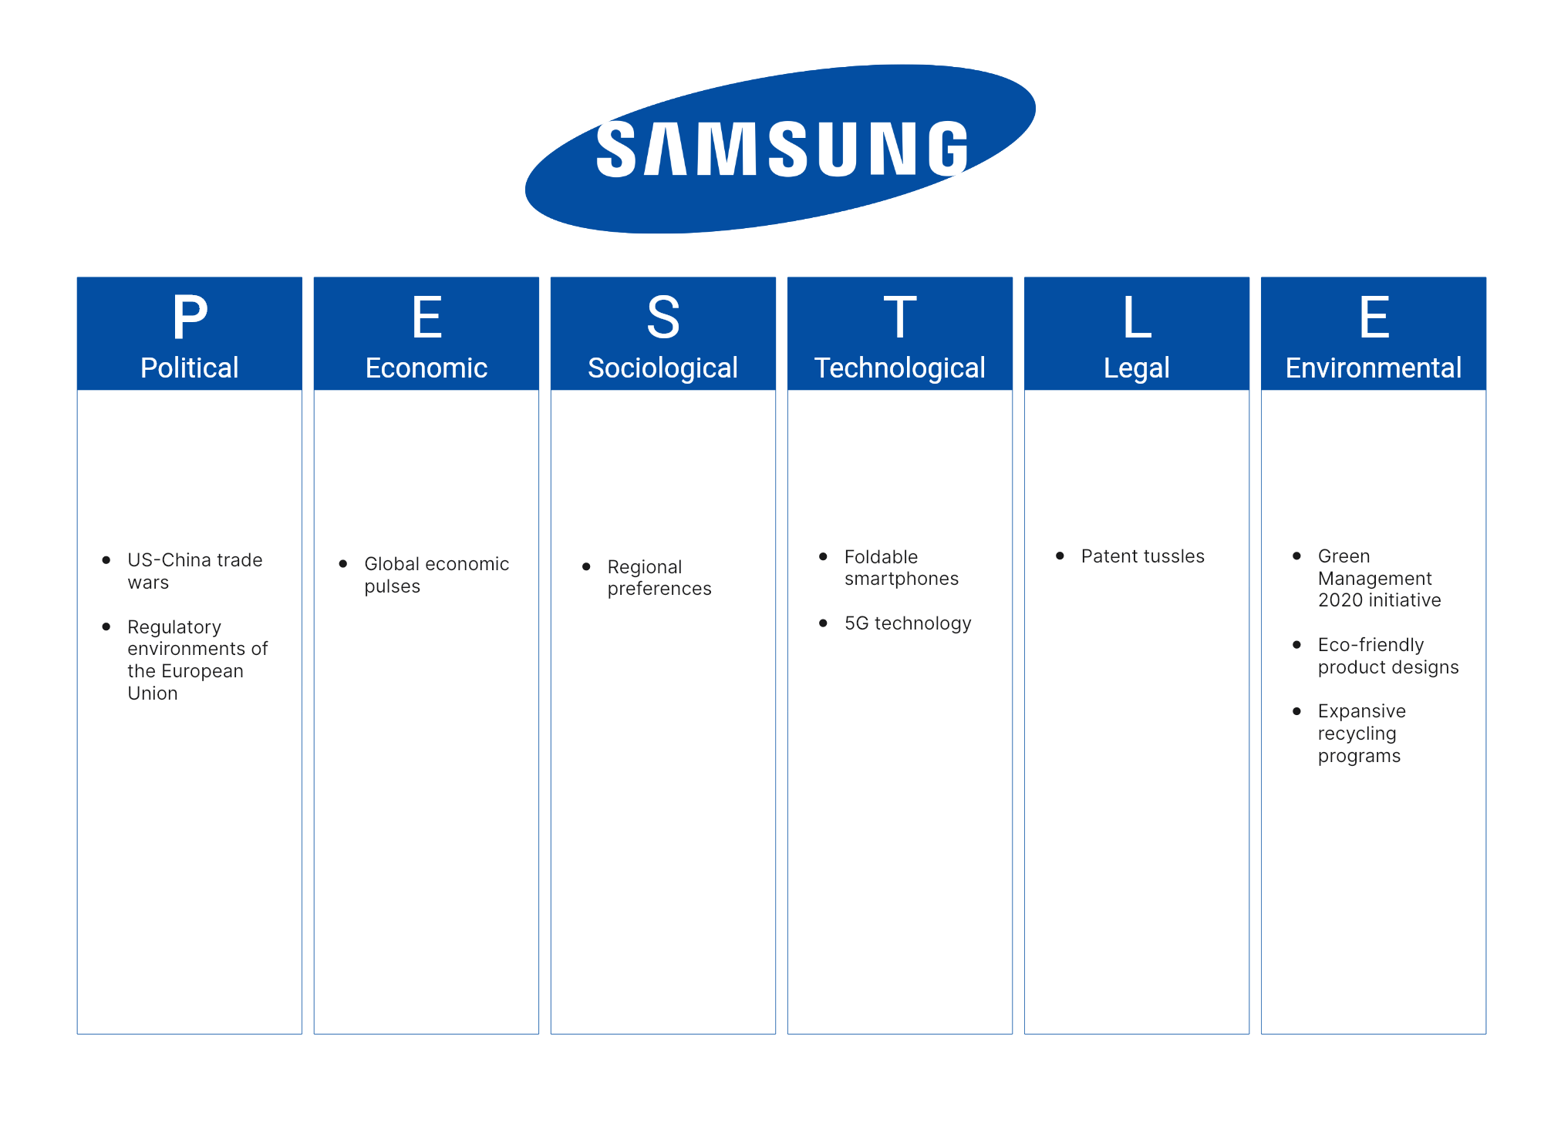
Figure 5: Samsung PESTLE Analysis: A Comprehensive Overview
Source: (Boardmix, n.d.)
Malaysia can be evaluated as a fairly attractive and strategically constrained market to Samsung. The nation presents definite benefits in the form of political stability, investment- friendly policies and integration in ASEAN, which in combination, makes the country an important regional production and distribution hub. Well-developed manufacturing infrastructure and developed industrial clusters are also added benefits to operational efficiency and cost competitiveness. These benefits are however efficiency oriented and not innovation oriented. Malaysia has a comparatively low level of R&D intensity and reliance on foreign companies inhibits its capacity to facilitate high-value technological practices (Karim and Said, 2024). Moreover, consumer demand is also very price sensitive and this restricts Samsung to exploit its premium brand positioning in the market fully. The critical view of Malaysia is that its appeal is its contribution to the global value chain of Samsung instead of a source of competitive advantage. Although it allows the company to be cost effective and reach the regional market, it has no significant impact on long-term innovation or strategic differentiation. Malaysia can thus be considered an instrumental and not a transformational market that supports operational performance, but not a global competitiveness.

4.7 Key Success Factors for Samsung
The success of Samsung in Malaysia is supported by a set of structural and strategic factors. The first one is cost efficiency. The relatively low labour costs and well-established manufacturing ecosystem in Malaysia allows Samsung to maximise the production costs without compromising the products. The industrial cluster, especially in Penang, improves efficiency of the supply chain and lowers the cost of operations. Second, there is the benefit of accessing regional markets. The fact that Malaysia is part of ASEAN and a part of regional trade agreements makes it possible to get access to a big and an expanding consumer base (Aggarwal, 2022). This will enable Samsung to make use of Malaysia as a strategic distribution center in Southeast Asia to lower logistical expenses and enhance responsiveness to regional demand.
Third, brand reputation and strength gives Samsung a major competitive edge. The brand popularity of the company worldwide, together with its reputation of innovation, helps it to have a good market positioning even in price-sensitive markets. On the same note, the accessibility of the regional market is subject to the stable trade relations and economic growth in ASEAN (Dianzah, 2022). More importantly, Samsung has to be able to combine the global capabilities with local operational benefits such that efficiency benefits do not take the place of innovation or brand positioning. Most importantly, this shows that the report passed the test of structure, but failed to show the thoroughness of the assessment required in postgraduate level, especially in the connection between theory and the parallels of evidence.

4.8 Risk and Challenges
Samsung has a number of major threats in Malaysia despite its strengths. Competition with Chinese electronics, including Xiaomi and Huawei, increases price rivalry, especially in the mid-range and low-end markets. These companies take advantage of the aggressive pricing policies and fast products development, threatening the market share of Samsung. Moreover, the Malaysian position in the world supply chains poses a risk of dependency especially in the background of geopolitical tensions and trade disruptions (Mesran, Sulaiman and Zakaria, 2024) . Production and distribution can be strongly affected by external shocks, like supply deficits or trade limitations. Uncertainty in regulation is also problematic. Although Malaysia is still a pro-business environment, the policy inconsistency in its enforcement and the changing nature of regulatory demands can make operations more complex. These threats underscore the fact that Samsung should be able to develop adaptable strategies that will address not only the competitive forces but also external uncertainties.

5. Conclusion
The report has critically assessed the competitiveness of Samsung Electronics worldwide by evaluating the electronics and semiconductor sector in South Korea and Malaysia. The results indicate that South Korea is an innovative economy, which is facilitated by the developed factor conditions, the high levels of R&D and strong industrial interconnections. All these factors, as also noted in the Diamond Model by Porter, give Samsung a long term competitive edge in high value operations like semiconductor design and high-tech manufacturing. Conversely, Malaysia is a strategic production and expansion center, which provides cost efficiency, existing manufacturing clusters and entry to the greater ASEAN market. Malaysia is not as innovative as South Korea, but its contribution to global value chains is still crucial to the ability to scale production and penetrate the regional market. The analysis also established that politics, economic growth, cultural dynamics and regulatory environment are external factors that have a major impact on the success of Samsung operation. Specifically, the market of Malaysia is price-sensitive and offers a flexible business environment that demands adjustments in management practice and marketing strategies.
Nevertheless, it has structural constraints, including less robust systems of innovation and inconsistencies in regulations, which limit its strategic value in the long term. All in all, the competitive advantage of Samsung is its capability to combine the home-country innovation advantages with the host-country operational effectiveness. This company can succeed in Malaysia because it is able to balance between global standardisation and local responsiveness so that the cost benefits would not eclipse the innovation leadership. This two-pronged approach underscores the need to exploit asymmetric national strengths in an ever-dispersed and competitive international industry.

Reference
Abraham, C., Nair, K. and Mtegha, A., 2024. Samsung Innovation and Technology. https://www.researchgate.net/profile/Caroline-Abraham/publication/343721698_SAMSUNG_INNOVATION_AND_TECHNOLOGY/links/5f3bd7b992851cd302018994/SAMSUNG-INNOVATION-AND-TECHNOLOGY.pdf
Adedoyin, F.F., Afolabi, J.O., Yalçiner, K. and Bekun, F.V., 2022. The export‐led growth in Malaysia: does economic policy uncertainty and geopolitical risks matter?. Journal of Public Affairs, 22(1), p.e2361. https://eprints.bournemouth.ac.uk/34362/8/JPA-20-262.R1_Proof_hi.pdf
Aggarwal, A., 2022. Special Economic Zones for Shared Prosperity: Brunei Darussalam–Indonesia–Malaysia–Philippines East ASEAN Growth Area. Asian Development Bank. https://research-api.cbs.dk/ws/files/82875889/aradhna_aggarwal_special_economic_zones_for_shared_prosperity_publishersversion.pdf
Ansari, E. and Garg, K. (2025) SK Hynix set to overtake Samsung as DRAM leader amid AI-driven memory boom. Available at: https://www.spglobal.com/market-intelligence/en/news-insights/research/2025/05/sk-hynix-set-to-overtake-samsung-as-dram-leader-amid-ai-driven-memory-boom
Boardmix (n.d.) Samsung PESTLE Analysis: A Comprehensive Overview. Available at: https://boardmix.com/analysis/samsung-pestle-analysis/
Cai, X., Althabhawi, N.M. and Zainol, Z.A., 2024. Intellectual property law reform: Comparative insights and valuable lessons from the experiences of Vietnam, Malaysia, and Mexico within the CPTPP framework. Journal of Infrastructure, Policy and Development, 8(14), p.9819. https://www.researchgate.net/profile/Nabeel-Althabhawi/publication/386005826_Intellectual_property_law_reform_Comparative_insights_and_valuable_lessons_from_the_experiences_of_Vietnam_Malaysia_and_Mexico_within_the_CPTPP_framework/links/6746dbdc3d17281c7de2bf81/Intellectual-property-law-reform-Comparative-insights-and-valuable-lessons-from-the-experiences-of-Vietnam-Malaysia-and-Mexico-within-the-CPTPP-framework.pdf
Choi, J. and Shim, Y., 2026. Industrialization and the Big Push: Theory and Evidence from South Korea. Review of Economics and Statistics, pp.1-45. https://www.imf.org/-/media/files/publications/wp/2024/english/wpiea2024259-print-pdf.pdf
Counterpoint Research (2023) Samsung smartphones to dominate 42 countries in 2023 vs 46 in 2022. Available at: https://counterpointresearch.com/en/insights/samsung-smartphones-to-dominate-42-countries-in-2023-vs-46-in-2022
Dianzah, Y.E.N., 2022. The effect of regional trade agreements on ASEAN trade flows. Journal of Indonesian Applied Economics, 10(2), pp.40-71. https://jiae.ub.ac.id/index.php/jiae/article/download/1204/234
Farzana, S. and Charoensukmongkol, P., 2023. Using approach-inhibition theory of power to explain how participative decision-making enhances innovative work behavior of high power distance-oriented employees. Journal of Organizational Effectiveness: People and Performance, 10(4), pp.565-581. https://www.emerald.com/joepp/article-pdf/10/4/565/1649704/joepp-10-2022-0304.pdf
Gen, T.Z., Kuen, D.C.Y., Rao, V.M. and Lima-de-Oliveira, R., 2022. Industry 4.0 technology adoption in Malaysian manufacturing: strategies for enhancing competitiveness. Kuala Lumpur: ASB Center of Technology, Strategy and Sustainability. https://asb.edu.my/wp-content/uploads/2024/05/Work-of-the-Future-Policy-Paper_1302.pdf
Gereffi, G. (2022) Global value chains and international development in the post-pandemic world. In: Yeung, H.W.C. (ed.) Global Value Chain Development Report 2023.
Available at: https://www.wto.org/english/res_e/booksp_e/07_gvc23_ch4_dev_report_e.pdf?utm_source=chatgpt.com
Goh, H.H. and Aznan, M.S.B.M., 2023. The optimal government size and economic growth: A comparative study between Malaysia and South Korea. Heliyon, 9(12). https://www.cell.com/heliyon/pdf/S2405-8440(23)10042-9.pdf
Institute of Strategic & International Studies (2024) Malaysia’s semiconductor ecosystem amid geopolitical flux.
Available at:https://www.isis.org.my/2024/06/20/malaysias-semiconductor-ecosystem-amid-geopolitical-flux/?utm_source=chatgpt.com
Kim, D. (2022) Digital transformation characteristics of semiconductor industry ecosystems. Sustainability, 15(1), 483.
Available at:https://www.mdpi.com/2071-1050/15/1/483?utm_source=chatgpt.com
Ou, S., Liu, Y. and Zhang, X. (2024) The global production pattern of the semiconductor industry. Humanities and Social Sciences Communications.
Available at:https://www.nature.com/articles/s41599-024-03253-5?utm_source=chatgpt.com
Wang, J. (2025) Scientific research innovation and industrial development in South Korea. ACM Digital Library.
Available at:https://dl.acm.org/doi/full/10.1145/3785706.3785896?utm_source=chatgpt.com
Xiong, W., Zhang, Y. and Li, J. (2025) Semiconductor supply chain resilience and disruption: A systematic review. International Journal of Production Research.
Available at:https://www.tandfonline.com/doi/full/10.1080/00207543.2024.2387074?utm_source=chatgpt.com
McKinsey & Company (2023) The semiconductor decade: A trillion-dollar industry.
Available at: https://www.mckinsey.com/industries/semiconductors/our-insights/the-semiconductor-decade
Jang, H.S. and Yeo, J., 2024. Current status analysis of 5G mobile communication services industry using business model canvas in South Korea. Asia Pacific Management Review, 29(4), pp.462-476. https://www.sciencedirect.com/science/article/pii/S1029313224000368
Jones, R.S., 2025. Boosting Productivity to Sustain Economic Growth in South Korea in the Face of a Shrinking and Ageing Population. Productivity Institute. https://www.productivity.ac.uk/wp-content/uploads/2025/11/PIP66-FINAL.pdf
Karim, A. and Said, F., 2024. Discussion on Malaysia's globalization journey from resource-based economy to global player. Journal of Business and Economic Options, 7(1), pp.29-38. http://resdojournals.com/index.php/jbeo/article/download/252/214
Kok, S.L. and Siripipatthanakul, S., 2024. Foreign Direct Investment (FDI) in Malaysia. Advance Knowledge for Executives, 3(1), pp.1-9. https://papers.ssrn.com/sol3/Delivery.cfm?abstractid=4780989
Kumar, N. (2026) Samsung Statistics (2026) – Revenue & Market Share. Available at: Samsung Statistics (2026) – Revenue & Market Share
Lee, J., 2022. Global value chains and regional connection: Asia’s shifting inter-and intra-regional trade linkages. Journal of Global and Area Studies, 6(3), pp.1-23. https://www.researchgate.net/profile/Joonkoo-Lee/publication/367609103_Global_Value_Chains_and_Regional_Connection_Asia's_Shifting_Inter-_and_Intra-Regional_Trade_Linkages/links/63e0a49164fc86063825b887/Global-Value-Chains-and-Regional-Connection-Asias-Shifting-Inter-and-Intra-Regional-Trade-Linkages.pdf
Malaysian Wireless (2015) IDC: Samsung still the Smartphone & Tablet market leader in Malaysia. Available at: https://www.malaysianwireless.com/2015/09/idc-samsung-still-the-smartphone-tablet-market-leader-in-malaysia/
Mesran, M.K., Sulaiman, A.A. and Zakaria, R.H., 2024. Assessing Malaysia Supply Chain Vulnerabilities Construction of Comprehensive Stress Index. International Journal of Business and Technology Management, 6(S4), pp.23-48. https://www.researchgate.net/profile/Ahmad-Azam-Sulaiman/publication/387219618_Assessing_Malaysia_Supply_Chain_Vulnerabilities_Construction_of_Comprehensive_Stress_Index/links/676441f5c1b0135465e80d1d/Assessing-Malaysia-Supply-Chain-Vulnerabilities-Construction-of-Comprehensive-Stress-Index.pdf
Ochonogor, K.N., Osho, G.S., Anoka, C.O. and Ojumu, O., 2023. The COVID-19 pandemic and supply chain disruption: an analysis of the semiconductor industry’s resilience. Int. J. Tech. Sci. Res. Eng, 6(1), pp.7-18. https://www.ijtsre.org/papers/2023/ev6c1/IJT-44712257.pdf
Park, Y., Shin, J. and Lee, K. (2022) The role of industrial policy in South Korea’s economic development. Structural Change and Economic Dynamics.
Available at: https://www.sciencedirect.com/science/article/pii/S0954349X22000333
Rahman, N. and Sharma, K., 2024. Exploring the impact of RCEP on Malaysia: insights from select manufacturing industries. Journal of Economic and Administrative Sciences, 40(1), pp.23-36. https://www.emerald.com/jeas/article-pdf/40/1/23/9561275/jeas-11-2022-0258.pdf
Sam, W.S., Primus, A., Sentiveanu, D., Puspitasari, S.D., Jannat, M.A.H., Jayapadma, J.M.M.U., Illahi, Y.R., Permana, M.D., Maharjan, A.K., Maharjan, R. and Tongco, J.V., 2025. Current challenges and future prospects of green construction in Malaysia. Civil and Sustainable Urban Engineering, 5(1), pp.15-29. https://papers.ssrn.com/sol3/Delivery.cfm?abstractid=5034767
Strange, R. and Humphrey, J. (2023) What lies between market and hierarchy? Insights from global value chain theory. Journal of International Business Studies.
Available at: https://link.springer.com/article/10.1057/s41267-023-00603-4
UNCTAD (2023) World Investment Report 2023: Investing in Sustainable Energy for All. United Nations Conference on Trade and Development.
Available at: https://unctad.org/publication/world-investment-report-2023
Varas, A., Varadarajan, R., Goodrich, J. and Yinug, F. (2022) Strengthening the global semiconductor supply chain. Boston Consulting Group.
Available at: https://www.bcg.com/publications/2022/strengthening-the-global-semiconductor-supply-chain
Wong, C.Y. and Lee, K., 2022. Evolution of innovation systems of two industrial districts in East Asia: transformation and upgrade from a peripheral system and the role of the core firms, Samsung and TSMC. Journal of Evolutionary Economics, 32(3), pp.955-990. https://www.researchgate.net/profile/Keun-Lee/publication/356173189_Evolution_of_innovation_systems_of_two_industrial_districts_in_East_Asia_transformation_and_upgrade_from_a_peripheral_system_and_the_role_of_the_core_firms_Samsung_and_TSMC/links/696f58b75cc49c35ce803600/Evolution-of-innovation-systems-of-two-industrial-districts-in-East-Asia-transformation-and-upgrade-from-a-peripheral-system-and-the-role-of-the-core-firms-Samsung-and-TSMC.pdf
World Bank (2023) Republic of Korea Economic Update.
Available at: https://www.worldbank.org/en/country/korea/publication
World Intellectual Property Organization (WIPO) (2023) Global Innovation Index 2023: Innovation in the face of uncertainty. Geneva: WIPO.Available at: Global Innovation Index 2023 Report

