SUSTAINABILITY HOSPITALITY pROJECT

Student Name: Elena Silvia Cazacu
Student Id: 2207618
Module Title: Sustainable Hospitality BMIH4011
Lecture’s Name: Daniel Payne
Word Count: 3000
Table of Contents

Introduction 4
Sustainability in tourism and hospitality 6
Analysis of Sustainability for Rural, Coastal, and Urban Areas 9
Sustainability in Cruises Ships and its impact on the environment and the local people 13
Core Aspects of Sustainability and how it fits within the hotel industry 14
Comparison of the positive and negative impacts on industry 14

Conclusion 17

Refferences 18

Table of Figures

Figure 1: Commitment to Sustainability 4
Figure 2: Sustainability Model for the Tourism Sector 6
Figure 3: Size, Scale and Scope of Hospitality Industry Globally 7
Figure 3: Sustainability Framework 9
Figure 5: Contribution of Travel and Tourism Business in the UK 12

Introduction

Sustainability, in its broader sense, is the capacity to sustain or continue a process over an extended period. Sustainability in business contexts aims to keep natural or physical resources from running out so they can be used for a long time to come. The project focuses on the concept of Sustainability in the hospitality and tourism industry. Hence, the report aims at understanding the concept of Sustainability along with its principles and its impact on the environment and the local people. In addition, the report will also shed light on the analysis of Sustainability for Rural, Coastal, and Urban Areas. Furthermore, the primary aspects of Sustainability and how it fits within the hotel industry and the comparison of the positive and negative impacts on the industry will be discussed thoroughly. However, sustainability is a societal concept; it has become very essential for every organization in every business sector to achieve sustainable practices in the business. For this study, the report will also address the long-term goals, short-term goals, and medium-term goals of the hospitality and tourism sector so that businesses can understand how to deal with uncertainties and disturbances in the business due to ineffective sustainability practices (coursera.org, 2023).

Figure 1: Commitment to Sustainability
(Source: forbes.com, 2023)
Since sustainability itself demands to protect the natural resources, it is the primary responsibility of the business sectors to enhance sustainability. Hence, the report mainly considers the tourism and hospitality sectors to develop insights into how sustainability could be achieved in the sector through the effective use of available resources (gstcouncil.org, 2022). Considering this, the report will also study the various aspects through which sustainability can be maintained in the industry like tourism and hospitality. Also, the significance and importance of sustainability will be studied and addressed in detail way in this report. Therefore, hotel chains will be focused primarily and the transport sector within the hospitality and tourism sector, considering Cruises ships, and the climate and environmental changes those can bring will be as well analysed. Moreover, a separate analysis of the hotel and the Cruise ships industry to understand the negative and positive aspects will be examined.

Sustainability in tourism and hospitality
The concept of sustainability in the tourism and hospitality industry revolves around three major aspects that involve social equity, economic equity, and environmental preservation. Furthermore, these three aspects focus on sub-aspects as an economy based on the local community, integration of economy and environmental factors, and conservation with equity (Yousafet al.,2021). Achieving sustainability in the tourism and hospitality sector requires the industry to take internal business procedures seriously such as recycling, avoiding or reducing environmental degradation and agricultural land use as well as increasing employment by attracting more tourists by focusing on the social aspects of accomplishing sustainability practices in the tourism and hospitality sector (Consiglio et al., 2021). In recent times, sustainability has been an essential aspect in every sector across the globe as it is a measure that eventually boosts overall business performance and develops a certain position for the company in the marketplace. In addition to this, sustainable business practices, especially in the hospitality industry enrich various other opportunities for businesses like increasing cultural and natural attraction of tourists towards tourist destinations, contributing to the economic growth of the country, shaping the employability opportunities for local communities around the development of tourism and hospitality management as well as to establish the environment for tourism and hospitality industry to deal with changing demands, and for every person by thinking about involving sustainable resources in business. Furthermore, to analyse these changing needs of the customers, sustained options are advantageous as it becomes necessary for people to seek help from travel planners or tourism agencies who have good business relationships, collaboration and partnerships with the organisations serving hospitality businesses. Moreover, having sustainable resources, especially in the hospitality business would be a great help for consumers to trust the services they are offering and for the businesses to boost customer engagement. Also, it is an unquestionable fact in the hospitality and tourism industry that worsening the natural resources, biodiversity and environmental factors will only harm human beings more in the future. Thus, by implementing a sustainable business framework, it would be very beneficial for an entirely large hospitality sector to present the world with sustainability and good brand value.
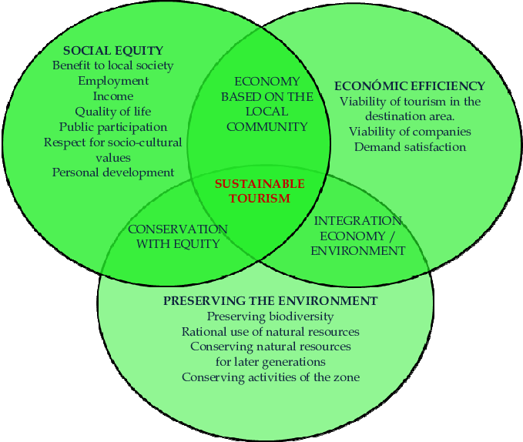
Figure 2: Sustainability Model for the Tourism Sector
(Source: researchgate. net,2012)
Sustainable tourism significantly reflects on practicing sustainability in the tourism and hospitality sector which can also be referred to as the eco-tourism and eco-hospitality. Sustainable tourism includes both positive and negative effects of sustainable practices on tourism and hospitality (statista.com, 2023). The misuse of the landscape for personal use by society, economic leakage as well as the damage provided by the local people to the tourist spots are some of the very serious negative impacts on the sustainable tourism sector. On the contrary parts of it, there are also the positive impacts of sustainable tourism which include employment opportunities, preservation initiatives taken to protect the natural environment and cultural heritages, by environment preservation departments across the globe (linkedin.com, 2023). Further, considering the hospitality industry, rapid innovation is harming sustainable hospitality with the growing transformation and digitalization going on in the sector to enhance customer experience. Thus, it has become extremely important for hospitality businesses to perform environmentally focused and conscious procedures (forbes.com, 2023).

Figure 3: Size, Scale and Scope of Hospitality Industry Globally
(Source: statista.com, 2023)

Analysis of Sustainability for Rural, Coastal, and Urban Areas
The development of sustainability in the Rural, Coastal, and Urban areas specifically focusing on hotels and transportation services like London Transport to carry passengers for Cruises Naval ships may affect the climate and bring changes in the environment, for instance, digitalization (Sakas et al.,2022). Sustainable urban and rural development mostly improves the overall quality of services provided by the tourism and hospitality sectors. Since, the necessary part for the sector is not to harm the natural resources including economic, social, and environmental aspects for their good. In addition to this, the rural and urban as well as coastal development based on sustainable business practices, it is very important to reduce the use of natural assets as well as taking excessive and unwanted local arrears to use them in the future to enhance business performance or to deliver extraordinary experience to the business consumers (Blowfieldand Blowfield, 2013). Furthermore, taking the separate analysis of the hotel and the Cruise ships into consideration, it can be observed that both have negative as well as positive factors regarding sustainable practices in the business. Hence, sustainable development in the cruise is one of the best examples to consider when analysing the sustainability practices in the tourism and hospitality industry which may further involve innovation policies as well (Khatri, 2019).
The cruise shipping sector has been actively working for many years across mainly the coastal regions all over the globe (). However, it is essential to maintain sustainable practices in the naval ships as well if the industry does not want to get significantly affected by the impacts of the industry. The involvement of stakeholders in the business has a positive impact due to the effective management of internal business practices. Thus, it is also important for naval cruise shipping to indulge corporate social responsibility, management, or territory to enhance the business collaboration practices and involvement of stakeholders for accomplishing sustainable business development in the long run. In addition to this, the interaction with the public will have a positive impact on the business to form good connections and eventually, it will result in the handling the issues in the shipping sector regarding supply and demand as well as logistic operations in the business (Abdelmoetyet al.,2022). Therefore, the necessity to achieve sustainability also reflects on effective financing, supply, and demand as well as minimizing the impact of cruising emissions on biodiversity as well. In addition to this, the cruising tourism and hospitality sector eventually affects the climate through many factors like reduction in GHG emissions, and travel risk as it requires conserving the marine lifestyle as well. Hence, through this analysis, it can be observed that sustainable practices need to be smart and get promoted through practising more human-centric approaches like involving behavioural economics, and community tourism which supports passenger shipping operations and efficient internal management as well (sciencedirect.com, 2023).
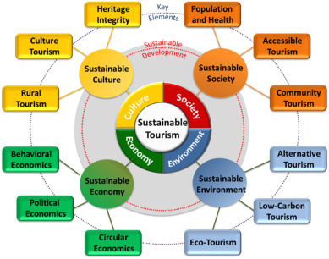
Figure 3: Sustainability Framework
(Source: ScienceDirect.com, 2023)

Henceforth, achieving sustainability in the hospitality and tourism sectors deals with the preservation of not only cultural aspects but also naturally made-up tourist places and attraction spots to draw the attention of tourism enthusiasts and eventually increase the revenue of the businesses that are serving travel and tourism as well as the hospitality industry. Boosting sustainability for the hospitality and tourism sector reflects on practising a harmonious balance between tourists and businesses in the hospitality sector. Also, it is very essential for the companies’ offering services to the travel businesses to work on understanding the basic demands and requirements of the customers so that they would not be disappointed after visiting any destination or tourist attraction. In addition to this, sustainability is also achieved by undertaking the practices to conserve biodiversity and by respecting the opinions of local communities and understanding the perspectives they carry while living around tourist places is extremely important to accomplish sustainable business practices.
Also, the long-term stability and success depend on how sustainable the business is and what ways businesses in the tourism and hospitality industry are using to establish a more sustainable business approach. Moreover, long-term success can be ensured in the tourism and hospitality sector by performing activities like developing sustainable culture, sustainable society, sustainable economy, and sustainable environment altogether. Since these four are the key elements of sustainable tourism, it consists of various other factors like building rural tourism, shaping culture tourism, and building heritage integrity through sustainable culture. In addition to this, the sustainable economy can be developed by considerably focusing on factors behavioural economic, and political aspects and practicing circular economy in hospitality businesses (Rodríguez et al., 2020). Along with this, to form a sustainable society, the approaches are necessary to work on factors like population and health, community tourism and providing accessible tourism to society as well. Furthermore, by protecting the ecological processes, and trying to conserve natural resources, environmental sustainability could be achieved. It also involves alternative tourism, low-carbon tourism, and eco-tourism. Thus, to improve overall business performance, these four stages giving justification to the sustainability framework are necessary to implement and practice to accomplish sustainability in the hospitality and tourism sector.

Sustainability in Cruises Ships and its impact on the environment and the local people
The effective internal management at the Cruises Ships impacts the local people considerably with the specific segment. For instance, considering passenger shipping, many attempts have been made by the shipping industry to deal with the implementation of sustainability in the operations and management policy. However, the coastal regions are most affected by climate change as well as poor sustainability practices, the ocean-based policies are necessary to be more powerful to measure and evaluate their impact on local people, for example, the use of AI-driven practices would make it hard for localities to understand the rapid change (Reier et al.,2021). The naval cruise shipping sector has been consistently attracting the attention of societal aspects because of poor and unsustainable business policies. The reason behind these unsustainable business practices in the shipping industry is due to the uncertain changes in climate as well as increasing supply and demand, the harm to natural resources like biological diversity and ecosystem, excessive emission of greenhouse gas (GHG) for the personal use, and the post-pandemic effects especially reflecting on managing the travel disruptions. In addition to this, a negative impact has been observed at Cruise management due to weak disposal management like poor garbage disposal, grey water issues, waste management considering both poor human and solid waste management as well as the problematic situations caused due to contaminated and oily water, which is very harmful for marine lifestyle, furthermore harmful for public health as well. However, to reduce these impacts, in recent years, Shipping Cruises has taken various measures to deal with climate change and other impacting factors and looking forward to accomplishing sustainability in the sector. Also, according to the leaders and experts of the shipping industry, it is projected that not only ocean-based tourism but also coastal regions will be accomplishing sustainability in business as the local people believe that sector is trying to reduce pollution and perform conservation for the ecosystem and biodiversity by becoming more resilient and is investing in the employment opportunities till the end of 2030 (mdpi.com, 2023).

Core Aspects of Sustainability and how it fits within the hotel industry
The core aspects of Sustainability in the hospitality sector involve preventing the excessive use of natural resources, utilizing green policies to carry business practices forward, and applying green use to logistics, supply and demand, services, maintenance, etc. Thus, achieving a greener future is one of the biggest priorities of the hospitality sector. For example, Hilton has taken the vow to reduce waste by 50% by the year 2030 (forbes.com, 2023). Also, primarily these core aspects of sustainability focus on reducing waste material from the business, electricity conservation as well and practicing the water conservation policies in the business. Since the hospitality sector captures good attention from the primary consumer base of the businesses, it is extremely essential for every organization in the hospitality sector to ensure sustainability policies while they are serving the industry to achieve the common good (Davahliet al., 2020). Hence, the core aspects also involve local people and communities paying more attention towards protecting and suggesting conservative practices for saving the environment and natural resources. Specifically considering the hotel industries, sustainability is extremely important to achieve as this system receives support from almost every existing natural resource and energy to remain operational. Thus, not implementing sustainable practices in the hospitality sector will not only harm natural resources but also affect energy waste by polluting them during the development of the hotel and tourism sector. Therefore, it is one of the very essential aspects for hotel industries to focus on achieving sustainable development (Abdou et al., 2020).

Comparison of the positive and negative impacts on the industry
To compare the positive and negative impacts of Sustainability or Unsustainable business practices for the tourism and hospitality sector, the most affected aspect is the local people. Since the governmental factors keep on changing for both of these sectors, it becomes difficult for the localities to deal with these changes and accept them which is a negative impact (Ho et al.,2021), one of the primary reasons behind this inconvenience that local people feel is their dependency on these businesses as employment opportunities specifically in the hospitality sector positive impact on the hospitality industry, for example, employability at the Marriott Hotel chain across the globe (Aronsson, 2000).
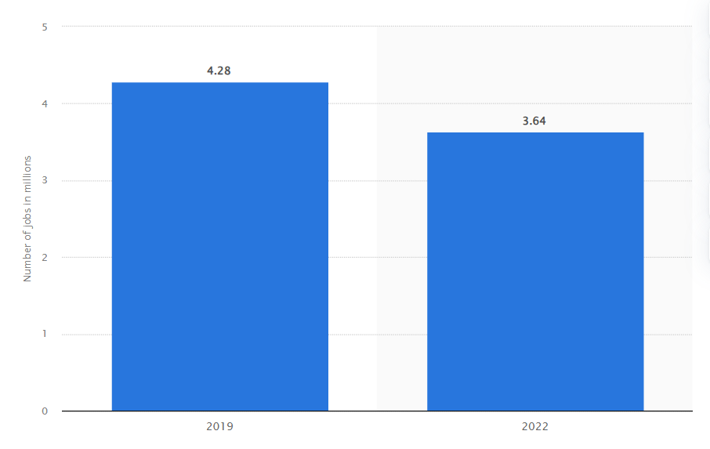
Figure 5: Contribution of Travel and Tourism Business to employment in the UK
(Source: Statista.com, 2023)
On the other hand, the most negative impact of the tourism industry involves the use of agricultural land as well as the degradation of land, harming natural resources like using fossil fuels, minerals, deforestation, and so on (Goodwin, 2011). Whereas, the positive impacts focus on the support by the government to tourism promotions, employment options for local people, improved and enhanced transportation services as well as the generation of policies like tourists’ welfare, etc (Edehet al., 2022). As positives, sustainability in hospitality has been associated with many advantages such as adhering to sustainability standards and regulations, green certifications or improving business position and reaching the target group of the audience, for instance, the youth and travel bloggers or travel planners to engage them in business, responding to the frequently changing climatic conditions and the crisis happening due to them alongside improving the brand value of the company.
The initiatives taken by hospitality and tourism also encourage the hospitality businesses towards the implementation of incentives, such as support from the government to boost savings related to costs and funds. In addition to this, the incorporation of sustainability in business operations especially for those working in hospitality requires working on inspiring the company employees and helping them excel in their careers as well through practising open and effective communication (Suliman et al., 2023). Moreover, sustainable development in hospitality is also helpful for the employee workforce to set very precise and clear goals, developing positive approaches and teamwork on them as well. Thereafter, employees become open to building mindfulness and pursue creating ideas in them. Furthermore, the accomplishment of sustainability in the hospitality and tourism sector also tends to adapt multiple other practices, like the execution of smart thermostat technology, and practising recycling operations in hostels, giving opportunities for the local food stores as well. Most importantly, sustainability in this sector has the potential to offer free and easily available access to bicycles so that the customer experience can be enhanced and the reduction in environmental impact can also be achieved successfully.
On the other hand, considering the negatives, the biggest challenge for the hospitality industry is the drastically changing trends due to the contemporary business practices that are getting carried forward following sustainability. Considering this, the negatives are specifically seen in the elimination of the plastic material the one with single-use policy, to create paperless or net zero in using paper from the environment (Khatter, 2023), sourcing from the sustainable providers, to purchase net zero cleaning supplies. Also, designing and taking initiatives for the implementation of recycling programs is a challenging task for the hospitality sector. Furthermore, since, many people travel every day, it affects the frequency of hotel service availability and eventually lowers the customer experience as the options are not environmentally friendly due to a lack of sustainability options in businesses. Considering this, it becomes risky for the hospitality and tourism industry to demonstrate and establish the commitment to achieve net zero in green environment policies to improve brand image and attract more tourists.

Conclusion
In the conclusion part of the report, sustainability and its impact on the environment and the local people is primarily addressed. In addition, the report has performed a detailed analysis of Sustainability for Rural, Coastal, and Urban Areas. Furthermore, the primary aspects of Sustainability and how it fits within the hotel industry are studied with the comparison of the positive and negative impacts on the industry as well. In addition, sustainable practices stimulate a social responsibility by supporting local economies, preservation of cultural heritage, encourages community engagement so to fully realize the benefits of sustainability ,it is essential for the businesses, tourism, hospitality and cruise ships industry to combine, integrate, sustainable principles into their core strategies, to invest in progressive technologies, to improve operational efficiency practices, collaborations with the community citizens, investors, shareholders, adhere to legislatives requirements, to promote sustainable development. In simpler terms, by working together towards a more sustainable future while safeguarding the population, the Natural World, ecosystem, furthermore, the environment for generations to come.

References
Aragon-Correa, J.A., Martin-Tapia, I. and de la Torre-Ruiz, J. (2015) “Sustainability issues and hospitality and tourism firms’ strategies: Analytical review and future directions,” International journal of contemporary hospitality management, 27(3), pp. 498–522. Available at: https://doi.org/10.1108/IJCHM-11-2014-0564. [Accessed on: 12 March,2024]
Abdou, A.H., Hassan, T.H. and El Dief, M.M., (2020). A description of green hotel practices and their role in achieving sustainable development. Sustainability, 12(22), p.9624.
Blowfield, M. and Blowfield, M., (2013). Business and sustainability. Oxford University Press.
coursera.org, (2023) [Online] Available at: https://www.coursera.org/articles/what-is-sustainability [Accessed on: 8 February,2024]
Daniel, P. (2024) Formal class lecture – Sustainable Hospitality BMIH4011.The growth of Cruise Tourism -Economic, Cultural and Environmental Impacts. University of Wales Trinity Saint David, Wales. 13 February ,2024.
Davahli, M.R., Karwowski, W., Sonmez, S. and Apostolopoulos, Y., (2020). The hospitality industry in the face of the COVID-19 pandemic: Current topics and research methods. International Journal of Environmental Research and Public Health, 17(20), p.7366.
forbes.com, (2023) [Online] Available at: https://www.forbes.com/sites/lbsbusinessstrategyreview/2023/05/30/how-business-ecosystems-can-drive-sustainable-tourism/?sh=a22c88b2c95b. [Accessed on: 24 February ,2024]
forbes.com, (2023) [Online] Available at: https://www.forbes.com/sites/forbesbusinesscouncil/2022/09/29/implementing-sustainability-into-the-hospitality-industry/?sh=322e7f06c302. [Accessed on: 24 February ,2024]
forbes.com, (2023) [Online] Available at: https://www.forbes.com/sites/michellemartin/2019/09/27/sustainable-tourism-needs-to-be-the-new-normal-heres-why/?sh=5113670b4310. [Accessed on: 24 February ,2024]
Goodwin, H., (2011). Taking responsibility for tourism (pp. 1-256). Woodeaton: Goodfellow Publishers Limited.
gstcouncil.org, (2022) [Online] Available at: https://www.gstcouncil.org/what-is-sustainable-tourism/#:~:text=Negative%20impacts%20to%20a%20destination,preservation%20landscape%20restoration%2C%20and%20more. [Accessed on: 24 February 2024]
Ho, C.Y., Tsai, B.H., Chen, C.S. and Lu, M.T., (2021). Exploring green marketing orientations toward sustainability in the hospitality industry in the COVID-19 pandemic. Sustainability, 13(8), p.4348.
Khatri, I., (2019). Information technology in tourism & hospitality industry: A review of ten years’ publications. Journal of Tourism and Hospitality Education, 9, pp.74-87.
Khatter, A., (2023). Challenges and Solutions for Environmental Sustainability in the Hospitality Sector. Sustainability, 15(15), p.11491.
Legrand, W., Chen, J.S. and Laeis, G.C.M. (2023) Sustainability in the hospitality industry: principles of sustainable operations. Fourth edition. London; Routledge.
linkedin.com, (2023) [Online] Available at: https://www.linkedin.com/pulse/organizational-culture-hospitality-shehan-rajith-liyandara-1c [Accessed on: 8 March ,2024]
mdpi.com, (2023) [Online] Available at: https://www.mdpi.com/journal/sustainability/sections/urban_and_rural_development. [Accessed on 12 March 2024]
researchgate.net, (2012) [Online] Available at: https://www.researchgate.net/figure/Sustainable-Tourism-Model-Source-Sanagustin-Fons-MV-Mosene-Fierro-JA-Gomez-y_fig2_221925572 [Accessed on: 8 March ,2024]
Rodríguez, C., Florido, C. and Jacob, M., (2020). Circular economy contributions to the tourism sector: A critical literature review. Sustainability, 12(11), p.4338.
Sakas, D.P., Reklitis, D.P., Terzi, M.C. and Vassilakis, C., (2022). Multichannel digital marketing optimizations through Big Data Analytics in the tourism and Hospitality Industry. Journal of Theoretical and Applied Electronic Commerce Research, 17(4), pp.1383-1408.
sciencedirect.com, (2023) [Online] Available at: https://www.sciencedirect.com/science/article/abs/pii/S004896971831194X. [Accessed on 8 March 2024]
statista.com, (2023) Market size of the hotel and resort industry worldwide from 2013 to 2022, with a forecast for 2023 [Online] Available at: https://www.statista.com/statistics/1186201/hotel-and-resort-industry-market-size-global/ [Accessed on: 24 February 2024]
Robina-Ramírez, R., Medina-Merodio, J.A. and Estriegana, R. (2022) “What do urban and rural hotel managers say about the future of hotels after COVID-19? The new meaning of safety experiences,” Cities, 120, pp. 103492–103492. Available at: https://doi.org/10.1016/j.cities.2021.103492.[Accessed on 15 March 2024]

Suliman, M.A., Abdou, A.H., Ibrahim, M.F., Al-Khaldy, D.A.W., Anas, A.M., Alrefae, W.M.M. and Salama, W., (2023). Impact of Green Transformational Leadership on Employees' Environmental Performance in the Hotel Industry Context: Does Green Work Engagement Matter? Sustainability, 15(3), p.2690.
Tomej, K. and Liburd, J.J. (2020) “Sustainable accessibility in rural destinations: a public transport network approach,” Journal of sustainable tourism, 28(2), pp. 222–239. Available at: https://doi.org/10.1080/09669582.2019.1607359. [Accessed on 15 March 2024]

Yousaf, Z., Radulescu, M., Sinisi, C.I., Serbanescu, L. and Paunescu, L.M., (2021). Harmonization of green motives and green business strategies towards sustainable development of hospitality and tourism industry: Green environmental policies. Sustainability, 13(12), p.6592.
Wu, X., Chen, H. and Min, J. (2021) “Sustainability assessment of cruise-industry development: a case study of Xiamen, China,” Maritime policy and management, 48(2), pp. 213–224. Available at: https://doi.org/10.1080/03088839.2020.1773557. [Accessed on 15 March 2024]

