WHY IS DIGITAL TECHNOLOGY IMPORTANT WHEN WORKING WITH PEOPLE?

Programme: Certificate of Higher Education Skills for the Workplace
Module: Digital Skills and Research Methods
Student’s ID: 2110984

Word Count: 2378

Contents
Introduction 3
An overview of the types of digital technology used in the workplace 3
How has Covid-19 increased the use of technology in the workplace? 5
What are the benefits of using digital technology? 7
Conclusion 10
References 12

Introduction
Using Digital Technology became essential when working with people within an organisation or a group. It became the norm for many workplaces so considering the importance of digital technology needed to be discussed. Since the rise of Covid-19, the majority of the workforce has adopted digital technology to increase productivity and sustainability. In fact, during the high time of lockdown the average number of people invested in digital technology to adopt a flexible working system. The rise of using digital technology undoubtedly increased effective communication more easily and most simply with such a challenging time. This particular report would shed light on the overview of the different types of digital technology that have been used in the workplace. Besides that, the report would discuss how the rise of pandemics increased technology use in the workplace. The benefits of using digital technology along with its disadvantages would also be identified and discussed in this report. The DIKW model and CRAAP framework have been used to define and explain different types of data and information in this report.

An overview of the types of digital technology used in the workplace
There are different digital technologies used in the workplace in the present world of digitisation. Digital technology is used in multiple aspects of an organisation. These aspects are collaborative and social tools, communication tools, cloud storage, documentation sharing and organising, knowledge and content management system, cyber security, data analytics and corporate intranet platforms (Iivari et al., 2020). A visualised form of traditional office environment where many elements of productivity and collaboration are performed by some combination of digital applications, various artificial technology and cloud computing are defined as a digital workplace. With the help of technology, the business works efficiently. The employees and managers can easily supervise all the activities that are performed in the workplace by tracking everything with technology. The productivity and working experience will enhance with the digitisation of the workplace. The most widely used technologies that are helping to change the workplace are Cloud Computing, Artificial intelligence and mobile-friendly solutions (Parker and Grote, 2020). To centralise the work platform and information the strategy of the digital workplace has been adapted. Technology provides security to all confidential data and huge data storage. Cloud computation helps to store data in a safe place and gives access to the required people. The users of cloud computing get access to stored data, servers, and files through their internet-connected devices such as smartphones, computers, laptops and tablets. Microsoft Azure, Amazon Web services, Google Cloud, IBM Cloud, Cloud Linux, AWS etc. are examples of cloud computing services. With the help of cloud computing, data can be accessed from remote servers. Artificial Intelligence (AI) performs human-like tasks without any errors. Personalised recommendations to people are widely provided by AI (Hobbs and Coiro, 2019). The technology helps to complete the task before the deadline without any errors. The technology helps to improve the employees' productivity in the workplace. The staff can focus on their impactful work, creative solutions and complex problem solving. Some AI devices help to get a superior experience such as Google's assistant, Amazon Alexa, Apple's Siri and Microsoft Cortana. The technology added a new opportunity to the roles of many staff in different workplaces. The latest AI technologies that are widely used in the workplaces are Biometrics, Robotic process automation, Virtual agents, Natural language generation, Machine learning, Deep learning digital platforms and peer-to-peer network (Savić, 2020). Machine learning, automation and AI help to enhance the progress and efficiency of the business.

How has Covid-19 increased the use of technology in the workplace?
The rise of covid-19 suddenly impacted the working system of the whole world and it has elevated the role of digital technology in the workplace. The use of technology in the workplace became essential for the employees as they relied on machine learning, Artificial Intelligence and virtual reality to save the limit in personal contact and money (Hollister et al., 2021). With the rise of pandemic impact on the working system therefore the technology has become an effective tool to be adopted by the organisations. The technology became effective for managing teams, hiring, assessing employees' performance, training, and creating meaningful interactions easily even in the time of isolation. The employers also ensured that technology use in the workplace does not ruin the employment and labour laws. Focusing on the knowledge management regarding evaluating information about the use of digital technology in the workplace during Covid the DIKW model has been used. The pyramid of DIKW delivered curated, collected and contextualized data regarding the topic to the data scientist and provided proper information.
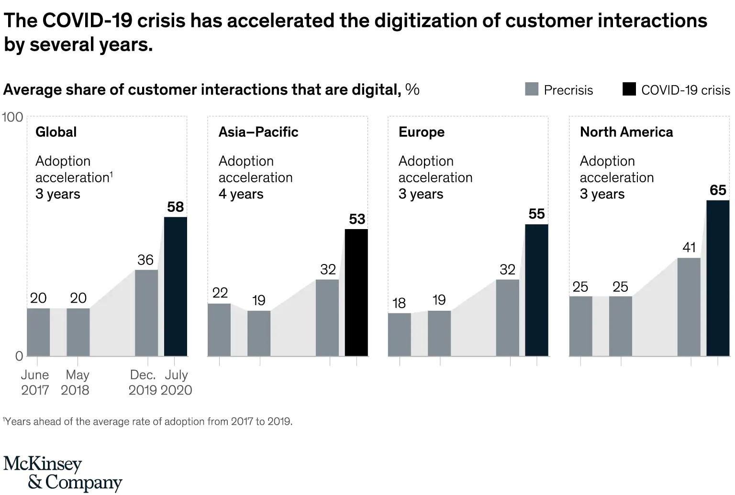
Figure 1: Use of Digital Technology in customer interaction
(Source: Hollister et al., 2021)
There was a huge challenge of innovation to make the home more effective for working during Covid. The big drawback of video calls along with interactions with the customers and the other stay holders of the organisation became challenging (Holmström, 2018). Therefore, the use of technology became, more importantly, essential to cope with the challenges and maintain the productivity of the organisation. Going forward to the other discussion Technology became increasingly beneficial for ensuring the health and safety of the workers. Following the virtual format, the meetings and conferences are shifted in this process. The companies adopted new ways with the help of digital technology to improve employee engagement and motivation.
Adopting automation solved the crucial problems immediately for which the firm might be struggling during the pandemic. The restrictions that are Covid based raised the demand and use of contactless technology in the workplace that can effectively monitor all the activities within a short period with zero error. The working process became easier, and error-free and saved time motivated the workers to easily balance work and life. Before adopting Technology, the organisation used the traditional way of human support to monitor its performance (Hobbs and Coiro, 2019). While the Covid has taken place the maximum, number of organisations adopted online monitoring tools to track the activities and performance of the employees. The organisation also utilised online service asking the customers regarding their preferences and feedback. Moreover, Technology provided huge support to organisations to maintain productivity in the workplace and continue their operations even in a pandemic situation.

What are the benefits of using digital technology?
Using Digital technology became the core strategy to improve work productivity and experiences. The benefits of using digital technology are as follows,
1. Increased Flexibility
Using digital technology, the employees became motivated due to the increase in flexibility in the work environment and schedule (Savić, 2020). With the help of effective digital tools the employees can be connected anywhere and can effectively manage the work-life balance with their personal lives.
2. Improved Productivity and Efficiency
From the data that has been gathered using the CRAAP framework, it has been identified that the community calendars and Google Docs effectively increased collaboration in the workplace. Apart from these tools, the other digital technologies effectively streamline the process of work collaboration by allowing the employees to work together in less time. It has improved efficiency and productivity (Soto-Acosta, 2020). Moreover, the use of digital technology effectively improved efficiency and productivity in the workplace.
3. Enhanced Communication and Innovation
Digital technology allowed the workplace free-flowing Idea exchanges among the employees of the organisation. Using different social intranets encouraged the employees to share their ideas at different levels of the organisation using effective communication tools. The CRAAP framework also identified that the interactive service insured twin hands the expression of ideas and opinions in the workplace that has improved Innovation.
4. Increased Revenue
By utilising digital technology, the organisation has successfully reduced the operating cost and increased productivity. It has ultimately resulted in an increase in revenue for the organisation even in this situation (Gobble, 2018). It has been identified from the survey of the pyramid of DIKW that around 43% of the revenue of the different organisations has been enhanced through using digital technology.
5. Reduced Operational Costs
Using digital technology the organization has successfully managed the virtual meetings and the interactions with the employees. The organisation therefore successfully reduced the cost of individual collaboration in the workplace, which has also saved the time, and cost of travel, office premises, furniture and electricity. The organisations also used a large IT team, SaaS platform and other communication tools that became effective to manage the team and save time.
6. Heightened Employee Experience and Performance
Using effective digital tools for the collaboration purpose like social profiles, employee directories, and activity feeds allowed effective communication and connection with individuals. It has created a strong professional bond, promoted teamwork, and enhanced performance in the workplace (Gobble, 2018). Moreover, it has improved the productivity and performance growth of the organisations.
What are the disadvantages of using digital technology?
The use of digital technology in the workplace became very much essential even after the rise of the pandemic. The benefits of using digital technology have been discussed above. However, the digital technology use comes with different disadvantages that are,
1. Data Security
Using digital technology means various sensitive information and data are being collected and updated in the storage device. This can be private, sensitive and concerning with essential assets organisations (van Laar et al., 2019). Therefore, it is challenging to keep the information safe. Breaching the information might create various challenges that might be going into the hands of a terrorist, criminals, business rivals, malign entities or foreign adversaries.
2. Complexity
The individual departments of the organisation interact regularly using digital technology. A mechanical process involves various tactics and skills. It might create complications and complicated settings that might be challenging for some users due to its complex nature. It might create complexity and affect the performance.
3. Social Disconnect
Digital technology undoubtedly improved workplace management. However, the intensive socialization and communicating face to face disconnect throughout the way. It became a sense of isolation and disconnection from social life (Love and Matthews, 2019). The social life of human beings is affected by the increasing use of digital technology in the workplace and it affects the connection and relation of the individuals in different departments. Lack of real-life contact caused mental illness, hypertension, and anxiety depression in this among the employees.
4. Job loss – Low value of human workers
The features of Technological advancement in the workplace replaced the job of human beings and caused the rise of unemployment. Using robots and machines replaced human work. The automated process and machines are used by the organisations to improve their production, efficiency and productivity (Hamann, 2021). However, it indirectly minimised the value of human resources.
5. Thrive of Cybercrime
According to the FBI report, 781,700 complaints registered by different organisations worldwide related to internet crime by 2020- 2021. This is the biggest downside of using digital technology. Cybercrime includes hacking of sensitive information of the organisation, customer data, employee data and other important information. This will ruin the financial reputation of the organisations.

Conclusion
From the above discussion regarding the use of digital technology and its importance while working with people in an organisation it can be stated that the rise of Covid-19 introduced huge changes in working patterns. In the new type of working pattern, the importance of digital technology is endless. The discussion evaluated different types of digital technology that have been used in the workplace. Modern technologies like artificial intelligence, virtual assistants, machine learning, information technology, virtual reality and many more improved the efficiency and productivity of the workplace. The employers also ensured that technology use in the workplace does not ruin the employment and labour laws. However, the technological use in the workplace increased during Covid discussed thoroughly throughout this report. The report has also identified very many benefits of using digital technology. Undoubtedly technological advancement improved higher productivity, efficiency, innovation, creativity and performance in the workplace. However, technological advancement comes with various disadvantages. The disadvantages of using digital technology in the workplace pinpointing various areas with effective evaluation mentioned in this report.

References
Gobble, M.M., (2018). Digital strategy and digital transformation. Research-Technology Management, 61(5), pp.66-71.
Greenway, A., Terrett, B. and Bracken, M., (2021). Digital transformation at scale: Why the strategy is delivery. Do Sustainability.
Hamann, T.K., (2021). Values Versus Technology? Why We Need to Consider a New Foundation for Work. In Managing Work in the Digital Economy (pp. 111-135). Springer, Cham.
Hobbs, R. and Coiro, J., (2019). Design features of a professional development program in digital literacy. Journal of Adolescent & Adult Literacy, 62(4), pp.401-409.
Hollister, R., Tecosky, K., Watkins, M. and Wolpert, C., (2021). Why Every Executive Should Be Focusing on Culture Change Now. MIT Sloan Management Review, 63(1), pp.1-6.
Holmström, J., (2018). Recombination in digital innovation: Challenges, opportunities, and the importance of a theoretical framework. Information and organization, 28(2), pp.107-110.
Iivari, N., Sharma, S. and Ventä-Olkkonen, L., (2020). Digital transformation of everyday life–How COVID-19 pandemic transformed the basic education of the young generation and why information management research should care?. International Journal of Information Management, 55, p.102183.
Love, P.E. and Matthews, J., (2019). The ‘how’of benefits management for digital technology: From engineering to asset management. Automation in Construction, 107, p.102930.
Parker, S.K. and Grote, G., (2020). Automation, algorithms, and beyond: Why work design matters more than ever in a digital world. Applied Psychology.
Savić, D., (2020). COVID-19 and work from home: Digital transformation of the workforce. Grey Journal (TGJ), 16(2), pp.101-104.
Soto-Acosta, P., (2020). COVID-19 pandemic: Shifting digital transformation to a high-speed gear. Information Systems Management, 37(4), pp.260-266.
van Laar, E., van Deursen, A.J., van Dijk, J.A. and de Haan, J., (2019). Determinants of 21st-century digital skills: A large-scale survey among working professionals. Computers in human behavior, 100, pp.93-104.

