Learning and Development Blog
Author: Eve Churchward Dated: 2nd October 2024.

Be an Upstander not a bystander and motivation to learn.
This training was developed by The College of Policing and has been rolled out as mandatory training for every person employed in the Police Service. The training is being delivered initially to Police Officers followed by Police staff over the whole organisation.
The course aims to tackle cultural issues within the police environment and provides a toolkit for officers and staff to be confident in reporting inappropriate behaviour in the workplace.
I was given the ‘train the trainer’ training in July and asked to deliver the package with other Police trainers to Police officers for their training days. The force training days are notoriously difficult to deliver training as they take up one of the Police Officers’ rest days therefore the officers are not happy when attending these sessions and would rather have their time off. My team and I raised their concerns regarding delivering this content during that time as it would be difficult to get learner engagement and it would lose the impact that is required for such a sensitive subject.
The issue of police culture has been a hot topic in the media in recent years which is now being addressed through this training package amongst other projects. It involves discussing examples of when inappropriate behaviour has happened either to themselves or they have witnessed such behaviour and maybe not felt confident to report it.
The first time I delivered this training was to a group of 20 Police officers including 2 Sergeants. I anticipated that this was going to be a tough session due to it being a force training day and because of the content of the lesson. I began by introducing myself and asking each officer to introduce themselves, so they felt at ease knowing who was in the room. The introductions gave me information that some of the officers had long service and some with only 3 years’ service. This helped me pitch the tone of the training and draw on the differences between culture of then and now and how it has vastly improved. I continued with discussion questions but quickly realised that the group were remaining silent and were reluctant to engage. It was evident that although adult learners learn by andragogy, they should be motivated to learn for several reasons and can draw on person life experience, however it wasn’t the case for this session.
Maslow’s hierarchy of needs underlies the motivation for human behaviour as explain that:
If a student is tired, cold, and hungry, then the quality of learning will be reduced. The student who feels threatened in the learning situation is unlikely to learn effectively. Our task as teachers is to create an environment where students feel part of a group and feel that their contribution has worth.
(Reece and Walker, 2007, p.87)

The difficulty with this training is that those factors won’t apply here as the officers’ basic needs are met, the group environment was created, however they will not feel that their contribution would be worth it as they believe whatever they say, it won’t be listened to by senior management as this has been proven in the past. So, no matter how comfortable they are, they will not open up about their experiences as they fear repercussions for their career.
The officers are told to attend the training as it is a mandatory requirement, but there is nothing to motivate them to engage with the session.

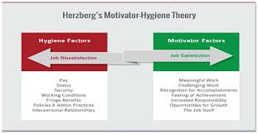
Hertzberg 2 factor theory of motivation identifies further motivational factors for adult learners including meaningful work, recognition, accomplishment, and opportunity for growth.

(Google stock images)
The Hertzberg theory identifies opportunity for growth so I used this as a motivation to encourage engagement with the training, explaining that the learners can use this training as an example in their promotional interviews and Personal Development Review (PDR) as they now have the toolkit and knowledge to assist them if an issue of inappropriate behaviour is reported to them. They can use personal examples and show the promotional board how they applied the toolkit, explained the reporting mechanisms, and provided support whilst doing so.
Adaptability is a key skill for trainers, and I realised that the session was not going well with learner engagement, therefore using Schon’s reflection-in-action theory I observed and reflected in the moment and acted immediately to improve their motivation and engagement.
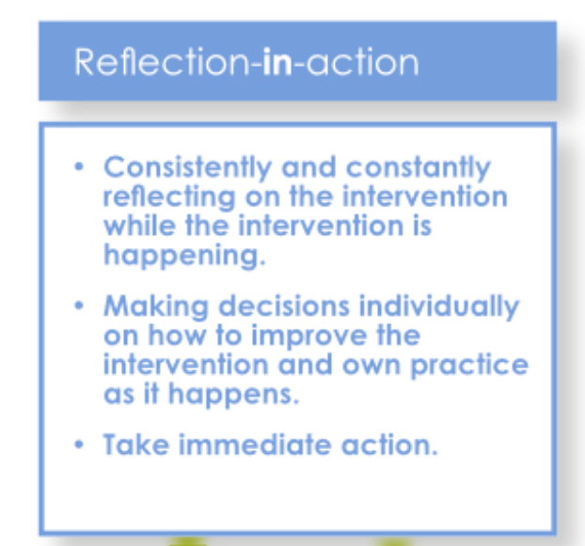
Schön - Reflection in action/on action - Marcr
I decided to use my personal experience of witnessing inappropriate behaviour in the workplace to get the officers talking as I knew that the offending person was known to some officers in the group which would create a talking point. I did not divulge the name of the person involved but the person was well known in the organisation for the behaviour and dismissed from the force a few years previously. I asked the learners to provide their opinion of the situation which then became a whole group discussion with most of the learners speaking out.
As a trainer it is important to have strategies to assist delivery of training, the Teaching and Learning Research Programme conducted from 2000-2011 highlights 10 guiding principles including Principle 6: Effective teaching and learning promotes the active engagement of the learner. Gregson and Duncan (2020, p.94).
By the end of the session the learners were fully engaged and understood the value of the training. I received good feedback from the learners and used Schon’s reflection on action theory to understand how the session was improved when I gave my own personal experience. I spoke to the other trainers delivering the package who said they would also implement this strategy as they were also finding it difficult to motivate and engage the learners. I have implemented the changes and will use this strategy going forward.

References:
Career Marcr for Career Professionals. Career Development Institute. https://marcr.net/marcr-for-career-professionals/career-theory/career-theories-and-theorists/schon-reflection-in-action-on-action-1983/ (Accessed 17/12/24).
Gregson, M. Duncan, S. (2020) Reflective Teaching in further, adult, and vocational education. Bloomsbury Publishing.
Reece, I. Walker, S. (2009) Teaching, training & learning. A practical guide. 6th Edition revised. Business Education Publishers.

